

An Investigation into The Fitness Industry and How They Use Guilt Tactics Within Their Marketing Communications.

By Laura Stoakes

P152037

Supervised by Will Fleming

May 2019

DECLARATION

This work has not previously been accepted in substance for any degree and is not being concurrently submitted in candidature for any degree.

Signed…………l.stoakes …………………………………

Date…………………14/05/19……………………………

STATEMENT 1

This dissertation is being submitted in partial fulfilment of the requirements for the degree of BA.

Signed……………l.stoakes ……………………………….

Date……………………14/05/19…………………………

STATEMENT 2

This dissertation is the result of my own independent work/investigation, except where otherwise stated.

Other sources are acknowledged by footnotes giving explicit references. A bibliography is appended.

Signed…………l.stoakes…………………………………

Date……………………14/05/19…………………………

STATEMENT 3

I hereby give consent for my dissertation, if accepted, to be available for photocopying and for interlibrary loan, and for the title and summary to be made available to outside organisations.

Signed…………l.stoakes……………………………………

Date……………14/05/19……………………………………

STATEMENT 4

I hereby give consent for my dissertation, if accepted, to be available on the university’s IT system to those who have consent to use the system.

Signed……………l.stoakes…………………………………

Date……………………14/05/19……………………………

Acknowledgments
Firstly I would like to express my sincere gratitude to my dissertation supervisor, Will Fleming, who has also been my marketing lecturer throughout my time at university, and who has pushed me to achieve the best work that I am possible, through high standards and guidance and love of debate. Without you I would not have been able to complete this dissertation, so thank you for your guidance, support and enthusiasm throughout.
I would also like to show my appreciation for the other lecturers that have supported me throughout my studies, and a special thank you to Gareth Hughes for his continued guidance and unquestionable support throughout my time at university.
I would like to thank my mother Sian Stoakes and brother Shaun stoakes for your support, not only through my studies but throughout my entire life. Also, my mother in-law Catherine Launder, Farther in-law David Launder and brother in-law Michael Launder, for the unbelieve help you have given us this past 18 months which has enabled us to own our own home.
A special thank you needs to be made to a friend who has become family, Line Rosenskiold, you have kept me sane the past three years and I would never have been able to get through university without your friendship. You have let me rant at you while I’m stressed and made me laugh when I’m feeling down about work and home. You have made this whole experience what it has been so I am eternally grateful to you for that and you will always be part of our family.
Hollie Burrows and George Burrows, you are my world and the reason I started this, to give you a better future you deserve and to make you proud of your mum. You’ve kept me going when I wanted to give up.
Lastly, I would like to thank my husband, John Launder, you have been my biggest supporter and always put every faith in me even when others didn’t. you encouraged me to pursue my studies even when it was a risk, and you continue to believe in me undoubtably in my studies and in our personal life. Without you there is no possible way I would have gotten through the last three years with everything, you have been my constant in all the chaos, and I will be forever grateful for everything you do for our family.

Abstract
This thesis was undertaken as part fulfilment of an undergraduate degree in business management. The researcher has investigated and analysed both primary and secondary data to ascertain whether the fitness industry use guilt tactics within their marketing communications, and how these communications affect the pubic.
A thorough literature review was undertaken on emotive marketing and guilt and shame techniques within this, in addition to this the researcher examined how companies within the fitness industry are currently using this technique within their marketing communications. Petter (2017) claims that this is implemented by “‘empowering individuals’ but perhaps only to feel bad about themselves and buy more things”.
The completed literature review will aid the researcher to formulate which research methods and strategy would best suit the research aims and objective. The primary research will be a mixed method approach and will include an online survey and a focus group, Hurmerinta-Peltomaki and Nummela (2006) found that by utilising a mixed method approach it added a further validity and value to the findings, increasing a deeper understanding and knowledge.
Once the researcher had formulated a strategy of how to collect the data required, the data was then collected, and the researcher then analysed the data to compile the main findings of this study. These main findings were that there is a definite pressure to the public as a result of the fitness communications, these findings were not always experienced as guilt or shame, they did however, experience anger and resentment towards some communications. In addition to this the main platform were this pressure was perceived to come from was social media. The last thing that was determined from this study was that the participants responded more positively to the communications that give a positive message of encouragement then the ones that tried engaging with them with negative messages.
Upon reviewing these findings and the rest of the thesis the researcher recommended that further research regarding this topic should implement longitude approach and use a different sample due to the limitations that were felt in regards of this.

Contents
1 Chapter One - Introduction 11
1.1 Background 11
1.2 Rational 13
1.3 Aims and objectives 13
1.4 Research 14
2 Chapter Two - Literature review 15
2.1 Major concepts 15
2.1.1 Marketing 15
2.1.2 Marketing mix 15
2.1.3 Marketing communication 17
2.1.4 Psychology of buying 18
2.1.5 Approaches to communication 19
2.1.6 Emotive marketing 19
2.1.7 Guilt 21
2.1.8 Shame 22
2.2 How Guilt and Shame techniques are implemented 22
2.2.1 Facilities 22
2.2.2 Products 24
2.3 Summary 24
3 Chapter Three - Methodology 25
3.1 Chapter overview 25
3.2 Definitions 25
3.3 Research onion 26
3.3.1 Research philosophy 27
3.3.2 Research approaches 28
3.3.3 Research methods 28
3.3.4 Research choices 29
3.3.5 Time horizons 29
3.3.6 Techniques and procedures 30
3.4 Sampling 31
3.5 Reliability and validity 32
3.6 Limitations 33
3.7 Ethical issues 33
4 Chapter Four - Analysis 35
4.1 Chapter overview 35
4.2 Demographics 36
4.2.1 Online Questionnaire 36
4.3 Perception of the fitness communications 40
4.3.1 Online questionnaire 40
4.3.2 Focus group 47
5 Chapter Five - Discussion 53
5.1 Chapter overview 53
5.2 Main findings 53
5.2.1 Chapter overview 53
5.2.2 What platforms are being used the most within the fitness industry for their marketing communications. 53
5.2.3 The effect of the marketing communications on individuals 54
5.2.4 How the public perceive and respond to different marketing messages. 55
6 Chapter Six - Conclusion 57
6.1 Chapter overview 57
6.2 Summary on main findings 57
6.3 Aims and objectives 58
6.3.1 Objective one 58
6.3.2 Objective two 58
6.3.3 Objective three 59
6.4 Implications of research 59
6.5 Limitations 60
6.6 Recommendations 60

Figures
Figure 2.1 McCarthy's 4P's (1960) (Belfour-Ohio-Yearbooks., 2014) 16
Figure 2.2 Booms and Bitner 7P's (1981) (Professional-academy, 2019) 17
Figure 2.3 promotion/ marketing communication mix. (The-Marketing-Mix, 2019) 18
Figure 3.1: Saunders research onion. (Saunders et al, 2007). 27
Figure 3.2. Deductive and Inductive Reasoning (Tucker, 2014). 29
Figure 4.1 graph showing the gender survey participants. 36
Figure 4.2 age range of the participants 37
Figure 4.3. exercise regularity of the online survey participant 37
Figure 4.4 perceived fitness level of the participants 38
Figure 4.5 survey participants most important aspects of keeping fit 38
Figure 4.6 do the survey participants feel there is a pressure to keep fit 39
Figure 4.7 where do the participants believe the pressure to keep fit is coming from 40
Figure 4.8 where do the participants experience the most marketing communications 40
Figure 4.9 the emotions experienced when encountering fitness marketing communications 41
Figure 4.10 do the participants feel that the general public is represented by the models seen in the marketing communications 42
Figure 4.11 why do they feel the general public is not represented 42
Figure 4.12 how much is the fitness industry influenced by celebrity culture 43
Figure 4.13 priorities for fitness wear 44
Figure 4.14 do the participants feel there is a pressure to wear certain items 44
Figure 4.15 where do the participants believe the pressure to wear certain items id coming from 45
Figure 4.16 participants view on whether the clothing industry are catering for all individuals within fitness 45
Figure 4.17 do the participants see all body types represented within the fitness industry 46
Figure 4.18 whether satisfaction is sustained upon reaching targets and goals 47
Figure 4.19 Gold's Gym: no shape for a girl campaign. Source: (Mather, 2016) 50
Figure 4.20 Virgin Active's grid games campaign. Source: (Wolff-Olins, 2019) 50

Appendices
Appendix A – Examples of Dove, Pretty Little Liars and Nike
Appendix B – You thought you were ready for the beach
Appendix C – Golds Gym
Appendix D – Pure Gym
Appendix E – Example of seasonal advertising
Appendix F – Survey questionnaire with declaration
Appendix G – Ethics form
Appendix H – Focus group transcript
Appendix I – Fabletics
Appendix J – Gym Shark

Chapter One - Introduction
This dissertation aims to analyse the emotive marketing communications techniques used within the fitness industry to attract clients and customers, by targeting their potentially pre-existing insecurities. It will also be used to determine to what extent the technique of “shame and/or guilt marketing “is used and to what success. In the simplest term “shame or guilt marketing “is a strategy used to entice new customers by inducing these emotions, for example “Are you overweight? how ashamed do you feel? Stop overeating, join our fitness programme and feel healthy all the time!” (Han, 2014). The findings gathered will help to generate an idea on how the methods used are perceived and whether other methods could be adopted as an alternative.

Background
In recent years there has been a push through out all media channels for body positivity and inclusivity, for example the results for the term ‘body positivity’ when entered into the google search engine has risen substantially from 14,800,000 during May 2015 to over 43,700,000 currently (Sastre, 2016). Backing this movement are well known companies such as Dove, Pretty Little Things and Nike (see appendix A for examples of each), by utilising a range of models and spokespeople to represent their companies.
With the growing trend of positivity and inclusion, the fitness industry in the UK is continuing its steady growth also. As of May 2018, the UK fitness industries market value has increased by 2.9% (£4.9 billion) and the total membership also increased by 2% (9.9 million) from the previous 12 months. In 2017 the figures were up by 6.3% in market value and 5.1% in membership from 2016 figures (Mint, 2018). This growth can be seen to be backed by the growing obsession with the need to look a specific way, “fitspiration” is one such trend that has gained traction, it’s the representation of muscular individuals with focus given to particular muscle groups like the abdomen or buttocks. These images are designed as a blueprint of what the general population should aspire to be (Bozsik, 2018).
The fitness industry are notorious for timing their campaigns around major yearly events, such as at Christmas there are slogans such as “new year, new you” (life-fit, 2018), and in the lead up to summer you can see slogans such as “rock your teeny bikini” (Brown, 2017). the fitness industry can also be seen to take advantage of the post-Christmas guilt with a predictable yearly rise in membership sign ups, from on average 8.3% year round increasing to 12% in January. (Kurtzleben, 2013)
However, there are companies who operate within the fitness industry who are not just taken advantage of the demand but can be argued to be actively using their marketing communications to entice an emotive reaction to gain customers or clients.

“Emotional marketing refers to marketing and advertising efforts that primarily use emotion to make your audience notice, remember, share, and buy. Emotional marketing taps into a singular emotion, like happiness, sadness, anger, or fear, to elicit a consumer response.”
(Decker, 2018)
In addition to the above mentioned, other emotions that are targeted by marketeers are guilt and shame, the shame or guilt that is tapped into can be manipulated by strategies that offer a positive outcome with appropriate messages. For example, gained weight over Christmas equals the guilt and the prospect of the individual to get in shape and lose the gained weight would be the positive message. (Han, 2014)
Golds Gym have previously been found to be using the emotive technique of shame within their marketing communications during there “this is no shape for a girl” campaign, due to this message being perceived as body shaming the public demanded a public apology be issued by the establishment. . It is evident however, that it is not only establishments that are using this method of marketing communications, Gym shark are a fitness clothing brand which was named Britain’s fastest growing company by the Sunday Times (2016), it can be argued that they do this, but they achieve this using subtler methods. Gym shark are very present on social media and their brand ambassadors would be seen as being at the peak of fitness, and the exact image what the perfect look is perceived to be. These images are not obtainable to a high majority of the population, Lincoln (2015) backs this by stating that the fitness industry has come up with a very specific look that is unrealistic and isn’t a representation of what health looks like.

Rational
As mentioned above there is a substantial push through all media channels for ‘body positivity’, this Is matched by the popularity and growth of personal fitness. However, although the two are growing in popularity it seems companies within the fitness industry are instead of backing the movement of body positivity and health by using encouraging messages in the marketing communications, are seen to be doing the opposite and targeting the insecurities of the consumers, by using guilt or shame inducing messages (Bozsik, 2018). As Krashinsky (2018) explains that there is an increased likelihood that individuals will purchase goods or services that are associated with self-improvement when they are experiencing the feelings of guilt or shame.
While examining this further it is apparent that although there has been research conducted on the cause and effect of this form of marketing communication, there isn’t much research to be found relating to the way the fitness industry has been using it to add to their growth over the recent years. This is the reasoning behind why this topic was chosen to be investigated in the way of adding to the research that is needed in this area.

Aims and objectives
The aim of this study is to investigate the use of emotive marketing within the marketing communications of the fitness industry to guilt or shame individuals into engaging with what they are trying to communicate, the objectives are as follows:
- To critically analysis academic literature to identify the extent to which guilt and shame are used in emotive marketing communications within the fitness industry.
- To conduct primary research in the forms of an online survey and a focus group to ascertain the impact on these communications.
- To combine primary and secondary research to evaluate the impact these approaches have on individuals, and to provide recommendations for further action and research on this topic based on the findings from this study.

Research
The researcher will conduct a research using the mixed method approach, this will be in the form of an online questionnaire using the survey development software Survey Monkey, and a focus group. The online questionnaire will be distributed over social media to take advantage of convenience sampling. Saunders, et al (2009) states that by using this form of data collection it gives the researcher re advantage of collecting a large amount of data in a way that can be easily managed and analysed, while the focus group will give more in depth answers relating to the topic. By using both quantitative and qualitative methods it will give the researcher a more comprehensive understanding of the chosen topic.
The proceeding chapter will consist of secondary data in the form of previous academic literature regarding emotive marketing communications, to support the results and findings from this study by the researcher.

Chapter Two - Literature review
This chapter will use a mixture of sources that would include textbooks, articles and peer reviewed journals to gain a further understanding of the marketing techniques used within the fitness industry. Firstly, this chapter will provide definitions for the fundamental techniques that are used through out the fitness industry. It will also aim to satisfy the first objective of the thesis:
- To critically analysis academic literature to identify the extent to which guilt and shame are used in emotive marketing communications within the fitness industry.
By furthering the understanding of how brands are using emotive marketing communications, this chapter will also ascertain the motivation behind this form of technique and if it is successful. Finally, this chapter will discuss the ethical implications of these marketing techniques and the limitations of the available research to the researcher.

Major concepts
This section will provide the definitions and key concepts that will be related to this thesis.

Marketing
Marketing is something that any successful company would have to engage in, its aim is the identification of target markets and how satisfied the consumers are. it provides the organisation with an idea of what strategy they would need to implement to increase their likelihood of success (Dibb, 2009). Jobber (2016) also claims that marketing is what drives the success of organisations however, he also states that it often gets misinterpreted, as gimmicks and ploys, which undermines the how much value there is in marketing activities of an organisation.

Marketing mix
The marketing strategy of an organisation is actioned through the use if the marketing mix, McCarthy (1960) best explains the marketing mix as the 4P’s:
Product. The product should be fit for the task that the customer purchased the item for, it should work and be what the customer expected.
Place. The product should be made available in a place where the targeted customers can get access to it with relative ease, this may be in physical form as in a shop, or be made available to order from online, magazine, catalogue and door step door stop delivery for the convenience of the customer.
Promotion. All promotion activities such as advertising, public relations, sales promotions and personal selling should be tailored to be suitable for the targeted audience.
Price. The product should be priced to represent good value for money, this however does not mean that it has to be the cheapest on the market due to the main tenets of the marketing concept is that customers are willing to pay a little more for goods that work for them, have a perceived value.

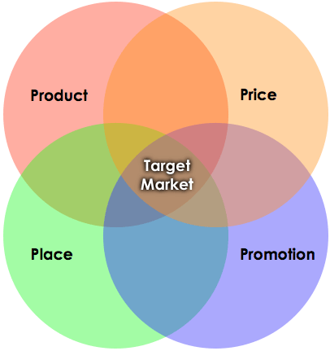
Figure 2.1 McCarthy's 4P's (1960) (Belfour-Ohio-Yearbooks., 2014)

McCarthy’s 4P’s model works well with manufacturing and physical products but with the increase in services provision, this model was seen as lacking, as even physical products have an element of service to them. Booms and Bitner extended the model further in 1981, by adding an extra three elements, people, process and physical evidence, this became known as the 7P’s (Blythe, 2012).
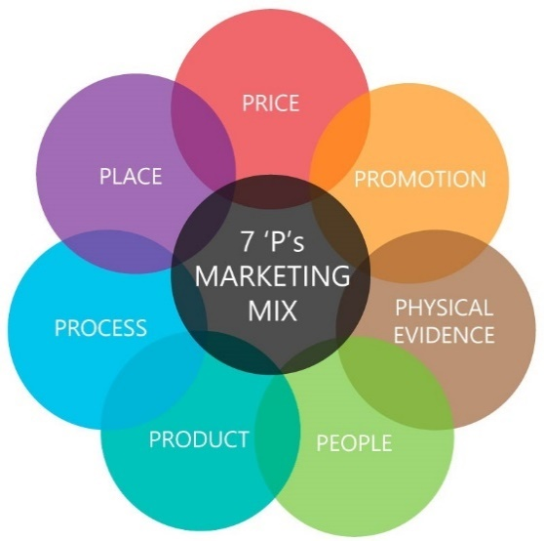
Figure 2.2 Booms and Bitner 7P's (1981) (Professional-academy, 2019)

Marketing communication
Marketing communication consists of all the way which a organisation can develop a range of methods to interact with existing and potential customers, these methods include advertising, personal selling, discounts and promotion, public relations and direct marketing. By maintaining a connection with customers an organisation can then build brand awareness which will then result in the increase of business security and revenue (McQuerrey, 2019).

Promotion mix
As previously mentioned, promotion is part of the marketing mix, as this thesis is relating to how organisations communicate with the public a further definition is needed.
Palmer (2007) identifies promotion as the activities that an organisation part takes in as a way of communicating to their chosen market. Various marketing techniques are used to achieve this, and they can be used tactfully in order for their products or services to gain a higher perceived value to the consumer, resulting in a higher sale and an increase of data that can be collected in the process (Fill, 2013).
The promotion mix model consists of five elements however there are some who add the sixth element of event sponsorship (Kokemuller, 2018).
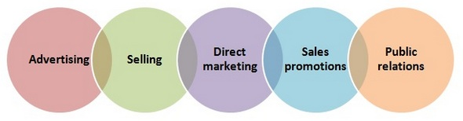
Figure 2.3 promotion/ marketing communication mix. (The-Marketing-Mix, 2019)

As there is a range of techniques involved in the promotional side of an organisation there is a need to coordinate all the messages and their execution, this is furthered by the realisation that different techniques of promotion were controlled and monitored by different departments. This led to the adoption of the integrated marketing communication concept in the early 1980’s (Fahy, 2012). Orasmäe (2017) furthers that it is used to correlate the messages from the four areas of: sales promotion, direct marketing communications, public relations and advertising. Y coordinating these messages it will allow the organisation to meet their goal of relaying a consistent image, to result in a higher influence over consumers communication and purchasing activities (Schultz, 2014).

Psychology of buying
Blythe (2016) outline the main three factors that influence the consumers buying decision, as follows:
Personal factors are the individual’s personal features that influence their buying behaviour, these features could be demographic, situational or the level of importance the individual paces on a product or service.
Psychological factors are the different elements of the individual’s thought process, such as perception, motives, attitude, personality or the knowledge an individual has about a specific product, service or market area.
Social factors are the way in which an individual is influenced by their peers, these are the individuals that the consumer has around them, these groups vary from an individual’s primary group and aspirational group to dissociative and also automatic groups.

Approaches to communication
Up until the early part of the 21st century the most common tools for marketing communications were television, radio, print and outdoor such as billboards. although these tools have not yet become completely obsolete, they have seen a decrease due to the increase in the use of social media and internet marketing (Winer, 2008). This originally started with the popularity of the internet with pop up bars and banners appearing on sites with the aim to entice the user to click on the ad, but in more recent years the rise in social media has enabled marketeers to gain access to their target audience through social media. Shankar & Hollinger (2007) argue that new media can be split into three classifications: intrusive, non-intrusive and user generated.
These forms of communications correspond with fast growth of social media marketing. The rise in investments for social advertising is set to grow from 32 billion US dollars in 2017 to over 48 billion US dollars by 2021, as it is considered as one of the most effective forms of marketing due to customers retention available (Statista, 2019)Marketeers know that if they use the right platform, and message then social media is a very powerful and sustainable way to make their campaign a success (Kumar, 2012).

Emotive marketing
An individual’s behaviour and decisions are driven by both rational an emotional factor. Marketers are aware of this, which prompts them to focus on feelings and emotions within their marketing communications (Hastings, 2007). Bakewell (2006) argues that
“For many people reasoned argument is not the final arbiter of how they choose to live their lives. They are swayed by feelings, moved by loyalties, willing to set logic aside for the sake of psychic comfort.” (Bakewell, 2006)
People buy and associate themselves with products not only for functional needs but to also satisfy emotional or social wants, for example self enhancement and social inclusion (Hirschman, 1982). This is furthered by Onate (2018) who concludes that emotive marketing communications are used to let the consumer believe that they are filling a need on a psychological level, such as affiliation, self-esteem and the need for self-fulfilment. By enticing consumers in this way, they are led to believe that the product or service they are purchasing is one that will fulfil these needs.
If emotive marketing is executed in a successful manner then organisations can gain a market advantage over their competition, as emotion is what inspires people to move or make decisions on purchases over rational thinking (Harvey, 2018).
Jenblat (2018) states that individuals who have an emotional association to a specific brand are 8.4 times more likely to trust the organisation, 7.1 times more likely to make a purchase from that organisation and 6.6 times more likely to forgive the organisation in that organisation were to make a mistake. Brant (2016) also argues that organisations that have a higher emotional response from its marketing communications have a 23% increase in sales.
The scope of emotions that marketeers try and induce is extensive and can be complex depending on the messages that are trying to be depicted. However, for the purpose of this research only the emotions of guilt and shame will be look at in further detail this is due to limited resources. It is important to note that even though guilt and shame are two different emotions, they are usually discussed together in the same context as they are both classed as negative self-conscious emotion (Saarelainen, 2018). The fitness industry uses these negative emotions and pairs them with positive messages of self-improvement to gain customers. Research from the University of the British Colombia’s School of Business conducted research that has found that individuals are far more likely to purchase products or services that are associated with self-improvement if they experience the emotion s of guilt or shame, even if the source of the guilt or shame have no relation to the product or service (Krashinsky, 2018)

Guilt
The emotions of guilt and shame are sometimes seen as interchangeable however, guilt is something that is felt on a personal level and involves the awareness of having done something wrong. Shame is a more painful emotion then guilt and may be the result of guilt, but not on the same level, it is the feeling of how we are perceived by others, it is a more external motion. A person does not need to have done something wrong to feel either of these emotions (Burgo, 2013).
Guilt marketing is the technique used within marketing communications to create a reaction of guilt from the consumer, as to generate a favourable response from them. It is found that it induces the best impact when paired with something that would be seen as short term commitment (Han, 2014). Bennett (1998) found that “guilt appeals are generally more likely to result in positive responses to advertisements and empathy”, Bennett (1998) also adds that for this to be effective any messages that may result in the consumer experiencing shame must be eliminated, as shame is argued to produce a negative effect if not executed correctly.
Marketing week (2009) uses the example of the guilt that an individual may feel when eating an unhealthy snack, and organisation would then exploit this guilt by offering up a healthier option as an alternative.
It can also be argued that for an individual to comply with the messages of guilt then the message must show some importance within the community in which the organisation works within. It should give the potential for peer approval Harvey (1988).

Shame
Han (2014) establishes that unlike guilt that is best used within a short term commitment, the use of shame within the marketing communication strategy is best utilised when combined with longer or larger commitments. Shame can be seen to be on a more personal level as it evaluates the individual personal attributes, unlike guilt which focuses on behaviour, by focusing on the individuals attributes it threatens that person’s self-esteem (Tangney, 2007).
Han (2015) further explains that a fitness club could induce the feelings of shame in messages such as ‘Are you overweight? How ashamed do you feel? Stop overeating and join our fitness program and feel healthy all the time’.
Brennan(2010) argues that a person can feel guilty but not feel the need to remedy it, however shame increases a person’s motivation to alleviate their shame. Boudewyns (2013) counters this argument by stating that the use of shame technique is unpredictable as they can lead to anger and denial which would result in the individual completely disregarding the message.

How Guilt and Shame techniques are implemented
The fitness industry is known for utilising shame and guilt inducing techniques to gain customers. To better illustrate how these messages are being implemented it would be beneficial to look at the different aspects of the fitness industry, the physical facilities and the products individually. In addition to these aspects, the continuous change in trends, with fitness and physical aesthetics will also be examined, as to ascertain the part they play in these marketing techniques.

Facilities
It would be argued that the most popular shame inducing technique that fitness facilities or gyms utilise in there marketing communications is ‘body shaming’. Praderio (2017) supports this claim by highlighting that the use of imagery and shame heavy slogans that provide the bases of the shame inducing technique. Praderio also explains that within just a few minutes and a few key words you can find a plethora of examples, with slogans like ‘just when you thought it was safe to go back on the beach, you tried on your bathing suit’ and ‘ would you rather be covered in sweat in the gym or covered in clothes on the beach’ (see appendix C).
In August of 2018 Golds Gym was forced to apologise due to the backlash they encountered in respect for one of their campaigns, which featured an image of a pear with the caption of ‘this is no shape for a girl’. However even though it was this particular image that inducted the backlash, there are numerous others from Golds Gym containing the same body shaming messages (see appendix D for a few examples) (Schlossberg, 2018). Golds gym however are not the only facility who is known to operate in this way, Puregym, Fit4less and SkinnyPigs fitness class are just some other examples (see appendix E).
Shame isn’t the only way that gym facilities try and get individuals to use their products, among the other available emotions that could be used to attract more customers, guilt is the other emotion that is used in different ways in an attempt to gain customers. Abs for life questions people who are to busy to give the time that they deem acceptable in one of their adverts, although within this advert they only list the basic needs of sleep, eating, showering and work, resulting in a 37hours of spare time. Abs for life also use social media as a way of communicating to the public, Instagram is one of the platforms of choice. On their page there are currently over 5379 posts, most of which are images of individuals which would be deemed by current standards as possessing the ideal body, the other images are of consumables that they see as healthy. Amongst these images there are little slogans and messages that are designed to induce guilt such as ‘the best ab exercise is 5 sets of stop eating so much crap’, all this combined would see anyone who views this page feel guilt for not looking like the images or for not eating the right food (Abs-for-life, 2019).
R2 fitness club uses Christmas, and the fact that this time of year is particularly busy, and people generally consume more during this period to guilt consumers about their Christmas habits in a bid to encourage them to take action against the effects of these habits.(see appendix F) Hosie (2016) provides some backing on that claim, and suggests that on average individuals consume around 5,905 on Christmas day alone.
This bombardment of messages that dictate what the perfect body is and how often a person should frequent a gym facility in addition to the diet restrictions causes what is known as ‘gym guilt’. This is a sense of failure that is experienced if a person hasn’t been able to meet their set goals, needs to miss a workout, or consumes something that is seen as not being one of the healthy products (Markula, 2015)

Products
In conjunction with the fitness facilities in this industry there are the also the more physical aspects, such as clothing and nutrition, equipment is also a product that falls into this area, including a product coined as the ‘booty band’ which is essentially a resistance band used to isolate the glutes while exercising (Fitness-Health, 2018), which is growing in popularity among individuals who wish to gain a certain aesthetic.
The sports apparel market alone was worth $173.68 billion at the end of 2018 (Statista, 2019), and by using images of individuals within their marketing communications that are unobtainable to the vast majority of people they are as Petter (2017) claims “‘empowering individuals’ but perhaps only to feel bad about themselves and buy more things”. Gym shark, mentioned above, has been observed to be guilty of this, there endorsed influencers are all what would be perceived as the ideal body, there other media communications also show the same type of individual, who most would deem a unobtainable image.

Summary
While examining the literature and academic studies behind the topic of this these it is apparent that there is limited credible resources available on this subject area. This may be due to the fact that the subject area that this thesis is based upon is a relatively contemporary subject matter. This however proves that there is a need for further research to be conducted in this area.

Chapter Three - Methodology

Chapter overview
Firstly, this chapter will provide definitions on what research is and why it is an important process, it will then underpin how the researcher will structure the investigation by using the Saunders, Lewis and Thornhills Research onion to help structure their research. It will explain in its entirety the whole process of the research methodology, by using the research onion as a step by step guide, with the use of definitions and academic resources to further why the researcher has chosen the structure they have.
Lastly this chapter will highlight the limitations of the research that will be undertaken and explain how they intend on remedying this, in addition to the ethical implications that may arise.

Definitions
Although businesses and academic activities rely heavily on research there is no agreed definition within the literature that surrounds this topic, Collis and Hussey (2009) argue that one reason for this is research means different things dependant on who you are or what you are looking to find. However, by looking at the varied definitions available there are common aspects that can be found across them. Collis and Hussey (2009) outline these three cross overs of what research is believed to be, “ a process of inquiry and investigation, systematic and methodical and research increases knowledge”.
Research can also be defined as a step by step process in the aim of generating answers to predetermined questions by a means of gathering, documenting, analysing and translating the information to enable decisions to be better informed (Wilson, 2010).
If the research is specific and focuses on one particular area, such as measurable outputs, making it harder to generalise the results, this research is known as applied research. However, if the research can be generalised such as gaining knowledge of social or organisational process, this is then classified as basic research (Gray, 2017).
The researcher is intent on obtaining a general consensus on the topic to gain a better understanding and to further any future investigation, this is due to the lack of previous research, therefore this thesis will be basic research.

Research onion
For the purpose of this research the author will use the research onion (see figure 3.1) as a means of ensuring that all stages of research are fully explained and appropriately justified.
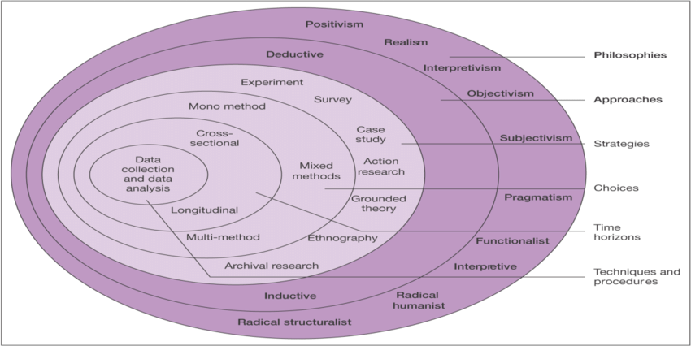
Figure 3.1: Saunders research onion. (Saunders et al, 2007).
The research onion works by way of peeling an onion, you work from the outside, working inwards through all six layers shown above, each layer gives options of techniques and tools for a researcher to choose from depending on what is suitable. By implementing each layer of the research onion, the research can be assured that upon completion they will have a full and comprehensive bit of research (Sahay, 2016).
The remainder of this chapter will utilise the research onion as a framework to structure the discussion and as justification of the methodology applied by this thesis.

Research philosophy
As shown in figure 3.1 research philosophy is shown as the outside layer of the research onion, this is due to it being the first stage of the research process. It refers to the “system of beliefs and assumptions about development of knowledge” (Saunders et al, 2007, p.?), the assumptions observed within the research philosophy will underpin the research strategy (Saunders, 2009). Research philosophy is comprised of three key terms, two of which are epistemology (what we believe is valid knowledge) and ontology (what we deem reality).
“ontology and epistemology create a holistic view of how knowledge is viewed and how we see ourselves in relation to this knowledge, and the methodological strategies we use to un/discover it. “
(Patel, 2015, p.1)

Easterby-Smith (2002) suggests that there are three reasons why it is important to understand research philosophy, the first is to understand research designs, second is to aid the researcher in which research design would be more beneficial. Lastly it can help the researcher identify the constraints of research within certain subject areas and adapt their research design accordingly.
As previously mentioned, research philosophy is the shown as the outside layer of the research onion and it consists of 10 different philosophies that could be used by the researcher, however for the benefit of this research, the researcher has decided that the interpretivism form of research philosophy would best suit this topic. The interpretivism approach supports the belief that the researcher must look at the social aspects of the chosen topic, as the social aspects of business are too complicated to be measured in the same way as natural sciences which more typically engages in positivistic research (Wilson, 2010).
As this research is based around how the marketing communications of the fitness industry there is a heavy social presence surrounding this topic so interpretivism is the research philosophy that would benefit the researcher the most.

Research approaches
Research approach is the second step in the research process, there are seen to be two approaches, deductive and inductive. A deductive research approach can be argued to be best suited towards a more quantitative form of research, this is due to it being a process of generating hypothesis, which can then be found true or false (Hyde, 2000). An inductive research approach is generally seen with a qualitative research model, it is based on the researcher having a completely open mind with no preconceptions on what the findings will show (Gabriel, 2013)
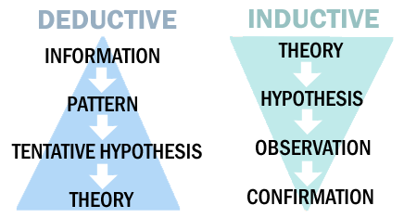

Figure 3.2. Deductive and Inductive Reasoning (Tucker, 2014).
This investigation will be using the deductive approach, as the main part of the primary research will be quantitative research in the style of questionnaires. The investigation is based on the notion that the marketing communications may be led by guilting or shaming consumers about their health.

Research methods
The research methods will be the use of surveys, these will be in the form of questionnaires and a focus group, but both will be used to collect the primary data needed.
Surveys are used to obtain data from a large sample of individuals and their attitudes and perceptions that would not be obtained during an observation technique (Glasgow, 2005).
Pinsonneault and Kraemer (1993) furthers this by defining a survey as a “means for gathering information about the characteristics, actions, or opinions of a large group of people” (p. 77).

Research choices
Snow and Hambrick (1980) argues that research strategy based on one data source can be very limiting and would not give a reliable view of the chosen topic. Based on this argument this research will use a mix method approach. Mix method is a research approach that consists of researchers collecting both qualitative and quantitative data within the same study (Shorten, 2017). When looking at how important mixed methods can be to a study Hurmerinta-Peltomaki and Nummela (2006) found that by utilising a mixed method approach it added a further validity and value to the findings, increasing a deeper understanding and knowledge.
However, mixed methods research can require additional time and funding due to the increase in data collection, different type of data that would need to analysed and the need to determine whether any data from to two approaches draw a parallel (Creswell, 2011).

Time horizons
The researcher is interested in studying a new phenomenon , which is not presently well understood due to its recent stage of development. Cross-sectional research has been chosen to capture the current zeitgeist within the area of social media and the fitness industry.
Cross-sectional research represents data that is collected at a single point in time which is a benefit if the research has a time restraint (Wilson, 2012). By using cross-sectional it can allow the researcher to collect a substantial amount of data in a relatively short space of time, and will help provide information on different variables such as age and gender as a way of determining what factors may correlate with the information that is required and what areas future research should focus on (Cherry, 2019).

Techniques and procedures
As previously mentioned, the researcher will use a mixed method approach to gather the information needed, this will be made up of quantitative research in the form of an online questionnaire and qualitative research will be a focus group.

Questionnaire
Questionnaires are a form of quantitative research, designed as a method to compile data suitable to achieve the desired research objectives (Wilson, 2010). It is a quantitative form of data collection as it is able to collect a significant amount of data that can be analysed with relative ease compared to qualitative data due to the data that is collected can be recorded as nominal data (Peters, 2019).
By using an online questionnaire, the researcher can determine whether there are certain factors such as age or gender that will have an effect on how individuals perceive the marketing communications within the fitness industry. For example, whether there is a correlation between a person’s age or gender and how they are affected by certain topics and areas.
The questionnaire will be loaded onto an online survey platform, Survey Monkey, by doing this the survey can be easily accessed and shared over multiple other platforms with ease. Survey Monkey also provides an analysis of the findings upon collection, including any questionnaires that have completed in the physical form as it allows the researcher to add the data in manually (Survey-Monkey, 2019).
The questionnaire will be designed to engage participants thoughts on how they feel and interpret the marketing communications that they encounter. It will aid in understanding the general consensus on where the sample experience the most communications from the fitness industry and whether there is a correlation on different factors and how they factor may affect the thoughts and feelings of the participants.

Focus groups
In addition to questionnaires, focus groups will also be administered, focus groups are a type of qualitative research. It is a form of group interview , it encourages its participants to talk and discuss the topics that arise during the interview, if there are agreeable dynamics within the group it could instil a discussion that may lead the researcher to look at points relating to the topic that have not yet been thought of. It also lets the interviewer to witness other forms of communication verbal and non-verbal, these variations can enable the interviewer t understand how much knowledge or experience the participant has, or whether they are being sincere (Kitzinger, 1995).
To analyse the data collected from conducting the focus group the interviewer will record and maintain a transcript, the transcript will then be analysed and evaluated in relation to the survey findings to form a complete and descriptive understanding of the findings produced.

Sampling
Lansford (1995) explains that sampling is a subsection of population that will be chosen to take part in the study. Sampling methods will fall under one of two types, probability which or non- probability (Burgess, 1982). The sampling for this research will be convenience sampling for both the questionnaire and the focus group, which fall under non-probability as there is no guarantee of the outcome and the findings will be subject to some form of chance (Tansey, 2007).
Convenience Sampling is based on the participants being easily accessible to the researcher, it also means that this form of research sample is the most cost and time effective (Lunsford, 1995). The widest population that is the most easily accessible to the researcher is social media, which is where the researcher will base their sample.
As the questionnaire is online based the researcher will share the questionnaire over various social media platforms in order to gain the most responses, these platforms will be Facebook, Instagram and WhatsApp. by using these platforms, it will allow for participants to complete the survey via a link, once completed that link can then be shared and passed on by the participant, giving the researcher an increased chance to gain the number of participants needed.
According to survey monkey (2019), which is the chosen platform for the online questionnaire, for a margin of error of 5%, the researcher will need 80 out of 100 surveys completed in full. Anything less than this will result in a higher margin of error, making the finding less reliable.
For the focus group the researcher will take advantage of the individuals that are known to the them, this is for an ease of process and to limit the time taken on finding individuals to participate. the researcher will aim to have between five to eight participants taking part in the focus group as this is the recommended number by Krueger (2002), as anything thing over 10 may make it difficult for the researcher to control the discussion.
To source the candidates for the focus group the researcher will offer a small incentive to secure their participation and to thank them for their input.

Reliability and validity
Research would be deemed reliable if the findings would remain predominantly consistent if process was repeated, this would show a true representation of the population that is being studied (Joppe, 2000).
The validity of research would be determined on whether the research finds the answers that it was implemented to do so. Joppe (2000) explains it as,
“whether the research truly measures that which it was intended to measure or how truthful the research result is”.
(Joppe, 2000 p.1)
Research reliability and validity is centred on the researcher to first produce well designed research and then for then to emote a convincing argument around the results. Then it is up to the readership to make up their mind on the credibility of the research (Lincoln & Guba, 1985).
By utilising a mixed method research the researcher is compensating for the shortfalls in the opposing paradigms. Questionnaires are deemed as a more positivist research method when used on the own, it is seen as high on reliability but low in validity. However, focus groups are an interpretivist research method and mitigates the shortfalls that are associated with the questionnaire, although it is low in reliability it is high in validity.

Limitations
Limitations are difficulties that the researcher may encounter during the course of the study but have little or no control over (Simon, 2013).
As this study will be conducted over a limited time period, the findings would be a snapshot of the participants opinions which would be dependent on conditions that are occurring during this time period. If the same research were to be recreated in another period in time the condition may be differ and so may the findings as a result (Simon, 2011). However, due to the researcher interested in the contemporary view on these issues this is a minor limitation.
In addition to the limited time the use of a convenience sample may limit the representation of the wider population, however, as already mention this is the best sampling that would meet the needs of the researcher and the time that has been given.
As the participants of the questionnaire opt in,is may create an inherent bias in the results, as self-selections may have different views to the public at large.
To remedy these limitations the researcher will produce and follow a Gantt chart as to better manage the limited time that the researcher has.

Ethical issues
Any individual who is party to collecting data from participants has the ethical duty to respect each participant’s autonomy (Kelley, 2003).
To remedy this the researcher will have a preamble before the questionnaire to explain that all persons have to right to withdraw at any point during the questionnaire and that all data collected will be anonymous and will be destroyed upon completion of the analysis. It will also give the participants the opportunity to contact the researcher will any questions or concerns they may have. See appendix G for the full preamble and sample questionnaire.
Participants are not compelled to take part as it is an opt in survey, and all data will be confidential and anonymous. All data will be kept on one laptop which will be in the possession of the named researcher only and subjected to password protection.
As the questionnaire and focus group will not include any participants that would be deemed vulnerable or under the age of 18 there will be no ethical considerations needed to ensure their well-being.
All research undertaken will be subject the researcher’s university’s ethical approval procedure, please see appendix H for a copy of the completed ethics form.

Chapter Four - Analysis

Chapter overview
This chapter will aim to satisfy the second objective:
- To conduct primary research in the forms of an online survey and a focus group to ascertain the impact on these communications.
It will analyse the findings that have been compiled during the investigation period using questionnaires and a focus group and see what the public perception is of these marketing techniques. The quantitative data will give a statistical evaluation of the participants view on the matter with the qualitative data from the focus group will be provide more substantial insight as it provided the not only the participants views by why they feel this way.

Demographics
This section will be used to identify the demographics of the 101 participants of the online survey and the 5 focus group.

Online Questionnaire

Gender
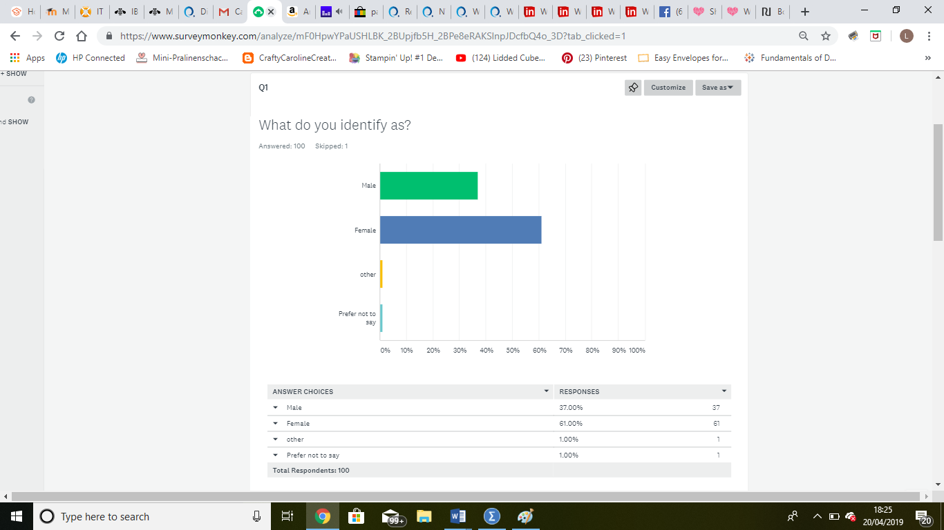
Figure 4.1 graph showing the gender survey participants.
figure 4.1 out of the 101 participants of the online survey 61% were female and 37% were male. The option ‘other’ and ‘ prefer not to say’ both had 1% and 1 participant skipped this question all together

Age
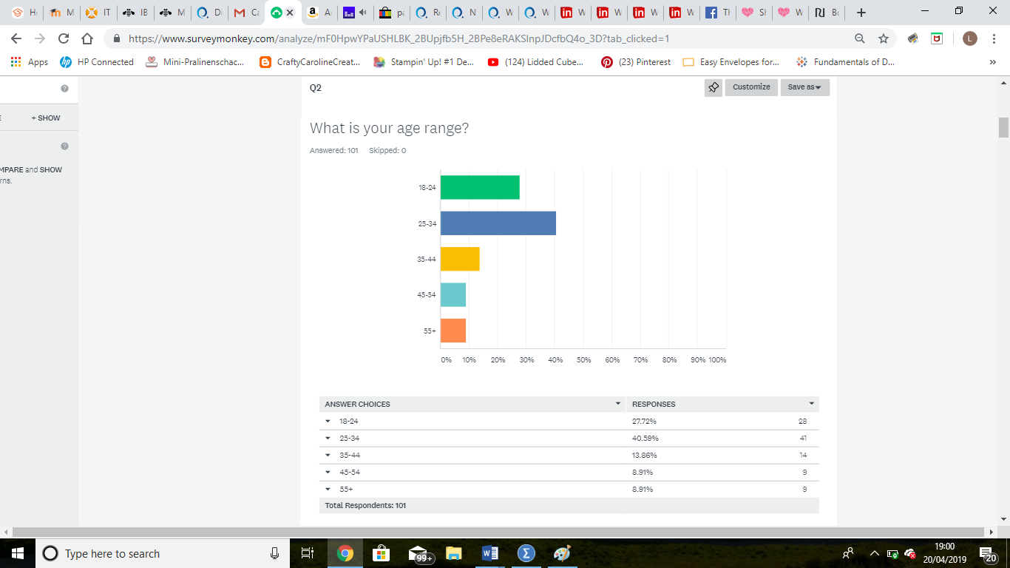
Figure 4.2 age range of the participants
Out of the 101 participants 68.31% were of te age 34 and under with only 17.82% being over 45 years of age. Please see figure 4.2 for the age ranges in detail along with percentages for each group.

Perception of personal fitness
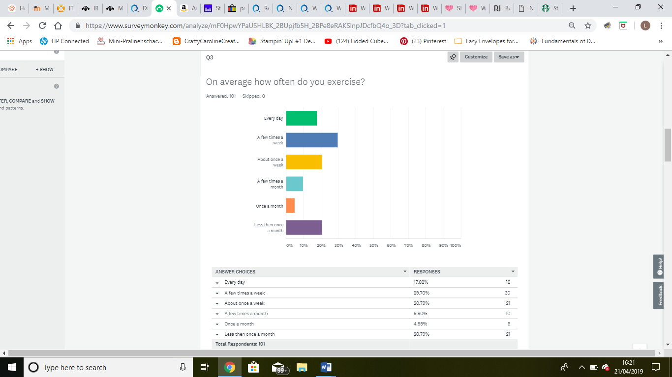
Figure 4.3. exercise regularity of the online survey participant
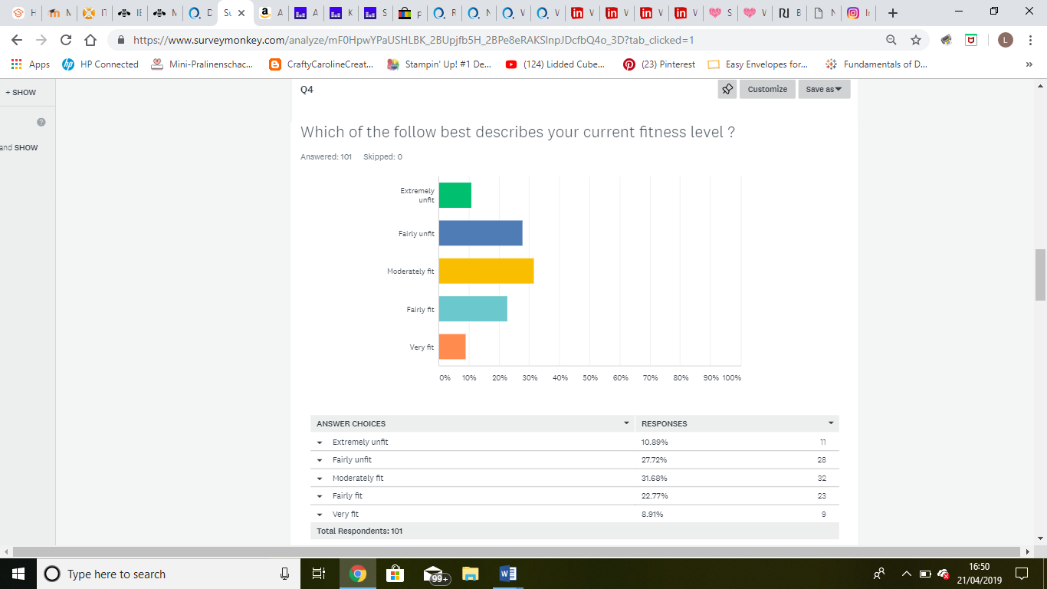
Figure 4.4 perceived fitness level of the participants
During the online survey the participants were asked about their personal fitness as a way to gage their level of insight into the subject. It was found that most of the participants participated in some form of exercise regularly (figure 4.3), and they had a generally moderate fitness level (figure 4.4).

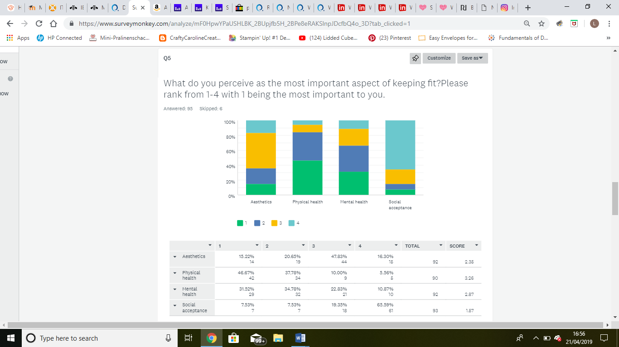
Figure 4.5 survey participants most important aspects of keeping fit
When asked what they perceive as the most important aspect of fit was 31.52% deemed mental health as the most important aspect, while 46.67% deemed it was their physical health that they saw as the most important aspect. Counter to this 65.59% seeing social acceptance was not a driving force behind staying fit. See figure 4.5 below for the full results from this question. However, six participants did skip this question but the this would do little to affect the current percentages as they are quite definitive.

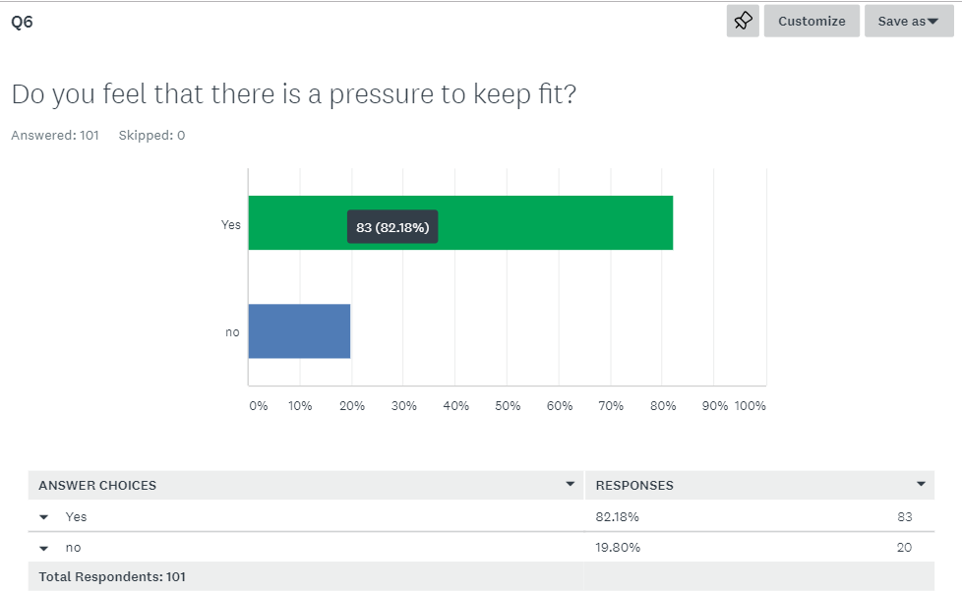
Figure 4.6 do the survey participants feel there is a pressure to keep fit
The final question in this section would be whether the participants feel that there is a pressure to keep fit. Figure 4.6 shows all participants answered this question and it resulted in a majority of participants feel that there is a pressure to keep fit.

Perception of the fitness communications

Online questionnaire
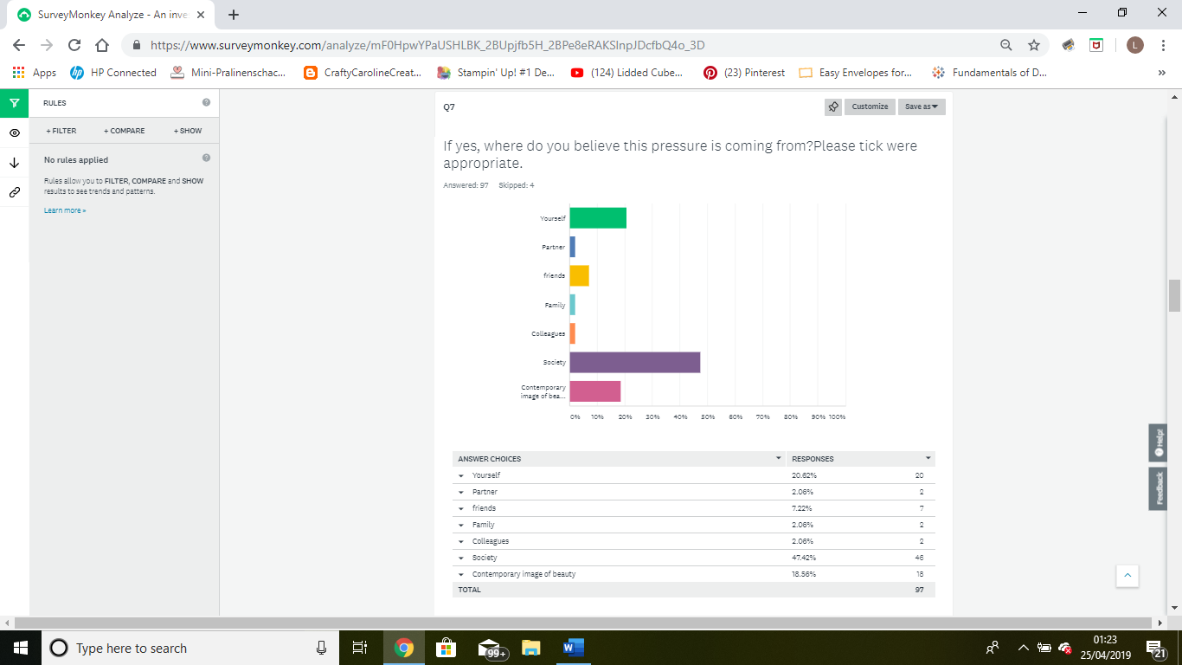
Figure 4.7 where do the participants believe the pressure to keep fit is coming from
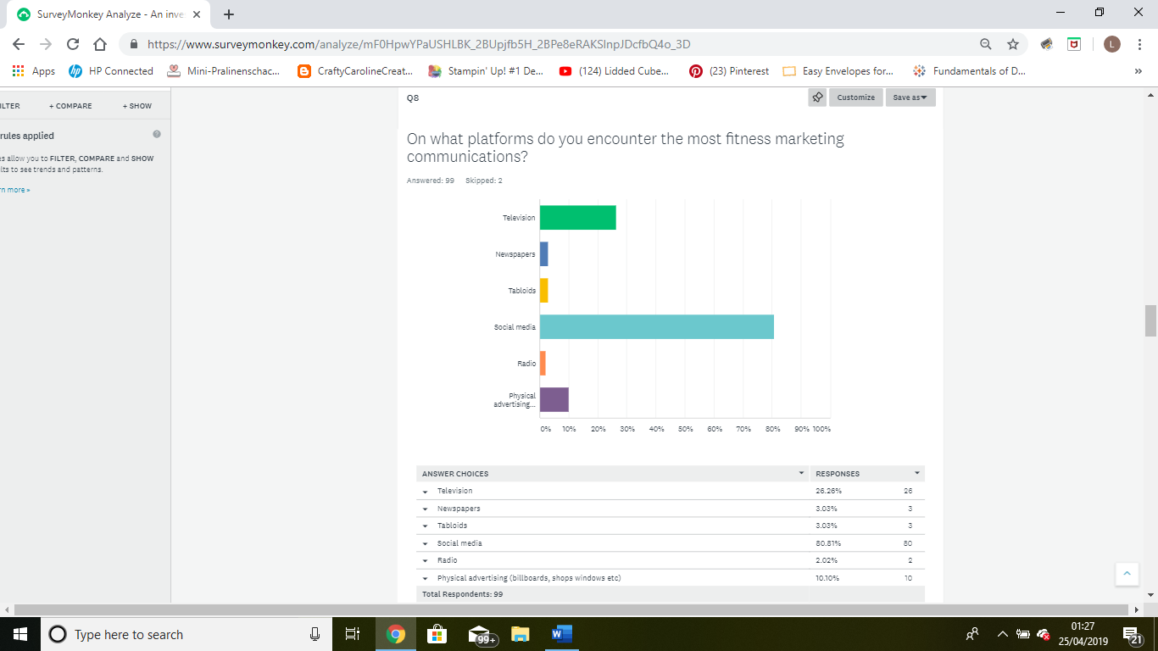
Figure 4.8 where do the participants experience the most marketing communications
In contrast to question 5 which seen 65.59% claim that social acceptance was not a factor that they deem an important aspect of keeping fit, figure 4.7 shows over half of the participants deem society or the contemporary image of beauty is where the pressure to keep fit is coming from. When asked where the participants are more likely encounter the most marketing communications relating to fitness was, a high majority of them, 80.81%, answered social media being the main platform (see figure 4.8). when combined these answers support each other in terms of where they are seeing the marketing communications and where they see that the pressure is coming from.

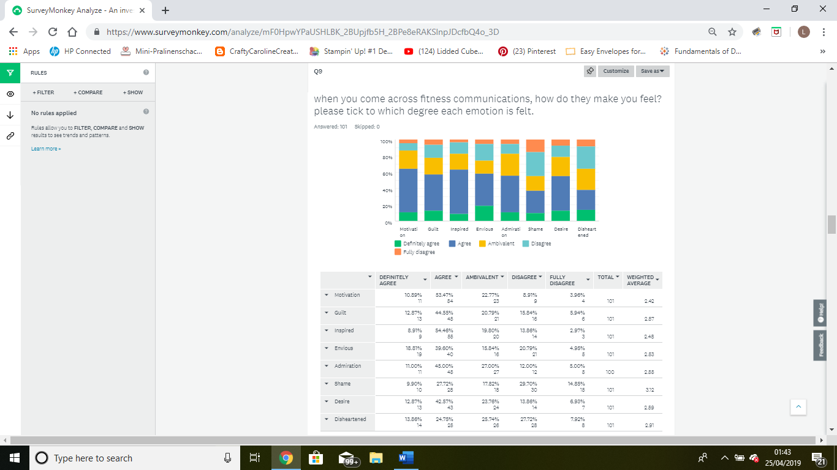
Figure 4.9 the emotions experienced when encountering fitness marketing communications
Figure 4.9 shows what emotions the participants fee they experience when they come across fitness marketing communications although there is a slight variation between each of the emotions listed there isn’t enough for this to be conclusive, this could be down to the way in which the question was presented. However, the emotion shame came up as the least agreed upon answer during this question.

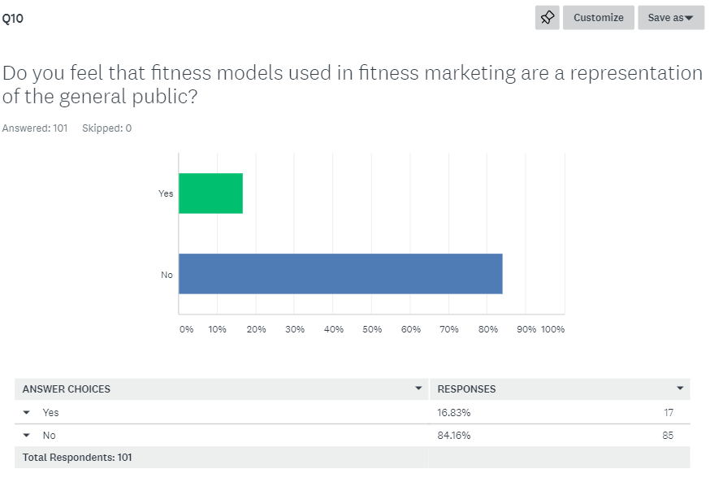
Figure 4.10 do the participants feel that the general public is represented by the models seen in the marketing communications
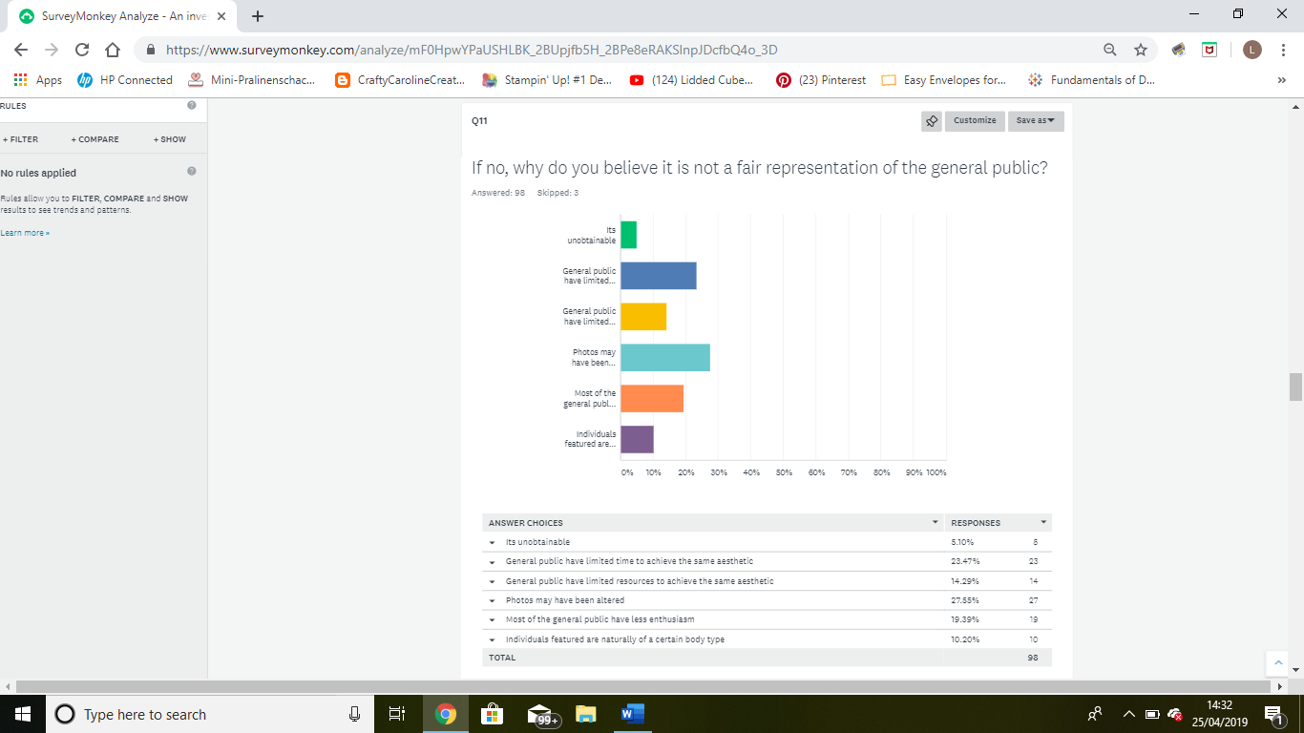
Figure 4.11 why do they feel the general public is not represented
84.16% of the participants agreed that the models depicted in the fitness marketing communications do not represent the general public (figure 4.10). When asked to highlight why they do not feel that the general public are not represented in the marketing communications there was a difference of opinion, although ‘the general public have limited time’ and ‘ the photos may have been altered’ were the answers that generated the highest response as shown in figure 4.11

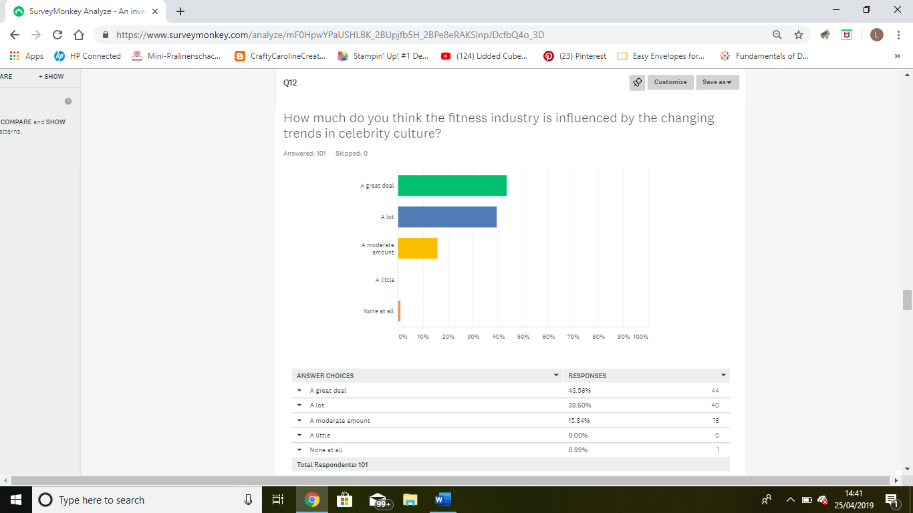

Figure 4.12 how much is the fitness industry influenced by celebrity culture
In addition to the majority of participants feeling that the general public are not being represented they also feel that that the is highly influenced by celebrity culture, to the point that only 1 out of the 101 participants disagreed with this statement (figure 4.12).

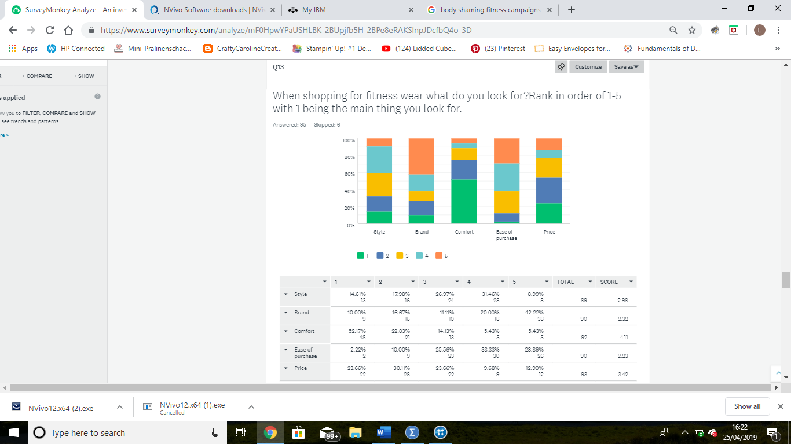
Figure 4.13 priorities for fitness wear
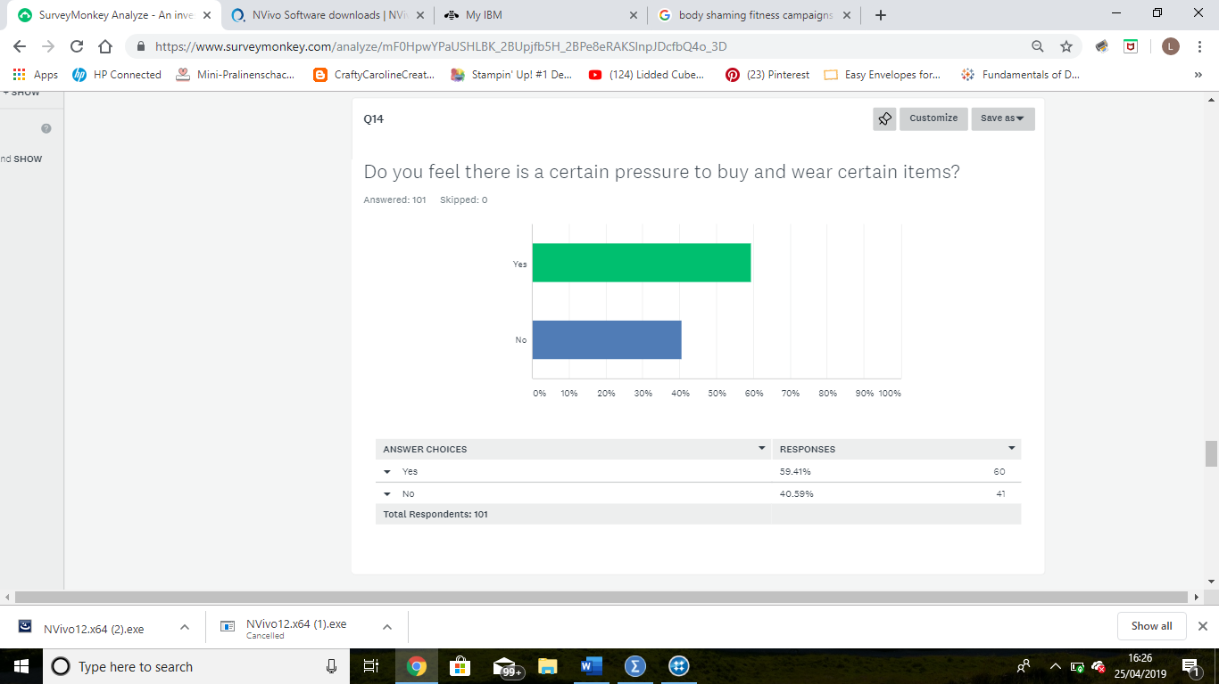
Figure 4.14 do the participants feel there is a pressure to wear certain items
The participants previously felt that there was significant pressure to maintain a certain level of fitness however when asked about the pressure to purchase certain items such as fitness clothing they do not feel as strongly, there is a higher percentage that agrees there is a pressure but it is only 59.41% (figure 4.13). even though they still feel there is certain amount of pressure they claim to not Sercombe to this pressure and purchase goods primarily for comfort (figure 4.14).

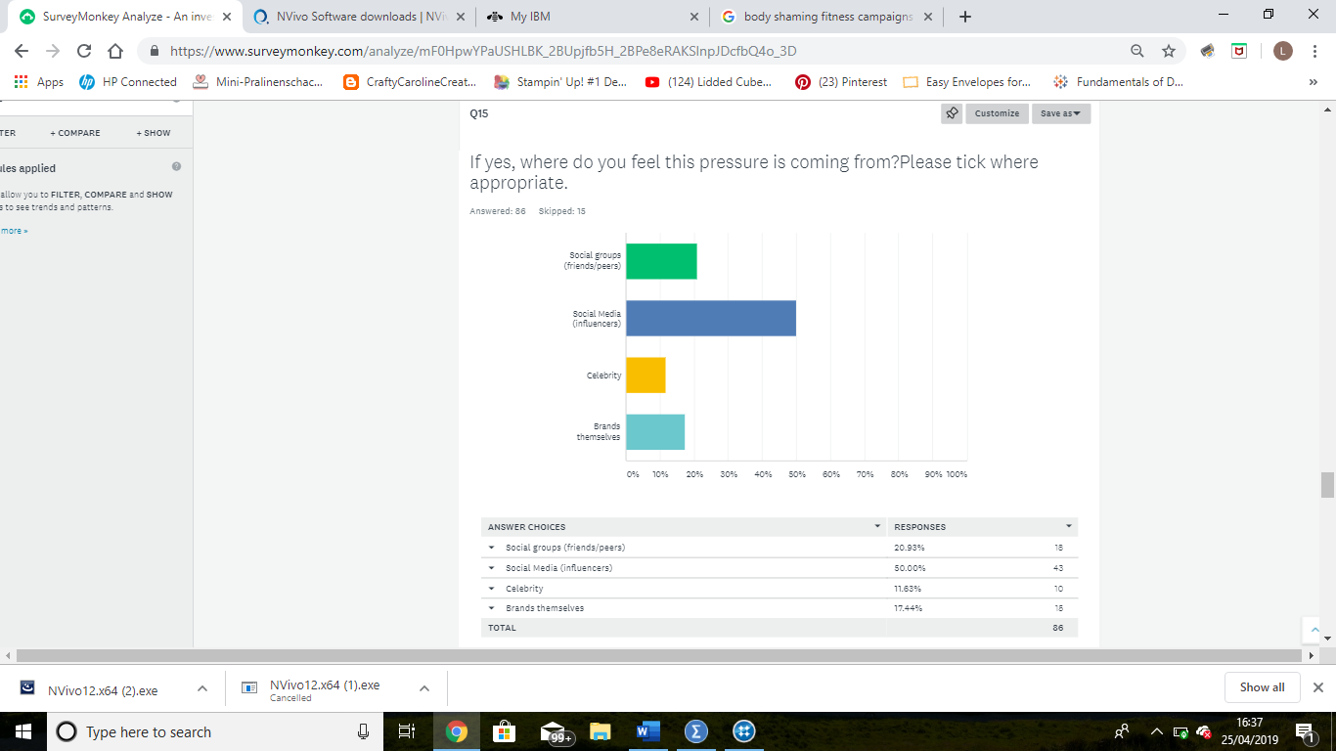
Figure 4.15 where do the participants believe the pressure to wear certain items id coming from
When asked where the participants believed this pressure is was coming from only half of them agreed that it was due to social media, see figure 4.15, in comparison to 80% previously found that social media was the cause of the pressure to keep fit.

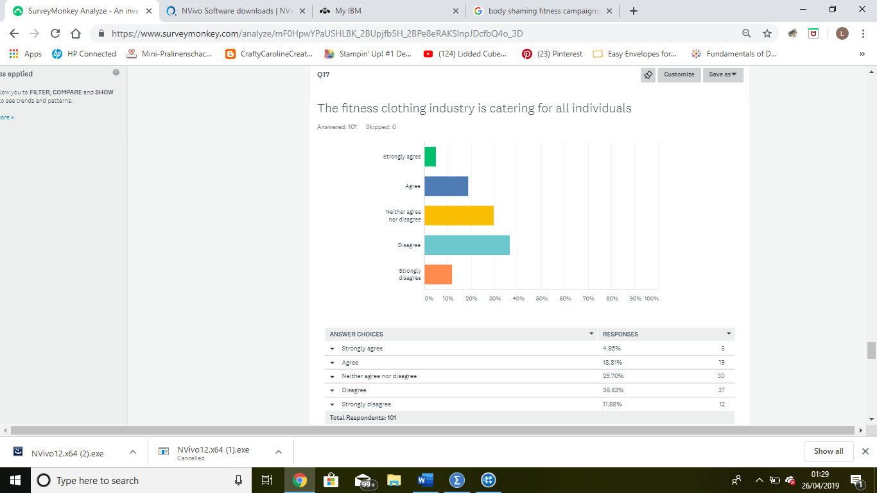
Figure 4.16 participants view on whether the clothing industry are catering for all individuals within fitness
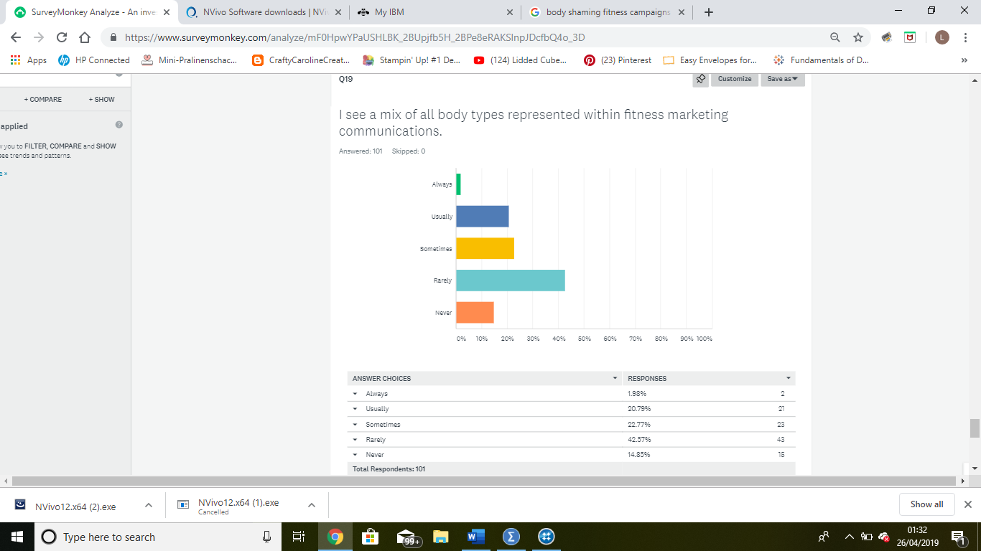
Figure 4.17 do the participants see all body types represented within the fitness industry
Furthering the perceived pressure that the participants have agreed on the having experienced due to the marketing communications of the fitness industry, the over half claim that they rarely or never see a mix of body types represented within the fitness industry, 22.77% claim that they sometimes see evidence of this. However, the participants less participants disagree that the fitness clothing industry is catering for all individuals, with 29.70% neither agreeing or disagreeing. This may be due to men possibly having less of an issue with the fit of clothing then women, this may be a point of interest in further research.
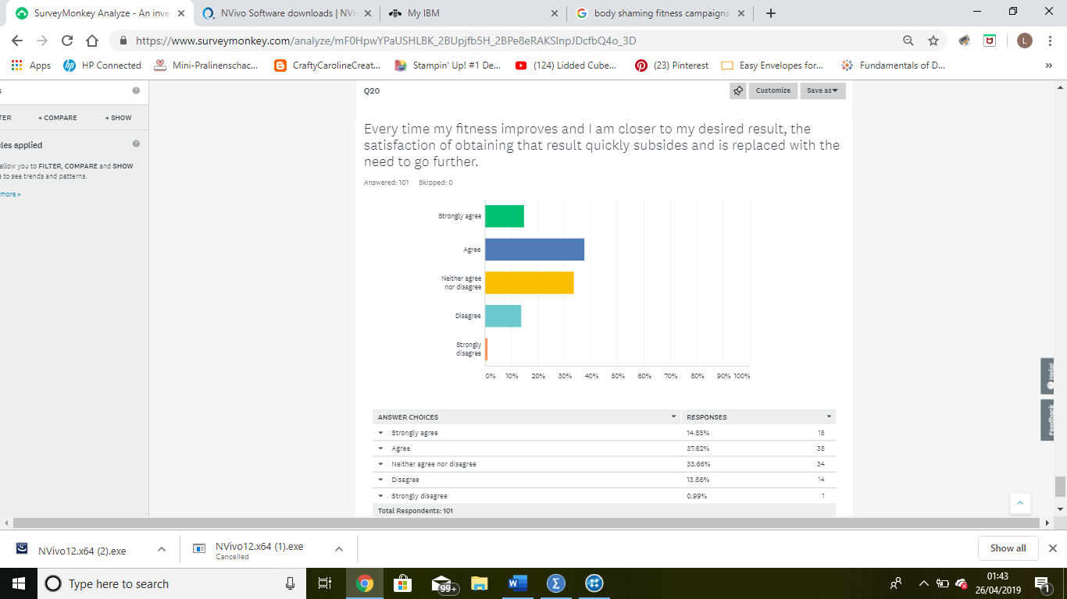
Figure 4.18 whether satisfaction is sustained upon reaching targets and goals
Furthering the perceived pressure that the participants have agreed on the having experienced due to the marketing communications of the fitness industry, the over half claim that they rarely or never see a mix of body types represented within the fitness industry, 22.77% claim that they sometimes see evidence of this. However, the participants less participants disagree that the fitness clothing industry is catering for all individuals, with 29.70% neither agreeing or disagreeing. This may be due to men possibly having less of an issue with the fit of clothing then women, this may be a point of interest in further research.

Focus group
The demographics of the focus group consisted of 3 females and 2 males, the age range of the participants were 25 to 35 years old, with varied personal fitness levels.
During the focus group while discussing a question on whether there is a pressure around keeping fit, participant E stated that although they do feel a pressure now they used to feel it a lot more when they were younger and since maturing the pressure has subsided a little, however they do understand and see that there is a growing pressure for the younger generations to be and maintain a certain fitness level.
To add to this participant B also stated that they can see that there is a pressure for people to be a certain way, look a certain way, fit a certain box, wear a certain brand and copy a certain celebrity. They however argue that the pressure is a little positive too as it can help people focus on staying healthy. Please see appendix I for the full transcription from the focus group.

During the discussion the participants of the focus group agreed with the participants of the questionnaire, they also believe that the majority of marketing communication form the fitness industry shown over social media, as they named the social media platforms, Instagram and Facebook although Instagram was named as the being the most used platform. Participant A addressed that Instagram is a picture based platform, so as your scrolling you’re seeing the communications whether realising or not.
When asked if the increase in popularity of fitness a good or bad thing, participants B stated that it was both good and bad, they furthered this by agreeing its good because its making people focus on being healthy, but its putting pressure on individuals to look a certain way. Participant C suggested that the trend may not be centred around fitness, but more ‘look at my perfect life, rather than being healthy they focus on looking good, faking healthy’.
As part of the focus group the participants were shown marketing images from two different fitness clothing companies, the brand names were kept anonymous to minimise any pre-existing preconceptions. When shown the images (see appendix J) from company A, known as Fabletics the participants described how they felt less pressured, and more included. Participant A suggested that ‘when you see people too perfect it can make you feel like what’s the point, but these ones (pointing at the images from company A) look more like something you can do’.
The participants then when on to say that they would be prompted to purchase items from this company as they would be more likely to have items that suit as they look like they have a various range to suit all individuals.
However, when shown the images (see appendix K) from company B, known as Gym Shark, the participants reaction was less positive with one participant claiming that the images were not real, with another participant agreeing to this statement and adding that the images had been manipulated and that the models ‘don’t look like that 100%’. Participant B added that the images were unrealistic and made them feel completely demotivated and envious, and that they are ‘not good enough’.
When prompted on whether the participants would purchase from company B the consensus was no, participant B explained why they would not purchase from this company due to, judging by the images the clothing doesn’t look like it would fit and that they would be uncomfortable.
Participant E strongly suggested that they would never dress in the way the models are dressed.
One of the images regarding company B, which is used to promote their leggings, gained the response from the participants as not having the purpose of promoting leggings, but to entice a reaction in a way to gain ‘ followers’ on social media.

Some of the differences that were addressed between the two companies were as follows;
- company B wanting to focus on looking good, while company A focus on being healthy rather then looks.
- Company B seems to have limited clothing options, which main consist of short tops for women and tight leggings, or vest tops for men with tight leggings. However, company A were seen to have a more varied range of products.

The second half of the discussion focused on the marketing communications of two fitness facilities, the first being Golds Gym campaign, which would be seen as having a shock factor , figure 4.19, and the second being Virgin Actives, grid games campaign, which can be argued to be more encouraging, figure 4.20.
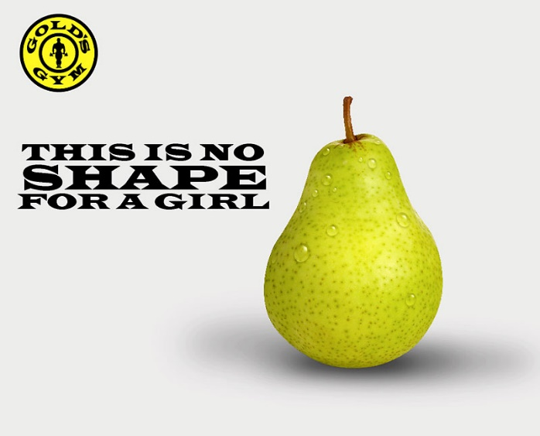
Figure 4.19 Gold's Gym: no shape for a girl campaign. Source: (Mather, 2016)
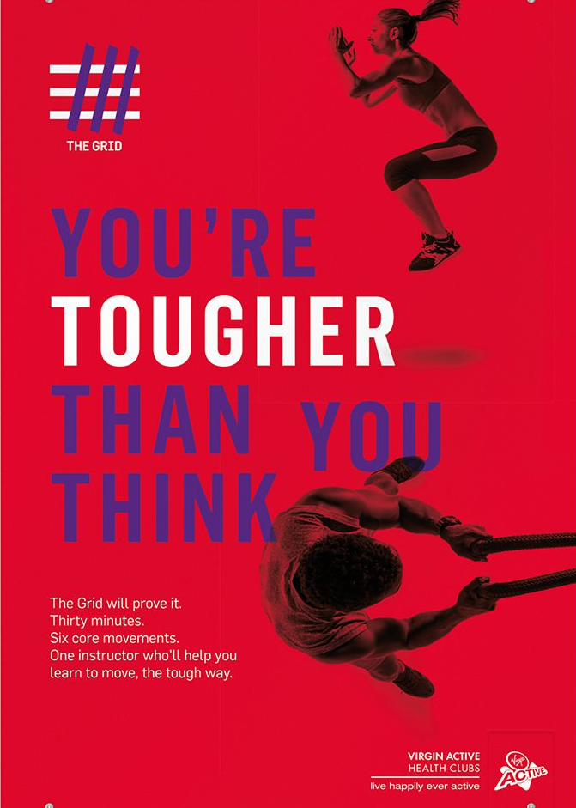
Figure 4.20 Virgin Active's grid games campaign. Source: (Wolff-Olins, 2019)
Each of these campaigns provided very different reactions from the participants. The Golds gym campaign was seen as ‘rude’, ‘disrespectful’, and ‘insulting’, with one participant voicing that it made them feel angry and does make them feel good about that establishment, remarking that “if they’re going to insult you within their advertising then what are they going to do when you get there”. Participant D made a comment that this campaign was made to gain publicity, even saying that ‘ there is no such thing as bad publicity’.
Virgin Actives, grid games campaign however, was seen as a more empowering message, and somewhere the participants would feel more welcomed.
Participant C also connected Golds Gym campaign with the marketing communications from Gym shark, stating that they would associate the two companies as being frequented and used by individuals who were not just interested in a healthy lifestyle. These individuals were described by the participants as being ‘posers’ who have the desire to take pictures of themselves while partaking in fitness activities just so they can post about themselves on social media. Their main goal was argued to be social media standing over health.
Further topics were highlighted by the participants during the discussion were the pressure that comes from social media is fuelling the rise in ‘quick fix’ solution such as bootcamp and beach body programs as individuals are pressured to look a certain way for any upcoming event.
One participant commented on how even if social media is not used by an individual they may still be subjected to the same pressures. They argued that the pressure that is coming from these platforms’ bleeds into other aspects such as peer pressure, this has already been highlighted in the respondents of the questionnaire as 82 out of the 97 participants who answered that question of where do they feel the pressure to keep fit is coming from?.
The last note that should be pointed out is that participant E pointed out that there is a rise in positive discrimination within the marketing communications they see. While participant B agrees with it being impressive to see an individual achieving what they are doing, due to the individual shown does not meet their perceived notion of a ‘healthy’ person. They also comment that it feels false and the marketeers are only trying to ‘tick boxes’ as there is a push for inclusivity in all media communications.

Chapter Five - Discussion

Chapter overview
This chapter will aim to address the third and final objective of this study:
- To combine primary and secondary research to evaluate the impact these approaches have on individuals, and to provide recommendations for further action and research on this topic based on the findings from this study.
The findings from the primary research conducted will be analysed further and amalgamated with the secondary research previously discussed in chapter two to gain a better understanding of the topic, additional research will be utilised when needed.

Main findings

Chapter overview
This chapter will combine the primary research from chapter four and the secondary research from chapter two, to compile the main findings of the overall research. These findings will then be used to formulate recommendations for further research on this topic.

What platforms are being used the most within the fitness industry for their marketing communications.
During the analysis of the survey and the focus group the participants expressed that they would come across the most marketing communications from the fitness industry on social media. Despite other platforms being mentioned such as Facebook, Instagram was believed to be the most prolific. During the analysis of the focus group it was made known that the participants had the understanding that even if an individual didn’t engage in social media, they would still be subjected to the communications as the popularity of some of the communications would filter out into broader media .
This is somewhat expected as already referenced in chapter two, Blythe (2016) states that one aspect that effects an individual’s buying behaviour is social acceptance. A person is more likely to purchase or engage with a company if it is seen that that product or service will give them the acknowledgement they need from their social group, or aspirational group. in chapter two section 1.1.5 it is found that there has been a steady rise in social media platforms being used with the marketing community due to the higher return on customer retention (Statista, 2019).
However if marketeers use the wrong form of communications while using social media and online marketing is can have the opposite effect, this is due to users becoming adverse to the bombardment to communications that are deemed as intrusive, with over 60% of users now having some form of blocker installed to combat the unwanted communications (knowonlineadvertising, 2019).

The effect of the marketing communications on individuals
While concluding the analysis on the survey and the focus group it is evident that there is a measurable pressure that is felt by the public. There it a running theme throughout the survey although some questions produced different measures of pressure then other. For example figure 4.5 showed that the participants deemed mental health and physical fitness over aesthetic and social acceptance as the main factors in fitness however, when asked if they feel pressure from the fitness industry in figure 4.6 the majority answered yes, and the majority of that coming from social media which is seen to be heavily based on aesthetics. Some of the focus group participants stated that there is a define pressure coming from the fitness industry, and that they do not see it as a push for health and fitness instead focuses on how individuals look.
When asked what emotions the participants feel at the time they are experiencing this pressure, the survey produced mixed answers, with the majority emotions having very similar answers over all. However, the negative emotions such as guilt, shame, envy and disheartened came up with the highest percentage of participants disagreeing to experiencing themselves while encountering the marketing communications from the fitness industry (see figure4.9). in comparison to this the participants of the focus group had a different experience to this as they said in relation to one campaign they felt angry due to the communications being ‘rude, disrespectful and insulting’, leaving them wondering ‘if they are going to insult you in their advertising what are they going to do when you get there. Another participant also mentioned during the focus group that the communications that they encountered were not centred on fitness or being healthy but instead on ‘ look at my perfect life’ or to ‘ look a certain way’.
This result is somewhat expected when it comes to the pressure that is experienced, however the lack of the negative emotions felt when experiencing the marketing communications is unexpected for the most part. As stated in Chapter two, persons are more likely to make purchases that are associated with self-improvement if they are feeling the emotions of guilt or shame (Krashinsky, 2018), Praderio (2017) furthers this by claiming that shame inducing fitness communications are easily found and they often present themselves as ‘body shaming’ messages with shame inducing slogans and images.
However, with 94% of young women and 65% of young men having experienced body shaming at some point (Bullyingstatistics, 2019) there is a push back against this form of marketing communication. Online campaigns and celebrity backing are being used to change the perception of what is classed as the ideal body/look within the media (McKelle, 2015).

How the public perceive and respond to different marketing messages.
During the focus group it was apparently clear that the participants reacted different to the different companies that were shown or described to them. When shown the images of Gym shark media posts and the campaign for Golds gym their reaction was that of complete negativity compared to that of the Fabletics and Virgins Grid Games campaign. They strongly claimed that the communications from Gym Shark and Golds gym made them not what to purchase their products or services, as stated by participant B “ it makes me feel completely demotivated and envious, and that I am not good enough”. One participant furthered this by stating that the images were not produced to entice new customers but for the purpose of click bait only. However, in regards to the Fabletics and Virgin’s Grid Games communications the participants had the opposite reaction, stating that they would definitely purchase from these companies or use their services. One participant felt that these communications were looking to empower individuals more with their messages, they also stated that by using ‘real’ people in their communications instead of the images of individual who they believed had been heavily altered, made them feel as though they were not excluded and could also do what the images portrayed.
The result of this are expected, as stated by Bennett (1998) in chapter two, if a marketeer is to gain the desired result from using negative emotions during their marketing communications, there is a need for caution. If this marketing strategy is not executed carefully there will be an increased chance of the negative emotions have the opposite effect, then what is planned for. For example, one of the organisations that were used in the focus group, Golds Gym, has already had to issue a public apology due to the messages being communicated during a marketing campaign, caused public disgrace.
However, it can be argued that there is a need for the use of negative emotions in fitness marketing communications as some individuals will need an extra push to gain their commitment. Fredrickson (2001) stated that the use of negative emotions can elicit a stronger reaction as the individual experiencing the negative emotion will feel the need to attack the cause of that emotion, for example, if they feel guilt or shame that they do not look like the models in the images, the use of negative emotions will be a way for them to get the motivation to act.

Chapter Six - Conclusion

Chapter overview
This chapter will evaluate the emotive marketing communications that are used within the marketing communications of the fitness industry, in relation to the findings of the survey ‘an investigation into the marketing communications of the fitness industry’ and the focus group that was conducted as part of this research paper. The primary research will then be combined with previous academic literature. Within this chapter there will also be discussion on whether the aims and objectives of this research paper were successfully fulfilled, and the limitations of the research that has been compiled. Lastly the implications of this research to academia and practitioners, with recommendation being made for future research to further the understanding of this topic.

Summary on main findings
Upon analysis of the quantitative data it was apparent that there is a perceived high level of pressure felt by individuals as a result of the communications from the fitness industry, this was also heavily expressed during the focus group discussion. Although the pressure that was experienced did not communicate as guilt or shame at the level that was expected, some found that some communications were false through altered images, and they did not represent the general public. Also, it was felt by the participants that the communications were insulting, demotivating and some communications were there just for ‘click bait’.
It was apparent that the pressure that was felt was channelled mostly through social media platforms such as Instagram and Facebook, but this pressure did not manifest itself in the participants in the way that may have been desired. The organisations that shared communications of ‘super fit’ models or slogans and images that would be meant to induce guilt or shame, as a way of motivation only demotivated the participants, resulting in them ignoring the communications altogether or finding insult with them. In contrast to this it was the communications that instilled empowerment and motivation through positive images and messages that had the desired effect on the participants.
This would show that although marketeers believe that using communications that promote negative emotions will entice individuals to engage with their company, this did not prove the case within this research, the communications that were deemed as more positive were the ones that had the desired effect instead. It was also apparent that although guilt and shame are used within the fitness industries communications, they may not be perceived as these emotions and they did not generate the desired effect within the primary research of this thesis.

Aims and objectives
The aim of this thesis was to investigate the use of emotive marketing within the marketing communications of the fitness industry to guilt or shame individuals into engaging with what they are trying to communicate. This aim was to be achieved through completing the following three objectives.

Objective one
- To critically analysis academic literature to identify the extent to which guilt and shame are used in emotive marketing communications within the fitness industry.
Objective one was completed by the researcher in chapter two of this study. It was competed by way of a detailed summary of secondary research and academic literature to gain a better understanding of the topic; a variety of sources were utilised including academic journals and textbooks. This chapter also included examples of brands and campaigns that used guilt and shame in their communications.

Objective two
- To conduct primary research in the forms of an online survey and a focus group to ascertain the impact on these communications.
Objective two was completed over chapter three and four, in the form of a comprehensive methodology on how the researcher was going to execute the research, and the full analysis on the findings that were collected upon completion of an online survey and focus group.

Objective three
3. To combine primary and secondary research to evaluate the impact these approaches have on individuals, and to provide recommendations for further action and research on this topic based on the findings from this study.
Objective three was mostly completed in chapter five as part of the discussion investigating the combined findings from the secondary research and te primary research. This discussion complied and compared the two forms of research and proved a more in depth understanding of the topic.
The remainder of this objective was completed within chapter six, upon completion of the discussion in chapter five, the researcher was then able to understand the implications of the research and provide recommendations for further research on this topic.

Implications of research
The findings of this study have several implications for academia, the organisations involved and marketeers that wish to engage with future customers and gain there custom. It partly supports the academic literature on using guilt and shame marketing techniques as it was evident that organisations use these negatives emotions during their communications regularly, however it became apparent that the public were not as susceptible to these communications as previously thought. It showed that the public are aware that what the communications are suggesting may not be true and they are in turn sceptical of the communications they witness.
The findings have also shown that communications that promote an overall healthy lifestyle with the use of images that would be deemed motivational in a positive manner faired much better during the discussions. This would suggest that although the use of negative emotions such as guilt and shame within fitness communications has been argued to produce the highest response rate in encouraging individuals to engage in there communications, it was actually the messages of positive encouragement that the public seen as the ones that they would engage with.

Limitations
A most noticeable limitation to this study was the strict time frame that researcher had to work within, this left the researcher with limited options with what type of data could be collected. A cross sectional approach was adapted and give the researcher the opinions of the public in the present, however it did leave the researcher unable to investigate the publics opinions and feelings in regards to this topic over a period of time, which would have given the researcher a better understanding of the overall effects of this marketing technique.
The sample size of the survey was relatively low to be a fully representative sample of the population, although there were 101 participants of the online survey and this satisfies the target number of 100 participants. The participants for the online survey and the focus group participated by way of convenience to the researcher due to the time limitation, this would have had an effect on the research findings as the participants may have been predisposed to certain questions. For example, the online survey was shared and completed primarily through social media platforms including Instagram and Facebook, this would have had effect on where the participants perceived they came across the most fitness communications.
This study was trying to determine the effects of guilt and shame inducing marketing communications from the fitness industry. However these emotions may not be felt in the same way by every person and they will have a different effect on each individual, in addition to this the marketing communications may not be clearly sending the messages of guilt and shame, instead hiding them within other messages, this would mean that this emotions are being missed or mixed up with others while experiencing these communications.

Recommendations
The first recommendation would be that further research should use a longitudinal study approach and incorporate a comparison method of study of the different marketing communications used over a period of time and the effects these have on participants. This would give the researcher a much broader understanding of the topic and contribute to the findings of this study.
The sampling of this study was relatively small to give the research a fully comprehensive understanding of the public’s views during this study, by using a much larger sample it would ensure that any findings were as complete as the researcher would need to enable a true interpretation of findings. To further this recommendation, it would be beneficial to any future research to ensure that the participants are of a varied background with varied interests, and not use one form of communication to engage with participants.
Lastly further research should include a method to gage the participants knowledge and understanding od the emotions that are trying to be represented within the marketing communications from the fitness industry. This would permit the researcher to understand whether the participants are genuinely not affected by these communications and not experiencing these emotions, or, whether they are but they don’t fully understand how and are misinterpreting the messages being used.

References
Abs-for-life, 2019. #absforlife. [Online]
Available at: https://www.instagram.com/explore/tags/absforlife/?hl=en
[Accessed 1st Feb 2019].
Bakewell, J., 2006. The Gaurdian Reveiw. 23rd Sept, p. p.7.
Belfour-Ohio-Yearbooks., 2014. The 4P's of Marketing. [Online]
Available at: https://balfourohioyearbooks.wordpress.com/2014/08/29/the-4-ps-of-marketing/
[Accessed 11th Feb 2019].
Bennett, R., 1998. Shame, guilt and responses to non-profit and public sector ads.. International Journal of Advertising , 17(4), pp. 483-499.
Blythe, J., 2012. Essentials of Marketing. 5th ed. Essex: Persons Education limited.
Blythe, J. M. ,. J., 2016. Essentials of marketing. 6th ed. Harlow : Pearson Education Ltd.
Boudewyns, V. T. M. P. R., 2013. ‘Shame‐Free Guilt Appeals: Testing the Emotional and Cognitive Effects of Shame and Guilt Appeals.’. Psychology & Marketing,, 30(9), pp. 811-825.
Bozsik, F. B. B., 2018. The ideal female body type is getting even harder to attain. The Conversation, 26th march.
Brandt, D., 2016. Emotions give a lift to advertising. [Online]
Available at: https://www.nielsen.com/content/dam/nielsenglobal/us/docs/solutions/emotions-give-a-lift-to-advertising.pdf
[Accessed 18th Feb 2019].
Brennan, L. B. W., 2010. Fear, guilt and shame appeals in social marketing.. Journal of Business Research, 63(2), pp. 140-146.
Brown, B., 2017. Get Bikini Ready | Ultimate Summer Body Workout | Full Body. [Online]
Available at: https://www.youtube.com/watch?v=ytn8TfH-TOI
[Accessed 17th nov 2018].
Bullyingstatistics, 2019. Fat Shaming and Body Shaming. [Online]
Available at: http://www.bullyingstatistics.org/content/fat-shaming-and-body-shaming.html
[Accessed May 3rd 2019].
Burgess, R., 1982. Feild Research: a sourcebook and field manual. 1st ed. London : Routledge .
Burgo, J., 2013. The Difference Between Guilt and Shame, One involves feelings about oneself, the other depends upon empathy for others.. [Online]
Available at: https://www.psychologytoday.com/gb/blog/shame/201305/the-difference-between-guilt-and-shame
[Accessed 17th Feb 2019].
Cherry, K., 2019. Cross-Sectional Research Method: How Does It Work?. [Online]
Available at: https://www.verywellmind.com/what-is-a-cross-sectional-study-2794978
[Accessed 28th March 2019].
Collis, J. H. R., 2009. Business Research: A Practical Guide for Undergraduate and Postgraduate Students. 3rd ed. Hampshire : Palgrave macmillan.
Creswell, J. W. P. C. V. L., 2011. Designing and conducting mixed methods research. 2nd ed. Thousand Oaks, CA.: Sage .
Decker, A., 2018. The Ultimate Guide to Emotional Marketing. [Online]
Available at: https://blog.hubspot.com/marketing/emotion-marketing
[Accessed 11th May 2019].
Dibb, S. S. L., 2009. Marketing essentials. Hampshire : South-western cengage learning .
Fahy, J. J. D., 2012. Foundations of Marketing. 4th ed. Berkshire : McGraw-Hill Higher Education .
Fill, C., 2013. Marketing Communications: brands, experiances and participation.. 6th ed. Harlow : Pearsons Eduction Ltd.
Fitness-Health, 2018. Booty Bands resistance exercises Do They Really Work ?. [Online]
Available at: https://fitnesshealth.co/blogs/fitness/booty-bands-resistance-exercise-do-they-really-work
[Accessed 8th Feb 2019].
Fredrickson, B. L., 2001. "The role of positive emotions in positive psychology: The broaden-and-build theory of positive emotions". American psychology, 56(3), pp. 218-226.
Gabriel, D., 2013. Inductive and deductive approaches to research. [Online]
Available at: http://deborahgabriel.com/2013/03/17/inductive-and-deductive-approaches-to-research/
[Accessed 15th nov 2018].
Glasgow, P., 2005. Fundamentals of Survey Research Methodology, Virginia: Mitre.
Gray, D., 2017. Doing Research in the Business World. London: SAGE Publications Ltd.
Han, D., 2014. How shame and guilt can be used to your advantage in marketing. Marketing Tech , 10th Dec.
Han, D., 2014. How shame and guilt can be used to your advantage in marketing. marketing tech, 10th dec.
Han, D., 2014. How shame and guilt can be used to your advantage in marketing. [Online]
Available at: https://www.marketingtechnews.net/news/2014/dec/10/how-shame-guilt-used-your-advantage/
[Accessed 11th nov 2018].
Han, D., 2015. How Shame and Guilt differ when it comes to Marketing. Digital Marketing Magazine , 9th Jan.
Harvey, J. M. K., 1988. Is there a better way of improving compliance with the tax laws? Insights from the philanthropic literature.. Journal of Public Policy & Marketing., 7(1), pp. 138-151.
Harvey, S., 2018. The power of emotional marketing: Once more with feeling. [Online]
Available at: http://fabrikbrands.com/the-power-of-emotional-marketing/
[Accessed 11th May 2019].
Hastings, G., 2007. Social Marketing: why should the devil have all the best tunes ?. Oxford : butterworth-Heinemann.
Hirschman, C. H. B., 1982. Hedonic consumption: emerging concepts, methods and propositions.. Journal of Marketing , 46(3), pp. 92-101.
Holbrook, M. H. E., 1982. The experimantal aspects of consumption; consumer fantasies, feeling and fun. journal of consumer research , Volume 9, pp. 132-140.
Hosie, R., 2016. The Average British Person Eats 6,000 Calories on Christmas Day, study Finds. Independant , 2nd Dec.
Hurmerinta-Peltomaki, L. N. N., 2006. Mixed methods in international business research: A value-added perspective. Management International Review, Volume 46, pp. 493-459.
Hyde, K., 2000. Recognising deductive processes in qualitative research. Qualitative Market Research: An International Journal, 3(2), pp. 82-90.
IBM, 2019. IBM SPSS software. [Online]
Available at: https://www.ibm.com/uk-en/analytics/spss-statistics-software
[Accessed 29th March 2019].
Jenblat, O., 2018. Let's Get Emotional: The Future Of Online Marketing. [Online]
Available at: https://www.forbes.com/sites/forbesagencycouncil/2018/02/26/lets-get-emotional-the-future-of-online-marketing/#612c55ce4d0c
[Accessed 17th Feb 2019].
Jobber, D. E.-C. F., 2016. Principles and Practices of Marketing. 8th ed. Maidenhead : McGraw-Hill Inc..
Joppe, M., 2000. The Research Process. [Online]
Available at: http://www.ryerson.ca/~mjoppe/rp.htm
[Accessed 29th March 2019].
Kelley, k. C. B. B. S. J., 2003. Good practice in the conduct and reporting of survey research. International Journal for Quality in Health Care, 15(3), pp. 261-266.
Kitzinger, J., 1995. Qualitative Research: Introducing focus groups. BJM, Volume 311, pp. 299-302.
knowonlineadvertising, 2019. Intrusive Marketing vs Non-Intrusive Markeing. [Online]
Available at: http://www.knowonlineadvertising.com/difference-between/intrusive-marketingvs-non-intrusive-marketing/
[Accessed 3rd May 2019].
knowonlineadvertising, 2019. Intrusive Marketing vs Non-Intrusive Marketing. [Online]
Available at: http://www.knowonlineadvertising.com/difference-between/intrusive-marketingvs-non-intrusive-marketing/
[Accessed 3rd May 2019].
Kokemuller, N., 2018. What Is a Marketing Communication Mix?. [Online]
Available at: https://smallbusiness.chron.com/marketing-communication-mix-63541.html
[Accessed 13th Feb 2019].
Krashinsky, S., 2018. For self-improvement products, guilt is a great motivator. [Online]
Available at: https://www.theglobeandmail.com/report-on-business/industry-news/marketing/for-self-improvement-products-guilt-is-a-great-motivator/article26402793/
[Accessed 17th Feb 2019].
Kumar, V. M. R., 2012. Increasing the ROI of Social Media Marketing. MIT Sloan Management Review , 54(1), pp. 55-61.
Kurtzleben, D., 2013. A long wait in line for the bench press. U.S.News , 3rd January .
life-fit, 2018. life_fit. [Online]
Available at: https://web.stagram.com/life_fit
[Accessed 17th nov 2018].
Life-fit, 2018. Life-fit. [Online]
Available at: https://web.stagram.com/life_fit
[Accessed 11th May 2019].
Lunsford, T. L. B., 1995. Research Forum:The Research Sample, Part 1:Sampling. Journal of Prosthetics and Orthotics , 7(3), pp. 105-112.
Marketing-Week, 2009. The guilt appeal. Marketing week, 8th Dec.
Markula, P., 2015. Feeling Exercise Guilt? Is guilt a motivator or immobilizer?. Psychology Today, 9th Feb.
Mather, A., 2016. Gold’s Gym terminates Egypt’s Dreamland over body-shaming ad. [Online]
Available at: https://adigitalboom.com/golds-gym-terminates-egypts-dreamland-over-body-shaming-ad/
[Accessed 26th April 2019].
McCarthy, E. .., 1690. Basic Maeketing: A Managerial Approach. 1st ed. Homewood, : Irwin .
McKelle, E., 2015. 9 Body Positive Social Media Campaigns That Are Changing How We Perceive Beauty Both In And Outside The Fashion World. [Online]
Available at: https://www.bustle.com/articles/75539-9-body-positive-social-media-campaigns-that-are-changing-how-we-perceive-beauty-both-in-and
[Accessed 8th May 2019].
McQuerrey, L., 2019. Purpose of Marketing Communication. [Online]
Available at: https://smallbusiness.chron.com/purpose-marketing-communication-61518.html
[Accessed 17th Feb 2019].
Mint, D., 2018. 2018 STATE OF THE UK FITNESS INDUSTRY REPORT. [Online]
Available at: http://www.leisuredb.com/blog/2018/5/16/2018-state-of-the-uk-fitness-industry-report-out-now
[Accessed 17th nov 2018].
NVIVO, 2019. Look through different lenses. [Online]
Available at: https://www.qsrinternational.com/nvivo/what-is-nvivo
[Accessed March 29th 2019].
Onate, C. T. E. C. P., 2018. Rational vs emotional communication models. definition parameters of advertising discourses. international review of the communication and marketing mix, 1(1), pp. 88-104.
Orasmäe, A., 2017. Integrated Marketing Communication, Helsinki: Helsinki Metropolia University of Applied Sciences.
Palmer, R. C. J. C. G., 2007. Manageing Marketing. Burlington : Butterworth-Heinemann.
Peters, C., 2019. How to Design and Analyze a Survey. [Online]
Available at: https://zapier.com/learn/forms-surveys/design-analyze-survey/
[Accessed 27th March 2019].
Petter, O., 2017. Does the Advertising Industry Feed Off of Female Insecurities? Experts Weigh In. Independant , 23rd Aug.
Praderio, C., 2017. Some gyms are trying to get customers by body-shaming them. this is insider, 25th Sep.
Professional-academy, 2019. Marketing Theories - The Marketing Mix - From 4P's to 7P's.. [Online]
Available at: https://www.professionalacademy.com/blogs-and-advice/marketing-theories---the-marketing-mix---from-4-p-s-to-7-p-s
[Accessed 10th Feb 2019].
Riley, J., 2019. Marketing & Buyer Behaviour - the Decision-Making Process. [Online]
Available at: https://www.tutor2u.net/business/reference/marketing-buyer-behaviour-the-decision-making-process
[Accessed 17th Feb 2019].
Saarelainen, A., 2018. Can Guilt and Shame-induced Marketing Encourage Environmentally Conscious Consumption?, Aalto: Aalto University school of business.
Sahay, A., 2016. Peeling Saunders Research Onion , unkown : Birla Institute of Business Technology .
Sastre, A., 2016. Towards a radical body positive: Reading the online body positive movement. Pennsylvania: University of Pennsylvania .
Saunders, M. L. P. T. A., 2007. Research Methods for Business Students. 4th ed. London: Pearson Education Ltd .
Schlossberg, M., 2018. A major gym chain is under fire after an actress called out its fat-shaming ads. Business Insider , 18th Aug.
Schultz, D. C. H. P. P. K. J., 2014. The Evolution of Integrated Marketing Communications: The Customer-driven Marketplace. 1st ed. Oxfordshire : Routledge .
Shankar, V. H. M., 2007. “Online Advertising: Current Scenario and Emerging Trends,” unpublished working paper, Texas : Mays Business School, Texas A&M University .
Shorten, A. S. J., 2017. Mixed method research:expanding the evidence base. vidence-based nursing , 20(3), pp. 74-75.
Simon, M., 2011. Dissertation and scholarly research: Recipes for success. Seattle, WA: dissertation recipes .
Simon, M. G. J., 2013. Scope, Limitations, and delimitations. Seattle, WA: dissertation success LLC.
Snow, C. C. H. D. C., 1980. Measuring organisational startegies: some theoretical and methodological problems. Academy of managment Reviwm, Volume 5, pp. 527-538.
socialchain, 2016. Why Use Emotive Marketing in Campaigns?. [Online]
Available at: https://www.socialchain.com/scribe/use-emotive-marketing-campaigns/
[Accessed 29th Jan 2019].
Statista, 2019. Social media marketing - Statistics & Facts. [Online]
Available at: https://www.statista.com/topics/1538/social-media-marketing/
[Accessed 3rd May 2019].
Statista, 2019. Total revenue of the global sports apparel market from 2012 to 2024 (in billion U.S. dollars). [Online]
Available at: https://www.statista.com/statistics/254489/total-revenue-of-the-global-sports-apparel-market/
[Accessed 13th Feb 2019].
Survey-Monkey, 2019. Survey Monkey. [Online]
Available at: https://www.surveymonkey.com/dashboard/
[Accessed 26th March 2019].
Tangney, J. P. S. J. M. D., 2007. ‘Moral emotions and moral behavior.’. Annual Review of Psychology, Volume 58, pp. 345-372.
Tansey, O., 2007. Process Tracing and Elite Interviewing:A case for Non-probability Samping. PS: Political Science and Politics, 40(4), pp. 1-23.
The-Marketing-Mix, 2019. Marketing Mix – Communication. [Online]
Available at: https://marketingmix.co.uk/communication/
[Accessed 13th Feb 2019].
Wilson, A., 2012. marketing Research:an intergrated appraoch. 3rd ed. Essex: Pearson eductaion Ltd.
Wilson, J., 2010. Essentials of Business Research: a guide to doing your research project.. London : SAGE publications Ltd .
Winer, R., 2008. New Communications Approaches in Marketing: Issues and Research Directions, New York: Marketing Science Institute New York University .
Winter, G., 1998. A comparative discussion of the notion of validity in qualitative and quantitative research. The Qualitative Report , Volume 4, pp. 3-4.
Wolff-Olins, 2019. Virgin Active. [Online]
Available at: https://www.wolffolins.com/case-studies/virgin-active/
[Accessed 26th April 2019].

Appendices

Appendix A

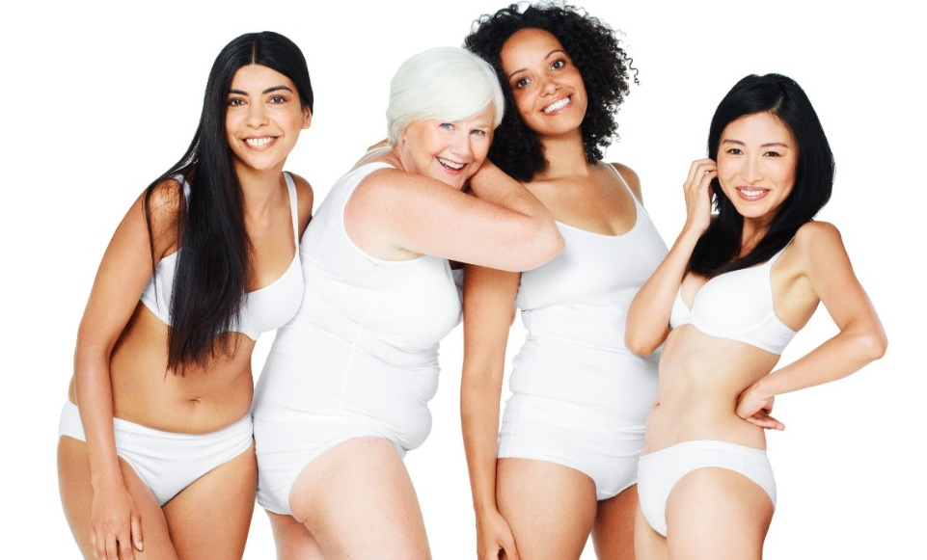
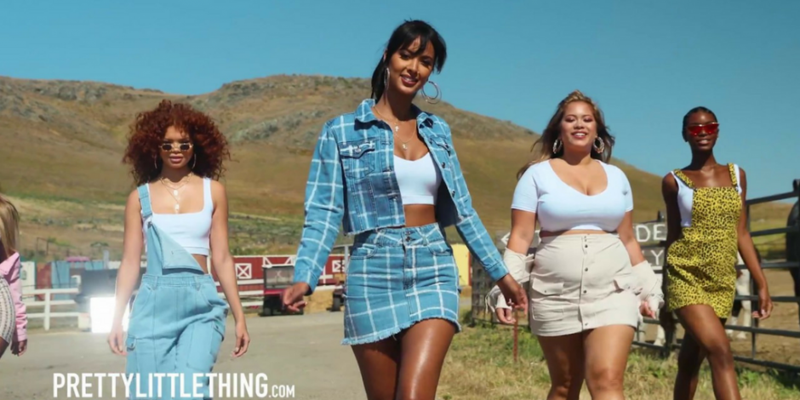
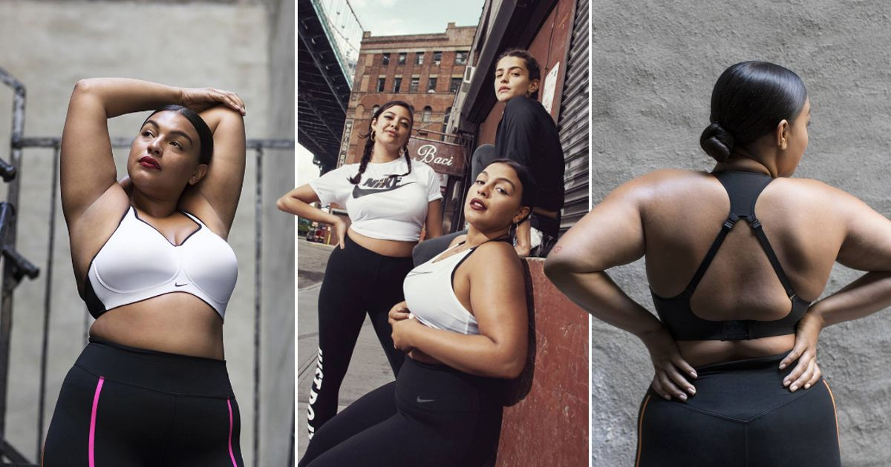

Appendix B

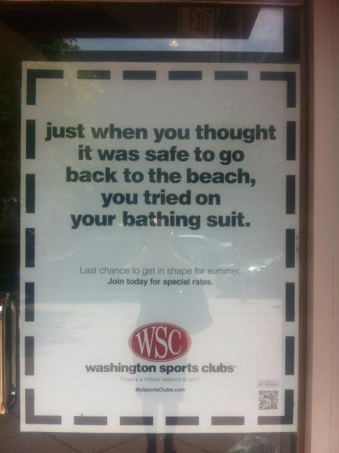

Appendix C
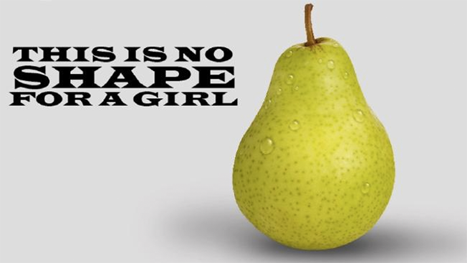
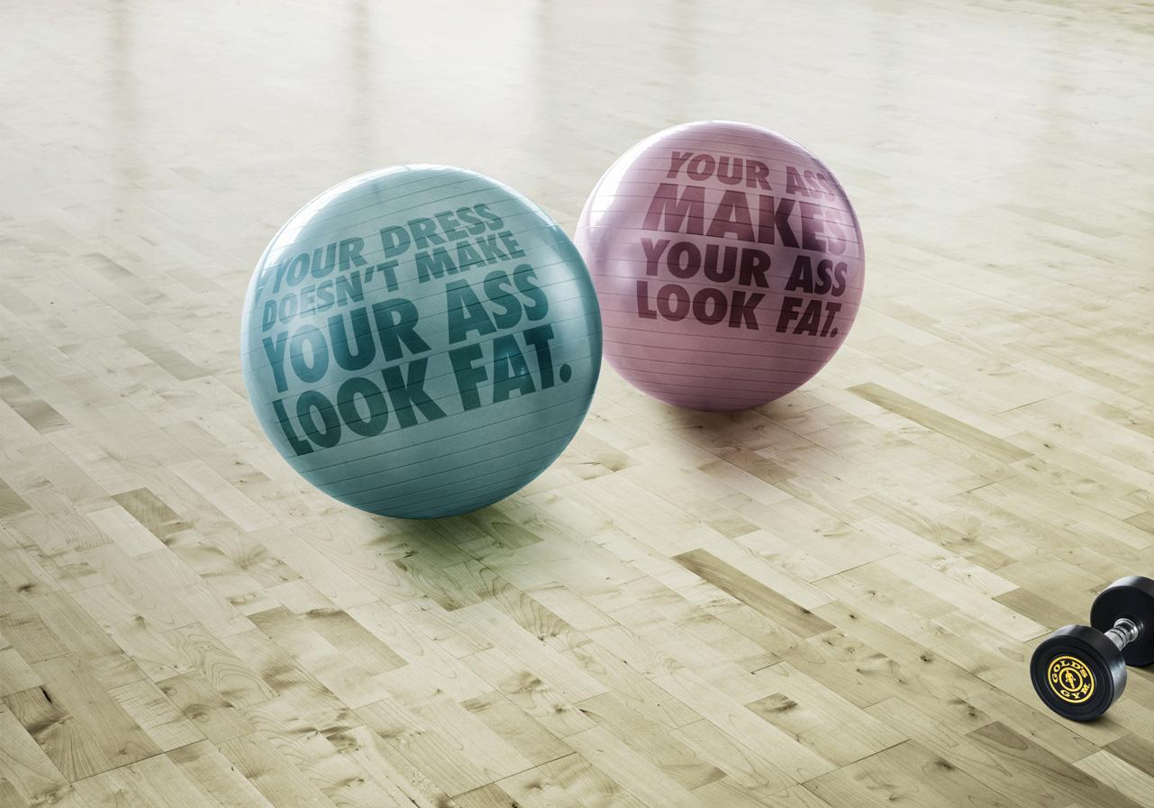
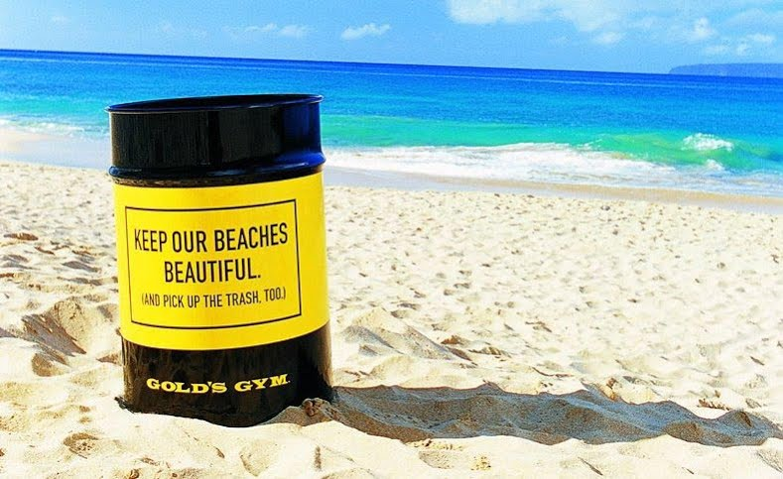

Appendix D
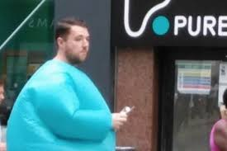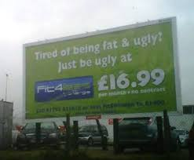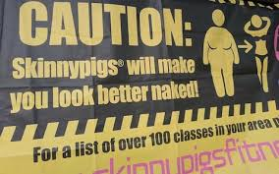

Appendix E
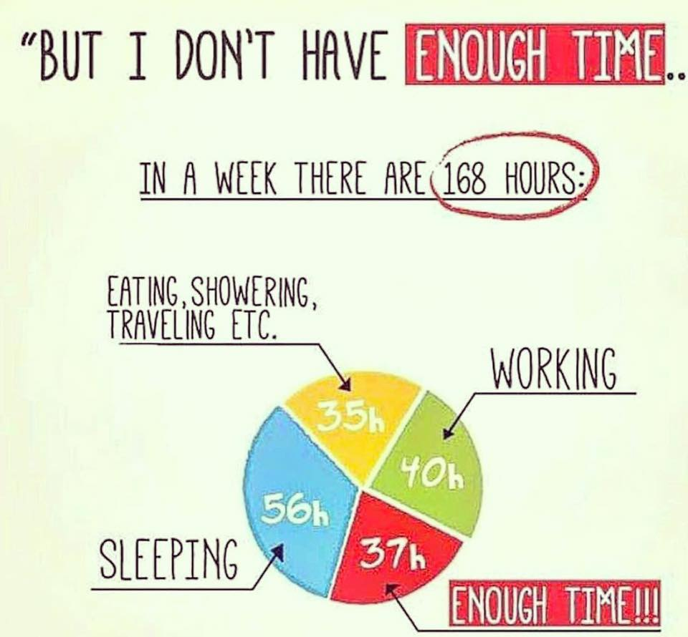

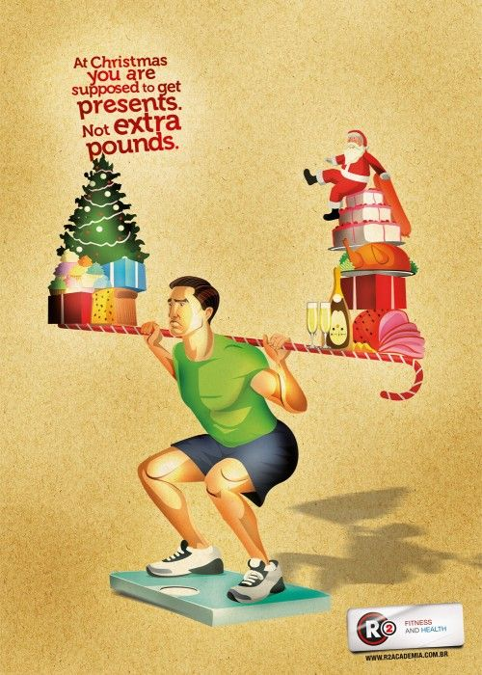

Appendix F
My name is Laura Stoakes and I am currently in my final year at UWTSD studying Business Management. I am undertaking a research project as part of my final studies, based around how the fitness industry use marketing communications to promote and target prospective customers. As some may be aware, there has been a rise in popularity of the fitness trend, it is evident in every aspect of media. What this questionnaire aims to highlight is how the marketing communications that surround the fitness industry during this rise in popularity affects the public.
"market penetration rate is at almost 15 percent, with one in every seven Brits now having a gym membership"
(Hill, 2018)
https://www.welltodoglobal.com/uk-fitness-industry-worth-5bn-as-number-of-gyms-continues-to-grow/

"The market size of the wellness and fitness segment in the United Kingdom has been growing steadily and is estimated to reach 22.8 billion British pounds by 2020."
(Statista, 2019)
https://www.statista.com/topics/3411/fitness-industry-in-the-united-kingdom-uk/

this survey takes approximately 5 minutes to complete. your participation will be completely anonymous and all data collected will only be used in regards of this research, upon analysis of this research all data will be destroyed.
As this survey in anonymous and there is no signature is required you may withdraw at any point, if you have any questions or concerns regarding this survey please contact lstoakes.152037@student.uwtsd.ac.uk

An investigation into the marketing communications of the fitness industry.
- What to you identify as?
- Male
- Female
- other
- Prefer not to say
- What is your age range?
- 18-24
- 25-34
- 35-44
- 45-54
- 55+
- On average how often do you exercise?
- Every day
- A few times a week
- About once a week
- A few times a month
- Once a month
- Less then once a month
- Which of the follow best describes your current fitness level ?
- Extremely unfit
- Fairly unfit
- Moderately fit
- Fairly fit
- Very fit
- What do you perceive as the most important aspect of keeping fit?
Please rank from 1-4 with 1 being the most important to you.
- Aesthetics
- Physical health
- Mental health
- Social acceptance
- Do you feel that there is a pressure to keep fit?
- Yes
- no
- If yes, where do you believe this pressure is coming from?
- Yourself
- Partner
- friends
- Family
- Colleagues
- Society
- Contemporary image of beauty
- On what platforms do you encounter the most fitness marketing communications?
- Television
- Newspapers
- Tabloids
- Social media
- Radio
- Physical advertising (billboards, shops windows ect)
- When you come across fitness communications, how do they make you feel?
Please tick to which degree each of these emotions are felt.
 | Defiantly agree | Agree | Ambivalent | disagree | Fully disagree
Motivated
Guilt
Inspired
Envious
Admiration
Shame
Desire
Desire
Disheartened

- Do you feel that fitness models used in fitness marketing are a representation of the general public?
- Yes
- No
- if no, why do you believe it is not fair representation of the general public?
Please tick where appropriate.
- Its unobtainable
- General public have limited time to achieve the same aesthetic
- General public have limited resources to achieve the same aesthetic
- Photos may have been altered
- Most of the general public have less enthusiasm
- Individuals featured are naturally of a certain body type
- How much do you think the fitness industry is influenced by the changing trends in celebrity culture?
- A great deal
- A lot
- A moderate amount
- A little
- None at all
- When shopping for fitness wear what do you look for?
Rank in order of 1-5 with 1 being the main thing you look for.
- Style
- Brand
- Comfort
- Ease of purchase
- Price
- Do you feel there is a certain pressure to buy and wear certain items?
- Yes
- No
- If yes, where do you feel this pressure coming from?
Please tick where appropriate.
- Social groups (friends/peers)
- Social media (influencers)
- Celebrity
- Brands themselves
- The push within social media for individuals to be fit is a positive thing?
- Strongly agree
- Agree
- Neither agree nor disagree
- Disagree
- Strongly disagree
- The fitness clothing industry is catering for all individual
- Strongly agree
- Agree
- Neither agree nor disagree
- Disagree
- Strongly disagree
- If a member of a gym, currently or in the past, I have always felt welcomed in all areas.
- Strongly agree
- Agree
- Neither agree nor disagree
- Disagree
- Strongly disagree
- I see a mix of all body types represented within fitness marketing communications.
- Always
- Usually
- Sometimes
- Rarely
- Never
- Every time my fitness improves, and I am closer to my desired result, the satisfaction of obtaining that result quickly subsides and is replaced with the need to go further.
- Strongly agree
- Agree
- Neither agree and disagree
- Disagree
- Strongly disagree

Appendix G
 |  | PG2/E1 FORM
APPLICATION FOR ETHICAL APPROVAL – BA level

CAIS AM GYMERADWYAETH MOESEGOL – Lefel BA

Mae'r ffurflen hon i'w chwblhau gan bob BA myfyrwyr. Rhaid i bob ffurflen gael ei ystyried gan diwtor y modiwl.  Dylai un copi o'r ffurflen yn cael ei roi ar y ffeiliau Gyfadran ac un copi cadw ar y ffeil myfyrwyr. | This form is to be completed by all BA students conducting research, projects or productions. This form should be completed by the student. All forms must be considered by the Module tutor. A copy of the form must be kept centrally and on the student file.
APPLICATION FOR ETHICAL APPROVAL

In order for research to result in benefit and minimise risk of harm, it must be conducted ethically. A researcher may not be covered by the University’s insurance if ethical approval has not been obtained prior to commencement.

The University follows the OECD Frascati manual definition of research activity: “creative work undertaken on a systematic basis in order to increase the stock of knowledge, including knowledge of man, culture and society, and the use of this stock of knowledge to devise new applications”. As such this covers activities undertaken by members of staff, postgraduate research students, and both taught postgraduate and undergraduate students working on dissertations/projects.

The individual undertaking the research activity is known as the “principal researcher”.

Ethical approval is not required for routine audits, performance reviews, quality assurance studies, testing within normal educational requirements, and literary or artistic criticism.

Please read the notes for guidance before completing ALL sections of the form.

This form must be completed and approved prior to undertaking any research activity. Please see Checklist for details of process for different categories of application.

SECTION A: About You (Principal Researcher)

Full Name: |  |  | Laura Jane Stoakes
Tick all boxes which apply:
Member of staff: | ☐ | Student: |  | ☒ | Honorary research fellow: | ☐

Faculty/School/Centre: | UWTSD Business School
Campus: | Swansea
E-mail address: | Lstoakes.152037@student.uwtsd.ac.uk
Contact Telephone Number: | 07514651289
For students:
Student Number: | 152037 | Undergraduate | ☒
Programme of Study: | Business management | Taught Postgraduate | ☐
Director of Studies/Supervisor: | Caroline Jawad | Research | ☐

SECTION B: Approval for Research Activity

Has the research activity received approval in principle?  (please check the Guidance Notes as to the appropriate approval process for different levels of research by different categories of individual) |  | YES | ☒ | NO | ☐
 |  |  |  | Date
If Yes, please indicate source of approval (and date where known): | Research Degrees Committee |  | ☐
 | Faculty Research Committee |  | ☐
 | Other (write in) |  | ☒ | supervisor
Approval in principle must be obtained from the relevant source prior to seeking ethical approval.

SECTION C: External Ethical Guidance Materials

Please list the core ethical guidance documents that have been referred to during the completion of this form (including any discipline-specific codes of research ethics, and also any specific ethical guidance relating to the proposed methodology). Please tick to confirm that your research proposal adheres to these codes and guidelines.
Dissertation handbook | ☒
Advise from supervisor | ☒
 | ☐

SECTION D: External Collaborative Research Activity

Does the research activity involve collaborators outside of the University? |  | YES | ☐ | NO | ☒
If Yes, please provide the name of the external organisation and name and contact details for the main contact person:
Institution
Contact person name
Contact person e-mail address

Where research activity is carried out in collaboration with an external organisation
Does this organisation have its own ethics approval system? | YES | ☐ | NO | ☐
If Yes, please attach a copy of any final approval (or interim approval) from the organisation

SECTION E: Details of Research Activity

Indicative title: | An investigation into the fitness industry and how they use guilt tactics in their marketing communications.
Proposed start date: | 20thNov’18 | Proposed end date: | 14thMay’19
Purpose of research activity (including aims and objectives)
Outline the purpose, aims and objectives of the research activity, including key research questions. Show briefly how existing research has informed the proposed activity and explain what the research activity will add and how it addresses an area of importance. (Maximum 300 words)
to investigate the methods used within the fitness industry to attract clients and customers, and to determine whether the method of “shame and/ or guilt marketing “is used and the success of this method. The objectives are as follows:
- Identify examples of gyms that use guilt themed marketing communications.
- Evaluate the impact guilt themed marketing communications has on the consumer.
- Make recommendations based on the efficacy of guilt- themed messages.

(this box should expand as you type)
Proposed methods
Provide a brief summary of all the methods that may be used in the research activity, making it clear what specific techniques may be used. If methods other than those listed in this section are deemed appropriate later, additional ethical approval for those methods will be needed. (Maximum 600 words)
Surveys, expert interviews and focus groups.

(this box should expand as you type)
Location of research activity
Identify all locations where research activity will take place.
Swansea business school

(this box should expand as you type)
Research activity outside of the UK
If research activity will take place overseas, you are responsible for ensuring that local ethical considerations are complied with and that the relevant permissions are sought. Specify any local guidelines (e.g. from local professional associations/learned societies/universities) that exist and whether these involve any ethical stipulations beyond those usual in the UK (provide details of any licenses or permissions required). Also specify whether there are any specific ethical issues raised by the local context in which the research activity is taking place, for example, particular cultural sensitivities or vulnerabilities of participants.
(this box should expand as you type)

SECTION F: Scope of Research Activity

Will the research activity include: | YES | NO
Use of a questionnaire or similar research instrument? | ☒ | ☐
Use of interviews? | ☒ | ☐
Use of diaries? | ☒ | ☐
Participant observation with their knowledge? | ☒ | ☐
Participant observation without their knowledge? | ☐ | ☒
Use of video or audio recording? | ☒ | ☐
Access to personal or confidential information without the participants’ specific consent? | ☐ | ☒
Administration of any questions, test stimuli, presentation that may be experienced as physically, mentally or emotionally harmful / offensive? | ☐ | ☒
Performance of any acts which may cause embarrassment or affect self-esteem? | ☐ | ☒
Investigation of participants involved in illegal activities? | ☐ | ☒
Use of procedures that involve deception? | ☐ | ☒
Administration of any substance, agent or placebo? | ☐ | ☒
Working with live vertebrate animals? | ☐ | ☒
Other primary data collection methods, please explain in this box | ☐ | ☒

If NO to every question, then the research activity is (ethically) low risk and may be exempt from some of the following sections (please refer to Guidance Notes).

If YES to any question, then no research activity should be undertaken until full ethical approval has been obtained.

SECTION G: Intended Participants

Who are the intended participants: | YES | NO
Students or staff at the University? | ☒ | ☐
Adults (over the age of 18 and competent to give consent)? | ☒ | ☐
Vulnerable adults? | ☐ | ☒
Children under 18? | ☐ | ☒
Prisoners? | ☐ | ☒
Young offenders? | ☐ | ☒
Those who could be considered to have a particularly dependent relationship with the investigator or a gatekeeper? | ☐ | ☒
People engaged in illegal activities? | ☐ | ☒
Others (please identify): | ☐ | ☒

Participant numbers and source
Provide an estimate of the expected number of participants. How will you identify participants and how will they be recruited?
this box should expand as you type)

Information for participants: | YES | NO | N/A
Will you describe the main research procedures to participants in advance, so that they are informed about what to expect? | ☒ | ☐ | ☐
Will you tell participants that their participation is voluntary? | ☒ | ☐ | ☐
Will you obtain written consent for participation? | ☒ | ☐ | ☐
Will you explain to participants that refusal to participate in the research will not affect their treatment or education (if relevant)? | ☒ | ☐ | ☐
If the research is observational, will you ask participants for their consent to being observed? | ☒ | ☐ | ☐
Will you tell participants that they may withdraw from the research at any time and for any reason? | ☒ | ☐ | ☐
With questionnaires, will you give participants the option of omitting questions they do not want to answer? | ☒ | ☐ | ☐
Will you tell participants that their data will be treated with full confidentiality and that, if published, it will not be identifiable as theirs? | ☒ | ☐ | ☐
Will you debrief participants at the end of their participation, in a way appropriate to the type of research undertaken? | ☒ | ☐ | ☐
If NO to any of above questions, please give an explanation
(this box should expand as you type)

Information for participants: | YES | NO | N/A
Will participants be paid? | ☐ | ☒ | ☐
Is specialist electrical or other equipment to be used with participants? | ☐ | ☒ | ☐
Are there any financial or other interests to the investigator or University arising from this study? | ☐ | ☒ | ☐
Will the research activity involve deliberately misleading participants in any way, or the partial or full concealment of the specific study aims? | ☐ | ☒ | ☐
If YES to any question, please provide full details
(this box should expand as you type)

SECTION H: Anticipated Risks

Outline any anticipated risks that may adversely affect any of the participants, the researchers and/or the University, and the steps that will be taken to address them.

If you have completed a full risk assessment (for example as required by a laboratory, or external research collaborator) you may append that to this form.

Full risk assessment completed and appended?

Yes ☐
No ☐

Risks to participants
For example: emotional distress, financial disclosure, physical harm, transfer of personal data, sensitive organisational information
na
(this box should expand as you type)
If research activity may include sensitive, embarrassing or upsetting topics (e.g. sexual activity, drug use) or issues likely to disclose information requiring further action (e.g. criminal activity), give details of the procedures to deal with these issues, including any support/advice (e.g. helpline numbers) to be offered to participants. Note that where applicable, consent procedures should make it clear that if something potentially or actually illegal is discovered in the course of a project, it may need to be disclosed to the proper authorities
na
(this box should expand as you type)
Risks to investigator
For example: personal safety, physical harm, emotional distress, risk of accusation of harm/impropriety, conflict of interest
na
(this box should expand as you type)
University/institutional risks
For example: adverse publicity, financial loss, data protection
na
(this box should expand as you type)
Adverse outcomes
List measures put in place to limit any adverse effects or outcomes of research activity where appropriate. Include any emergency protocols.
All data will be stored securely and confidentially with anonymity guaranteed.
(this box should expand as you type)

Disclosure and Barring Service
If the research activity involves children or vulnerable adults, a Disclosure and Barring Service (DBS) certificate must be obtained before any contact with such participants. | YES | NO | N/A
Has a DBS certificate been obtained? | ☐ | ☐ | ☒

SECTION I: Feedback, Consent and Confidentiality

Feedback
What feedback will be provided to participants, how will this be done and when?
Dissertation will be available to all participants upon request.

(this box should expand as you type)
Informed consent
Describe the arrangements to inform potential participants, before providing consent, of what is involved in participating. Describe the arrangements for participants to provide full consent before data collection begins. If gaining consent in this way is inappropriate, explain how consent will be obtained and recorded.
All participants will sign a form showing consent given to participate
(this box should expand as you type)
Confidentiality / Anonymity
Set out how anonymity of participants and confidentiality will be ensured in any outputs. If anonymity is not being offered, explain why this is the case.
No participant will be able to be identified at any stage of the investigation through data received.
(this box should expand as you type)

SECTION J: Data Protection and Storage

In completing this section refer to the University’s Research Data Management Policy and the extensive resources on the University’s Research Data Management web pages (http://uwtsd.ac.uk/library/research-data-management/).
 | YES | NO
Does the research activity involve personal data (as defined by the Data Protection Act)?  “personal data” means data which relate to a living individual who can be identified—  (a) from those data, or  (b) from those data and other information which is in the possession of, or is likely to come into the possession of, the data controller, and includes any expression of opinion about the individual and any indication of the intentions of the data controller or any other person in respect of the individual. | ☐ | ☒
If YES, provide a description of the data and explain why this data needs to be collected:
(this box should expand as you type)
Does it involve sensitive personal data (as defined by the Data Protection Act)?  “Sensitive personal data” means personal data consisting of information as to –  (a) the racial or ethnic origin of the data subject,  (b) his political opinions,  (c ) his religious beliefs or other beliefs of a similar nature,  (d) whether he is a member of a trade union (within the meaning of the Trade Union and Labour Relations (Consolidation) Act 1992),  (e) his physical or mental health or condition,  (f) his sexual life,  (g) the commission or alleged commission by him of any offence, or  (h) any proceedings for any offence committed or alleged to have been committed by him, the disposal of such proceedings or the sentence of any court in such proceedings. | ☐ | ☒
If YES, provide a description of the data and explain why this data needs to be collected:
(this box should expand as you type)

Will the research activity involve storing personal data on one of the following: | YES | NO
Manual files (i.e. in paper form)? | ☐ | ☒
University computers? | ☐ | ☒
Private company computers? | ☐ | ☒
Home or other personal computers? | ☐ | ☒
Laptop computers/ CDs/ Portable disk-drives/ memory sticks? | ☐ | ☒
“Cloud” storage or websites? | ☐ | ☒
Other – specify: | ☐ | ☒
For all stored data, explain the measures in place to ensure data confidentiality, including details of password protection, encryption and anonymisation:
(this box should expand as you type)

Will the research activity involve any of the following activities: | YES | NO
Electronic transfer of data in any form? | ☐ | ☒
Sharing of data with others at the University? | ☐ | ☒
Sharing of data with other organisations? | ☐ | ☒
Export of data outside the European Union or importing of data from outside the UK? | ☐ | ☒
Use of personal addresses, postcodes, faxes, emails or telephone numbers? | ☐ | ☒
Publication of data that might allow identification of individuals? | ☐ | ☒
Use of data management system? | ☐ | ☒
Data archiving? | ☐ | ☒
If YES to any question, please provide full details, explaining how this will be conducted in accordance with the Data Protection Act (and/or any international equivalent):
(this box should expand as you type)

List all who will have access to the data generated by the research activity:
Researcher/student

(this box should expand as you type)
List who will have control of, and act as custodian(s) for, data generated by the research activity:
Researcher/student

(this box should expand as you type)
Give details of data storage arrangements, including where data will be stored, how long for, and in what form. Will data be archived – if so how and if not why not.
Researchers/ students laptop, stored anonymously under password protected, no personal data to be collected, all other data to be held only for the duration of the research period.
(this box should expand as you type)

SECTION K: Declaration

The information which I have provided is correct and complete to the best of my knowledge. I have attempted to identify any risks and issues related to the research activity and acknowledge my obligations and the rights of the participants.

In submitting this application I hereby confirm that I undertake to ensure that the above named research activity will meet the University’s Research Ethics and Integrity Code of Practice
Signature of applicant: | l.stoakes | Date: | 19th nov 2018

For students:
Director of Studies/Supervisor:
Signature:
Date:

For staff:
Head of School/Assistant Dean:
Signature:
Date:

Checklist: Please complete the checklist below to ensure that you have completed the form according to the guidelines and attached any required documentation:
☒ | I have read the guidance notes supplied before completing the form.
☒ | I have completed ALL RELEVANT sections of the form in full.
☒ | I confirm that the research activity has received approval in principle
☒ | I have attached a copy of final/interim approval from external organisation (where appropriate)
☒ | I have attached a full risk assessment (and have NOT completed Section H of this form) (where appropriate)
☒ | I understand that it is my responsibility to ensure that the above named research activity will meet the University’s Research Ethics and Integrity Code of Practice.
☒ | I understand that before commencing data collection all documents aimed at respondents (including information sheets, consent forms, questionnaires, interview schedules etc.) must be confirmed by the DoS/Supervisor, module tutor or Head of School.

RESEARCH STUDENTS AND STAFF ONLY
All communications relating to this application during its processing must be in writing and emailed to pgresearch@uwtsd.ac.uk , with the title ‘Ethical Approval’ followed by your name.
You will be informed of the outcome of your claim by email; therefore it is important that you check your University and personal email accounts regularly.

STUDENTS ON UNDERGRADUATE OR TAUGHT MASTERS PROGRAMMES should submit this form (and receive the outcome) via systems explained to you by the supervisor/module leader.

This form is available electronically from the Academic Office web pages: http://www.uwtsd.ac.uk/academic-office/

Application Process

All staff research projects and all research students must submit the Ethical Approval Form to the University Ethics Committee via the Academic Office (pgresearch@uwtsd.ac.uk). Staff research directly in relation to personal study for taught undergraduate or Masters programmes should be submitted via the Faculty procedures explained below.

Taught masters and taught undergraduate research Ethical Approval Forms are considered within Faculties. Faculties will provide details of the specific processes for this. Where the Ethical issues within any single ethical application are of particular concern the Faculty will refer these to the University Ethics Committee. Any student activity that involves the collection of primary data needs to undergo Ethical approval, this includes assignment work as well as dissertations.

Notes for guidance in completion of this form

Section A: About You
Please complete all relevant sections

Section B: Approval for research activity
Research proposals must be approved in principle before applying for Ethical Approval. The proposal approval only becomes final when the ethical approval is received.

The process for proposal approval varies according the individual and programme of study:
- Research students, by application on form PG1 to the Research Degrees Committee
- Taught students by review of research proposal within Faculties (Faculties provide specific details of these processes)
- Staff, by agreement by the Head of School/Assistant Dean

Section C: External Ethical Guidance materials
Many discipline areas are required to operate with the discipline specific codes of research ethics (for example health, psychology, education etc.), any such codes must be listed and you must tick to confirm that you have consulted with these.

Section D: External Collaborative Research Activity
Provide details of the external collaborative partners, where appropriate you might want to submit a copy of the external collaboration agreement with the Ethical Approval Form. If the partner requires the research to be subject to its own internal Ethical approval process then please provide details of that process and a copy of any final (or interim) approvals received from the organisation.

Section E: Details of Research Activity
Remember that the individuals reviewing this Ethical Approval Form may not have seen your research proposal, and also may not be experts in the specific area of your research. The information provided should therefore be jargon free and clearly stated.
Indicative Title: please use the same title as used on the research proposal.
Purpose: the Ethical approval process will want to ensure that the methods you propose are adequate and appropriate to address the research aims and objectives. Excessive additional data collection can be seen as unethical.
Proposed Methods: the Ethical approval process seeks to ensure that you understand the methods that are intended, and that the implementation of those methods will be appropriate and without unnecessary impact on respondents. Please be specific.
Location: this needs to mention geographical location and also local situation (for example, within Local Authority Offices in Cardiff, using a private room but close to other individuals). If you are collecting data within an organisational setting then you need to explain the permissions that you have obtained to do this.
Research Activity outside of the UK: please complete this section in detail, and note any guidance you have received. Also describe your own familiarity (or not) with the location that you will be utilising.

Section F: Scope of Research Activity
Please tick ALL of the research activities that might be undertaken. If any additional types of activity are intended then please add an extra box and describe these.
If you have answered no to all questions in F then sections G and J do not need to be completed. Section H should be considered, and may be completed. Signatures are still required in section K.

Section G: Intended Participants
Please tick all categories that might apply.
Numbers & Source: if you are using a series of different methods or research activities please list numbers for each stage/phase. Be clear about how you will find respondents. Will you use intermediaries, and if so how? How will you ensure compliance with your sampling strategy?
Information for participants: all participants should be appropriately informed about the research, what is expected of them and what will happen to the information that they provide. The Ethical review process does not ask to see this documentation, but requires this to be reviewed and approved by the Director of Studies in the case of research students, the supervisor/module tutor in relation to students on taught programmes and the Head of School/Assistant Dean in relation to staff research.

Section H: Anticipate Risks
All research carries some level of risk. The answers you provide to questions in this section will be reviewed to ensure that you have an appropriate understanding of the type of risks involved and how you can mitigate against these risks. If you have completed a full risk assessment, as required for example for laboratory work, field work, clinical tests, diving operations, or by a collaborative partner, you may append that to this form. In that case, please tick the box indicating this has been provided. You will not then be required to complete Section H.
Risk to participants Think very carefully about how your actions/questions/discussions might affect the people you are involving as participants. You might identify the risk as small but it would still be a risk. Many types of question have the potential to make respondents less content with their life / job; you need to recognise and try to ameliorate any such effects
If these are business owners, time with you may reduce profit.
In some locations physical risk is very real to both participants and yourself, please consider this.
Risk to you, the researcher Think about where you will meet people, if there are any dangers involved in the location. If you are meeting people as individuals think about using a public place. In general do not visit people in their own homes or remote locations. If you are talking to individuals about certain issues think about how their responses might affect you emotionally. What about the risk of collecting insufficient data?
Risk to the University When undertaking your research, you are acting as a member of the University (student or staff). Professionalism is important, so it is important to be well organised and well prepared. Punctuality, clarity etc. are all part of this. What will you do to ensure this? You must ensure you do not harm the good name of the University in any way and do nothing to undermine the reputation of the research it conducts and sponsors. Upholding high standards of conduct and integrity are vital in this regard. You must also conduct the research in such a way to minimise the potential for claims of negligence made against the University, its researchers and any collaborating individual or organisation. In this respect you should always comply with ethical, legal and professional frameworks, obligations and standards as required by statutory and regulatory authorities, as well as the university’s Research Integrity and Ethics Code of Practice. Research misconduct in this respect can take many forms, including:
- fabrication: making up results or other outputs (eg, artefacts) and presenting them as if they were real
- falsification: manipulating research processes or changing or omitting data without good cause
- plagiarism: using other people’s material without giving proper credit
- failure to meet ethical, legal and professional obligations: for example failure to declare competing interests; misrepresentation of involvement or authorship; misrepresentation of interests; breach of confidentiality; lack of informed consent; misuse of personal data; and abuse of research subjects or material
- improper dealing with allegations of misconduct: failing to address possible infringements such as attempts to cover up misconduct and reprisals against whistle-blowers

Adverse Outcomes. Think carefully about the possibilities, and cover here

Section I: Feedback, Consent and Confidentiality
Feedback to participants: outline your approach. Will interview transcripts be shared with respondents to check accuracy? Will summaries of questionnaire analysis be made available to respondents in some way? Will an overview report be provided? How and when?
Informed consent: Draft letter / e-mail / or heading (or footer) section of questionnaire must be approved by DoS/supervisor (if research student), supervisor/module tutor if taught student, or Head of School / Assistant Dean if a member of staff.
Confidentiality/Anonymity. Explain clearly how you will ensure confidentiality and anonymity.

Section J: Data Protection and Storage
Before completing this section it is necessary to read the University’s Research Data Management information. The questions that follow are designed to ensure compliance with the Data Protection Act as well as established research protocols.

Many research activities will involve electronic transfer of data and use of data management systems in the summarisation and analysis of data. You will need to explain these in relation to compliance with the Data Protection Act.
Think carefully about who will have access to your data, this will include supervisors and examiners. Also that a thesis will be made available via the University library and the British Library system. If you are seeking an access bar for a period of time after completion then mention it here. If you will provide a copy of your findings, or intend to give a presentation, to a facilitating/ supporting/accessing organisation then explain that in this section. But also think about the general principle of data sharing, as explained in the Research Data Management information.
In terms of storage of data please ensure security, and also mitigate against loss of data.

Section K: Declaration
Ensure the appropriate countersignatures have been provided
Look carefully at the checklist and ensure that you comply with and tick all that are relevant to your research.

Appendix H
Participant A
Participant B
Participant C
Participant D
Participant E
How often do you come across marketing communications within the fitness industry, and where are you most likely to see?
Social media
Yea like everyday on Face book
Instergram
Magazines
Mostly instergram
I don’t use social media
It depends on where you spend the most time though doesn’t it, like I don’t use facebook to just scrolling I use facebook for more messenger, where as instergram is more pictures
So kind of stuff do you see on there?
Erm exercise photos and ads
Do you think the increase in the fitness trend is good thing or a bad thing and why so?
Bit of both really, like its good to make people focus on being fit and healthy and all that but also bad because its just like pressuring people to be a certain way, look a certain way, fit a certain box, wear a certain brand, copy a certain celebrity
Yea
There just seems to be more on look at my way of life im perfect, rather then actually being healthy just faking healthy, looking good.
You don’t really see much advertisements on being healthy its more influencers
Yea saying to look like this
How do you perceive the images that you see relating to fitness across social media
False
Yea its fake like isn’t it, like yea drink this tea to look like me and im amazing, well actually no cause you’ve got a personal trainer, you’ve got a personal chef you spend all day everyday in the gym, so no that cup of tea isn’t going to make me look like you, god never mind the surgery.
I have two lots of pictures from real companies, company A and company B, company A is a brand that would be seen to be more in clusive when it comes to shapes and sizes, company B is more like the trendy fitness fashion, like instergram.
So look at company A, how do these images make you feel.?
Less pressured
Makes you feel included
Yea, its more positive like insnt it like you wouldn’t feel uncomfortable working out next to people like that
, cause there a bit of every one all shapes and sizes.
When you see people too perfect you kind of think like do you know what theres no point anyways cause your never going to look like that, but these ones look more like something you can do.
Would these brands images prompt you to buy from them?
Yea
Yea
Youd think that there more likely to have something to suit you cause they look like they’ve got quite a good range
Yea and something that would fit, you see it and think right If I buy a size 16 its going to be a size 16

Ok so what about company B, all these images are from one company. How do these make you feel?
Its not real
Its real
But its not real, its altered photos
Yea its unrealistic as ****,
Do how do they make you feel?
completely demotivated, completely like envious but also like …
that the thin when you see photos like that you kind of think your not ever going to look like that anyways so theres no point
your not good enough like
I just think if there working to maintain a figure like that there not actually enjoying there lives, it looks obsessive
And they don’t look like that 100%
And it does look like theyre doing it for a healthy lifestyle it looks like doing it to look good =, rather the other company they just want to be healthy.
The other photos look like normal photos where as that just looks like staged and angles and filtered and photoshop
That’s 100% manipulated
Would these imaged prompt you to buy there products ?
No
hell no, doesn’t look like it would fit and it looks like it would be mage uncomfortable.
Looks like it would cut the circulation at some points
Yea
By comparing the 2 companies which would you buy from and why?
Well they don’t look very supportive for the women. (points at company B), it would dnot be comfortable to exercise in.
So what about you guys with the mens wear?
I would never dress like that (points at company B)
So you would be more inclined to go for company A?
Yea, yea I would
What abput you ASH would you were leggings to exercise
For the benefit of the tape im shaking my head
Company A looks like you average person could wear that, your average person could not wear that
Pointing at company B they don’t look very practical, they don’t look like they fit for purpose or that theyd last.
Company A looks like there exercising to exercise wheres as company B looks like there exercising to pose.
Why are they all in sports bras (points at company B), like this one (company A) couple of them do but at least you’ve got shorts, you’ve got jackets.
And tops
He is in actual men’s clothes
B looks more for fashion, and not for exercise
Yea definaitly
These two pictures here are trying to sell leggings to women(picture 1 from both companies) do you think these images appeal to women?
No that just an ass, that’s totally there for men isn’t it (B)
But it looks a bit stupid (B), like its too wide
Yea if she naturally had that proportion she wouldn’t have that gap or that size waist so its been altered. Or surgery
So you by what your saying youd go for company A?
But theyre are not showing you the leggings either, your jus seeing her ass, your not seeing the pattern the length
I couldn’t hire a gym instructor that looked like that because id just cry every time i walked through the doors (points at company B)
That might be enough to get people to follow them on social media though.
Yea
So you think its just for the followers ?
Could be
For the fat people who sign up and are then too intimated to go
Its probably for followers like, real pictures wont generate followers at all.
So do you think B ha more followers then A then?
Yea
Definaitly
Another thing why are none of them sweeting
I don’t know these ones (company B ) don’t look like they would sweet more like glow.
I think of the back of that you make a good point these (company B ) want a certain type of follower, they ….. people to follow them so they can say look this is our social media following they’re all cool all trendy blah blah, they don’t want average joe following.
no
It as if, if you need to lose weight you can’t come in.
Its like you already have to be perfect you cant join the club to get fit you already have to be perfect
Its very highly influencer based
There 2 companies with 2 separate marketing campaigns, one is a picture of a pear with the caption that says is no shape for women…
Rude
The other is a silhouette of a person working out with the caption of your tougher then you think. Which of the two establishments would you be inclined to visit and why?
The second one 100% yea
The first one is just insulting
Some people can be pear shaped no matter how much they exercised they aint going to be able to change teir DNA ar they
How did they ever think that that is a good marketing strategy
They are a very big gym company and they did have to issue an apology but they’ve still done well if the back of it
Probably just cause its been all over re media and that
The first one is Insulting people into going to the gym, like you fat ******* get in here
Yea but the second one is like empowering and like come and join us
Yea and pear shaped is just a body shape its not even fat or thing is doent matter.
There are plenty of thin people who are pear shaped
So do you think it would have worked ?
I don’t think … no …but I think it make people more aware of that gym cause they’ve had so much negativity.
No such thing as bad press
It’s not a very healthy attitude from the first one
So it doesn’t make you feel good about that gym?
No or yourself
It makes me feel angry
So would you feel comfortable going to a gym like the 1st one?
No
Oh god no
I mean if their going to insult you in their ads what are they going to do when you get there
Do you have a preconceived idea of the people who would go to these gyms?
In the pear one their going to be like stuck up and pretty
Posers
Kind of like that picture(referring to company B)
None sweeters
The kind of people who just turn up and socialise not exercise,
Taking pictures while there excersicing
Yea like posting them look at me I’m in the gym and then go home
Lastly do you have any thought s and feelings about the marketing comms in the fitness industry?
Ive seen loads of adverts lately on like social media advertising you know like larger people doing exercise, its quite impressive actually when you see like a bigger lady doing ridiculas yoga, like way more flexible and way more fit then I am, incrddible, but like it feels a bit false, like there only using this person because look how great they are its just feels like there like oh tick a box appealing to the larger people.
Positive discrimination
Yea
I find a lot of it you know Is quick lose 10 pounds for summer
Beach body ready
There’s lots of boot camps like 40 day ones, and there expensive I looked on one and it was like £200 so not even accessible for everyone
Its not even about getting fit or being healthy its like a boot camp the only purpose for that is for you to look good,
So you’ll look good for an event like a party or whatever, but there no follow up
Its not about changing your habits or making a change. Its just a quick fix
It says a lot about people, people want it now
Where do you think it comes from though, that people think they have to look a certain way?
Social media
The pressure is definitely from social media
I hate social media
You are on there all the time
I know.
Its addictive though
Even if you don’t use social media you still get the pressure from it because everybody else does so like society in general is giving you the pressure that is stemming from influencers on social media, it bleeds into other media doesn’t it
I don’t know though ash will prob agree with me on this one, you are not on Facebook are you and if you are not very much, but you don’t see that stuff really anywhere else.
I think women are kind of look for it more though
So do you think there is a difference between men and women?
Its not like we do it on purpose
Were socialised like from when were little, we have to look a certain way we have to be perfect we have to be a certain size, we cant possibly be happy if were fat
Yea
Its from all angles it’s not just from social media but its definitely the worst for it
I don’t see you know like billboards or bus adverts; I don’t see anything to do with fitness anywhere else but if I am looking at fitness stuff online then it is in your face like.
I mean men don’t get the same pressure as women do but it’s definitely creeping up more now because of social media
You see a lot of magazine and news papers that so and so has been fat shamed this week and the next week then ah she’s lost too much weight
Do you think the changing trends that surround body image, like for instance very curvy hourglass figure previously, to now its becoming a more muscular is maintainable?
The weird thing is though is those men they aren’t even strong, they look strong but there not strong cause its like fake muscle, there big but they couldn’t actually lift someone (referring to company B)
They seen to have big upper body and then sticks for legs
There’s like isn’t there, vanity muscle and then farm strength, cause look at the shape of a farmer there like a big round pudding
Yea
So all and all then when you see the images in social media, does it make you feel like you want to look like that or you work out more, what affect does it have
There all literally asses
It’s a bit of both for me to be honest
It makes me think that I should work out more because I should look after my health but like its unobtainable to look be and look like that
We haven’t all got that, real life isn’t what they put it up to be
I isn’t got time to spend most of my life in the gym
It used to affect me more when I was younger, but maturing now and it doesn’t really matter, just want to be the best you can be rather then
Yea yea
so I understand the pressure on young girls and things
so, if you see images now and there all beautiful and perfect they make you feel like there’s no point then is it?
Yea because you can’t live up to that
Would you feel different If you seen images of what you perceive as normal people working out?
Yea you be more encouraged then wouldn’t you
Yea you’d be like yea good for them
Yea and you’d feel like if they can do it then I can do it cause they’re normal like me
You want to see some one sweeting and hurting
Yea that’s real
Don’t you feel like theres no point don’t you feel like well that’s them and its different for them and it doesn’t matter,
no
Ok not there’s no point but it doesn’t matter is that important, if you could look like them would that be Important
No its not so much that its really off putting, like I wouldn’t want to go to a class or a gym where everyone is perfect and everyone knows what theyre doing and you’ve turned up the big marshmallow in the corner and haven’t got a clue whats gong on, its not that you don’t fit in or you don’t look like them its just embarrassing in other ways, you just feel like an idiot.
Would you want to though
No but id rather go to a class where there are a mix of people, with everyones a bit different and then no one is focused on what u=you look like theyre there to do the class not to look and say oh my god they look out of place what are they doing here
You do see some of these girls in the gym theyre hair is perfect theyre makeup is perfect you can see then looking a you
Yea they haven’t broken a sweet, full face of makeup
I never take them seriously, im like why are you here, what are you doing here
If you havnt got eyeliner running down your face your not working hard enough
I think its because of social media post and stuff like that
So you think that for the benefit of social media then?
Oh yea definitely
They are there to get there, oh I’m in the gym selfie
Social media posts trigger a feeling of being isolated because you see al these pictures and how there presenting their lives or how these fitness companies present their typical body shape, ten you feel isolated because you’re not part of that
Hmmm
But also how the instructor or the model worked to look that good, its just like bam you could look like this too in six weeks if you starve yourself and work out 12 hours a day
But that because that person doesn’t look like that,
And they lie to you with like for example when things like 300 came out they said do the 300 workout to look like the people on there, but every single person who was on 300 was already in a certain film before hand and they were already big anyway, so they were lying saying that they were doing this work out every day and they were charging people to train them but they were already pretty big and muscular anyway
Wasn’t a lot of that make up too, like contouring
Oh, yea and it was all glossy, but still they were trying to say that all of these people were average before but there are pictures that prove otherwise
It is quite intimidating like as a girl if I was single and I was looking for a guy and I see some massive eight pack gym bunny guy id look at him and think, even if I liked him I wouldn’t stand a chance, I does intimidate you that way and stuff and if you seen other pretty girl in the gym you’d be like oh well what’s the point, I might as well just go home now. So, you know it does knock you
Yea
Can I just ask ash because he’s in football and fitness, I’m not on social media and neither are you do you see fitness communications anywhere else day to day, because I don’t
I don’t get any tags or ads for fitness, I don’t see any Facebook stuff fitness wise, I don’t see anything
Yea it kind of prays on you a little bit though, so if you googled that or googled dieting or anything like that, then you start getting all these ads targeting you.
It’s just insulting
It’s like with Instagram, you can choose who you follow, so if you don’t want to follow any fitness stuff you don’t have to, but then they have that explorer page so you cant really get away from it anyway, because 100% there’s going to be some fitness related stuff on that page
You are all on Facebook and exposed to it, me and Ashley are not on Facebook and not exposed to it so I don’t think it’s a matter of women over men it is the fact that Facebook is clearly a massive factor
Social media is the root of all evil
Yea
Not that I use it but especially Instagram it looks as if thats the main one because its all pictures
Oh, yea definitely it’s all videos of people working out in that gym
Its like look at me in that gym, look at me with my food that ive had look how hot I look
But then again a lot of that is just an excuse to be sexy so they are wearing the skimpiest clothes, the most skin tight clothes so basically, im almost naked, im almost naked, its not so much the gym sells it’s the sex isn’t it
on Instagram there’s groups that are targeted towards women who want to be fit and healthy, and as we know the bum is the big trend right now, do you think they appeal to women?
No see there not even fitness it purely how you look, they are not instructive or informative theyre just trying to be sexy, its for men to look at basically
Its not aimed towards women when most of the angles filmed are from behind
I think its aimed towards getting as many likes and shares as possible so they can get the sponsors
And they are getting them from the men not the women they claim to advertise to
I find that the ads that target you can be quite insulting
I mean if you are going to be targeted ads about fitness then you want them to be helpful, like I could give that a try, what to you do, how do you do it, not close ups of someone’s bum
Yea, you if you look to follow someone’s weight loss journey and they are already tiny you don’t see any effects
Yea there’s no journey there is there
No
………….

Appendix I
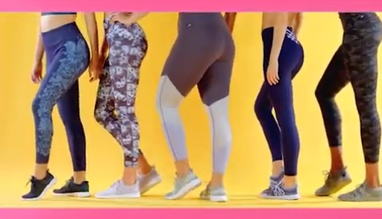
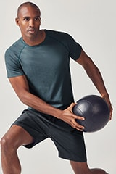
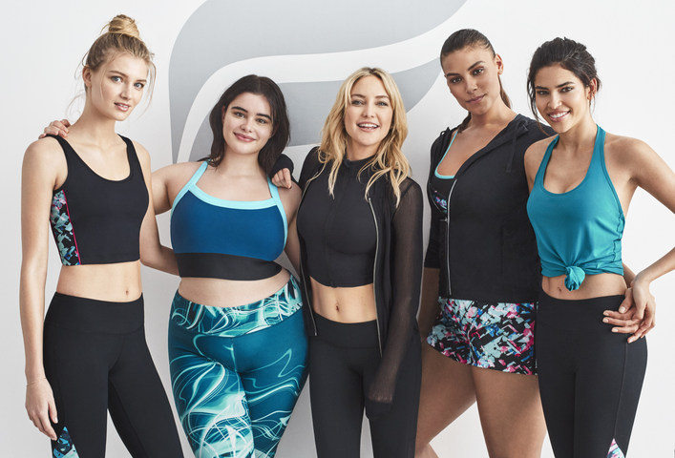

Appendix J


