Dr Md Nazmul Hasan
Component 2:
Major Health Issues
Nazreen Akhtar
(2128933)
Introduction to Public Health
(LCHS4004)
Contents

Introduction 1
Disease 1
Worldwide and UK Statistics 1
Main Body 2
Public Health Measures 2
The key Determinants/Risk Factors for Obesity 3
Short-term Health Consequences for Obesity 5
Long-term Public Health Consequences for Obesity 5
Conclusion 6
Reference List 7

Written Report: Obesity

Introduction

Disease - Obesity

In this report obesity will be discussed as well as statistics regarding the population of overweight and obese people in the UK and around the world. Risk factors, measures and the consequences will also be talked about. Overweight and obesity are defined as abnormal or excessive fat accumulation that presents a risk to health (Obesity 2022 World Health Organisation). Body mass index (BMI) is a method used to check If you’re a healthy weight, BMI can also determine whether a person is overweight.

Worldwide and UK Statistics

According to the 2019 Health Survey for England, 36.2 percent of adults in England are overweight but not obese, and 28.0% of adults in England are obese. Typically, having a BMI of 30 or higher is obese. A BMI of 25 to 30 is considered "overweight”. Men are more likely than women to be overweight or obese, according to the survey (68.2% of men vs. 60.4% of women). Overweight and obese people tend to be between the ages of 45 and 74.
It is estimated that one billion people globally will be living with obesity by 2030, According to the World Obesity Federation's World Obesity Atlas 2022, one in five women and one in seven men worldwide will be affected by obesity by 2030. Not only will countries fail to meet the WHO's goal of halting the rise in obesity to 2010 levels by 2025, but the number of obese people is also expected to double worldwide, according to the findings.

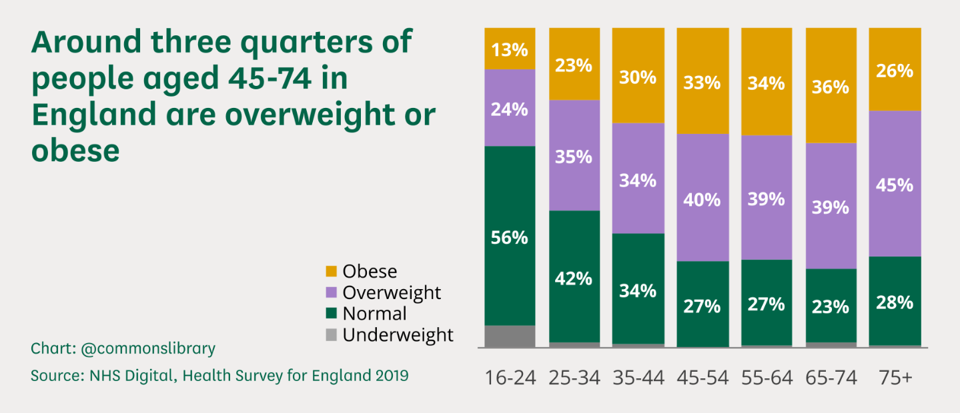
This graph shows the people that are obese in the UK

Main Body

Public Health Measures

The government has raised the issue of obesity by enforcing new policies and legislation that will help people make healthier choices and live a healthier lifestyle. One thing the government has introduced is the Better Health Campaign, the campaign helps people make changes to their diet and allows them to eat better preventing them of this disease obesity. The government has also developed a healthy eating app; the 12-week weight loss plan app helped people make healthier eating habits enabling them to maintain a healthier weight by eating better and exercising regularly.
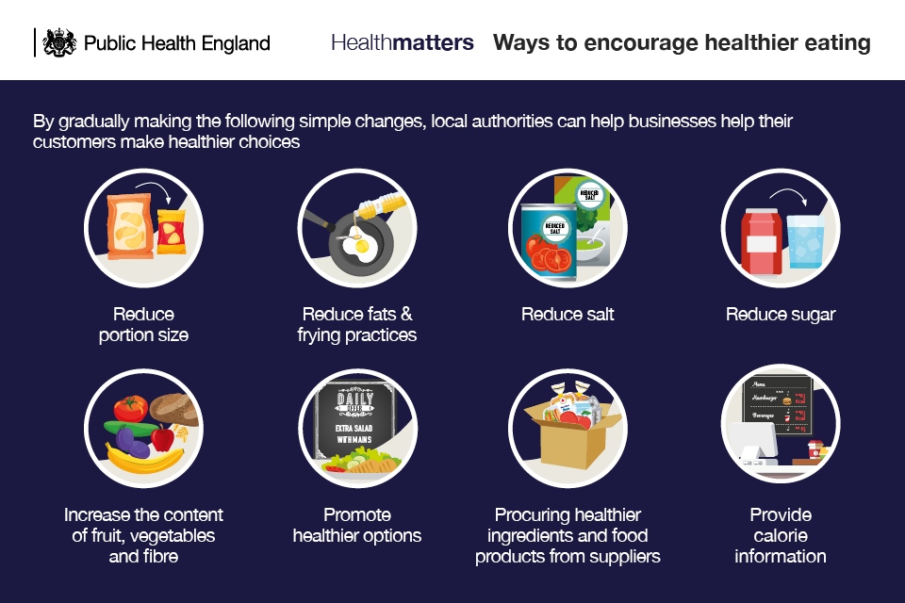

The 2020 Obesity management strategy: enabling children and adults to lead healthier lives This includes a call to action encouraging people to lose weight, plans to improve food labelling by requiring restaurants to list calorie counts on their menus, and plans to regulate how food is sold, such as prohibiting the airing of junk food advertisements on television before 9 p.m. The implementation of the Obesity Strategy will receive £100 million in funding from the Department for Health and Social Care in March 2021 (Department for Health and Social Care 2021b).
The Innovation and integration plan in 2021: cooperating to improve social and health care for all: outlines legislative proposals to enact the calorie labelling and advertising restrictions outlined in the Obesity Strategy. In addition, it explains how, in the coming years (Department for Health and Social Care 2021a), the NHS will place a greater emphasis on health and obesity prevention.
The Department for Environment, Food, and Rural Affairs commissioned this independent evaluation, which will result in a thorough plan for the UK food system's 2021 goals (Department for Environment, Food, and Rural Affairs 2020). The National Food Strategy 2020 underlined in its interim report, which was published in July 2020, that trade agreements should be used to maintain food standards because children from low-income households are more likely to experience hunger and obesity.
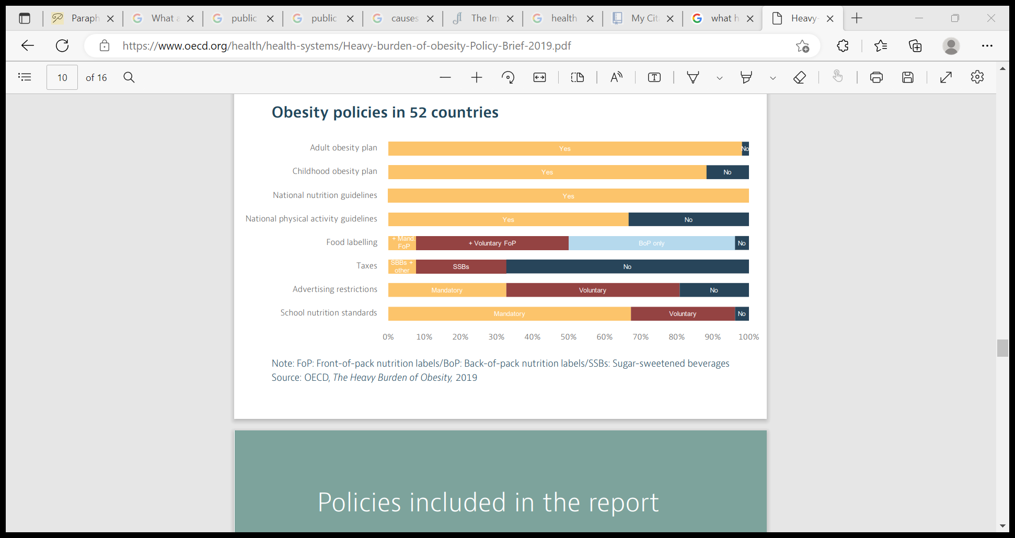
In the past ten years, countries have made significant progress in implementing policies to combat unhealthy eating and inactivity. A national obesity action plan is in place in almost all 52 countries examined. Most nations have both national guidelines for promoting healthy diets and active lifestyles and a specific action plan to combat childhood obesity. In general, countries have been particularly active in enacting policies to increase the number of healthy options and provide people with more information. There is less widespread implementation of policies to regulate unhealthy choices and to lower the cost of health-related choices, such as advertising restrictions or taxes on energy-dense foods and drinks. Despite this, the rising rates of overweight individuals demonstrate that the response has not yet fully met the challenge. Policies are sometimes put into action in ways that aren't the most effective, or actions aren't done the same way all over the country. Other times, the number of people who could benefit from the interventions is limited by practical issues or insufficient resources. The OECD examined a variety of policy options and packages to comprehend how various policies affect population health and the economy.

The key Determinants/Risk Factors for Obesity

The determinants/risk factors are the things considered as risks for obesity, when an adult has more calories than recommended these calories store as fat inside the body. This fat stacks up inside the body and is then shown as you become overweight or obese. BMI as discussed earlier is what is used to measure a person’s weight and what is used to measure this against what is a healthy weight, overweight and obese. The determinants are things that increase the chances of developing the disease in this case obesity, these factors can be things like; sleep routines, eating patterns, genetics, and medications. These are all factors that can increase a person’s weight then contributing to obesity if at a worried level. The social determinants are the conditions in which we live, work, play and learn in; these can be considered as things that will help increase the chance of getting obesity. These places are considered places such as childcare centres, schools, and workplaces as well as policies, marketing strategies and the affordability of healthier food options. Obesity and weight gain can also be influenced by diseases, steroids, and anti-depressants. Many factors can cause weight gain such as physical activity levels such as exercise, sleep routines, eating patterns, social determinants of health, genetics and taking certain medications. All these factors play a significant role in increasing a person’s weight.
Our surroundings also have an impact on our health, such as work settings, school settings, transportation and access to nutritious food and water or to work all contribute to your health style. Examples of these factors include housing, education, food access, and transportation. Too frequently, people lack control over their ability to access these resources that influence their health. Communities of colour, those with low incomes, and other vulnerable groups endure many health disparities that are caused by an inadequate distribution of resources. This links to our chosen disease which is obesity because there are certain risk factors such as excess consumption of high calorie foods, high intake of sugary drinks and lack of exercise. The factors discussed above also play a huge role in a person’s health as they determine whether a person is healthy or in this case obese.
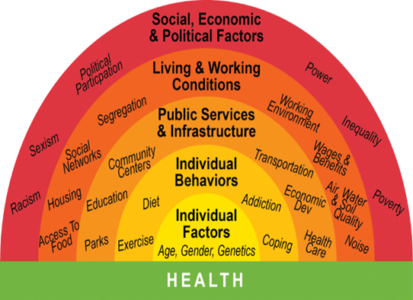
Home. Available at: https://www.publichealthwm.org/ (Accessed: November 21, 2022)

Short-term Public Health Consequences for Obesity

Obesity will have short term effects as the consequences for having the disease, the BMI is what is used to measure the rate of a person’s weight and whether they are at a healthy weight or overweight. A BMI of higher than 25 puts a person in the ‘overweight zone’ and when the BMI reaches 30 or above, they enter the ‘obese zone’; this is the area that will significantly harm the body as it is now easier to get other health conditions that may be harder to control and put the adult’s well-being at risk. The effects of this will cause a long list of health risks; these risks will be affected by the calories which will have converted to fat cells which will make actions of the person with obesity much more difficult and challenging. These short-term health consequences are. Shortness of breath during easy or routine activities, high cholesterol, high blood pressure, prediabetes, joint problems and muscle aches, headaches, physical discomfort, stomach problems, Infertility problems, tiredness when moving around and psychological distress. All of these mentioned above are consequences for having the disease obesity.

Long-term Public Health Consequences for Obesity

Obesity and overweight adults consume of 2/3 of England. One third of the population is made up of primary school graduates, who typically consume an extra 500 calories per day. Fast food restaurants are becoming more prevalent on high streets and are concentrating near schools. Children are exposed to a lot of television advertising for foods and beverages that are high in salt, fat, or sugar. In 2030 the obesity gap drops the least economic communities, and the wealthiest communities will be cut in half.
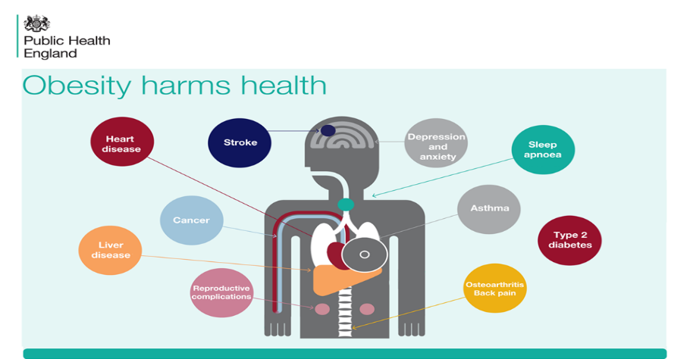
However, not everyone in the society has obesity, type 2 diabetes have been offered by the NHS targeted support and access to weight management services within primary care. This can improve health by a significant amount as well as cutting costs down. By 2022–2023, they expect to see up to 1,000 more children treated annually for severe obesity-related comorbidities like diabetes, heart disease, sleep apnoea, and poor mental health. Through these initiatives, children won't need as much intensive care.

Conclusion
Following the discussion of obesity, it’s been concluded that this disease is significantly bad for a person’s health. Obesity is a very popular disease; the public health of England has released many policies and procedures such as the 2020 Obesity Management Strategy identified key plans and strategies to help adults and children make healthier choices and live a healthier lifestyle. Obesity is not only a problem in England but also around the world, it’s now been affecting younger age groups such as school children, this is because of the excess consumption of fast food and enriched sugary drinks along with a bad lifestyle. It’s important to recognise just how harmful these factors are to a person’s health, by exercising daily and eating balanced meals along with restricted sugary foods a better much healthier lifestyle can be lived. The social determinants of health in which the conditions we live, work, play and learn. The places we work, go to school and how we use transportation all play a significant part in our health; its good to be aware of the food choices we make whilst being at work or school settings. It can be very easy to give in to fast food along with a busy schedule but its good to eat better and exercise which can be in the form of walking or going to the gym regularly. Most people don’t recognise how harmful obesity is, to be in good shape it is recommended to exercise daily four times a week, this will ensure your bodyweight is maintained at a healthy weight.

Reference List:
- Weightless (2016) The immediate and long-term effects of obesity, Acadiana Weight Loss Surgery. Available at: https://acadianaweightlosssurgery.com/blog/the-immediate-and-long-term-effects-of-obesity (Accessed: November 20, 2022).
- Baker, C. (2022) Research Briefings Publications - House of Commons Library. Available at: https://commonslibrary.parliament.uk/research-briefings/ (Accessed: November 19, 2022)
- Causes and risk factors (no date) National Heart Lung and Blood Institute. U.S. Department of Health and Human Services. Available at: https://www.nhlbi.nih.gov/health/overweight-and-obesity/causes (Accessed: November 20, 2022).
- Causes of obesity (2022) Centers for Disease Control and Prevention. Centers for Disease Control and Prevention. Available at: https://www.cdc.gov/obesity/basics/causes.html (Accessed: November 20, 2022).
- Holmes, J. (2021) Ideas that change health and care | the king's fund. Available at: https://www.kingsfund.org.uk/sites/default/files/2021-07/Tackling%20obesity.pdf (Accessed: November 20, 2022).
- NHS choices. NHS. Available at: https://www.longtermplan.nhs.uk/online-version/chapter-2-more-nhs-action-on-prevention-and-health-inequalities/obesity/ (Accessed: November 20, 2022)
- Obesity (2022) World Health Organization. World Health Organization. Available at: https://www.who.int/health-topics/obesity/#tab=tab_1 (Accessed: November 19, 2022).
- Tackling obesity: Empowering adults and children to live healthier lives (2020) GOV.UK. Available at: https://www.gov.uk/government/publications/tackling-obesity-government-strategy/tackling-obesity-empowering-adults-and-children-to-live-healthier-lives#a-call-to-action (Accessed: November 20, 2022).
- What influences health? Public Health Institute of Western MA. Available at: https://www.publichealthwm.org/what-health-equity/what-influences-health#:~:text=Our%20health%20is%20largely%20determined,to%20healthy%20food%20and%20water. (Accessed: November 21, 2022).
- World Obesity Atlas 2022 World Obesity Federation. Available at: https://www.worldobesity.org/resources/resource-library/world-obesity-atlas-2022 (Accessed: November 19, 2022)

