Academic and Employability Skills
Student name: Diana Olimpia Ciolte
Student ID: 2122278
Course Name: Academic and Employability Skills (BMSW4001_BIRM)
Lecturer name: Doreen Nyaa Amundam

Table of Contents
Task 2-Reflection report 3
Introduction 3
Reflection on your experience and learning using Gibbs reflection model 3
Feedback from peers on own skills and knowledge 6
Personal development plan 7
Conclusion 10

Task 2-Reflective report

Introduction
As evidenced by van Ginkel et al., (2019, p. 95), the benefits of academic pursuits, for example, presentations, report writing, research and learning are defined as academic skills. According to my perspective, learning skills are the extension of teaching skills that involve brainstorming, data collection, analysis, personal resilience, diligence, planning, experimental design and system thinking. On the other hand, a set of transferable skills are referred to as employability skills that create roles within the workplace. Employability skills identify the skill gaps and build self-confidence performing the behavioural interview. During my academic career, I have learned about academic and employability skills that would guide my future development. Therefore, the reflective report would consider Gibbs's reflection model and design a PDP plan that reflects my strengths and weaknesses.

Reflection on your experience and learning using the Gibbs reflection model
Self-reflection and management tool has been defined as Gibbs Reflective Cycle which was developed in 1988 (Kirkman, and Brownhill, 2020, p. 105). I have found that it delivers frameworks by examining the experiences and allowing the learning that covers six stages. Therefore, description, feelings, evaluation, analysis, conclusion and action plan are the six stages that offer learning experiences. In the workplace, I have been given the responsibility to motivate the employees. By using the reflective cycle, it would discuss the identified additional sources in the below section.
Description
From this point of view by Kallarackar, and Thomas (2020, p. 95), the description stage according to Gibbs's reflective model describes the detailed situation involving the main points. Recently, I have been working in a reputed organisation and I have been given the responsibility to motivate my team members and play the role of a team member. The principles and stages are equally important and share single experiences of individuals. Five members are included within a team where I have found that not everyone is active to perform their responsibilities. They are engaging with mobile phones or other personal activities in their working time. It distracts mental abilities from the working schedule and consumes effective time. Indeed, the factual description has been created with suitable background information and provide incident understanding describing the situation. Throughout the report, additional sources are identified by me that cause demotivation to the work. As workplace motivation employees can contribute their efforts to the organisations to achieve organisational objectives. Flourishing workplace environment I can motivate the workforce and bring maximum benefits to the organisation. Employees within my organisation set a clear direction along with strategic frameworks and promote positive self-esteem employee. Within my group, employees are inactive and they are lacking training and development programs that help to motivate them.
Feelings
Gibbs's reflective Cycle explores the thoughts and feelings about the situation. As per my belief, it provides experiences and explores thoughts. Therefore, I have realized that employees are involving unnecessary activities that consume their efficient timing. Moreover, they could not concentrate on their professional activities. Such a situation tends to be an unsatisfactory business crisis and the project can be failed and faced several challenges in the competitive business market. I have also realized that involvement, recognition, communication and relationships are the motivating factors. Moreover, good and friendly working conditions, additional holidays, awards and recognition can increase motivation. The symptom of motivation contributes to team performance. Overcoming inertia, boredom and staleness are the strategies that promote individual motivation and growth within the workplace. I have also realized that employee motivation helps to reach important goals during the working days. Therefore, they feel enthusiastic and take action to meet their respective goals. According to my viewpoint, equal pay motivates employees, moreover, the additional holiday can reduce stress and they feel energetic which bring productivity. Based on Maslow's theory employee motivation is important that increase higher productivity levels and lower staff turnover. However, I have felt that recognition offer impressive benefits and a sense of loyalty to the company.
Evaluation
From this point of view Adeani et al., (2020, p. 145), the evaluation stage of the Gibbs Reflective Cycle evaluates positive as well as negative experiences in understanding the current situation. During the project work, workplace staff motivation was lacking due to a lack of concentration. I have also felt communication challenges. Therefore, employee motivation needs to allow the quick measure of identifying the issues and motivate them ultimately. Implementing motivation strategies incentives are working as great motivators that deserve reward based on certain cases and show extra effort. Lifetime trips, experiences encourage to promote positive behaviours and recognise employees to motivate others. I have also evaluated that more than 25 percent of employees require training and career development plans to enhance business performance. In addition, I have found that there are two types of motivational inhibitors such as external and internal that address minimizing the motivational triggers. Fear of failure, laziness, and unachievable goals can reduce the motivation of individual employees. I have evaluated that some employees could not maintain a work-life balance that creating uncertainty in their respective working fields. However, a positive work environment stimulates the senses and promote casual collusion increasing motivation in the working environment. Throughout the business, communication is the active element that can resolve many problems.
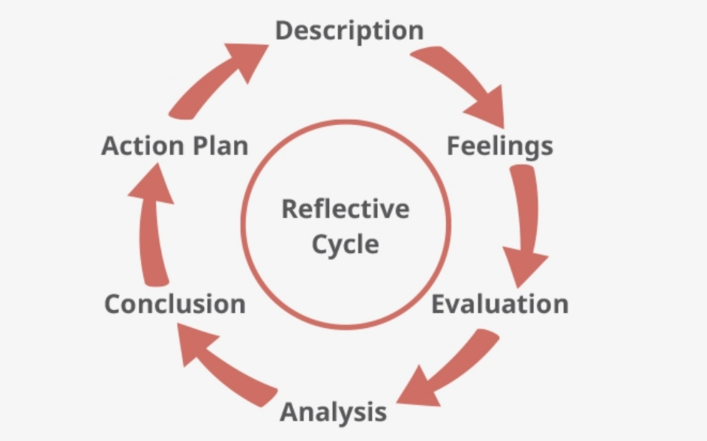
Figure: 1 Gibbs Reflective Model
(Source: Adeani et al., 2020, p. 145)
Analysis
By understanding the situation Gibbs Reflective Cycle's fourth stage is knowns as analysis which is focusing on details and finding the extracted meaning of experiences. I have analysed that achieving organisational goals motivated employees can but the maximum efforts that bridge the gap between willingness and the ability the works. Consequent lower costs of production and better performance can lead to higher productivity that I have observed. Good and effective working conditions promote the efficiency of the employee and recommendations are necessarily based on their performances. The five-member group need effective training and development as such they can balance their professional and personal life that I have realized after completing the project work. Awards and recognition can also motivate employees within the workspace environment. Moreover, maintaining equality in the workplace also encourage employees to perform better. With the help of motivation strategies, it can minimize the barriers and build a better organisational image in the internal environment. However, it leads to building high morale and satisfaction that I have realized throughout the work.
Conclusion
Understanding the actions Gibbs Reflective Cycle helps to draw conclusions based on the overall prospects. I can conclude that motivation guides the shaping of working behaviours of labour forces and it supports to gain energy of employees to achieve organisational goals. Moreover, organisations have to bring changes in terms of motivating factors and reduce motivation challenges to the organisation. In the case study of my workplace project, I can outline that several opportunities would be ensured through the rewards satisfactory systems. Therefore, it promotes maximum contribution and increases the level of productivity and efficiency by following a cooperative attitude. Workplace motivation helps me to perform better and I learn how to minimise operational costs for business purposes.
Action plan
I have evaluated the co-operative attitude and I draw a SMART goal plan to identify the challenges and how to recover them. I gather knowledge and understand the situations to perform better in future projects. However, I have planned to draw a SWOT diagram to identify my weaknesses and recover them for future perspectives.

Feedback from peers on own skills and knowledge
I have observed that feedback or suggestions are important to rectify individual weaknesses and that also strengthen strengths. After completing the group project, there has been arranged a feedback session to identify the challenges. My peers help me to point out the issues that generate obstacles in my working progress. Indeed, my peers suggested modifying my communication skills as such it is the only medium that helps to connect the known or unknown ones. Therefore, I have to develop time management skills as such lack the skill I could not meet the deadline mentioned by my peers. On the other hand, my organising skills are rewarded and appreciated by my peers. On the contrary, resilience, self-management help me to make effective decisions that bring me better benefits within the organization. Due to a lack of communication skills, I could not effectively perform within a team. My emotional intelligence is also appreciated because I can understand others' views and emotions positively. Desiring the outcomes, the abilities are to perform to achieve organisational goals. I was also unable to resolve the conflicts due to a lack of communication strategies. Although I understand others' emotions, I was weak to confess and throw language along with the barriers. On the other hand, my note-making style is highly appreciable of what I have learned during my academic period. I can make short notes from the huge information that is easy to understand and help to make draw conclusions. My peers also point out that my problem-solving skills are not satisfactory and it takes more time to solve the problems. However, from the interpersonal analysis, I have stated that I have to develop my interpersonal skills for future development. Hence, particular areas are identified to bring more opportunities.

Personal development plan

What are my skills-  related development  Objectives? | What activities do I need to  Undertake to achieve my objectives? | What support/ resources do I need to  Achieve my objectives? | Target date for  Achieving my objectives | Interim dates to  review progress
Communication skills | It is no doubt that communication skills are necessary to interact with others (Schroth, 2019, p. 15). Considering the importance of communication skills I have attended an internship program to develop my communication skills. Moreover, I have read the relevant articles to build a stock of vocabulary that enhance the fluency of my communal throw. | The internship program, Relevant and rated articles. | 30.03.2022  06.05.2022 | 02.05.2022
Problem-solving skills | The problem-solving skills are necessary to solve critical issues within the working environment. Therefore, I used to solve critical puzzles to enhance my IQ levels. Moreover, I gather knowledge through detective books or scientific books to analyse the problems. Moreover, my subordinates help me to solve critical problems and they guide me on how to deal with critical issues. | Interesting puzzles solve Scientific books, Suggestions from Subordinates. | 31.03.2022  05.06.2022 | 04.06.2022
Time management skills | To enhance my ability in time management I used to prioritise the table which figures the priority-based works. From the table, I can understand which work is urgent and need to provide priority to complete. Moreover, my peers also suggest following timers to meet the deadline. Moreover, my professors share their experiences where they utilize effective time without wasting it. | Priority-based tables, Timer Clock, Professors' experiences and Peer suggestions. | 04.04.2022  25.06.2022 | 20.06.2022
Conflict management | Conflict management is necessary that can promote workplace productivity. I was a little bit weak in conflict management. As such I have initiated to develop my interpersonal skills involving eye-contact communication, interaction skills. However, to develop interpersonal skills I have joined an online course program that suggests to me how to deal with conflicts. However, I can understand both sides' views to make a conclusion. | In an online course, my friends, analyse different case studies. | 16.04.2022  07.07.2022 | 06.07.2022
Team working skills | Team working skills have the ability to promote confidence and build effective relations with others (Niebuhr, and Michalsky, 2019, p. 307). I have realized that communication skills, empathy, emotional intelligence, negotiation skills are necessary to work within a team. However, a combined course helps me to develop team working skills. | Combine course, interpersonal abilities. | 05.05.2022  09.09.2022 | 05.09.2022

Conclusion
However, in order to get success, academic skills and professional skills are necessary that help to establish employment brand identity. Therefore, without soft skills employees cannot gain success or job market opportunities. Indeed, the reflection report analysis my academic and professional abilities that need to be recovered for future development. The gaps are also identified by peers as such I can rectify them and gain self-confidence in the job market. However, the personal development plan spots my employability skills and achieve them successfully.

References
Adeani, I.S., Febriani, R.B. and Syafryadin, S., 2020. USING GIBBS’REFLECTIVE CYCLE IN MAKING REFLECTIONS OF LITERARY ANALYSIS. Indonesian EFL Journal, 6(2), pp.139-148.https://journal.uniku.ac.id/index.php/IEFLJ/article/view/3382
Kallarackar, T.J. and Thomas, P.J., 2020. Framework for structured reflective journal for professional development of student teachers at secondary level. International Journal of Multidisciplinary Educational Research, 5(6), pp.92-99.http://ijmer.s3.amazonaws.com/pdf/volume9/volume9-issue5(6)-2020.pdf#page=100
Kirkman, P. and Brownhill, S., 2020. Refining professional knowing as a creative practice: towards a framework for Self-Reflective Shapes and a novel approach to reflection. Reflective Practice, 21(1), pp.94-109.https://www.tandfonline.com/doi/abs/10.1080/14623943.2020.1712195
Niebuhr, O. and Michalsky, J., 2019, September. PASCAL and DPA: A Pilot Study on Using Prosodic Competence Scores to Predict Communicative Skills for Team Working and Public Speaking. In INTERSPEECH (pp. 306-310).https://www.isca-speech.org/archive_v0/Interspeech_2019/pdfs/3034.pdf
Schroth, H., 2019. Are you ready for Gen Z in the workplace?.California Management Review, 61(3), pp.5-18.https://journals.sagepub.com/doi/abs/10.1177/0008125619841006
van Ginkel, S., Gulikers, J., Biemans, H., Noroozi, O., Roozen, M., Bos, T., van Tilborg, R., van Halteren, M. and Mulder, M., 2019. Fostering oral presentation competence through a virtual reality-based task for delivering feedback. Computers & Education, 134, pp.78-97.https://www.sciencedirect.com/science/article/pii/S0360131519300351

