Unit 1

Ideas and values

• What is innovation?

Innovation is about successfully implementing a new idea and creating value for your customers and partners. Innovation starts with a new idea. It could be a new plan for a product or a service to improve it.

• What is the definition of innovation?

Innovatio is the systematic practice of developing and marketing breakthrough products and services for adoption by customers, creating something purely new, improving on your innovation for better usage.

• What innovations impresses me the most?

There are a few breakthrough technologies and solutions that have really impressed me like –

(1) Ipads no one really knew how the public would receive the idea of a personal tablet a sort of hybrid between phones and computers.
(2) Siri, iphone were nothing new 10 years ago but voice commands iphone was new.
(3) Online banking is great, let’s you do your day to day to banking with the touch of a finger

• Different types of innovations –

(1) Sustaining or incremental innovation.
(2) Breakthrough innovation.
(3) Disruptive innovation.
(4) Basic research

session 2 Creating the future

In the last two decades technology advancement has benefited almost in every sector, however there have been remarkable changes in fields like media and communication, climate and health care. With every passing year the climate change is becoming more real, therefore the majority of the world’s companies are taking action for sustainable development goals.

The 7 technologies changing our world is –

(1) Internet of things
(2) Artificial Intelligence
(3) Drones
(4) Video conferencing
(5)Cloud services

We are creators of the next wave of innovation and human evolution.

session 3 Creativity and society

Creativity is like a blank canvas, you can create anything you can imagine. Think differently think outside the box. All great innovations started as an idea. Your idea could relate to something you love and enjoy, a hobbie, passion or a personal interest. Our problems, frustrations and challenges in life can be a great source of inspiration too. Create something to make life easier, simpler and more enjoyable. It could educate, inform or satisfy a human or a community need.

My personal favourite creativity is I like to knitting, clothes and henna designing and also I like do a lot of creative cooking

Unit 2 session 1

A change maker is someone who is taking creative action to solve a social problem, every change maker is intentional about solving a social problem. We live in a complex world it is unlikely one can create change without creating value in more than dimension. People manage value creation differently to create successful change. Using the five forms of value you will get to appreciate that change makers are motivated to make changes differently.

(1) Enjoyment Value
(2) Economic Value
(3) Influence Value
(4) Harmony Value
(5) Social Value.

Jaimie Oliver- British chef and change maker who achieved worldwide fame for his food revolution. He took cooking food to a different level.

Unit 2 session 2
Value creation pedagogy

Value Creation is an essential base to support a profitable and lasting business. Value creation for customers helps sell products and services. It is a product or service that they build a bond of loyalty with, in today’s economy, such value creation is based on four things. The product, process, innovation, and fulfilling unique customer needs with not only speed but precision as well.

Tsunesaburo Makiguchi as part of his value creation philosophybelieved that happiness includes truth is found in the correspondence between an objective reality and the world and concepts applies by human to the reality an (bbg).

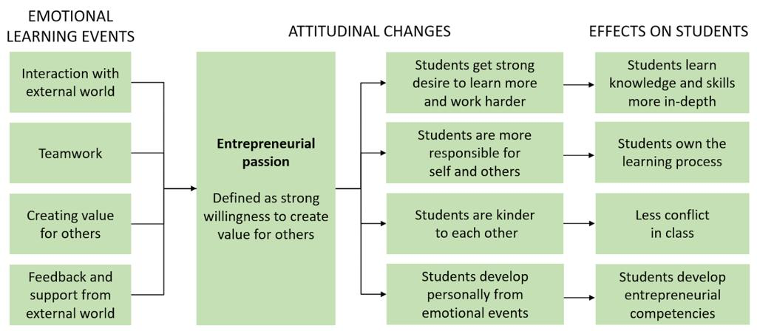

Origami

It helps to develop patience, concentration power, and self-esteem. Origami is a well suited activity to do with the whole classroom.

Each fold of a piece of paper changes the memory of the paper. It changes the paper’s shape and the position that the paper most wants to be in that changes the value of paper. More technically, a fold changes the paper’s last energy state in this way a single fold can change the behaviour of the entire sheet of paper.

Change stories

Single use plastic cutlery, plates and polystyrene cups are reportedly banned in England by the government after a consultation. More than 99.75% of disposable used cups in the uk do not get recycled. The PCA, which represents manufacturers wants government and councils to increase the number of bins to recycle paper cups and mechanisms to transport them to the processing facilities.

Unit 2 session 3

Active listening reveals to us the reality of what other think. If we are to action change we need to collaborate. This means we must accommodate the area that our team value. If we do not, we risk coming into conflict and if we are in conflict it is unlikely that the change can happen.we must find common agreement with what we value and what they value.

The practice of change making hearing and listening.

Hearing Listening
• accidental. • focused
• involuntary • voluntary
• effortless. • intentional

When You don’t listen it makes it impossible to empathise with other. You may also miss out on important information. You increase the risk of disengagement people. You lose the respect of others.

We all have moments when we don’t listen and tune others out when they’re talking. Listening is a skill that can be learned.

