0
Ethan Anderson (2214407)
2214407@student.uwtsd.ac.uk
BENG2-PT Embedded Electronic Systems
Advanced RF Systems ACDA6019

Advanced RF Systems
Laboratory Report
Table of Contents

Abstract 3
Introduction and Literature Review 4
Antenna theory 4
Impedance matching 4
Societal and environmental factors in antenna design 4
Microstrip antennas 4
Microstrip antenna inset feed design 7
Dipole and folded dipole 7
Horn 8
Helical antenna 8
Array theory 8
Methodology 10
CST 10
MATLAB 13
Results 15
CST 15
MATLAB 16
Dipole 17
Folded dipole 19
Horn 21
Helical antenna 23
Helical antenna array 25
Analysis 28
CST 28
Dipole and folded dipole 28
Horn antenna 29
Helical antenna 29
Helical array antenna 29
Conclusion and recommendations 30
References 31

Abstract

This report presents the design, simulation, and performance analysis of various antenna types as part of a comprehensive study in electromagnetic theory and antenna engineering. A microstrip patch antenna was designed and simulated using CST Studio Suite, with a focus on control of antenna impedance and resonant frequency through the selection of appropriate antenna dimensions. Additionally, MATLAB was employed to model and simulate a range of classical antennas, including a dipole, folded dipole, horn antenna, helical antenna, and a helical array. Each antenna type was evaluated based on key parameters such as return loss, bandwidth, radiation pattern, and antenna gain. Comparisons were drawn between the radiation characteristics of each antenna, and their suitability for applications like radar and wireless communications was assessed. These findings offer insight into the practical considerations and trade-offs involved in antenna selection and optimization for modern RF systems.

Introduction and Literature Review

Antenna theory

Impedance matching
Impedance matching is a key consideration when designing any antenna system, including patch antennas. The primary goal of impedance matching is to regulate the input impedance of an antenna to match the characteristic impedance of the transmission line which feeds it. A mismatch in impedance causes unwanted reflections back towards the RF source at the point at which the feed interacts with the antenna, producing a standing wave characterised by the VSWR (Voltage Standing Wave Ratio). A greater VSWR means reduced antenna performance as a smaller proportion of input energy is being radiated and can damage transmission components due to the high voltage points in the standing wave. On receive, this can result in reduced SNR (Signal to Noise Ratio) [1].

Societal and environmental factors in antenna design
The primary societal and environmental impact of antenna design, particular for handheld devices, is the risk of excess RF exposure. The International Commission on Non-Ionising Radiation Protection (ICNIRP) is the international body which governs legal safe limits for prolonged RF exposure [2]. Antenna engineers must be aware of these set limits when designing their antennas, factoring in the radiated power, antenna gain and the environment which the antenna will be employed. For example, mobile phone engineers will design the patch antenna in a mobile device to radiate very little EM energy towards the user’s head, intending to radiate as much as possible into free space.

Microstrip antennas
Microstrip antennas are extremely common in modern wireless communication systems due to their low profile, relative design simplicity, and ease of fabrication (particularly as a form of printed antenna which can leverage modern PCB manufacturing methods and incorporate themselves directly into printed circuit boards). Constantine A. Balanis comments on the versatility of microstrip antennas, particularly when the patch shape and mode are selected, in chapter 14 of Antenna Theory: Analysis and Design [3]. Patch antennas do, however, bring limitations in efficiency, power handling, and bandwidth (typically only a few percent).
Because of their compact size and simplicity, patch antennas are found in virtually every single modern smartphone for wireless communications in the 3G, 4G and 5G bands.
A typical patch antenna leverages the same construction as a low-frequency/DC PCB circuit, using a layer of substrate material sandwiched between two layers of conductive material (typically copper). Like a microstrip transmission line, the top conductive layer is the driven, or excited, conductive layer which carries the signal transmission, with a ground plane on the other side of the substrate used as a ground reference point [1].
Substrate material and thickness have a substantial effect on antenna performance. Substrate materials are often characterised by their relative dielectric constant, ε_{r}, with a low constant generally improving bandwidth and radiation efficiency at a higher cost [4]. In this example, FR-4 is selected, with a ε_{r} modelled as 4.3, due to its wide availability in PCB manufacture and low cost.
The most basic patch antenna is a rectangular patch element, fed at its edge by a microstrip transmission line with the ground plane covering the entire underside of the PCB. However, this is configuration is rarely used beyond an initial starting point in the design process, due to the large impedance mismatch that occurs with an edge-fed patch.
There are a number of methods of reducing impedance mismatch in a microstrip line, including LC tuned circuits, open and short circuit stubs, and quarter-wave transformers. However, this report will focus exclusively on modifying the patch antenna itself to control input impedance. The input impedance of a patch is controlled by carefully modifying its geometric dimensions. For a given desired resonant frequency, f_{r}, in this instance 2.2GHz, substrate dielectric permittivity (4.3), and substrate height h (1.6mm), the required patch length, L, and width, W, is well documented by the IET publication Microstrip and Printed Antenna Design: 3rd Edition [1]:
The length L is calculated by the formula
$$L= L_{eff}-2ΔL$$
Where L_{eff} is the effective electrical length of the antenna, determined by
$$L_{eff = \frac{c}{2f_{r}\sqrt{ε_{reff}}}}$$
With $ε_{reff}$ calculated by
$$ε_{reff}= \frac{ε_{r+1}}{2}+ \frac{ε_{r-1}}{2}\left(\frac{1}{\sqrt{1+12\left(\frac{h}{w}\right)}}\right)$$
Where h is the height of the substrate, in this instance modelled as 1.6mm, typical for FR-4 and w is the width of the patch antenna, calculated by
$$w= \frac{c}{2f\sqrt{\frac{ε_{r}+1}{2}}}$$
Finally, ΔL can be derived from
$$ΔL=0.412h\left(\frac{\left(ε_{reff}+0.3\right)\left(\frac{w}{h}+0.264\right)}{\left(ε_{reff}-0.258\right)\left(\frac{w}{h}+0.8\right)}\right)$$
This series of equations yields length, L (32.54mm), and width, W (41.88mm), for the patch antenna.
For a desired characteristic impedance, Z₀, in this instance the standardised 50Ω, and electrical conductor thickness, t, in this instance 0.035mm as is standard for 1oz copper on a printed circuit [5], the width of the microstrip transmission line feed can also be calculated from the formula
$$W_{feed}= \frac{7.48h}{e^{\left(Z_{0}\frac{\sqrt{ε_{r+1.41}}}{87}\right)}}$$
Which approximates the Hammerstad and Jensen model in Accurate Models for Microstrip Computer-Aided Design [6]. This produced the approximate value 2.99mm.
To derive the dimensions of the ground plane (and subsequently FR-4 substrate assuming complete coverage by the ground plane), the formulas suggested by Pranathi et.al. in Patch Antenna Parameters Variation with Ground Plane Dimensions [7] are used:
$$W_{g}=W+6h$$
$$L_{g}=L+6h$$
Hence a basic patch antenna can now be modelled, including a full-coverage ground plane and edge-fed microstrip feed. The process of modelling and simulating the antenna in CST is detailed in the Methodology section of the report.

Microstrip antenna inset feed design
For a microstrip-fed antenna, an inset-feed technique is needed to reach a point of lower impedance within the patch. The inset-feed is a technique which insets the point at which the microstrip feed meets the patch further towards the centre of the patch, using two indents either side of the patch to separate it electrically from the microstrip line [8].
A mathematical model must be applied and its effectiveness measured (and adjusted where necessary) until the impedance mismatch between the patch and the feed line is minimised.
The two key dimensions required are the length of the inset and the width of the separating indents either side of the inset feed. For this paper, a model suggested by M. Ramesh of the Motorola company was implemented to derive inset-feed length y₀ [9]
$$y_{0}= {10}^{-4}\left\{0.001699{ε_{r}}^{7}+0.13761{ε_{r}}^{6}-6.1783{ε_{r}}^{5}+93.187{ε_{r}}^{4}-682.69{ε_{r}}^{3}+2561.9{ε_{r}}^{2}-4043ε_{r}+6697\right\}\frac{L}{2}$$
for $\left(2≤ ε_{r} ≤10\right)$
Which results in the approximate value 9.9mm from the edge of the patch. Initially, the width of the indents was modelled as identical in width to the microstrip feed.

Dipole and folded dipole
A dipole antenna is one of the simplest forms of microwave transducers. It consists of two identical conductive elements, typically aligned end-to-end and fed at the centre with a balanced transmission line. The most common form of dipole is the half-wave dipole, with an end-to-end length of one half of its operating wavelength. This is because the input impedance of a half-wave dipole is approximately 73Ω, which is very closely matched to the industry standard 75Ω that is used in the telecommunications industry for residential television systems. The resonant length of a dipole is calculated as [3]
$$L= \frac{λ}{2}$$
Dipoles have an omnidirectional radiation pattern in the horizontal plane, resulting in an antenna ideal for communication systems where precise alignment between transmitter and receiver is not required. It has poles in the vertical orientation, resulting in minimal radiation being projected towards the ground or directly above into the sky which can reduce unwanted interference with other systems [3].
A folded dipole is a variation of the dipole antenna with a parallel conducting element connected at each end of the antenna. A folded dipole electrically behaves like a loop antenna, while retaining the radiation pattern of a standard dipole antenna. A folded dipole has improved bandwidth and a significantly higher input impedance (approximately 300Ω), making it well matched for higher impedance transmission lines. Folded dipoles are often used as feed elements for Yagi-Uda antennas, which themselves are arrays of excited and passive dipole and folded dipole antennas [3].

Horn
A horn antenna is empirically a flared waveguide end, controlling the impedance match between the feeding waveguide and free space, whilst also directing the electromagnetic waves in free space. Horn antennas have a simple construction, fixed controllable beamwidth and high gain. Horn antennas are utilised in RF test and measurement applications like standard gain transmitting antennas and radiation pattern measurements, as well as radar applications like feeds for reflector antennas due to their reliability and stable antenna gain [10].

Helical antenna
A helical antenna consists of one or more conducting wires wound in the form of a helix, typically around a central support. These are also usually mounted over a ground plane.
There are two primary modes of operation for helical antennas: normal and axial. In the normal mode, where the radius of the helix is small compared to its operating wavelength, the antenna behaves similarly to a monopole antenna (a dipole with one of the conducting elements substituted for a ground plane). Like a dipole, the radiation pattern is omnidirectional in the horizontal azimuth plane.
In axial operation, the diameter and pitch of the helix is similar in size to the wavelength. In this instance, the majority of radiated energy is projected along the axis of the antenna, resulting in a relatively directional antenna.
In essence, depending on the pitch of the helix, the helical antenna is placed on a spectrum between acting as a loop antenna and a basic monopole, as was characterised by John D. Kraus in The Helical Antenna [11].
Helical antennas are used extensively in communication systems, particularly those dedicated for satellite communications which require circular polarisation and high directionality.

Array theory
An antenna array is typically an n x n matrix of antenna elements on a single plane, driven by a coherent feed. The radiation patterns of these elements will superimpose constructively and destructively in the free space in front of the array in a way in which a more desirable net radiation pattern is formed in the far field. Antenna arrays are useful for producing very high gain antennas whilst reducing the antenna’s physical footprint. These have applications in communication systems which consistently strive for higher antenna gain to improve SNR and signal quality, while having constraints on antenna size and power. [3].

Methodology

CST

The inset-fed patch antenna was modelled and simulated in Dassault’s CST Studio Suite, a high frequency electromagnetic solver software package. The process of modelling and simulating the antenna is detailed below.
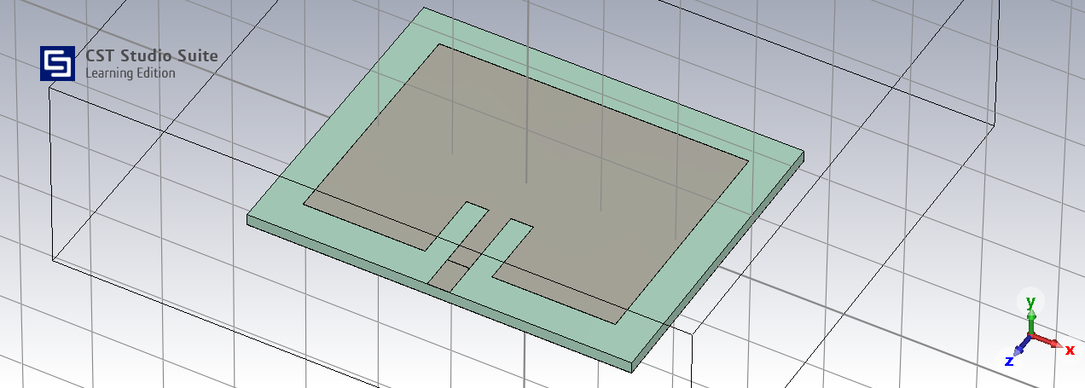
Figure 1: Patch antenna orthogonal view
The patch antenna was first modelled using the physical constraints calculated in the introduction section. The patch element, feed and ground plane were modelled using a loss-free PEC (Perfect Electric Conductor) and the dielectric FR-4 substrate was modelled using CST’s in-built materials library.
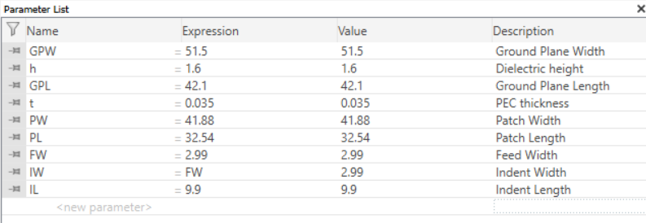
Figure 2: Parameter list
Each dimension was parameterised to enable simple editing post-modelling.
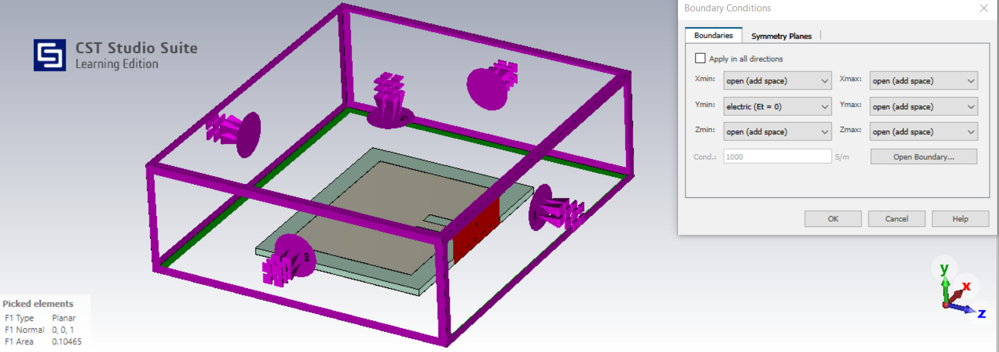
Figure 3: Boundary conditions
Because the underside of the model is an electrical ground plane, an electric short boundary can be placed on the underside plane of the model to reduce the number of mesh cells and subsequently simulation time.
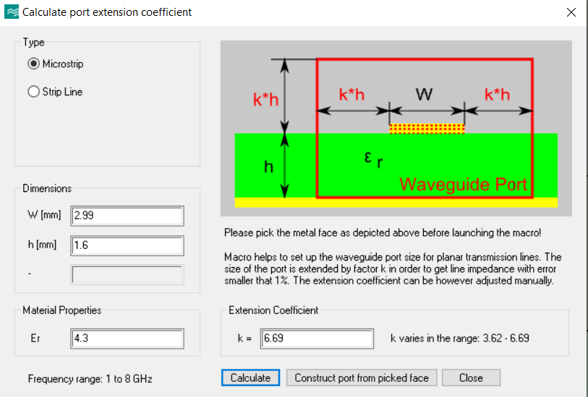
Figure 4: Port extension coefficient
The dimensions for the waveguide port that feeds the antenna were calculated using CST’s in-build waveguide port extension coefficient calculator.
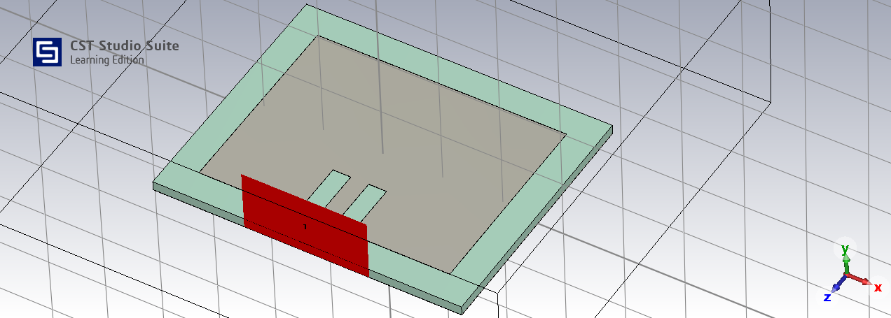
Figure 5: Waveguide port
A waveguide port was selected to excite the antenna as this closely represents the TM₁₀ mode that microstrip transmission lines are designed for.

Figure 6: Time-domain solver parameters
A time-domain solver was selected due to its computational efficiency when operating over a large frequency range. An accuracy level of -30dB was selected to reduce computational load. The input was normalized to a fixed 50Ω impedance to simulate a 50Ω transmission line feed.

MATLAB

The dipole, folded dipole, horn, helical and helical array antennas were simulated using MATLAB’s in-built Antenna Designer and Antenna Array Designer apps. These apps take input parameters like operating frequency and apply them to a pre-loaded library of antenna designs. This enables fast and simplistic simulation of basic antennas.
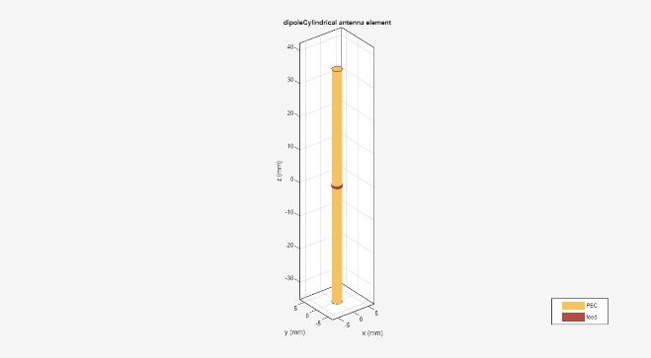  Figure 7: Dipole antenna | 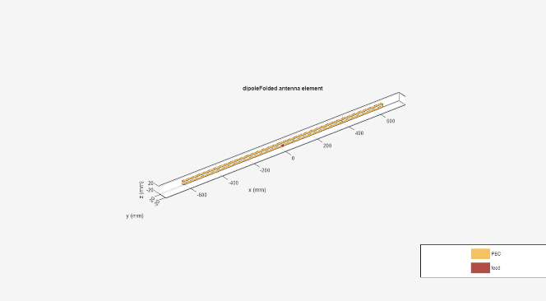  Figure 8: Folded dipole antenna
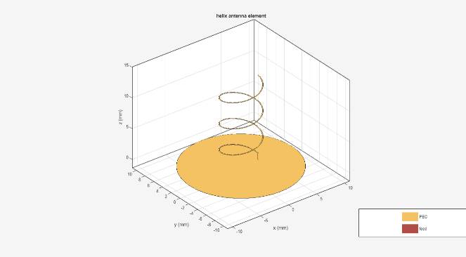  Figure 9: Helical antenna | 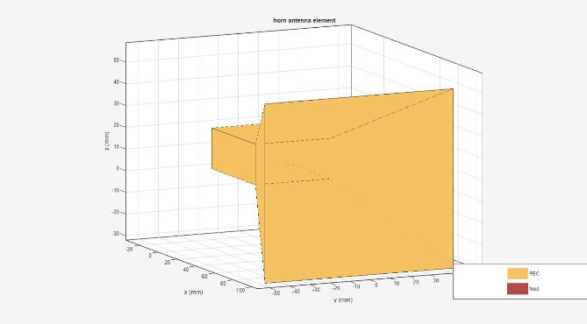  Figure 10: Horn antenna

Each antenna was selected and its resonant frequency was inputted based on the student number. 2GHz, 110.5MHz, 7GHz and 21GHz respectively.
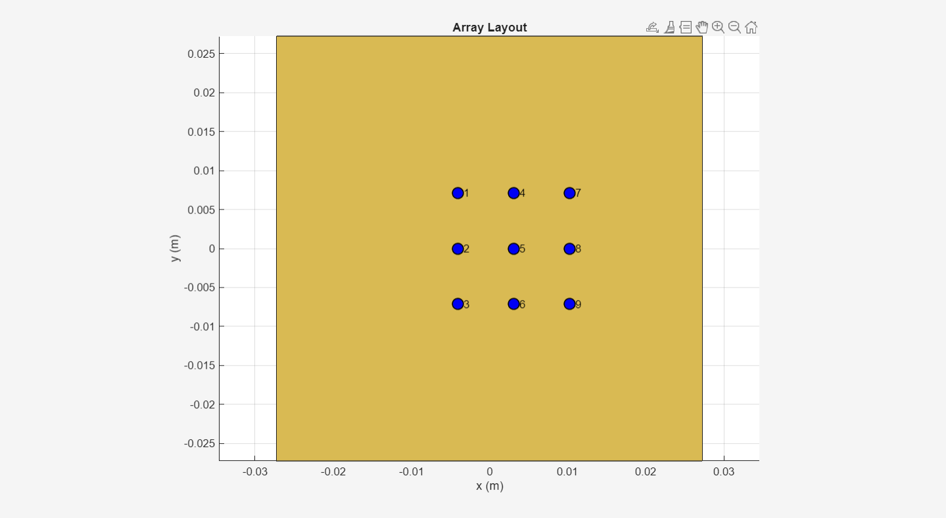
Figure 11: Helical array grid
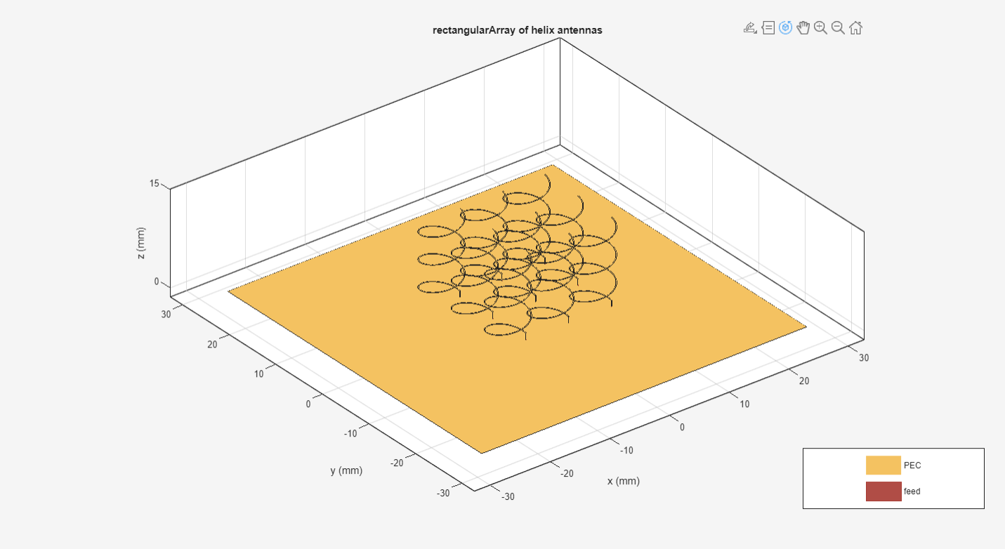
Figure 12: Helical array
A 3x3 helical array was constructed and its resonant frequency of 21GHz was inputted into MATLAB. The simulation was then allowed to run to produce impedance, far field and S-parameter plots.

Results

CST

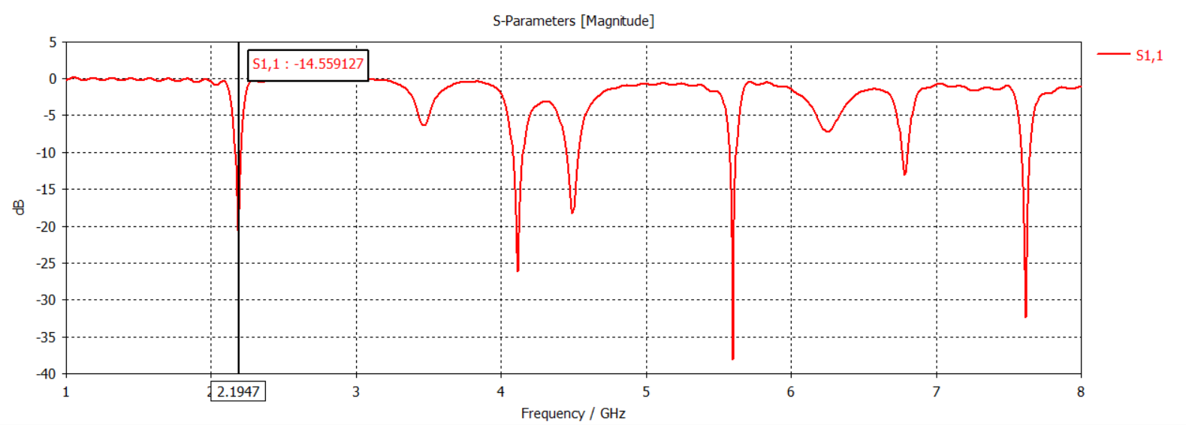
Figure 13: Patch antenna S11 from 1 - 8GHz
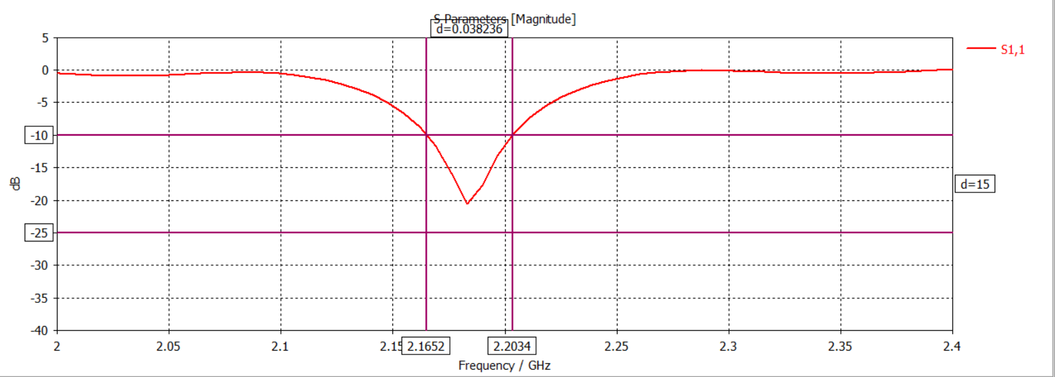
Figure 14: Patch antenna S11 bandwidth measurement
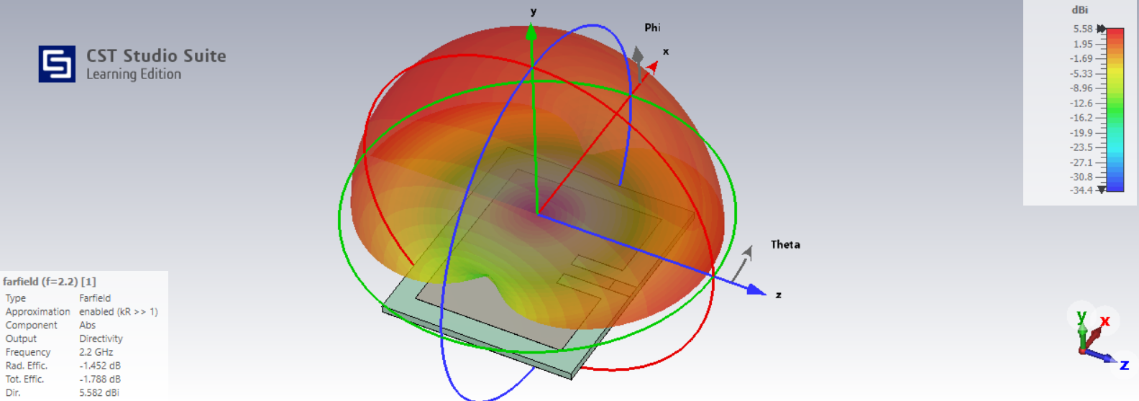
Figure 15: Patch antenna far field radiation pattern at 2.2GHz
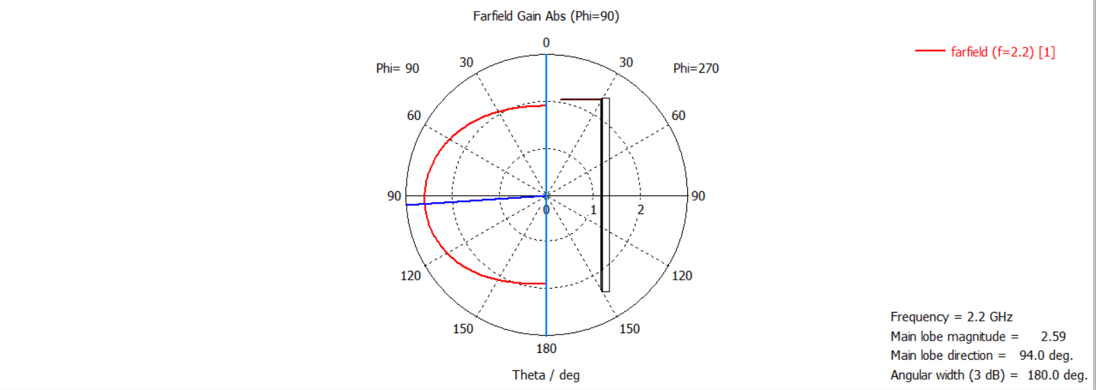
Figure 16: Patch antenna polar far field plot at 2.2GHz
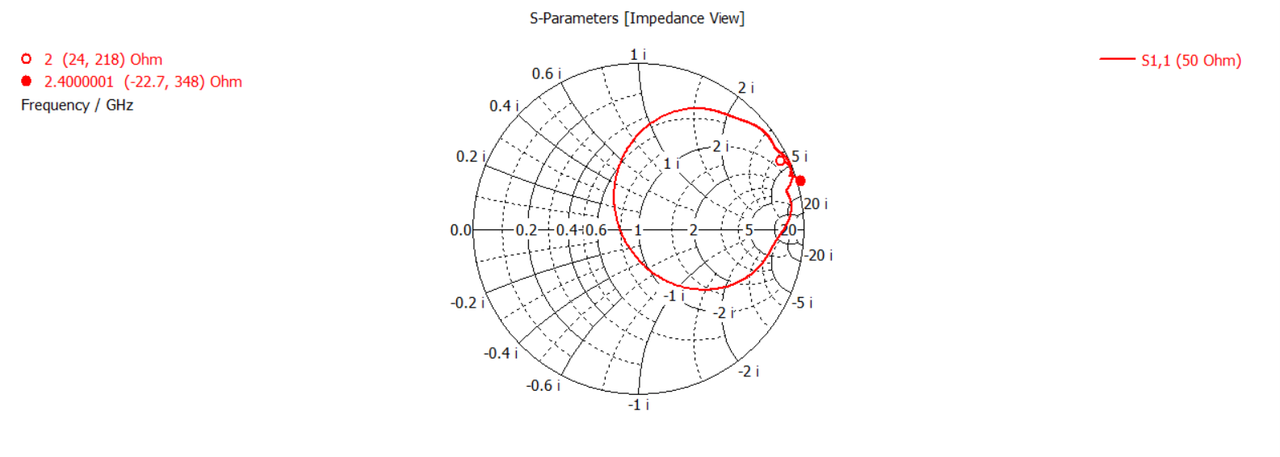
Figure 17: Patch antenna Smith chart impedance measurement from 2 to 4GHz

MATLAB

Dipole
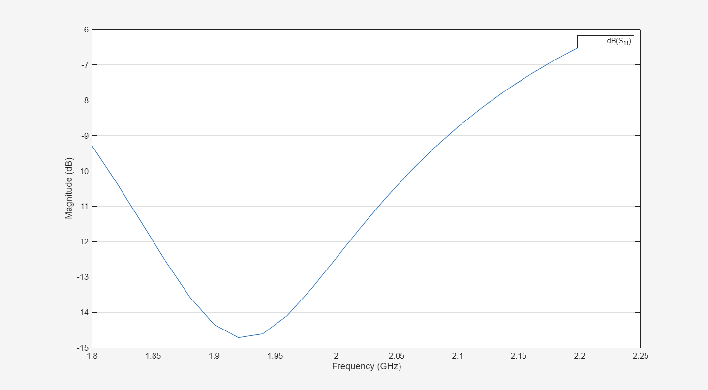
Figure 18: Dipole S11
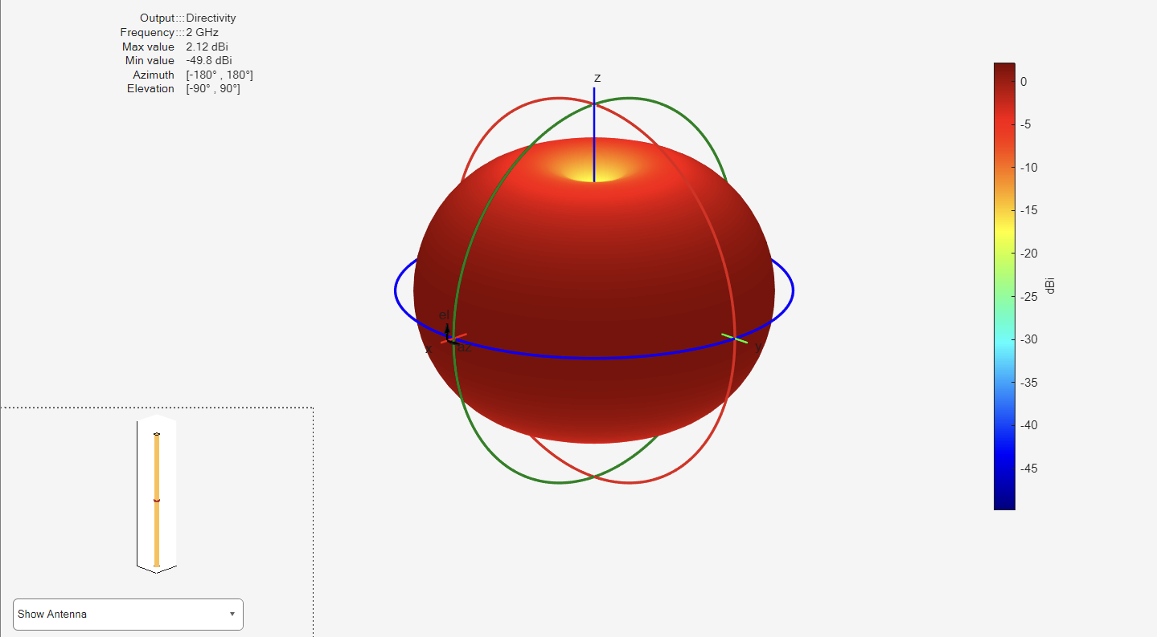
Figure 19: Dipole 3D Far field plot
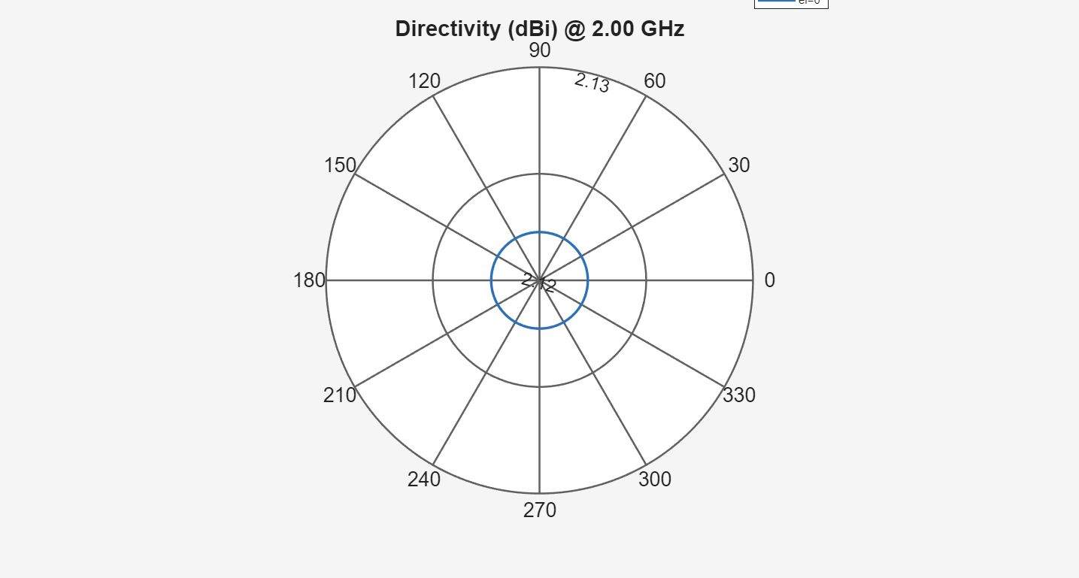
Figure 20: Dipole azimuth far field plot
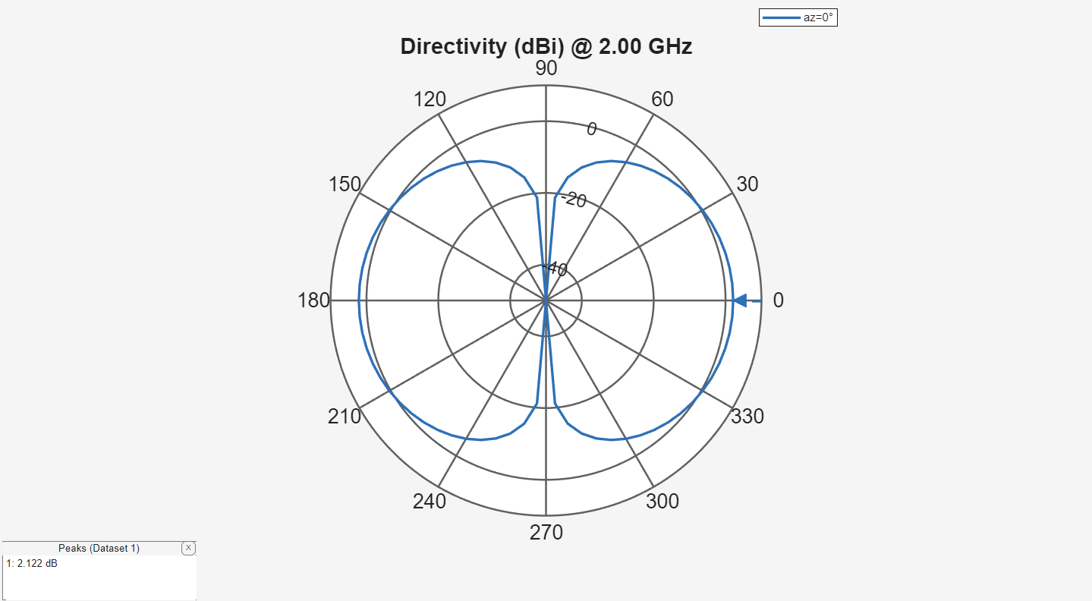
Figure 21: Dipole elevation far field plot

Folded dipole
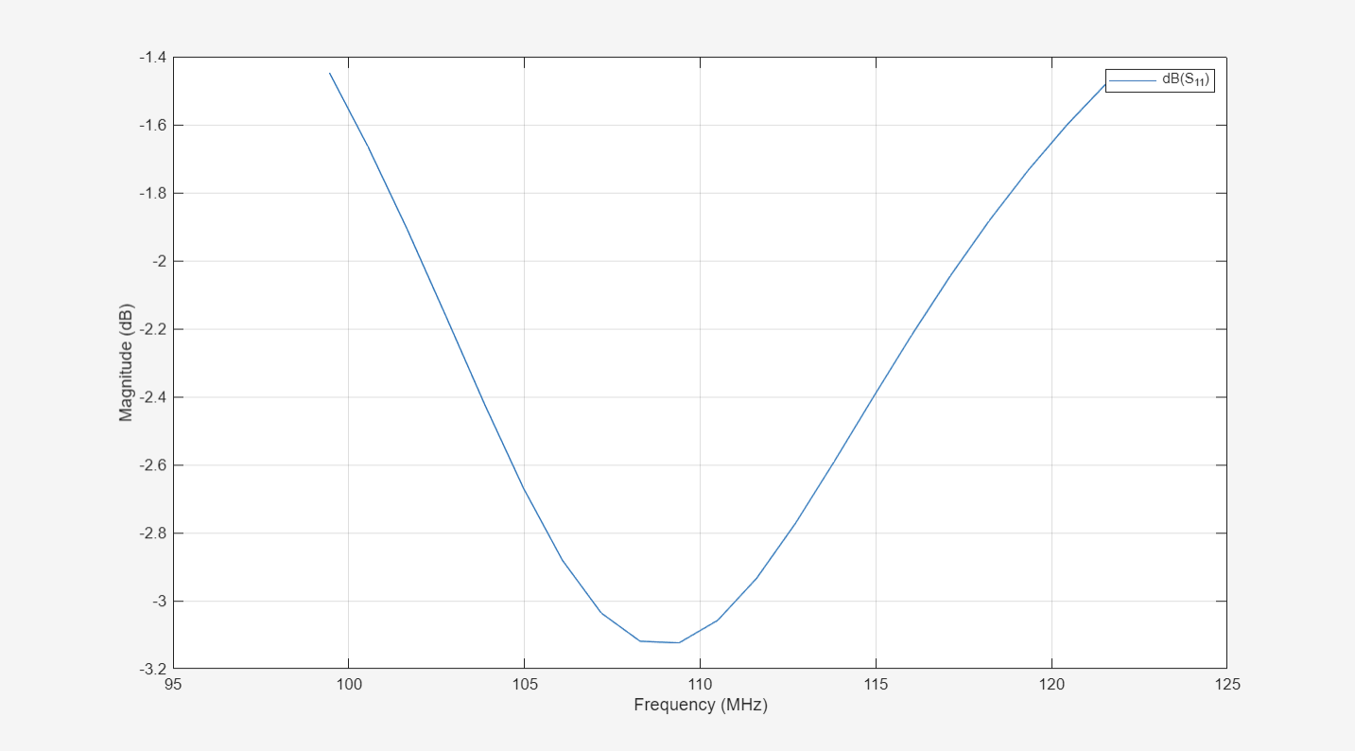
Figure 22: Folded dipole S11
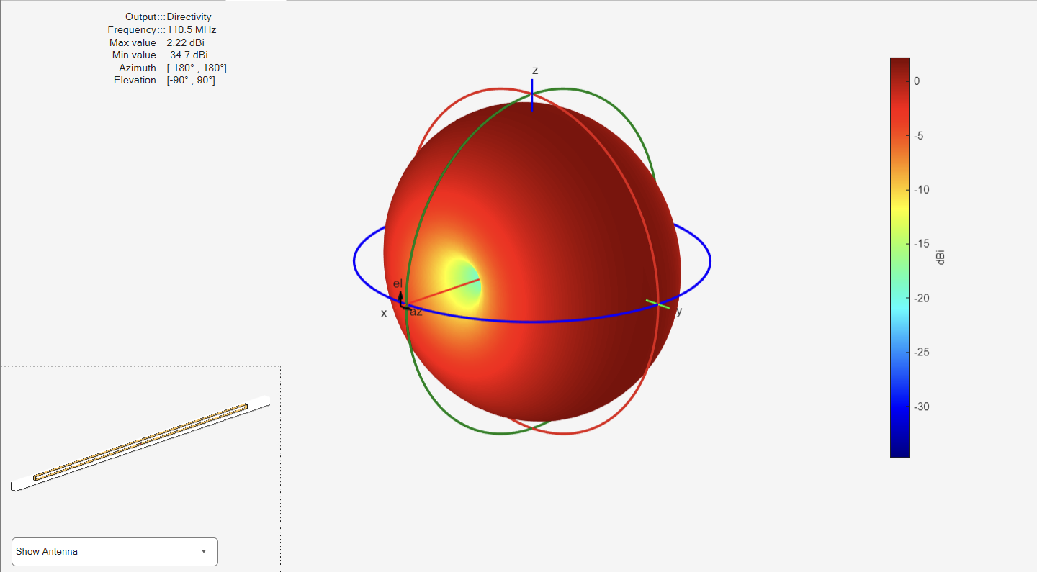
Figure 23: Folded dipole 3D far field plot
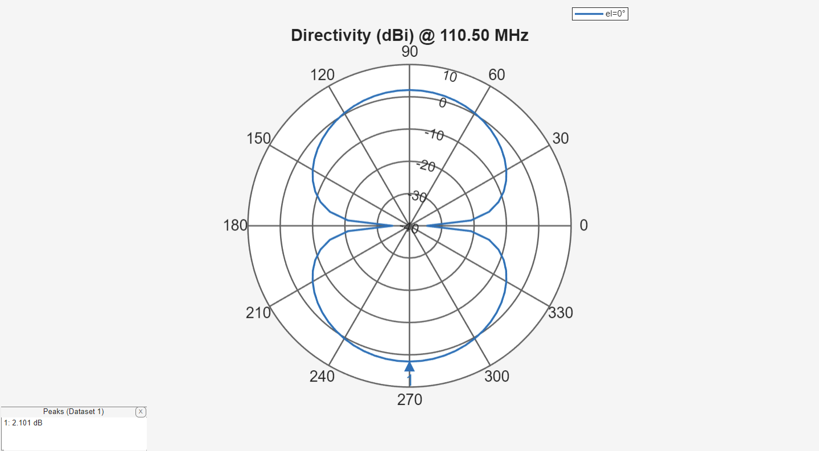
Figure 24: Folded dipole far field azimuth plot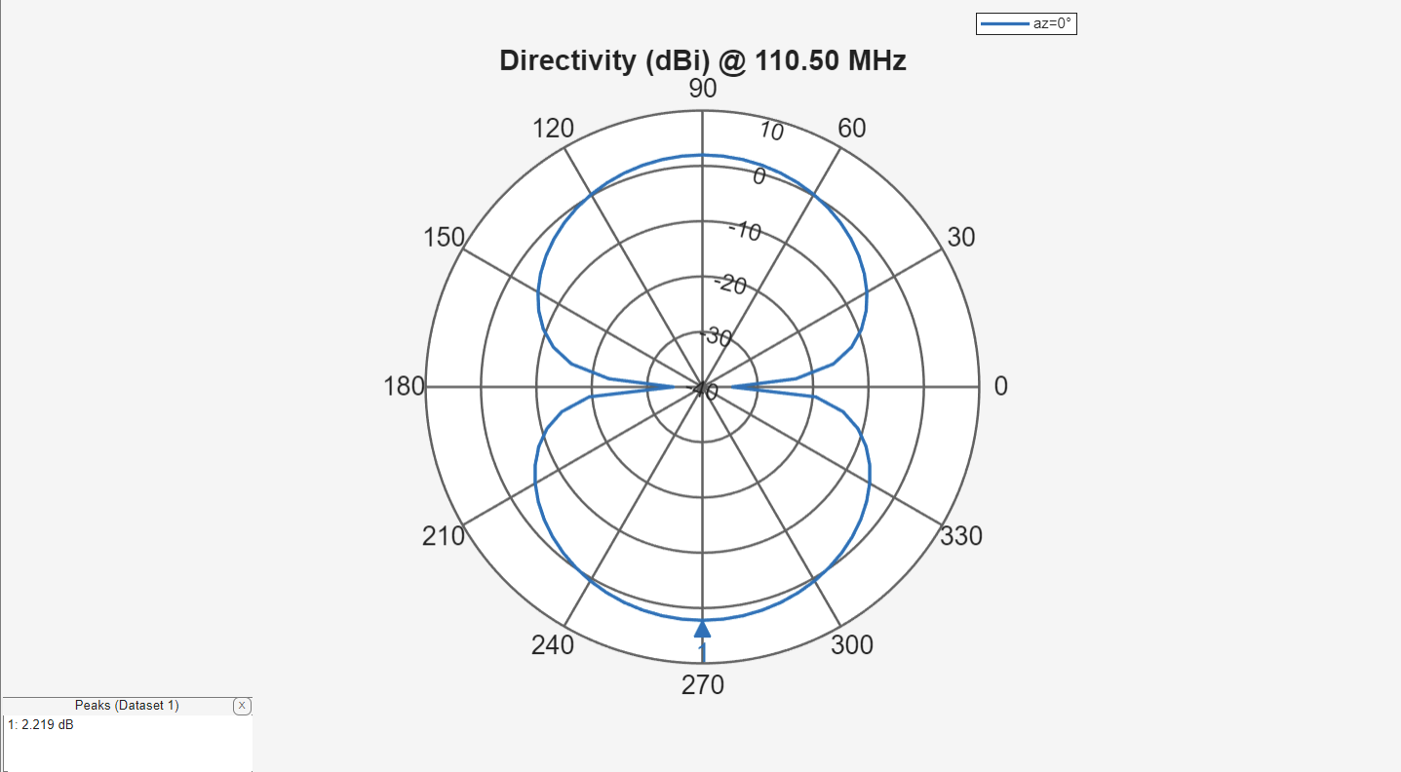
Figure 25: Folded dipole far field elevation plot

Horn
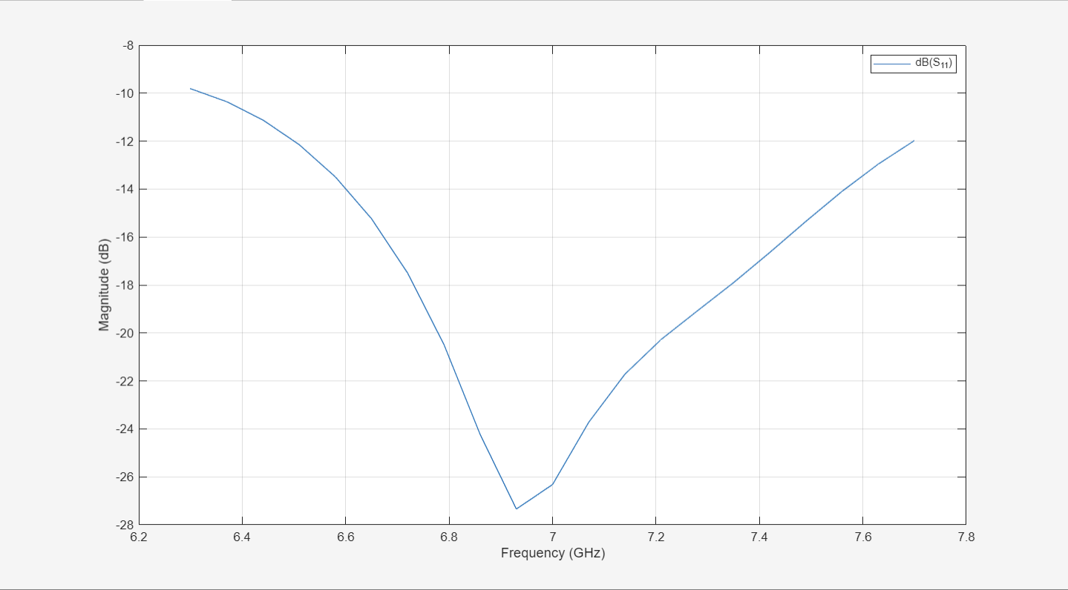
Figure 26: Horn S11
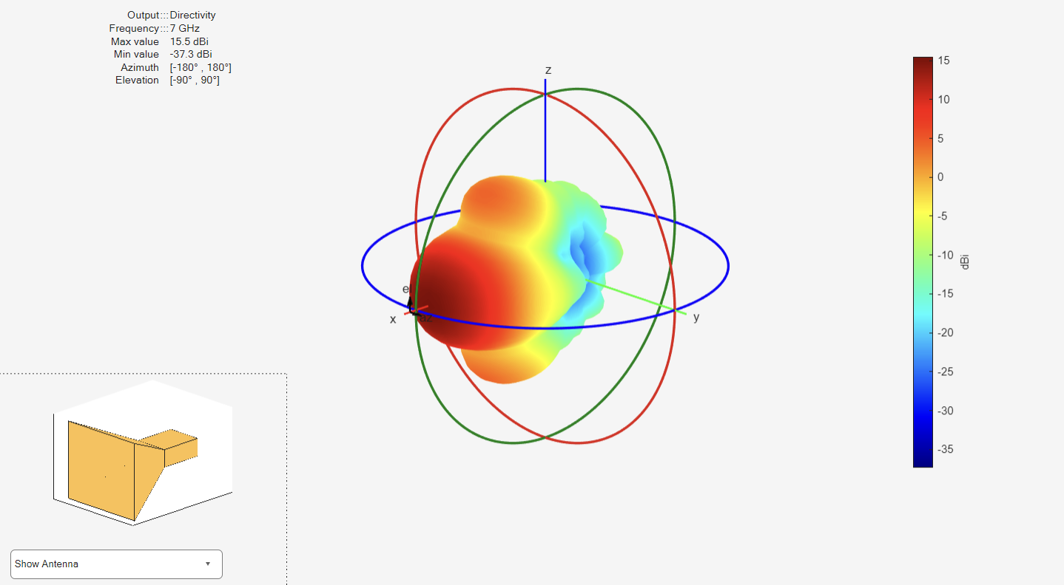
Figure 27: Horn 3D far field plot
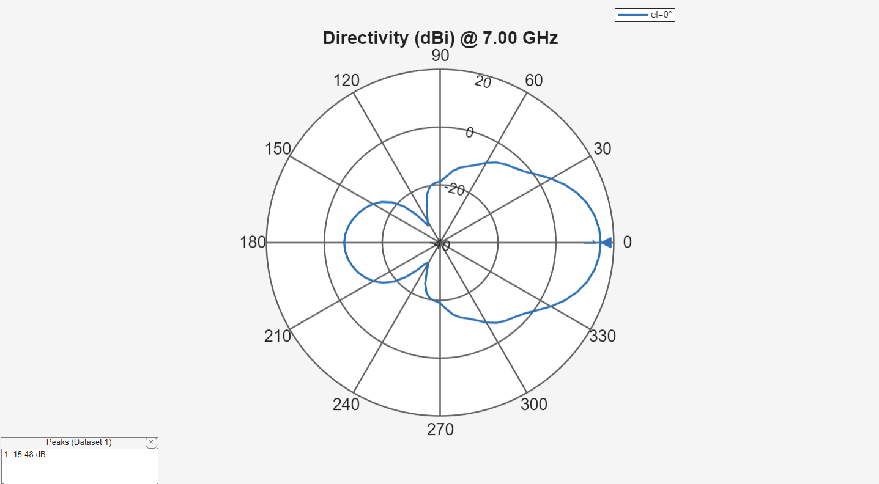
Figure 28: Horn far field azimuth plot
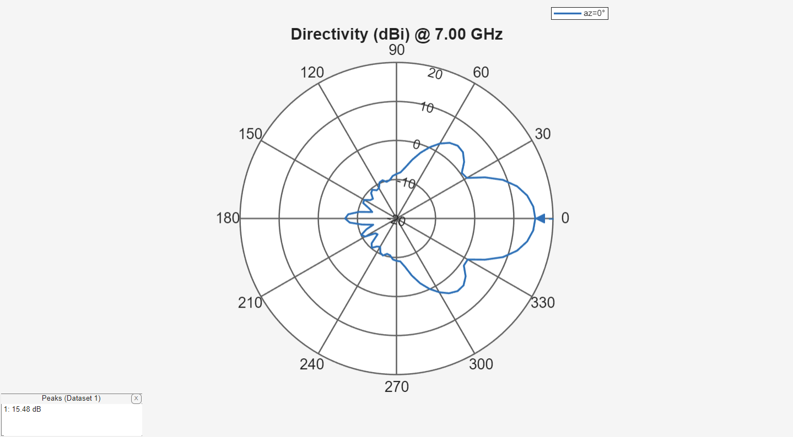
Figure 29: Horn far field elevation plot

Helical antenna
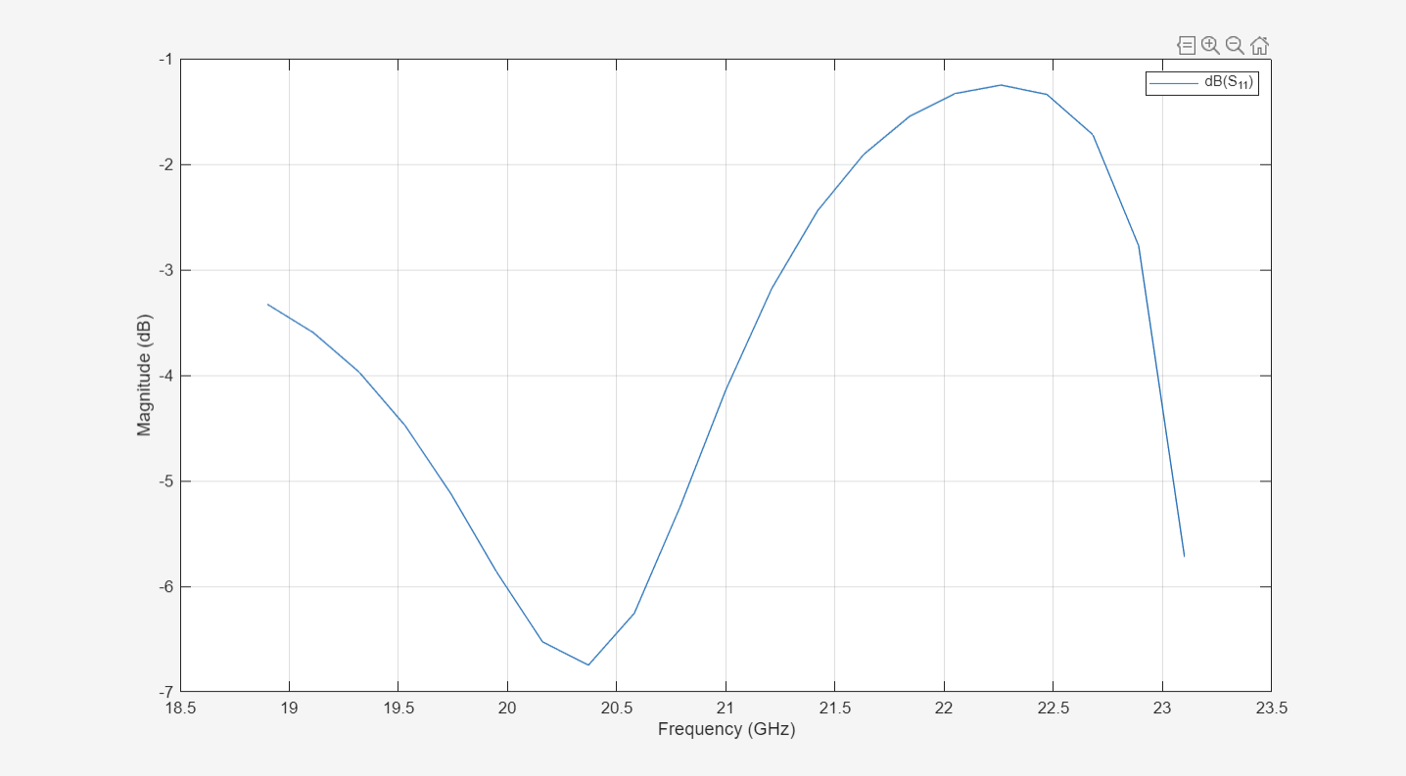
Figure 30: Helical antenna S11
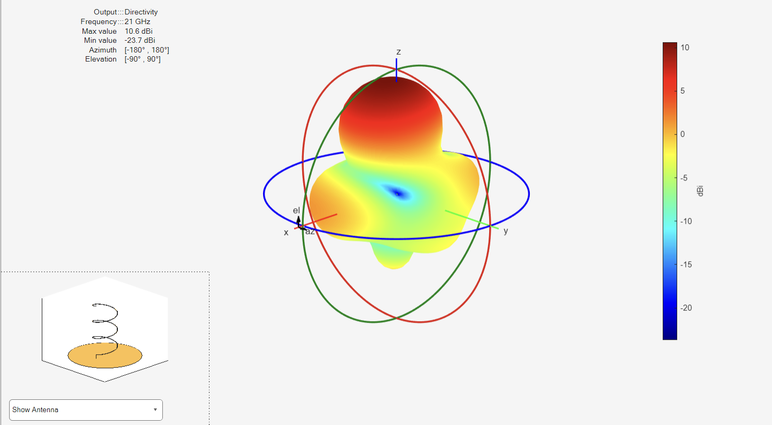
Figure 31: Helical antenna 3D far field plot
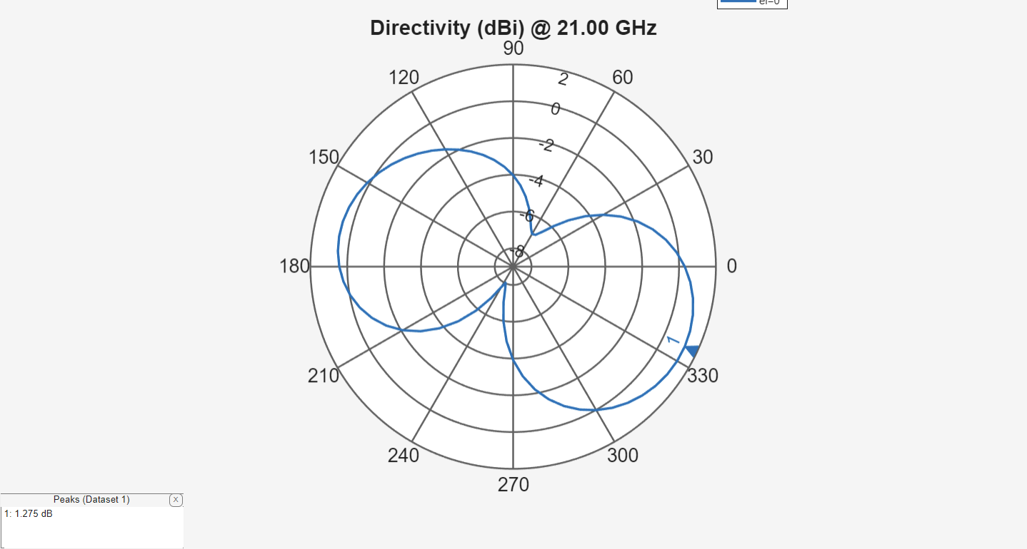
Figure 32: Helical antenna far filed azimuth plot
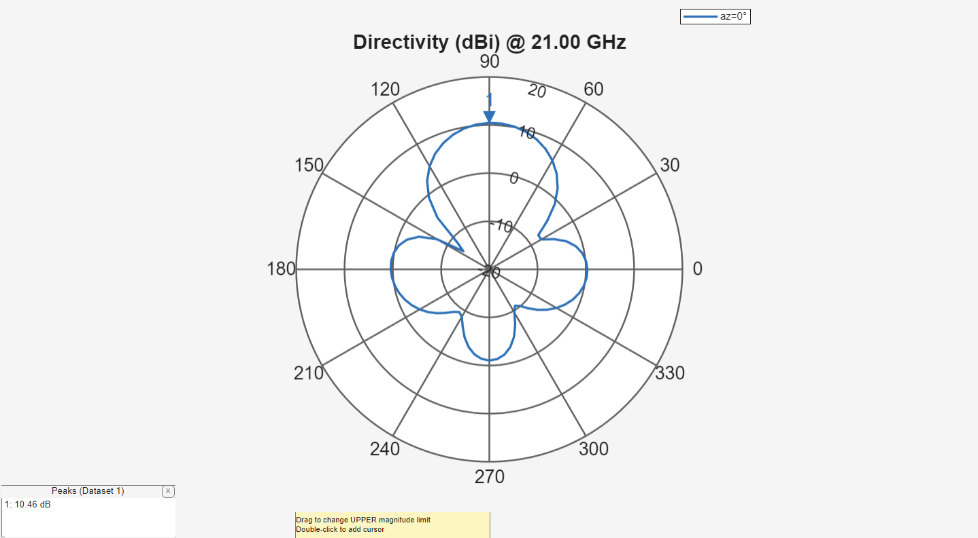
Figure 33: Helical antenna far field elevation plot

Helical antenna array
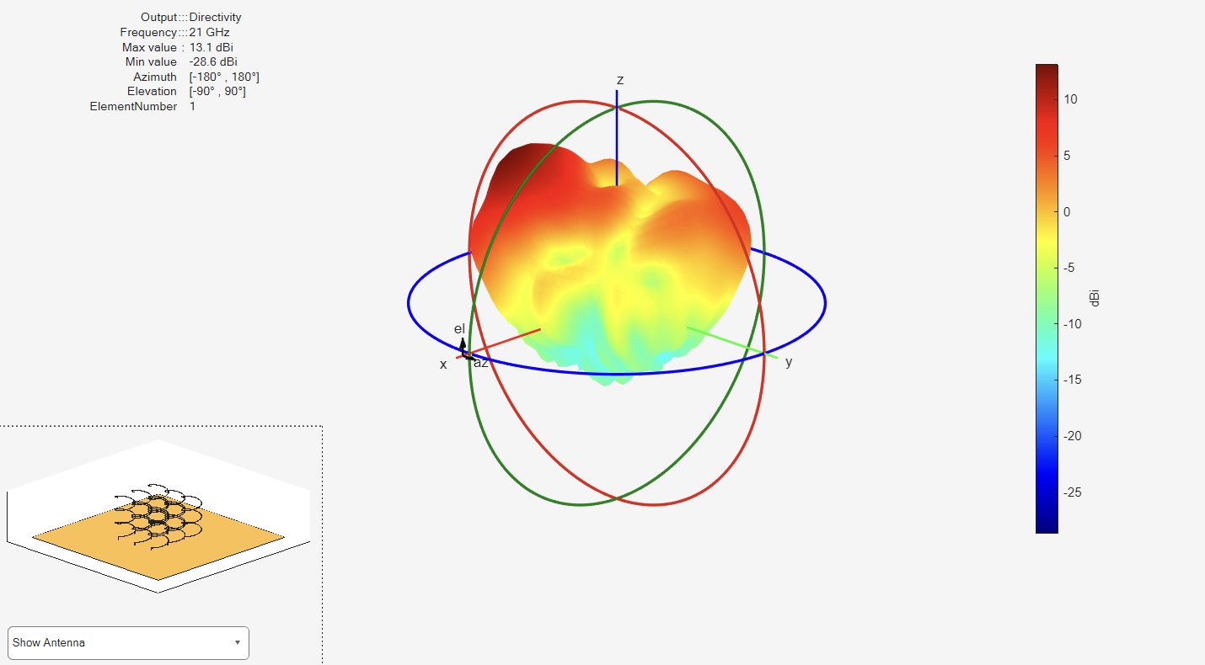
Figure 34: Single element 3D far field plot
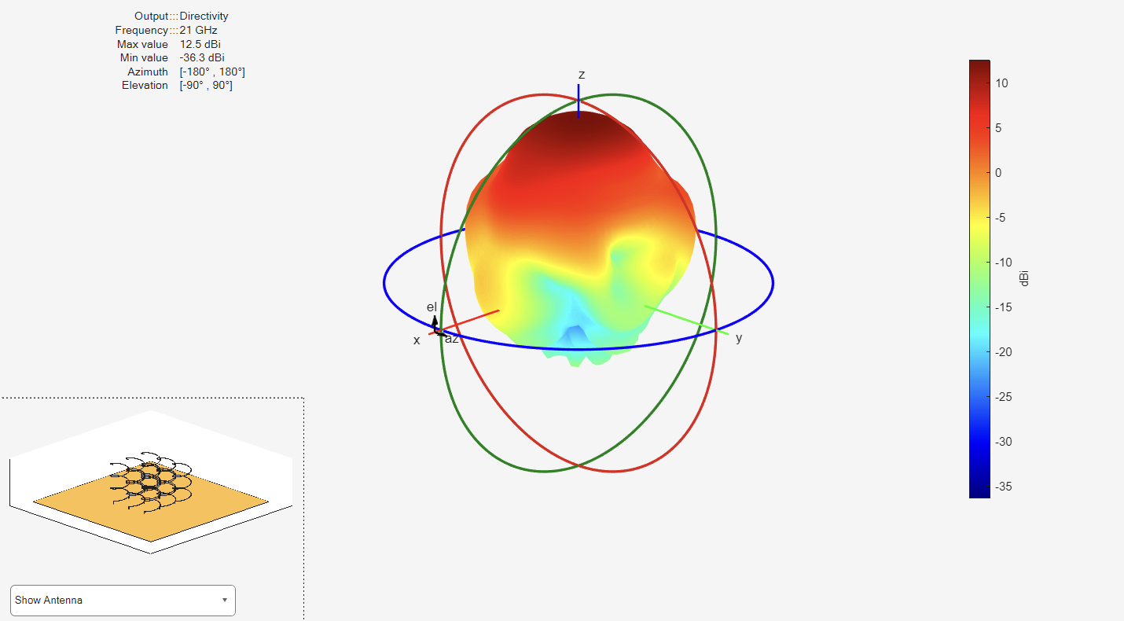
Figure 35: Antenna array 3D far field plot
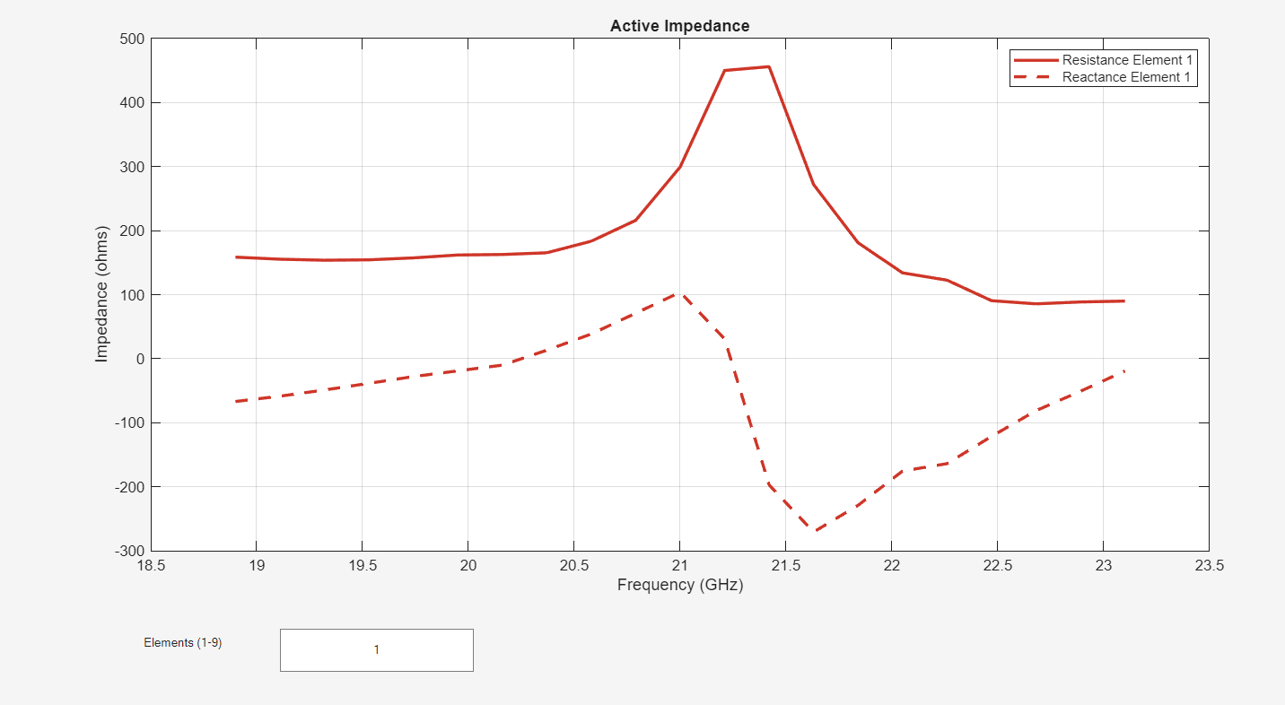
Figure 36: Single element impedance
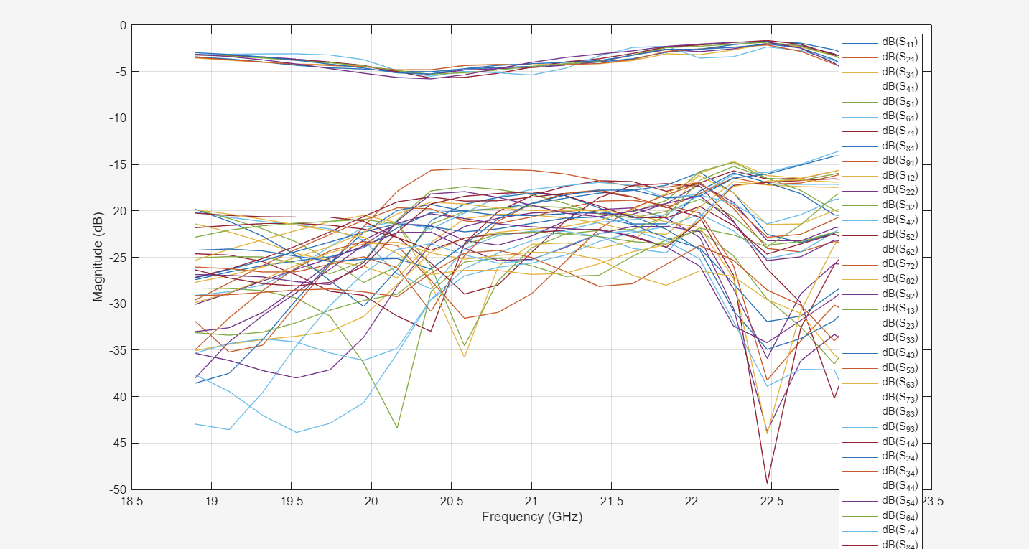
Figure 37: All element S parameters
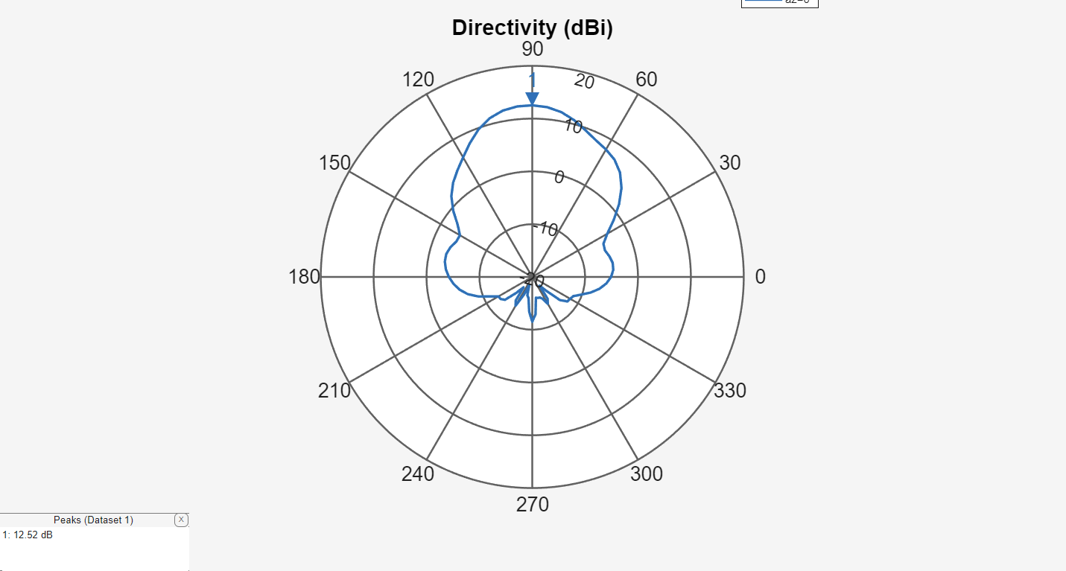
Figure 38: Array far field elevation plot

Analysis

CST

Figure 13 shows the patch antenna’s S11 measurement across the entire 1 – 8GHz frequency band. S11 is a measurement of (undesirable) reflected energy. Therefore, a small amount of reflected energy is desirable. An industry standard is to take -10dB as an acceptable point: anything below -10dB is acceptable. Figure 13 shows a significant trough at 2.1987Ghz, showing that the patch design functions relatively well for its intended frequency as a large amount of power is being radiated, implying the impedance match is similar. A small tweak to the patch length could adjust the resonant frequency to bring it closer to exactly 2.2GHz.
Figure 14 shows a zoomed S11 display from 2 – 2.4GHz. Using the markers an upper and lower frequency band can be taken using the -10dB reference points. 2.1652 – 2.2034GHz gives a bandwidth of 38.2MHz, or 1.7%, which is typical for a patch antenna.
Figures 15 and 16 show the far field radiation pattern of the patch antenna at 2.2GHz, which is directional at the broadside of the antenna. This is to be expected according to theory [1] and shows that electromagnetically the antenna is performing well at the selected frequency with a peak broadside gain of roughly 5.58dBi.

MATLAB

Dipole and folded dipole
Figure 18 shows the lowest S11 value at 1.925GHz, indicating its resonant frequency is just below the design specification of 2GHz. This centre frequency could be shifted by marginally decreasing the length of the dipole. However it should be noted that even at 2GHz the reflected power is less than -10dB which is an acceptable level. S11 below -10dB indicates the impedance between the antenna and the feed line is matched well.
Figure 19 shows an omnidirectional radiation pattern in the azimuth plane, typical of a dipole antenna. The dipole shows very little directionality with a peak at 0dBi (this is expected as the dBi measurement is relative to an ideal dipole, and so there should be no disparity). Figures 20 and 21 show this same radiation pattern with a horizontal and vertical plane slice, highlighting its omnidirectionality and low gain.
Figure 22 shows the S11 for the folded dipole, similar to the dipole slightly below its intended resonant frequency of 110.5MHz at roughly 108MHz. This may be due to an error in how MATLAB simulates its antennas. Unlike the dipole, the folded dipole has very high S11 values, indicating a poor impedance match and much of the power is being reflected back. Figures 23, 24 and 25 show a radiation pattern very similar to the normal dipole.

Horn antenna
Figure 26 shows the S11 for the horn antenna. It shows a very large bandwidth, in excess of 1.5GHz. Figures 27, 28, and 29 display the high directionality of the horn antenna with a peak gain of 15dBi.

Helical antenna
Figure 30 shows the S11 response of the helical antenna. At no point does it dip below -10dB, indicating poor power acceptance. It also changes greatly with frequency, meaning it does not perform well as a wideband antenna. Figure 31 shows the radiation pattern, which is relatively directional with two notable sidelobes. As mentioned the helical antenna appears to be behaving similar to both a loop and monopole antenna. Tweaking the diameter and pitch may improve the directionality.

Helical array antenna
Comparing figures 34 (single element far field) and 35 (array far field) clearly shows the increase in directionality that is produced when an array antenna is constructed from its individual elements. The highest gain is now pointed directly broadside to the array with fewer sidelobes which is more preferable for communications and radar tracking applications as it can reduce interference from the sidelobes.

Conclusion and recommendations

The modelling and simulation of a patch antenna in CST Studio Suite has been demonstrated. The difference between theoretical resonant frequencies and simulated has been shown and the effectiveness of the simulation evaluated. The patch antenna performed very similarly to its theoretical resonant frequency and only requires slight adjustment to achieve the expected resonant frequency. This highlights the iterative nature of antenna design.
Additionally, the simulation of a dipole, folded dipole, horn, helical and helical array antennas was conducted in MATLAB’s antenna designer app. This was a useful tool in displaying the expected S11 parameter and far field plots of the various antennas. However, there was some consistent mismatch in expected and actual resonant frequencies which may warrant further investigation and manual adjustment of the antennas parameters to rectify.

References

[1] | R. Bancroft, Microstrip and Printed Antenna Design: 3rd Edition, The Institution of Engineering and Technology, 2019.
[2] | International Comission on Non-Ionizing Radiation Protection (ICNIRP), "ICNIRP Guidelines for Limiting Exposure to Electromagnetic Fields (100kHz to 300GHz)," 2020.
[3] | C. A. Balanis, in Antenna Theory: Analysis and Design, Third Edition, John Wiley & Sons, 2005.
[4] | M. F. Ahmed, M. H. Kabir and A. Zafor, "Effect of the Substrate Material and Thickness on the Performance of the Rectangular Patch Microstrip UWB Antenna," SSRG International Journal of Recent Engineering Science, vol. 8, no. 4, pp. 15-18, 2021.
[5] | g. circuits, "Farnell," [Online]. Available: https://www.farnell.com/datasheets/2884069.pdf. [Accessed May 2025].
[6] | E. Hammerstad and J. O, "Accurate Models for Microstrip Computer-Aided Design," in 980 IEEE MTT-S International Microwave symposium Digest, Washington DC, 1980.
[7] | G. V. P. Pranathi, D. N. Deepika Rani, D. M. Satyanarayana and P. G. T. Rao, "Patch Antenna Parameters Variation with Ground Plane Dimensions," International Journal of Advanced Research in Electrical, Electronics and Instsrumentation Engineering, Vol 4, Issue 8, August 2015.
[8] | M. A. Matin and A. I. Sayeed, "A Design Rule for Inset-Fed Rectangular Microstrip Patch Antenna," in WSEAS Transactions on Communications.
[9] | M. Ramesh, "Design Formula for Inset Fed Microstrip Patch Antenna," Journal of Microwaves and Electronics, vol. 3, 2003.
[10] | R. E. Collin, Foundations for Microwave Engineering, Wiley Interscience, 2001.
[11] | J. D. Kraus, "The Helical Antenna," in Proceedings of the Institute of Radio Engineers, 1949.
[12] | A. Elrashidi, K. Elleithy and H. Bajwa, "THE FRINGING FIELD AND RESONANCE FREQUENCY OF CYLINDRICAL MICROSTRIP PRINTED ANTENNA AS A FUNCTION OF CURVATURE," University of Bridgeport.

