

E-Portfolio Evidence of Learning
Tasks 1 Mind map
Task 2 Blog
Student: Mihaela Juganaru 1912276 Lecturer: Dr Azora Hurd | 2/19/21 | Changemakers: Creativity and Value Creation BMHP5014_BIRM

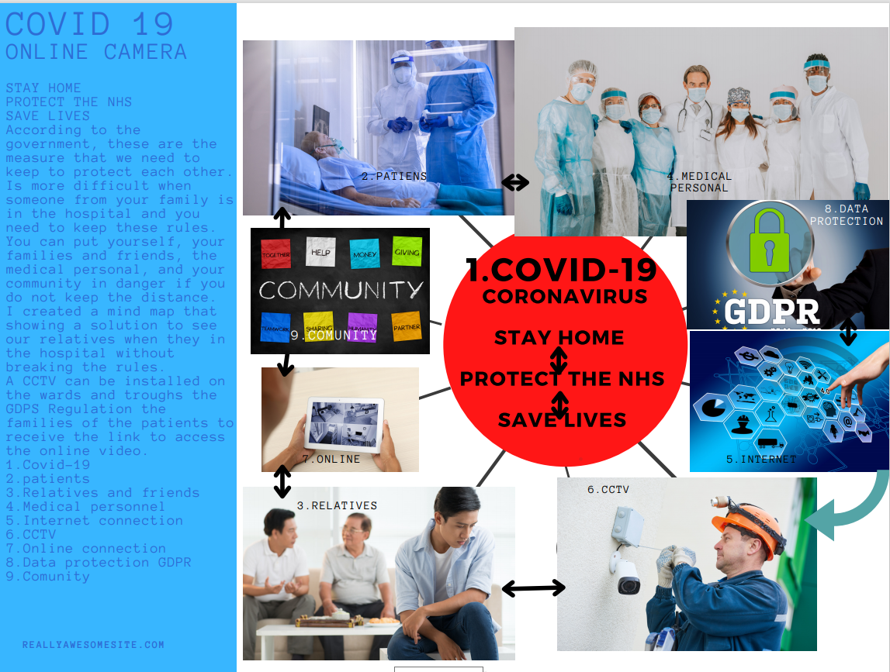
Task 1 Mind map

Task 2 Blog
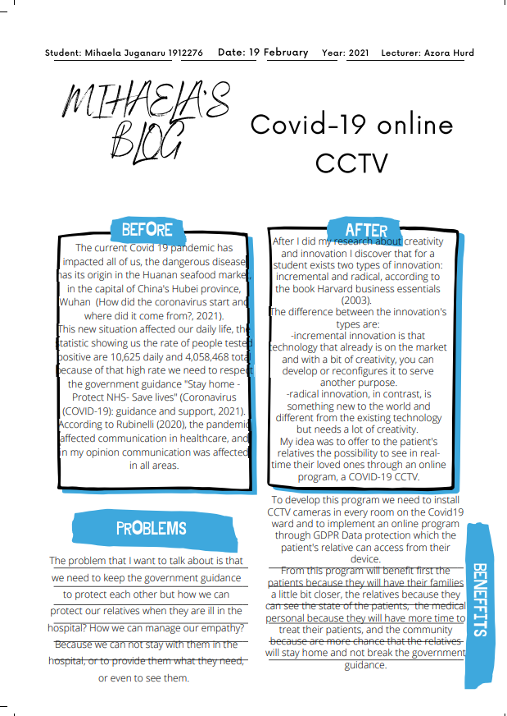

References

Harvard business essentials (2003). Boston, Mass.: Harvard Business School Press.
Blog Template (2021) [online] Available at: https://www.canva.com/graphs/mind-maps/ (Accessed 16 February 2021).
Cqc.org.uk (2021) Using hidden cameras to monitor care | Care Quality Commission. [online] Available at: https://www.cqc.org.uk/news/stories/using-hidden-cameras-monitor-care (Accessed 16 February 2021).
GOV.UK (2021) Coronavirus (COVID-19): guidance and support. [online] Available at: https://www.gov.uk/coronavirus (Accessed 16 February 2021).
Image 1-9 (2021) [online] Available at: https://www.canva.com/graphs/mind-maps/ (Accessed 16 February 2021).
Netdoctor (2021) How did the coronavirus start and where did it come from?. [online] Available at: https://www.netdoctor.co.uk/conditions/infections/a32264052/how-did-coronavirus-start/ (Accessed 16 February 2021).
Rubinelli, S., et al. (2020) Implications of the current COVID-19 pandemic for communication in healthcare. Patient Education and Counseling, 103(6), pp.1067-1069.
Themdu.com (2021) CCTV in healthcare - The MDU. [online] Available at: https://www.themdu.com/guidance-and-advice/guides/cctv-in-healthcare?role=norole (Accessed 16 February 2021).

