2018
University of Wales Trinity Saint David London

Priyankkumar Patel (1704831)

[Software development]
Programs of all the parts (1 to 3)

Exercise 1:
Allow the user to declare different types of variables to hold name of customer, price of a product and quantity. Also, try to find out the total price of the order.

using System;
using System.Collections.Generic;
using System.Linq;
using System.Text;

namespace assignmentQ1
{
class Program
{
static void Main(string[] args)
{
string name;
Double price;
int quantity;
Double total;

Console.Write("Enter the name: ");
name = Console.ReadLine();

Console.Write("Enter the price: ");
price= Convert.ToDouble(Console.ReadLine());

Console.Write("Enter the quanity: ");
quantity=Convert.ToInt32(Console.ReadLine());

total = price * quantity;

Console.WriteLine("The total price is: {0}", total);
Console.ReadLine();

}
}
}

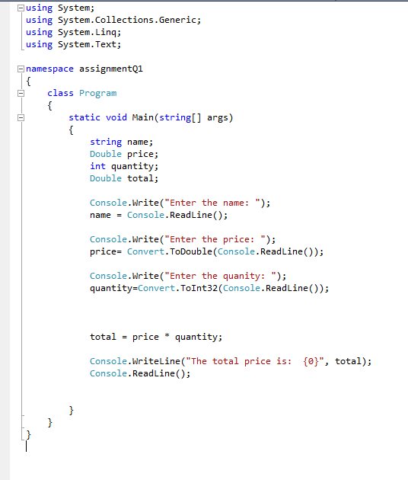

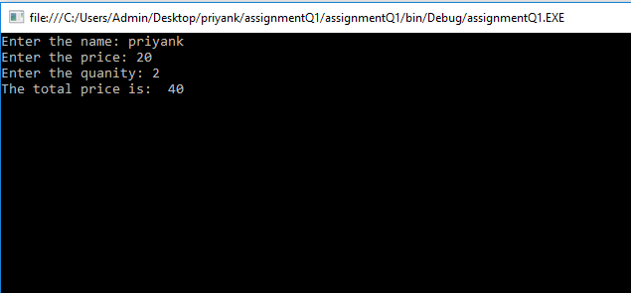

Exercise 2:
Allow the user to enter the dimensions (x and y) of shape below, then calculate the display the area of shaded region (coloured portion).
using System;
using System.Collections.Generic;
using System.Linq;
using System.Text;

namespace AssignmentQ2
{
class Program
{
static void Main(string[] args)
{
double x;
double y;
double a;

Console.WriteLine("Enter the value of x");
x = Convert.ToDouble(Console.ReadLine());

Console.WriteLine("Enter the value of y");
y = Convert.ToDouble(Console.ReadLine());

a = (x * 3) + ((y - 3) *( x - 7) ) - 4 ;
Console.WriteLine("The shaded area is: {0}", a);
Console.ReadLine();

}
}
}

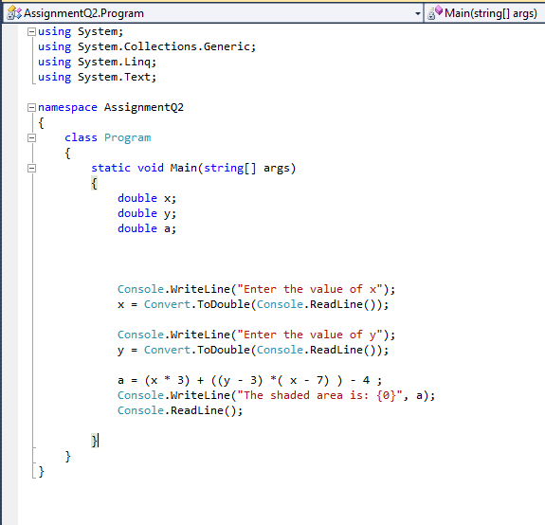

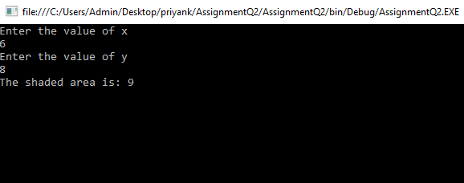

Exercise 3:
Build a fruit machine but representing the 3 reels of symbols by numbers ranging from 0 to 9, randomly chosen each time the player asks to the take another go.
using System;
using System.Collections.Generic;
using System.Linq;
using System.Text;

namespace AssignmentQ3
{
class Program
{
static void Main(string[] args)

{
int a;
int b;
int c;
int score;
int choice;
score = 0;

do
{
Random rnd = new Random();
a = rnd.Next(0, 9 + 1);
b = rnd.Next(0, 9 + 1);
c = rnd.Next(0, 9 + 1);
Console.WriteLine("your number is: {0} {1} {2}", a, b, c);

if (a == b && b == c)
{

if (a == 9)
{
score = score + 2000;

}
else
{
score = score + 15;

}
}
else if ((a == b) || (b == c) || (c == a))
{
if (a == 9 && b == 9 || b == 9 && c == 9 || c == 9 && a == 9)
{
score = score + 200;

}
else
{
score = score + 5;

}

}

else
score = score + 0;

Console.WriteLine("your score is:{0}", score);
Console.ReadLine();

Console.WriteLine("Do you want to continue");
choice = Convert.ToInt32(Console.ReadLine());

} while (choice == 1);

}

}
}

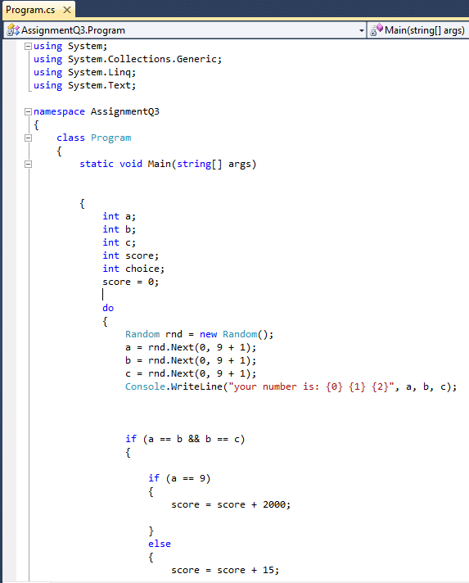

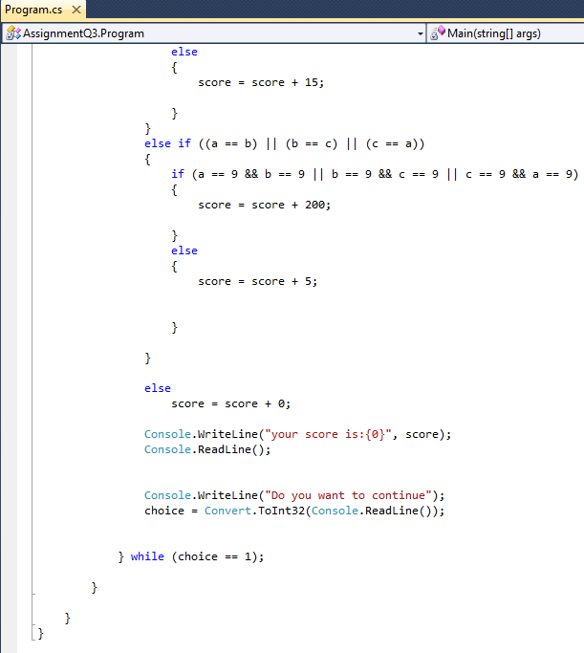

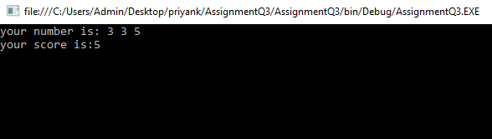
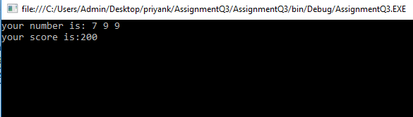

Section 2
Part B (Testing)
In the application provided in the Appendix, there are three problems:
- When choosing an option from the menu, try entering text instead of numbers.
- When the user is asked if they wish to quit, the only input value that can be entered is “YES”. Try other variations e.g. “Yes”, “yes”, “y”.
- Try displaying all the numbers entered.
using System;
using System.Collections.Generic;
using System.Linq;
using System.Text;
using System.Threading.Tasks;
namespace ConsoleApplication1
{
class Program
{
const int MAXNUMBERS = 3;

static void Main(string[] args)
{
int[] theNumbers = new
int[MAXNUMBERS]; int chosenOption = 0;
bool quit = false;
InitialiseNumbers(theNumbers);
while (quit == false)
{
DisplayHeader();
DisplayMenu();
chosenOption = ReadNumber("Please choose an option: ");
quit = ProcessMenu(chosenOption, theNumbers);
Console.Clear();
}
}
static void InitialiseNumbers(int[] numbers)
{
for (int index = 0; index < MAXNUMBERS; index++)
{
numbers[index] = 0;
}
}
static void DisplayHeader()
{
WriteText("*******************************************************************************", 0, 0); // Top left hand corner of screen is x = 0, y = 0;
WriteText("* This application is designed to allow you to choose numbers *", 0, 1); // Next line down is x = 0, y = 1, etc
WriteText("* and finds the biggest and the smallest value *", 0, 2);
WriteText("*******************************************************************************", 0, 3);
}
static void DisplayMenu()
{
WriteText("Select an option", 20, 8); // Display menu at at x = 20, y = 8
WriteText("1. Enter the numbers", 20, 9);
WriteText("2. Find the smallest", 20, 10);
WriteText("3. Find the largest", 20, 11);
WriteText("4. Display all numbers", 20,
12); WriteText("5. Quit", 20, 13);
}
static void WriteText(string text, int x, int y)
{
Console.CursorLeft = x;
Console.CursorTop = y;
Console.Write(text);
}
static int ReadNumber(string prompt)
{
string text;
int number;
WriteText(prompt, 20, 14);
text = Console.ReadLine();
number = int.Parse(text);
ClearText(20, 14, prompt.Length + text.Length); // Clear the text at this line
return number;
}
static void ClearText(int x, int y, int length)
{
// Write space ' ' characters starting at x, y for 'length' times
WriteText(new String(' ', length), x, y);
}
static bool ProcessMenu(int option, int[] numbers)
{
bool quit = false;
switch (option)
{
case 1:
GetNumbers(numbers);
break;
case 2:
WriteText(string.Format("The smallest value is {0}", FindSmallest(numbers)), 20, 15);
Console.ReadKey(); // Pause
break;
case 3:
WriteText(string.Format("The largest value is {0}", FindLargest(numbers)), 20, 15);
Console.ReadKey(); // Pause
break;
case 4:
DisplayNumbers(numbers);

break;
case 5:
quit = IsQuitting();
break;
default:
WriteText("Unknown option value entered", 20, 15);
Console.ReadKey(); // Pause
break;
}
return quit;
}
static void GetNumbers(int[] numbers)
{
for (int index = 0; index < MAXNUMBERS; index++)
{
numbers[index] = ReadNumber("Enter number: ");
}
}
static void DisplayNumbers(int[] numbers)
{
Console.WriteLine("The Numbers Are:");
for (int index = 0; index < MAXNUMBERS; index++)
{

Console.Write(numbers[index] + "\t");
}
Console.ReadKey();
}
static int FindSmallest(int[] numbers)
{
int smallest = numbers[0];
for (int index = 0; index < MAXNUMBERS - 1; index++) // <-- subtract 1
{
if (numbers[index + 1] < smallest)
{
smallest = numbers[index + 1];
}
}
return smallest;
}
static int FindLargest(int[] numbers)
{
int largest = numbers[0];
for (int index = 0; index < MAXNUMBERS - 1; index++) // <-- subtract 1
{
if (numbers[index + 1] > largest)
{
largest = numbers[index + 1];
}
}
return largest;
}
static bool IsQuitting()
{
string response;
bool quit = false;
WriteText("Do you really wish to quit? ", 20,
13); response = Console.ReadLine();
if (response == "YES" )
{
quit = true;
}
else if (response == "yes")
{
quit = true;
}
else if (response == "Yes")
{
quit = true;
}
else if (response == "y")
{
quit = true;
}
return quit;
}

}

}

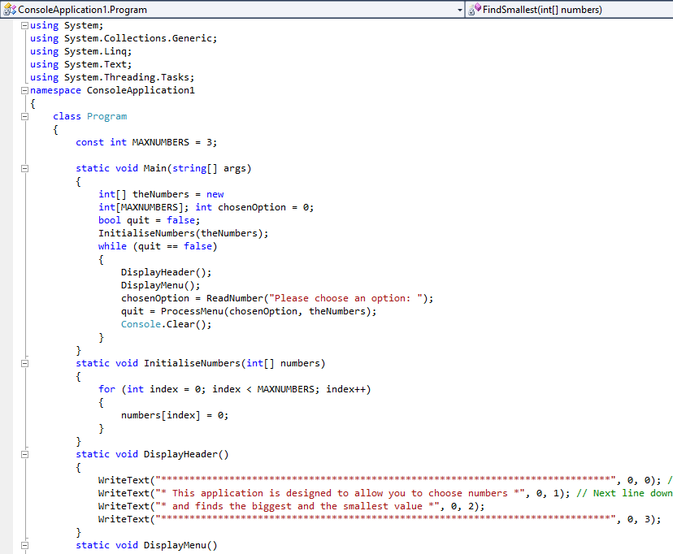

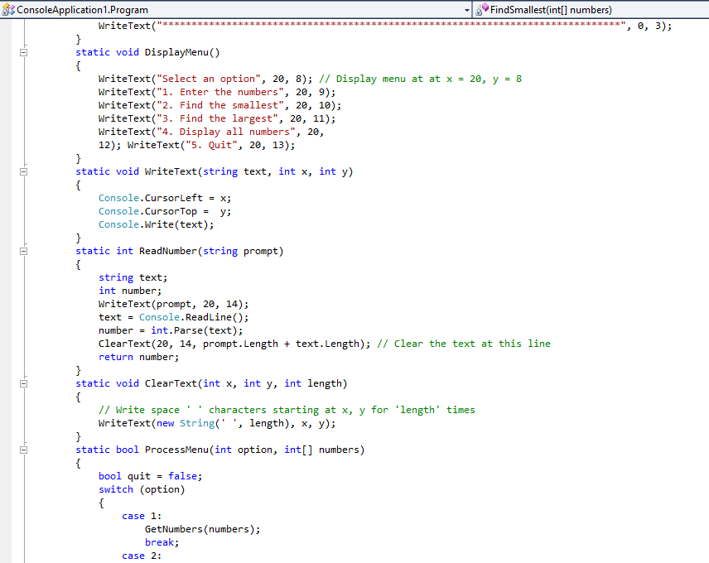

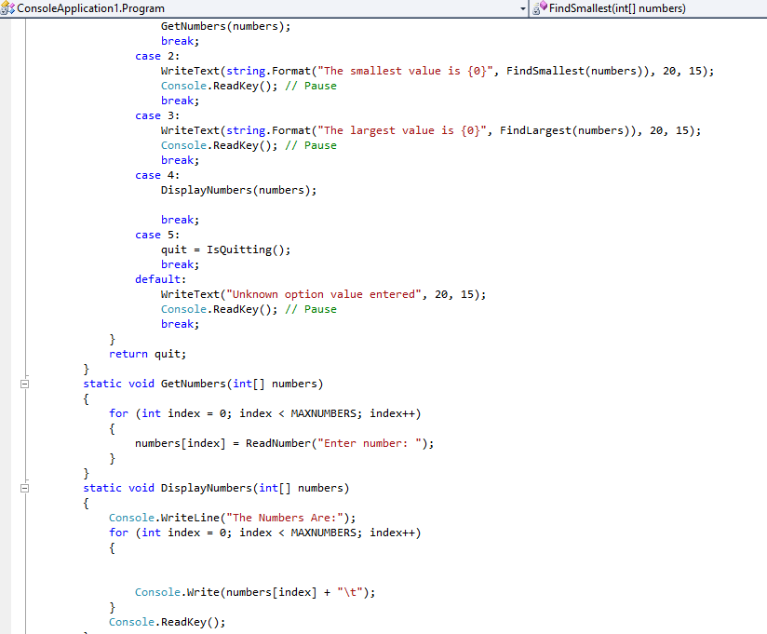

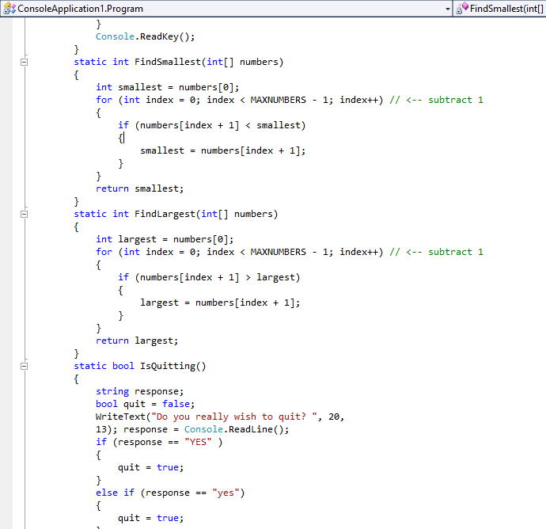

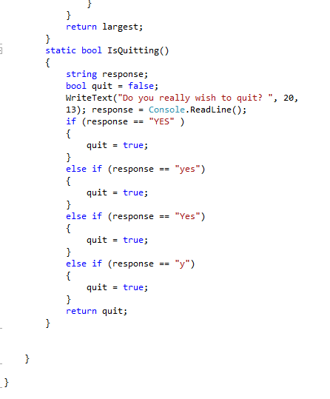

Output:
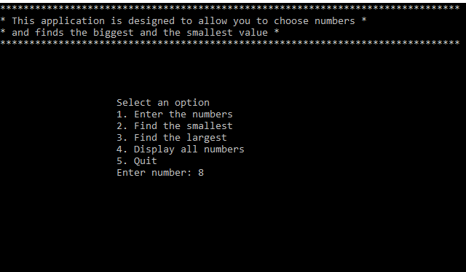

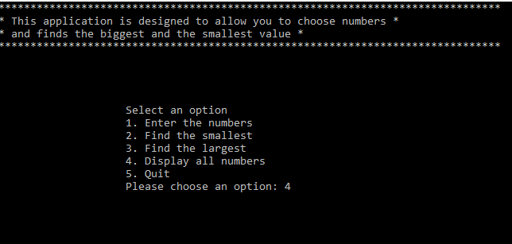

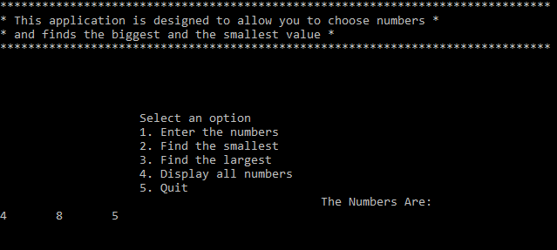

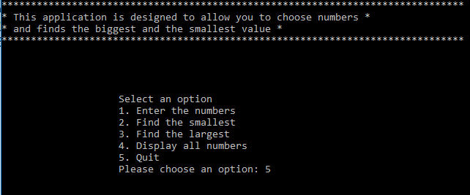

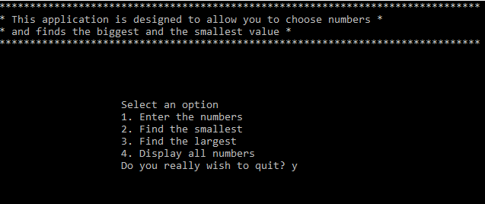

Part c:
Exercise 1:
Ask the user to enter an arbitrary set of numbers into an array and display all the entered numbers.
using System;
using System.Collections.Generic;
using System.Linq;
using System.Text;
namespace ConsoleApplication6
{
class Program
{
static void Main(string[] args)
{
int n;
int j;
Console.WriteLine("Enter the number of elements you want: ");
n = Convert.ToInt32(Console.ReadLine());
int[] i = new int[n];
Console.WriteLine("Enter the numbers: ");
for (j = 0; j < n; j++)
{
i[j] = Convert.ToInt32(Console.ReadLine());
}
for (j = 0; j < n; j++)
{
Console.WriteLine("Element[{0}] = {1}", j, i[j]);
}
Console.ReadLine();

}
}
}

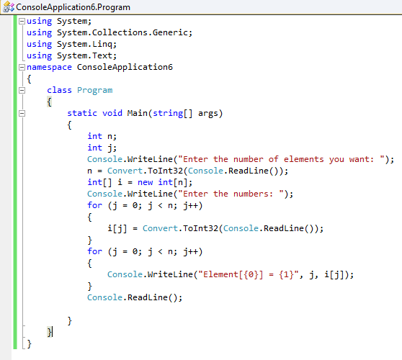

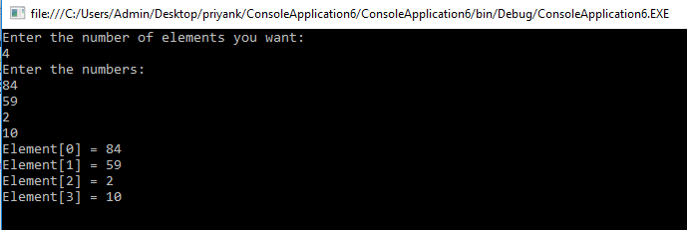

B) Then multiply pairs of numbers together and display the results. If you have an odd number of numbers then just display the last number.
using System;
using System.Collections.Generic;
using System.Linq;
using System.Text;

namespace ArrayMultiplication
{
class Program
{
static void Main(string[] args)
{
int n;
int j;

Console.WriteLine("enter the number of elements you need");
n = Convert.ToInt32(Console.ReadLine());
int[] i = new int[n];
Console.WriteLine("Please enter the numbers");
for (j = 0; j < n; j++)
{
i[j] = Convert.ToInt32(Console.ReadLine());
}
Console.WriteLine("Your Numbers Are:");
for (j = 0; j < n; j++)
{
Console.Write(i[j] + "\t");
}
Console.ReadLine();

int k = i.Length;
Console.WriteLine("Your Output is:");
if (k % 2 == 0)
{
for (j = 0; j < n; j += 2)
{

Console.Write(i[j]*i[j+1] + "\t");
}
}
else
{
for (j = 0; j < n - 1; j += 2)
{
Console.Write(i[j]*i[j+1] + "\t");
}
Console.WriteLine(i[j]);
}

Console.ReadLine();
}

}
}



