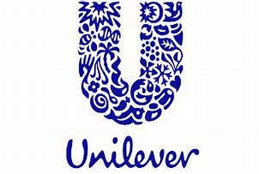 | Strategies for resilience and prosperity Bmsp 6006  Glenn behenna  Natalie Emma Male 1702161  Report

Table of Contents

1.0: Introduction 2
1.1 Company background 3
1.2 Report objectives 4
1.3 Competitive strategy 4
2.0: Main Findings 6
2.1 Organisations strategy 6
2.2 Detailed strategy analysis 7
3.0: Conclusion 13
References 13

Executive summary

This report has been undertaken to identify and analyse strategic management practises. The organisation Unilever Plc has been selected as a company of interest in this field. They represent an appropriate example, due to the size and scope of their operations and business model.

1.0: Introduction

Strategy and Strategic management.
There are many theorist views to describe strategy. (Johnson, Scholes, & Whittington, 2007) state that “Strategy is the direction and scope of an organisation over the long term, which achieves advantage in a changing environment through its configuration of resources and competences with the aim of fulfilling stakeholder expectations”
( Phillips, 2011) suggests that “Strategy is very simple. It’s about what and why, not how or by when”. Although this may not offer the most sophisticated or technical description, it does however simplify the subject of strategy.
Henry Mintzberg views strategy as an emergent process, that strategies change over time. It could be considered that Mintzberg’s theory may be more relevant today. Whereas Porter argues that the need for strategy is about defining and communicating to achieve a unique position, thus gaining a competitive advantage. Porter offers a more traditional approach to strategic management.
Implementation is how the plan will be carried out. This is the point where many businesses will fail, it is important to note that strategy and implementation are two separate entities. Essentially it is how the activities are performed that is the essence of strategy. If not, strategy becomes little more than a marketing phrase. (Porter M. E., 1996)
Strategic management is an important tool in the success or failure of an organisation. “Strategy is also the test of the theory of the Business. Failure of the strategy to produce the expected results is usually the first serious indication that the Theory of the Business needs to be thought through again”. (Drucker, 2012)
(Gongmin, 2015) insists that theorists and practitioners in strategic management require new scientific theories. In the modern unstable environment, strategic management and its research can no longer satisfy the practical, development or theoretic needs of strategic management.
(Lynch, 2018) purports that “Strategic management is exciting and challenging. It makes fundamental decisions about the future direction of an organisation, its purpose, its resources and how it interacts in the world in which it operates. The views above offer a developmental view, acknowledging the changing and uncertain elements to consider in strategic management.

Company background

Lever brothers was established by William Hesketh Lever. He developed his idea for sunlight soap in the 1890’s. This revolutionary product would popularise hygiene and cleanliness in the Victorian era. Their message, to assist to make women’s work easier, a pioneering viewpoint in Victorian England. Fast forward to today and the organisation, now called Unilever PLC, is a multi-national organisation. Concentrating mainly on food and beverages, laundry, and cleaning products. Despite the corona virus pandemic the company has seen growth in the first half of 2020 “ The Anglo-Dutch multisector retailer--which owns consumer brands such as Ben & Jerry's ice cream and Dove soap--made a net profit for the six months of 3.28 billion euros ($3.80 billion), compared with EUR3.01 billion in the year-earlier period”. (Castia, 2020)
Despite its proven track record in retail, Unilever has had a series of corporate social responsibility issues within the last decade. This is possibly due to developments in technology and social media platforms. According to Forbes in 2016 the company settled a lawsuit with 600 Indian workers regarding their exposure to mercury. ( Borelli, 2017) Following a number of controversies, a change in strategy was implemented, to increase CSR, sustainability and ethics. (Our strategy, 2020) states that “A belief that sustainable business drives superior performance lies at the heart of the Unilever Compass – our strategy to create long-term value for our stakeholders”.
Their vision appears to have remained similar to when the company was first established. (Alan Jope , 2020) CEO purports that “I intend to build further on Unilever’s century-old commitment to responsible business. It is not about putting purpose ahead of profits, it is purpose that drives profits. A timeline of the company can be seen in Image 1
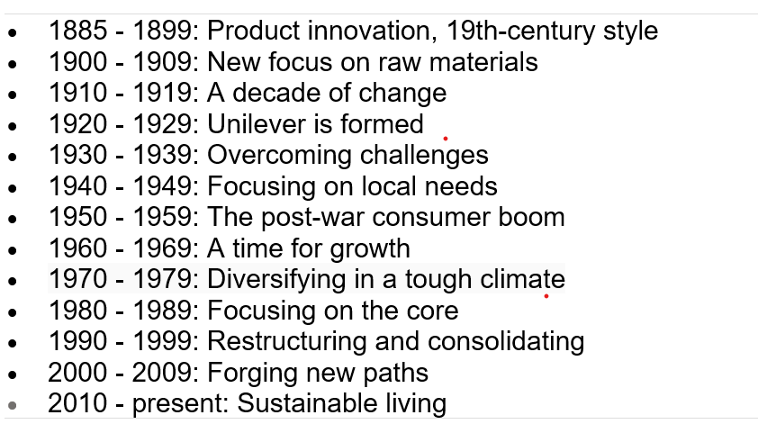
Image 1 (Our History, 2020)

Report objectives

The aim of this report is to ascertain the strategic management approach of Unilever. Utilising appropriate relevant literature, theoretical models, and frameworks. The report will seek to determine what the organisations business model seeks to achieve, and their future objectives.

1.3 Competitive strategy

Unilever is positioned in highly competitive and saturated market. There are numerous companies who offer similar products, covering both food, beauty, and domestic products. Their main competitors are Proctor and Gamble and Colgate Palmolive. What sets Unilever apart is unique selling point and a high degree of sustainable practises, which the public is becoming to demand from organisations. Unilever have set a clear differentiation with its products, mission, vision, and objectives. (Porter M. E., 1996) proposes that “Competitive strategy is about being different. It means deliberately choosing a different set of activities to deliver a unique mix.
The organisation’s strategy encompasses many elements, with sustainable practises running through their business model. Long term strategies have been developed to add value to shareholders. There is an emphasis on profitable and responsible growth. (Hill, Jones, & Schilling, 2014) describe a business model as “The conception of how strategies should work together as a whole to enable the company to achieve competitive advantage”. An example of the organisations long-term strategic direction:
Portfolio choices | Brands and innovation | Market development | Agility and cost | People
Category  choices | A focused approach to innovation | Routes to market | Zero-based budgeting | Attracting talent
Active portfolio management | Driving efficiency and margins | Emerging markets | Manufacturing base and overheads | Developing talent
Building a Prestige business | Increased investment in digital marketing | E-commerce | Leveraging scale | Values-led and empowered

(Our strategy, 2020)

It would appear that part of the organisation’s success is that it has a clear and detailed competitive strategy. This enables the ability to constantly assess and adapt to future changes. Achieving a stance of competitive advantage and intensifying performance comparable to its competitors. Are two important objectives an organisation should strive to attain, equalling that of their rivals. (Dirisu, Iyiola, & Ibidunni, 2013)

2.0: Main Findings

The organisation has a comprehensive wealth of information on their website and academic material. However, the main attribute that is apparent appears to be strategic planning and sustainability. The findings of the analysis are displayed and critically analysed as follows:
2.1 Organisations strategy
A key part of business strategy is developing Mission, value, and vision statements. A mission statement explains how the organisation will achieve its vision. A vision statement describes where the organisation wants to be in the future. “Our vision is to grow our business, while decoupling our environmental footprint from our growth and increasing our positive social impact”. (who we are, 2020)
A value statement describes the ethos and ethics. It outlines the behaviour expected of those who interact with the organisation. “Our Corporate Purpose states that to succeed requires the highest standards of corporate behaviour towards everyone we work with, the communities we touch, and the environment on which we have an impact." (who we are, 2020)
The importance of the clear strategic vision will assist in selection of the most appropriate strategic management plan and tools. (Joachim, 2020) agrees that “There are compelling reasons for organisation to develop strategic vision. It stimulates organisations mission and challenge employees. In addition, corporate mission statements which are fundamental unique purpose that differentiates a firm, sets the organisational context for strategic decisions”. It appears that the organisation has a strong sense of purpose and direction.
The organisation puts a lot of emphasis on sustainable living, this appears to be the main strategic focus. Believing that profitable growth should also be responsible. “We believe that sustainable business drives superior performance and that this is the only way to create long-term value for all our stakeholders”. (Our strategy, 2020) It is possible that due to previous negative exposure in the media this new direction was likely emergent. Strategy in nature has many variables it is partly planned and partly reactive.
(Baldassarre et al; 2017) argues that “The core of a sustainable business model is a sustainable value proposition; namely, a value proposition that allows multiple-stakeholder value creation by considering the needs of customers, shareholders, suppliers and partners as well as the environment and society”. The organisation also appears to appreciate the value of human capital. Without a strong culture the organisation will not be successful. Indeed (Beardwell, 2017) suggests that “Attention to human resource development also plays a key role in attracting and retaining talent and ought to be a critical pillar of the HR strategy in organisations operating in the public, private and non for profit sectors”.
Unilever has developed a strategic management approach that encompasses sustainability, corporate social responsibly and ethical considerations. Sustainability can also increase profitability in the long-term This creates value for all stakeholders and society. The benefit is that the organisation is that they are better equipped to deal with environmental, Social, and economic changes “From the start of the Covid-19 crisis, we have been guided by clear priorities in line with our multi-stakeholder business model to protect our people, safeguard supply, respond to new patterns of consumer demand, preserve cash and support our communities. “ (Unilever, 2020)

2.2 Detailed strategy analysis
Swot and pest analysis , Unilever October 2020
STRENGHTS | WEAKNESSES
1. Human capital- Staff knowledge, experience, value, large volume of expertise  2. Size and proven history of the organisation  3. Operates in a large geographical market with a  high degree of sustainability and ethics | 1. High operational costs  2. Changing customer requirements  3. Prices are usually higher
OPPERTUNITIES | THREATS
1. Further research and development into products, particularly cleaning products due to Covid 19  2. Diversifying their food products into the health food market  3. Social media marketing | 1. Fluctuating economy  2. Strong competition  3. Large proportion of products are premium brands

Political | Economic
1. Impact of Covid-19 and unpredictable changes in government policy  2. Volatile emerging markets and uncertain trade agreements  3. Subject to regulations and laws in different countries | 1. Economic recession due to lockdown restrictions  2. Reduced customer wealth due to furlough and loss of jobs  3. Currency exchange rates
Social | Technology
1. Age demographics  2. Lifestyle preferences  3. Population growth | 1. High level of automation  2. Advance technologies mean products can be copied by competitors  3. Development of E-commerce and marketing

The swot and pest analysis highlights that there are several areas of consideration. The company employs a large compliment of staff globally. The fluctuating economy and strong market competition could be a cause for concern in the future. Ensuring future profits, sustainability, and employment will be challenging. New government legislation due to Covid-19 will undoubtedly bring new challenges moving forward.
Swot and Pest analysis identifies potential threats, this helps to reduce impact. Clearly determines strengths and highlights weaknesses and areas for improvement. The model provided the structure to conduct and analysis, although this is dependent on imputing all the relevant information. It has the potential to lead individuals down the wrong path and conclusion. Hierarchy is also a consideration as to what area to concentrate on first.

Bowmans strategy clock was developed by economists, Bowman and Faulkner. This marketing models aim is to assist organisations to determine and analyse their market position, in comparison to their competitors. The clock has two dimensions price and perceived value of products and services. The clock is divided into eight potential strategies that can be adopted. This enables organisation to evaluate and analyse their current strategy therefore potentially improving market position. Unilever’s position on the clock is displayed in image 2.
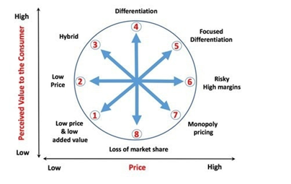
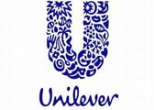

Image 2 (Bhasin, 2019)
Bowmans clock is a useful model in determining market position. Although, it is dependent on the input and interpretation of the individual conducting the analysis. Points 6,7 and 8 provide little opportunity in the competitive marketplace.
Unilever utilises broad differentiation as its collective strategy. This both ties into Porters generic strategy and Bowmans clock. Differentiation concentrates on features and characteristics, making products stand out from the competition. (Porter, 1985) argues that “A firm that can achieve and sustain differentiation will be an above-average performer in its industry if its price premium exceeds the extra costs incurred in being unique”.
For example, one of their beauty products is Dove soap, despite the high cost it stands out from other products due to the fact it concentrates on moisturising. Other products focus on cleaning and could be considered harsh or drying. This gives Unilever a unique selling point, addressing both price and perceived value for the customer

Power and interest matrix
This matrix assists organisations to understand, prioritise and manage stakeholders, it determines the level of power and interest. Some stakeholders will hold more power, whilst some will hold more interest. (Freeman, 2001) states that “The central task in this process is to manage and integrate the relationships and interests of shareholders, employees, customers, suppliers, communities, and other groups in a way that ensures the long-term success of the firm”.

High Level of interest Low
High

Level of power

Low

Keep satisfied  . Stakeholders  . Government  . Suppliers  . Finance  . Legal department | Manage Closely  . Key shareholders  . Directors/executives  . Competitors
Monitor (Minimum effort)  . Media  . Customers | Keep Informed  . Research and development  . Employees  . Marketing

The matrix above is an analysis of Unilever’s stakeholders and their level of power and interest. Key stakeholders hold a high level of power and interest, whereas media and customers have a low level of power and require minimum effort.
Mendelow’s stakeholder analysis assists to identify the most powerful stakeholders. This enables shaping the project at the early stages. A good example of stakeholder analysis will recognise how people react to project changes. Thus, acts as a guide to assist in managing difficult shareholders.
However, the analysis needs to be performed frequently or continuously, since stakeholders’ power and interest may quickly alter. Like Bowman’s clock the analysis is open to individual interpretation. The model does not show attitude, for example if a stakeholder is opposed to the proposed strategy.

3.0: Conclusion

Unilever is an organisation that has adapted and progressed over more than a century. Their strengths are that they have had to overcome many societal and economic changes. Despite some controversial issues they have managed to come back in a strong position, honouring the original ethos of the company whilst responding to change. Their ability to adapt and utilise strategic management techniques has no doubt assisted in its longevity. The organisation recognises the importance of human capital in its operations. In the light of Covid 19 and the economic downturn there may be challenges ahead. There will likely be considerations with regard to employment if product demand decreases. Use of appropriate strategic management techniques and forward planning, will no doubt be essential in this turbulent environment

References

Borelli, T. (2017, March 15th). Unilever And The Failure Of Corporate Social Responsibility. Retrieved October 15th, 2020, from Forbes: https://www.forbes.com/sites/econostats/2017/03/15/unilever-and-the-failure-of-corporate-social-responsibility/#b056274498d2
Phillips, L. D. (2011). What is strategy ? The Journal of the Operational Research Society, 62(5), 926-929.
Alan Jope . (2020, October 12th). About Unilever. Retrieved from Unilever : https://www.unilever.com/about/who-we-are/about-Unilever/
Baldassarre, B., Calabretta, G., Bocken, N., & Jaskiewicz, T. (2017). Bridging sustainable business model innovation and user-driven innovation. Journal of Cleaner Production, 175-186. Retrieved October 16th, 2020
Beardwell, J. (2017). Human resource management A contemporary approach. London: Pearson Education.
Bhasin, H. (2019, April 17th). What is Bowman’s Strategy Clock? Retrieved October 13th, 2020, from Markettin 91: https://www.marketing91.com/what-is-bowmans-strategy-clock/
Castia, M. (2020, July 23rd). Unilever profit climbs in first half. Retrieved October 16th, 2020, from Market watch: https://www.marketwatch.com/story/unilever-profit-climbs-in-first-half-2020-07-23
Dirisu, J. I., Iyiola, O., & Ibidunni, O. S. (2013, December). Product differentation: A tool of competitive advantage and optimal organizational performance (A study of Unilever Nigeria PLC). European Scientific Journal, 9(34), 258-281.
Drucker, P. (2012). Management chalenges for the 21st century. London: Butterworth-Heinemann.
Freeman, R. E. (2001). A stakeholder approach to strategic management. . Virginia: Darden Graduate School of Business Administration .
Gongmin, B. (2015). What theories are used for strategic management. Nankai business review international, 6(4). Retrieved October 16th , 2020
Hill, C. W., Jones, G. R., & Schilling, M. A. (2014). Strategic management theory: An intergrated approach. USA: Cengage learning .
Joachim, A. (2020, April). Interface between Corporate Vision, Mission and production and opperations management. Global Journal of Management and Business Research, 10(2), 18-22.
Johnson, G., Scholes, K., & Whittington, R. (2007). Exploring corporate strategy. London: Pearson Prentice Hall.
Lynch, R. (2018). Strategic management (8th ed.). London: Pearson.
Our History. (2020, October 13th). Retrieved from Unilver.co.uk: https://www.unilever.co.uk/about/who-we-are/our-history/
Our strategy. (2020, October 15th). Retrieved from Unilever : https://www.unilever.com/about/who-we-are/our-strategy/
Porter, M. (1985). Competitive advantage. New York: The Free Press.
Porter, M. E. (1996). What is strategy. Harvard Business Review, 61-78.
Unilever. (2020, July 23rd). Half-year results: performance reflects agility and resilience of the business. Retrieved October 16th, 2020, from Unilever: https://www.unilever.com/news/press-releases/2020/half-year-results-performance-reflects-agility-and-resilience-of-the-business.html
who we are. (2020, October 16th). Retrieved from Unilever: https://www.unilever.co.uk/about/who-we-are/

