Student Name: Lloyd Pennington
Course Name: Business Information Technologies
Module: Business Information Technologies
Assignment Name: Data warehouse build / Data Governance: Part 1
Assignment Deadline: 17/05/2019

Contents
Cleaning Data 3
ETL Plan – UKAEA Transactions Data Warehouse – Orders Star – Initial Build 4
Source Systems 4
Dimensions 6
Fact 7
Database to data warehouse table mapping: 7
InvoiceFact 7
DepartmentDim 8
ProductFamilyDim 8
Supplier 8
PayDateDim 9
Entity 9
ExpenseArea 9
TransactionNumberDim 9
MInvoices 10
AInvoice 10
DataSources 11
TablesAttributes 11
Users 11
Reports 12
Expense Area 12
Expense Type 13
Supplier 14

ETL Process

Cleaning Data
With any data there will be errors, in this case there were three errors in all the different excel documents. There was one error in the April document, there were no errors in the May document and there was a final error in the June document.
The error in the April document was that there was a February entry entered – 27/02/2018. This piece of data was deleted from the document as it was not able to be slotted in any other table, and therefore the best solution for this issue was for the record to be deleted. The main reason as to why this record was placed in this document was mainly due to the fact that that record was lost in transaction.
Figure 1 shows the exampled error input.

Figure 1
The workbook for May 2018, as previously mentioned, had no errors apart from the one error that was in all the documents. This error was nothing to do with the actual data but more to do with the headings of the data columns. The error was that there was a space on the left of NetAmount title and this caused issues when trying to implement the data into the Microsoft Access database. The solution for fixing this problem was to erase the space – this fixed the issue and the data was successfully implemented within the Microsoft Access database.
Figure 2 shows the highlighted title with the 2 extra characters on either side of the title.

Figure 2
The June 2018 document needed cleaning; in this case it was to do with the missing data from the workbook, as is shown in figure 3, with the solution being implemented in figure 4. As figure 3 shows there was a lot of missing data, so instead of implementing a text based solution, i.e. adding “unknown” to the columns, the option was to remove the “data” entirely, as there was no data in the extended rows.
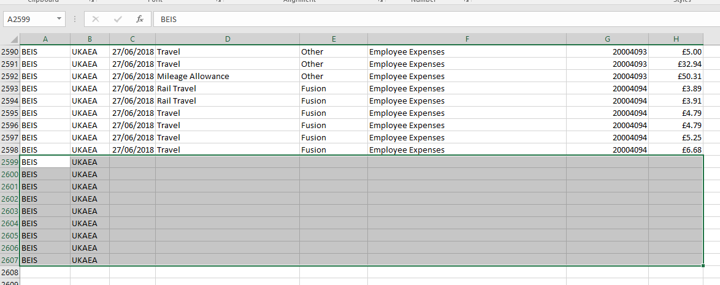
Figure 3
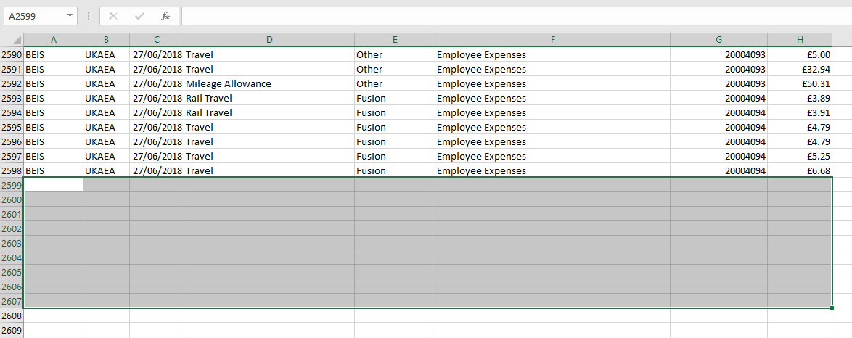
Figure 4

ETL Plan – UKAEA Transactions Data Warehouse – Orders Star – Initial Build

Source Systems
The source systems for this database were the three Microsoft Office Excel documents that can be found online. Within the three Excel Documents there are records for April 2018, May 2018 and June 2018 – these being the, said, three Excel Documents.
April
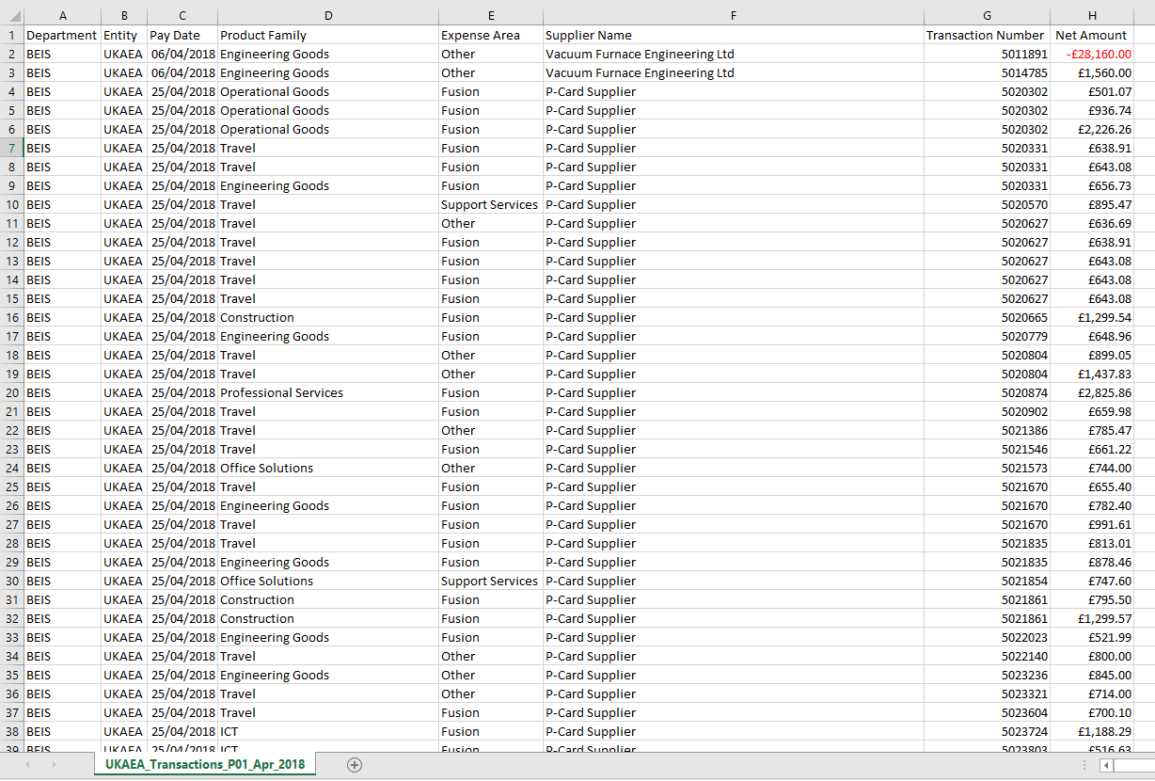
May
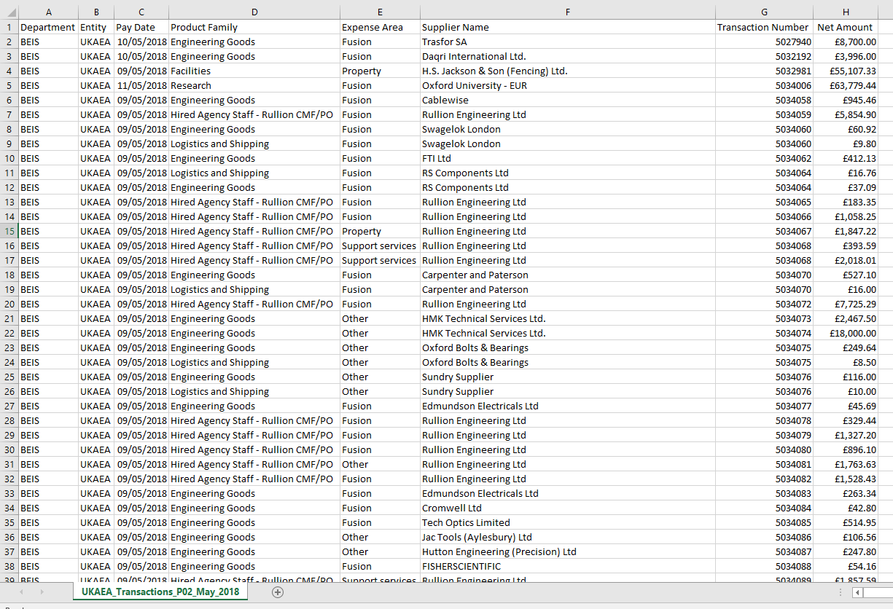

June
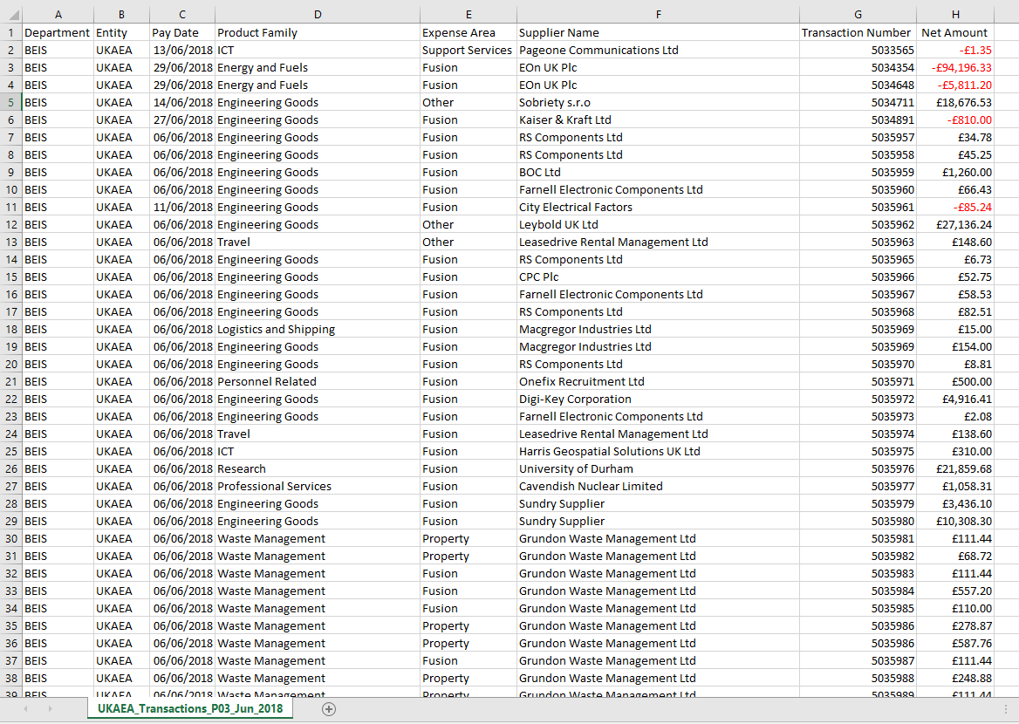

These are stored as an Access database with separate tables for each table shown on the schema.
The new design for the data warehouse UKAEA Transactions schema is:
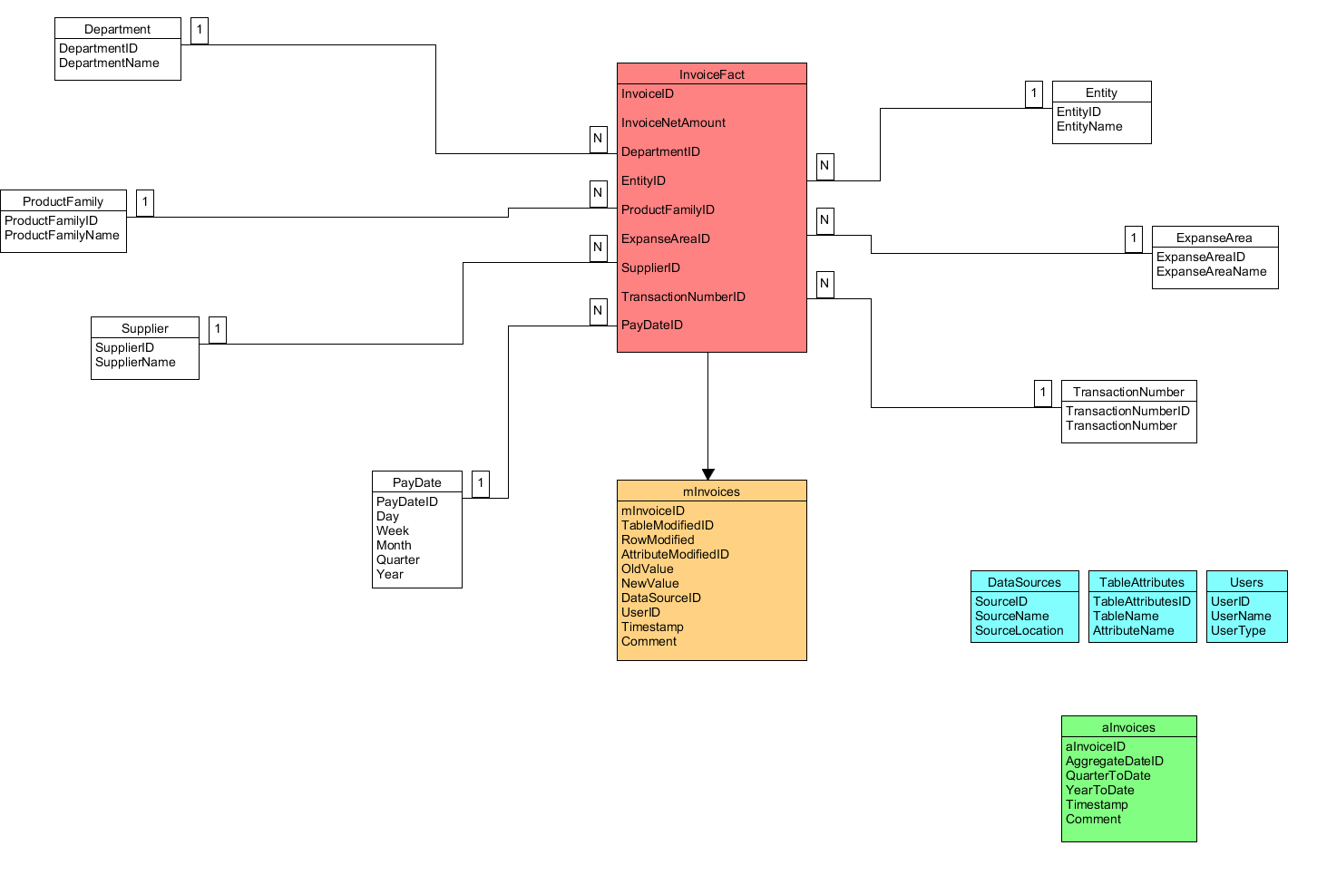
Figure 5 shows the Star Schema that was designed, this shows the various tables and what information will be stored within them all. Starting off with the Fact table, there is the invoiceFact table.

Dimensions
The dimensions of the new Access database were chosen as these were the headings in the three excel documents. All the headings where the user would not need to manually need to insert their information would be dimensions, while any other headings would be facts.
The dimensions have duplications and therefore will be better suited within a drop down box, rather than the user needing to type in each field this, as previously mentioned, would make these headings dimensions over facts.
All three Excel documents had the same headings and therefore made it easy when transferring the data over to the Access database. The following headings are the dimension tables and these headings are;
- Department
- Entity
- ProductFamily
- ExpenseArea
- Supplier
- TransactionNumber
- PayDate

Fact
The last heading is called NetAmount and, as the user would enter the information regarding this field; this heading would be categorised as a fact table.

Database to data warehouse table mapping:
DATABASE TABLES | DATA WAREHOUSE TABLE
Comes from Spreadsheet | InvoiceFact
DB.Department | DepartmentDim
DB.Entity | EntityDim
DB.ProductFamily | ProductFamily
DB.ExpenseArea | ExpenseAreaDim
DB.Supplier | SupplierDim
DB.TransactionNumber | TransactionNumberDim
DB.PayDate | PayDateDim
DB.Department; DB.Entity; DB.ProductFamily, DB.ExpenseArea, DB.Supplier, DB.TransactionNumber, | ME_Meta
Not Applicable – This table needs to be generated from Fact | A_Aggregate
Not Applicable – This table needs to be generated from scratch | MA_Users

InvoiceFact
TARGET ATTRIBUTE | SOURCE(S) | PROCESSING REQUIRED | MISSING VALUE? | INCORRECT VALUE?
InvoiceID | Generated | Primary Key - None | Shouldn’t happen | Refer to staff
DepartmentFamilyID | DB.DepartmentFamily | Link to DepartmentFamilyDim | Set to “Unknown” value | Refer to staff
EntityID | DB.Entity | Link to EntityDim | Set to “Unknown” value | Refer to staff
PayDateID | Generated | Link to PayDateDim | Shouldn’t happen | Refer to staff
ExpenseTypeID | DB.ExpenseType | Link to ExpenseTypeDim | Set to “Unknown” value | Refer to staff
ExpenseAreaID | DB.ExpenseArea | Link to ExpenseAreaDim | Set to “Unknown” value | Refer to staff
SupplierID | DB.Supplier | Link to SupplierDim | Set to “Unknown” value | Refer to staff
TransactionNumberID | DB.TransactionNumber | Link to TransactionNumberDim | Set to “Unknown” value | Refer to staff
ContractNumberID | DB.ContactNumber | Link to ContactNumberDim | Set to “Unknown” value | Refer to staff
ExpenditureTypeID | DB.ExpenditureType | Link to ExpenditureTypeDim | Set to “Unknown” value | Refer to staff
Description | Generated / User type | None | None | None

DepartmentDim
TARGET ATTRIBUTE | SOURCE(S) | PROCESSING REQUIRED | MISSING VALUE? | INCORRECT VALUE?
DepartmentID | Generated | Primary Key - None | Shouldn’t happen | Refer to staff
DepartmentName | DB.Department | None | Refer to Staff | Refer to staff

ProductFamilyDim
TARGET ATTRIBUTE | SOURCE(S) | PROCESSING REQUIRED | MISSING VALUE? | INCORRECT VALUE?
ProductFamilyID | Generated | Primary Key - None | Shouldn’t happen | Refer to staff
ProductFamilyName | DB.ProductFamily | None | Refer to staff | Refer to staff

Supplier
TARGET ATTRIBUTE | SOURCE(S) | PROCESSING REQUIRED | MISSING VALUE? | INCORRECT VALUE?
SupplierID | Generated | Primary Key - None | Shouldn’t happen | Refer to staff
SupplierName | DB.Supplier | None | Refer to staff | Refer to staff

PayDateDim
TARGET ATTRIBUTE | SOURCE(S) | PROCESSING REQUIRED | MISSING VALUE? | INCORRECT VALUE?
PayDateID | Generated | Primary Key - None | Shouldn’t happen | Refer to staff
Day | DB.PayDate/Generated | None | Shouldn’t happen | Refer to staff
Week | DB.PayDate/Generated | None | Shouldn’t happen | Refer to staff
Month | DB.PayDate/Generated | None | Shouldn’t happen | Refer to staff
Quarter | DB.PayDate/Generated | None | Shouldn’t happen | Refer to staff
Year | DB.PayDate/Generated | None | Shouldn’t happen | Refer to staff

Entity
TARGET ATTRIBUTE | SOURCE(S) | PROCESSING REQUIRED | MISSING VALUE? | INCORRECT VALUE?
EntityID | Generated | Primary Key - None | Shouldn’t happen | Refer to staff
EntityName | DB.Entity | None | Refer to staff | Refer to staff

ExpenseArea
TARGET ATTRIBUTE | SOURCE(S) | PROCESSING REQUIRED | MISSING VALUE? | INCORRECT VALUE?
ExpenseAreaID | Generated | Primary Key - None | Shouldn’t happen | Refer to staff
ExpenseAreaName | DB.ExpenseArea | None | Refer to staff | Refer to staff

TransactionNumberDim
TARGET ATTRIBUTE | SOURCE(S) | PROCESSING REQUIRED | MISSING VALUE? | INCORRECT VALUE?
TransactionNumberID | Generated | Primary Key - None | Shouldn’t happen | Refer to staff
TransactionNumberName | DB.TransactionNumber | None | Refer to staff | Refer to staff

MInvoices
TARGET ATTRIBUTE | SOURCE(S) | PROCESSING REQUIRED | MISSING VALUE? | INCORRECT VALUE?
MInvoicesID | Generated | Primary Key - None | Generated | Refer to staff
TableModifiedID | DB.OrderDetails | Update | Generated | Refer to staff
RowModified | Row Name | Update | Shouldn’t happen | Refer to staff
AttributesModifiedID | Table Name | Update | Shouldn’t happen | Refer to staff
OldValue | Generated | Update | Shouldn’t happen | Refer to staff
NewValue | Generated | Update | Shouldn’t happen | Refer to staff
DataSourceID | Generated | Update | Shouldn’t happen | Refer to staff
UserID | Generated | Update | Shouldn’t happen | Refer to staff
Timestamp | Current Time | Update | Shouldn’t happen | Refer to staff
Comment | Generated | Update | Shouldn’t happen | Refer to staff

AInvoice
TARGET ATTRIBUTE | SOURCE(S) | PROCESSING REQUIRED | MISSING VALUE? | INCORRECT VALUE?
AInvoiceID | Generated | Generated | Shouldn’t happen | Refer to staff
AggregateDataID | Generated | Generated | Shouldn’t happen | Refer to staff
QuarterToDate | Generated | Generated | Shouldn’t happen | Refer to staff
YearToDate | Generated | Generated | Shouldn’t happen | Refer to staff
Timestamp | Generated | Generated | Generated | Refer to staff
Comment | Generated | Generated | Shouldn’t happen | Refer to staff

DataSources
TARGET ATTRIBUTE | SOURCE(S) | PROCESSING REQUIRED | MISSING VALUE? | INCORRECT VALUE?
SourceID | DataSources | None | Generated | Refer to staff
SourceName | DataSources | None | Generated | Refer to staff
SourceLocation | DataSources | None | Generated | Refer to staff

TablesAttributes
TARGET ATTRIBUTE | SOURCE(S) | PROCESSING REQUIRED | MISSING VALUE? | INCORRECT VALUE?
TableAttributesID | TableAttributes | None | Generated | Refer to staff
TableName | TableAttributes | None | Generated | Refer to staff
AttributesName | TableAttributes | None | Generated | Refer to staff

Users
TARGET ATTRIBUTE | SOURCE(S) | PROCESSING REQUIRED | MISSING VALUE? | INCORRECT VALUE?
UserID | User | None | Generated | Refer to staff
UserName | User | None | Generated | Refer to staff
UserType | User | None | Generated | Refer to staff

Reports
There main report design that was implemented was to have a category, i.e. Expense Area, and then with a descending NetAmount total cross referenced with the PayMonth and PayQuarter. An example would be this;

Expense Area
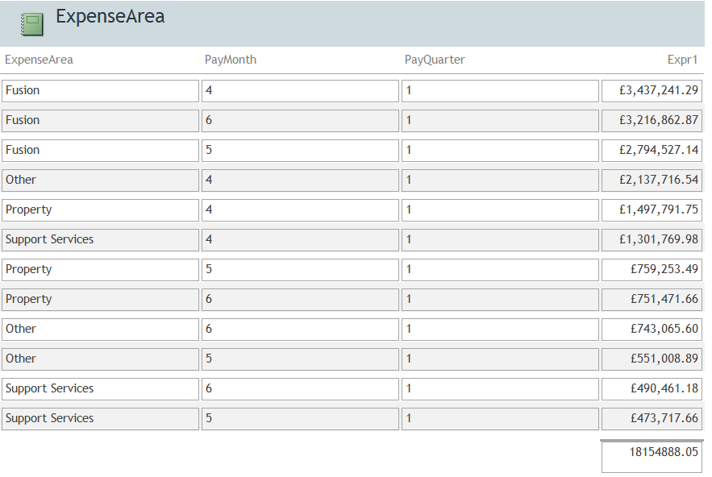
Figure 6 shows the Expense Area report.
The information being understood from this report shows that the top Expense Area in total is Fusion during the month of April, followed by Fusion, again, for the next two spots – the second spot for June and the third for May.
The top four expense areas were, in order, Fusion, Other, Property and Support Services. This is shown by the amount of net amount each expense area cost over the quarter. For the month of April the most costly expense area was Fusion. For the month of May the most costly expense area was also Fusion. Finally, for the final month of June, the most costly expense area was also Fusion.

Expense Type
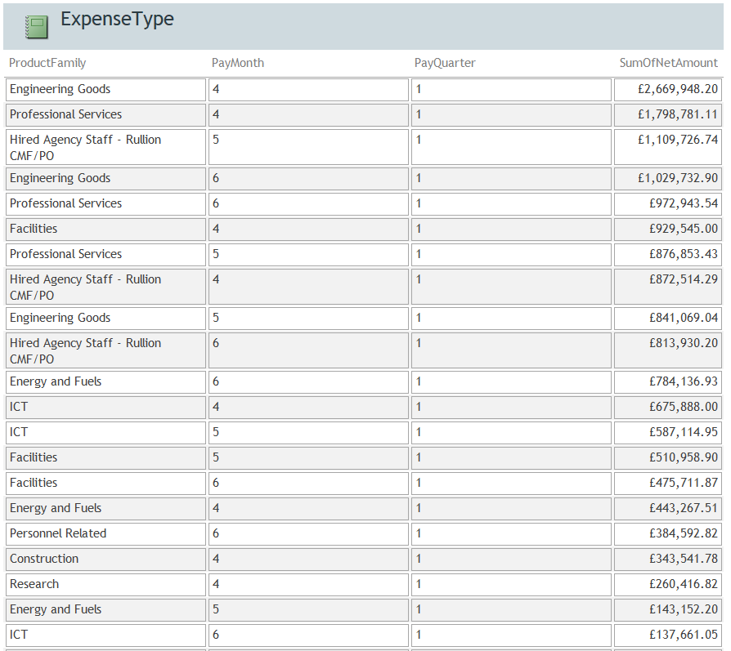
Figure 7 shows the Expense Type report.
The information being understood from this report shows that the top expense type in total is Engineering Goods during the month of April, followed by Professional Services for the second spot, also in April, with Hired Agency Staff – Rultion CM/PO for the third most costly expense type
The top four expense areas were, in order, Engineering Goods, Professional Services, Hired Agency Staff – Rultion CM/PO and, finally, Facilities. This is shown by the amount of net amount each expense area cost over the quarter.
For the month of April, the most costly expense type was Engineering Goods, followed by professional services, Facilities, Hired Agency Staff – Rultion CM/PO and then ICT.
For the month of May the most costly expense type was Hired Agency Staff – Rultion CM/PO, professional services, Engineering Goods, ICT and then Energy and Fuels.
For the month of June the most costly expense type was the Engineering Goods followed by the professional services, Hired Agency Staff – Rultion CM/PO, Energy and fuels and then, finally facilities.

Supplier
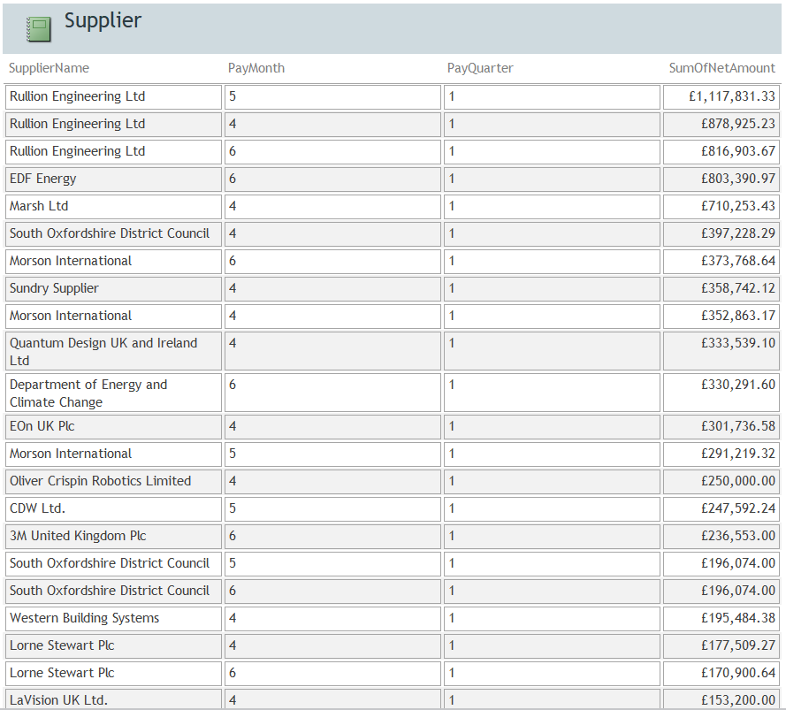
Figure 8 shows the supplier report.
The information being understood from this report shows that the top supplier is Rultion Engineering LTD for all months; April, May and June.
The top five suppliers were, in order, Rultion Engineering LTD, EDF Energy, Marsh LTD, South Oxfordshire District Council and finally, Morson International. This is shown by the amount of net amount each supplier over the quarter.
For the month of April, the most costly expense type was Rultion Engineering LTD, followed by Marsh LTD, South Oxfordshire District Council, Sundry Supplier and then, finally, Morson International.
For the month of May the most costly supplier was Rultion Engineering LTD, Morson International, CDW ltd and finally, South Oxfordshire District Council.
For the month of June the most costly supplier was Rultion Engineering LTD, EDF Energy, Morson International, Department of Energy and Climate Change, 3M United Kingdom PLC and, finally, South Oxfordshire District Council.

