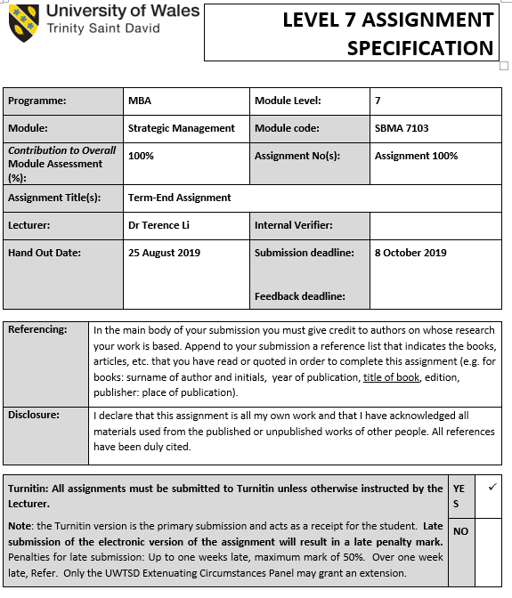

Table of Contents

Part 1 E-Sprit Company status page

1 Introduction 4
1.1 Esprit Company background and Esprit company structure

(Strategy formulation)
2 Vision and mission statement 4

3 External audits 4
3.1 Nature of an External audit for E-Sprit
3.2 Competitive force that affect E-Sprit
3.3 Porter’s five-force model for E-Sprit
3.4 Key success factors for E-Sprit

4 Internal audits 11
4.1 Nature of an internal audit for E-Sprit
4.2 Management audit for E-Sprit
4.3 Marketing audit for E-Sprit
4.4 Finance and accounting audit for E-Sprit
4.5 Production and operation audit for E-Sprit

Part 2 Recommendations for E-Sprit

5 Long term objectives 13
5.1 Long term objectives for E-Sprit
5.2 Financial objective for E-Sprit
5.3 Strategic objective for E-Sprit
5.4 Alternative strategies for E-Sprit
5.5 Defensive strategies for E-Sprit
5.6 Competitive strategies for E-Sprit

6 Generate evaluate and select strategies 14
6.1 SWOT matrix analysis for E-Sprit
6.2 Strategic position and action evaluation SPACE matrix for E-Sprit
6.3 Boston consulting group BCG matrix for E-Sprit
6.4 Internal external EI matrix for E-Sprit
6.5 Grand strategy matrix for E-Sprit

(Strategy implementation)
7 Implement strategies management issues, implement marketing, finance, accounting, R&D and MIS issues
18
(Strategy evaluation)
8 Measure and evaluate performance 19
9 Conclusion 20
10 References 21

Part 1 E-Sprit Company status

1 Introduction
  - Esprit Company background and Esprit company structure
Esprit’s business markets are in over 40 countries in the world, and have around 500 retail stores and over 5000 wholesale. Esprit group has two brands, their name are Esprit and edc. Esprit has two headquarters in Hong Kong and Germany. Esprit is a listed company in Hong Kong since 1993.

(Strategy formulation)
- Vision and mission statement
The vision and mission of Esprit is to take responsibility for protect global environment and expresses a positive attitude towards life. Esprit provide inspiring collections and elegant image, colorful fashion products for woman, men and children. Esprit’s products can make customers feel good to look good. The band of Esprit brand is to have joy and to have experiences that lift spirit.

3 External audits
3.1 Nature of an External audit for E-Sprit

PESTEL frame-work
PESTEL consists the factors are political, economic, sociocultural, technological, Environmental and legal.

For the political factor, there is no government pressures to fashion industry and selling in Hong Kong. Because Hong Kong people can wear any clothes without religion consideration. And Hong Kong government does not request any citizen to wear any kind dressing.

For the economic factor, (https://tradingeconomics.com/hong-kong/gdp-growth-annual)
Hong Kong's second quarter GDP growth is lowered to a 10-year low
In the second quarter of 2019, Hong Kong's annual economic growth rate was lowered to 0.5%, while the preliminary data was 0.6%. This is the weakest pace since the contraction in the third quarter of 2009, when trade tensions between China and the United States increased and social unrest increased.
After shrinking by 7% in the previous quarter, the total domestic fixed capital formation in the second quarter dropped significantly by 11.6%. In the total GDFCF, spending on machinery, equipment and intellectual property products fell by 12.4% (-1.7% in the first quarter), while construction spending fell by 10.6% (-3.5% in the first quarter). In this category, construction spending in the private and public sectors decreased by 6.2% and 19.5%, respectively.
At the same time, private consumption spending increased by 1.1%, faster than the 0.4% in the first quarter. Government spending rose by 4.2%, compared with a 4.5% increase in the previous period.
During the same period, total merchandise exports fell by 5.6% (-3.7% in the first quarter), while merchandise imports fell by 7% (-4.2% in the first quarter). Service exports fell by 0.2% (0.8% in the first quarter), while service imports increased by 1.6% (-1.5% in the first quarter).
After seasonally adjusted quarterly data, the economy contracted by 0.4% in the second quarter, down from a preliminary estimate of a 0.3% decline.
The government lowered its growth forecast for 2019 from the previous 2-3% to 0-1%.

The Hong Kong current employment levels status is as following:
(https://www.google.com/search?sxsrf=ACYBGNRdXSXw4Uc-O09MPWJw5mJrwSS18w%3A1570354308819&ei=hLSZXePPMY38wQPK65foAg&q=hong+kong+employment+level%27&oq=hong+kong+employment+level%27&gs_l=psy-ab.3..35i39.1702.5575..6580...7.0..0.121.746.9j1......0....1..gws-wiz.......33i160j35i304i39.cwWkGPdv_FU&ved=0ahUKEwjjof7VqYflAhUNfnAKHcr1BS0Q4dUDCAo&uact=5#spf=1570354317158)
Hong Kong Jobless Rate Flat at 1-1/2-Year High of 2.9%
Hong Kong Labor | Last | Highest
Unemployment Rate | 2.90 | 8.50
Employed Persons | 3863.70 | 3882.40
Unemployed Persons | 120.60 | 307.70
Labor Force Participation Rate | 60.60 | 66.50

The Hong Kong dollar currency exchange is same US dollar, so it is very stable in the world.

For the sociocultural factor, should consider the more factors such as norms, culture, values, lifestyle changes, etc. (http://hdl.handle.net/10397/2229)
Hong Kong SAR government CEO introduced a policy objective of developing Hong Kong into a world class design and fashion center. In 2003 and aimed to establish the Hong Kong city to be an international fashion center. And it is very closely to lifestyle of people, societal concepts of status, sense, value, cultural identity and values.

For the Technological factor, it consists innovation, research & development
(https://www.polyu.edu.hk/fast/en/research/research-highlights/fashion-technology/index.html)
The Fashion Technology in Hong Kong is so advanced, it consists so many innovation, research & development area, such as:
1.New Fiber Spinning & Development
2.Non-contact Image-based Color Measurements
3.Bio-based Green Colorants
4.Functional & Nano Fabric Surface Finishing
5.Environmental-friendly Coloration & Finishing
6.New Nanomaterials Synthesis, Assembly, & Simulation
7.New Fabric Structure Development
8.Smart Materials & Textiles
9.Textile-based Wearable Electronics
10.Biomedical Textiles & Materials
11.High Performance Sport Textiles
12.Energy Harvesting & Storage
13.Health Care Apparel Product Development
14.Bra Fitting, Comfort & Development
15.Thermal & Wearing Comfort Evaluation & Optimization
16.Robotic Mannequin
17.Virtual Clothing Simulation & Animation
18.Intelligent Fabric Defect Detection

Environmental (global warming, sustainability, pollution)
(https://www.commonobjective.co/article/can-fashion-stop-climate-change)
The following is the guideline to fashion industry in the near future.
Limiting the damage from climate change requires cutting net greenhouse gas emissions to zero by 2050, and every industry has a part to play.
The fashion industry is responsible for around 5% of all manmade greenhouse gas emissions, and that percentage is set to grow.
Most emissions come from raw materials, so improving the way we produce polyester and cotton could have a huge impact.
Challenging the current fast fashion ethos of the industry is going to be essential in the fight against global warming.

For the Legal (court system, legislation, hiring laws) factor, it is good for fashion industry in Hong Kong.

For the demographic factor, the following figure can represent Hong Kong nowadays population data.
(https://www.censtatd.gov.hk/hkstat/sub/so20.jsp)
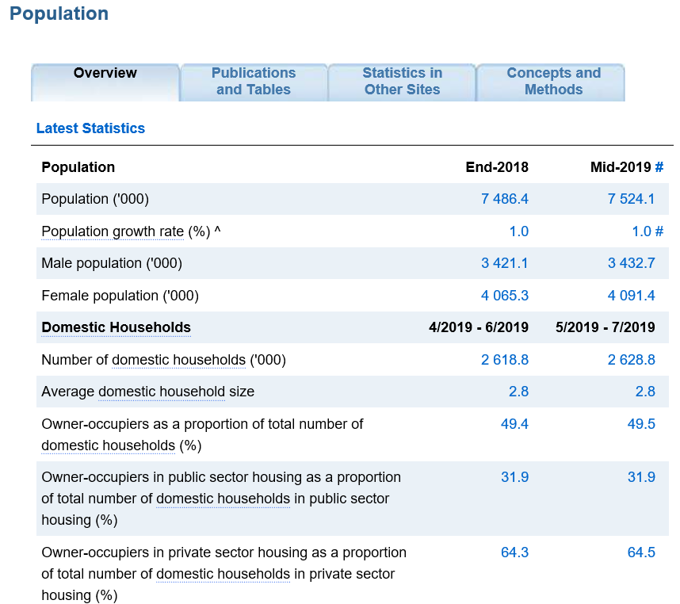
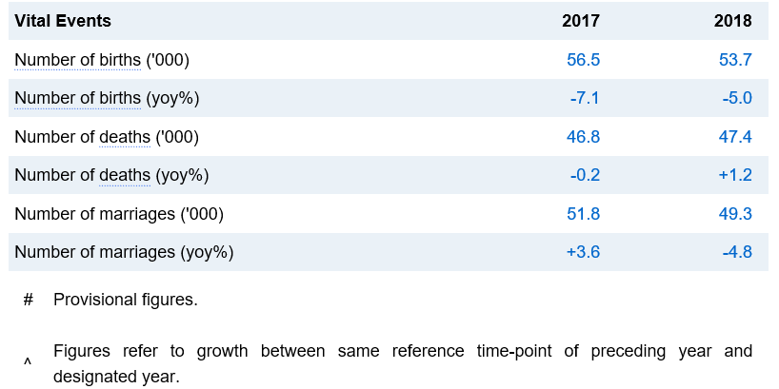

3.2 Competitive force that affect E-Sprit
There are so many small competitors in Hong Kong, such as Fashion Walk, ACF, Aanya, Anorak, Aly Rachelle, Ashiq Studio, Basics for Basics, Book of Deer, Central Central, Chicameo, Cynthia Xiao, Daydream Nation, Glush, Goods of Desire, House of V, Ika Butoni, Isabella Wren, Jo's Ready to wear, Jourden, Kay Li, Kotur, La French Cut, Linva Tailor, Maisha Concept, MAMEDIO, Marie France Van Damme, Mase, Melissa Bui, Mer Culture, Minki, Mischa, Miss Runner, Nishe, Nude is Rude, Phvlo, Pi'a, Rabaenco, Rising Lotus, robags, Rue Madame, S Nine, Sarah Lai, Sau Lee, SKETCHAROUND, The Only Alice, Twisted Sister, Vaughan, What the Frock and ZOOBEETLE Paris, etc.
And there are so big competitors also such as Bossini, Giordano, Baleno, Uniqlo, G2000, OEM, H&M, Zara, etc.

The Esprit major competitors recent year status:
In recent years, I have found some local fashion brands such as bossini, giordano, G2000, baleno, etc. Their stores seem to be getting fewer and fewer people. I didn't look at their performance, but I don't want to see that they also have a market share in Hong Kong that must have declined in recent years. In my observation, although it has not been confirmed, it is related to the invasion of Hong Kong by international brands.
These local brands have had a good time in the 1980s and 1990s, and they have become the inevitable place for Hong Kong people to buy clothes. Like the G2000 of the Tian family, they came down from Shanghai to Hong Kong and brought in capital, technology and machinery to build a textile factory in Hong Kong. The customer is a US retailer and does OEM business. The OEM's gross profit is reduced under the competition, so it is backed by the factory, and it is made into a fashion brand. The G2000 was of course very successful in the 1980s and 1990s. When Hong Kong people thought of a suit and a work clothes, they remembered the G2000.
In the past three or four years, some international brands have chosen to use Hong Kong as a stepping stone to make a name for themselves and then enter the mainland. Zara, H&M and Uniqlo have expanded and localized in the past three or four years, and the number of branches has increased. They have a clear positioning and focus on different target customers. H&M sells cheap fashion, Zara is a better quality than H&M. Uniqlo is a clothing that sells more cloth.
Time is very important to fashion. Today's fashionable and popular things may be out of date tomorrow. Zara's advantage is that their product life cycle and production time are extremely short. From design to goods, they claim to be completed within two weeks. The reason they can put the products on shelves in two weeks is that they are a vertically integrated company with a production base in Spain and 50% of the products are produced by Spain and then shipped to the world.
If the product is found to be unsalable within a week, it will be immediately removed and replaced with other products. No products can stay in the store for more than four weeks, ensuring that customers see different things every time they go to the store.
Seeing the gradual decline of Hong Kong brands, international brands have emerged, I think of the M-type society mentioned by Daizen. The M-type society is the middle class that is gradually disappearing, some upward mobility, and some downward-flowing society. In the M-type society, because the middle class is getting poorer, they want to enjoy the taste of the past, so things that make customers feel luxurious will be very popular.
Whether Hong Kong is an M-type society or not, three international brands can supply a much stronger sense of fashion and luxury than local brands. It is really difficult for Hong Kong brands to reverse this trend. I think they seem to have given up the Hong Kong market halfway and went to the mainland. The problem is that people have not yet opened a store in the mainland today. If you want to go to the mainland to open a store tomorrow, what other tricks are you available?
If Hong Kong fashion brands are no longer working hard, even on the mainland, they will be beaten and run without a cone.
But however the Esprit marketing status is very poor because it is market positioning shrunk in the middle. Esprit can not provide very high quality and higher price to the customer and it can not provide very low price and lower quality to the customer. Any customer is hard to remember Esprit and its market value.

3.3 Porter’s five-force model for E-Sprit
Five forces model of competition can be used to study business impact to Esprit business. The five forces are Rivalry among existing competitors, Threat of new entrants, bargaining power of buyers, bargaining power of suppliers and threat of substitute products.
For the rivalry among existing competitors there have number of direct competitor in local Hong Kong market, for example Bossini, Giordano, Baleno, Uniqlo, G2000, OEM, H&M, Zara, etc. And the fashion industry concentration is high but the industry growth is stable. The fashion product quality is quite differences, because some of them the quality is cheap and the price is low, and some of them have unique selling point, the quality and price are high. In fashion market the brand loyalty is not so high, because customer can select different kind of fashion clothes. The barriers to exit of fashion industry is quite high, because it needs to rent store and hire many staff, and some of them are named companies and their switching costs are high.
For threat of new entrants, the barriers of the fashion industry is not high or low, because fashion clothes is not a very high technology and but the capital cost is not low. The Hong Kong government wants to support fashion industry to be a center in the world. The brand loyalty of fashion industry is not high so customer can buy any new entrants product base on new style, better quality and reasonable cost. The economies of scale, cumulative experience, switching costs, access to distribution channels are fine.
For the bargaining power of buyers, in Hong Kong the number of customers is high. The customer’s price sensitivity is high so if the fashion clothes quality is high and cost is low, they will buy it. Nowadays the buyer’s information availability is very high, customer can get information from internet phone, television, radio, pc website, newspaper, etc. And the switching costs, differences between competitors, buyer’s ability to substitute, differences between competitors are fine.
For the bargaining power of suppliers, the number and size of suppliers are high, uniqueness of each supplier’s product is high, focal company’s ability to substitute is high.
For threat of substitute products, the number of substitute products available is so many, there are so many fashion shops in Hong Kong. And buyer propensity to substitute, relative price performance of substitute, perceived level of product differentiation, switching costs are fine.

Industry analysis: competitive profile matrix for E-Sprit
Competitive profile matrix (CPM)
 |  | Esprit | Esprit | Bossini | Bossini | G2000 | G2000
Critical success factor | weight | score | Weighted score | score | Weighted score | score | Weighted score
Marketing share | 0.1 | 1 | 0.1 | 2 | 0.2 | 3 | 0.3
Brand reputation | 0.1 | 1 | 0.1 | 2 | 0.2 | 3 | 0.3
Location | 0.1 | 1 | 0.1 | 2 | 0.2 | 3 | 0.3
Product quality | 0.05 | 1 | 0.05 | 2 | 0.1 | 3 | 0.15
Customer service | 0.05 | 1 | 0.05 | 2 | 0.1 | 3 | 0.15
Customer loyalty | 0.2 | 1 | 0.2 | 2 | 0.4 | 3 | 0.6
Product range | 0.05 | 1 | 0.05 | 2 | 0.1 | 3 | 0.15
Price | 0.2 | 1 | 0.2 | 2 | 0.4 | 3 | 0.6
Positioning | 0.05 | 1 | 0.05 | 2 | 0.1 | 3 | 0.15
Global expansion | 0.05 | 1 | 0.05 | 2 | 0.1 | 3 | 0.15
Competitiveness | 0.05 | 1 | 0.05 | 2 | 0.1 | 3 | 0.15
Total | 1 |  | 1 |  | 2 |  | 3

Esprit should takes external opportunities and minimize the impact of potential threats, it should focus on identifying and evaluating trends and events beyond the control of a single firm. Esprit also reveals key opportunities and threats confronting an organization so that managers can formulate strategies to take advantage of the opportunities and avoid or reduce the impact of threats.

3.4 Key success factors for E-Sprit
We can identify the key variables that offer actionable response, it includes consumer references, technological changes, labor and ethics, economic conditions

3.5
External factor evaluation EFE Matrix for Esprit:
Key external factors
 | Opportunity | weight | rating | Weight score
1 | Industrial strength | 0.1 | 2 | 0.2
2 | Environmental stability | 0.1 | 1 | 0.1
3 | Retailer | 0.2 | 2 | 0.4
5 | Market share | 0.2 | 1 | 0.2
 | Threats | weight | rating | Weight score
1 | Number of competitors in fashion market | 0.1 | 1 | 0.1
2 | Increase in target customer demand | 0.1 | 2 | 0.2
3 | Inappropriate advice on development | 0.2 | 1 | 0.2

 | total | 1 |  | 1.4

4 Internal audits

4.1 Nature of an internal audit for E-Sprit
The internal audits of the Esprit consists Esprit company departments, such as management, marketing, finance, accounting, operation, research and development, management information system. The internal audits can provide more opportunity for participants and divisions fit in the whole firm.
For the hardware resource audits, they include tangible resource: physical, financial, resource, technological assets, organizational resource and intangible resource: human assets and intellectual capital, brand assets, relationship, company culture.
For the software they include capability, knowledge-based and aspects of organizational culture.

4.2 Management audit for E-Sprit
The Esprit management audit include planning, organizing, motivating, staffing, controlling. And its decision areas are process, capacity, inventory, workforce, quality.

4.3 Marketing audit for E-Sprit
The marketing audit for E-Sprit include segmentation, targeting, positioning.
The marketing function for E-Sprit include customer analysis, selling products and services, product and service planning, pricing, distribution, marketing research, cost/benefit analysis.
The various strategies of Esprit can be a low cost provider, a high quality provider, great customer service provider, new products market leader, highly automated, minimize layoffs.
For the marketing audit for Esprit, the Porter’s value chain model is very useful. Its consists primary activities, inbound logistics, operation, outbound logistics, marketing and sales, service, and firm infrastructure, human resource management, procurement, technology, and support activities, and estimated profit.

4.4 Finance and accounting audit for E-Sprit
Finance/accounting function: investment decision, financing decision, dividend decision
Finance/accounting audit checklist:
Financially strong/weak? Financial ratios? Need short-term/long term capital? Sufficient working capital? Budgeting procedures effective? Are dividend payout policies reasonable? Good relationship with investor and stockholder? Financial manager well trained? Firm debt situation excellent?

4.5 Production and operation audit for E-Sprit

Internal factor evaluation IFE Matrix for Esprit:
Key external factors
 | Strengths | weight | rating | Weight score
1 | Very large company in the world | 0.1 | 2 | 0.2
2 | Good reputation in market | 0.05 | 2 | 0.1
3 | Good reputation and image | 0.1 | 1 | 0.1
4 | Close proximity to the market | 0.05 | 1 | 0.05
5 | Strong magement team | 0.05 | 2 | 0.1
6 | Increasing cash flow | 0.05 | 1 | 0.05
7 | Loyal employees | 0.05 | 2 | 0.1
8 | Access to cheap and reliable financing | 0.05 | 1 | 0.05
9 | Financial ratios | 0.1 | 2 | 0.2

 | Weaknesses | weight | rating | Weight score
1 | Saturated market | 0.1 | 1 | 0.1
2 | Sensitive to prices | 0.1 | 2 | 0.2
3 | Little diversification | 0.05 | 2 | 0.1
4 | Absence of strategic partner | 0.05 | 1 | 0.05
5 | Limited access to international markets | 0.05 | 1 | 0.05
6 | Rental cost | 0.05 | 2 | 0.1

 | total | 1

Part 2 Recommendations for E-Sprit

5 Long term objectives
5.1 Long term objectives for E-Sprit
For the long term objectives, its include provide direction, allow synergy, assist in evaluation, establish priorities, reduce uncertainty, minimize conflicts, stimulate exertion, allocation of resources and design of jobs (Characteristics of objectives: specific, measurable, attainable, realistic, time-bound).

5.2 Financial objective for E-Sprit
The current Esprit revenue is HK$6766 million and it is down by 14.4 per cent. And the gross margin is down by 51.3 per cent. That is refer the Esprit annual report 2018. Therefore for shot term financial objective for E-sprit is down by 5 per cent and the long term (3 years) financial objective is up by 3 per cent.

5.3 Strategic objective for E-Sprit
Spend one year slightly to change part of fashion business to franchising business to reduce business risk and increase company cash flow.
Spend three years to develop food store new business, such as food supermarket.

5.4 Alternative strategies for E-Sprit
There have so many alternative strategies for Esprit, such as forward integration, backward integration, horizontal integration, market penetration, market development, product development, related diversification, unrelated diversification, divestiture, liquidation.
As the result we can select related diversification and begin to do franchising business. And we can select unrelated diversification and begin to develop food store new business.

5.5 Defensive strategies for E-Sprit
There have some defensive strategies, such as retrenchment, divestiture, and liquidation. We can consider to use retrenchment for current business to reduce any unnecessary expense.

5.6 Competitive strategies for E-Sprit
There have some competitive strategies such as low cost provider, broad differentiation, focused low cost, focused differentiation, best cost provider. We can consider to select broad differentiation competitive strategy.

6 Generate evaluate and select strategies

6.1 SWOT matrix analysis for E-Sprit
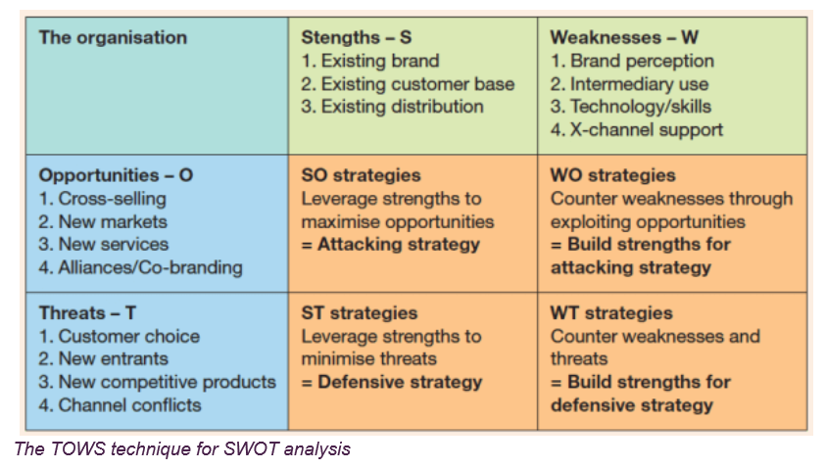
The TOWS technique for SWOT analysis
Strengths – S (existing brand, existing customer base, existing distribution), the existing related brand are Bossini, Giordano, Baleno, Uniqlo, G2000, OEM, H&M, Zara, etc. And the existing customer base are children, teenager, adult, elderly, male, female.
Weaknesses – W (brand perception, intermediary use, technology / skills), the Esprit brand is not so well known. And the technology is not so high.
Opportunities – O (cross selling, new markets, new services, alliances/Co-branding), Esprit CEO is searching new global market, but not in Hong Kong.
Threats – T (customer choice, new entrants, new competitive products, channel conflicts), customers have many choice in Hong Kong because there are so many related competitors, some of them can provide very low cost product and some of them have their product unique selling point and higher product/service quality.
SO strategies (leverage strengths to maximize opportunities = attacking strategy)
WO strategies (counter weaknesses through exploiting opportunities = build strengths for attacking strategy)
ST strategies (leverage strengths to minimize threats = defensive strategy)
WT strategies (counter weaknesses and threats = build strengths for defensive strategy)

6.2 Strategic position and action evaluation SPACE matrix for E-Sprit
Space matrix
Financial position (FP) | Rating | Stability position (SP) | Rating
Return of investment | 4 | Technological changes | -2
Leverage | 6 | Rate inflation | -4
Liquidity | 3 | Demand variability | -6
Working capital | 3 | Price range of competing products | -5
Cash flow | 4 | Barriers to entry into market | -2
Inventory turnover | 6 | Competitive pressure | -6
Earnings per share | 5 | Ease of exit from market | -3
Price earnings ratio | 5 | Price elasticity of demand | -3
 |  | Risk involved in business | -4
FP AVERAGE | 4.5 | SP AVERAGE | -3.889
Competitive position (CP) | rating | Industry position (IP) | rating
Market share | -4 | Growth potential | 6
Product quality | -3 | Profit potential | 3
Product life cycle | -5 | Financial stability | 3
Customer loyalty | -7 | Extent leveraged | 5
Capacity utilization | -3 | Resource utilization | 4
Technological know-how | -1 | Ease of entry into market | 4
Control over suppliers and distributors | -3 | Productivity, capacity utilization | 5
CP AVERAGE | -3.714 | IP AVERAGE | 4.286

6.3 Boston consulting group BCG matrix for E-Sprit
(https://www.strategicmanagementinsight.com/tools/bcg-matrix-growth-share.html)
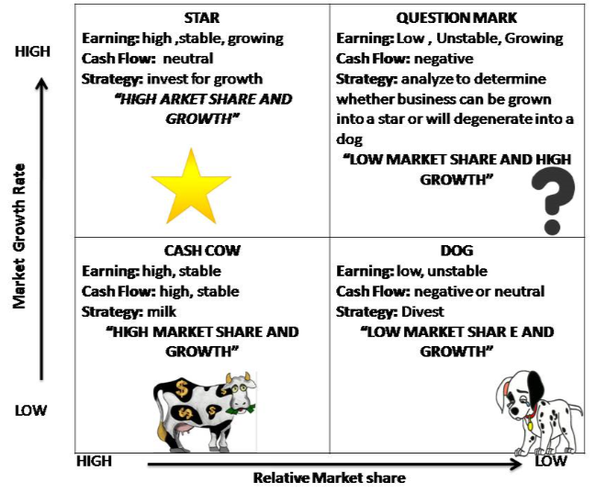
We can use BCG matrix to evaluate the strategic position of Esprit business brand portfolio and position. We can classify Esprit in which category of the BCG four categories, they are question marks, stars, poor dogs and cash cows. We also need to identify the market growth rate and relative market share of the current Esprit business and market condition.
Refer to the current 2019 annual report of the Esprit company, the current relative market share of Esprit company is low, and the market growth rate is also low. So we can classify the Esprit company should be in DOG category. Its means that Esprit company cost of goods sold is low and can earn less money in the same time.
Dogs. Compared to competitors, dogs have a low market share and operate in a slowly growing market. Often, they are not worth investing because they generate low or negative cash returns. But this is not always true. Some dogs may benefit in the long run, they may provide synergies for other brands or SBUs, or simply act as a defense against competitors. Therefore, a more in-depth analysis of each brand or SBU is always important to ensure that they are not worth investing or must be divested.
Because the Esprit is in DOG category, therefore the company strategic choices can be retrenchment, divestiture, liquidation

6.4 Internal external EI matrix for E-Sprit
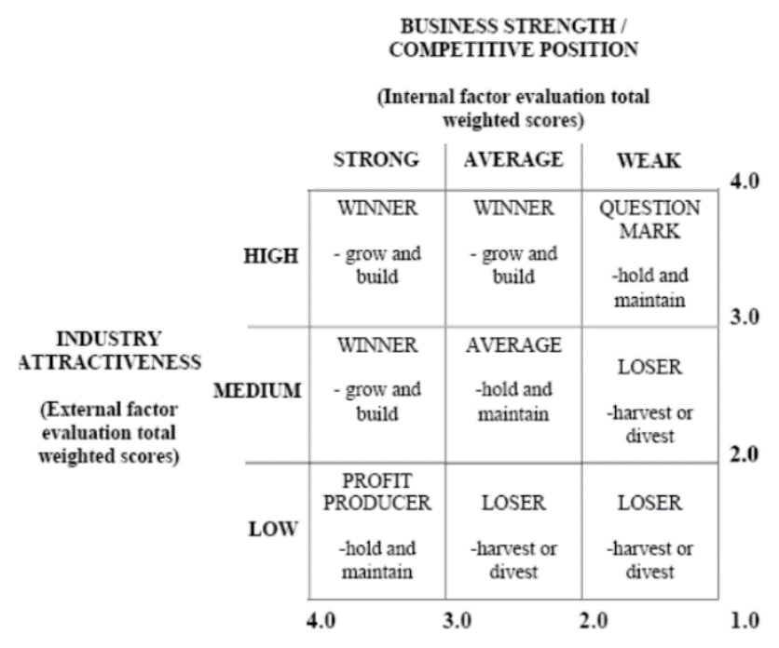
The internal factor evaluation total weighted scores of Esprit should be weak and the industry attractiveness (external factor evaluation total weight scores of Esprit should be low. So it should be a loser and can consider to harvest or divest.
6.5 Grand strategy matrix for E-Sprit
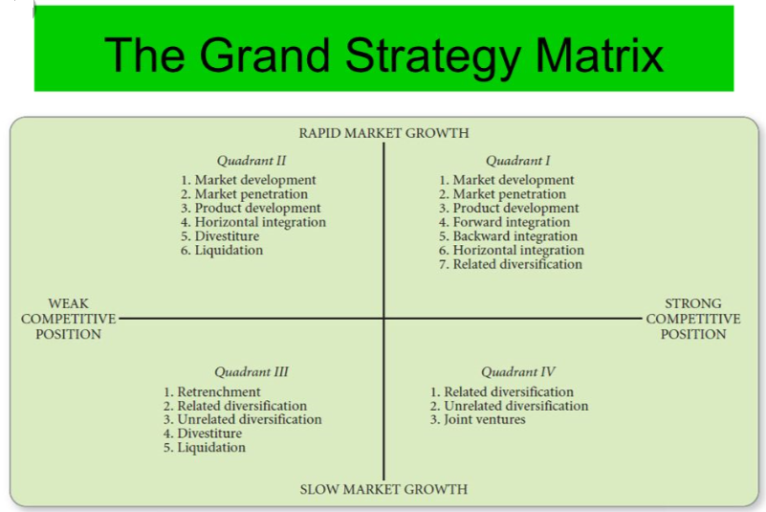
For the Esprit current marketing position. The market growth is slow and the competitive position is weak. So Esprit CEO can consider the strategies are retrenchment, related diversification, unrelated diversification, divestiture and liquidation.
As the result Esprit CEO can select related diversification and begin to do franchising business. And Esprit can select unrelated diversification and begin to develop food store new business.

(Strategy implementation)
7 Implement strategies management issues, implement marketing, finance, accounting, R&D and MIS issues
The net current assets of Esprit are HKD 5005 million, the EBIT is 1750 HKD million. Therefore, Esprit still have capital to select related diversification and begin to do franchising business. And Esprit can select unrelated diversification and begin to develop food store new business.
The following is the 3 years long term company objective:
First to third year planning and objective is to start the fashion franchising business, then Esprit company can increase cash flow. And Esprit can reduce number of fashion store base on number of franchising business growth rate.
Second to third year planning and objective is to continue the fashion franchising business. And begin to start the food store business if the franchising business is good.
R&D annual objective: Develop new franchising business and new food store business.
Production annual objective: Increase business production efficiency. And company need to do purchasing, shipping, quality control.
Marketing annual objective: To develop the new franchising business and new food store business. And company need to do the advertising, promotion, research, public relations.
Finance annual objective: obtain long term financing of net current assets HKD 5000 million.
Personnel annual objective: reduce original fashion store employee and recruit new staff for the new franchising business and new food store business.

(Strategy evaluation)
8 Measure and evaluate performance
For the Esprit measure and evaluate performance, CEO can consider to use Rumelt’s Criteria for Evaluating strategies. It consists consistency, consonance, feasibility and advantage.

Balanced scorecard
Financial perspective  Financial result and growth  Key financial parameters and performance (ROE, ROCE)  Higher profit margin  Improved cash flow  Lower bad loans and lower debt  Net interest margin  Reduced overhead expenses  Proper revenue mix |  | Learning and growth  Develop critical skills and knowledge  Proper knowledge management  Provide strategic information to all  Align personal goals with company goals  Employee growth and turnover  Employee satisfaction and retention
 | Balance scorecard
Customers  Increase customer satisfaction  Increase customer loyalty  Retention of key customers  Sales revenue per customer  Competitive pricing and product offering  High quality service  Customer preference compared to competitors |  | Internal business processer  Cross sell products  Improve operational efficiency and minimize problems  Proper customer relationship management  Higher success rate in converting business opportunities  Fast business decisions and approvals  Proper work culture and higher employee confidence

9 Conclusion
Esprit chief executive officer consider the Esprit faces so many business problem. For instance Esprit affected by the rapidly evolving retail industry environment and the profit becomes lower.
Esprit CEO wants to build more effective organization and redesign the cost base. On the other hand Esprit wants to eliminate loss making stores and reduce the headcount. Those method are not a business growth strategy in Hong Kong. But Esprit CEO intends to find new market in global market.
For the strategy of Esprit fashion products, they are broad/mas market but are not a narrow market. Esprit Company has a market differentiation problem. They does not provide a very low cost product and does not have any unique selling point. The product price is not low. Refer to the theory of Micro Porter, it is stuck in the middle. In this situation Esprit cannot earn big money and easy to be bankruptcy. Esprit cannot do differentiation from other rival.
When 70’s 80’s Esprit Company was successful because elegant image, colorful. But the customers become old, and they do not want to buy clothes, goods more. Link with marketing positioning, and so many competitor in market, as the result customers begin to forget Esprit. Customer has limited time, effort, they can select which one is most suitable.

Suggestion
Esprit CEO can do the fashion franchising business. The advantage are easy to get more cash flow and have lower business risk. But the CEO should need to control the business very carefully.
For the feasibility study of Esprit CEO is that he can begin the develop food store business. Mark and Spacer Company is a good example. They changed the fashion business to food store business successfully.

10 References
Dess, G. G., Eisner, A., McNamara,. G., (2016) Strategic Management: Texts and Cases, McGrraw-Hill

Esprit company limited Interim Report FY2018/2019
Available at:
https://www.esprit.com/zh/company/investor-relations/publications/annual-interim-reports

Esprit company limited Annual Report FY2017/2018
Available at:
https://www.esprit.com/zh/company/investor-relations/publications/annual-interim-reports

Esprit company limited Interim Report FY2017/2018
Available at:
https://www.esprit.com/zh/company/investor-relations/publications/annual-interim-reports

Esprit company limited Annual Report FY2016/2017
Available at:
https://www.esprit.com/zh/company/investor-relations/publications/annual-interim-reports

Esprit company limited Interim Report FY2018/2017
Available at:
https://www.esprit.com/zh/company/investor-relations/publications/annual-interim-reports

Esprit company limited Annual Report FY2017/2016
Available at:
https://www.esprit.com/zh/company/investor-relations/publications/annual-interim-reports

Esprit company limited Interim Report FY2017/2016
Available at:
https://www.esprit.com/zh/company/investor-relations/publications/annual-interim-reports

Esprit company limited Annual Report FY2016/2015
Available at:
https://www.esprit.com/zh/company/investor-relations/publications/annual-interim-reports

Esprit company limited Interim Report FY2014/2015
Available at:
https://www.esprit.com/zh/company/investor-relations/publications/annual-interim-reports

Esprit company limited Annual Report FY2013/2014
Available at:
https://www.esprit.com/zh/company/investor-relations/publications/annual-interim-reports

Garner, J., Stead, W., Stead, E, (2014), Sustainable Strategic Management 2nd edition, London: England: Greenleaf Pub.

Grant, R.M. (2015),. Contemporary Strategy Analysis: Texts and Cases 9th edition

Hayes, J.,(2014), The theory and practice of change management 4th edition, Palgrave

Johnson, G., Whitittington, R., Scholes, K., Angwin, D., Regner, P., (2017), Exploring Strategy Text and Cases 11th edition Harlow: Pearson

Lynch, R., (2015), Strategic Management 7th edition, Pearson: Harlow

