Portfolio of Writing
Naomi Seaward

Tutor’s Name: Julia Lockheart

Student Number: 1706436

BA Course Title: Surface Pattern Design

Module Title: Research Practices

Keywords: Theory, Passion, Potential

Word count: 2688

Nature is intrinsically linked to humanity. Edward Wilson for The Biophilia Hypothesis clarifies it as “the innately emotional affiliation of human beings to other organisms” (Kellert and Wilson, 1993). In the realm of art and design, nature is an immense influence used by artists across the globe, from Claude Monet’s Water Lily Pond, to Botticelli’s symbolism rife Primavera, leading to our more modern reactions to natural forms and life. Artists are passionate about nature, “...and then, I have nature and art and poetry, and if that is not enough, what is enough?” (Van Gogh Museum, 2019). Vincent truly believed in the power and strength of nature as a form, and created alongside it. In this essay, I aim to consider how nature has influenced key points of art across our history, and how it will continue to affect our design in the future of technology and progress.

Theory

Throughout the nineteenth century, architecture relied on the concept of historicism. “They are empowered by history.” Van Pelt and Westfall commented on the practice of historicism, and how it is utilised by artists. “The worthwhile critic not only has a keen eye… but also has a vision of history. Without the historical perspective there is no norm to the ‘meaning’ of the work displayed on the wall” (Westfall and van Pelt, 1991). This ethos instructed artists to draw inspiration from history as the base for new design, reusing iconic styles and methods used in years before, or recreating the work of already iconic artisans. However, a new form of expression began to erupt, based on challenging imitation in art, in favour of deriving inspiration from studying morphology and the natural order. Artists such as Antoni Gaudi and Victor Horta began to turn to designing architecture according to natural law, and one of the founding drivers of this law was Johann Wolfgang von Goethe.

Goethe, an intelligent poet and writer, explored his named ‘new science’ through his book The Metamorphosis of Plants. He wanted to discover one simple, archetypal plant so to say, signifying a unity across the immense variety of plants. He believed that this must exist, because otherwise how are we able to recognise a plant is a plant if they are not all created from the same form?

Whilst studying various leaves however, it dawned on Goethe that the plant in reality is nothing but leaf, ‘which is so inseparable from the future germ that one cannot think of one without the other” (Wolfgang Von Goethe, 2009, p17). Therefore, we can determine that the unifying form of plant life is derived from their leaves, and the growth and development of them into stem leaves, petals, pistil and stamens is what Goethe meant by the metamorphosis of plants. The book is an enlightening read into how we can enrich our minds and relationship with nature through a deeper, more thorough understanding of the natural world.

The passion held by Goethe concerning plants and nature is seen all over the work and writings of the 19th and 20th century creators. One triumph came in the form of the Bauakademie, which Friedrich Adler drew comparisons to the design to Goethe’s idea of the archetypal plant. Considered one of Berlin’s first ‘modern’ buildings, the academy is adorned with imagery that are not so much a chronology, as many buildings portrayed, but are more relative to being an unfolding and developing array of forms, ‘a distinct parallel to Goethe’s notion of the stages of development. (Sachs and Zürich, 2007). One interesting and distinctive feature of this portal door, is the lowest panel of the door, where a bushel of thistles and leaves sprout, the emphasis being on them flowing upwards rather than repeating, very much like the botanic illustrations Goethe referenced in his studies.
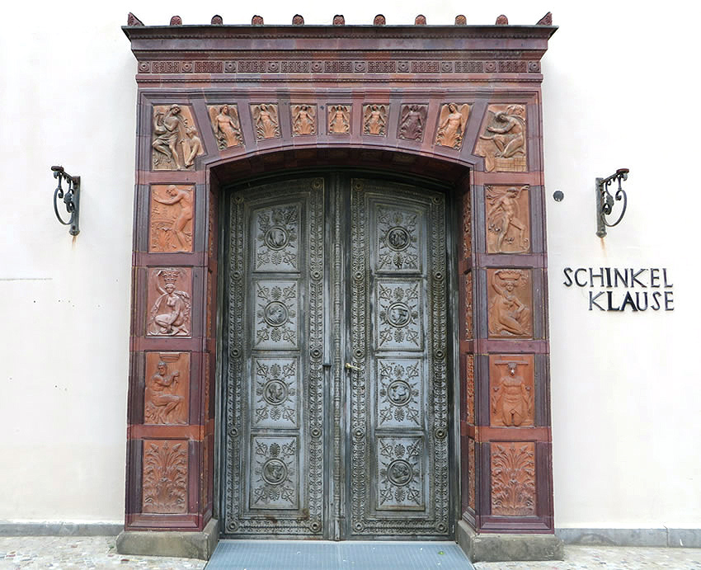
(Schinkel, 1832)

On introducing the book, Gordon Miller remarked, “my belief that Goethe’s way of science offers hope for lessening the modern alienation from nature that not only diminishes the beauty and joy of human life but also fuels environmental irresponsibility and apathy” (Wolfgang Von Goethe, 2009). Miller believed, like many others, that even in the 19th century we as a society were distancing ourselves from nature and the natural world. This has led to a non-empathetic attitude towards nature. Decades later, these comments are direly true. The decline and extinction of our world’s various animal species is a hot topic in modern culture. A report from the united nations found that around one million of our animal and plant species are now facing extinction in the next decade. Our natural world is dying, and “The health of ecosystems on which we and all other species depend is deteriorating more rapidly than ever. We are eroding the very foundations of our economies, livelihoods, food security, health and quality of life worldwide” (United Nations, 2019). Amongst the destruction and natural imbalance that we as humans are causing around us, are we still celebrating and embracing nature as we once did? Going back to the challenging of historicism, and architecture being recreations and copies of historical design, all of these theories and concepts set out by thinkers like Goethe and Schinkel inspired some of the greatest pieces of art of our time, focused around the love of nature and the natural form, found in movements like Art Nouveau and the Arts and Crafts concept. These artists challenged old ways of imitating and embraced a completely new style, theories and ideas setting the foundation for a new era of design.

Passion

The Art Nouveau movement spanned across the globe, taking on different names and expressing itself through wildly different personalities in the art and design world. In the words of Colin Martin, “it is easy to recognise but harder to define.” Aiming to break free from the constraints of historicism the art of the movement was far more liberal, utilising the body and its eroticism, one key factor being its evolving line, which twists and turns and curls in sensual ways, ‘both sinuous and sensuous” (Martin, 2000). Art Nouveau was the result of a frustrated society of artists, tired of imitation and restriction. The change to a more liberal method of creating was spurred by their passion for change.

The key source the movement drew its passion from is the natural world, colour schemes reflected the seasons and moods of the change of time, budding stems and full blooms decorated art, and both human, flora and fauna are explored in many pieces of popular art nouveau art. Turning to adornment, there is no clearer celebration of the female body and the art of nature than René Lalique’s jewellery. Taking reference from the ‘Japonisme’ style of working, a study was conducted into the innovation brilliance of Lalique’s designs, and his “search for a profusion of colour, transparency, brilliance.” Exploring the three dimensions, the jewellery produced was comprised of precious jewels, stones and enamels (Tissot, Manso and Guerra, 2018). These were inspired by the form of the dragonfly, intertwined with the silhouette and features of a woman. Detailed in the piece’s bibliography by the Calouste Gulbenkian Museum on their website, it is ‘without a doubt’ one of Rene Lalique’s best works. Encrusted in opals, moonstones and enamelled gold, the female silhouette emerges from the dragonfly, becoming a hybrid species.

René Lalique was a revered and loved creator, emanating immense amounts of passion for his craft and for the art nouveau movement. Commenting on Lalique’s later works, Gabriel Mourey (1902, quoted in Holme, 1902, p.2) believes that Lalique takes on the role of an observer, “more devoted to simplicity and breadth.” These new pieces seem to document nature, where the petals and flowering buds flow from the material of the comb, decorated with enamel and obsidian. Mourey suggests that these pieces are evidence that Lalique is still eager to research and expand his knowledge and skills, ‘spurred by a desire for conquest.” This talk of desire and the need to conquer all evokes the feeling of passion that Lalique has for his work, like many other artists of the Art Nouveau era similarly held.

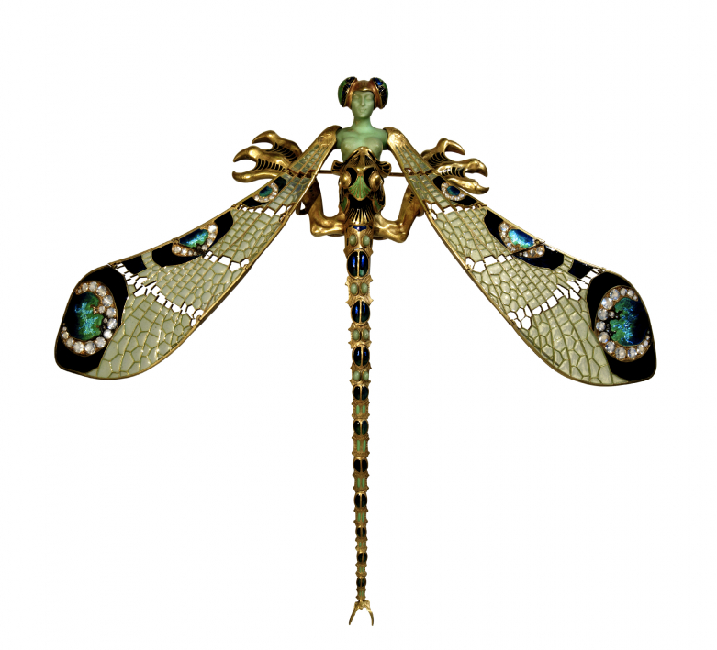
(Lalique, 1898)

Metamorphosis was a concept followed in many art nouveau pieces, the transformation from the primordial seed and its stages, as illustrated by Goethe. (Martin, 2000) Alphonse Mucha and his piece ‘The Seasons’ shows this. As a creator, Mucha was hugely diverse in how he expressed himself, through painting, sculpture, jewellery, and stained glass, and did them all well. Ronald F. Lipp (1998) writing for the Alphonse Mucha: the spirit of art nouveau exhibition book, explains the ‘spirit’ of Mucha, describing him as a ‘virtuoso’ of his craft, ‘skilled and prolific craftsman with a workaholic temperament,” as the figurehead of the movement within Paris, Mucha’s dedication and enthusiasm for his craft is clear. (Mucha et al., 1998)

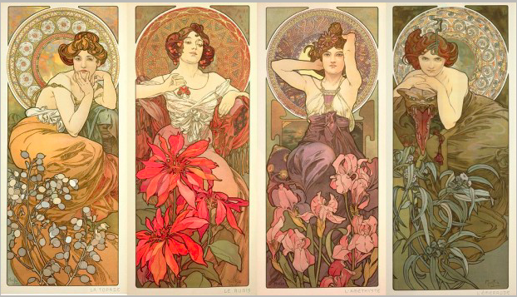
(Mucha, 1900)

The image above shows Mucha’s piece ‘Precious Stones’, comprised of four decorative panels. These decorative panels were sought after during the 19th century, in the age of mass production and lithographs. Personification and symbolism is rife within Mucha’s art, and is clearly shown above with his personification of precious gems as women. Topaz, Ruby, Amethyst and Emerald, each have distinctive features and motifs that highlight their meanings. Each has a flower in the foreground of the image, that is said to relate to the gemstone.

Symbolism is a large part of Mucha’s work and part of his drive to create. “Decorative art is intended to be nothing less than the expression in symbolic form of man’s highest and most abstract values” (Mucha et al., 1998, p14). Alphonse Mucha expressed his values and beliefs through the symbolism and deeper meanings he proposed in his imagery. On a surface level we can certainly see that Mucha is inspired and driven by the natural world and portraying that through the elegant, idealistic form of woman. However, as Ronald Lipp (1998) explains, ‘La Nature’ also is a representation of ‘the intermediating spirit between man and the divine,” a representation of an angel, personified in a human woman.

Of course, there are countless other large scale contributors to the natural-centric movement across the globe. William Morris shared the same views on symbolism and metaphors in his work as Mucha, “any decoration is futile… when it does not remind you of something beyond itself, of something of which it is but a visible symbol” (Gillow, 1995, p). For Morris, nature to him was a clear source for research and inspiration for art, however not to be copied literally, but to be illustrated in accordance with what is associated with beauty and natural form. The Art Nouveau movement inspired many to act, but when it has run its course, what comes next?

Potential

So how has nature intertwined itself into our design, art and architecture in the ‘modern’ world? Potential, “Having or showing the capacity to develop into something in the future”(Oxford University Press, 2019), suggests an optimism around the possibility of the event. In this way, I am hopeful that we can continue our love of the natural world and form in our art and design for years to come. Where previously in this essay I have touched on artists and society’s love of nature and the use of it in our everyday lives, Biophobia is an increasingly worrying issue.

Returning back to the idea that we lack empathy and concern for our resources suggested by Gordon Miller, and the imminent crisis of species endangerment and extinction, how much truth is there in this concept of biophobia? Described as the discomfort or reluctance to be within nature, Biophobia is believed to be an acquired urge to seek technology and man-made constructs in place of natural space; “The affinity for life is now a choice we must make” (Orr, 1993). Our developments in science have allowed us to come away from reliance on nature, and if we want to preserve our world where we can embrace biophilia, ‘we will have to decide to make such a world.” From the same collection of essays, three concepts for the downfall of biophilia are surmised as ‘the loss of biodiversity... the extinction of experience… the demise of oral traditions of plant and animal stories” (Nabhan and Antoine, 1993). Whilst losing our planets varied species, Nabhan theorises we are also pulling away from experiencing nature for ourselves, in addition to not recounting our tales of nature to the new generations and encouraging biophilia.

However, there is clear evidence in opposition to these theories. Referring back to Nature Design (2007, p229) Design in general will supposedly re-establish a connection and relationship with nature in times of crisis, aiming to regain a balance. Sachs (2007) considers this in his essay ‘contemporary strategies of nature design’. When being inspired by organic forms, we can define that process as being strictly ‘anti modern’, opposing the norm of our industrialised and technology driven world. This ties well with the concept of art nouveau, the escape and challenging of the historicism era, and looking for new solutions and inspirations.

Much of the new era design inspired by nature ties hand in hand with sustainability, and mental well-being. Working with Interface, Kellert (2015) explains “Biophilic design is about creating good habitat for people as a biological organism in the modern buildings,” boosting productivity and establishing an effective, satisfying environment that caters to our innate need for nature. “The creative interplay of natural lighting, spaciousness, plants, and water in a central atrium can simulate the qualities of an exterior setting in an indoor space.” Much of this theory is about bringing the outside to the inside, blurring the lines between our modern technological world and our natural habitat. This can be done in various ways, such as encouraging natural light into architectural design, appealing to the senses of touch and sound, essentially creating an ecosystem.

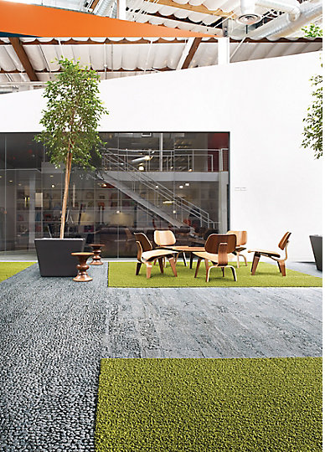
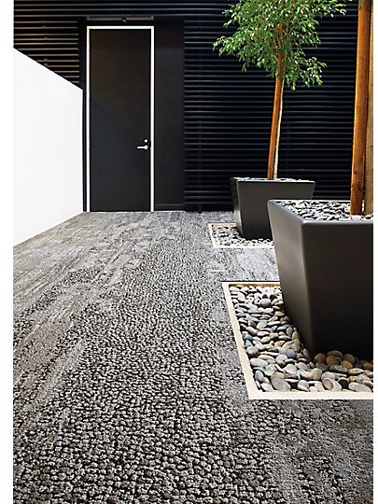

(Interface, 2014a)

One company who embraced this system Is Interface with their Human Nature range. Creating a range of modular carpet tiles that are textured and coloured to mimic surfaces such as grass, pebbles and slate. They can be mixed and interchanged, allowing the user to play and interact with the design. “This is what Human Nature is about: helping to create a flexible, informal, barrier-less work environment, while giving it structure, form and personality” (Interface, 2014b). The culmination of research into the effect of nature and natural form on society has led to designs like these, and the advancements in our technology makes our options almost limitless. There is endless potential for progression and growth when it comes to natural design and biophilia, whether that’s in architecture, art and design, product design and so on.

To surmise the key texts I have touched on throughout this essay, the natural world is clearly an important and relevant source of inspiration for artists, through the various movements like Art Nouveau, and provides a capacity for change and diversification. During historical design, pieces were heavily symbolic and served as metaphors for expressing the artist’s values and beliefs. In contrast, with our worsening conditions in relation to our loss of biodiversity and the destruction of natural habitats, nature design is now more focused on sustainability. Referring back to Nature Design, “design oriented on nature seems to acquire relevance whenever modern society finds itself in a crisis” (Sachs and Zürich, 2007), and I am eager to further explore the concept of incorporating Biophilia into our contemporary design and how this can benefit us. I have just completed a project with Orangebox, a furniture design company based in the UK, on utilising their waste to create a commercial stool. Undertaking an internship with them during the Summer, I aim to gather research and information on how our natural world is being brought into our interiors, breaking modern conventions.

‘Considering and evaluating the use of the natural world as an inspiration source for artists in the 19th and 20th century, in relation to art and design as a whole, how does nature currently influence design in the 21st century given our deteriorating relationship with the environment, and how can we continue to use nature as a design resource in the future?’

Bibliography

Gillow, N. (1995) William Morris : designs and motifs. London: Studio Editions.
Van Gogh Museum (2019) Van Gogh Museum Website. Available at: https://www.vangoghmuseum.nl/en/organisation (Accessed: 9 May 2019).
Holme, C. (1902) Modern design in jewellery and fans. The Studio.
Interface (2014a) ‘Case Study Photographs of Human Nature Product’.
Interface (2014b) Human Nature - Changing World, Changing Work. Available at: https://www.interface.com/EU/en-GB/about/modular-system/Human-Nature-en_GB (Accessed: 9 May 2019).
Kellert, R. S. and Wilson, E. (1993) The Biophilia Hypothesis. Washington: Island Press.
Kellert, S. (2015) Nature by Design: the Practice of Biophilic Design. Available at: https://blog.interface.com/nature-by-design-the-practice-of-biophilic-design/ (Accessed: 9 May 2019).
Lalique, R. (1898) ‘“Dragonfly” Broach’. Available at: https://gulbenkian.pt/museu/en/works_museu/dragonfly-broach/ (Accessed: 8 May 2019).
Martin, C. (2000) ‘Art Nouveau unraveled’, The Lancet , 356(9226), p. 348.
Mucha, A. (1900) ‘Precious Stones’. Available at: http://www.muchafoundation.org/gallery/browse-works/object/243.
Mucha, A. et al. (1998) Alphonse Mucha: the spirit of art nouveau. Alexandria Virginia : Art Services International.
Oxford University Press (2019) English Oxford Dictionary Online. Available at: https://en.oxforddictionaries.com/definition/potential (Accessed: 9 May 2019).
Sachs, A. and Zürich, M. für G. (2007) Nature Design: From inspiration to innovation. Edited by C. Reble. Baden : Lars Müller.
Schinkel, K. (1832) ‘Schinkel Klause Portal Door’. Available at: http://www.secretcitytravel.com/berlin-may-2014/schinkel-door-hidden-berlin.shtml.
Tissot, I., Manso, M. and Guerra, M. F. (2018) ‘Unveiling the art of René Lalique with XRF and Raman spectroscopy – Technological innovation in jewellery production’, Journal of Cultural Heritage, 33, pp. 83–89. Available at: https://www-sciencedirect-com.ezproxy.uwtsd.ac.uk/science/article/pii/S1296207418300761.
United Nations (2019) UN Report: Nature’s Dangerous Decline ‘Unprecedented’; Species Extinction Rates ‘Accelerating’ - United Nations Sustainable Development. Available at: https://www.un.org/sustainabledevelopment/blog/2019/05/nature-decline-unprecedented-report/ (Accessed: 7 May 2019).
Westfall, W. C. and van Pelt, R. J. (1991) Architectural Principles in the Age of Historicism. Yale University Press.
Wolfgang Von Goethe, J. (2009) The Metamorphosis of Plants. Massachussetts: The MIT Press. Available at: https://rekveld.home.xs4all.nl/growth/Goethe_MetamorphosisPlants2009.pdf (Accessed: 29 April 2019).

