Cert. HE S4BA Assignment

Title page.
Software for Business E-Portfolio
Student: Arshard Hussain
Student ID: 2229730
Module: Software and Apps for Business (ACCA4031)
Lecturer: James Williams

Task 1: e-Portfolio.
- https://sites.google.com/view/arshardhussain2229730/home
- Task 1 (google.com)

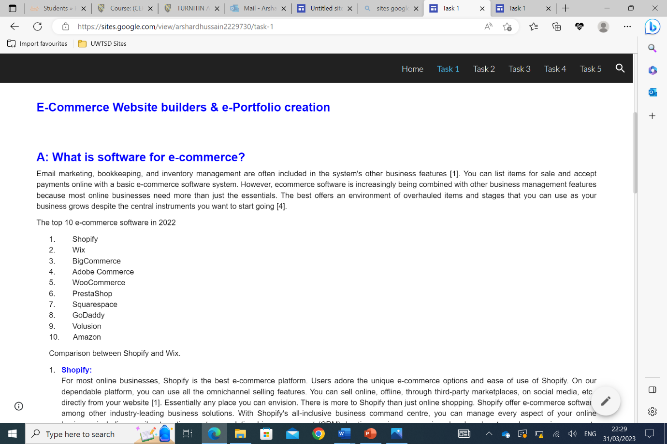
- 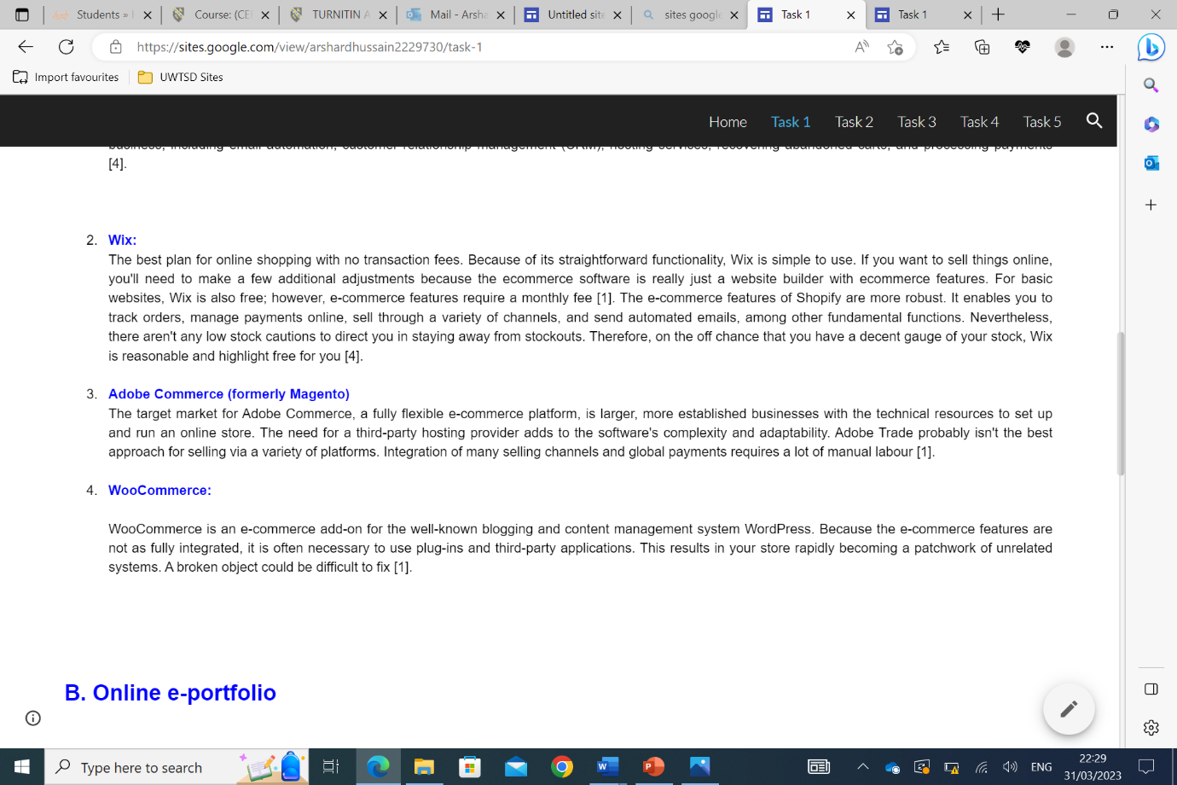
- 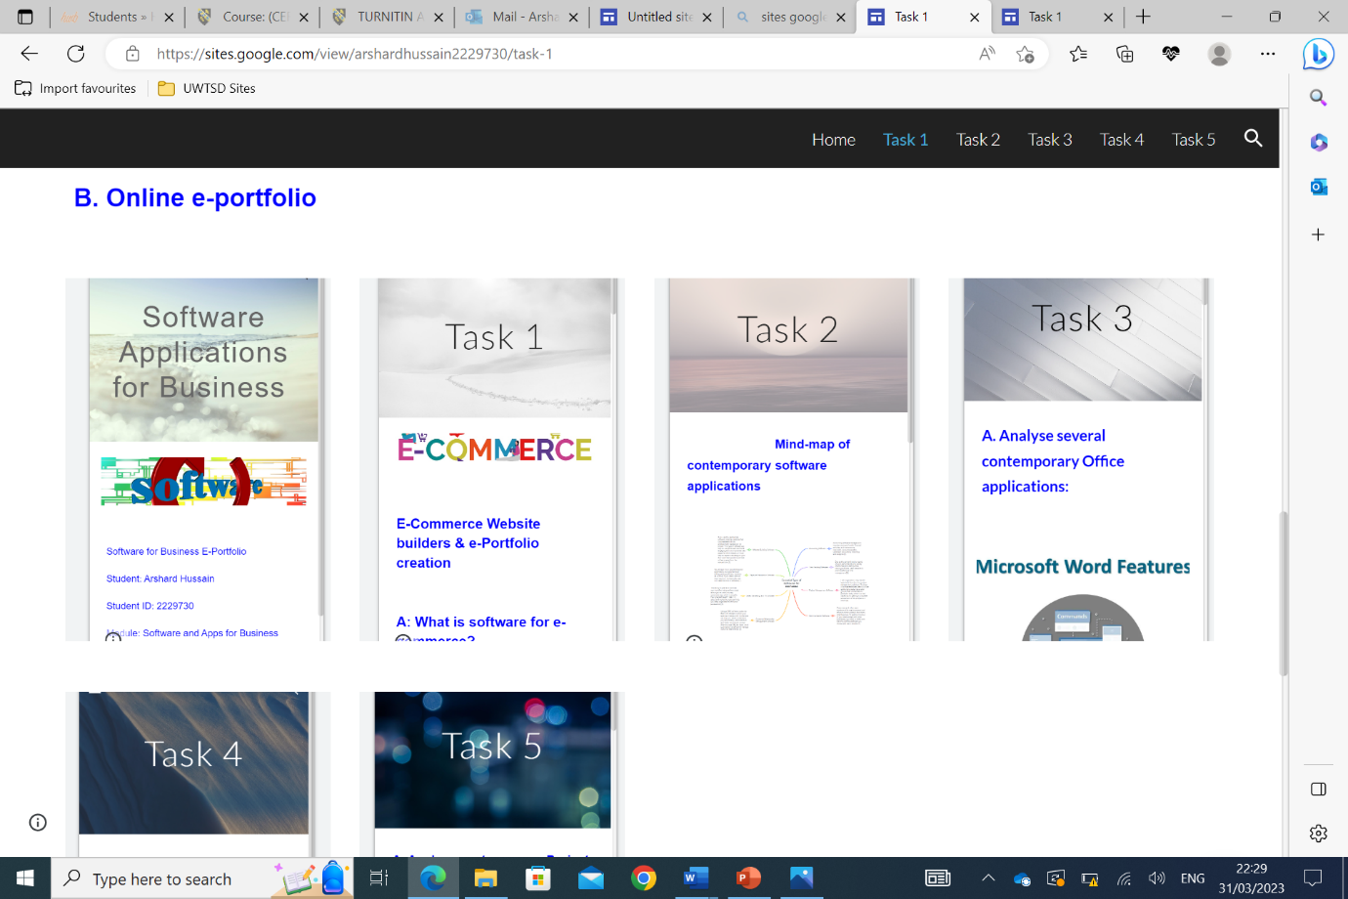

Task 2 – Mind-map.
- 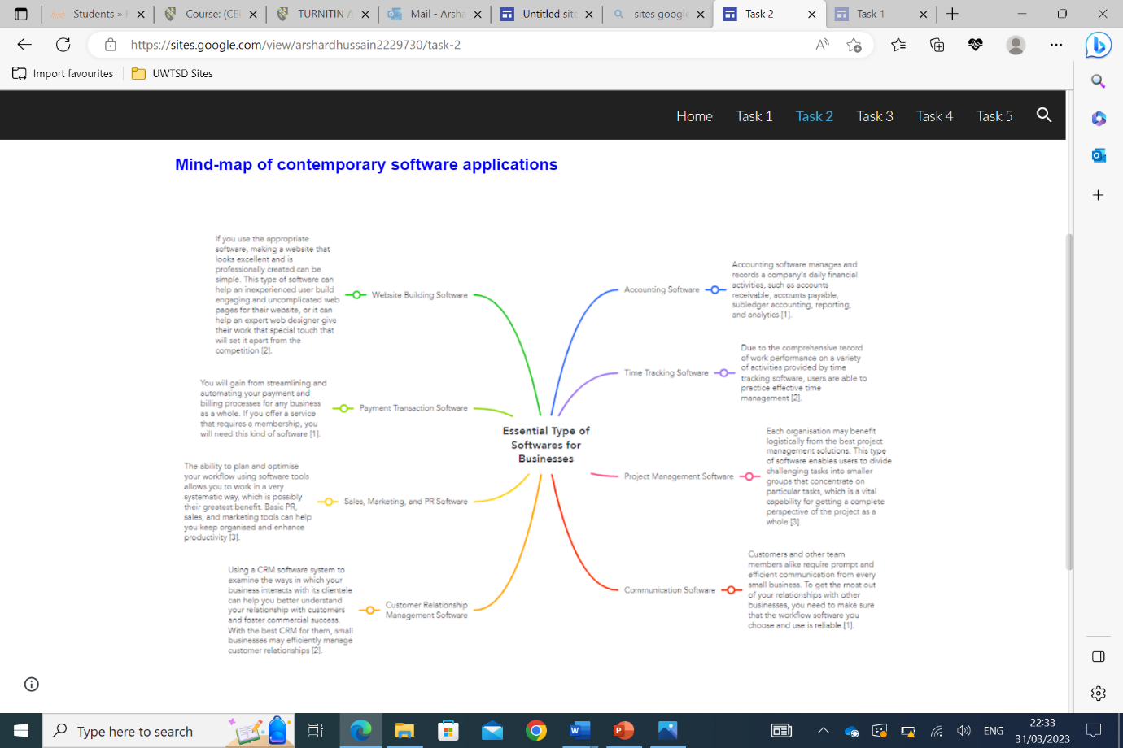

Task 3 – Office Applications.
- 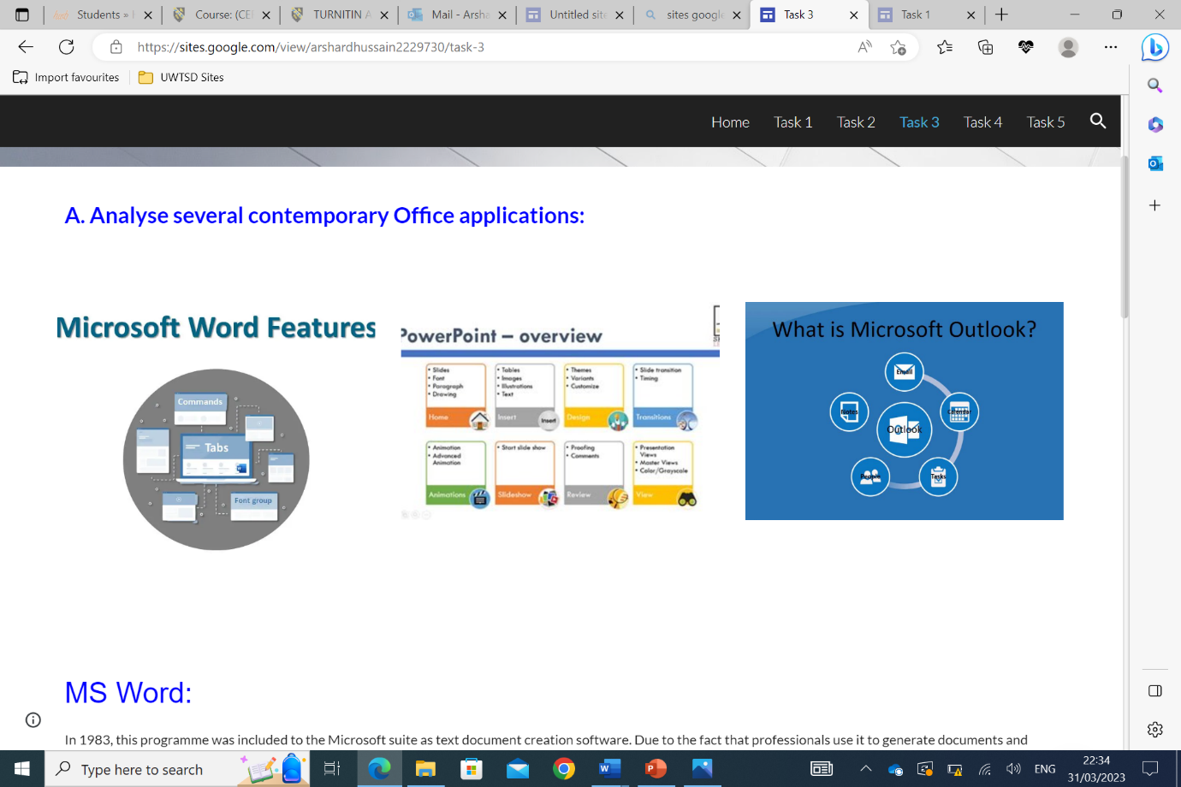
- 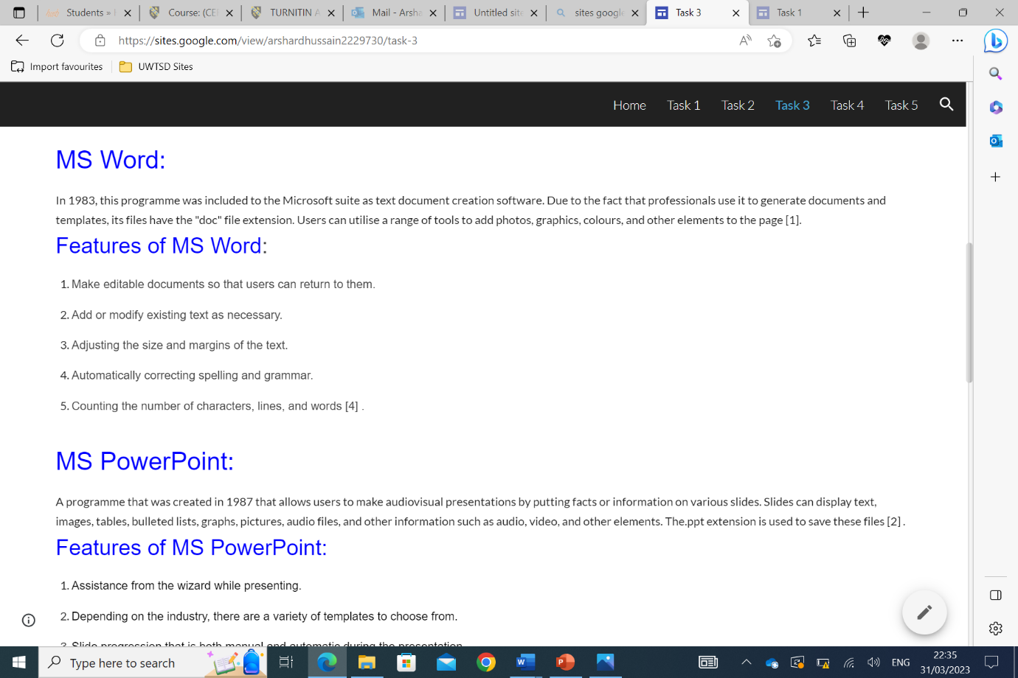
- 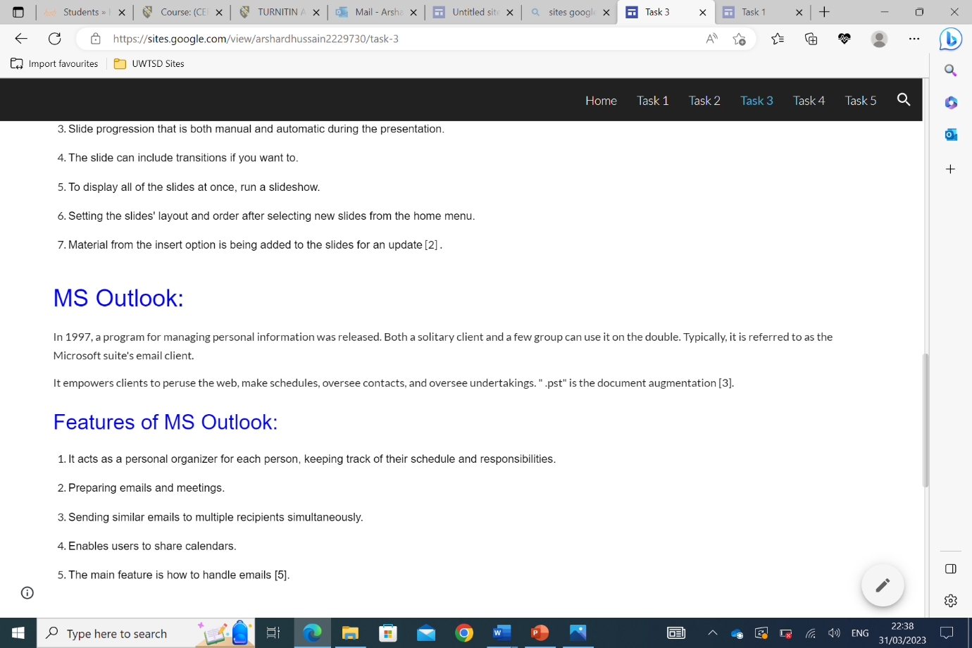
- 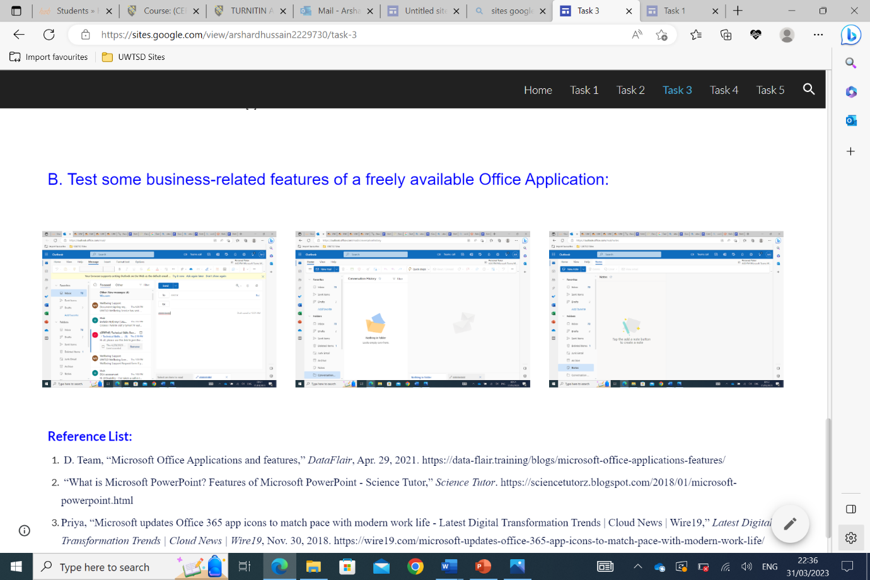
Task 4 – Digital Dashboard and Data Analytics software.
- 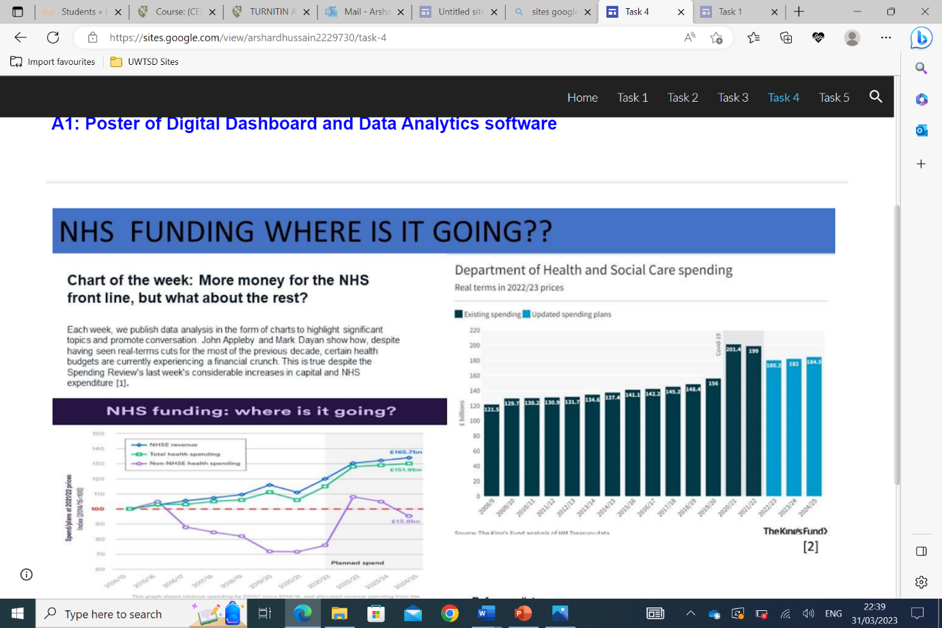

Task 5 - Communication, Collaboration & Project Management
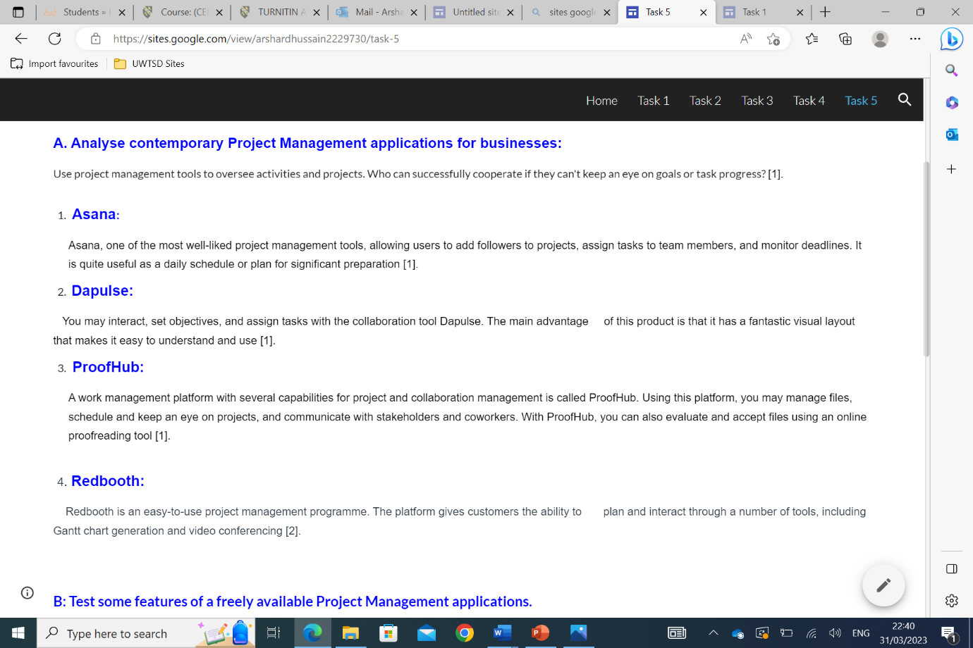
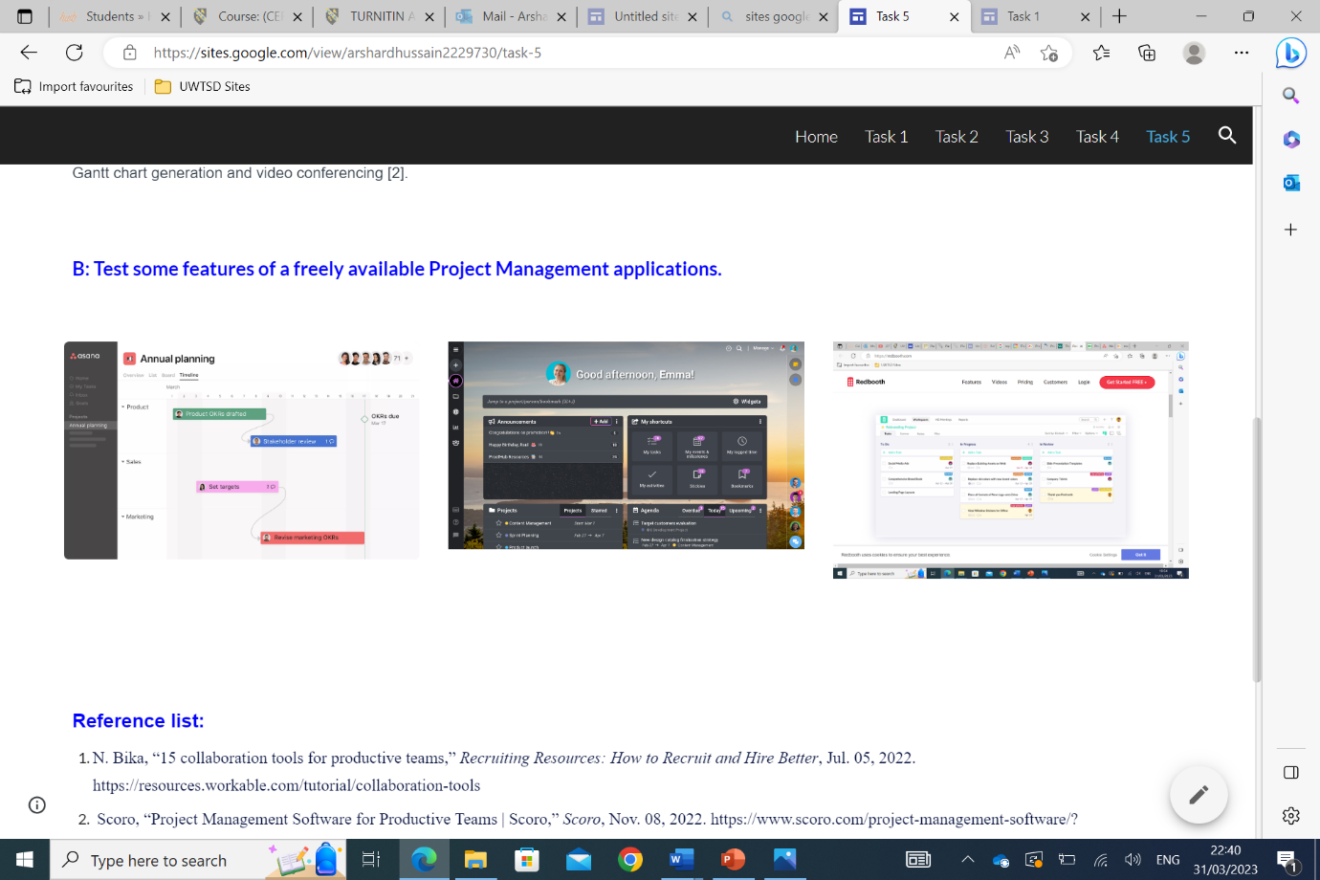

IMPORTANT LINK TEST REMINDER: to ensure your work is accessible for marking it is important to test your work can be accessed by the tutors. To do this either try opening the e-portfolio link in a private/incognito tan in a web browser or sign out of the e-portfolio and to try to open it in a web browser with the link you are providing in this document.

