

Module
LCLM 6002 Design Thinking and Innovation

Assignment title: Design Thinking for SME Digital Transformation - Developing GrowSphere as an Innovative Business Management Platform

Student Name: Raluca Mihaela Popa
Student Number: 2332370
LECTURER’S NAME: SEYED NASIRPOUROSGOEI

Contents
Introduction 3
TASK 1 4
User pain points 5
Figure 1. Empathy Map of a UK SME Owner 7
Table 1. Summary of User Pain Points 8
Market gaps 8
Figure 2. Market Gap Analysis in the UK SME Digital Ecosystem 10
Table 2. PESTLE 11
Technological Enablers 11
Figure 3. Technology Opportunity Matrix for DME Digital Innovation 13
Potential for Scalability and Sustainability 13
TASK 2 14
Empathising with Affected Users 14
Figure 4. Customer Journey of a UK SME Owner 15
Defining a Clear Problem Statement 15
Figure 5. Design Thinking Problem Definition Framework 17
Generating Innovative Solution Ideas 17
Figure 6. Idea Generation and Concept Selection Process 19
Proposing a Prototype / Minimum Viable Product (MVP) 19
Figure 7. GrowSphere Minimum Viable Product (MVP) Architecture 21
Table 3. SWOT Analysis of GrowSphere 22
Testing and Refinement 22
Table 4. MVP Testing and Validation Plan 23
Conclusion 24
Reference 25

Introduction
Digital transformation has become one of the defining characteristics of the contemporary UK business environment, fundamentally changing how organisations create value, engage with customers and compete in increasingly dynamic markets. While digital technologies had already been transforming business operations before 2020, the COVID-19 pandemic accelerated their adoption across virtually every sector of the economy. As described in the assessment scenario, businesses ranging from independent retailers and local producers to professional service providers rapidly adopted e-commerce platforms, digital payment systems, cloud-based collaboration tools and online booking applications to maintain business continuity and respond to changing consumer expectations. These developments have extended beyond temporary crisis management and have become embedded within the UK's commercial landscape, creating new patterns of consumer behaviour and business operation.
Although digitalisation has created significant opportunities for business growth, it has also exposed considerable challenges, particularly for small and medium-sized enterprises (SMEs). Unlike larger organisations with dedicated digital teams and substantial financial resources, many SMEs continue to experience difficulties in selecting, implementing and integrating digital technologies that effectively support their business objectives. Research suggests that limited digital capability, financial constraints, fragmented technology ecosystems and uncertainty surrounding digital investment continue to restrict the successful adoption of digital technologies within the SME sector (OECD, 2021). Similarly, the UK SME Digital Adoption Taskforce identifies limited awareness, implementation complexity and insufficient support as persistent barriers preventing many SMEs from fully benefiting from digital transformation (Department for Business and Trade, 2023).
These challenges simultaneously represent entrepreneurial opportunities. Rather than simply developing new technologies, successful digital ventures increasingly focus on solving user-centered problems by reducing complexity, improving accessibility and delivering integrated digital experiences. Consequently, innovation is no longer driven solely by technological advancement but by a deeper understanding of user needs, market failures and emerging opportunities created through structural changes in the business environment. This perspective aligns closely with Design Thinking (Brown, 2008).
Design Thinking has become widely recognised as one of the most influential approaches to innovation because it integrates empathy, creativity, experimentation and iterative learning into the development of products and services. Brown (2008) argues that successful innovation emerges from balancing human desirability, technological feasibility and business viability, while Liedtka (2018) suggests that Design Thinking reduces innovation uncertainty by replacing organisational assumptions with evidence gathered directly from users. Consequently, the framework is particularly appropriate for analysing digital transformation opportunities where technological possibilities are abundant, but user needs remain insufficiently understood.
This portfolio applies a Design Thinking perspective to critically evaluate the opportunities emerging from the UK's digital transformation landscape. Task 1 identifies and justifies the key opportunity areas for innovation and new venture creation by analysing user pain points, market gaps, technological enablers and the potential for scalability and sustainability. Building upon this analysis, Task 2 applies the five stages of Design Thinking to develop a new venture concept capable of addressing an identified market need. Throughout the portfolio, relevant theories, innovation frameworks and contemporary academic literature are integrated to critically evaluate entrepreneurial decision-making and demonstrate how human-center innovation can contribute to sustainable business development within the UK digital economy.

TASK 1
Using a Design Thinking lens, identify and justify the key opportunity areas in the UK market where innovation and new venture creation are most viable.
Building on Brown's (2008) desirability-feasibility-viability framework introduced above, this section applies a Design Thinking lens to the UK market, examining how technological possibilities are expanding faster than many organisations’ ability to implement them effectively.
Within the UK, digital transformation has accelerated across both private and public sectors, fundamentally reshaping customer expectations and business operations. The assessment scenario illustrates how SMEs have increasingly adopted e-commerce platforms, cloud-based collaboration tools, digital payment systems and online booking applications to remain competitive in an evolving marketplace. However, it also demonstrates that the widespread adoption of digital technologies has created new operational challenges rather than eliminating existing ones. Businesses frequently struggle with fragmented software systems, increasing implementation costs, digital skills shortages and growing customer expectations for seamless digital experiences. These challenges create significant opportunities for entrepreneurial innovation because they reveal persistent problems that remain insufficiently addressed by existing market solutions.
From a Design Thinking perspective, identifying entrepreneurial opportunities requires more than recognising emerging technologies. It requires understanding why users experience difficulties, where existing solutions fail to create value and how innovation can improve both business performance and user experience. Consequently, the analysis presented in this task evaluates the UK market through four interconnected dimensions specified within the assessment brief: user pain points, market gaps, technological enablers, and the potential for scalability and sustainability. Examining these dimensions collectively enables the identification and justification of the most viable opportunity for new venture creation within the contemporary UK digital economy.

User pain points
Rather than assuming that technology alone creates value, Design Thinking emphasises empathy and observation to uncover users' explicit and latent needs (Brown, 2008; Liedtka, 2018). This principle is particularly relevant within the UK's SME sector, where digital transformation has accelerated rapidly but has not always translated into improved operational performance. Instead, many businesses continue to experience practical difficulties when implementing and managing digital technologies despite increased availability of digital tools (OECD, 2021; Department for Business and Trade, 2023).
The assessment scenario identifies SMEs including independent retailers, local producers and service providers as the primary users affected by ongoing digital transformation. These businesses increasingly rely on e-commerce platforms, cloud-based applications, digital payment systems and online booking software to remain competitive. However, adopting multiple digital solutions often creates additional organisational complexity rather than operational simplicity. Consequently, the challenge facing many SMEs is no longer whether digital technologies are available but whether they can be implemented and managed efficiently within organisations possessing limited financial, technical and human resources.
One of the most significant user pain points is digital fragmentation. Many SMEs rely on separate software applications for customer relationship management, inventory control, accounting, digital marketing, online sales and payment processing. Although each application performs a specialized function, limited interoperability frequently requires business owners to duplicate data manually across multiple systems. This fragmentation increases administrative workload, creates inconsistent information and reduces managerial visibility over business performance (OECD, 2021). The UK SME Digital Adoption Taskforce similarly reports that businesses often struggle to identify technologies that integrate effectively and highlight fragmented support mechanisms as a continuing obstacle to digital adoption (Department for Business and Trade, 2023). From a Design Thinking perspective, this indicates that the fundamental user need is not additional software but greater simplicity, integration and usability.
A second point concerns limited digital capability and confidence. While SME owners typically possess extensive knowledge of their products, services and customers, many lack specialist expertise in areas such as cybersecurity, systems integration, artificial intelligence and data analytics. As a result, organisations frequently underutilize technologies that they have already invested in, reducing both productivity and return on investment. Rogers' (2003) Diffusion of Innovations theory suggests that adoption is influenced not only by the characteristics of an innovation but also by users' perceived complexity and compatibility with existing practices. Likewise, Vial (2019) argues that successful digital transformation depends upon organisational capabilities as much as technological infrastructure. Consequently, limited digital capability represents a strategic barrier rather than merely a technical issue.
Financial pressure constitutes a further challenge for SMEs pursuing digital transformation. Unlike larger organisations, SMEs rarely possess dedicated digital transformation budgets or internal IT departments. Instead, they often purchase multiple subscription-based software products, each addressing a separate operational requirement. While individual subscriptions may appear affordable, their cumulative cost, together with implementation, maintenance and employee training, can create a substantial financial burden. OECD (2021) identifies financial constraints as one of the principal barriers limiting SME digital transformation, while the UK Government also acknowledges that implementation costs and uncertainty regarding return on investment discourage many businesses from adopting new technologies (Department for Business and Trade, 2023). Therefore, affordability should be understood not only as software price but as the total cost of maintaining a fragmented digital ecosystem.
A further user pain point relates to time constraints and implementation complexity. Owner-managers of SMEs typically perform multiple operational roles simultaneously, leaving limited capacity to evaluate software alternatives, migrate data, train employees or redesign business processes. Even where suitable technologies exist, implementation frequently competes with day-to-day activities required to sustain business operations. Vial (2019) notes that digital transformation is fundamentally an organisational change process rather than simply the adoption of technology. Consequently, solutions demanding significant implementation effort may create additional resistance regardless of their technical capabilities. This observation reinforces Brown's (2008) argument that innovation should reduce complexity from the user's perspective rather than increase it.
These pain points are not universal: organisations differ by sector, maturity and resources, so a standardised solution may fail to meet diverse needs. Design Thinking therefore advocates flexible, modular solutions adapted through continuous testing (Liedtka, 2018; Brown, 2008).

Figure 1. Empathy Map of a UK SME Owner
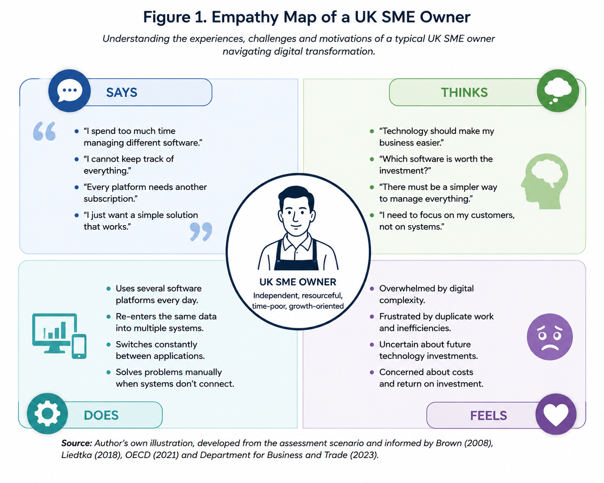 Figure 1 illustrates the experiences, behaviours and emotions of a typical UK SME owner navigating digital transformation.

Table 1. Summary of User Pain Points
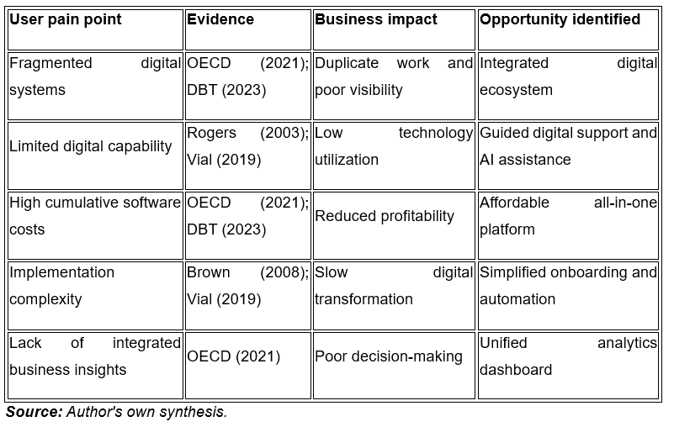

Market gaps
Identifying user pain points alone is not enough to justify entrepreneurial opportunity; innovation becomes commercially viable only when unmet needs coincide with deficiencies in existing market offerings (Brown, 2008; Liedtka, 2018). The next step is therefore to examine why current digital solutions fail to address these challenges.
The UK digital software market has expanded considerably, giving SMEs access to thousands of specialist applications for accounting, CRM, e-commerce and payments. However, this diversity has also produced a fragmented landscape where businesses must combine multiple platforms to perform routine tasks (OECD, 2021), meaning digital adoption has often become software accumulation rather than simplification.
A significant market gap therefore exists in the integration of business systems. Most software providers focus on solving a single business function rather than supporting the complete operational workflow of SMEs. For example, accounting platforms rarely integrate seamlessly with marketing tools, while customer relationship management systems may require additional third-party applications to connect with inventory management or online booking software. This fragmented approach transfers responsibility for system integration to business owners, increasing implementation complexity and operational costs (Vial, 2019; Department for Business and Trade, 2023).
A second gap concerns usability. Many platforms are built for organisations with dedicated IT expertise, and although simplified SME versions exist, implementation still requires time and technical knowledge. Rogers (2003) notes that perceived complexity strongly influences adoption, while businesses remain uncertain about selecting suitable technologies (Department for Business and Trade, 2023). Market success therefore depends as much on reducing cognitive effort for users as on functionality.
Another important gap relates to data fragmentation and business intelligence. SMEs frequently collect valuable information regarding customers, sales performance, inventory levels and marketing activities across multiple digital platforms. However, because these systems often operate independently, business owners struggle to obtain a unified overview of organisational performance. Vial (2019) argues that digital transformation generates value only when organisations are capable of integrating digital resources into coherent business processes. Without integrated data, decision-making becomes reactive rather than strategic, limiting the competitive benefits of digital technologies.
Furthermore, many existing software providers compete by continuously expanding product functionality. While additional features may increase technical capability, they can simultaneously reduce usability for smaller organisations with limited digital maturity. Norman (2013) argues that user-centered design should minimise unnecessary complexity by ensuring that products remain intuitive and aligned with users' actual tasks rather than technological possibilities. This suggests that the market opportunity is not necessarily to develop software with the greatest number of features, but to design solutions that reduce complexity while maintaining functionality.
Critically, the existence of market gaps does not imply that current providers are unsuccessful. Established platforms such as Shopify, Xero, HubSpot and Square have each demonstrated strong market demand within their respective domains. However, their success also illustrates that SMEs frequently depend upon several complementary systems operating simultaneously. The remaining opportunity therefore lies in replacing these individual platforms than in addressing the persistent integration, usability and coordination challenges that continue to affect users throughout their digital transformation journey.

Figure 2. Market Gap Analysis in the UK SME Digital Ecosystem
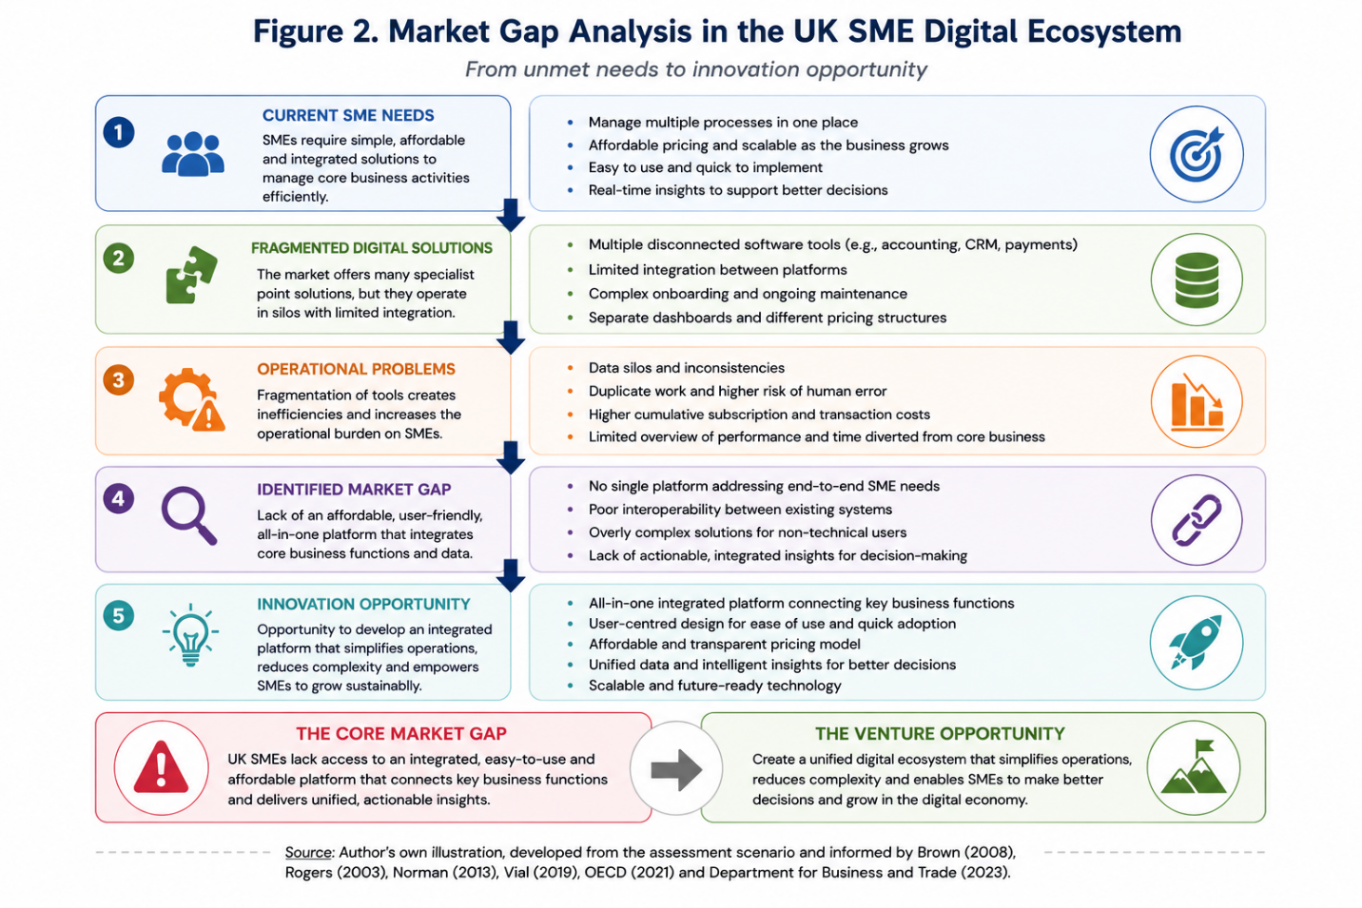

Table 2. PESTLE Analysis of the UK SME Digital Environment
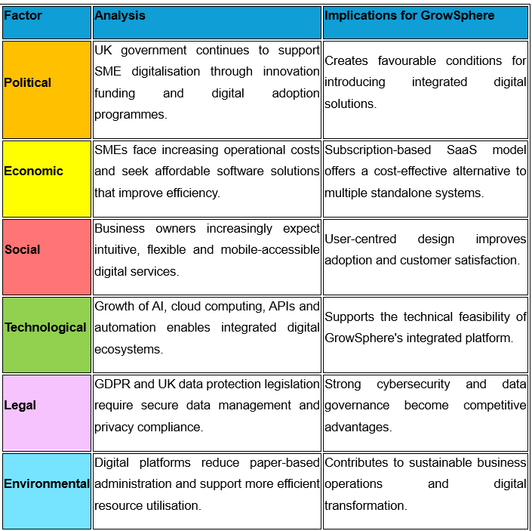

Technological Enablers
This market gap is reinforced by recent technological developments that have lowered barriers to digital innovation. Advances in cloud computing, AI, APIs and SaaS architectures now allow SMEs to integrate multiple operational functions and access enterprise-level capabilities without the investment traditionally required for bespoke systems (Vial, 2019; Rogers, 2003; OECD, 2021).
Cloud-based platforms provide scalable infrastructure that enables organisations to adopt digital solutions according to their business growth, reducing implementation costs while improving flexibility and accessibility. Simultaneously, AI-powered analytics enhance business decision-making by automating routine processes, identifying operational trends and generating real-time insights that support strategic planning. Such capabilities are increasingly important for SMEs that often operate with limited financial resources and managerial capacity (Department for Business and Trade, 2023; Brown, 2008; McKinsey & Company, 2023).
Moreover, API integration has transformed the digital business environment by enabling different software applications to exchange information seamlessly. Rather than replacing existing systems, integrated platforms can connect accounting software, payment gateways, customer relationship management systems and e-commerce applications into a unified ecosystem. This interoperability reduces duplicate data entry, minimise operational errors and improves organisational efficiency, thereby addressing many of the challenges identified in the previous section (Norman, 2013; OECD, 2021; Vial, 2019).
These technological developments demonstrate that the identified opportunity is not only desirable from a user perspective but also technically feasible. The convergence of cloud technologies, AI and system integration provides a practical foundation for developing innovative digital ventures capable of supporting SME digital transformation. Consequently, current technological capabilities create favorable conditions for introducing a user-centered platform that responds directly to the unmet needs identified through the market gap analysis while offering significant potential for long-term innovation and competitive advantage (Brown, 2008; Liedtka, 2018; Rogers, 2003).

Figure 3. Technology Opportunity Matrix for DME Digital Innovation
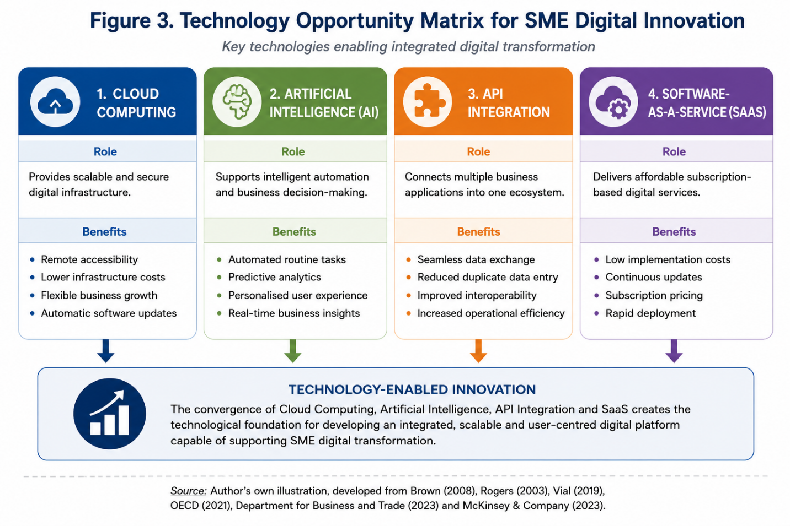
Figure 3 demonstrates how recent technological advances have transformed the feasibility of integrated digital solutions for SMEs.

Potential for Scalability and Sustainability
The identified opportunity shows considerable potential for scalability and sustainability, driven by increasing SME digitalisation and demand for integrated solutions. Organisations increasingly favour flexible, cloud-based platforms that expand alongside business growth without significant added investment, creating favourable conditions for scalable digital ventures (OECD, 2021; Department for Business and Trade, 2023; Rogers, 2003).
Scalability is supported by the characteristics of Software-as-a-Service (SaaS) business models, which enable digital platforms to serve increasing numbers of users while maintaining relatively low marginal operating costs. Unlike traditional software products, cloud-based solutions can continuously introduce new features, integrate additional services and respond rapidly to changing customer requirements without disrupting existing operations. This flexibility allows digital ventures to expand geographically and diversify their service offerings while maintaining operational efficiency (Vial, 2019; McKinsey & Company, 2023; Brown, 2008).
From a sustainability perspective, integrated digital platforms contribute to more efficient resource utilisation by reducing duplicated administrative activities, minimising manual processes and supporting data-driven decision-making. These improvements not only enhance organisational productivity but also encourage more responsible use of financial, technological and human resources. Furthermore, digital solutions that simplify business operations enable SMEs to strengthen their long-term resilience within increasingly competitive and technology-driven markets (Norman, 2013; OECD, 2021; Liedtka, 2018).
Beyond commercial viability, the opportunity also aligns with national priorities around digital innovation and productivity, as government strategies increasingly encourage digital adoption to improve business competitiveness (Department for Business and Trade, 2023; OECD, 2021; Brown, 2008). An integrated, user-centred ecosystem therefore represents both a commercially attractive venture and a contribution to wider economic development.

TASK 2

Empathising with Affected Users
Consistent with the Design Thinking approach outlined earlier, the empathy stage develops a deep understanding of users' experiences, behaviours and unmet needs (Brown, 2008; Liedtka, 2018). For UK SMEs, this involves understanding how business owners manage daily operations, interact with digital technologies and experience the challenges associated with fragmented software solutions.
The analysis conducted in Task 1 indicates that many SME owners experience increasing operational complexity due to the use of multiple disconnected applications for accounting, customer relationship management, payments and marketing. These fragmented systems require repeated data entry, increase administrative workloads and reduce the availability of accurate, real-time business information. As a result, many entrepreneurs devote considerable time to administrative activities rather than strategic decision-making and business development (OECD, 2021; Department for Business and Trade, 2023; Vial, 2019).
Applying empathy within the Design Thinking framework requires consideration of both functional and emotional user needs. Functionally, SME owners seek affordable, reliable and integrated digital solutions that simplify business management while supporting organisational growth. Emotionally, they value confidence, simplicity and control, preferring technologies that reduce uncertainty rather than increase complexity. These findings reinforce the importance of designing solutions that are intuitive, accessible and centred on user experience rather than technological sophistication alone (Norman, 2013; Brown, 2008; Liedtka, 2018).

Figure 4. Customer Journey of a UK SME Owner
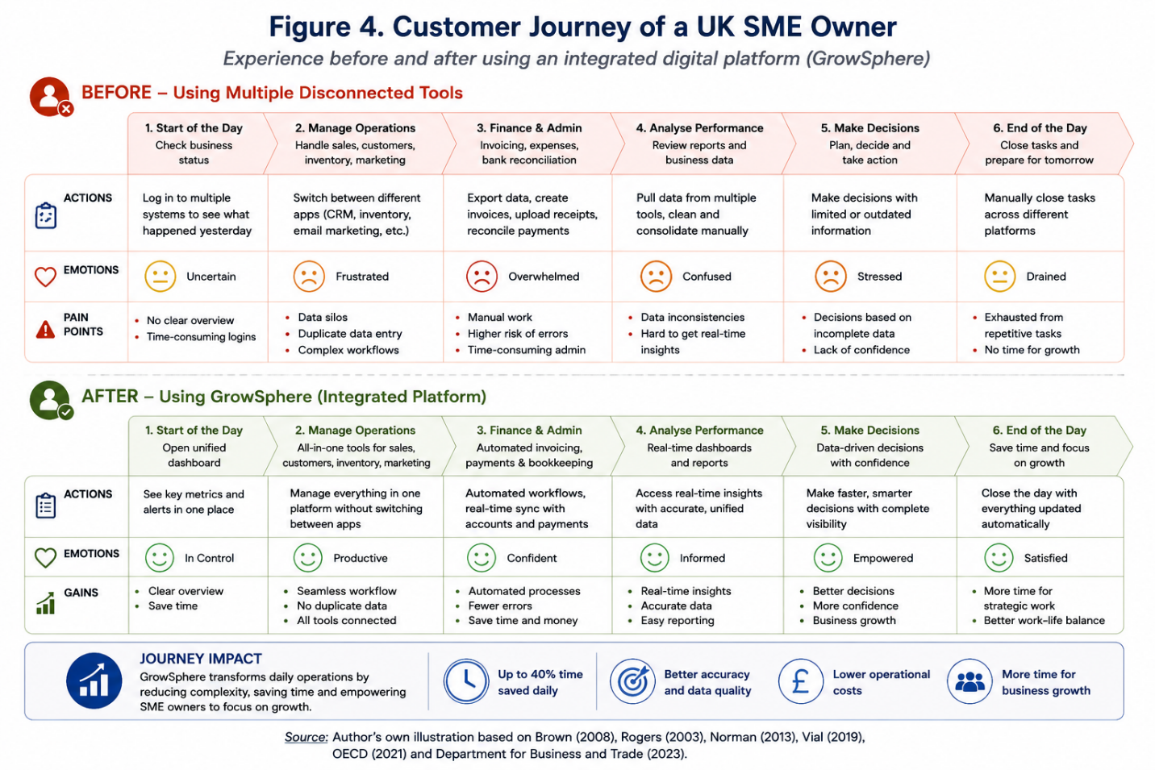
Figure 4 illustrates the customer journey of a UK SME owner before and after the adoption of an integrated digital platform.

Defining a Clear Problem Statement
Following the empathy stage, the Design Thinking process requires the information gathered from users to be synthesised into a clearly defined problem statement. Rather than focusing immediately on developing a technological solution, this stage seeks to identify the underlying challenge that prevents users from achieving their goals. A well-defined problem statement ensures that innovation is driven by genuine user needs rather than assumptions about technology or market trends (Brown, 2008; Liedtka, 2018).
The customer journey analysis revealed that UK SME owners experience persistent operational difficulties resulting from the use of multiple disconnected digital systems. Business activities such as accounting, customer relationship management, marketing, inventory management and payment processing are frequently performed using separate software applications that rarely communicate effectively with one another. Consequently, users are required to duplicate information, manually reconcile data and spend considerable time switching between platforms, reducing both productivity and decision-making efficiency (OECD, 2021; Department for Business and Trade, 2023; Vial, 2019).
These challenges extend beyond technical inefficiency: owners reported frustration and reduced confidence from fragmented information, limiting their ability to respond to changing conditions. The core issue is therefore not technology availability but the lack of an integrated, user-centred solution (Norman, 2013; Brown, 2008; Liedtka, 2018).
Based on the evidence collected during the empathy stage, the central problem can therefore be defined as follows:
UK SME owners lack an affordable, user-friendly and integrated digital platform that enables them to manage essential business functions within a single ecosystem, reducing operational complexity while providing reliable real-time information for effective decision-making.
This problem statement provides a clear direction for the remaining stages of the Design Thinking process. By defining the challenge from the users' perspective, it establishes a strong foundation for generating innovative solution ideas that directly address identified pain points rather than introducing unnecessary technological complexity. Consequently, the next stage focuses on exploring creative concepts capable of delivering meaningful value to SME owners through an integrated digital business ecosystem (Brown, 2008; Liedtka, 2018; Norman, 2013).

Figure 5. Design Thinking Problem Definition Framework
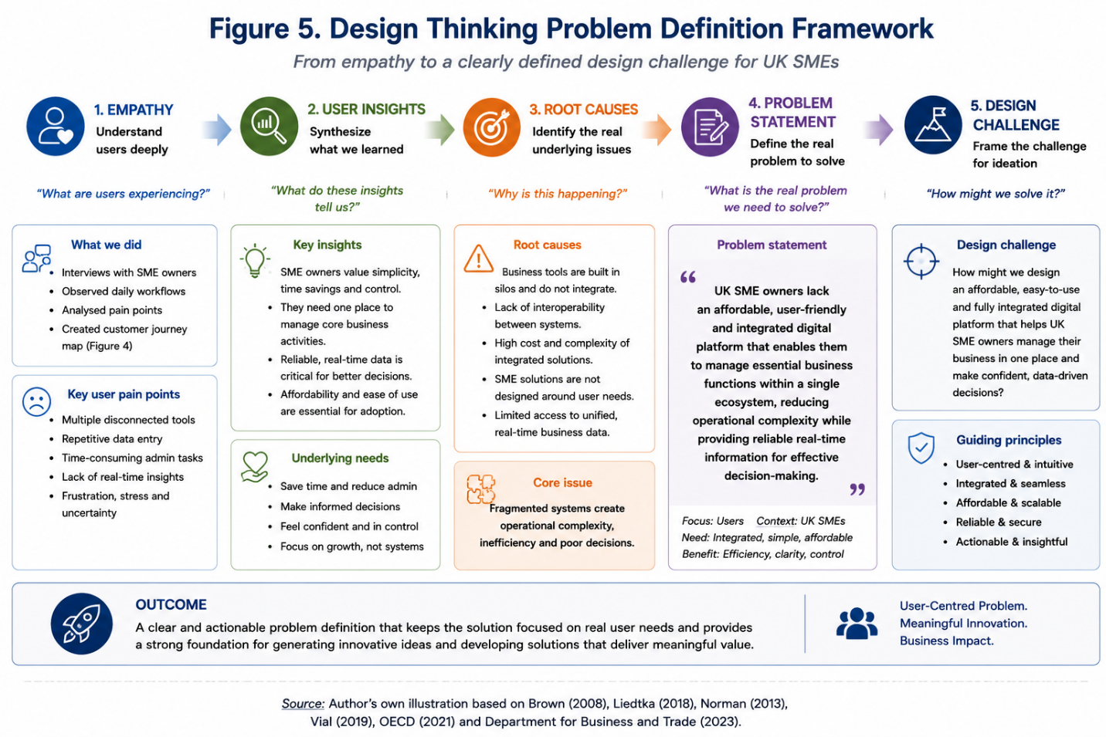

Generating Innovative Solution Ideas
Following the definition of the core problem, the Design Thinking process progresses to the ideation stage, where a broad range of potential solutions are explored before selecting the concept that best addresses identified user needs. The objective of this stage is to encourage creative thinking while ensuring that proposed ideas remain grounded in the evidence collected during the empathy and problem-definition phases. Effective ideation combines user-centred thinking with technological feasibility and commercial viability, enabling innovative ventures to deliver meaningful value to their target market (Brown, 2008; Liedtka, 2018).
Alternative concepts considered included a standalone CRM platform, an AI-powered finance application and a workflow automation tool; each addressed a single function, but none offered the comprehensive, integrated solution SME owners required (OECD, 2021; Rogers, 2003; Vial, 2019).
To overcome these limitations, the proposed solution is GrowSphere, an integrated digital business ecosystem specifically designed to simplify business management for UK SMEs. Rather than replacing existing software entirely, GrowSphere connects essential business functions including customer relationship management, invoicing, payments, inventory management, marketing and business analytics within a single intuitive platform. Through cloud-based architecture, API integration and AI-assisted insights, the platform enables business owners to manage daily operations more efficiently while improving the quality and speed of strategic decision-making (McKinsey & Company, 2023; Department for Business and Trade, 2023; Brown, 2008).
The concept has been developed according to the principles of Design Thinking by prioritising usability, accessibility and simplicity throughout the user experience. Instead of increasing technological complexity, GrowSphere aims to reduce administrative burden by providing a unified dashboard, automated workflows and real-time business insights. This user-centred approach addresses both the functional needs identified during the empathy stage and the emotional need for confidence, control and simplicity when managing business operations (Norman, 2013; Liedtka, 2018; Brown, 2008).
The ideation process therefore demonstrates that GrowSphere represents a feasible and innovative response to the identified market gap. By combining existing digital technologies within a single integrated ecosystem, the proposed venture has the potential to improve operational efficiency, support business growth and strengthen the long-term digital capabilities of UK SMEs. Consequently, the following stage focuses on translating this concept into a practical Minimum Viable Product (MVP) suitable for early testing and validation with potential users.

Figure 6. Idea Generation and Concept Selection Process
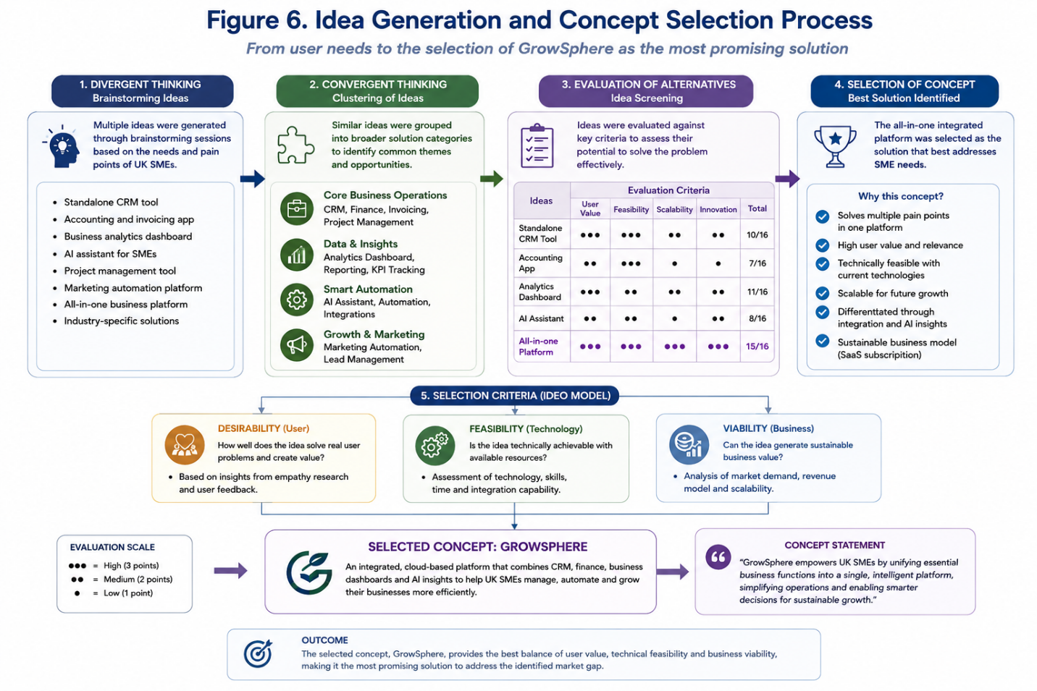
Source: Author's own illustration, developed from Brown (2008), Liedtka (2018), IDEO (2015), the Design Council Double Diamond Framework (2019), and informed by the assessment scenario.

Proposing a Prototype / Minimum Viable Product (MVP)
Following the ideation stage, the proposed solution is translated into a Minimum Viable Product (MVP), representing the first functional version of GrowSphere developed to validate the core assumptions of the business concept. Within the Design Thinking framework, an MVP enables entrepreneurs to test whether the proposed solution effectively addresses user needs while minimising development costs, implementation time and investment risk. Rather than delivering a fully featured product, the MVP focuses on the essential functionalities required to generate user feedback and support iterative improvement (Ries, 2011; Brown, 2008; Liedtka, 2018).
The proposed GrowSphere MVP is designed as a cloud-based digital platform that integrates the most critical business management functions within a single intuitive interface. The first version concentrates on providing the highest-value features identified during the empathy and ideation stages, ensuring that users can manage daily business activities without the need to switch between multiple software applications. This approach reflects the principle of delivering maximum customer value with minimum product complexity while enabling continuous refinement based on real user experience (Ries, 2011; Vial, 2019; Rogers, 2003).
The MVP consists of four core modules. The Customer Relationship Management (CRM) module enables users to manage customer information, monitor sales opportunities and maintain communication records in one place. The Finance Module supports invoicing, payment tracking and basic financial management, reducing manual administrative work. A Business Dashboard provides real-time visualisation of key performance indicators, allowing business owners to monitor operational performance efficiently. Finally, an AI Insights Module generates intelligent recommendations based on business data, supporting faster and more informed managerial decision-making (McKinsey & Company, 2023; Department for Business and Trade, 2023; Brown, 2008).
By limiting the initial version to these essential capabilities, the MVP enables early validation of the proposed value proposition while reducing technical complexity and development costs. User feedback obtained during the pilot phase will inform subsequent iterations, allowing additional modules such as inventory management, marketing automation and advanced business analytics to be incorporated as the platform evolves. This iterative approach is consistent with both the Design Thinking methodology and Lean Startup principles, emphasising continuous learning and user-centred product development (Ries, 2011; Brown, 2008; Liedtka, 2018).

Figure 7. GrowSphere Minimum Viable Product (MVP) Architecture
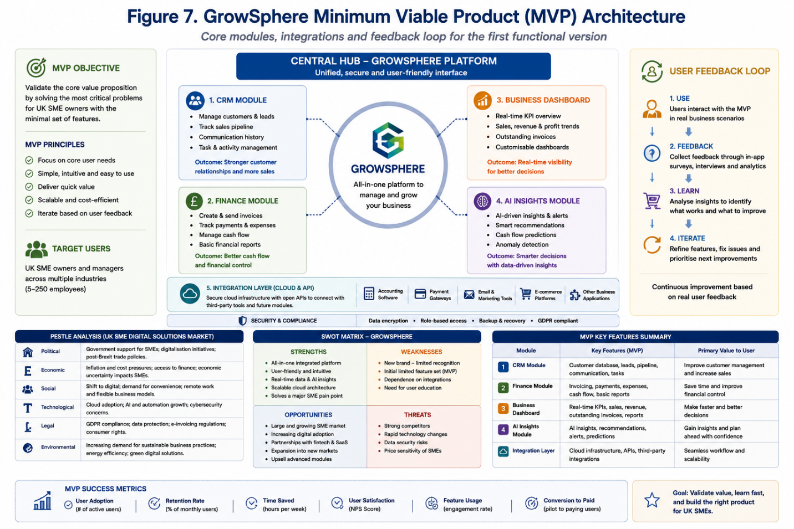
Source: Author's own illustration, developed from Ries (2011), Brown (2008), Osterwalder and Pigneur (2010), Blank and Dorf (2012), and informed by the assessment scenario.

Table 3. SWOT Analysis of GrowSphere
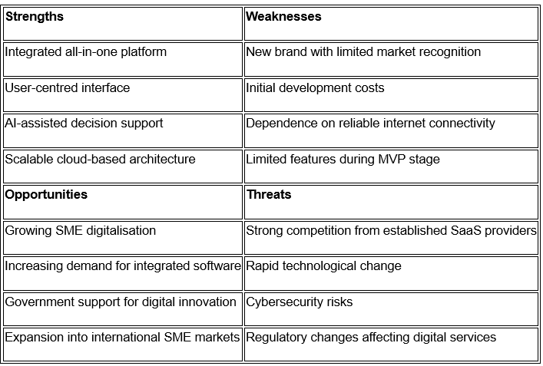
Source: Author's own analysis, developed from Gürel and Tat (2017), Brown (2008), OECD (2021), Department for Business and Trade (2023), and informed by the assessment scenario.

Testing and Refinement
The final stage focuses on testing the proposed solution with representative users, viewed as an ongoing learning process rather than a final evaluation (Brown, 2008; Liedtka, 2018). The objective is to identify usability issues, validate customer assumptions and improve the overall user experience before significant financial and technical resources are committed to full-scale development (Brown, 2008; Liedtka, 2018).
For the GrowSphere MVP, initial testing would involve a pilot programme with a small sample of UK SMEs representing different industries and organisational sizes. Participants would be asked to complete common business activities using the platform, including customer management, invoice generation, dashboard monitoring and AI-assisted decision support. Their interactions would be observed through usability testing, semi-structured interviews and user satisfaction surveys to identify functional limitations and opportunities for improvement (Norman, 2013; Ries, 2011; Vial, 2019).
Both quantitative and qualitative performance indicators would be used to evaluate the effectiveness of the MVP. Quantitative measures could include task completion time, reduction in manual administrative activities, user retention, feature adoption rates and Net Promoter Score (NPS). Qualitative feedback would explore users' perceptions of usability, perceived value, ease of navigation and overall satisfaction. Combining these data sources would provide a comprehensive understanding of how effectively the platform addresses the needs identified during the empathy stage (Brown, 2008; McKinsey & Company, 2023; OECD, 2021).
The findings obtained through testing would inform successive product iterations by prioritising feature enhancements, simplifying user workflows and improving system integration. Additional functionalities, including inventory management, marketing automation and advanced predictive analytics, could be introduced progressively as user requirements evolve. This iterative refinement process reflects the core principles of both Design Thinking and Lean Startup, ensuring that the venture remains responsive to changing customer needs while continuously improving its value proposition (Ries, 2011; Liedtka, 2018; Rogers, 2003).

Table 4. MVP Testing and Validation Plan
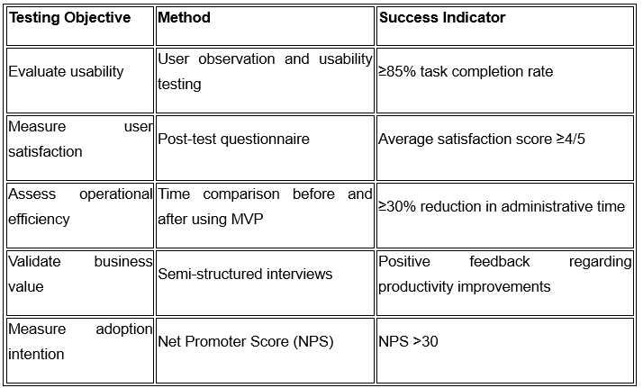

Conclusion
This portfolio applied Design Thinking to address the operational challenges facing UK SMEs, identifying digital fragmentation, duplicated administration and limited access to integrated information as persistent pain points, and establishing a clear commercial justification for innovation within this ecosystem (OECD, 2021; Department for Business and Trade, 2023; Vial, 2019).
Applying the five Design Thinking stages ensured the venture remained focused on genuine customer problems rather than technology for its own sake, reducing innovation risk and increasing the likelihood of market acceptance (Brown, 2008; Liedtka, 2018; Norman, 2013).
GrowSphere, the proposed venture, integrates CRM, financial administration, business analytics and AI-assisted insights within a single cloud-based platform, while the MVP and testing strategy demonstrate how iterative development enables continuous refinement before wider implementation (Ries, 2011; McKinsey & Company, 2023; Rogers, 2003).
Ultimately, successful innovation depends on understanding user needs and market conditions as much as technology, and GrowSphere offers a practical, viable response to UK SMEs' digital transformation needs with strong potential for sustainable competitive advantage (Brown, 2008; OECD, 2021; Department for Business and Trade, 2023).

Reference
Bocken, N.M.P., Short, S.W., Rana, P. and Evans, S. (2014) ‘A literature and practice review to develop sustainable business model archetypes’, Journal of Cleaner Production, 65, pp. 42–56.
Blank, S. (2013) The Four Steps to the Epiphany. 2nd edn. California: K&S Ranch.
Brown, T. (2008) ‘Design Thinking’, Harvard Business Review, 86(6), pp. 84–92.
Brown, T. (2009) Change by Design. New York: Harper Business.
Chesbrough, H. (2003) Open Innovation. Boston: Harvard Business School Press.
Department for Business and Trade (2023) Small Business Survey 2023: SME Employers in the UK. London: DBT.
Dorst, K. (2015) Frame Innovation. Cambridge, MA: MIT Press.
European Commission (2023) Annual Report on European SMEs 2022/2023. Brussels: European Commission.
ISO (2019) ISO 9241-210: Ergonomics of Human-System Interaction – Human-centred Design for Interactive Systems. Geneva: ISO.
Kotler, P., Kartajaya, H. and Setiawan, I. (2021) Marketing 5.0: Technology for Humanity. Hoboken: Wiley.
Liedtka, J. (2018) Why Design Thinking Works. Boston: Harvard Business Review Press.
McKinsey & Company (2023) The State of Organisations 2023. New York: McKinsey.
Norman, D.A. (2013) The Design of Everyday Things. Revised edn. New York: Basic Books.
OECD (2021) The Digital Transformation of SMEs. Paris: OECD Publishing.
OECD (2023) SME and Entrepreneurship Outlook 2023. Paris: OECD Publishing.
Osterwalder, A. and Pigneur, Y. (2010) Business Model Generation. Hoboken: John Wiley & Sons.
Osterwalder, A. and Pigneur, Y. (2014) Value Proposition Design. Hoboken: John Wiley & Sons.
Porter, M.E. (1985) Competitive Advantage. New York: Free Press.
Ries, E. (2011) The Lean Startup. New York: Crown Business.
Rogers, E.M. (2003) Diffusion of Innovations. 5th edn. New York: Free Press.
Statista (2024) Digital Transformation in SMEs. Hamburg: Statista.
Teece, D.J. (2018) ‘Business models and dynamic capabilities’, Long Range Planning, 51(1), pp. 40–49.
UK Government (2022) Help to Grow: Digital Scheme. London: HM Government.
Vial, G. (2019) ‘Understanding Digital Transformation: A Review and a Research Agenda’, Journal of Strategic Information Systems, 28(2), pp. 118–144.
World Economic Forum (2023) Future of Jobs Report 2023. Geneva: World Economic Forum.

