Web Development Assignment 1
Submission date: May 3rd, 3:00pm
Jonty Phillips – 2115836

Table of Contents –
Introduction
Requirements
Implementation
Evaluation
References
Appendices

Introduction
The website I have designed is based on my hobby of skateboarding, with the purpose of introducing new people to the sport and showing them the basics. The intended target audience would be anyone that would be willing to start getting into skateboarding, most commonly from a young age (around 10 to 15) but people above this age range could also be included.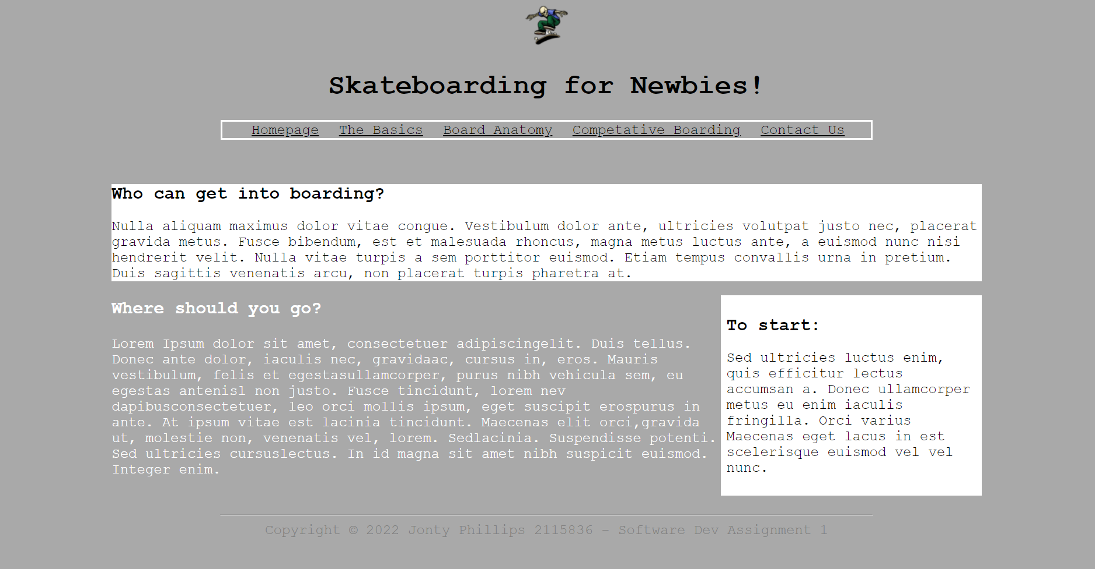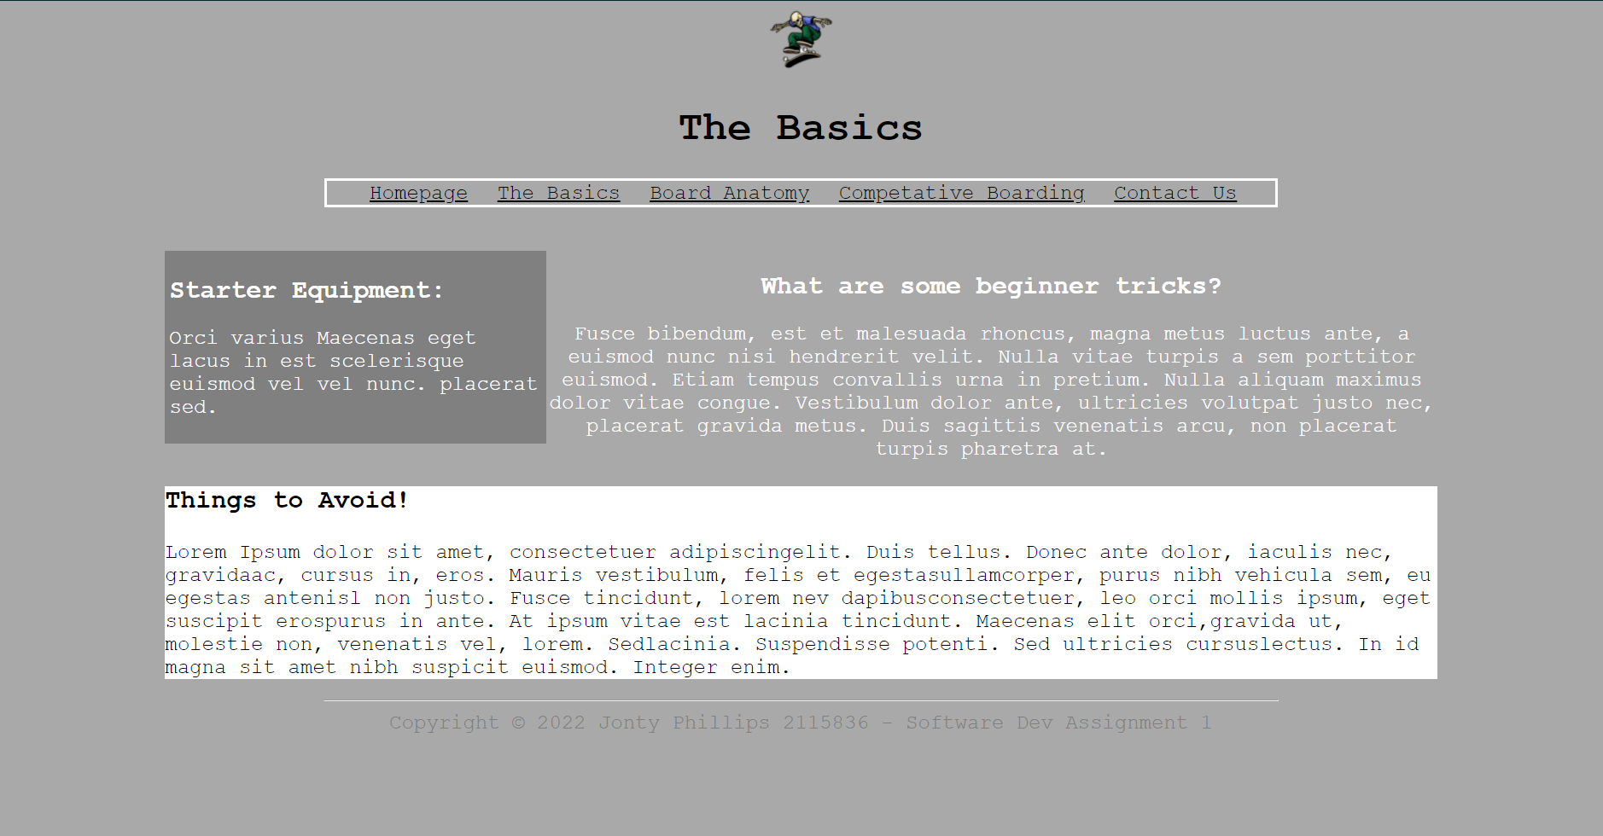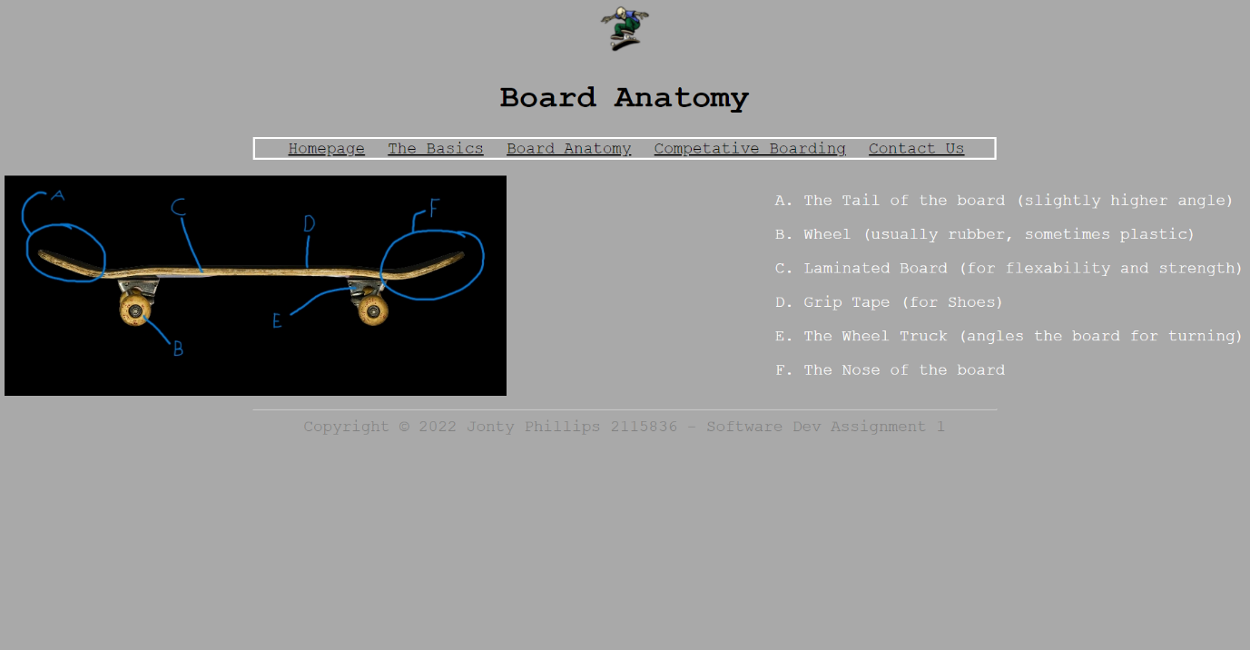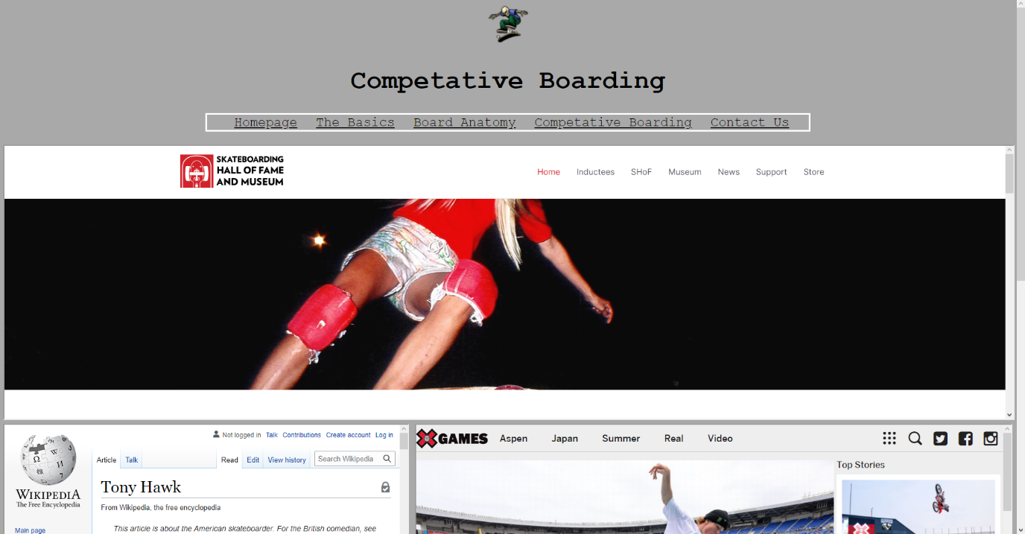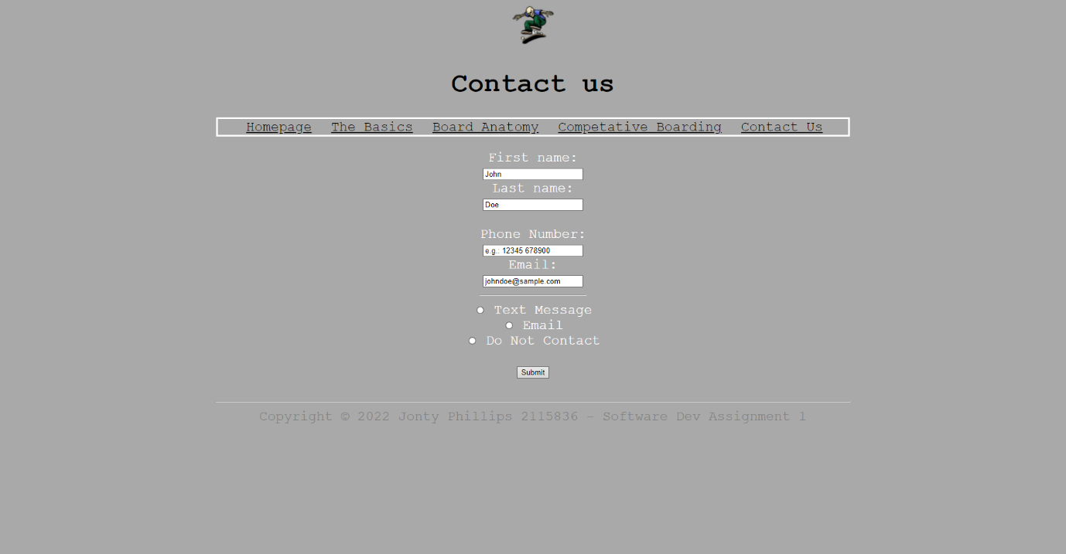
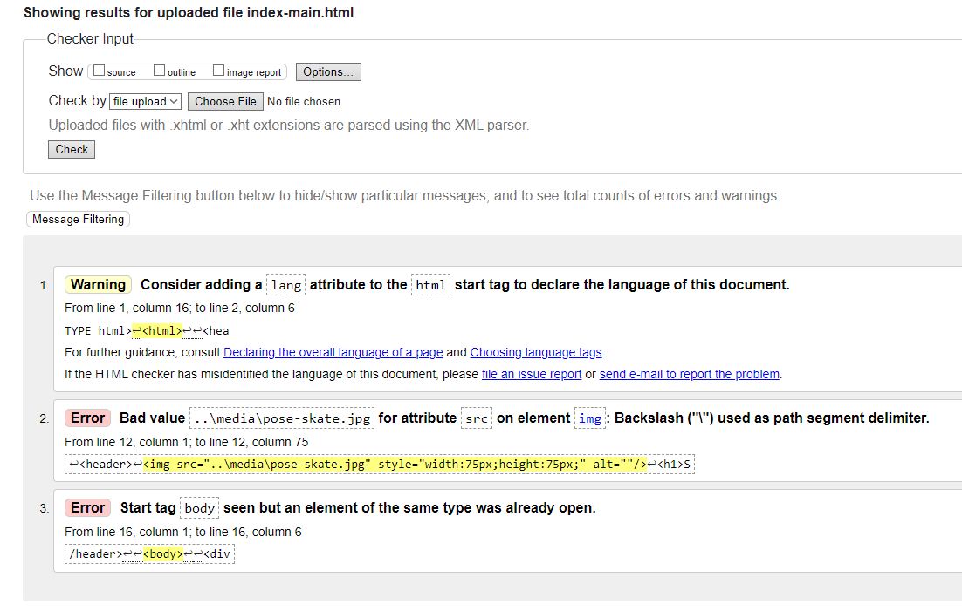
This is the validation of my main html page, it shows 1 warning and 2 errors, all of which I tried to correct but couldn’t find a way to fix – functionally however, they impact the web page in no noticeable way.

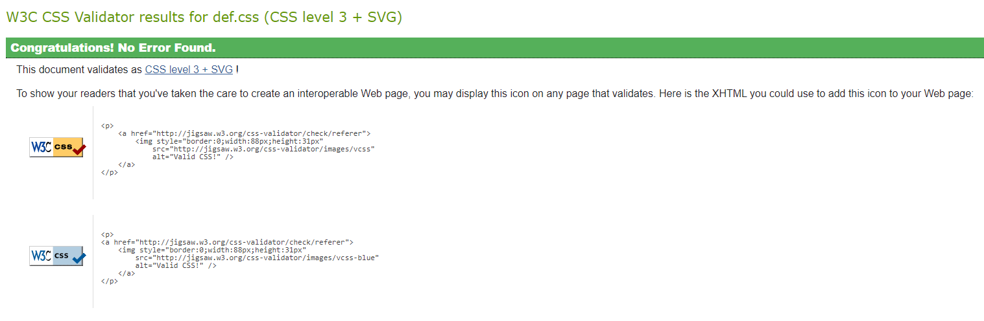
My CSS document however showed no errors and fully validates.
˝Unless a web site meets the needs of the intended users it will not meet the needs of the organization providing the web site. Web site development should be user-centred, evaluating the evolving design against user requirements˝ [Ref 1]
Website usability is the presentation of information in a defined way, that allows readers to easily access and read said information, as well as enabling the webpage itself to work across different browsers and devices.
According to “Usability Issues in Web Site Design” websites that are limited in the information they share show a sign of “corporate incompetence” , however, to avoid this a web developer must take the user into consideration and focus the design process on them whenever possible.
Similar to its real-world counterpart, web accessibility is the practice of making webpages that aren’t hindered if the user has a disability, like being colour-blind or hard-of-hearing.
“The needs that web accessibility aims to address include:
- Visual
- Motor/mobility
- Auditory
- Seizures
- Cognitive and intellectual” – [Ref 2]
According to "Web Accessibility: An Introduction" [Ref 3], over one billion people have a permanent disability, meaning some websites don’t cater themselves to 15% of the world’s population. Also, according to [Ref 3], a company could be victim to a lawsuit because of a user that cannot use their website, and within America the “Title III of the Americans with Disabilities Act” has been passed, which essentially allows websites to be labelled discriminatory.
“The process of improving the quality and quantity of website traffic to a website or a web page from search engines” – [Ref 4]
SEO is also used by online companies to manipulate how multiple search engines work and discover which search engines are the most used for certain queries/tasks.
According to "Classifying Web Search Queries in Order to Identify High Revenue Generating Customers.”, if a corporation understands the way internet traffic effects them, they understand the way users behave when submitting keywords. In the article, they explain a research task using 712,643 keywords from a Spanish music site, and how they could work out clickthrough rate and revenue.
As far as the feel of my website goes, its pretty simple to use – with the page bar being located at the top at all times and all information being shown on screen without the need to scroll through it. For its utility, I feel as though it does what it was designed to – inform and show clear concise information for someone who wants to become a beginner skater. For this webpage I didn’t optimise my webpages as I didn’t feel as though they needed to be with how simple they are in regard to complexity and demand.

References –
[1] "Usability Issues in Web Site Design" (PDF). Bevan, Nigel (April 1998).
[2] https://en.wikipedia.org/wiki/Web_accessibility
[3] "Web Accessibility: An Introduction". Treehouse Blog. 30 July 2020
[4] https://en.wikipedia.org/wiki/Search_engine_optimization
[5] "Classifying Web Search Queries in Order to Identify High Revenue Generating Customers." Journal of the American Society for Information Sciences and Technology

Appendices –
CSS ------
header{
color:black;
font-family:Courier;
font-size:24px;
font-weight:bold;
text-align:center;
}

#page-bar > li {
display:inline;
padding:10px;
text-decoration:none;
list-style:none;

}
#page-bar{
border:solid 3.5px;
}
.pagebar-content{
width:60%;
margin:auto;
}
a{
color:black;
}
a:hover{
color:red;
}

#showcase{
background:url("..\media\background.jpg");
}

body{
background-color:darkgrey;
color:white;
font-family:Courier;
font-size:24px;
font-weight:normal;
}

h2{
font-size:30px;
font-weight:bold;
}

h3{
font-size:30px;
font-weight:bold;
}

.content{
width:80%;
margin:auto;
}

#sidebar1{
float:right;
width:30%;
background-color:white;
color:black;
padding:10px;
box-sizing:border-box;
}
#sidebar2{
float:left;
width:30%;
background-color:grey;
color:white;
padding:5px;
box-sizing:border-box;
}
#board-layout{
float:right;
text-align:left;
}

.para1{
background-color:white;
color:black;
}
.para2{
color:white;
}
.column1{
text-align:left;
}
.column2{
text-align:right;
}

.contactus{
text-align:center;
}
#page-bar{
border:solid 3.5px;
}

footer{
text-align:center;
color:grey;
}
Page 1 -----------
<!DOCTYPE html>
<html>

<head>
<meta charset="utf-8" />
<title> Skateboard Home </title>
<link rel="stylesheet" type="text/css"
href="def.css">
</head>

<header>
<img src="..\media\pose-skate.jpg" style="width:75px;height:75px;" alt=""/>
<h1>Skateboarding for Newbies!</h1>
</header>

<body>

<div class="pagebar-content">

<ul id="page-bar">
<li><a href="index-main.html">Homepage</a></li>
<li><a href="page2.html">The Basics</a></li>
<li><a href="page3.html">Board Anatomy</a></li>
<li><a href="page4.html">Competative Boarding</a></li>
<li><a href="page5.html">Contact Us</a></li>
</ul>
</div>

<div class="content">
<br/>

<div class="para1">
<section id="main">
<h2>Who can get into boarding?</h2>
<p>Nulla aliquam maximus dolor vitae congue. Vestibulum dolor ante, ultricies volutpat justo nec, placerat gravida metus. Fusce bibendum, est et malesuada rhoncus, magna metus luctus ante, a euismod nunc nisi hendrerit velit. Nulla vitae turpis a sem porttitor euismod. Etiam tempus convallis urna in pretium. Duis sagittis venenatis arcu, non placerat turpis pharetra at.
</p>
</section>

<aside id="sidebar1">
<h2>To start:</h2>
<p>Sed ultricies luctus enim, quis efficitur lectus accumsan a. Donec ullamcorper metus eu enim iaculis fringilla. Orci varius Maecenas eget lacus in est scelerisque euismod vel vel nunc.<p>
</aside>

</div>

<div class="para2">
<h3> Where should you go? </h3>
<p>
Lorem Ipsum dolor sit amet, consectetuer adipiscingelit. Duis tellus. Donec ante dolor, iaculis nec, gravidaac, cursus in, eros. Mauris vestibulum, felis et egestasullamcorper, purus nibh vehicula sem, eu egestas antenisl non justo. Fusce tincidunt, lorem nev dapibusconsectetuer, leo orci mollis ipsum, eget suscipit erospurus in ante. At ipsum vitae est lacinia tincidunt. Maecenas elit orci,gravida ut, molestie non, venenatis vel, lorem. Sedlacinia. Suspendisse potenti. Sed ultricies cursuslectus. In id magna sit amet nibh suspicit euismod. Integer enim.
</p>
</div>
</div>
<br/>

<hr style = "width:60%">
<footer> Copyright © 2022 Jonty Phillips 2115836 - Software Dev Assignment 1 </footer>

</body>
</html>
Page 2 --------
<!DOCTYPE html>
<html>

<head>
<meta charset="utf-8" />
<title> Basics of the Board </title>
<link rel="stylesheet" type="text/css"
href="def.css">
</head>

<header>
<img src="..\media\pose-skate.jpg" style="width:75px;height:75px;"/>
<h1>The Basics</h1>
</header>

<body>

<div class="pagebar-content">

<ul id="page-bar">
<li><a href="index-main.html">Homepage</a></li>
<li><a href="page2.html">The Basics</a></li>
<li><a href="page3.html">Board Anatomy</a></li>
<li><a href="page4.html">Competative Boarding</a></li>
<li><a href="page5.html">Contact Us</a></li>
</div>
<div class="content">
<br/>

</ul>

<aside id="sidebar2">
<h2>Starter Equipment:</h2>
<p>Orci varius Maecenas eget lacus in est scelerisque euismod vel vel nunc. placerat sed. <p>
</aside>

<div class="para2">
<section id="main" >
<h2><center>What are some beginner tricks?</center></h2>
<p><center>Fusce bibendum, est et malesuada rhoncus, magna metus luctus ante, a euismod nunc nisi hendrerit velit. Nulla vitae turpis a sem porttitor euismod. Etiam tempus convallis urna in pretium. Nulla aliquam maximus dolor vitae congue. Vestibulum dolor ante, ultricies volutpat justo nec, placerat gravida metus. Duis sagittis venenatis arcu, non placerat turpis pharetra at.
</center></p>
</section>
</div>

<div class="para1">
<h3> Things to Avoid! </h3>
<p>
Lorem Ipsum dolor sit amet, consectetuer adipiscingelit. Duis tellus. Donec ante dolor, iaculis nec, gravidaac, cursus in, eros. Mauris vestibulum, felis et egestasullamcorper, purus nibh vehicula sem, eu egestas antenisl non justo. Fusce tincidunt, lorem nev dapibusconsectetuer, leo orci mollis ipsum, eget suscipit erospurus in ante. At ipsum vitae est lacinia tincidunt. Maecenas elit orci,gravida ut, molestie non, venenatis vel, lorem. Sedlacinia. Suspendisse potenti. Sed ultricies cursuslectus. In id magna sit amet nibh suspicit euismod. Integer enim.
</p>
</div>
</div>

<hr style = "width:60%">
<footer> Copyright © 2022 Jonty Phillips 2115836 - Software Dev Assignment 1 </footer>

</body>
</html>
Page 3 -------
<!DOCTYPE html>
<html>

<head>
<meta charset="utf-8" />
<title> Board Anatomy </title>
<link rel="stylesheet" type="text/css"
href="def.css">
</head>

<header>
<img src="..\media\pose-skate.jpg" style="width:75px;height:75px;"/>
<h1>Board Anatomy</h1>
</header>

<body>

<div class="pagebar-content">

<ul id="page-bar">
<li><a href="index-main.html">Homepage</a></li>
<li><a href="page2.html">The Basics</a></li>
<li><a href="page3.html">Board Anatomy</a></li>
<li><a href="page4.html">Competative Boarding</a></li>
<li><a href="page5.html">Contact Us</a></li>
</div>

<section>
<aside id="board-layout">
<p>A. The Tail of the board (slightly higher angle)</p>
<p>B. Wheel (usually rubber, sometimes plastic)</p>
<p>C. Laminated Board (for flexability and strength)</p>
<p>D. Grip Tape (for Shoes)</p>
<p>E. The Wheel Truck (angles the board for turning)</p>
<p>F. The Nose of the board</p>
</aside>
<img src="..\media\skateboard.jpg"
</section>
<br/>

<hr style = "width:60%">
<footer> Copyright © 2022 Jonty Phillips 2115836 - Software Dev Assignment 1 </footer>

</body>
</html>
Page 4 -------
<!DOCTYPE html>
<html>

<head>
<meta charset="utf-8" />
<title> Competative Boarding </title>
<link rel="stylesheet" type="text/css"
href="def.css">
</head>

<header>
<img src="..\media\pose-skate.jpg" style="width:75px;height:75px;"/>
<h1>Competative Boarding</h1>
</header>

<body>

<div class="pagebar-content">

<ul id="page-bar">
<li><a href="index-main.html">Homepage</a></li>
<li><a href="page2.html">The Basics</a></li>
<li><a href="page3.html">Board Anatomy</a></li>
<li><a href="page4.html">Competative Boarding</a></li>
<li><a href="page5.html">Contact Us</a></li>
</div>

<div class = "column1">
<iframe src="https://skateboardinghalloffame.org/" width="100%" height="500"></iframe>
<iframe src="https://en.wikipedia.org/wiki/Tony_Hawk" width="40%" height="500"></iframe> <iframe src="http://www.xgames.com/" width="59%" height="500" align="right"></iframe>
<iframe src="https://en.wikipedia.org/wiki/Skateboarding_sponsorship" width="59%" height="500"></iframe> <iframe src="https://en.wikipedia.org/wiki/Lizzie_Armanto" width="40%" height="500" align="right"></iframe>
</div>

<hr style = "width:60%">
<footer> Copyright © 2022 Jonty Phillips 2115836 - Software Dev Assignment 1 </footer>

</body>
</html>
Page 5 -------
<!DOCTYPE html>
<html>

<head>
<meta charset="utf-8" />
<title> Contact us </title>
<link rel="stylesheet" type="text/css"
href="def.css">
</head>

<header>
<img src="..\media\pose-skate.jpg" style="width:75px;height:75px;"/>
<h1>Contact us</h1>
</header>

<body>

<div class="pagebar-content">

<ul id="page-bar">
<li><a href="index-main.html">Homepage</a></li>
<li><a href="page2.html">The Basics</a></li>
<li><a href="page3.html">Board Anatomy</a></li>
<li><a href="page4.html">Competative Boarding</a></li>
<li><a href="page5.html">Contact Us</a></li>
</div>

<div class="contactus">
<form action="action_page.php">
<label for="fname">First name:</label><br>
<input type="text" id="fname" name="fname" value="John"><br>
<label for="lname">Last name:</label><br>
<input type="text" id="lname" name="lname" value="Doe"><br>
<br>
<label for="FNumber">Phone Number:</label><br>
<input type="text" id="fnum" name="fnum" value="e.g.: 12345 678900"><br>
<label for="Email">Email:</label><br>
<input type="text" id="inputemail" name="inputemail" value="johndoe@sample.com"><br>
<hr style = "width:10%"/>
<input type="radio" id="text" name="preferred_contact" value="Text">
<label for="html">Text Message</label><br>
<input type="radio" id="email" name="preferred_contact" value="Email">
<label for="css">Email</label><br>
<input type="radio" id="donotcontact" name="preferred_contact" value="DoNotContact">
<label for="javascript">Do Not Contact</label><br>
<br>
<input type="submit" value="Submit"><br>
<br>
</form>
</div>

<hr style = "width:60%">
<footer> Copyright © 2022 Jonty Phillips 2115836 - Software Dev Assignment 1 </footer>

</body>
</html>

