  Component One: Student Journal (learning log) 750 words +/- 10% | Student No: | Zakia Sultana Rahman  2211724
 | Module Title: | Hotel Administration and Front Office
 | Module Code: | BMIH4004
 | Lecturer: | Muhammad Cassamo
The employees in the hotel front office need to go through diversified activities throughout their job and for doing that the employees of the hotel front office require a huge number of skills (Tewari, 2020). In this component, the skills that are highly required for managing or working within the hotel front office will be discussed in this paper. Then I will provide a reflection on my experience in working in the hotel front office of Holiday Inn of Sunderland where I will use the Gibbs Reflective Cycle as a model of reflective practice.
There exist various types of skills that are required to work in a hotel front office the major ones are mentioned below:
Communication skill is one of the most crucial skills that is required to work in a hotel front office and the reason behind that is communication skill is the one that helps an employee of a hotel front office in working his tasks properly (Merhaut et al., 2017). The major task of an employee of a hotel front office is to communicate with a huge number of guests as well as with the upper management regarding hotel management activities and that is the reason why becoming an employee of a hotel front office the communication skills a must.
Time Management is another important skill that is required by an employee of the hotel front office (Melad et al., 2021). The reason behind mentioning this skill as a requirement of an employee of the hotel front office is that without proper time management skills an employee cannot help the customers of the hotel and as customer service is the major priority of the hotel front office department, time management skills become a must skill that the employees need to have if they want to work with hotel front office.
Problem-solving skills can be mentioned as a helpful skill for an employee to work in a hotel front office. The reason behind that is problem-solving. It helps an employee of this department to find a quick solution to the problem that the customer is having or the customer is complaining about (Sayin and Karaman, 2019). This skill also helps the employee to provide better-quality customer service to the customers of the hotel and that is the reason why this skill is necessary for an employee of the hotel front office (Ishizaka et al., 2019).
Multilingual Proficiency is nowadays a highly required skill for an employee of the hotel front office. And the reason behind that is nowadays travelling from one country to another has become easier for the people of the world and because of that hotel organisations need to deal with a huge number of people from different countries who use different types of languages. As the employees of the hotel front office are the ones who face customers with different languages, multilingual proficiency nowadays becomes a must-acquiring skill for the ones who want to work in a hotel front office (Bardi, 2011).
To discuss the experience and learnings of my organisational placement which was in the Holiday Inn of Sunderland I am presenting my reflection with the use of the Gibbs reflective cycle which is one of the most popular reflective models to date.
The first step of Gibbs's reflective cycle is description (Williams et al., 2020). To discuss this part, I need to say that my placement organisation was the Holiday Inn of Sunderland which is one of the most popular hotels in the hotel industry. I have learned several hotel management skills and have gone through practical experiences by working there. To discuss my feelings part which is the second step of the reflective model I need to mention that firstly I was nervous about my placement work as this is the first time I am working for an organisation directly but as an employee of the hotel front office department was friendly, I enjoyed my time of the placement there. Then for the part of evaluation, it can be said that I have found it positive that the hotel front office team was friendly to me but on the contrary, it was a tough placement for me in the perspective of time management and communication perspective. And to discuss the analysis part I can say that I have developed my time management skills and communication skills properly by going through this placement activity. In conclusion part it needs to be said that overall, it was a great experience for me to work in this hotel industry organisation for my career. In the action plan or last part of the reflection, I am planning to improve some of my skills such as analytical skills and problem-solving skills so that I can do better in the hotel front office in future.

Component Two

Trip Advisor Review Response
Thank you so much for your lovely and insightful review regarding the hotel management and customer service management of Hotel Inn Sunderland, Voyage521566. We are really honoured that you have loved our services alongside the hotel environment and staff behaviour within the hotel. It is always satisfactory for us to receive such an overwhelming review and feedback from a customer as we always try to give our best to satisfy the customers in Hotel Inn Sunderland with proper customer services and with proper infrastructures and features within the hotel. And we really are grateful that you have found our staff friendly and helpful as you are satisfied with the performance and behaviour of our staff.
We will be looking forward to have you again soon in future in Hotel Inn Sunderland. Thank you once again for your time in providing this amazing review regarding Hotel Inn Sunderland through Trip Advisor.

Screen shot of referenced Trip Advisor review used:
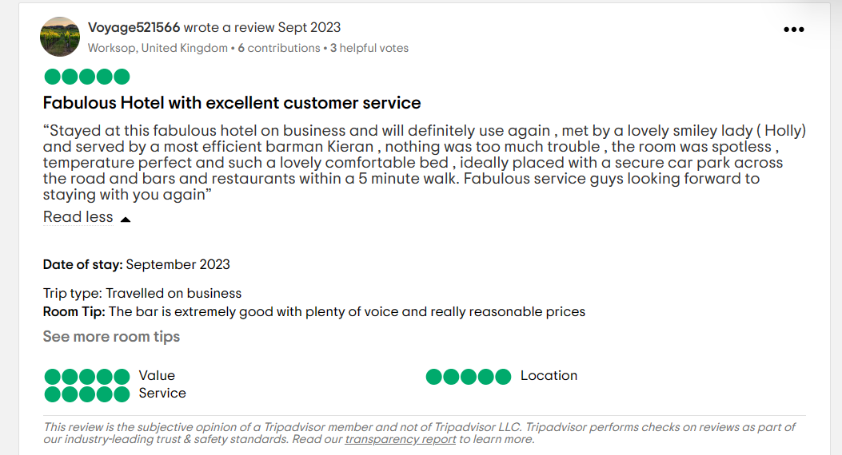
Figure 1: Review of Hotel Inn Sunderland in Trip Advisor
Source:(TripAdvisor, 2023)
Letter of complaint response
Mr. Ronald Federick
17 Trinity Court
Swansea
SA1 2AR

Subject: Response to Your Complaint

Dear Sir,
I hope you are well by the grace of almighty. I would like to start this letter with my deep apologies for the inconvenience that you have mentioned about our hotel management and services of Holiday Inn Sunderland. According to your feedback regarding our hotel service the visit of yours on Saturday 26th of August in room 205 was dissatisfactory as there were several issues like breakfast taste, noisy environment, room cleanliness issue etc. Your feedback is very precious to us and that is the reason why in this letter I will be explaining all the issues that you have mentioned in the letter properly.
Breakfast Quality: According to your feedback the breakfast that was served to you was cold as well it was tasteless. I am really sorry about that as I understand the necessity of a proper breakfast at the start of the day and I am expressing my deepest apologies as you had gone through something like this at our hotel. I am taking immediate action for reviewing this breakfast issue and I will be ensuring that no further issues regarding food service happen in the future.
Noise Disturbance: According to your feedback sleeping was nearly impossible for you as there were noises of the baby crying in the neighbour's room. I am expressing my sincere apologies for this noise disturbance as I understand the need for proper sleep and noise free environment at night and that is the reason why I am going to take immediate action at the hotel services so that it can be ensured that no guest suffer any noise disturbance like this at Holiday Inn Sunderland from now on.
Room Cleanliness: According to your feedback the room was not clean as there was hair in the room and the toilet was not clean. In response to this, I want to say that I am very sorry about this issue that you had to face in our hotel. For better experiences in future, I am taking action immediately so that in future no guest needs to experience something like this.
As a gesture of goodwill, I would like to offer you a complimentary one-night stay at Holiday Inn Sunderland according to your preference. This time I will be ensuring that your satisfaction is met with our hotel services.
Hence, once again I am expressing my apologies regarding those bad experiences that you had to go through and I am looking forward to serving you better once you come to our hotel again in the near future. Thank you so much again for mentioning these issues as these issues will help us provide better services to our guests in future as we are working now to improve the services that you have mentioned as faulty.
Yours sincerely,
Zakia
Guest Relations Manager
Holiday Inn Sunderland

Component Three:
Essay on “Hotel Guest Cycle”
The hotel guest cycle includes four important phases of hotel guest management that are to be maintained well by the employees of hotel management organisations if the organisations want to do well in the hotel or hospitality industry. Pre-arrival, arrival, duration of stay and departure, these four are the stages that are stated as hotel guest cycle stages (Lukanova and Ilieva, 2019). Here, in this essay, these four stages will be explained with industry examples:
Element 1 – Pre-Arrival

The stage where customers communicate with a hotel organisation regarding booking or reservation procedures is the stage that is called the pre-arrival stage. It is the first stage of the hotel guest cycle and that is why it has much importance (Johnston et al., 2012). As this is the first interaction between the consumers and the hotel organisation this needs to be an impressive one so that the organisation can put a positive impression on the minds of the guests regarding the hotel. To do that the employees of the hotel need to communicate with the customers in a proper manner and through a proper informative perspective (O'Fallon and Rutherford, 2011). As in this pre-arrival stage the consumers want to know about the hotel and its services along with its availability and offers, the employees need to have a proper idea about these factors before communicating with the consumers. The guests will need information about reservation and booking procedures and employees need to help the guests with these procedures properly so that positive impressions get created in the minds of the guests (Hammer, 2016). For industry example, it can be mentioned that Intercontinental Hotel Group trains their employees properly so that they can communicate with the guests attractively when they communicate with the guests regarding room reservations or booking procedures (Evans, 2015).
Element 2 – Arrival

The stage where the guests actually arrive at the hotel and make their entry to the hotel is called the arrival stage which is the second stage of the hotel guest cycle (Kosar and Kordić, 2018). Arrival is the stage where the customers come to the hotel and go through check-in procedures and in this stage, the room allocation along with briefing or guidelines procedures are also included. This is the stage where the customers get to see the hotel in reality and can start experiencing the hotel management or service in reality (Ishizaka et al., 2019). That is the reason why it is highly necessary for the employees to make sure that the customers feel at home whenever they arrive. To do that the employees need to complete the check-in procedures as well as the room allocation procedures smoothly (Vallen and Vallen, 2009). In this arrival stage, the employees of hotel management organisations need to ensure that they are explaining everything to the customers without forgetting anything and it is a must when a guest comes to the hotel for staying for the first time (Kainthola, 2015). Nowadays hotel management is also technologically advanced a huge number of hotel organisations such as Hotel Mariott, Hotel Hilton etc. are using advanced technological tools like keyless entrance, modern card system entrance etc.
Element 3 – Duration of stay

The stage which is the longest stage of the guest cycle and the stage which is the major stage of the hotel guest cycle is called the duration of stay stage (Evans, 2015). In the duration of their stay, the guests get to experience the services of a hotel organisation as this is the stage where customers enjoy the features they booked for like breakfasts, lunch, entertainment facilities, swimming pool facilities, bed facilities etc. and that is the reason why it is called the most important stage of the hotel guest cycle. In this stage, customers spend more time than in the other three stages of the hotel guest cycle (Vasadze et al., 2018). Hence, the employees of a hotel organisation need to focus on customer service properly so that the customers get to enjoy their time at the hotel with satisfactory feelings and experiences. To mention satisfactory experiences the name of IHG needs to be mentioned as they are popular for satisfactory customer experiences and services.
Element 4 – Departure

The last stage where the guest gets to leave the hotel after experiencing the service of the hotel is called the departure stage of the hotel guest cycle (Tesone, 2017). Although this is the stage where the guests leave the hotel, the hotel organisations need to give special attention and care to the guests at this stage. The reason behind saying that is in this stage the guests get the last impression of the employees or the service of the hotel and this can have an impact on the customer loyalty rate and whether they can come to the hotel in future or not (Pizam, 2017). That is the reason why proper communication and manner are required in this stage from the employees. Alongside that customer feedback alongside their complaints need to be gained in this stage of the hotel guest cycle so that by using the feedback from the customer the hotel organisations can take necessary steps to make the hotel management service better. Through this way, the organisations can learn from their mistakes and improve their services to the guests of the hotel in future. Hotel Mariott uses a questionnaire system of surveys to get feedback from the customers at their departure for continuous improvement of their services (Chen, 2015).

After the discussion above on the hotel guest cycle it can be concluded that every stage of the hotel guest cycle has its own importance and requirements. This is why the employees as well as the hotel organisations need to focus on all of these stages to do better in the hotel industry. For example, in the first stage, proper communication and manner are necessary so that the first impression can be good regarding hotel reservations and booking. Alongside that helpful and friendly behaviour with informative behaviour can help the employees of the hotel organisation in providing a satisfactory experience to the guests of the hotel.

References

Component One-
- Bardi, J.A. (2011) Hotel Front Office Management. Hoboken, NJ: John Wiley & Sons.
- Ishizaka, A., Quintano, A., Labib, A. and Apostolakis, A. (2019) Do five-star hotel managers know their customers’ priorities? An AHP-Prioritised scorecard study. EuroMed Journal of Business, 14(2), pp.137-167.
- Melad, E., Taleb, M.A., Abbas, J. and Abdelaal, E. (2021) The Effects of Time Management on Job Performance of Employees in Hotels. Journal of the Faculty of Tourism and Hotels-University of Sadat City, 5(1/1).
- Merhaut, M., Chadt, K., Mičková, E. and Lánská, D. (2017) Managerial competencies as an integral part of corporate culture of hotel management of front office. Czech Hospitality & Tourism Papers, 13(29), pp.35-55.
- Sayin, O.G.K. and Karaman, A. (2019) Communication and productivity with guests at front office; A qualitative study on hotels. Journal of International Management and Social Researches, 6(11), pp.186-196.
- Tewari, J.R. (2020) Hotel Front Office: Operations and Management. Oxford: Oxford University Press.
- Williams, K., Woolliams, M. and Spiro, J. (2020) Reflective writing. London: Red Globe Press/Macmillan International Higher Education.

Component Two-
- Hu, F., Trivedi, R. and Teichert, T. (2022) Using hotel reviews to assess hotel frontline employees’ roles and performances. International Journal of Contemporary Hospitality Management, 34(5), pp.1796-1822.
- Ineson, E.M., Čomić, D. and Kalmić, L. (2019) Towards a hierarchy of hotel guests’ in-room needs. International Journal of Contemporary Hospitality Management, 31(12), pp.4401-4418.
- Pizam, A. (2017) Hotel Guest Surveys: Uses and misuses. International Journal of Hospitality Management, 65, pp. 125–126.
- TripAdvisor (2023) Holiday Inn Sunderland, an IHG Hotel - updated 2023. Tripadvisor. Available at: https://www.tripadvisor.co.uk/Hotel_Review-g227059-d25070859-Reviews-Holiday_Inn_Sunderland_an_IHG_Hotel-Sunderland_Tyne_and_Wear_England (Accessed: 10 October 2023).
- Wood, R.C. (2013) Key concepts in hospitality management. Los Angeles ; London ; New Delhi etc.: Sage.

Component Three-
- Chen, R. J. (2015) From sustainability to customer loyalty: A case of full service hotels’ guests. Journal of Retailing and Consumer Services, 22, 261-265.
- Evans, N. (2015) Strategic management for tourism, hospitality and events. Routledge.
- Hammer, J. (2016) Revenue superstar!: The simple rules of hotel revenue management. S.l.: Johan Hammer.
- Ishizaka, A., Quintano, A., Labib, A. and Apostolakis, A. (2019) Do five-star hotel managers know their customers’ priorities? An AHP-Prioritised scorecard study. EuroMed Journal of Business, 14(2), pp.137-167.
- Johnston, R., Clark, G. and Shulver, M. (2021) Service Operations Management. Harlow, England: Pearson.
- Kainthola, V. P. (2015) Principles of hotel management. Global Media.
- Kosar, L. and Kordić, N. (2018) Transformation of the hotel product in the digital age. In Tourism International Scientific Conference Vrnjačka Banja-TISC (Vol. 3, No. 1, pp. 95-112).
- Lukanova, G. and Ilieva, G. (2019) Robots, artificial intelligence, and service automation in hotels. In Robots, artificial intelligence, and service automation in travel, tourism and hospitality (pp. 157-183). Emerald Publishing Limited.
- O’Fallon, M.J. and Rutherford, D.G. (2011) Hotel Management and Operations. Hoboken (N.J.): J. Wiley.
- Pizam, A. (2017) Hotel Guest Surveys: Uses and misuses. International Journal of Hospitality Management, 65, pp. 125–126.
- Tesone, D.V. (2017) Principles of Management for the Hospitality Industry. Taylor & Francis Ltd.
- Vallen, G.K. and Vallen, J.J. (2009) Check-in check-out: Managing hotel operation. Upper Saddle River, NJ: Pearson Education International.
- Vasadze, M., Mosashvili, I. and Duruli, T. (2018) Hotel Guest Service Technology. Economics, 6(3), pp.185-190.

