LCBB5008
Management Economics
Assessment Component 1: Individual Report
Lecturer: Muno Zuwirai
Student ID: 2027348
Oana Georgescu

Contents
Introduction 3
Discuss profit maximization theory through the ASSI and Zole’s statement 4
Profit Maximization Theory 4
Applying appropriate economic theories 10
Price elasticity of demand theory 10
Business Environment Theory 12
Business Objectives 13
Profit maximization 13
Long-term sustainability 13
Market Structure 14
Market share analysis 14
Supplier relationships 14
Stakeholder Issues 15
Shareholder perspectives 15
Customer satisfaction 15
Conclusion 16
Recommendations 17
References 18

Introduction
Concerning diminishing profitability and growth during the previous five years, All Seasons Supplies Incorporated (ASSI), a major consumer products retailer in the UK, has experienced issues that are the focus of this report. The report looks at Jesse Zole, a significant stakeholder, who emphasizes profit maximization and advocates raising pricing, especially for ASSI's own-label items. It examines the idea of profit maximization, assesses the creator of ASSI's historical viewpoint, examines potential solutions for increasing profitability, and analyses the elements behind profit reduction. The report also takes into account the competitive environment, shifting customer preferences, and the significance of improving operational effectiveness and optimizing the product mix.

Discuss profit maximization theory through the ASSI and Zole’s statement

Profit Maximization Theory
Profit maximization theory refers to farms only focusing to maximize their profit by increasing the current value of farm share. Two types of theory are used by the different kinds of farms. One theory is wealth maximization and another theory is profit maximization. The theories are determined by the farm's goal (Ambec et al., 2013). In the profit maximization theory, the particular farm only focuses that to increase its current share values. In addition, in this way, they increase their profit. Profit maximization is a good theory for a particular farm but it has some kind of limitations such as it is not the perfect goal of a business organization, it only focuses on current situations that are not effective for this competitive business world. That is why it is not the best choice goal for a farm.
Historical perspective of profit maximization
The core theme of profit maximization is that it increases the farm's share value from the perspective of current situations (Andreyeva et al., 2010). There are so many factors that are affected this profit maximization theory like sales. It is not a long-term sustainable goal for a particular business organization. It is perfect from a short-term point of view.
Gaining more money would have allowed the business to reinvest in growth, enhance its product line, and draw in more clients. It was probably seen as a sign of achievement and a means of preserving market dominance.
Jesse Zole's concentration on maximizing profits mirrors the founder's viewpoint. He carried on the third generation of shareholders' tradition of putting profits first. His fixation on raising pricing, particularly for ASSI's brands, reveals a conviction that higher prices will inevitably result in larger profit margins and, as a result, improve the financial performance of the business. While increasing profits is still a key goal for any company, today's viewpoint recognizes the need of striking a balance between profitability and other factors like client happiness, sustainability, and ethical behavior (Baumeister and Peersman, 2013). The potential advantages of developing long-term customer connections, investing in innovation and distinction, and attending to societal issues may be overlooked if profit maximization is the only focus.
The potential benefits and limitations of profit maximization as a sole objective for ASSI
Profit maximization as ASSI's main goal might have a positive impact on the company's financial performance, shareholder value, and capacity to reinvest earnings in growing and improving the company. Efficiency, cost management, and strategic decision-making can be influenced by it. ASSI may be able to improve its market position, draw in investors, and earn funds for future expansion by concentrating on maximizing profits (Cao et al., 2012).
However, focusing only on profit maximization has its limits. It might result in the disregard of other important aspects including long-term viability, staff wellbeing, and consumer happiness. A solely profit-driven approach runs the danger of harming brand loyalty, reputation, and consumer relationships (Ditlev‐Simonsen, 2011). Furthermore, it could disregard the value of moral behavior and social responsibility, thus undermining stakeholder confidence. Profit maximization must be balanced with other factors to create a more thorough and long-lasting approach to corporate success.

Analysis of ASSI's Profit Decline
ASSI's profitability has decreased during the previous five years. This drop has been caused by several causes. The retail market for consumer products is more competitive, which has caused prices to decline and impacted ASSI's profit margins. Sales volume and market share have been influenced by shifting customer tastes and changes in the market's dynamics. Profitability has also been hampered by increased operational expenses including rent, labor, and raw materials. Due to its reliance on items bearing its brands, the business may not have much price flexibility, which makes it difficult to offset cost increases (Dylst and Simoens, 2011). Furthermore, the conventional brick-and-mortar retail model of ASSI has faced difficulties due to technology upheavals and the expansion of e-commerce. The downturn in ASSI's financial performance during the previous five years has been attributed to a combination of these causes.
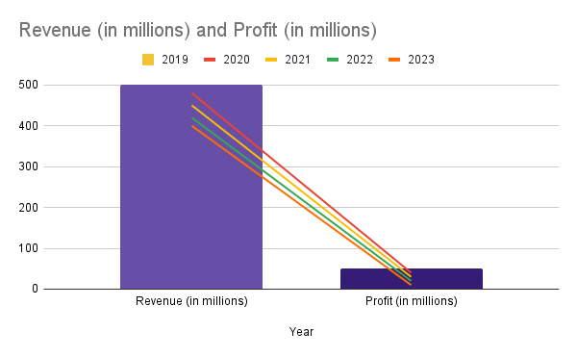
Figure 1: Analysis of Profit decline by ASSI (Source: Owned design)
Both revenue and profit consistently decline from 2019 until 2023. ASSI brought in £500 million in sales and had £50 million in profit in 2019. The income had dropped to £400 million and the profit to £10 million by 2023, though. This shows a sharp fall in ASSI's financial performance on both the top and bottom lines.
The declining profit margins provide evidence of how severe the decrease is. The profit margin for 2019 was 10% (determined by dividing the profit by the revenue and multiplying by 100). The profit margin, however, had significantly declined by 2023, reaching just 2.5%, showing a significant degradation in profitability.
ASSI's revenue reduction

The factors can be attributable to several important factors, including:
Increased Competition: ASSI competes in the very competitive retail market for consumer products. The market has seen an infusion of new participants over the past five years, as well as increased rivalry from current rivals. As shops compete to attract customers with cheaper pricing, the increasing competition has resulted in price wars and decreased profit margins for ASSI (Ghamkhari and Mohsenian, 2013).
Changing Consumer Preferences: In recent years, there has been a substantial change in consumer tastes and buying habits. Online purchasing has become more popular, and people now choose convenient, affordable, and customized experiences. The conventional brick-and-mortar business model of ASSI may have had trouble adjusting to these shifting tastes, which resulted in a drop in foot traffic and sales volume.
Cost Structure: The cost structure of ASSI probably contributed to the reduction in earnings. Over the previous five years, operating expenses—including rent, labor, and raw materials—have probably gone up. Increased minimum wages, increased shop site rent, and inflationary pressures on input costs can all affect profit margins. ASSI probably struggled to successfully manage and control these expenses, which reduced profitability (Glover et al., 2014).

Market Dynamics: The fall in ASSI's earnings has been impacted by the general market dynamics within the retail trade for consumer products. Recessions and other economic slowdowns can influence consumer spending and purchasing power, which in turn can damage ASSI's sales. Lower profitability may come from ASSI's inability to extend its client base and boost sales due to market saturation or a halt in market growth.
Competitive Price and Promotions: To remain competitive and draw in customers, businesses are relying more on price tactics and marketing campaigns. Price reductions and frequent sales promotions can reduce profit margins, especially if they are not well controlled. Striking a balance between maintaining strong profit margins and keeping competitive may have presented difficulties for ASSI (Herry et al., 2019).
Lack of Differentiation: In a competitive market, it is essential to be able to stand out and present distinctive value propositions. Reduced client loyalty and increased price sensitivity may result from ASSI's inability to differentiate its product offers and overall customer experience from those of other companies. Without an effective differentiation strategy, ASSI could find it difficult to charge premium rates and keep a profit.
For ASSI to increase its financial performance, it will be essential to address these major causes of the earnings drop. ASSI can recoup profitability and spur future growth by putting plans into place to manage the increasing competition, comprehend and adjust to shifting consumer tastes, optimize the cost structure, and differentiate itself in the market.

Assessing the Viability of Price Increases
It is important to carefully consider Jesse Zole's recommendation to raise pricing, especially for ASSI's brand items. Price hikes may boost overall profitability, but there are several things to keep in mind.
A drop in sales volume may result from raising pricing. Price-sensitive clients may find ASSI's goods less fascinating if prices are raised, which might limit demand and cause the company to lose market share to rivals with more affordable options. Additionally, clients may be particularly sensitive to price adjustments if demand for ASSI's products has a high price elasticity, which would result in a proportionately higher decline in sales volume (Iglesias et al., 2011).
Price is the determinator of profit, but price should be determined carefully because it has both positive and negative impact on consumer mind and their product purchasing ability.
The proposal by Jesse Zole to raise pricing for ASSI's own-label goods necessitates a careful analysis of the possible effects on sales volume, market share, and overall profitability. An effective pricing plan must strike a balance between the need for higher profit margins and the possible dangers of declining demand and market share loss.

Applying appropriate economic theories

Price elasticity of demand theory
The price elasticity of demand for the goods of ASSI is evaluated as part of the demand and supply study. The analysis takes into account several variables, including customer preferences, income levels, and the presence of replacements.
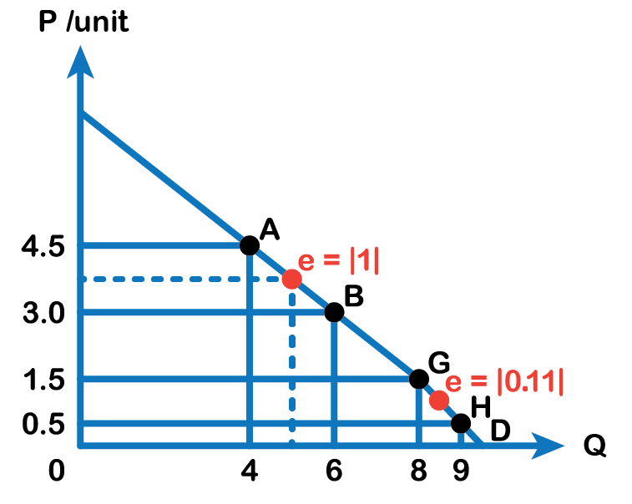

Figure 2: Price elasticity of demand curve (Source: Owned design)
Price elasticity of demand is a basic economic concept that is used to determine the relationship between price and consumer demand (Jensen, 2010). Price elasticity is a concept that measures how price affects consumer demand. If any particular product price is increased then the consumer is demotivated to buy those kinds of products. Here product price is the main factor. ASSI has set its price according to price elasticity because they know that if any product price is reasonable then consumers are more comfortable to purchase. That is why maintaining elasticity is most important for ASSIs.

Cost analysis
Cost analysis is assessing ASSI's cost structure to comprehend how price hikes could affect profitability. This examination covers a range of topics, including pricing tactics, operational costs, and manufacturing costs (Jindal et al., 2016).
Costs of production include all outlays for purchasing or creating goods. This covers the costs of labor, raw materials, equipment, and overhead. ASSI can examine the viability of price hikes and their effects on profit margins by examining production costs.
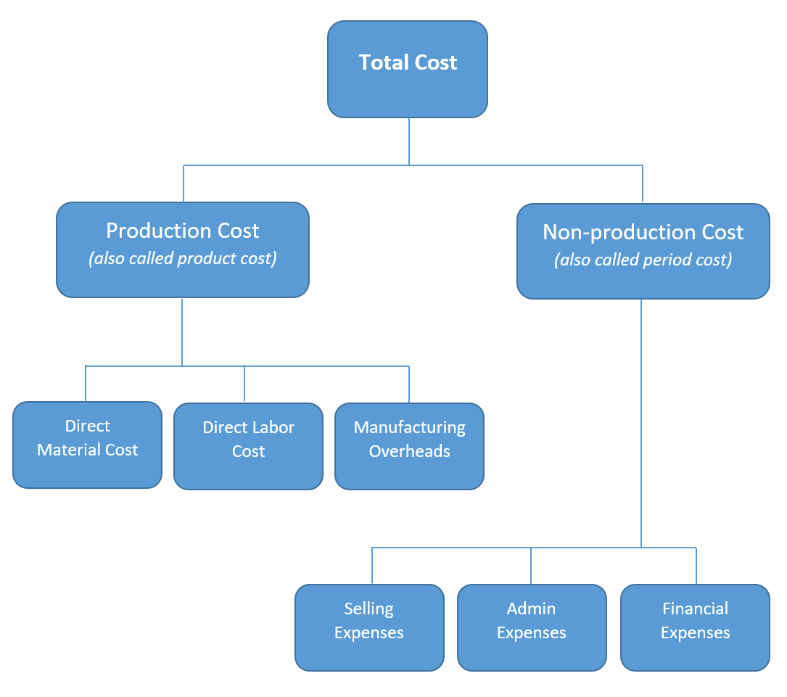

Figure 3: Cost structure (Source: Owned design)
Cost is influenced a profit maximization theory the most. For determining the cost perfectly one business organization can achieve this desired goal. Cost are two types one is production cost and the other is non-production cost. Production costs are costs that are directly related to the production process. In addition, non-production costs are indirectly related to production.
ASSIs determine their cost effectively so that they will succeed to achieve their target. Because if cost is more than product profit then the company will face great trouble.

Business Environment Theory
The market structure and competition
Analyzing the market structure and competition that ASSI faces is part of the competitive landscape study. In this research, issues including the existence of competing stores, developing market trends, and the possible effects of pricing adjustments on market share are taken into account (Kowalski, 2016). ASSI can determine the amount of competition, pinpoint the main rivals, and analyze their pricing tactics by comprehending the competitive environment. This research aids in determining how proposed pricing adjustments may affect ASSI's market share, clientele, and level of competition in general.
Consumer behavior analysis
Analyzing consumer behavior entails examining shifting customer preferences, purchasing trends, and how prices affect consumer choices. Understanding how customers view and react to price changes is made easier by this approach (Kuhn et al., 2010). The likely response of consumers to price rises can be estimated by ASSI by researching consumer behavior. Considerations are made for elements including price sensitivity, brand loyalty, and the accessibility of alternatives. ASSI can foresee customer reactions, assess the possible influence on sales volume, and decide on price strategies with knowledge of consumer behavior.

Business Objectives

Profit maximization
The term profit maximization refers to setting the maximum degree of profitability as a major goal for a firm. Profit maximization for ASSI entails making every effort to increase the difference between revenues and costs. Given that prices have a direct influence on revenues and profit margins, this purpose informs pricing decisions. ASSI must carefully take into account elements including pricing elasticity of demand, competitive dynamics, and consumer preferences in its pursuit of profit maximization (Labandeira et al., 2017). Prices that are set too high or too low can affect profit margins as well as sales volume and market share. ASSI can combine the requirement for profitability with customer value and market competitiveness to weigh the effects of profit maximization on pricing decisions to optimize its financial performance.

Long-term sustainability
To achieve sustained profitability, ASSI must retain stakeholder confidence, brand reputation, and consumer loyalty over the long term. ASSI can maintain a sizable client base and encourage return business and favorable word-of-mouth by placing a high priority on customer satisfaction and loyalty (Levinthal and Wu, 2010). Building and maintaining a solid brand reputation guarantees that ASSI will continue to be competitive and dependable to customers. Long-term success is also influenced by gaining the confidence and assistance of stakeholders including workers, suppliers, and the community. Building long-lasting relationships and providing value that goes beyond short-term profit maximization are prerequisites for sustainable success. By taking into account the significance of these aspects, ASSI may build a basis for long-term market position security, customer retention, and stakeholder satisfaction.

Market Structure

Market share analysis
Analyzing market share entails determining ASSI's present market share and comprehending how it affects price choices and competitive positioning. The amount of the market's total sales that ASSI controls will allow the business to assess its position concerning rivals. ASSI might have more pricing power and market sway with a higher market share (Moench et al., 2010). Depending on market factors, it enables strategic price options, such as competitive pricing or premium pricing. Additionally, market share research aids in spotting chances for market share expansion or protection through clever pricing tactics.

Supplier relationships
For ASSI's operations, especially when it comes to exclusive items, supplier connections are crucial. It is crucial to assess how price rises will affect these connections. Increased costs might sour the relationship with producers, who might look for different merchants or bargain for better terms. If manufacturers believe price decisions may harm their interests, the supply of unique items may be in jeopardy (Weyl, 2010). To negotiate favorable terms and ensure a steady supply of exclusive items, maintaining strong supplier connections is essential. It calls for open lines of communication, just pricing policies, and agreements that benefit both ASSI and its suppliers.

Stakeholder Issues

Shareholder perspectives
Analysis of shareholder perspectives includes examining Jesse Zole's expectations and viewpoints as a significant shareholder as well as any potential effects his suggested approach may have on other stakeholders (Ambec et al., 2013). It is essential to comprehend Jesse Zole's viewpoint since it affects strategic decision-making. To maintain a balanced approach that takes into account the larger ramifications of any plan, it is crucial to take into account the interests of other stakeholders, including those workers, customers, and suppliers.

Customer satisfaction
When assessing the possible effects of price rises, customer happiness is an important factor to take into account. Customers' pleasure, loyalty, and overall experience can all be impacted by price fluctuations. If higher prices are viewed as unjust or inadequate for the value received, consumer happiness may suffer. The impact on customer perception, retention, and brand loyalty should be carefully considered. The impact should then be proactively managed by effective communication, value-added services, and upholding strict standards for the quality of both the product and the service itself. Long-term success in the retail sector depends on striking a balance between profitability and consumer happiness.

Conclusion
The fall in ASSI's profitability during the last five years has highlighted the necessity for strategic decision-making to solve the problems the firm is currently facing. Profit maximization is a crucial goal, but it needs to be balanced while taking into account many aspects including market dynamics, competition, and shifting consumer trends. Simply raising pricing might have an impact on market share, client loyalty, and overall profitability, particularly for ASSI's own branded items.

Recommendations
Diversify Product Offering: To meet changing consumer tastes, ASSI should concentrate on boosting the number of products it offers. ASSI can increase its market appeal and strengthen its competitive position by providing a larger range of products.
Enhance Operational Efficiency: Reducing costs and boosting profitability may be achieved by streamlining operations, enhancing supply chain management, and optimizing procedures. ASSI can improve its financial performance by identifying inefficient areas and putting in place practical cost-saving initiatives.
Strengthen Supplier Relationships: It's important to have strong connections with suppliers, particularly those that make specialized items. To achieve mutually advantageous agreements, fair pricing, and a consistent supply of distinctive items, ASSI should collaborate closely with suppliers.
Embrace technology: Using digital platforms and technology may increase productivity, reach a bigger audience, and offer options for individualized marketing and interaction. To remain competitive in the digital age, ASSI should make investments in e-commerce capabilities, data analytics, and customer relationship management technologies.
By following these suggestions, ASSI may put itself in a position for long-term success in the very cutthroat retail consumer products sector. The management of ASSI must carefully assess the effects of price choices, give the highest priority to customer happiness, and take into account the interests of all stakeholders when determining the company's strategic path.

References
Ambec, S., Cohen, M.A., Elgie, S. and Lanoie, P., 2013. The Porter hypothesis at 20: can environmental regulation enhance innovation and competitiveness? Review of environmental economics and policy.
Andreyeva, T., Long, M.W. and Brownell, K.D., 2010. The impact of food prices on consumption: a systematic review of research on the price elasticity of demand for food. American Journal of public health, 100(2), pp.216-222.
Baumeister, C. and Peersman, G., 2013. The role of time‐varying price elasticities in accounting for volatility changes in the crude oil market. Journal of Applied econometrics, 28(7), pp.1087-1109.
Cao, J., Hwang, K., Li, K. and Zomaya, A.Y., 2012. Optimal multiserver configuration for profit maximization in cloud computing. ieee transactions on parallel and distributed systems, 24(6), pp.1087-1096.
Ditlev‐Simonsen, C.D. and Midttun, A., 2011. What motivates managers to pursue corporate responsibility? A survey among key stakeholders. Corporate social responsibility and environmental management, 18(1), pp.25-38.
Dylst, P. and Simoens, S., 2011. Does the market share of generic medicines influence the price level? A European analysis. Pharmacoeconomics, 29, pp.875-882.
Ghamkhari, M. and Mohsenian-Rad, H., 2013. Energy and performance management of green data centers: A profit maximization approach. IEEE Transactions on Smart Grid, 4(2), pp.1017-1025.
Glover, J.L., Champion, D., Daniels, K.J. and Dainty, A.J., 2014. An Institutional Theory perspective on sustainable practices across the dairy supply chain. International Journal of Production Economics, 152, pp.102-111.
Herry, E., Permana, P.Y.E., Aji, W.B. and Muhtadi, R., 2019. Total Quality Management Development and Sharia Governance Efforts in Sharia Micro Financial Institutions to Improve Market Share. IJIEEB International Journal of Integrated Education, Engineering and Business eISSN 2615-1596 pISSN 2615-2312, 2(1), pp.27-35.
Iglesias, R.L., Arantegui, R.L. and Alonso, M.A., 2011. Power electronics evolution in wind turbines—A market-based analysis. Renewable and Sustainable Energy Reviews, 15(9), pp.4982-4993.
Jensen, M.C., 2010. Value maximization, stakeholder theory, and the corporate objective function. Journal of applied corporate finance, 22(1), pp.32-42.
Jindal, R.P., Sarangee, K.R., Echambadi, R. and Lee, S., 2016. Designed to succeed: Dimensions of product design and their impact on market share. Journal of Marketing, 80(4), pp.72-89.
Kowalski, A., 2016. Censored quantile instrumental variable estimates of the price elasticity of expenditure on medical care. Journal of Business & Economic Statistics, 34(1), pp.107-117.
Kuhn Jr, J.R., Courtney, J.F., Morris, B. and Tatara, E.R., 2010. Agent-based analysis and simulation of the consumer airline market share for Frontier Airlines. Knowledge-Based Systems, 23(8), pp.875-882.
Labandeira, X., Labeaga, J.M. and López-Otero, X., 2017. A meta-analysis on the price elasticity of energy demand. Energy policy, 102, pp.549-568.
Levinthal, D.A. and Wu, B., 2010. Opportunity costs and non‐scale free capabilities: Profit maximization, corporate scope, and profit margins. Strategic Management Journal, 31(7), pp.780-801.
Moench, E., Vickery, J.I. and Aragon, D., 2010. Why is the market share of adjustable-rate mortgages so low? Current Issues in Economics and Finance, 16(8).
Weyl, E.G., 2010. A price theory of multi-sided platforms. American Economic Review, 100(4), pp.1642-1672.

