PLC Controlled Conveyor Sorting System

Abstract
This report presents the design, implementation, and testing of a PLC-based conveyor sorting system used to classify cylindrical aerospace components by size. The system uses a Siemens PLC, sensors, pneumatic pistons, and a touch-screen HMI to easily operate the system. Object size is determined by measuring the time delay between two sensors, allowing parts to be categorised into small, medium, or large and pushed into the correct collection container. The system includes start-up and stop systems, and real-time operator feedback via the HMI. Testing was done using physical components to verify correct operation. The results show that the system meets the requirements described in the project brief, giving reliable sorting of objects with operator control. The project highlights practical PLC programming, system integration, and industrial automation principles.

Table of Contents
Abstract 2
Table of Contents 3
Table of Figures 5
Introduction 6
System Specification 7
Non-Functional Requirements 7
Reliability 7
Safety 7
Maintainability 7
Usability 7
Scalability 7
Functional and Operational Requirements 8
Sensors, Pistons, PLC inputs & outputs, and HMI Description 9
Timing and Control Logic 9
Scope of the Project 10
Timeline 10
Impact 11
Restrictions 11
System Design 12
System Implementation 14
PLC Network Setup 14
HMI Design 15
Testing and Results 16
Test Plan 16
Results 16
Limitations Identified 16
Evaluation and Critical Reflection 17
Conclusions 18
References 19
Appendices 20
Appendix A 20
PLC Coding Terminology and Functions 20
Appendix B 21
PLC Network Coding Setup 21
Appendix C 29
HMI Setup 29
Appendix D 30
PLC Hardware & Network Setup 30
Appendix E 37
HMI Setup 37

Table of Figures
Figure 1: Flowchart of Conveyor Sequence 12
Figure 2: Conveyor System Labels 13
Figure 3: HMI Design & Layout 15
Figure 4: PLC Data Block (Part 1) 21
Figure 5: PLC Data Block (Part 2) 21
Figure 6: PLC Data Block (Part 3) 22
Figure 7: Project PLC Start-up Network 22
Figure 8: Project PLC Main Networks (1 & 2) 23
Figure 9: Project PLC Main Network 3 24
Figure 10: Project PLC Main Network 4 25
Figure 11: Project PLC Main Network 4 (Cont.) 25
Figure 12: Project PLC Main Network 5 26
Figure 13: Project PLC Main Network 5 (Cont.) 26
Figure 14: Project PLC Main Network 6 27
Figure 15: Project PLC Main Network 6 (Cont.) 27
Figure 16: Project PLC Main Network 7 28
Figure 17: Project HMI Tag List 29
Figure 18: Connecting PLC to Power Source 30
Figure 19: Linking PLC to PC 30
Figure 20: Verification of Working PLC 31
Figure 22: Finding Correct PLC Type & Version 31
Figure 23: Setting Up Direct Connection to PLC (Part 1) 32
Figure 24: Setting Up Direct Connection to PLC (Part 2) 32
Figure 25: Setting Up Direct Connection to PLC (Part 3) 33
Figure 26: Verifying Connection 33
Figure 27: Assigning IP Address 34
Figure 28: Adding Organisation Block for Coding Startup 34
Figure 29: Adding Data Block for Identification Tags 35
Figure 30: PLC Tag List Setup 35
Figure 31: Setting Up HMI Device 37
Figure 32: Setting Up HMI Connection to PLC (Part 1) 37
Figure 33: Setting Up HMI Connection to PLC (Part 2) 38

Introduction
Industrial automation plays an essential role in modern manufacturing, especially in aerospace production where accuracy, repeatability, and traceability are essential (Muelaner, J. E., Martin, O. C., & Maropoulos, P. G., 2013). Manual handling brings human variables which increases the chance of an error, whereas automated systems give consistent and constant results.
Programmable Logic Controllers (PLCs) are widely used in industrial automation due to their durability and suitability for electrically noisy, harsh, unhospitable environments. (Crandall, Crandall and C, 2010) state “PLC… is rugged and able to operate in industrial environments”.
This project focuses on the design and implementation of a PLC-controlled conveyor system used to sort cylindrical aerospace components into three sizes. The classification method is based on measuring the time taken for each object to travel between two optical sensors positioned at fixed distances. By using timing data compared to complex visual systems, the system remains cost-effective while still achieving accurate sorting.
The final aim of this report is to present a fully programmed and tested automation system that demonstrates actual PLC programming, control logic, and safe industrial design bases.

System Specification

Non-Functional Requirements
Non-functional requirements describe how the system must accomplish its task, through the quality, reliability, and safety of the system.
Reliability
The system must be capable of running continuously without any unintended stops during the program. PLC-based control is chosen due to its high reliability in industrial environments (Crandall, Crandall and C, 2010).
Safety
The system must include an emergency stop function. A normally closed stop circuit is implemented so that loss of power or wiring failure results in system shutdown, aligning with industrial safety best practice (Bell, 2024).
Maintainability
According to Siemens (2025), the PLC code must be structured accurately with accurate names for each of the variables, so that it can be updated and modified easily in the future.
Usability
The design of the HMI must be simple with simple easily identified start and stop buttons, system indicators, and counters for ease-of-use of the operator.
Scalability
The code should allow adjustment of size ranges via tag limits rather than rewriting the entire program. This makes sure different component dimensions can be added/changed in the future, which supports the IEC 61131-3 structured programming principles and Siemens programming guidelines, which recommends modular (separate) design to improve reusability, maintainability, and system adaptability (Siemens, 2018; IEC, 2003).

Functional and Operational Requirements
Functional requirements describe the requirements for what the system must do to accomplish its task.
The purpose of the system is to automatically sort components into three size categories: small, medium, and large.
To work correctly, the system must:
- Start only when the green start button is pressed and held for three seconds
- Show the start-up using a flashing green LED, then a steady green LED when running
- Stop when the red stop button is pressed, with a red LED showing the stop status
- Detect objects moving along the conveyor using two sensors
- Measure the time taken for the object to move between the sensors
- Use this measured value to determine the size of the object
- Activate the correct piston to push the object into the correct container
- Stop automatically if no objects are detected by the sensors for 30 seconds
- Show the part counts on the HMI tablet

Sensors, Pistons, PLC inputs & outputs, and HMI Description
Two sensors are placed on the conveyor a set distance away from each other. These sensors detect when an object passes them, and as each of the sensors are triggered, they each send a signal to the PLC. The PLC uses these signals to measure the time between detections. Pistons are used to push objects off the conveyor into different containers depending on their size.
The PLC setup has:
- Inputs for the start and stop buttons
- Inputs for the two object detection sensors
- Outputs for the conveyor motor
- Outputs for the pneumatic piston valves
- Outputs for the green and red LEDs
A Siemens HMI (Human Machine Interface) is connected to the PLC and provides an easy-to-use interface for the user. The HMI allows the system to be started and stopped and shows live counts of sorted objects to be viewed.

Timing and Control Logic
The timing algorithm is a key part of the system design. Instead of relying on PLC scan cycle timing, which may vary slightly depending on system load, the RD_SYS_T block is used to record actual system time values. The T_DIFF block subtracts the first timestamp from the second, producing a time difference value that represents object travel time. This approach improves measurement consistency because it reduces dependency on scan cycle fluctuations. The resulting time difference is converted using T_CONV to produce an integer value that can be processed using comparison blocks (Siemens, 2016). For information on the specifics of the functions of PLC coding, see (Appendix A)

Scope of the Project
This project covers:
- PLC programming in Siemens TIA Portal
- Integration of optical sensors and pneumatic pistons
- HMI design
- Functional testing
The project does not include:
- Mechanical redesign of the conveyor
- Motor speed variations
The system is developed as a learning project and demonstration rather than a certified aerospace design. The skills and experience gained in PLC coding is both essential and transferrable to real-world job requirements (Siemens Careers, 2026).

Timeline
The project was completed over approximately 9 weeks, with coding and testing mainly done between 9:00am to 11:00am every Thursday:
Week 1 - 3: Learning the history and functions of the PLC
Week 4: System flowchart creation
Week 5: PLC hardware configuration and tag setup
Week 6: Programming of detection and classification networks
Week 7: Final programming configuration
Week 8: HMI design and integration
Week 9: Testing, debugging, and write-up
Week 10: Final write-up

Impact
The conveyor sorting system shows how automation can improve efficiency and consistency in the manufacturing process. By automatically detecting and sorting components, the system reduces the need for manual handling, which lowers the risk of human error and improves repeatability. This type of system could increase productivity and ensure that components are correctly processed every time.
This project also provides practical experience of PLC programming, sensor integration, and HMI design. This helps build skills that are directly relevant to real-world engineering and automation roles.

Restrictions
There were external restrictions that affected the design and implementation of the system. Access to the PLC hardware was limited, there were only 2 conveyor rig setups to test on, and software was limited to licensed pc’s only. These factors reduced the amount of time available for development and testing. This meant that changes often had to be tested occasionally and all-at-once rather gradually and continuously, which negatively impacted the flow of learning and coding.
The system is also limited by its reliance on fixed conveyor speed and sensor positioning. Any variation in speed or adjustment of sensors would affect the accuracy of the timing-based size detection. In a real industrial system, additional sensors or speed feedback could be used to reduce this limitation.

System Design
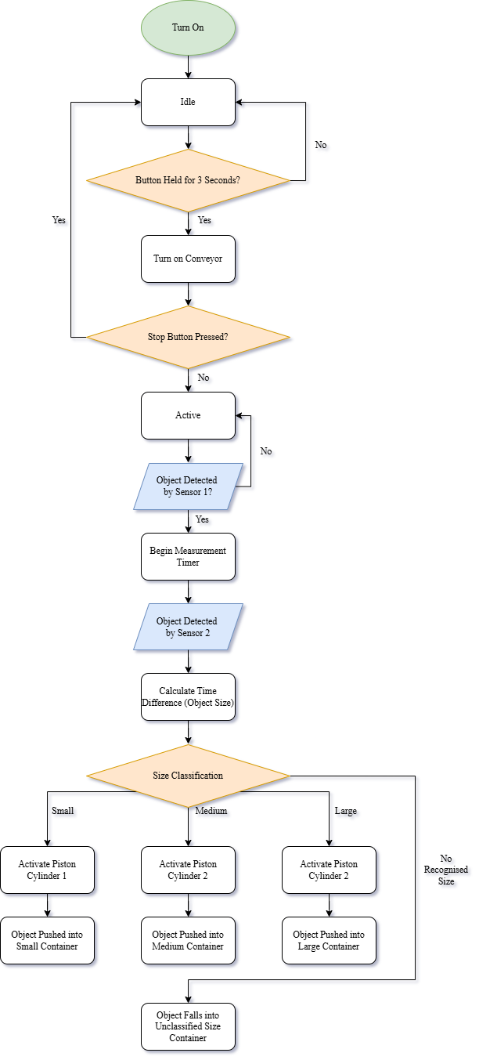
Figure 1: Flowchart of Conveyor Sequence
The figure above shows a flowchart for the function of the system to be based on.
The PLC program is divided into:
- Start-up and safety logic
- Object detection and timing logic
- Sorting decision logic
- Output actuation control
- HMI communication and data handling
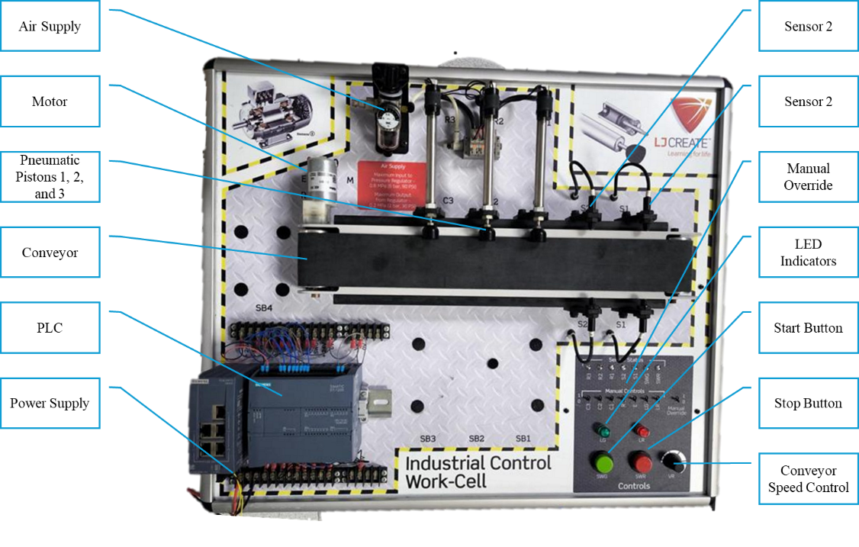
Figure 2: Conveyor System Labels
The figure above shows an overview of the conveyor sorting system hardware layout. The system consists of a PLC mounted at the lower section of the panel, connected to a dedicated power supply and wired to all input and output devices. The conveyor motor drives the belt which moves components past two optical sensors positioned at a fixed distance from one another. Three pistons are positioned along the conveyor to push components into the appropriate containers based on PLC output signals. The compressed air supply feeds the pneumatic pistons. Interaction is used through the start and stop push buttons, LED status indicators, and manual override controls.

System Implementation

PLC Network Setup
The PLC program was structured using separate networks to clearly separate safety, detection, classification, and timeout codes. This allows improved easy readability and fault diagnosis, which is important in industrial PLC applications (Siemens, 2018). Detailed ladder logic and tag configuration are provided in Appendix B, with hardware setup shown in Appendix D.
A timer-based interlock is used for the 3 second hold-to-start requirement, preventing accidental starts. The stop condition is done using normally closed logic to create a fail-safe shutdown path.
Object sizes and detection are run independently from piston activation. The program calculates the time between two sensor activations and then compares this value against the defined limits. Separating measurement from decision-making makes the program easier to modify if classification thresholds need to be altered.
The 30-second idle timeout is implemented as a supervisory control layer. If no sensor input is detected within 30 seconds, the conveyor shuts down to prevent unnecessary running, reflecting the energy efficiency considerations in systems (IEA, 2022).

HMI Design
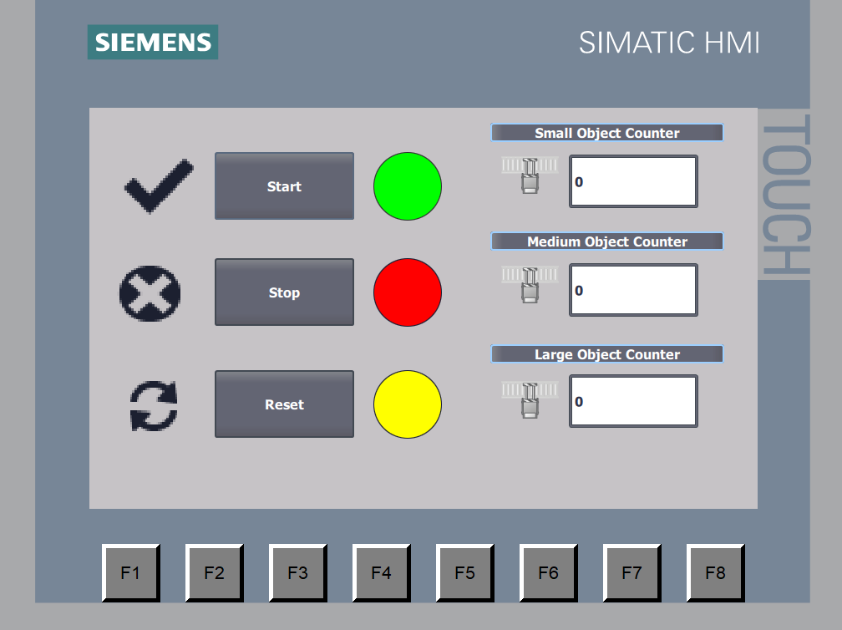
Figure 3: HMI Design & Layout
The HMI was designed to provide clear operator control and real-time system feedback without overcomplicating the interface. Full setup details and tags are shown in Appendix C, with device setup in Appendix E.
The main screen includes start, stop, and reset controls, system status indicators, and live part counters for each size category. These counters are directly linked to PLC variables, allowing operators to monitor sorting performance in real time. The system indicators have all been activated simultaneously for clarity to show each has a unique colour, they are grey by default. The pistons also each have an indicator showing when the pistons are extended, these indicators are next to the part counters, and all have been extended for clarity.
This layout prioritises simplicity through large buttons, indicators and counters, with symbols and text combining to very easily show the function of each button. This reduces the risk of operator error and supports safe interaction with the automation system (Bryksin, Vysotsky and Guseynov, 2023).

Testing and Results

Test Plan
Testing was divided into five stages:
- Start-up test: Confirm 3-second delay with flashing LED.
- Stop override test: Press stop during process to confirm shutdown.
- Piston test: Trigger pistons manually and confirm activation.
- Size classification test: Pass objects through sensors and confirm correct piston activation.
- Idle timeout test: Run conveyor without any objects and confirm 30-second shutdown.

Results
The start-up sequence and stop functions worked correctly, this was repeated three times.
The timing classification worked reliably with conveyor speed set to max. However, any change in speed rendered the size thresholds meaningless, meaning the system is sensitive to speed variation.
The idle timer reset correctly whenever a sensor was activated, and the system deactivated after no object was detected for 30 seconds.

Limitations Identified
The internal limitations for the project are:
- The system assumes the conveyor belt is at a constant speed.
- If external objects move/block even one sensor, the system will stop functioning.
- No redundancy is implemented for sensor failure.

Evaluation and Critical Reflection
The final system meets all functional requirements listed in the system specification and project brief. Objects are sorted automatically, counters count correctly, and the HMI gives real-time feedback.
Using timing-based sensors instead of more visual sensors which could visually identify object sizes with even one sensor is more cost-effective, but it does mean the system conveyor must run at a consistent speed. This could have been fixed by bringing in speed feedback in the code which would improve robustness and help maintain consistent accuracy for an industrial environment.
The HMI interface, while simple and intuitive, could be improved upon by adding additional systems such as manual override for the pneumatic pistons, creating a separate maintenance page for debugging issues, and possibly even adding a log sheet for operators to recognise and understand previous issues.
Structuring the PLC program into separate networks made fixing any errors easier. By splitting the logic into start-up, detection, classification and timeout sections, faults could be tracked more quickly rather than searching through one large block of code.
Future versions improvements would include:
- Variable speed compensation
- Fault alarms displayed on HMI
- Maintenance mode with motor speed control

Conclusions
This project successfully demonstrates the design, implementation, and testing of a PLC-controlled conveyor sorting system. The system meets the specified functional requirements, including timed start-up, automated size classification, pneumatic sorting, idle detection, and HMI monitoring.
The use of structured programming techniques and system time functions ensured reliable object detection and classification. Testing confirmed that the system operates as intended under controlled conditions.
While limitations exist regarding conveyor speed variation, the system provides a strong foundation for further industrial development. The project has strengthened practical understanding of PLC programming, automation design, and system validation in an engineering context.

References
- Bell, L. (2024). Whitepaper Emergency Stop Integration for Machinery. [online] NEUGUARD. Available at: https://irp.cdn-website.com/f9cf7b8f/files/uploaded/Neuguard_-_Emergency_Stops_for_Machinery_-_White_Paper_-_November_2024_-_REV02-be5be73d.pdf.
- Bryksin, M., Vysotsky, N., Guseynov, P. (2023). Industrial HMI design principles for highly automated manufacturing processes. In: Tareq Ahram and Redha Taiar (eds) Human Interaction & Emerging Technologies (IHIET 2023): Artificial Intelligence & Future Applications. AHFE (2023) International Conference. AHFE Open Access, vol 111. AHFE International, USA. Available at: http://doi.org/10.54941/ahfe1004043
- Crandall, R.E., Crandall, W. and C, C. (2010). Principles of Supply Chain Management. [online] Boca Raton: Crc Press/Taylor & Francis Group. Available at: https://www.sciencedirect.com/topics/computer-science/programmable-logic-controller.
- IEA (2022). Energy Efficiency 2022. [online] International Energy Agency. Available at: https://iea.blob.core.windows.net/assets/7741739e-8e7f-4afa-a77f-49dadd51cb52/EnergyEfficiency2022.pdf.
- IEC (2003). Programmable Controllers - Part 3: Programming Languages Automates Programmables - Partie 3: Langages De Programmation. 2nd ed. [online] IEC. Available at: https://d1.amobbs.com/bbs_upload782111/files_31/ourdev_569653.pdf [Accessed 12 Feb. 2026].
- Muelaner, J. E., Martin, O. C., & Maropoulos, P. G. (2013). Achieving low cost and high quality aero structure assembly through integrated digital metrology systems. Procedia CIRP, 7, 688-693. https://doi.org/10.1016/j.procir.2013.06.054
- Siemens (2016). S7-1200 Programmable Controller System Manual. [online] Support.Industry.Siemens.com. Siemens. Available at: https://cache.industry.siemens.com/dl/files/593/109741593/att_895681/v1/s71200_system_manual_en-US_en-US.pdf
- Siemens (2018). Programming Guideline for S7-1200/1500 TIA Portal. [online] Siemens. Available at: https://cache.industry.siemens.com/dl/files/040/90885040/att_970576/v1/81318674_Programming_guideline_DOC_v16_en.pdf.
- Siemens (2025). Programming Style Guide for SIMATIC S7-1200/S7-1500 TIA Portal. [online] Siemens.com. Siemens. Available at: https://cache.industry.siemens.com/dl/files/084/109478084/att_1323050/v1/81318674_Programming_Styleguide_DOC_V2_1_0_en.pdf.
- Siemens Careers (2026). Specialist Engineer (SCADA). [online] Siemens. Available at: https://jobs.siemens.com/en_US/externaljobs/JobDetail/492726 [Accessed 12 Feb. 2026].

Appendices

Appendix A

PLC Coding Terminology and Functions

Main Coding Elements
Normally Open: | |
A normally open gate is the connection that will only allow power though it when the input/output connected to the gate is turned on, for example, power will only be allowed through when the button is pressed and held.
Normally Closed: |/|
A normally closed gate is the opposite of the normally open gate, where this gate lets power through continuously until the input/output is activated, for example, power will be allowed through until the button is pressed and held.
Output: ( )
An output is used to switch something on/off when power gets sent to it, for example, LEDs.
Timers: (TON, TOFF, TP)
TON timers are used to create a delay before power is allowed through, while a TOFF timer creates a delay before power is cut-off. A TP timer is used to create a short pulse that stays on for a certain amount of time.
Counters: (CTU)
Counters are used to count results. A CTU counter increases its number each time a specific condition happens, which allows the system to keep track of how many times something has happened.
Comparison and Range Blocks: (IN_RANGE)
Range functions are used to check whether a number falls between two limits that have been created.
Time Handling Blocks: (T_CONV, T_DIFF, RD_SYS_T)
Time functions are used to work with time values inside the PLC program. These functions allow the system to read the current system time, calculate the difference between two times, and convert time into a usable language for PLC logic decisions.

Appendix B

PLC Network Coding Setup

Main Coding Networks
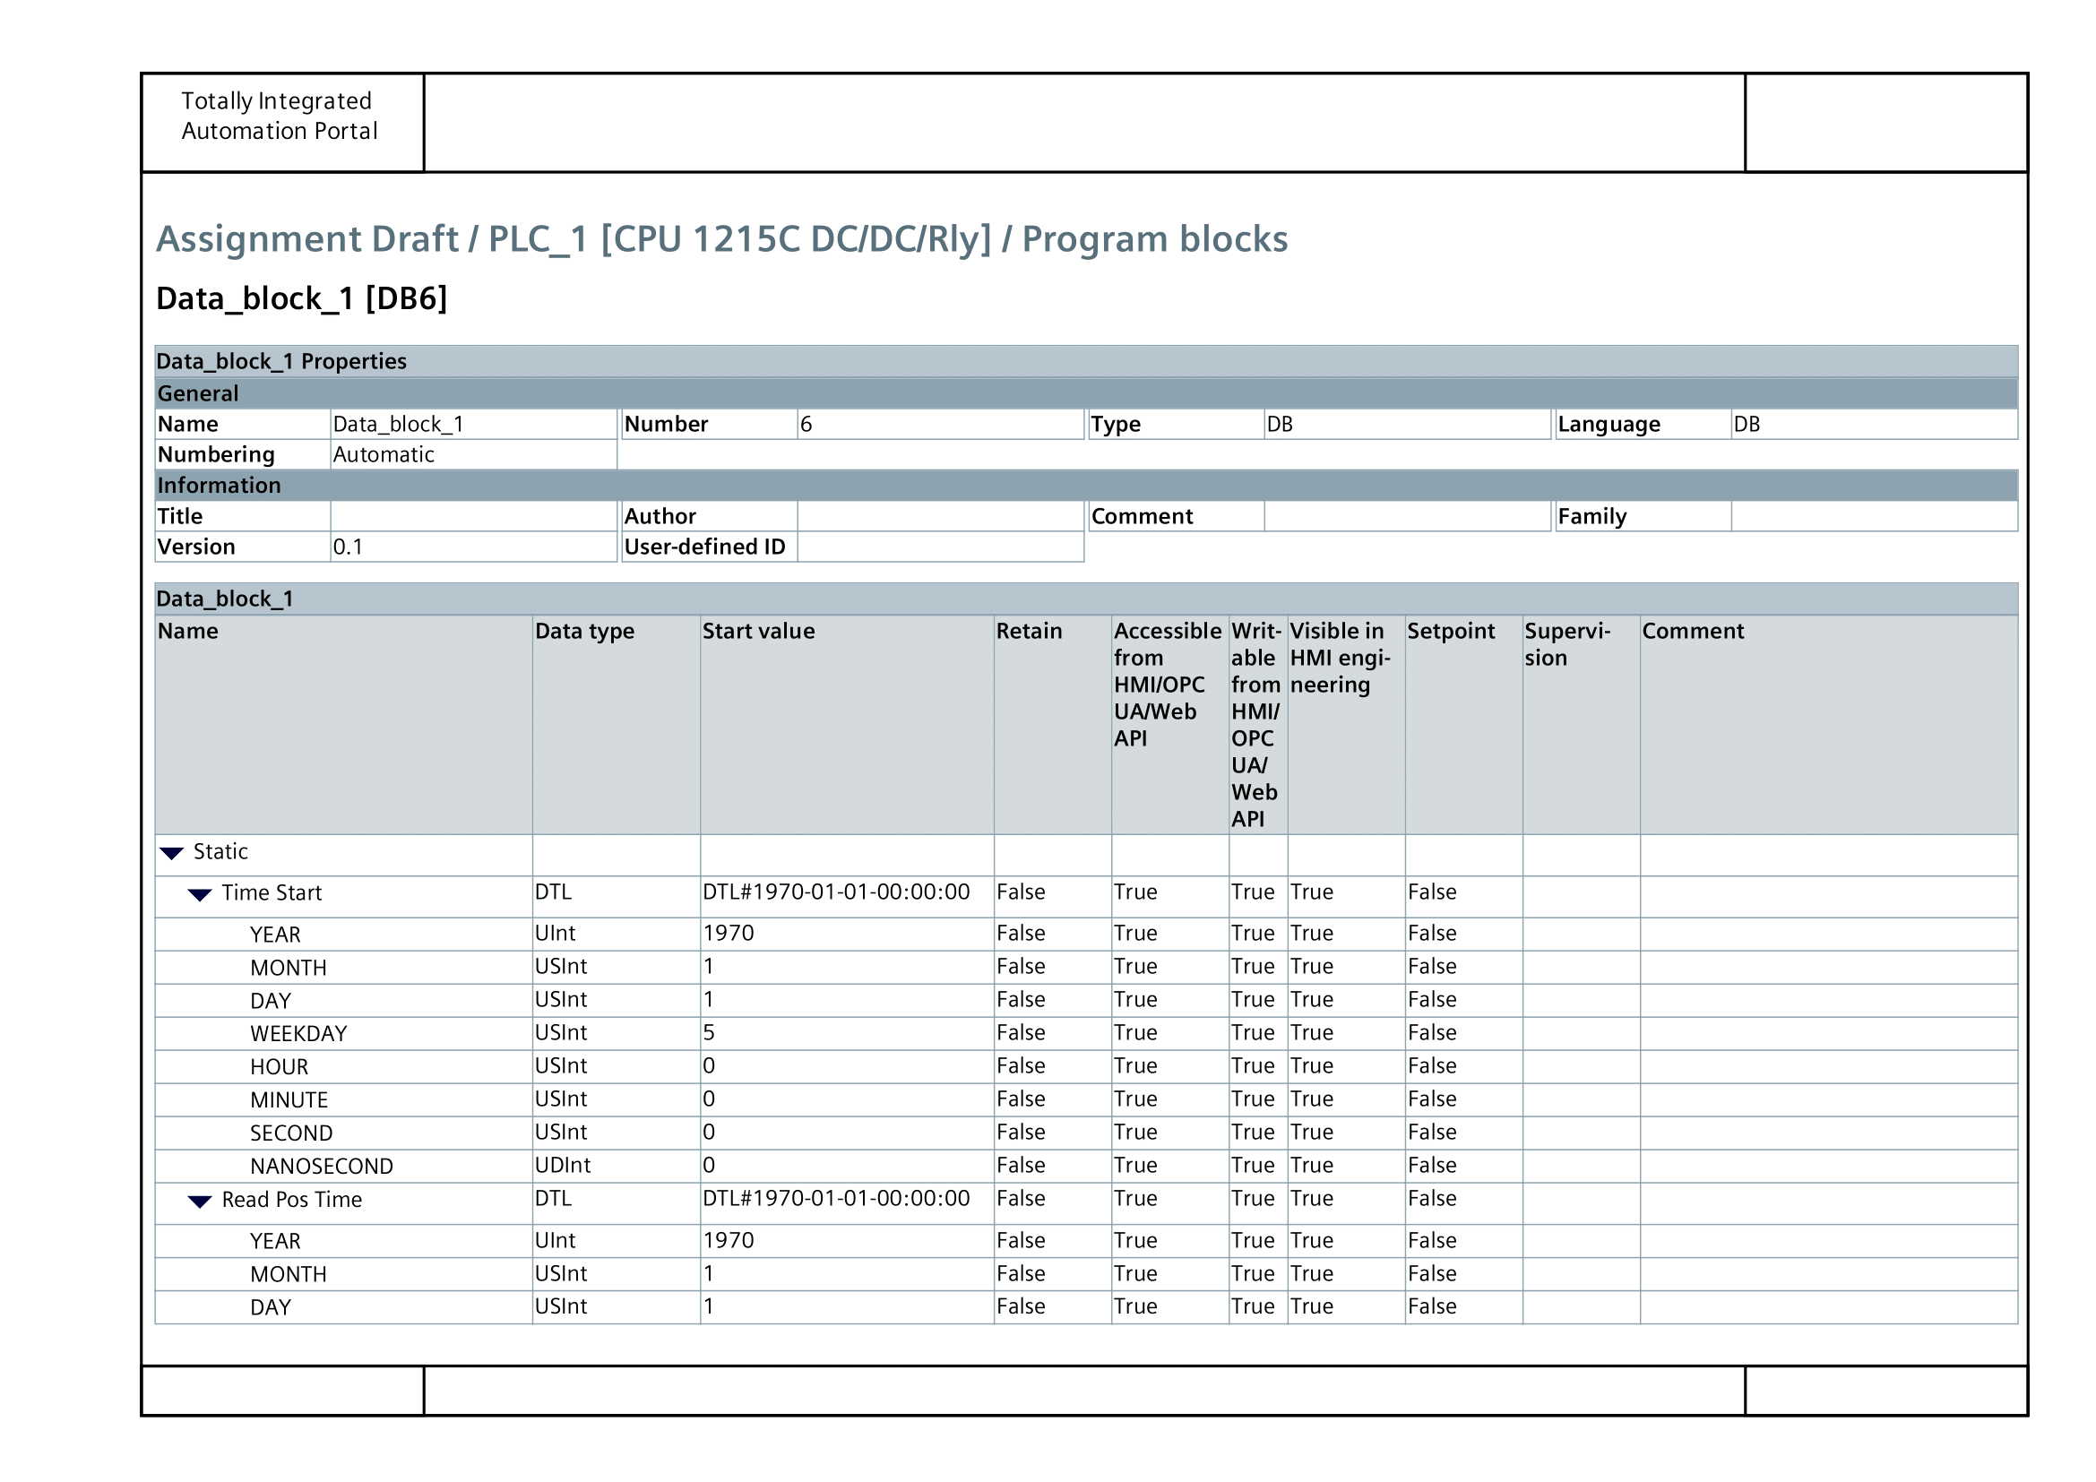
Figure 4: PLC Data Block (Part 1)
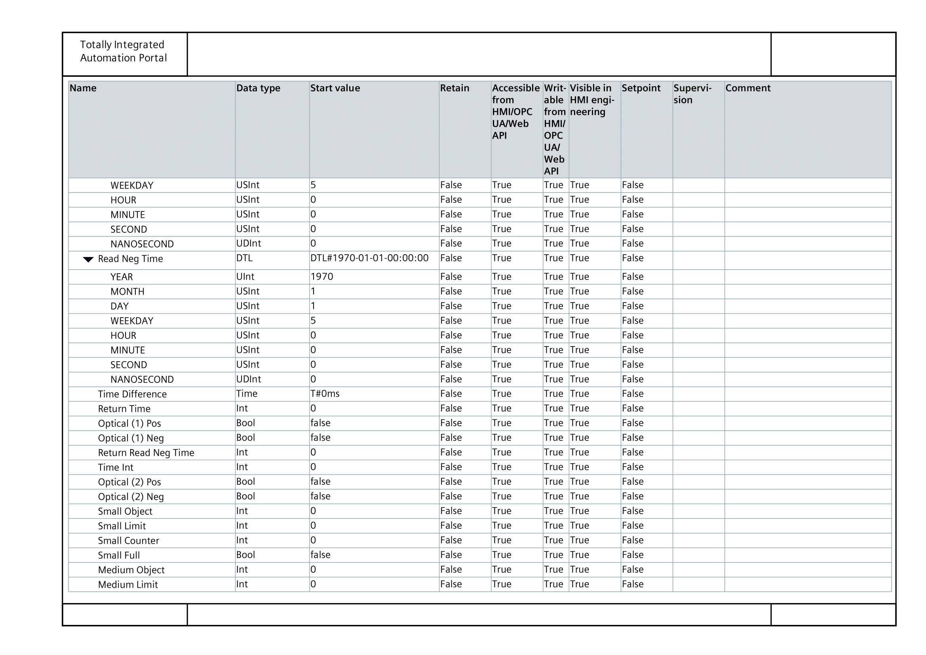
Figure 5: PLC Data Block (Part 2)
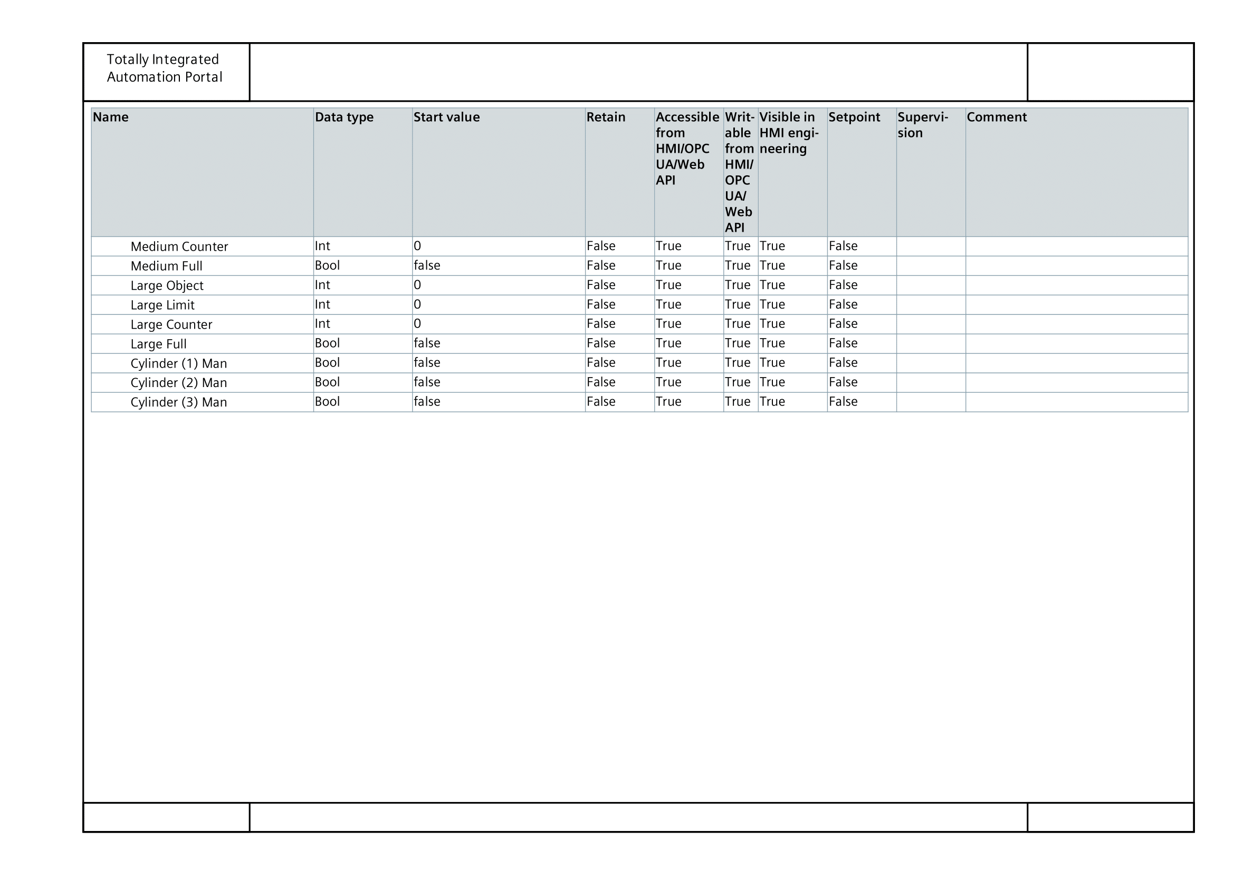
Figure 6: PLC Data Block (Part 3)
Figures 4, 5, and 6 above show the list of tags used for the networks of the PLC project program. PLC tags are names used to name, and put values on the inputs, outputs, and values of the program networks.

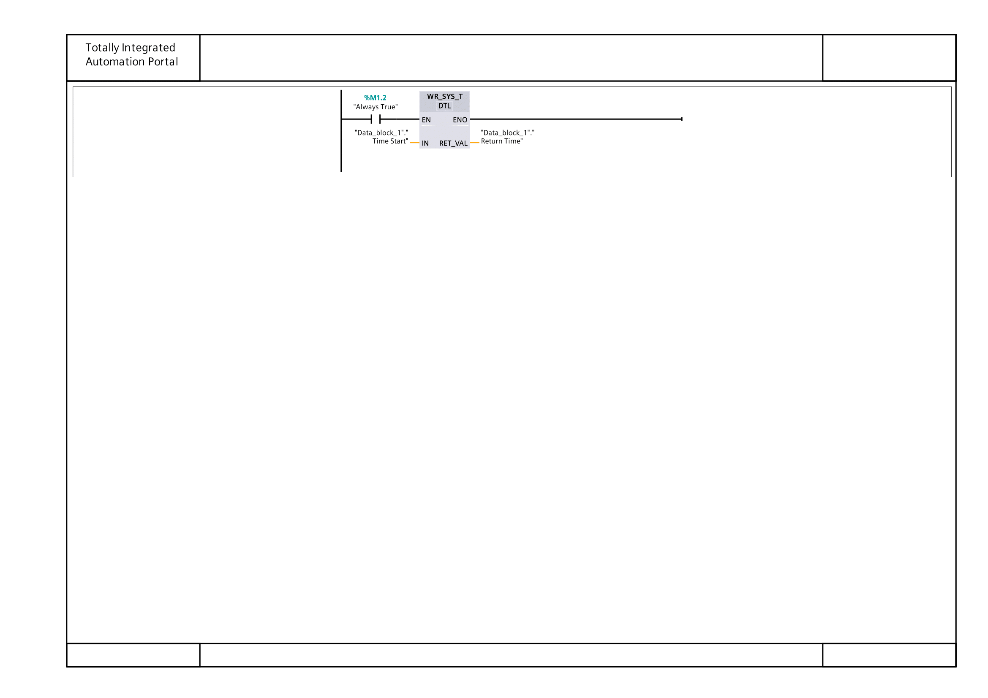
Figure 7: Project PLC Start-up Network
Figure 7 shows the network that continuously updates a variable with the PLC’s current real-time clock value.

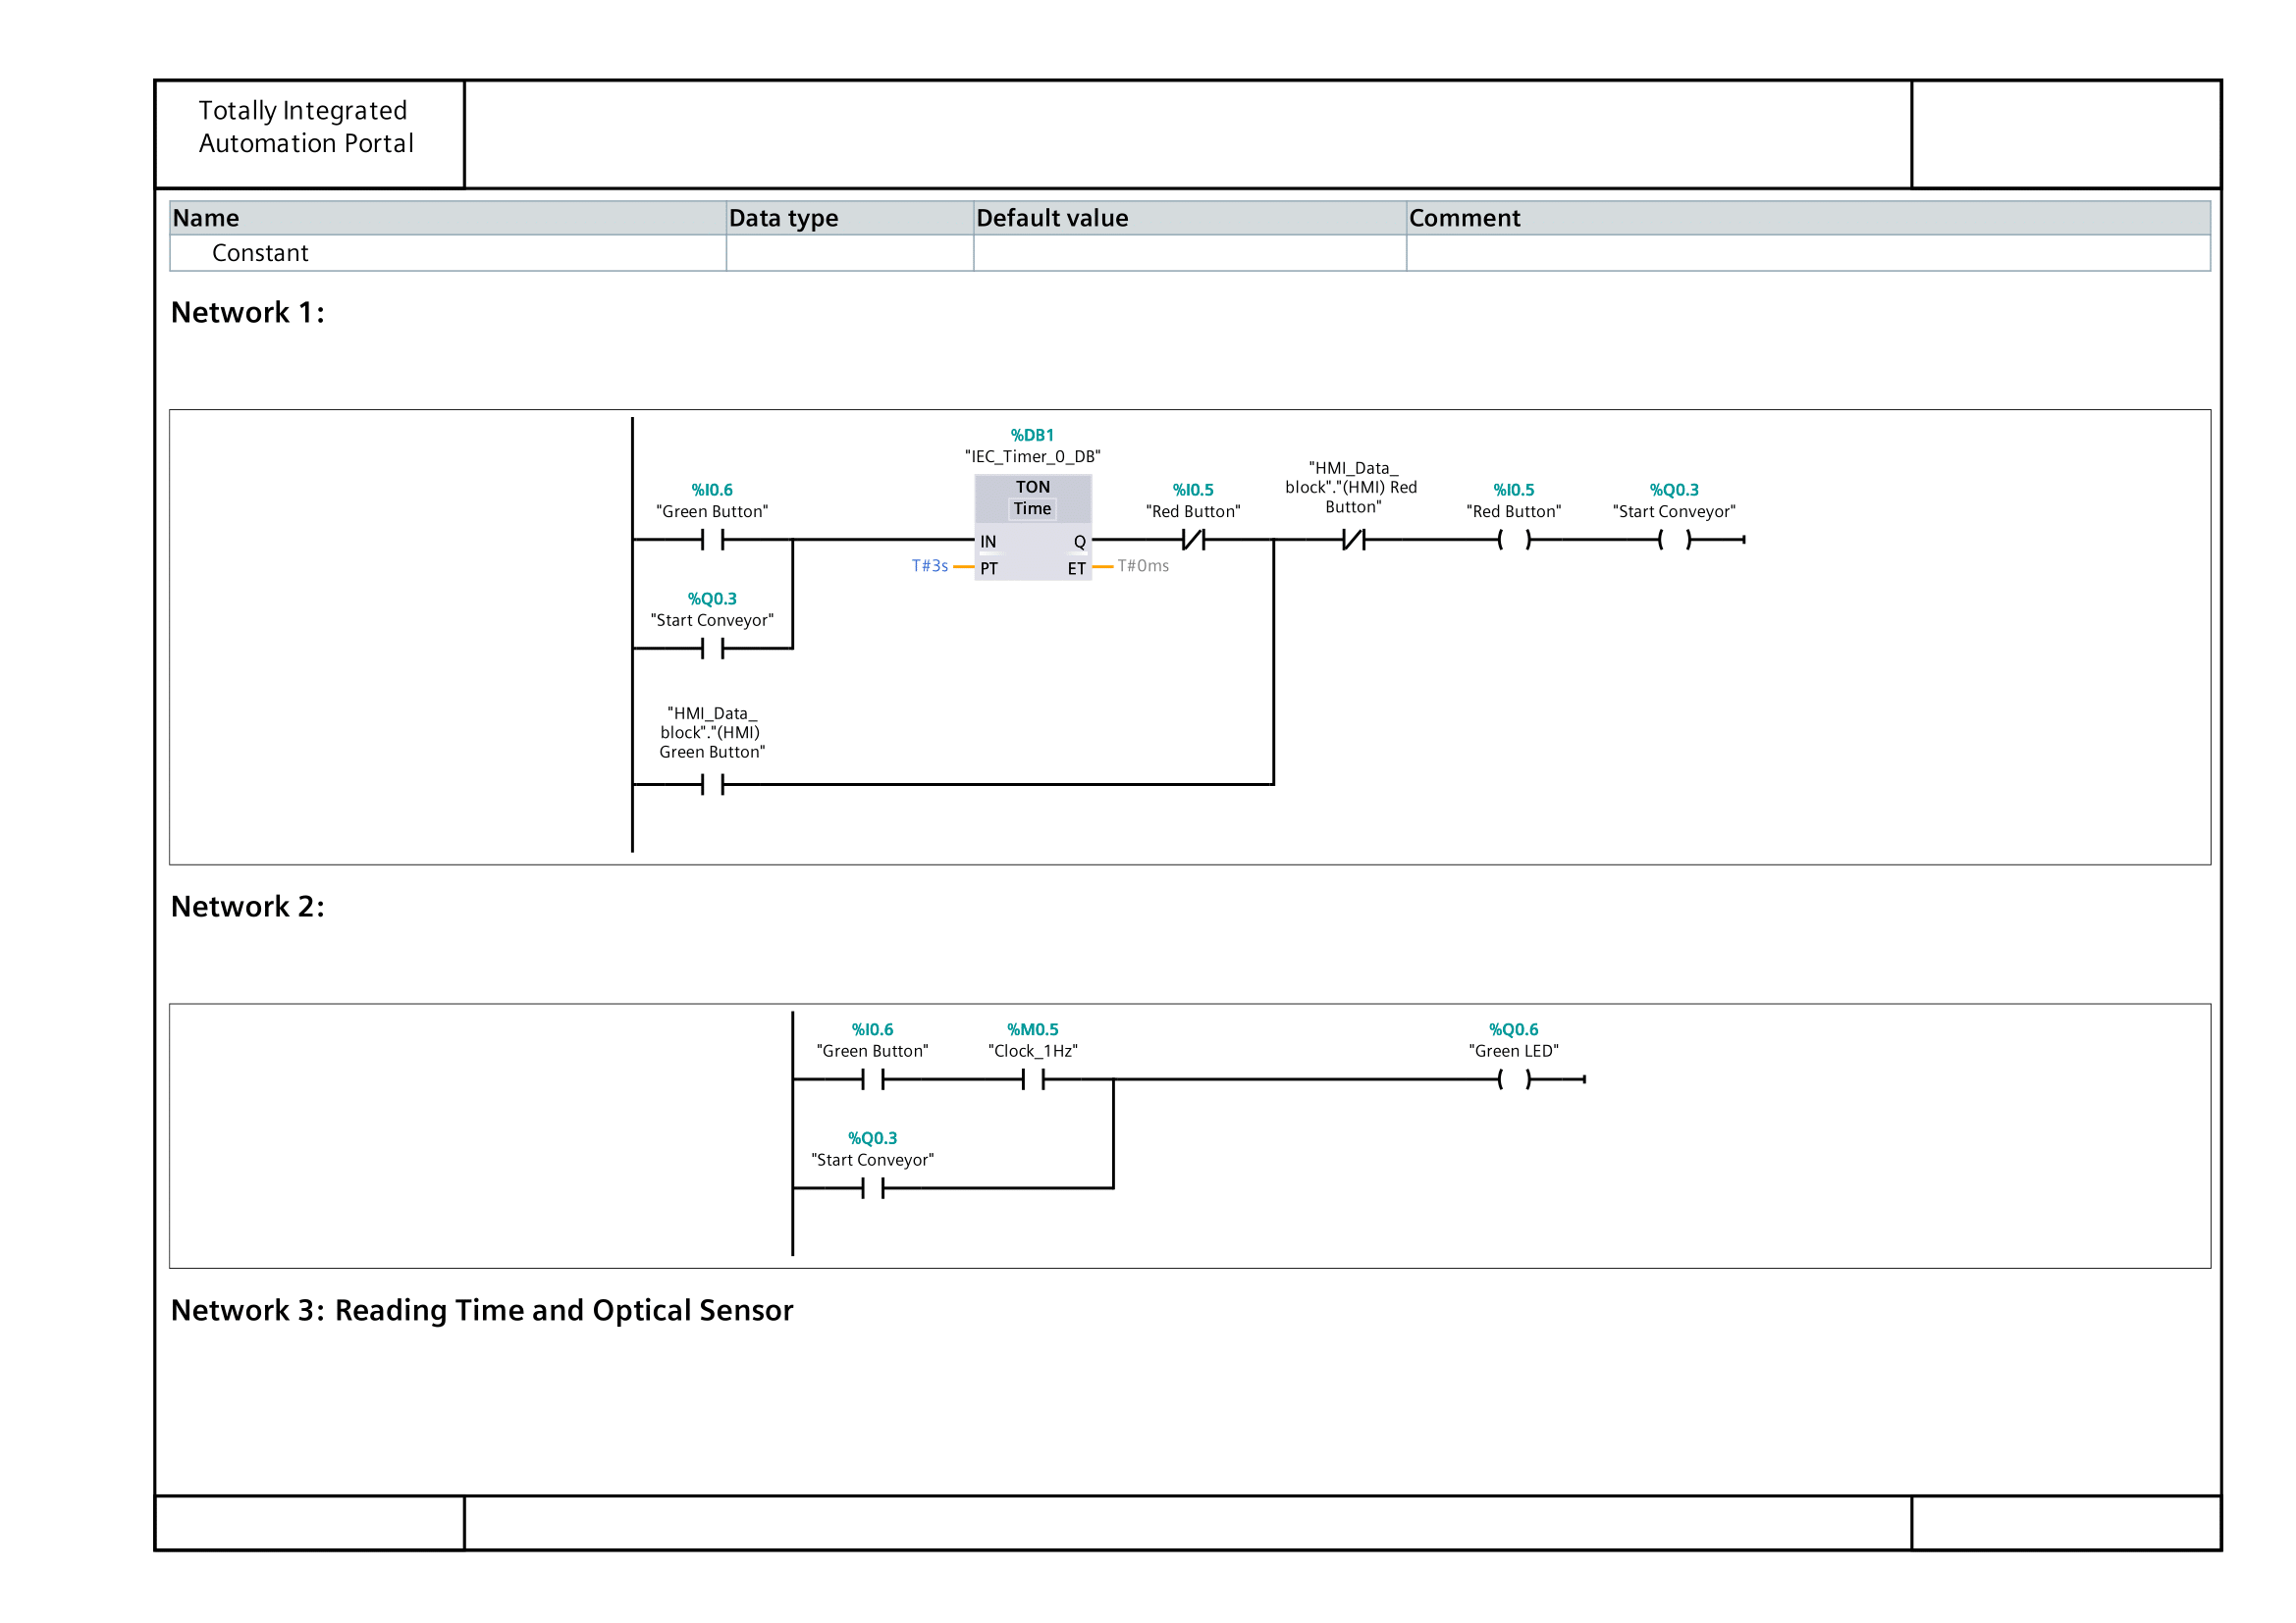
Figure 8: Project PLC Main Networks (1 & 2)
Figure 8 shows both network 1 and 2 of the program.
Network 1 controls the conveyor start sequence. When the green start button is pressed and held, a TON timer is used to create a three-second delay before the conveyor is started. This helps stop accidental start-ups. When the “start conveyer” output is reached, it activates the “start conveyer” gate, which bypasses the need to hold the green button.
Network 2 controls the green LED. The lamp flashes during the start-up phase using a clock signal and then stays on continuously once the conveyor is running due to the “start conveyer” gate. This creates a clear visual cue to show the system is beginning.

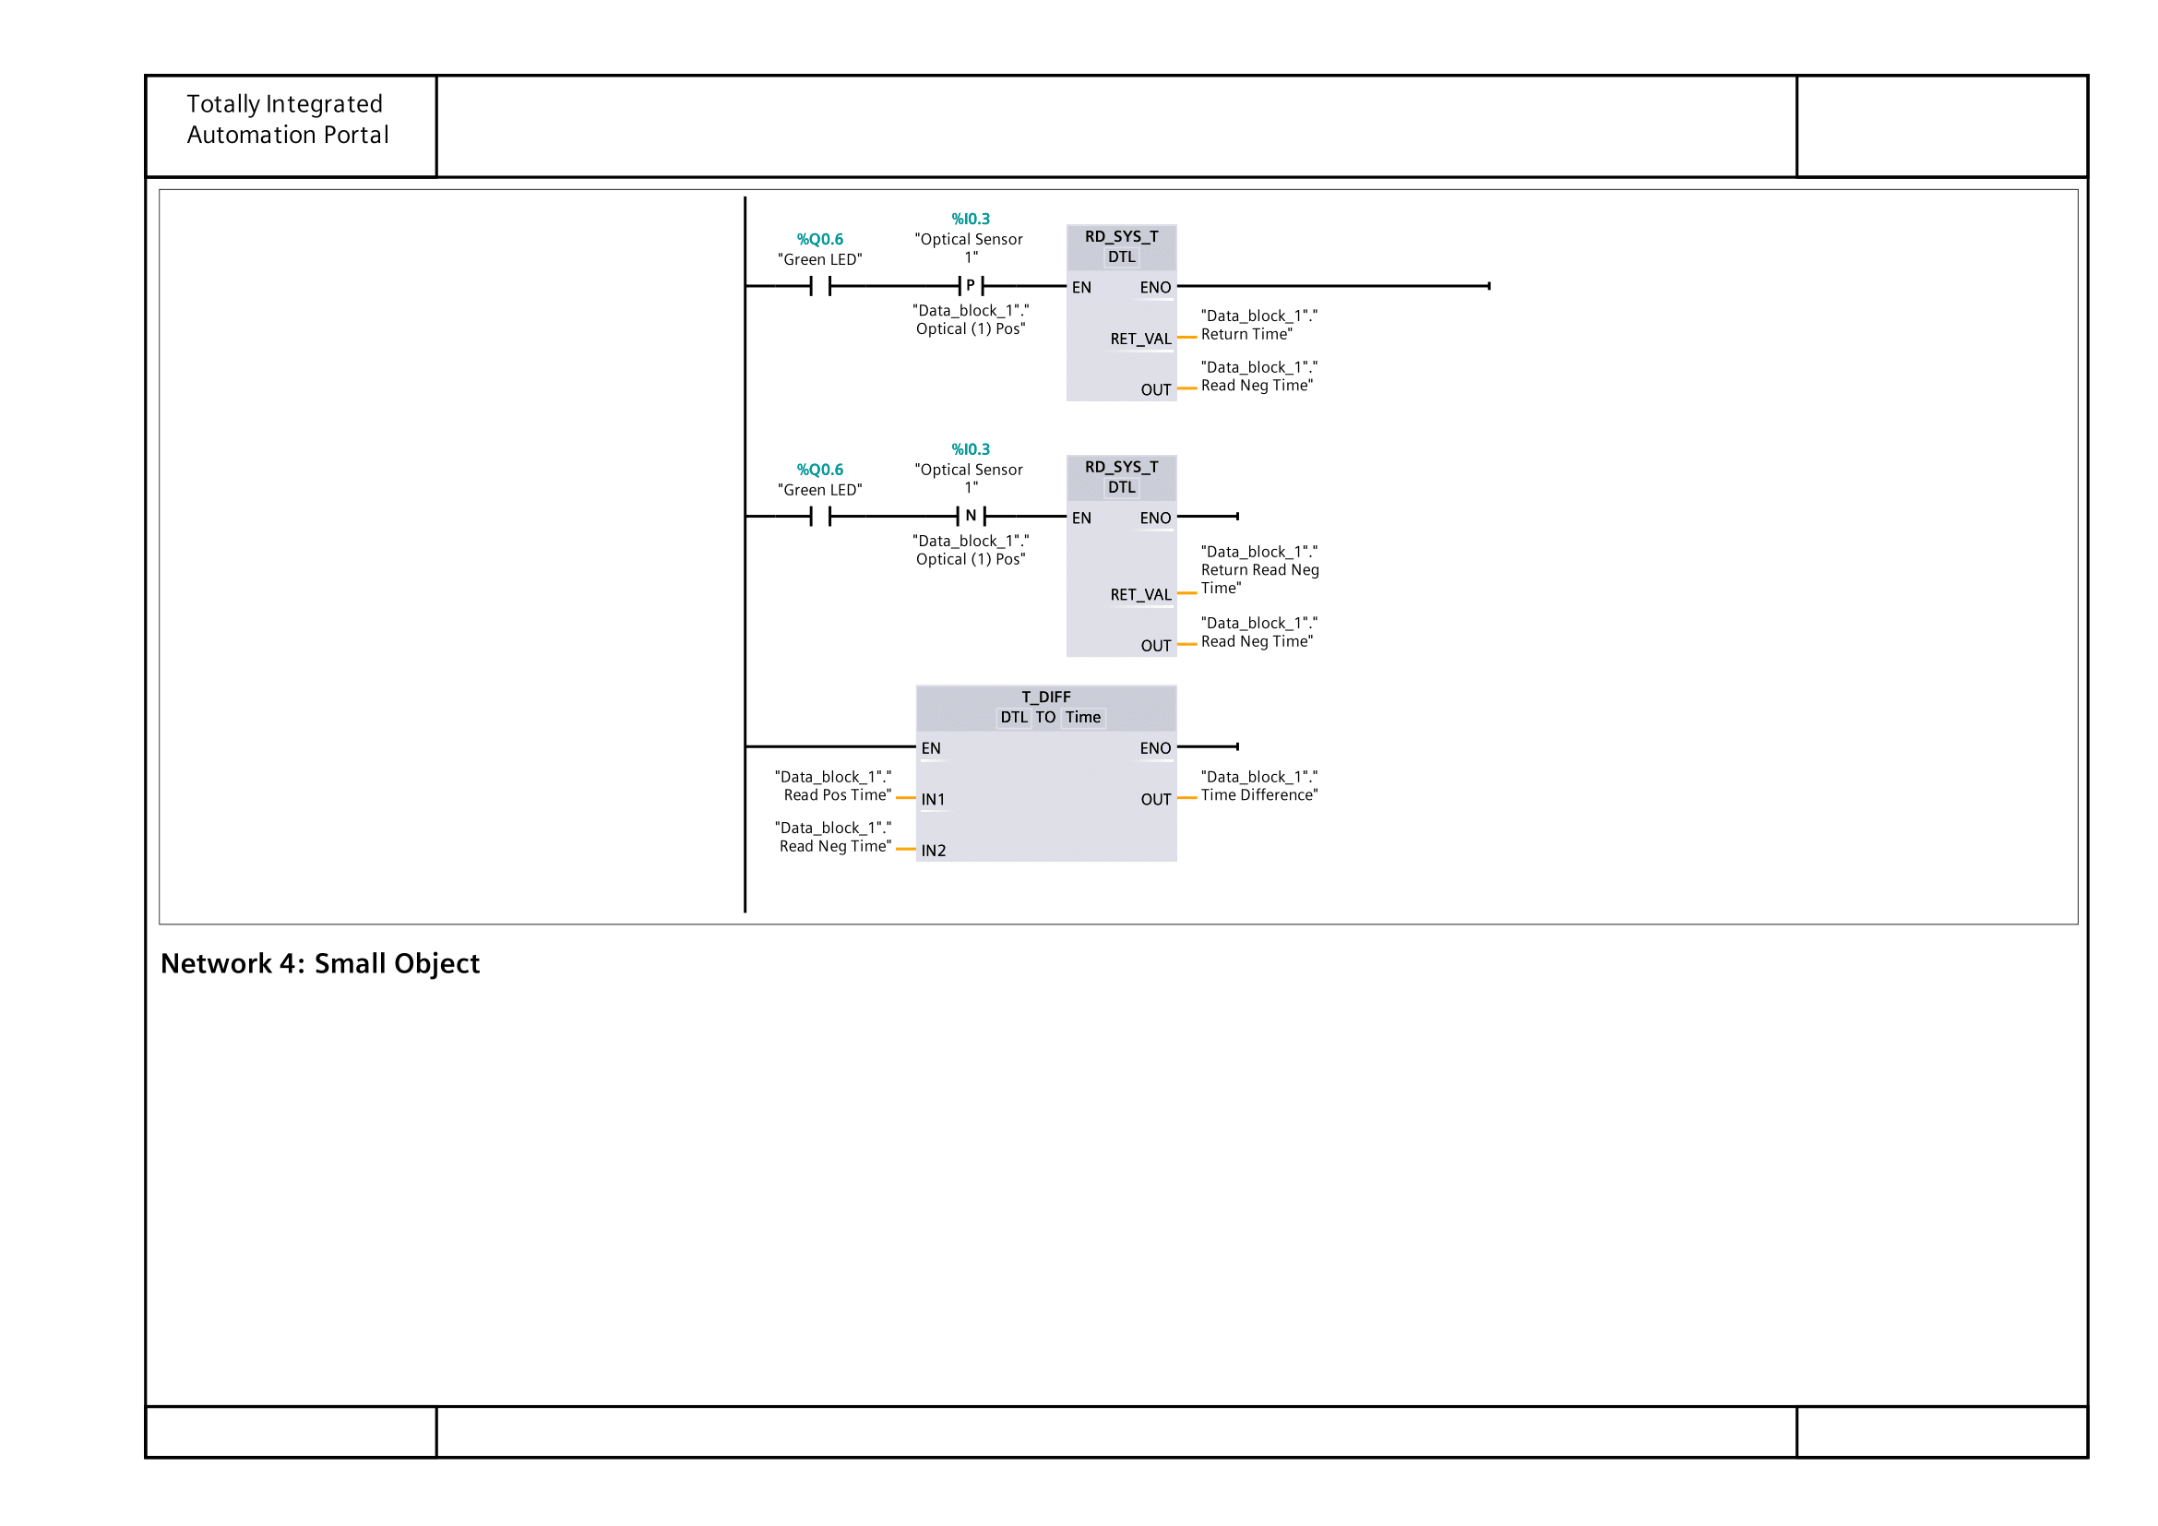
Figure 9: Project PLC Main Network 3
Figure 9 shows network 3 of the program, which is used to read timing information from the optical sensors. When the first optical sensor is triggered, the PLC uses the RD_SYS_T block to record the current system time and store it.
The T_DIFF block is used to calculate the time difference between the two recorded time values. This time difference represents how long the object took to travel between the sensors and is later used for size classification. Using the system time means the measurements remains accurate and independent of scan time.

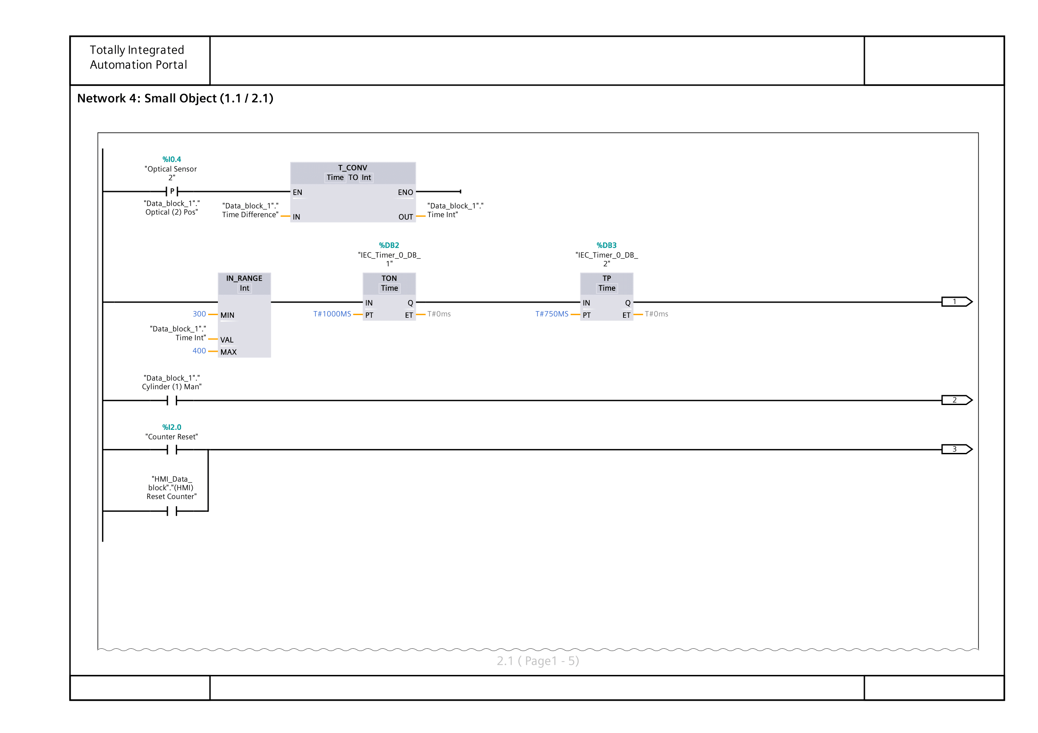
Figure 10: Project PLC Main Network 4
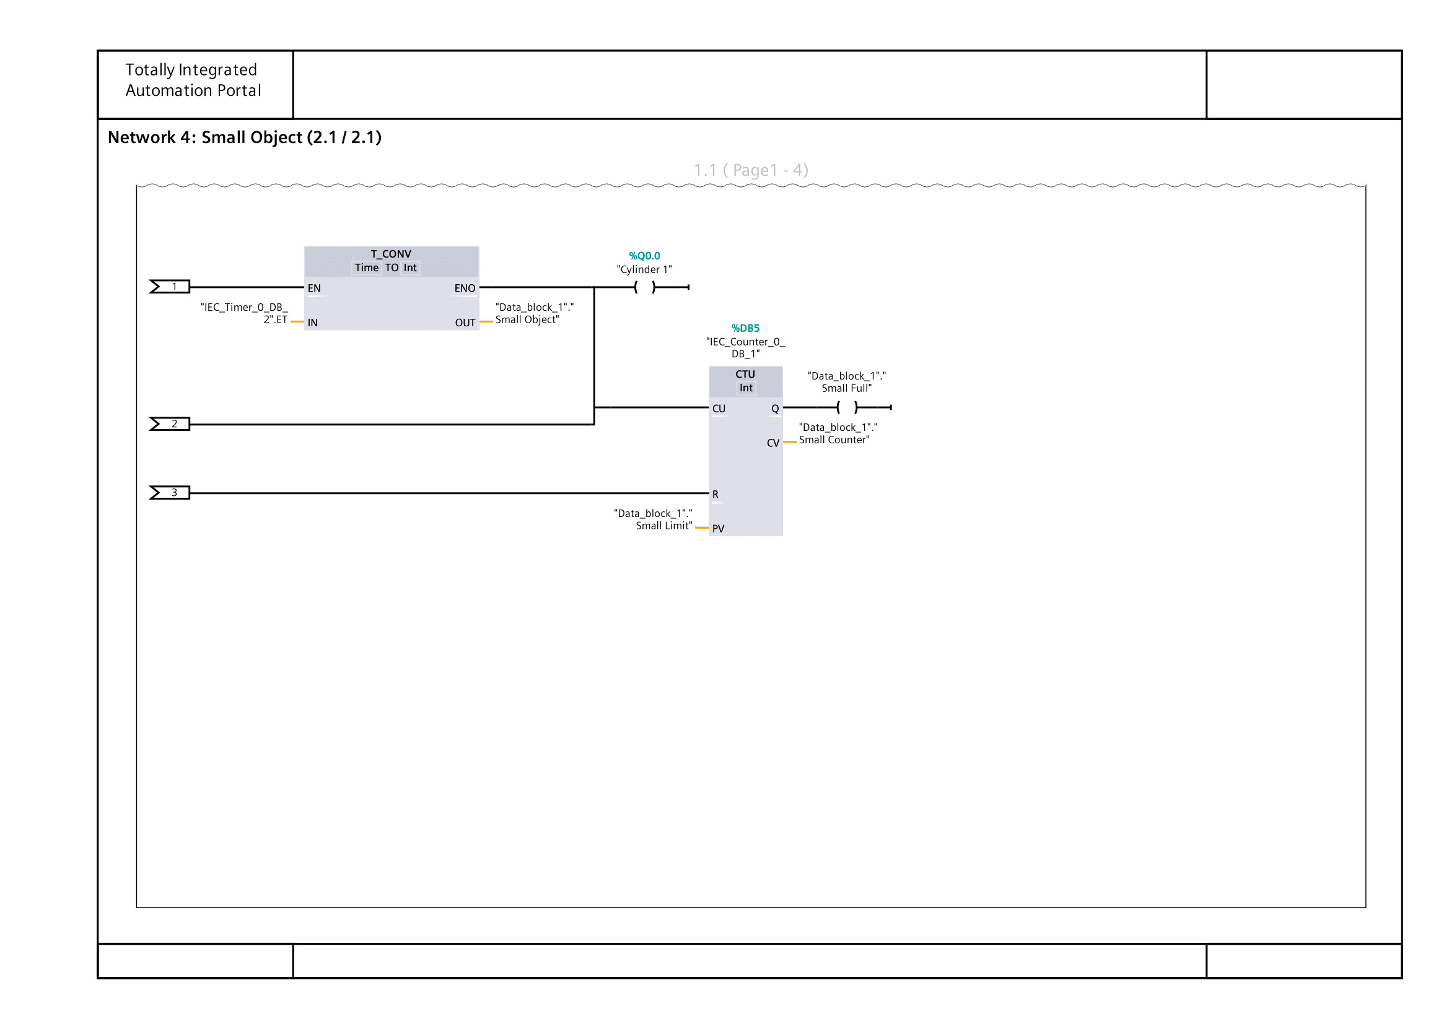
Figure 11: Project PLC Main Network 4 (Cont.)
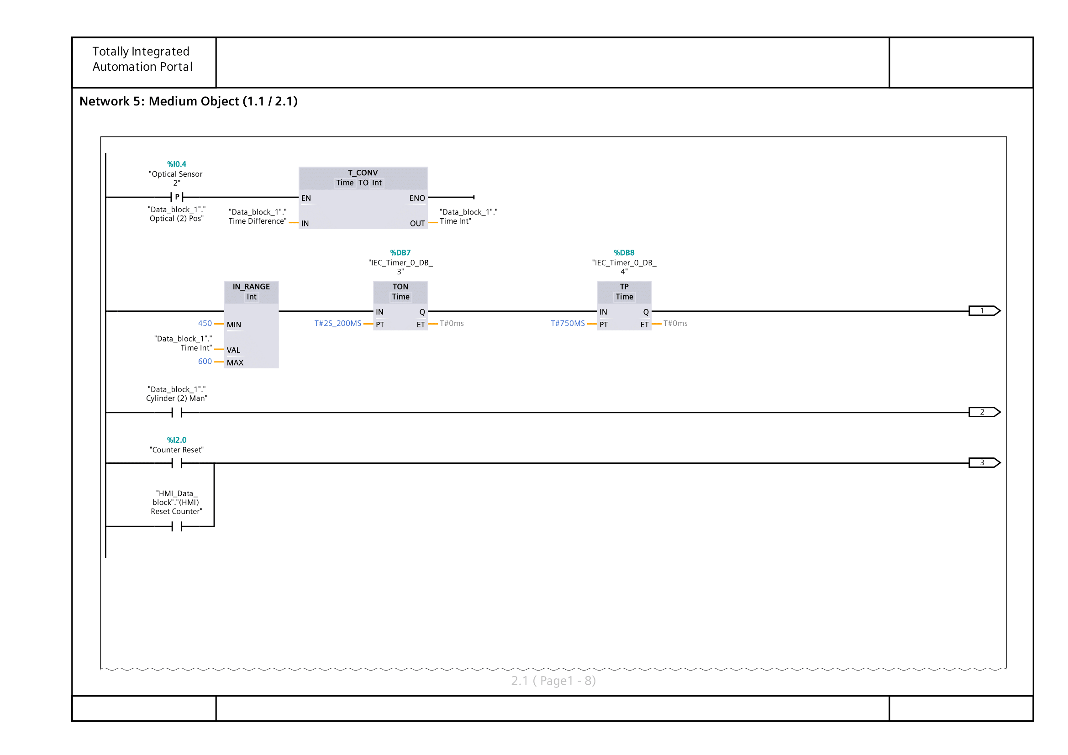
Figure 12: Project PLC Main Network 5
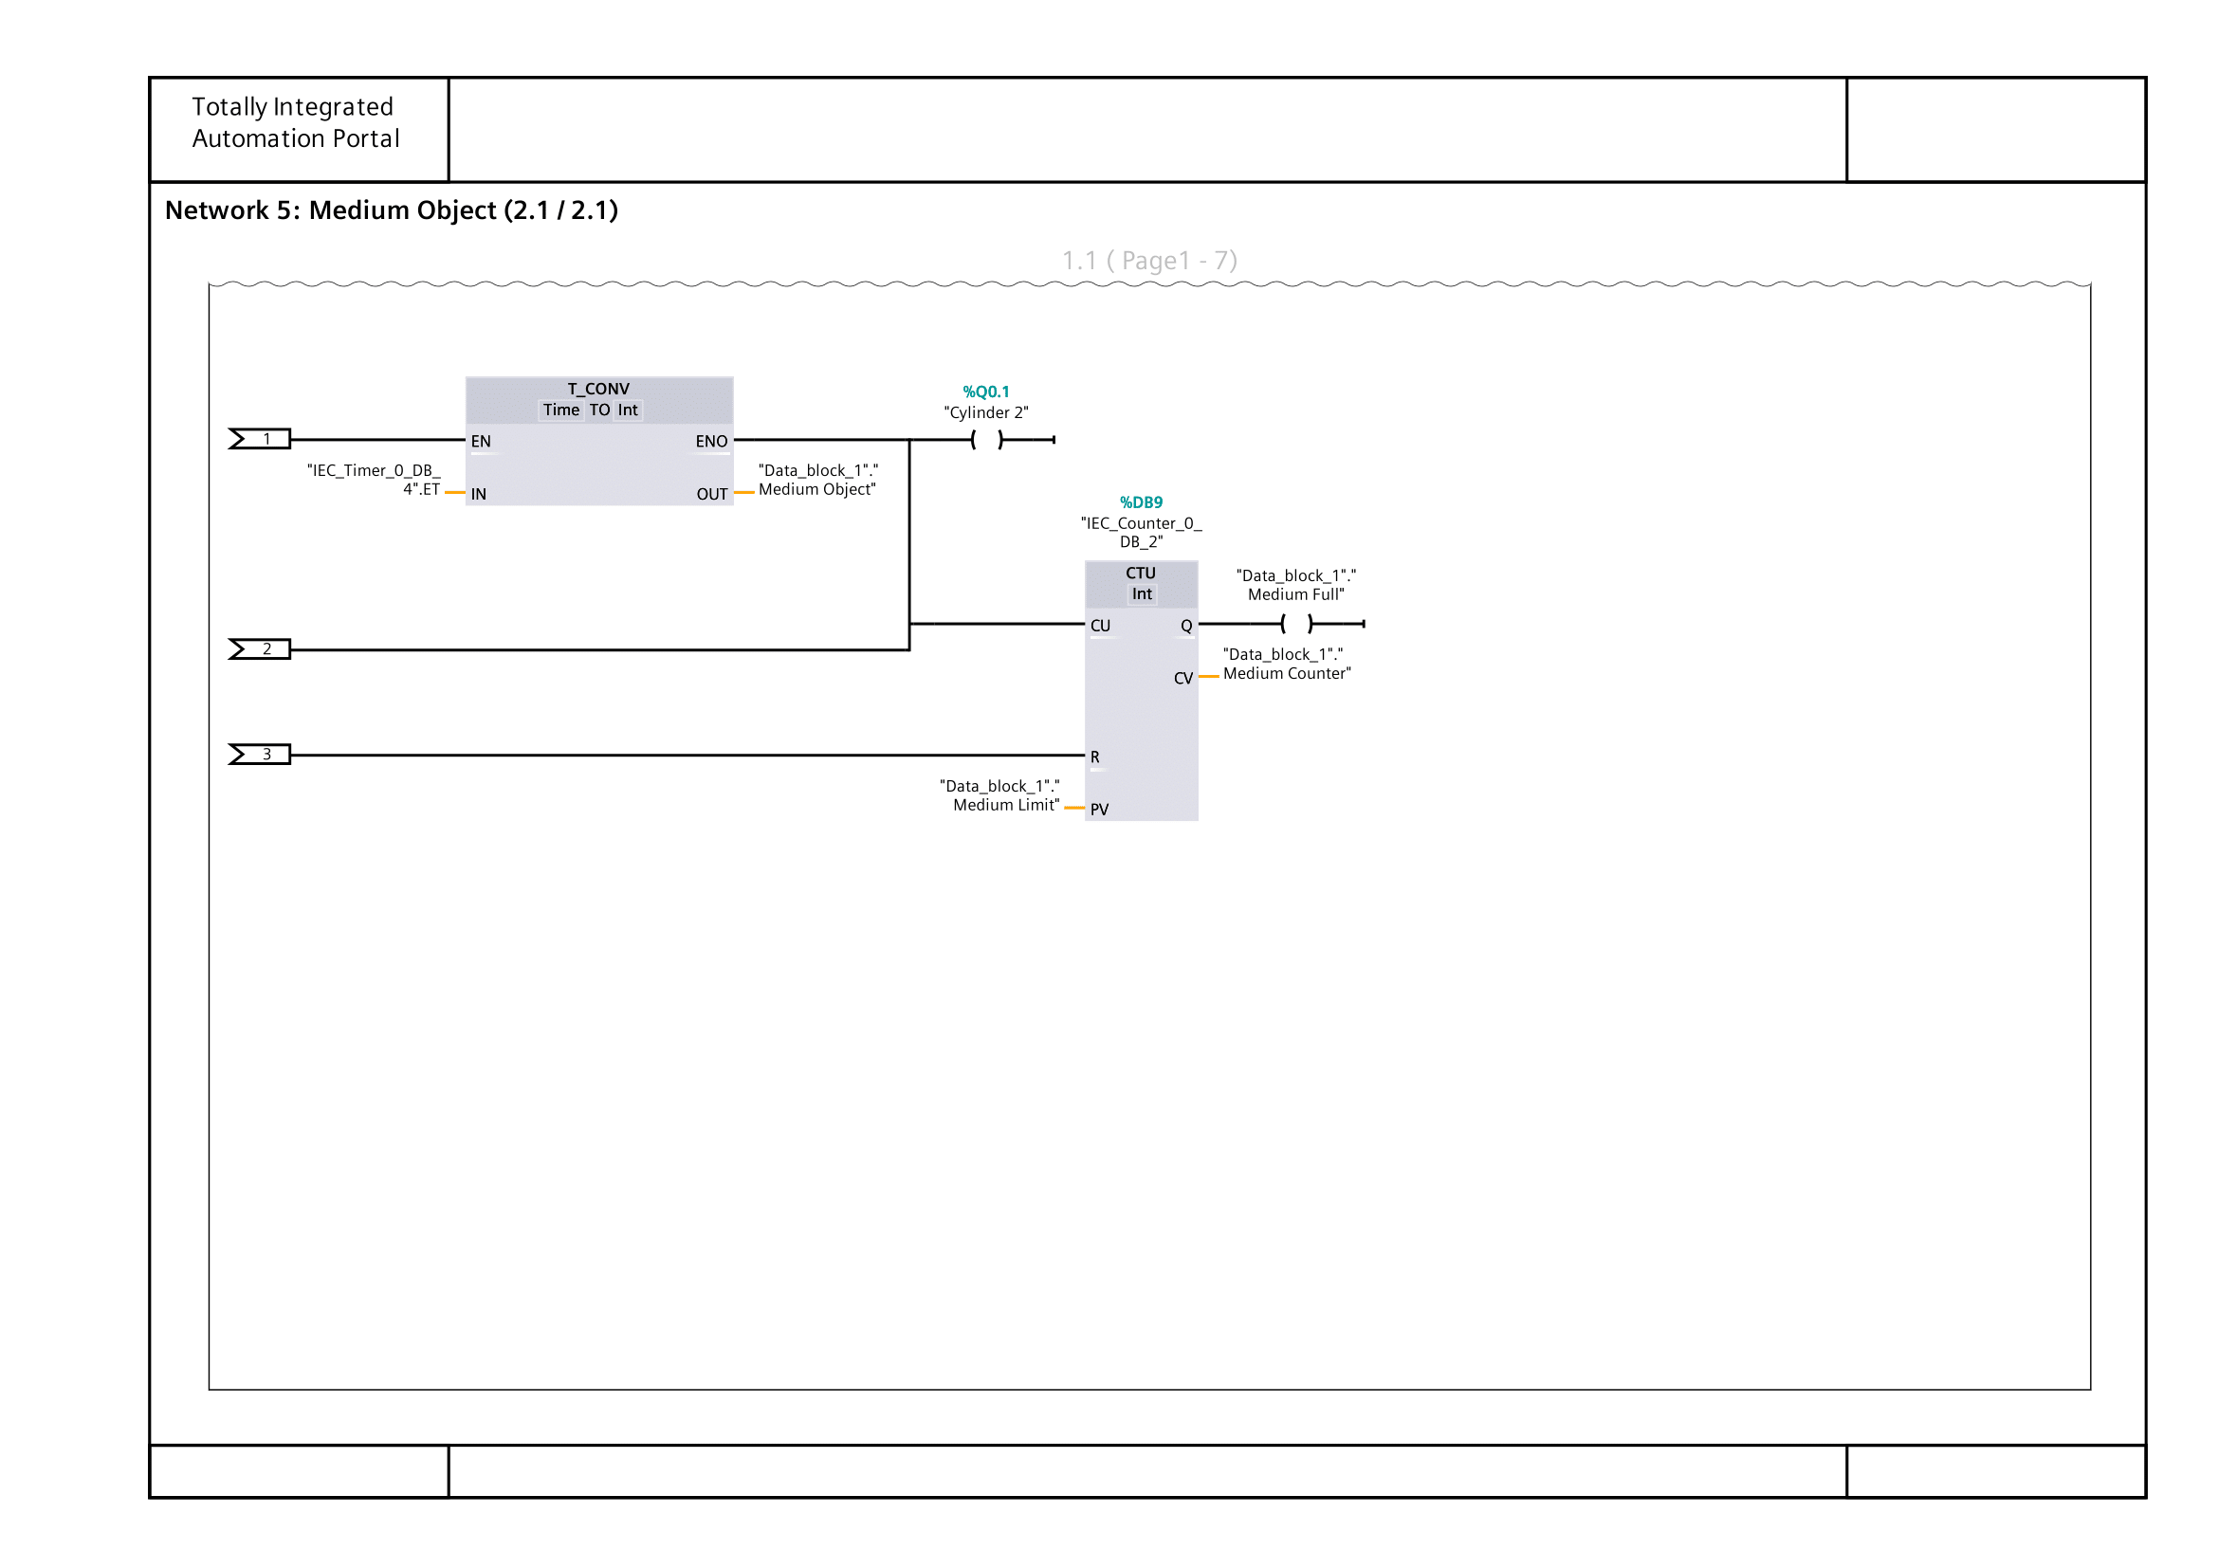
Figure 13: Project PLC Main Network 5 (Cont.)
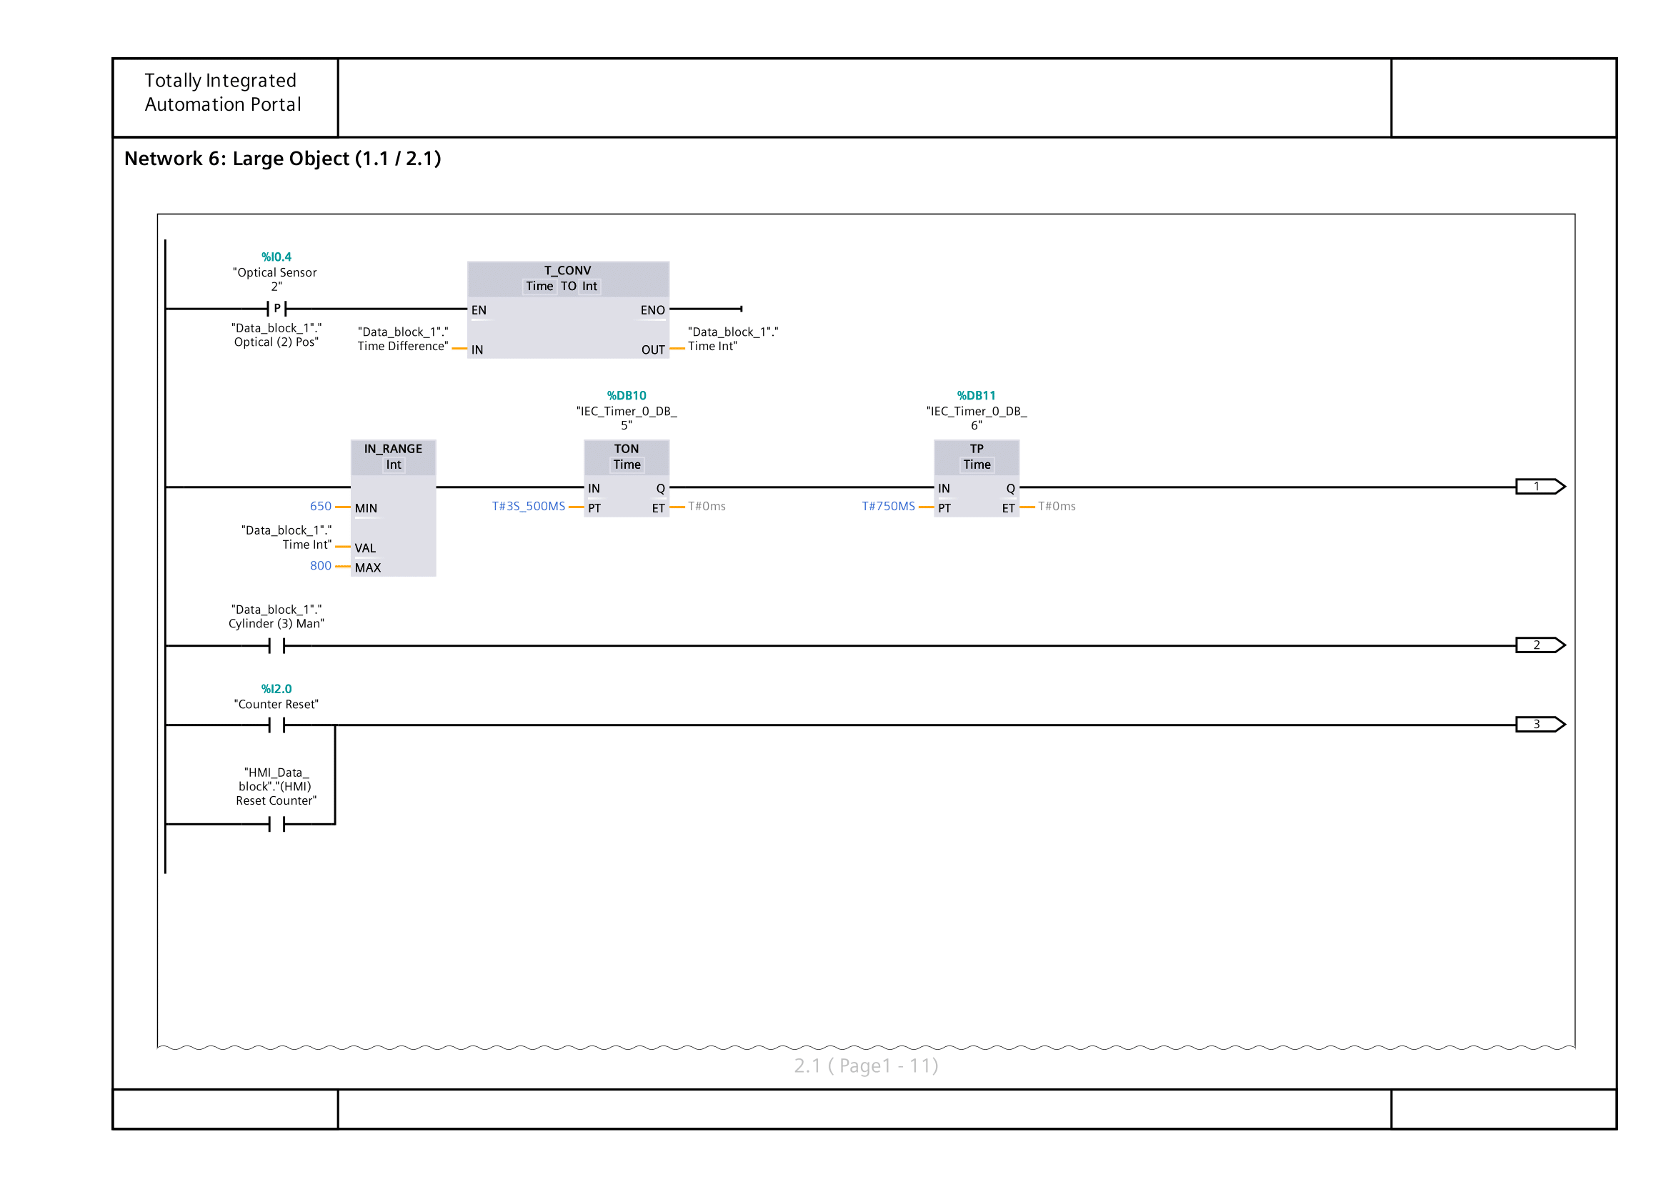
Figure 14: Project PLC Main Network 6
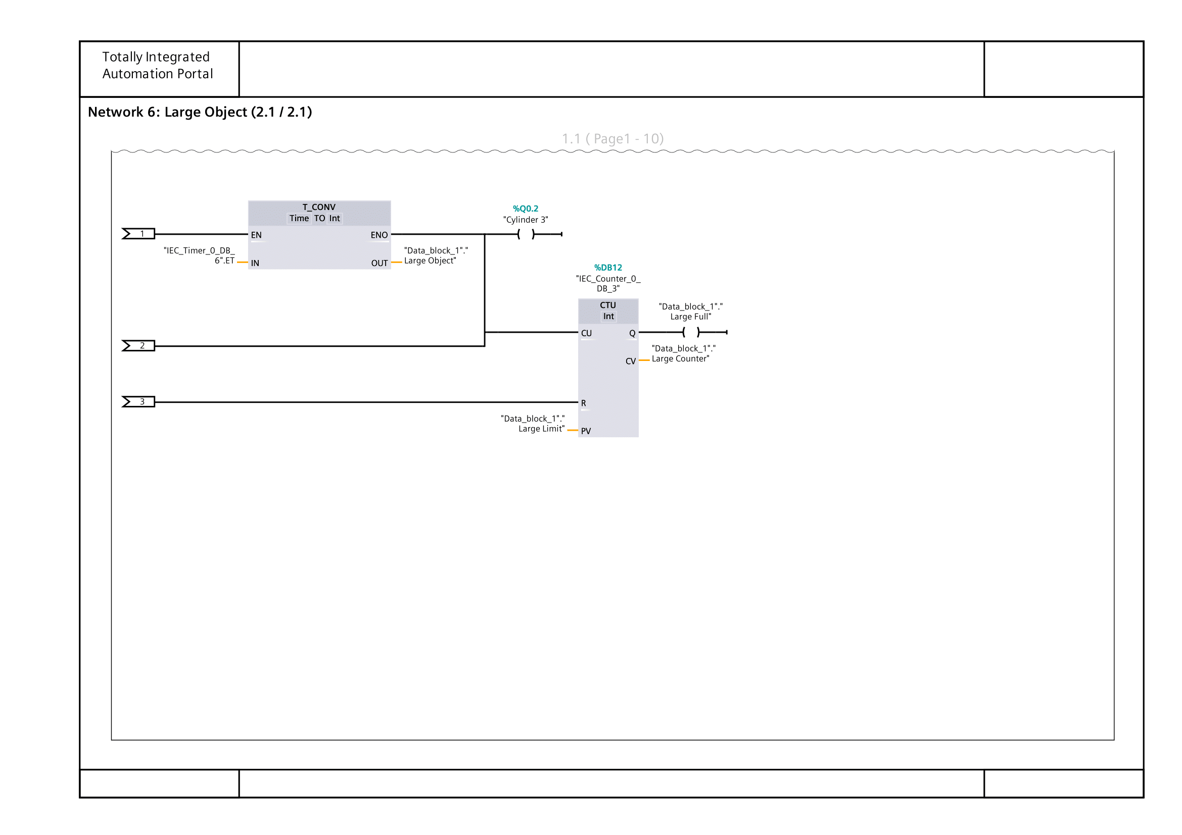
Figure 15: Project PLC Main Network 6 (Cont.)
Figures 10–15 show the PLC networks used to classify and count small, medium, and large objects. For each, the time difference measured between the two optical sensors is converted into a usable value and compared against predefined limits using an IN_RANGE block. Depending on which range the value falls into, the corresponding logic is triggered. For small and medium objects, a short pulse is generated to increment the relevant CTU counter, allowing the total number of sorted parts to be recorded and reset via the HMI if required. For large objects, a timed delay ensures correct positioning before the pneumatic cylinder is activated to divert the part, after which the large object counter is incremented. This structure keeps the classification process consistent across all object sizes while maintaining clear separation between each sorting condition.
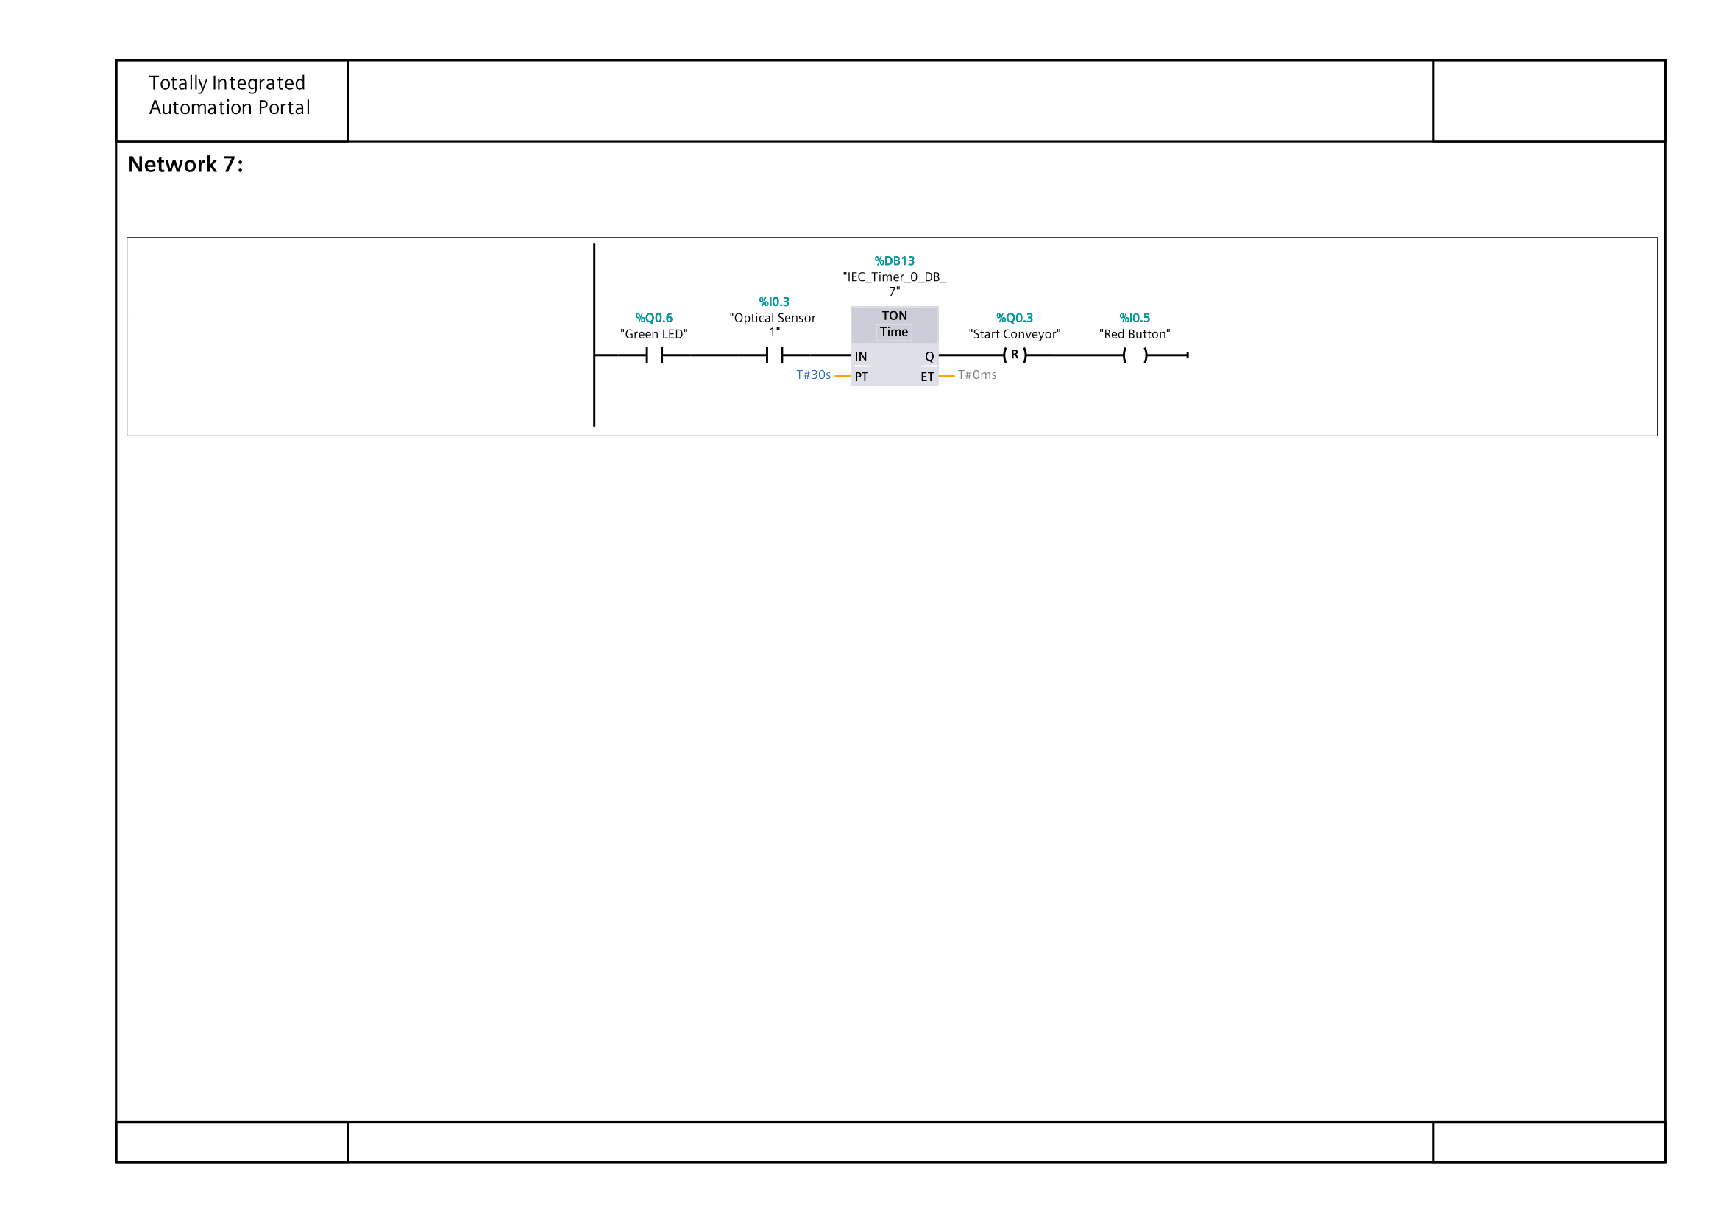
Figure 16: Project PLC Main Network 7
Figure 16 shows the idle-deactivation timer, which shows the TON timer activating upon start-up through the green LED. The timer is reset via the first sensor detecting an object, after which, the timer will begin the count down again.

Appendix C

HMI Setup
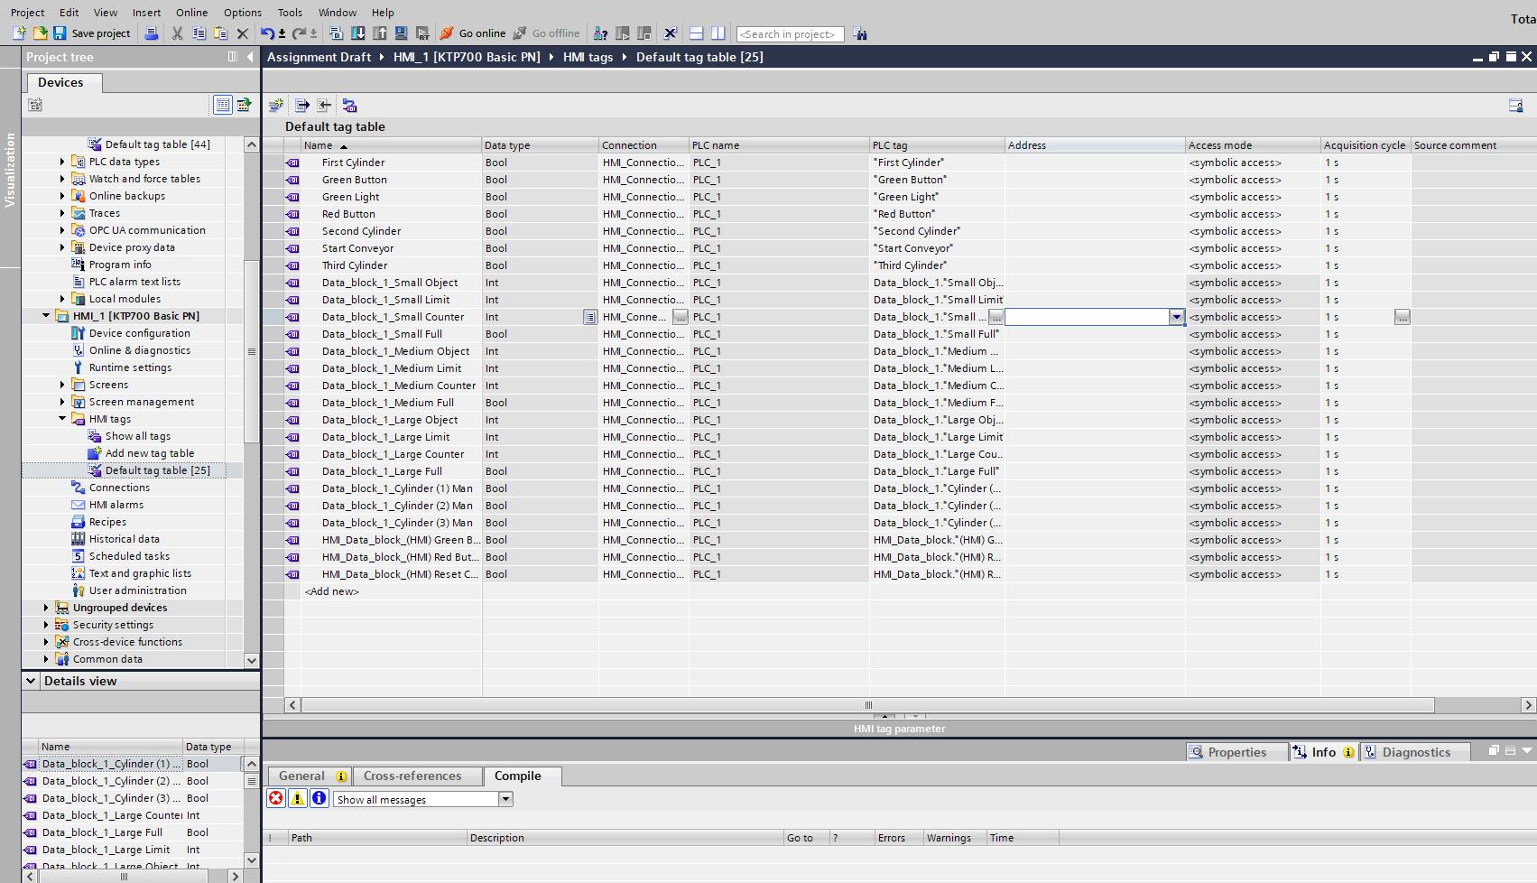
Figure 17: Project HMI Tag List
Figure 17 shows the HMI tag table used to link the HMI interface to the PLC tags/variables. This table connects buttons, indicators, counters, and limit values on the HMI to their PLC tag counterparts.

Appendix D

PLC Hardware & Network Setup

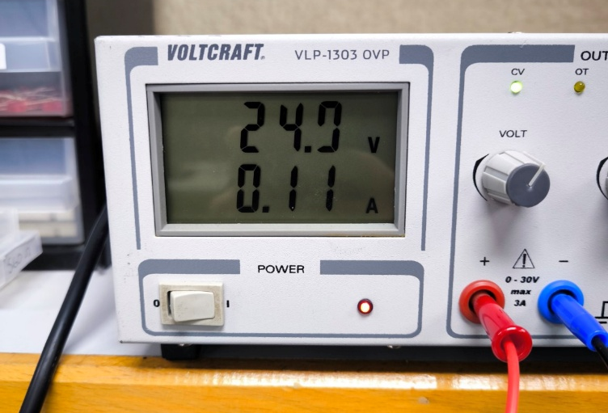
Figure 18: Connecting PLC to Power Source
The PLC must be powered by with approximately 24V and a minimal Amperage.

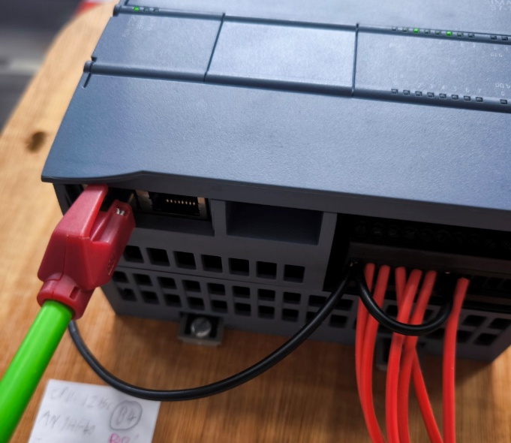
Figure 19: Linking PLC to PC
The PLC must be connected to the PC with an ethernet cable. The left ethernet input on the PLC is best used as the PLC prioritises that input over the other.

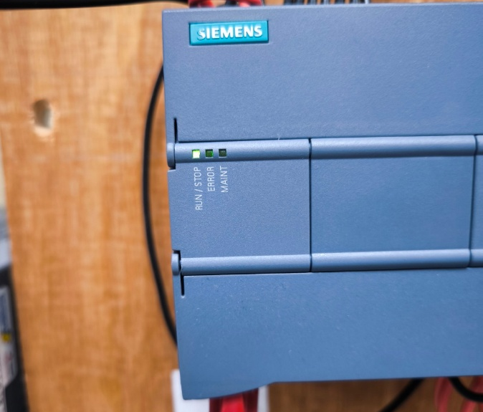
Figure 20: Verification of Working PLC
If powered correctly, the powered PLC can be identified via the green LED stating “Run/Stop”.

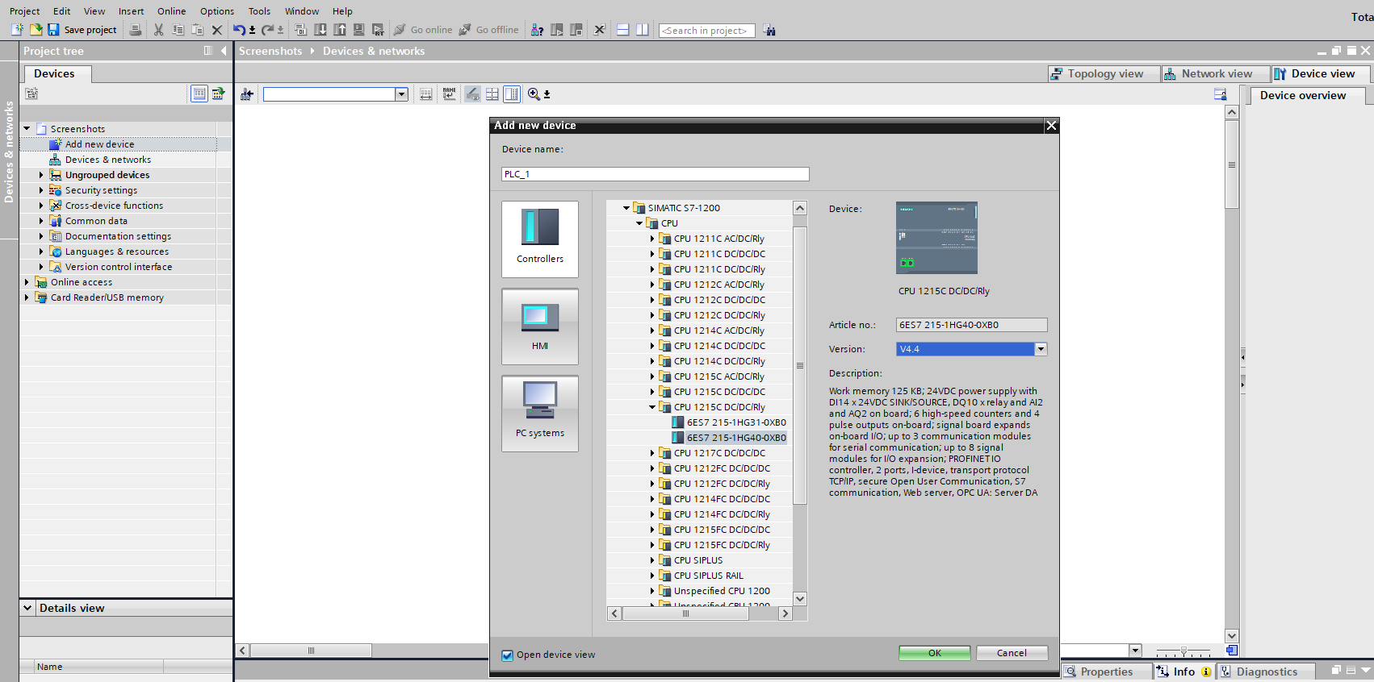
Figure 21: Finding Correct PLC Type & Version
Once connected to the PC, open the TIA app. Once opened, start a new project, and then on the left side bar, click “Add new device”. On the “Add new device” tab, find the chosen PLC as seen on the figure above.

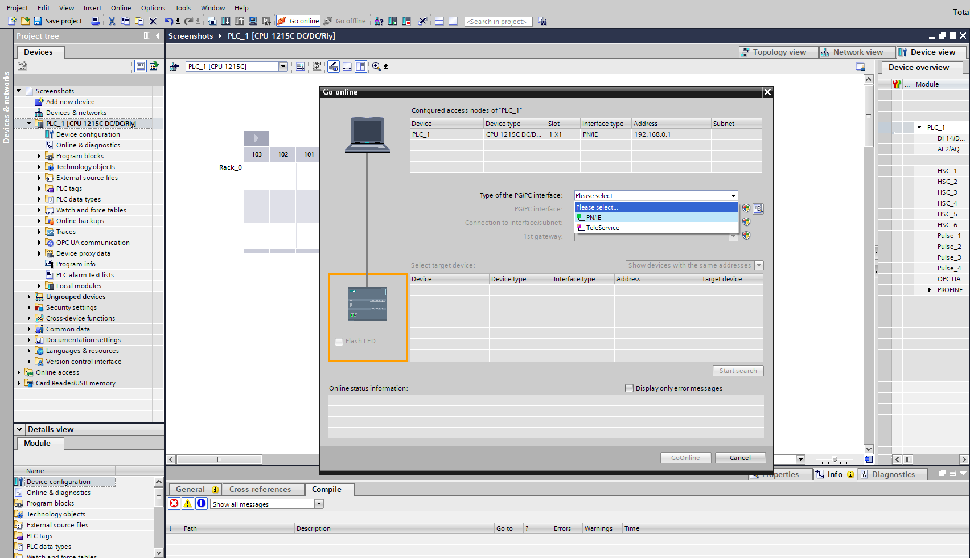
Figure 22: Setting Up Direct Connection to PLC (Part 1)
Once the device has been successfully added, choose to “Go online” in the top toolbar, this will bring up the “Go online” tab. Select the PN/IE from the dropdown list for the type of PG/PC interface.

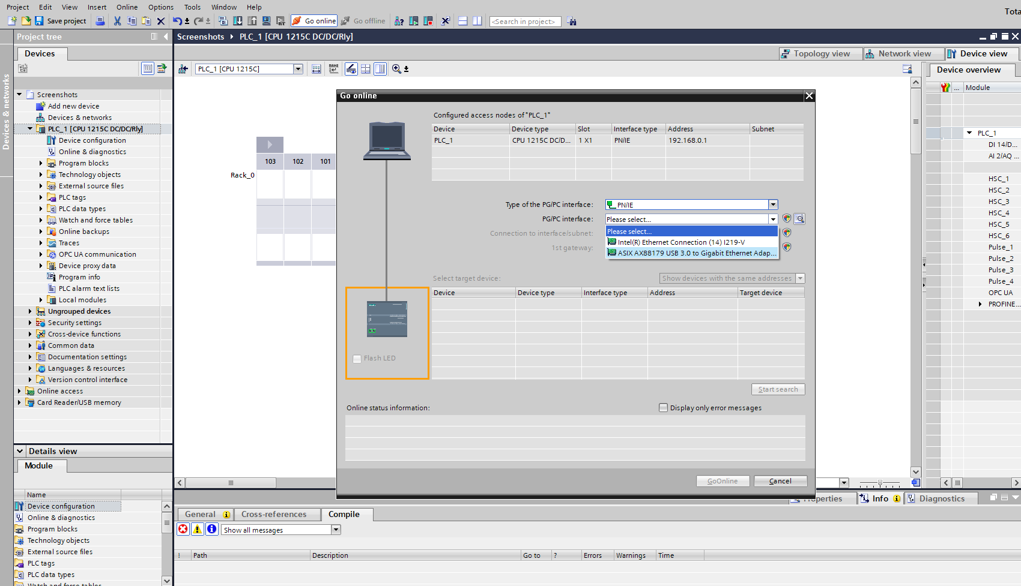
Figure 23: Setting Up Direct Connection to PLC (Part 2)
Then select the “ASIX Gigabit Ethernet” option from the PG/PC interface dropdown list.

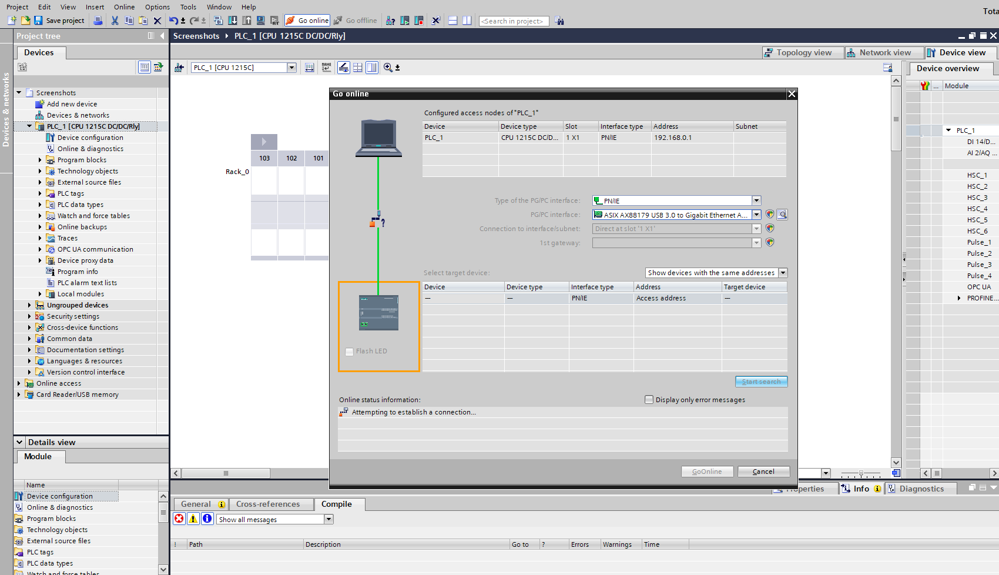
Figure 24: Setting Up Direct Connection to PLC (Part 3)
After selecting the correct options, you will be given the option to “Start search”, do so.

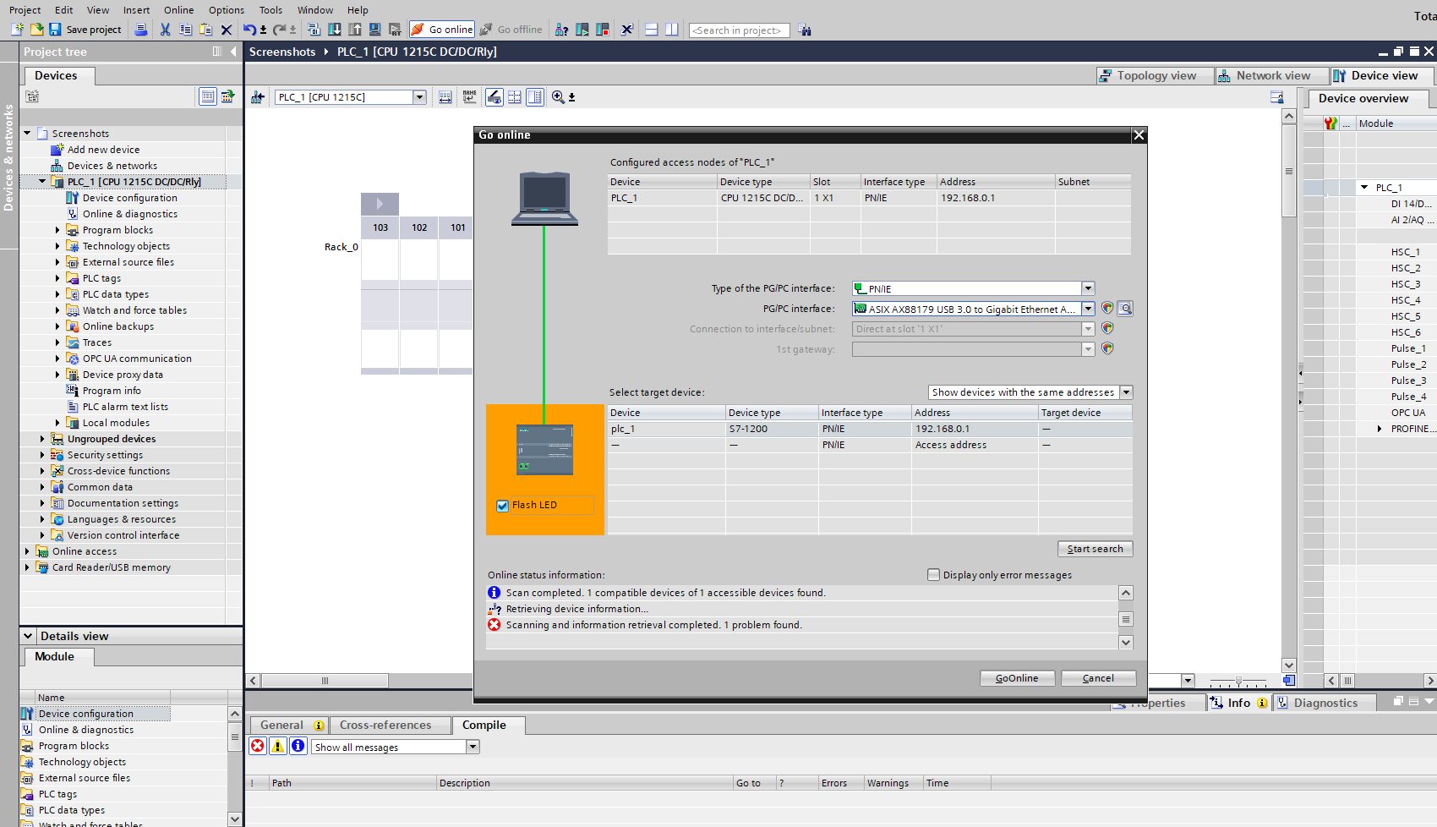
Figure 25: Verifying Connection
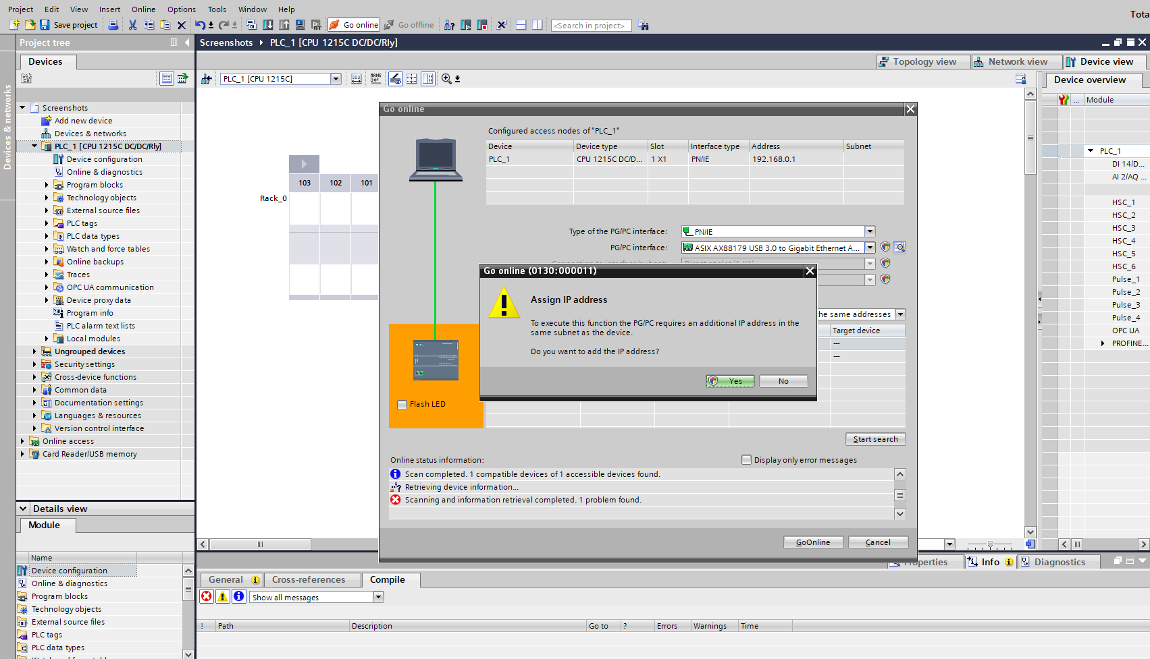
Figure 26: Assigning IP Address
After searching, you will be given the option to “Assign IP address”, do so. Once done, you can test for a successful online connection by clicking “Flash LED” which will flash all the LEDs on the PLC itself.

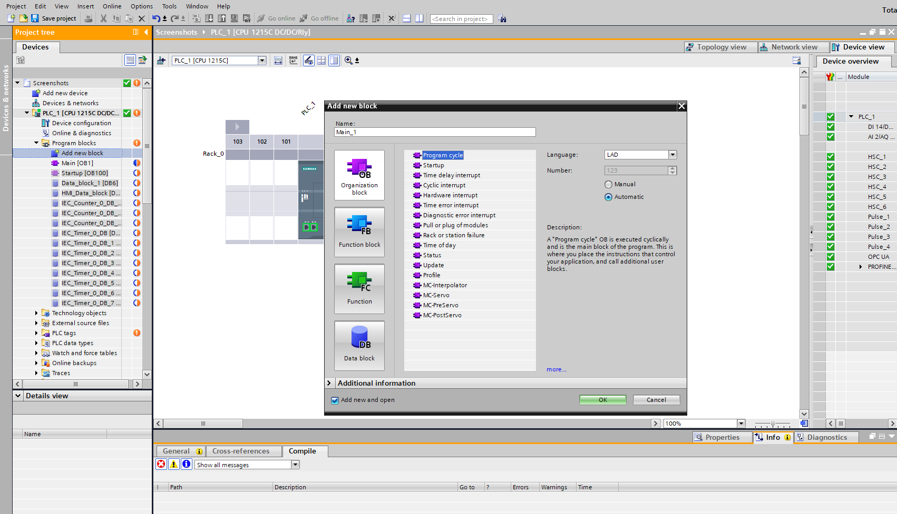
Figure 27: Adding Organisation Block for Coding Startup
The PLC is now online. Coding can now begin by adding a new network block (program cycle).

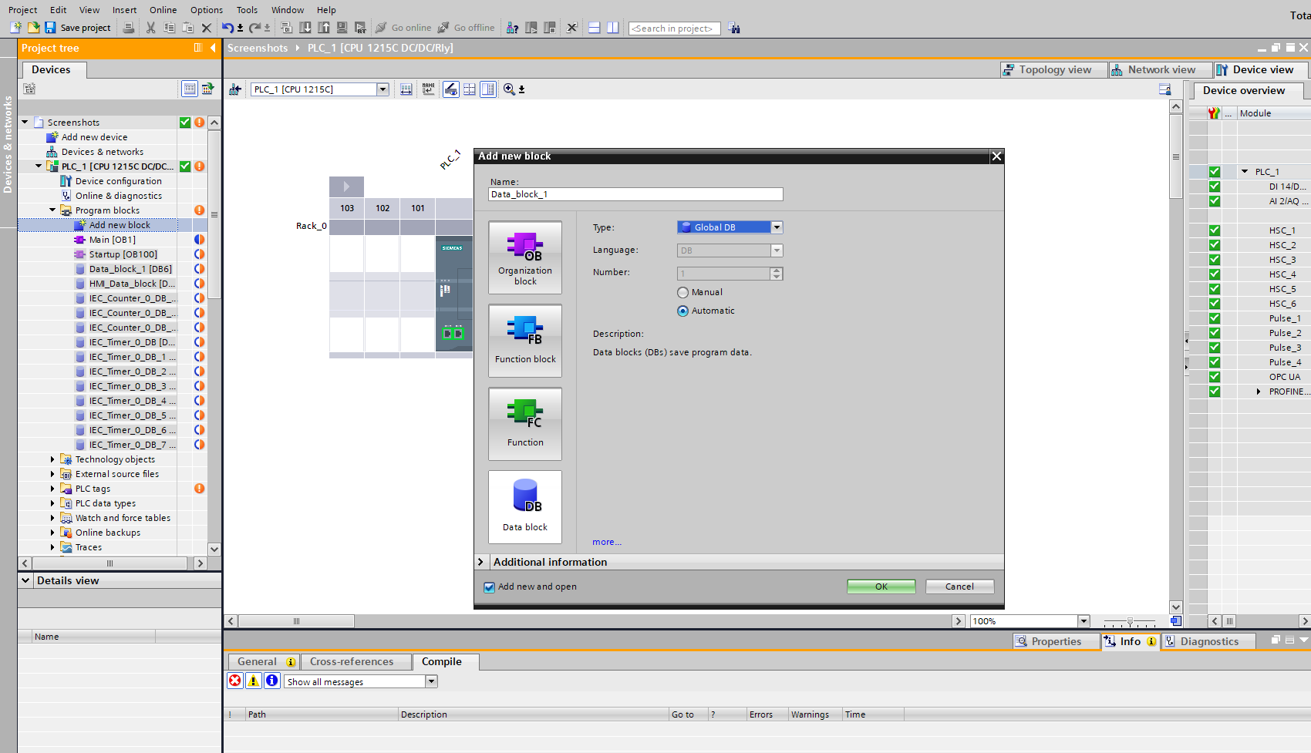
Figure 28: Adding Data Block for Identification Tags
Once the network block has been added, a “tag” block (Data block) must now be added for the variables to be assigned to/from.

Appendix E

HMI Setup
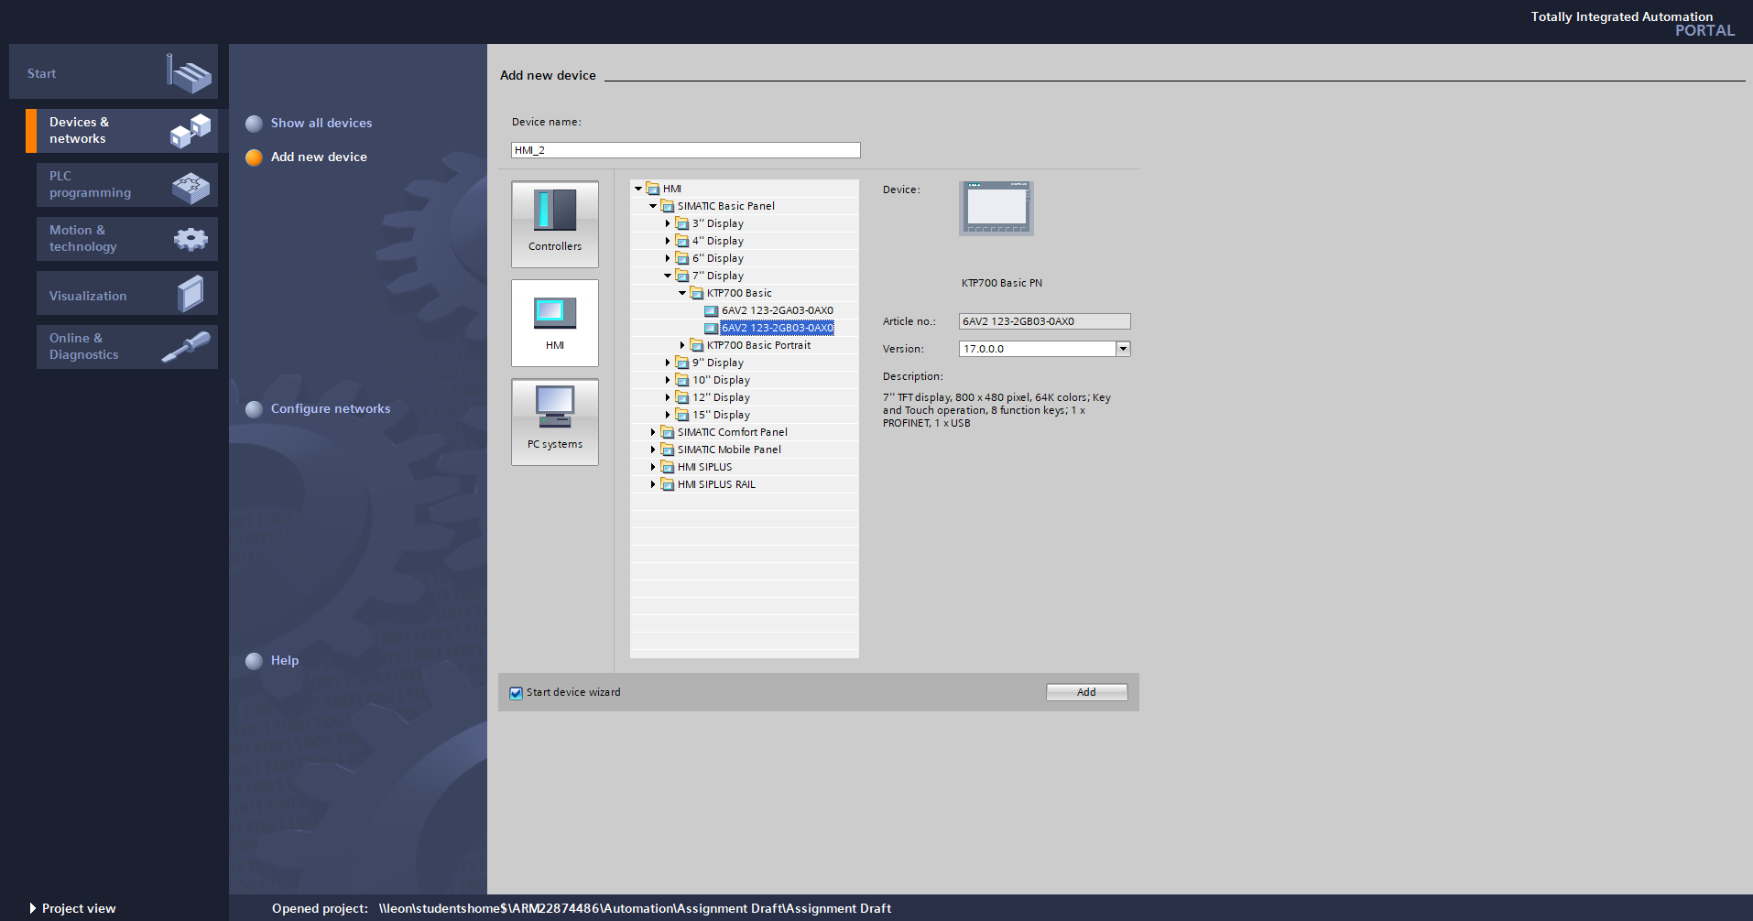
Figure 29: Setting Up HMI Device
The process of adding the HMI device to the TIA Portal project is much like selecting the correct PLC in Figure 21. The correct HMI model is selected and linked so it can communicate with the PLC.

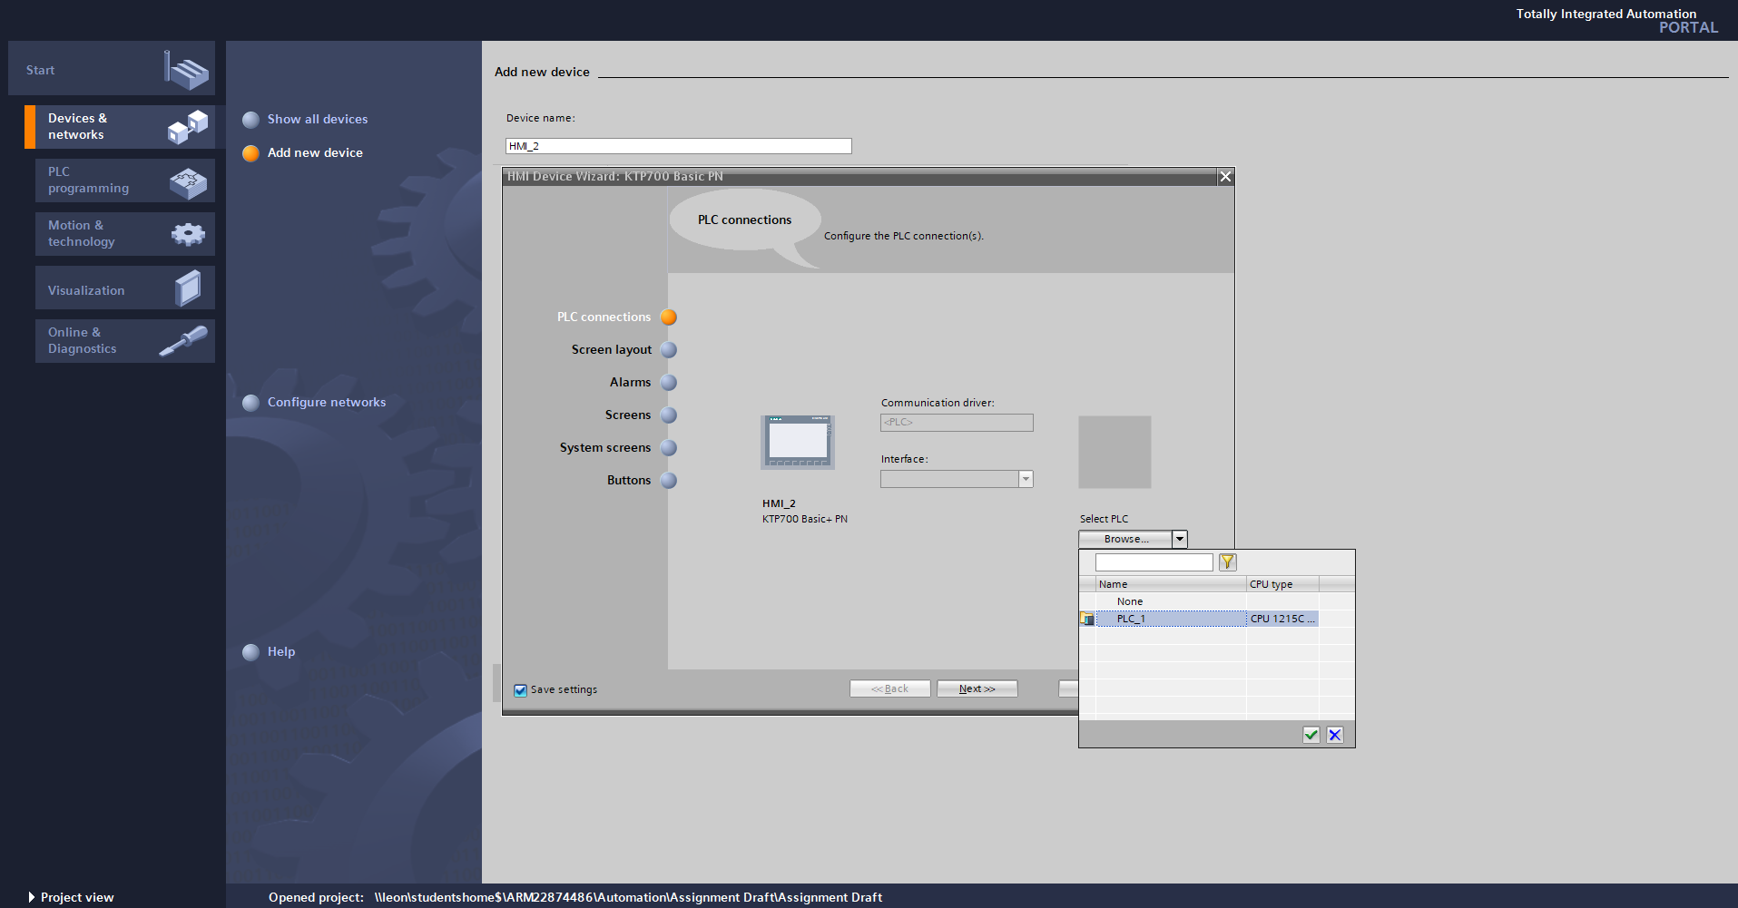
Figure 30: Setting Up HMI Connection to PLC (Part 1)
Once the correct HMI is selected, the option to link and interface with a PLC will appear. select the chosen PLC.
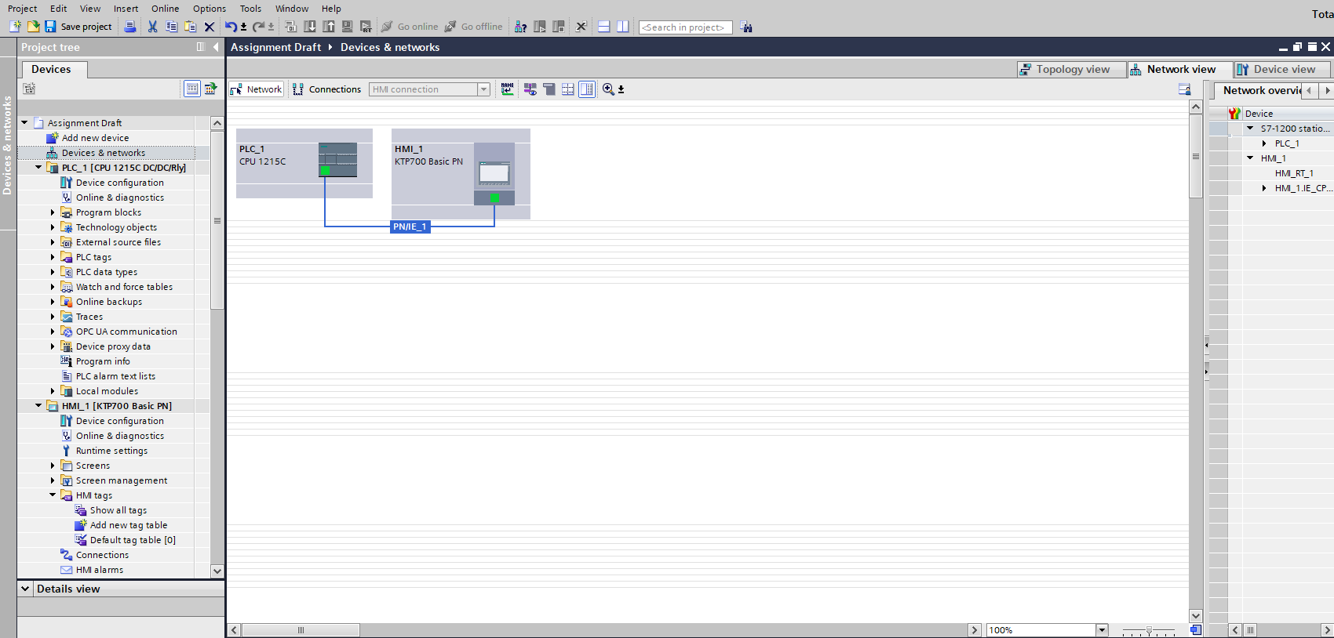
Figure 31: Setting Up HMI Connection to PLC (Part 2)
On the “Devices & networks” tab, the ability to “link” the HMI and PLC will appear. Simply click on the green indicator on either the PLC or the HMI and drag it to the other, doing so will successfully link them.

