Dylan Evans
[Email address]
Abstract
This report will outline problem solving and testing and implementation of problems within programing. The language that the report will outline will be C++.
Report Programming 2
By Dylan Evans

Contents
Part A Understanding Problem solving techniques 2
Subdividing code into functions. 2
Pseudo code 2
Flow charts 3
Part B – Testing 0
Part C implementation 0
Exercise 1 – Identifying Problems. 0
Exercise 2 – Mapping problem space to code 1
Exercise 3 – Connect 4 3
Evidence of working code 5
Task 1 – Guessing game 5
Task 2 – split numbers 5
Task 3 - connect 4 5
References 6
Appendix 6
Appendix 1 – calculator (testing) 6
Source.cpp 6
Application.cpp 7
Console.cpp 9
Console.h 10
Application.h 11
Appendix 2 – Task 1 guessing game 12
Appendix 3 – Task 2 split numbers 14
Appendix 4 – task 3 Connect 4 17
Source.cpp 17
Board.cpp 18
Board.h 21

Part A Understanding Problem solving techniques

Subdividing code into functions.
When given a problem it can be easier to solve if its split down into sections. The problem can be split into functions for each part of the problem. This not only makes the overall code better but it makes it easier to solve the problem. For example, if you take the problem of a calculator, this could be split down into 6 functions:
Menu: this is where the option in the calculator will be selected by the user.
Add: this is where additions take place within the program.
Subtract: this is where subtractions take place within the program.
Multiply: this is where multiplications take place within the program.
Divide: this is where divisions take place within the program.
DisplayResult: this is where the result would be calculated and displayed depending on the operation selected by the user.
Coding the problem this way makes it easier. If the coder had issues with getting their head around how to divide or multiply they could code the other parts of the problem first which may make the problem easier for them to solve.

Pseudo code
Another problem solving technique is pseudo code this is when you write how to solve the problem in basic English before writing the code. This can help as sometimes it’s difficult to think how to write problems in code. You can’t write the code for a problem you haven’t solved. Some example pseudo code is found for a problem of a revision of the game pong which was programmed by Dylan Evans in college
Set window size to 640x480
Set game area to 640x480
Call assets to the game
Ball
Paddle
Background
Title screen Background
Put title screen background to the display
Define location for buttons
Define play button to bring the background and all of the assets to the display
Define the instructions button to bring the instructions background to the display
Define the exit button to exit the program
Define variables
Ball speed
Paddle speed
Ball
PaddleA
PaddleB
PaddleC
Score
Assign left and right keys to move bottom paddle
Assign up and down keys to move right paddle
Assign w and s keys to move left paddle
When ball collides with paddle bounce the ball off the paddle in a random direction
If the ball goes off the screen load the game over screen
[1]

Flow charts
A problem solving technique such as flow charts is another great example of a problem solving technique this is where you show how the program works as a diagram using arrows to show the flow of the problem. An example of this is shown below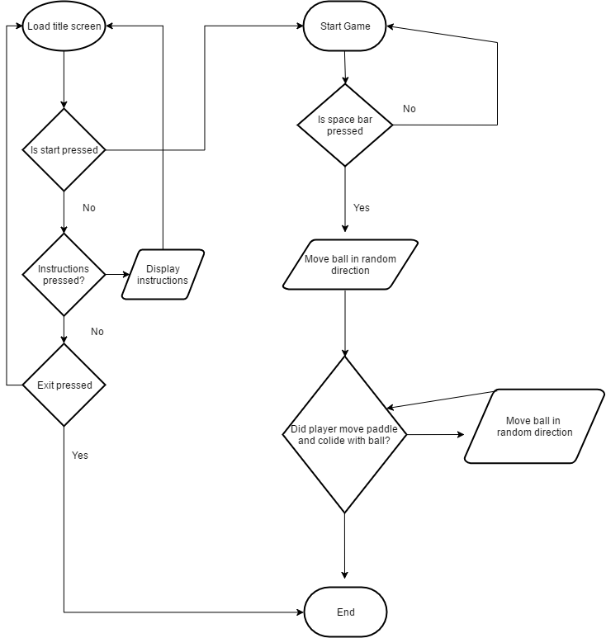 [1]

Part B – Testing
enters a number.

1 | User enters menu option
Description |  | The user enters a valid option number
 |  | Test Steps :
1 | Message displayed asking user to enter number
2 | The number 1 is entered

Response |  | The program should not produce an error message and should continue to next step which is to enter the numbers to added together
Status |  |  | Date |  |  | Description
Fail |  |  | 18/10/17 9.30 |  |  | An incorrect error message was displayed warning that the number was not valid
Pass |  |  | 18/10/17 10.05 |  |  | Passed

2 | User enters invalid menu option
Description |  | The user enters a value that is neither a number nor a valid option
 |  | Test Steps :
1 | Message displayed asking user to enter number
2 | Enter values that are not numbers:  a, a1, 1a  Enter a number that is not an option:  44
3 | Re-enter an invalid number or option

Response |  | For invalid numbers the program should display an error message and ask the user to re-enter a number  For an invalid option number the program should display an error message and telling the user the option was invalid and the user should be asked to enter another menu option choice.
Status |  |  | Date |  |  | Description
Fail |  |  | 18/10/17 9.30 |  |  | A warning message was not displayed when 1a was entered
Pass |  |  | 18/10/17 10.05 |  |  | Passed for all values

3 | Does the program run
Description |  | Unedited code pasted into visual studio and compiled and run.
 |  | Test Steps :
1 | Paste code into visual studio
2 | Compile and run

Response |  | The expected result is for the program to run with no errors and for the menu to be displayed to the screen.
Status |  |  |  | Date |  |  |  |  |  | Description
Fail |  |  |  | 15/03/2018 |  |  |  |  |  | The code displayed two errors stating that “stdafx.h” could not be found. This is the precompiled header and isn’t included in empty projects therefore is an easy fix all that is required is to copy the file from another project along with its dependencies.  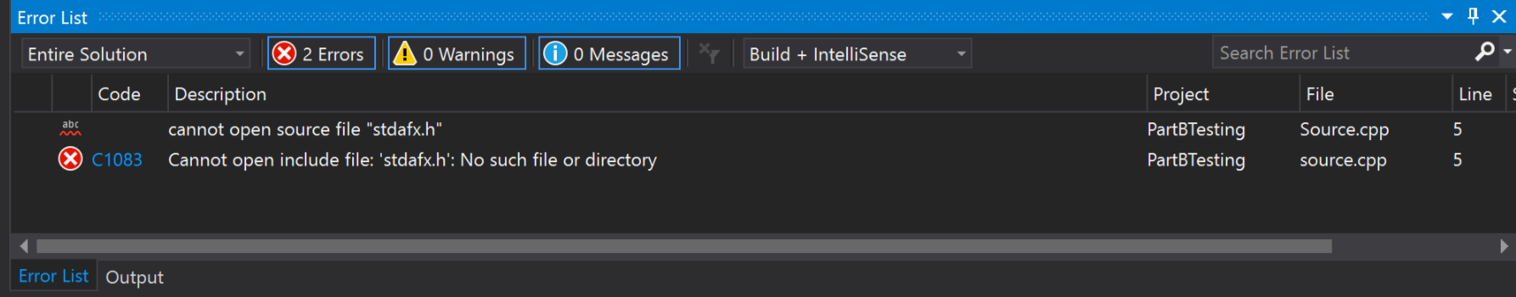
Pass |  |  |  | 15/03/2018 |  |  |  |  |  | The code compiled and ran without any visible bugs. This wasn’t really an error but more of a user error.
4 | User enters value which isn’t a number when adding values.
Description |  |  | The user enters a value which isn’t a number for example char
 |  |  | Test Steps :
1 | Message displayed to user asking to enter number to add
2 | User enters A and B

Response |  |  | The program should not allow the user to enter invalid values and inform them of the error.
Status |  |  |  |  | Date |  |  |  |  |  | Description
Fail |  |  |  |  | 15/03/2018 9:02pm |  |  |  |  |  | The program continues and throws a random value back to the user of -1717986920
Pass |  |  |  |  | 17/03/2018 1:40pm |  |  |  |  |  | The program now stops the loop if a value which isn’t a number is entered and displays a message to the user telling them to input a number. 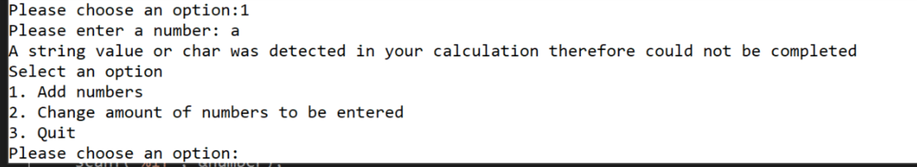

5 | User enters “Y” “Yes” “y” “yes” as option to quit
vDescription |  | The user will enter yes in a number of different ways and each way must be accepted by the program
 |  | Test Steps :
1 | User selects option 3 to quit.
2 | Enter “Yes” or ”y” or “Y” or “yes”

Response |  | The program should quit no matter what variant of yes the user enters.
Status |  |  | Date |  |  | Description
Fail |  |  | 17/03/2018 3:52pm |  |  | The program did not accept all variants of yes only “YES”
Pass |  |  | 17/03/2018 3:57pm |  |  | The problem was with the if statement it only allowed for the value “YES” so this was changed to  if (response == "YES" || response == "Yes" || response == "y" || response == "Y" || response == "yes") in order for it to work
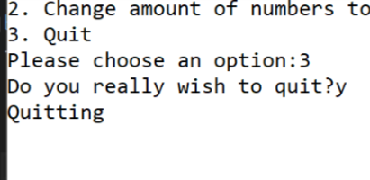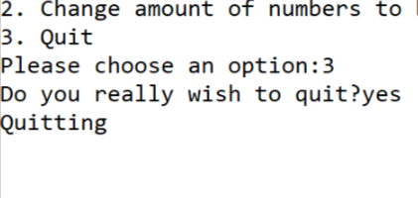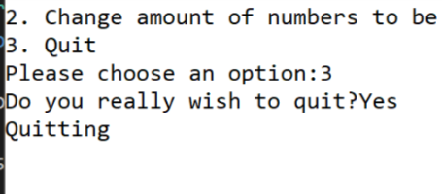

06 | Does the display function correctly when the total is more than one digit?
Description |  | The user will type in bigger numbers to add to see if the display still functions as it should.
 |  | Test Steps :
1 | The user selects option 1 to add numbers
2 | The user types in 5 large numbers

Response |  | The expected response when the test is run
Status |  |  | Date |  |  | Description
Fail |  |  | 17/03/18 4:05pm |  |  | The display breaks when the total is displayed.
Pass |  |  | 17/03/18 4:25pm |  |  | The display works with any given number changes to the code and evidence of it working provided below:
int LenOfTotal = std::to_string(result).length();
printf("###############################################################################\n");
printf("###############################################################################\n");
printf("################## ");
printf("%s", to_string(result).c_str());
for (int index = 0; index < 22 - LenOfTotal ; index++)
{
printf(" ");
}
printf("##################\n");
printf("###############################################################################\n");
printf("###############################################################################\n");

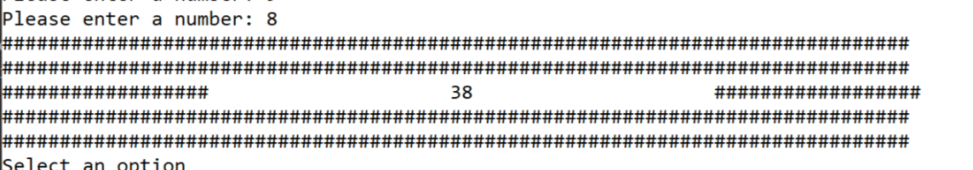Broken

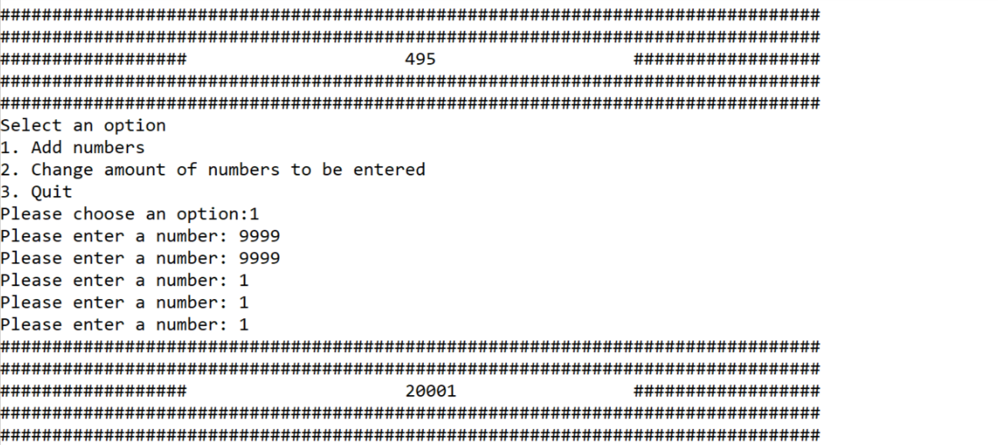Fixed

Part C implementation

Exercise 1 – Identifying Problems.
A problem given where a user has to guess a random integer between -20 and + 20 giving hints each time the user guesses can be split down into 4 problems. These problems are
- Getting the user guess
This problem is by far the easiest as all you are doing is taking an input from the user and storing it in a variable for the program to use later.
- Generating the random integer
This is the second most difficult problem but still very easy all this function would do is generate a random number between -20 and + 20 and then store it in a variable to be used later.
- Checking the users guess against the random integer

This again is an easy problem it would just require a simple if statement to check if the users guess is equal to the random integer.

- Giving the hint based upon the users guess.
This would be the most difficult problem as it requires to give the user 4 hints this could be done by putting a switch statement within a function and creating a variable for the number of user guesses and each time the function is called it will pass it this information to give the user the correct hint.
  - Hint 1 – is the number positive or negative?
This can be solved with a simple if statement if the number is less than 0 tell the user its negative if it is more than or equal to 0 tell the user the number is positive.
  - Hint 2 – is the users guess within – or + 10
This can be solved using an if statement by using the or function by asking if user guess – rand int is less than or equal to 10 or if rand int – user guess is smaller than or equal to 10.
  - Hint 3 is the users guess within – or + 5
This can be solved using an if statement by using the or function by asking if user guess – rand int is less than or equal to 5 or if rand int – user guess is smaller than or equal to 5.
  - Hint 4 is the users guess within – or + 2
This can be solved using an if statement by using the or function by asking if user guess – rand int is less than or equal to 2 or if rand int – user guess is smaller than or equal to 2.

Implemented code for exercise found in appendix.

Exercise 2 – Mapping problem space to code
A problem of when a string of numbers is passed to the program in which will fail when given letters and split numbers down into a list when a ‘-‘ is passed for example if ‘123-456-789’ was given to the program it would put ‘123’,’456’,’789’ into array. This is a complex problem and would be easier to split down into individual problems. It can be split down too:
- Checking if the numbers valid
This function checks to see if the values given contain any non number values or if the values given were larger or smaller than the length specified if this is the case the program would return the Boolean value of false and the program would not complete if the values were valid the program would return true and continue to run the program.
- Finding the separator ‘-‘
This function checks to find where in the array the separator ‘-‘ is and then returns the index.
- Converting the string to number
This function takes the int value of the char and converts it to a integer value based upon the matching value in the ASCII table (American Standard Code for Information Interchange) and then returns each number as an integer.
- Splitting the numbers in an array using the separator ‘-‘
This function calls the find separator function to see where all the separators are and then appends the numbers in between them into the numbers array and then returns a Boolean of true or false if the split has been successful.

To test functions are working correctly a test harness can be used to pass in numbers the code can be found below and the full program can be found in the appendix:
string testValues[4] = { "1","12","123","aa123" };
bool splitSuccessful;
int numbers[3];
splitSuccessful = SplitIntoNumbers("120-34-5056",10, numbers, 3);
if (splitSuccessful == true)
{
printf("Numbers were split succsesfully!! \n");
}
else
{
printf("Numbers were split unsuccsesfully!! \n");
}

if (ConvertToNumber(testValues[0].c_str(), 0, 0) == 1)
{
printf("Pass \n");
}
else
{
printf("Fail \n");
}

if (ConvertToNumber(testValues[1].c_str(), 0, 1) == 12)
{
printf("Pass \n");
}

else
{
printf("Fail \n");
}

if (ConvertToNumber(testValues[2].c_str(), 0, 2) == 123)
{
printf("Pass \n");
}

else
{
printf("Fail \n");
}

if (ConvertToNumber(testValues[3].c_str(), 0, 4) == 123)
{
printf("Pass \n");
}

else
{
printf("Fail \n");
}

what the above code does is it takes the splitSucsessfull variable and checks if the numbers split and then returns true or false. The second part then takes the array and splits that down into numbers failing if any of the numbers contain letters.

Exercise 3 – Connect 4

Building connect 4 is a challenge as it’s a big game the easiest method to solve big problems is to break them down into smaller problems. Connect 4 can be broken down into:
  - Checking the users input for the row
This is an easy problem to solve the program just needs to ask the user for a row this can be done using a scanf and then an if statement to make sure that the number is a valid one between the number of rows specified on screen

  - Creating a container for the values to be stored
The container for the values needs to be something which can be used to store the information in an easy to manage way the best way of doing this would be by using a multidimensional array the first index being for the row and the second for the column.

  - Dropping the counter onto the board
This can be done by using a for loop to check if there is any counters already in the column and if there is then it can drop the counter above that one.
  - Displaying the board onto the screen
Displaying the board can be done by using a nested for loop to loop through each index for the rows and columns printing them using a printf as it goes through the numbers.

  - Checking to see if the user has got 4 counters vertical
This can be done by using a for loop which checks the board for player counters and then increments the index of row to check if there is four of the same counters in a row and if this is the case it will return true and that player will win the game.

  - Checking to see if the user has got 4 counters horizontal
This can be done by using a for loop which checks the board for player counters and then increments the index of column to check if there is four of the same counters in a row and if this is the case it will return true and that player will win the game.

  - Checking to see if the user has got 4 counters diagonal
There is three different cases that the counters can come from diagonally they can be checked by using nested for loops in the code there are comments showing where each test starts and end they have been named “up and up”, “down and up”, “up and down” the logic behind each of these tests is shown as an illustration on the next page. Each case is shown on the board as it would be in the game in a different colour so that it can be matched up with the relevant pseudo code below it.
  - Checking to see if the board is full

As the game goes on every time a player counter is dropped a variable is incremented by one when this reaches 42 the game ends and a message is displayed to the screen declaring a draw game.

Horizontal logic
0 1 2 3 4 5 6
0 B ■ ■ ■ ■ ■ R
1■ B ■ ■ ■ R ■
2 ■ ■ B R ■ R ■
3 ■ ■ R B R ■ ■
4 ■ ■ ■ R ■ ■ ■
5 ■ ■ R ■ ■ ■ ■

[0][0] // up and up
[1][1]
[2][2]
[3][3]

[5][2] //down and up
[4][3]
[3][4]
[2][5]

[0][6] // up and down
[1][5]
[2][4]
[3][3]

Evidence of working code

Task 1 – Guessing game
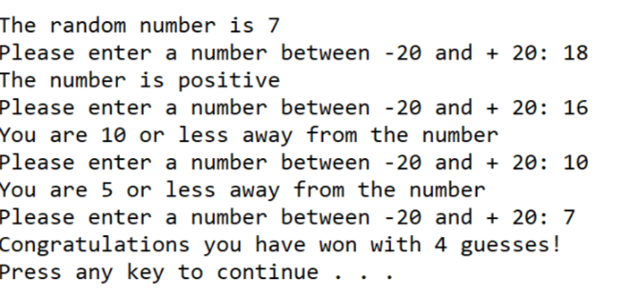

Task 2 – split numbers
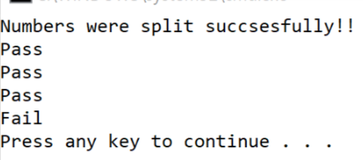

Task 3 - connect 4
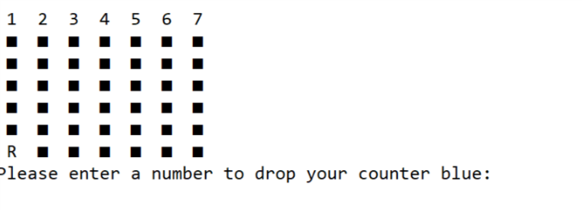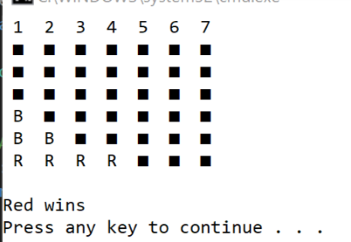
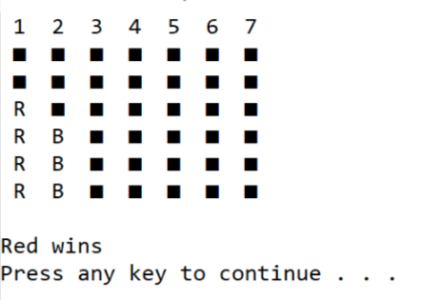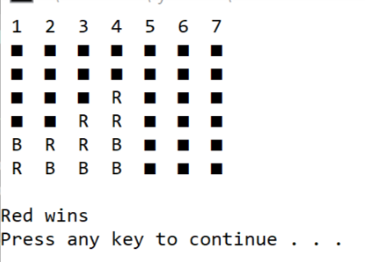

References

[1] | D. Evans, “Assignment 2 Unit 22 Gower College Swansea,” 2017.

Appendix

Appendix 1 – calculator (testing)

Source.cpp
#define _CRT_SECURE_NO_WARNINGS
#pragma warning(disable:4996)

#include "stdafx.h"
#include <string>

#include "Console.h"
#include "Application.h"

using namespace std;

int main(int args, char* argv[])
{
Console* console = new Console();
Application* application = new Application(console);
bool quit = false;

console->PrintLine("*****************************************************************************");
console->PrintLine("* This application is designed to allow you to select the number of numbers *");
console->PrintLine("* you wish to enter, and sum the numbers that you provide. *");
console->PrintLine("*****************************************************************************");

while (quit == false)
{
application->DisplayMenu();
application->ChooseOption();
quit = application->ProcessOption();
}

console->Pause();

delete application;
delete console;
return 0;
}

Application.cpp
#include "Application.h"

Application::Application(Console * console)
{
_console = console;
_chosenOption = 0;
_numNumbersReqd = 5;
}

void Application::DisplayMenu()
{
_console->PrintLine("Select an option");
_console->PrintLine("1. Add numbers");
_console->PrintLine("2. Change amount of numbers to be entered");
_console->PrintLine("3. Quit");
}

void Application::ChooseOption()
{
_chosenOption = ReadNumber("Please choose an option:");
}

int Application::ReadNumber(string prompt)
{
_console->Print(prompt);
return _console->ReadInteger();
}

bool Application::ProcessOption()
{
bool quit = false;

switch (_chosenOption)
{
case 1:
int total;
total = GetTotal();
DisplayResult(total);
break;
case 2:
_numNumbersReqd = ReadNumber("Please enter the number of numbers to be entered:");
break;
case 3:
quit = IsQuitting();
break;
default:
_console->PrintLine("Unknown option value entered");
break;
}

return quit;
}

int Application::GetTotal()
{
int total = 0;
int index;
int number;

for (index = 0; index < _numNumbersReqd; index++)
{
number = ReadNumber("Please enter a number: ");
if (number == NULL)
{
total = NULL;
break;
}
else
{
total = total + number;
}

}

return total;
}

void Application::DisplayResult(int result)
{
if (result == NULL)
{
_console->PrintLine("A string value or char was detected in your calculation therefore could not be completed");
_chosenOption = 0;
}
else
{

int LenOfTotal = std::to_string(result).length();
printf("###############################################################################\n");
printf("###############################################################################\n");
printf("################## ");
printf("%s", to_string(result).c_str());
for (int index = 0; index < 22 - LenOfTotal ; index++)
{
printf(" ");
}
printf("##################\n");
printf("###############################################################################\n");
printf("###############################################################################\n");

}
}

bool Application::IsQuitting()
{
string response;
bool quit = false;

_console->Print("Do you really wish to quit?");

response = _console->ReadString();

if (response == "YES" || response == "Yes" || response == "y" || response == "Y" || response == "yes")
{
_console->PrintLine("Quitting");
quit = true;
}

return quit;
}

Console.cpp
#include "Console.h"

string Console::ReadString()
{
char text[100];

scanf("%99[^\n]s", text);
ClearInputBuffer();

return (string)text;
}

int Console::ReadInteger()
{
int number = 0;
cin >> number;
if (cin.fail())
{
cin.clear();
ClearInputBuffer();
return NULL;
}
else
{
ClearInputBuffer();
return number;
}

}

double Console::ReadDouble()
{
double number;

scanf("%lf", &number);
ClearInputBuffer();

return number;
}

void Console::ClearInputBuffer()
{
char ch;
while ((ch = getchar()) != '\n' && ch != EOF);
}

void Console::Print(string text)
{
printf("%s", text.c_str());
}

void Console::PrintLine(string line)
{
Print(line + "\r\n");
}

void Console::Pause(void)
{
while (1) { if (_kbhit()) break; } // Pause
_getch();
}

Console.h
#pragma once
#pragma warning(disable:4996)
#include <conio.h>
#include <string>
#include <iostream>

using namespace std;

class Console
{
// Attributes
// NONE

// Constructors
// NONE

// Properties
// NONE

// Methods
public:
string ReadString();
int ReadInteger();
double ReadDouble();
void Print(string text);
void PrintLine(string line);
void Pause(void);

private:
void ClearInputBuffer();
};

Application.h
#pragma once
#include "Console.h"

class Application
{
// Attributes
private:
Console* _console;
int _chosenOption;
int _numNumbersReqd;

// Constructors
public:
Application(Console* console);

// Properties
// NONE

// Methods
public:
void DisplayMenu();
void ChooseOption();
bool ProcessOption();
private:
int ReadNumber(string prompt);
int GetTotal();
void DisplayResult(int result);
bool IsQuitting();
};

Appendix 2 – Task 1 guessing game
#define _CRT_SECURE_NO_WARNINGS
#include <stdio.h>
#include <string>
#include <time.h>
#include <stdlib.h>

using namespace std;
int RandInt()
{
srand(time(NULL));
int rndNumber;
int PositveNegative;
PositveNegative = (rand() % 2);
rndNumber = (rand() % 21); // 0 to 4

if (PositveNegative == 0)
{
rndNumber = rndNumber - rndNumber - rndNumber;
return rndNumber;
}
else
{
return rndNumber;
}
}
int GetGuess()
{
int userGuess =0;
printf("Please enter a number between -20 and + 20: ");
scanf("%i", &userGuess);
return userGuess;
}
bool checkGuess(int userValue, int RndValue)
{
if (userValue == RndValue)
{
return true;
}
else
{
return false;
}
}
string GiveHint(int numOfGuess,int userGuess, int rndNumber)
{
switch (numOfGuess)
{
default:
{
return "Oh dear something went wrong! \n";
}
case 1:
{
if (rndNumber >= 0)
{
return "The number is positive";
}
else
{
return "The number is negative";
}
}
case 2:
{
if ((userGuess - rndNumber) <= 10 || (rndNumber - userGuess) <= 10)
{
return "You are 10 or less away from the number";
}
else
{
return "You are more than 10 away from the number";
}
}
case 3:
{
if ((userGuess - rndNumber) <= 5 && (userGuess - rndNumber < 6 || (rndNumber - userGuess) <= 5 && (rndNumber - userGuess) < 6))
{
return "You are 5 or less away from the number";
}
else
{
return "You are more than 5 away from the number";
}
}
case 4:
{
if ((userGuess - rndNumber) <= 2 && (userGuess -rndNumber < 3|| (rndNumber - userGuess) <= 2 && (rndNumber - userGuess) < 3))
{
return "You are 2 or less away from the number";
}
else
{
return "You are more than 2 away from the number";
}
}
}
}
void EndGame(int userGuess,int numOfGuess,int rndNumber)
{
if (checkGuess(userGuess, rndNumber) == true)
{
printf("Congratulations you have won with %i guesses! \n", numOfGuess+1);
}
else
{
printf("You have lost! \n");
}
}
void main()
{
int rndNumber = RandInt();
int userGuess = 0;
int numOfGuess = 0;
printf("The random number is %i \n", rndNumber);
userGuess = GetGuess();
while (checkGuess(userGuess, rndNumber) == false && numOfGuess != 4)
{
numOfGuess = numOfGuess + 1;
printf("%s \n",GiveHint(numOfGuess,userGuess,rndNumber).c_str());
userGuess = GetGuess();
}
EndGame(userGuess, numOfGuess, rndNumber);
}

Appendix 3 – Task 2 split numbers
#define _CRT_SECURE_NO_WARNINGS
#include <string>
#include <stdio.h>
using namespace std;

bool IsValid(const char str[], int stringLength, char separator);
int FindChar(const char str[], int stringLength, int startPos, char character);
int ConvertToNumber(const char str[], int startPos, int endPos);
bool SplitIntoNumbers(string digits, int stringLen, int numbers[], int arrayLength);

void main()
{
string testValues[4] = { "1","12","123","aa123" };
bool splitSuccessful;
int numbers[3];
splitSuccessful = SplitIntoNumbers("120-34-5056",10, numbers, 3);
if (splitSuccessful == true)
{
printf("Numbers were split succsesfully!! \n");
}
else
{
printf("Numbers were split unsuccsesfully!! \n");
}

if (ConvertToNumber(testValues[0].c_str(), 0, 0) == 1)
{
printf("Pass \n");
}
else
{
printf("Fail \n");
}

if (ConvertToNumber(testValues[1].c_str(), 0, 1) == 12)
{
printf("Pass \n");
}

else
{
printf("Fail \n");
}

if (ConvertToNumber(testValues[2].c_str(), 0, 2) == 123)
{
printf("Pass \n");
}

else
{
printf("Fail \n");
}

if (ConvertToNumber(testValues[3].c_str(), 0, 4) == 123)
{
printf("Pass \n");
}

else
{
printf("Fail \n");
}

}
bool SplitIntoNumbers(string digits, int stringLen, int numbers[], int arrayLength)
{
const char *digitArray = digits.c_str();
int startOfNumber = 0;
int dashPosition;
int index = 0;

if (IsValid(digitArray, stringLen, '-') == false)
{
return false;
}

dashPosition = FindChar(digitArray, stringLen, startOfNumber, '-');
while (dashPosition > 0 && index < arrayLength)
{
numbers[index] = ConvertToNumber(digitArray, startOfNumber, dashPosition - 1);
index++;

startOfNumber = dashPosition + 1; // Start of next number
dashPosition = FindChar(digitArray, stringLen, startOfNumber, '-');
}

// Read number at end of string
if (index < arrayLength)
{
numbers[index] = ConvertToNumber(digitArray, startOfNumber, stringLen - 1);
}
index++; // Account for number at end of string even if we don't read it.

// Too few or too many numbers to be read
if (index < arrayLength || index > arrayLength)
{
return false;
}

return true;
}

bool IsValid(const char str[], int stringLength, char separator)
{
int index;
int dashCount = 0;

for (index = 0; index < stringLength; index++)
{
if (str[index] == separator)
{
if (dashCount > 0)
{
return false;
}
dashCount++;
}
else if (isdigit(str[index]) == 0)
{
return false;
}
else
{
dashCount = 0;
}
}

// Can't start with a separator
if (str[0] == separator)
{
return false;
}

// Can't end with a separator
if (str[stringLength - 1] == separator)
{
return false;
}

return true;
}

int FindChar(const char str[], int stringLength, int startPos, char character)
{
int index;

if (startPos < stringLength)
{
for (index = startPos; index < stringLength; index++)
{
if (str[index] == '-')
{
return index;
}
}
}

return -1; // end of array
}

int ConvertToNumber(const char str[], int startPos, int endPos)
{
int digit;
int number = 0;

for (int i = startPos; i < endPos + 1; i++)
{
digit = (int)str[i] - '0'; // Convert from ASCII
number = (number * 10) + digit;
}

return number;
}

Appendix 4 – task 3 Connect 4

Source.cpp
#define _CRT_SECURE_NO_WARNINGS
#include <stdio.h>
#include <string>
#include "Board.h"

using namespace std;

int GetInt(string text)
{
int number = 0;
printf("%s \n", text.c_str());
scanf("%i", &number);
return number;
}
void main()
{
int red = 0;
int blue = 0;
int CountersDropped = 0;
Board* board = new Board();
board->displayBoard();
while (true)
{
red = GetInt("Please enter a number to drop your counter red: ");
while (red > 7 || red <= 0)
{
red = GetInt("Sorry that is not a valid drop zone\nPlease enter a number to drop your counter red: ");
}
board->dropCounter(red, 'R');
CountersDropped = CountersDropped + 1;
if (board->checkBoard('R',red) == true)
{
board->displayBoard();
printf("\nRed wins\n");
break;
}
if (board->checkBoardFull(CountersDropped) == true)
{
board->displayBoard();
printf("Draw Game! \n");
break;
}
board->displayBoard();
blue = GetInt("Please enter a number to drop your counter blue: ");
while (blue > 7 || blue <= 0)
{
blue = GetInt("Sorry that is not a valid dropzone\nPlease enter a number to drop your counter blue: ");
}
board->dropCounter(blue, 'B');
CountersDropped = CountersDropped + 1;
if (board->checkBoard('B',blue) == true)
{
board->displayBoard();
printf("\nBlue wins!\n");
break;
}
if (board->checkBoardFull(CountersDropped) == true)
{
board->displayBoard();
printf("\nDraw Game! \n");
break;
}
board->displayBoard();
}
}

Board.cpp
#include "Board.h"

Board::Board()
{
_counterCount = 0;
for (int index = 0; index < 6; index++)
{
for (int index2 = 0; index2 < 7; index2++)
{
_board[index][index2] = 254;
}
}
}

Board::~Board()
{
}

void Board::displayBoard()
{
bool line1 = true;
system("cls");
printf(" 1 2 3 4 5 6 7\n");
for (int index = 0; index < 6; index++) // Index of row
{
for (int index2 = 0; index2 < 7; index2++) // index of row pos
{
printf(" %c ", _board[index][index2]); // Prints each board pos value
}

if (index < 7) // Prints new line for each line.
{
printf("\n", index + 2);
}
}
}

void Board::modifyBoard(int row, int collum, char value)
{
_board[row - 1][collum - 1] = value;
}

char Board::GetTargetValue(int row, int collum)
{
return _board[row - 1][collum - 1];
}
bool Board::dropCounter(int dropZone, char Player)
{
dropZone = dropZone - 1;
if (_board[0][dropZone] == 'R' || _board[0][dropZone] == 'B')
{
return false;
}
for (int index = 0; index < 6; index++)
{
if (_board[index][dropZone] == 'R' || _board[index][dropZone] == 'B')
{
_board[index - 1][dropZone] = Player;
return true;
}
if (index == 5 && _board[index][dropZone] == 'þ')
{
_board[index][dropZone] = Player;
return true;
}
}
}

bool Board::checkBoard(char Player, int dropzone)
{
_counterCount = 0;
for (int row = 0; row < 6; row++)
{
for (int collum = 0; collum < 7; collum++)
{
if (_board[row][collum] == Player)
{
int temp = row + 4;
int test1 = collum;
int test = row;
for (test; test < temp; test++) // Vertical test starts here
{
if (_board[test][collum] == Player)
{
_counterCount = _counterCount + 1;
}
}
if (_counterCount >= 4)
{
return true;
}
else
{
_counterCount = 0;
test = collum;
temp = collum - 4;
} // Vertical test ends here

for (test; test > temp; test--) // Horizontal test starts here
{
if (_board[row][test] == Player)
{
_counterCount = _counterCount + 1;
}
}
if (_counterCount >= 4)
{
return true;
}
else
{
_counterCount = 0;
test = row;
test1 = collum;
temp = row + 4;
} // Horizontal test ends here

for (test; test < temp; test++,test1++) // Diagonal test "up and up" starts here (see report)
{
if (_board[test][test1] == Player)
{
_counterCount = _counterCount + 1;
}
}
if (_counterCount >= 4)
{
return true;
}
else
{
_counterCount = 0;
test = row;
test1 = collum;
temp = row + 4;
} // Diagonal test "up and up" ends here (see report)

for (test; test > temp; test--, test1++) // Diagonal test "down and up" starts here (see report)
{
if (_board[test][test1] == Player)
{
_counterCount = _counterCount + 1;
}
}
if (_counterCount >= 4)
{
return true;
}
else
{
_counterCount = 0;
} // Diagonal test "down and up" ends here (see report)

for (test; test < temp; test++, test1--) // Diagonal test "up and down" starts here (see report)
{
if (_board[test][test1] == Player)
{
_counterCount = _counterCount + 1;
}
}
if (_counterCount >= 4)
{
return true;
}
else
{
_counterCount = 0;
test = row;
test1 = collum;
temp = row + 4;
} // Diagonal test "up and down" ends here (see report)
}
}
}
return false;
}

bool Board::checkBoardFull(int CountersDropped)
{
if (CountersDropped == 42)
{
return true;
}
else
{
return false;
}
}

Board.h

#pragma once
#include <stdio.h>
#include <string>
#include <windows.system.h>
using namespace std;

class Board
{

// Atributes
private:
char _board[6][7];
int _counterCount;

// Constructors
public:
Board();
~Board();

// Properties
public:
// Methods
public:
void displayBoard();
void modifyBoard(int row, int collum, char value);
char GetTargetValue(int row, int collum);
bool dropCounter(int dropZone, char Player);
bool checkBoard(char player, int dropzone);
bool checkBoardFull(int CountersDropped);
};

