Developing Workplace Critical Thinking

Programme: BA (Hons) Leadership and Management Skills for the Workplace.
Module: Developing workplace critical thinking.
Module code: BMSW5101.
Student Name : LOUAY ALSAYED-OMAR.
Student Number: 1922056.
Level 5 Term 2 Group 2.
Module lecturer: Dr Gregory Cowan.
Assignment Title:
Part 1- Individual Business Report.
Part 2- Reflective Journal.

1

Executive Summary:

This report purposes are to analysis and applying examination on organisational beliefs, attitudes, and value systems that affect workplace behaviour and the workplace changes for the post lockdown of Coronavirus disease (COVID -19). Analysing the effectiveness of developing workplace critical thinking (DWC) on Tesco’s organisation, a demonstration how can beliefs, attitudes, and value systems affecting positively the workplace behaviour context when Tesco’s organisation and human resource HR. in organizations mangers applying the key management theories and models to create and fulfilment employees satisfaction by creative thinking in the workplace environment, the findings discriminates and analyse the difference between beliefs, attitudes, and values within the workplace context, with critical assessment of beliefs, attitudes and value systems and its impact on workplace behaviour utilizing key management theories by applying practical implications for answering the assignment questions and applying the key management theories on Tesco’s organization. Also, evaluation of the same theories that might be interpret by someone differently and an evaluation of the same theories differently demonstrating the value of Tesco’s organisation beliefs, attitudes, and value systems that affect workplace behaviour , including changes in the workplace environment of post lockdown caused by (COVID -19). Including developing wide understanding from learned lessons of CT theories and models.

2

Table of contents:
Part 1- Individual Business Report.
1.0.Intrduction……………………………………………………………………………….....…4.
2.0.Tesco’s organisation introduction…………………………………………….………….5.6.
3.0. key management theories underpin this report.
3.1. Human relations theory…………………………………………………………....….7.
3.2. Bureaucratic management theory……………………………………………….......8.
3.3. Contingency theory……………………………………………………………...…9.10.
4.0. Answering and applying the key theories on Tesco’s organization.
4.1.The relevance of Human relations theory…………………………………..….....…11.
4.2.The relevance of Bureaucratic management theory………………...……………...12.
4.3. The relevance of Contingency theory:……………………………………….......….13.
5.0. Evaluation of the same theories might interpret by someone differently……..14.15.16.
6.0. Recommendations for Tesco’s challenges of post-COVID and resiliency in future...17.
7.0. Conclusion………………………………………………………………………….............18.
Part 2- Reflective Journal.
Week 1…………………………………………………………….……………………….…….19.
Week 2……………………………………………………………………………………..…….20.
Week 3……………………………………………………………………………………...…....21.
Week 4……………………………………………………………………………………….......22.
Week 5……………………………………………………………………………………………23.
Week 6……………………………………………………………………………………………24.
Week 7……………………………………………………………………………………………25.
Week 8……………………………………………………………………………………….…...26.
Week 9………………………………………………………………………………………....…27.
References.
Appendix.
3

Part 1- Individual Business Report.
1.0.Intrduction:
Developing workplace critical thinking according to analyses of Spiru Haret university economic series stated that the framework of human resource motivation gives a high importance of organisational beliefs, attitudes, and value systems (MOISE 2014).beliefs, attitudes, and value systems affecting positively the workplace behaviour context when human resource HR. and organizations mangers applying the key management theories to create and fulfilment employees satisfaction with creative thinking in the workplace environment, leading to the main organization target to maximising its productivity that increase the annual revenue and financial incomes, this creation is only a part of developing workplace critical thinking DWC.
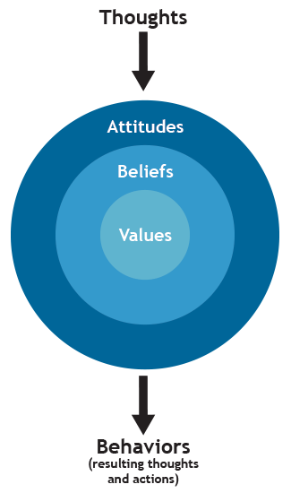
Figure 1. (Vroom et al. 2010 p1).

4

2.0.Tesco’s organisation introduction.

Figure 2. The head office of Tesco in Cheshunt, Business news Reuters (2016).
Tesco’s history started from sells surplus groceries in the east end of London, Tesco PLC (2022 ). Tesco’s today is the UK's biggest supermarket chains, statistics shows that Tesco’s have the biggest market share of grocery stores during and post the pandemic of Coronavirus disease (COVID -19). in Great Britain from January 2017 till January 2022 organization have 30% of market-share in the United Kingdom market according to Great Britain Statista (2017).Tesco serving millions of customers a week in stores and online shopping by apply the core academic management models, methods, and theories for organisational beliefs, attitudes, and value systems in the workplace in a case study Tesco Case study (2017) .which is a proof that also organization managers applying in practice Mayo's motivation theory (Mayo's 2018). And Herzberg’s motivation theory model which justify that Tesco’s possess the core knowledge of CT theories models and the organization developing it in continues in the workplace for high level of critical thinking (DWC). All together with other different CT theories models such as Model of Vroom-Yetton-Jago for an effective decision making to achieve its goals and objectives maintaining the organization as a top market leader.

5

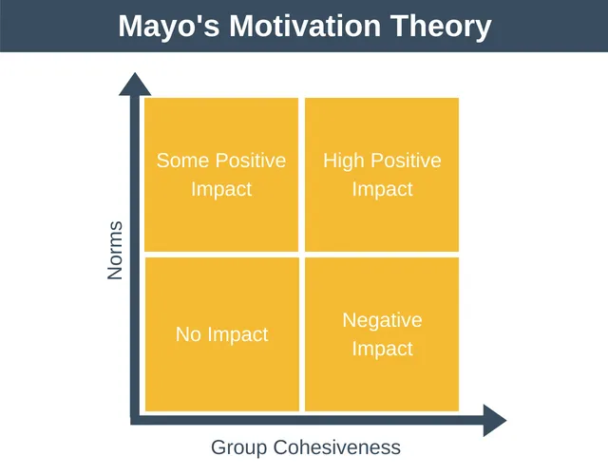
Figure 3. (Mayo's 2018).
Taylor’s motivation theory known also as a scientific management theory one of the primary theories in the workplace for motivations that emphasize on workers productivity including deferent levels of impacts, employees can be motivated by more than paying and high workplace standards , it is very important to understanding employees needs to recognition the sense of belongings also employees attitudes in the workplaces strongly affected by the groups which Tesco’s broadly apply this theory concept in the workplace also the Herzberg’s motivation theory model, or two factor theory for job satisfactions, systems theory and scientific management theory logically are in the organization hierarchy structure already included with limited centralization for senior managers decision making.
Systems theory scientific management,
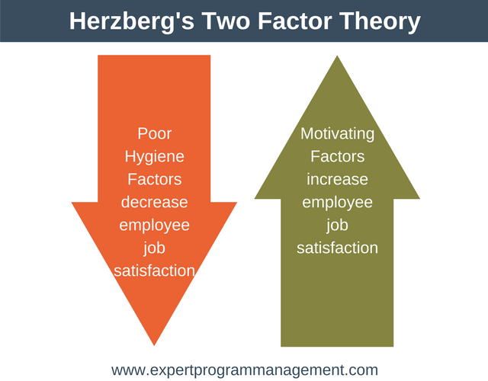
Figure 4. (Mayo's 2018).
6

3.0. key management theories underpin this report.
The main aim of management theories learned by engagement with literature skills is enhancing productivity this individual business report will underpin the following theories:
3.1. Human relations theory.
3.2. Bureaucratic management theory.
3.3. Contingency theory.
3.1. Human relations theory:
Human relations theory concentrate on individuals needs and behaviours result and groups it is an approach that managing interpersonal human beings presents the organization consist as a formal and informal element the formal elements is the organization structure, and the informal elements is the individuals interactions between them according to human relations theory of management explained ( Gordon 2022). So, managing individual’s needs is the formal aspect of the organization and the informal aspect of the organization is the organization employees interactions in this way the organizations form a type of the social system structure that create job satisfaction and employees individual motivation human relations theory elements doesn’t focus on machines or economics it focuses on human beings, the importance of human relation is peoples motivating, The organizational environment has its own private rights that allow the organization to not participate and make spart of any organized public context, Human relations theory requires the acceptance of considerable assumptions about human behaviours that includes and influences the employees beliefs, attitudes and values theories and systems.

7

3.2. Bureaucratic management theory:
Definition: The bureaucratic management theory introduced by Max Weber 1864-1920 about manage an organization efficiently, organization should has an evident line of authority along with appropriate rules to control every business operation , bureaucracy possessing control all over a group of people or activities by applying the power of knowledge or authority’s (Max Weber 2019).
Primary two criteria of Bureaucratic management theory are:
1.Evolving in the organization in a hierarchical system.
2.Determining procedures, methods, rules, and regulations to carry out the business operations and transactions.
Max Weber’s bureaucracy theory adopted from government organizations because it possesses the six principles that managing an organization effectively:
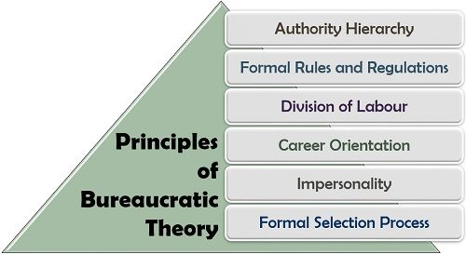
Figure 4. (Max Weber 2019).

We do need to understand bureaucracy theory concept in a positive way because it acts under the law of government organizations in the large modern organizations it has the hierarchy structure, it is normally applied to carry out the business operations for an effective legal decision-making that controlling employees behaviour.

8

3.3. Contingency theory:
Fundamental concepts of contingency theory are the following:
Situation of the organizational is the best way that organize any organization and it depends on the nature of its related environment (Scott, 1992: 89).
Contingency theory has two basic underlying assumptions:
1. There is no one best way to organize.
2. Any way of organizing is not equally effective (Galbraith,1973).
Contingency theory emphasizes on organization performance and organization behavior it is an academic method and techniques to control the organization behavior, it identifies the action process that depend on the external and internal situations of the organization in time of forming effective decision making and problem solving, the size of the organization can select and defines many of its characteristics that also form the organization structure (Pugh, Hickson, Hinings, and Turner 1968). Burns & Stalker management theory is an extension of Weber’s and Fayol’s theory were organizations related to their external environment of organizations characteristics the external environment is segmented as characteristics the external environment is segmented in two parts that rats changes in the scientific techniques theory and marketing classified in two structures one is organizational organic structure and second is the mechanistic organizational structure Fiedler’s contingency Model of leadership (Fiedler’s 2020). according to Villanovau university (Villanovau 2021) . the power of effective leadership style that control the situation based on groups monitoring not by teams monitoring it define the leader ability that apply situational leadership Hersey and Blanchard’s situational leadership Model and Path-Goal theory also Vroom-Yetton-Jago for decision making Model that include leaders information (LI) and quality requirement QR ( Vroom et al. 2010 p1).

9

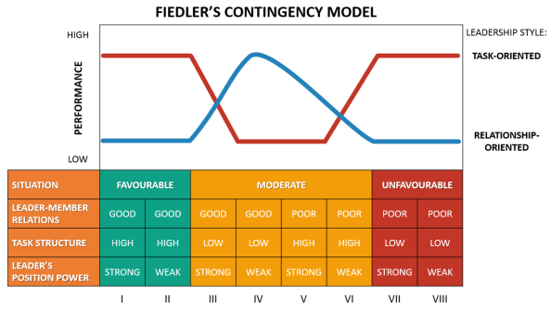
Figure 5. (Fiedler’s 2020).

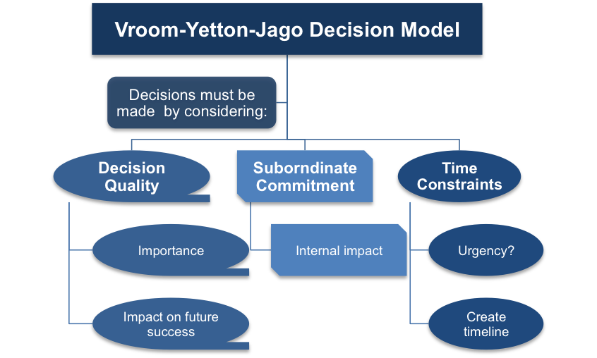
Figure 6. ( Vroom et al. 2010 p1).

10

4.0. Answering and applying the key theories on Tesco’s organization.
This individual business report section answering the questions about how organisational belief, attitude and value’s influence or affect workplace behaviour in the context of Tesco’s and the relevant underpinned report theories as following:
Tesco’s is an international organisation growing in markets by a sustainable development strategy influenced by belief, attitude, and value’s systems this strategy starts from a decade where Tesco’s values introduced with high standards that ultimately formed a part of the society cutler, this strategy is applied in Tesco’s leadership skills (Tesco PLC 2022). Tesco’s considers all employees as a colleague with equality group CEO Dave Lewis want everyone who works for Tesco to be proud of the business achievements for customers and the communities with honesty and freedom to speaking up, all these factors have a wide impact on employees behaviour that help to build a powerful business in the future.
The relevance application of the key theories underpinned this report theories:
4.1.The relevance of Human relations theory:
Tesco’s as an international organization have a big responsibility of managing employees in the workplace with equality, Tesco’s apply Human relations theory that focus on peoples by using management cods strategy that influences positively the human relations environments as an example applying the words of colleagues and people office on mangers doors Tesco’s policies inside the organization create a comfortable environment atmosphere, Tesco’s created its inner own social context of Human relations theory elements applied by expert managers by fulfilling individual needs with organization objectives completely together to achieve human relations within the teams members that enhancing productivity’s , Tesco’s go further with this theory by focusing on social needs in these assumptions context to Tesco community grants 2022 (Tesco PLC 2022) supplying local community projects across the UK.

11

4.2. The relevance of Bureaucratic management theory:
Tesco’s have hierarchical system structures ; organisational multinational retailer bureaucratic management theory helps Tesco’s to manage the organization efficiency having a clear line levels of managers management authority along the organization and appropriate rules that control operations system it is the relevance between knowledge power of Bureaucratic management theory and managers authority’s (BRM 2016). The criteria of Bureaucratic management theory introduced directly in controlling systems of hierarchical structure which determines the operational systems in organization methods and rules that obviously leads to a successful business transaction.
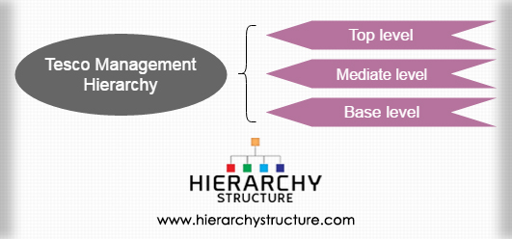
Figure 7. (hierarchy structure 2017).
Bureaucratic management theory in practice applied in governance framework that provide an effective support to the board in business workplace strategy for beliefs, attitudes, and value systems that maintain a long-term sustainable corporate governance (Tesco PLC 2022).
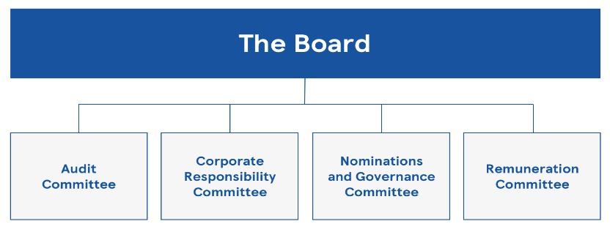
Figure 8. Corporate Governance - (Tesco PLC 2022).

12

4.3. The relevance of Contingency theory:
Pandemic situation of COVID-19 forced whole world to adapt a new methods and theories contingency theory had been applied in Tesco’s as an urgent modification that follows the government’s rolls to hold the performance and organization behavior in a high standard which deliver the first part of contingency theory assertiveness.
The second part of contingency theory affect fundamentally beliefs, attitudes, and value systems in the workplace behaviour, beliefs of health and safety where in high risk during (COVID -19). attitudes of peoples where incomprehensible with low social communications, values during the lockdown highly affected families and jobs environments these factors influenced Tesco in different levels in the workplace behaviour, some employees lost motivation and they decide working with reticence to support their families, Tesco leaderships struggling to enhancing performance and productivity.

13

5.0. Evaluation of the same theories might interpret by someone differently.
As a critical evaluation first, we must clarify the differences between beliefs, attitudes and values in the workplace context that has an impact on the workplace behaviour (MOISE 2014). then secondly assessing how someone with different beliefs, attitudes and values might interpret the theory differently, the differences between beliefs, attitudes, and values they are as the followings:
Firstly, the difference between values and attitudes:
-Values are belief systems that direct our behaviour are we doing right or wrong, good, or unfair. Attitudes are what we do like or dislike relating to objects and peoples, it is responses of our values result, the cognitive figuration of attitudes are involved in beliefs.
The difference between values and beliefs is linked to the certainty that values can be changed by the time, also persons improving with their wide experience of beliefs that remain in continuously , the changing of beliefs are unpredictable especially when it is related to the person age, this concept recently was highly affected by the impact of COVID-19 .

14

Secondly assessing how someone (Duty manager) might interpret the theories differently:
Theorise among history has been interpreted by individuals in different ways depends on their points of view or the actual situation and their needs to apply any academic theories, someone that we will consider him or her as unknown person under the name of Duty manager that interpreting theories by different point of views as the following:
1. Human relations theory interpreted differently by Duty manager:
Duty manager:
Duty manager start to Interpret the theory of Human relations differently by asking why Human relations theory focusses on peoples rather than economics and machines, peoples are paid by their salary to do the job tasks also machines have high cost in business investment it could lead the business to insolvency , Duty manager continuing to explain that organizational environment dose make a part of our society so it is not acceptable that it doesn’t owns to an organized social context, we do not need motivating peoples how doesn’t came to work because they will not receive any salary, individuals must accept teamwork as a groups and do their work tasks without any discussions because every organization must achieve its own objectives, Duty manager disagree concept of individual motivations and it doesn’t need or request any acceptance regarding the humans behaviour.

2. Bureaucratic management theory interpreted differently by Duty manager:
Duty manager:
Duty manager interpreted differently the Bureaucratic management theory, he doesn’t agree that organization in a hierarchical system can achieve any developments because there are a lot of organisations that operate under flat business organization structure, and they are operating successfully, the centralization of decision making is a bearer for creativity and affect the productivity, continuing with a strong argument about Max Weber’s bureaucracy theory and its six principles that managing an organization, Duty manager presented an argument of Henry Ford (1863-1947) when Henry Ford documented that any colour so long as it is black in 1909 ( Ford 2016). this bureaucratic decision ultimately was cancellated, another thing interpreted by Duty manager about difference of formal rules in the workplace which minimizing and limited managing the organization efficiently.

15

3. Contingency theory interpreted differently by Duty manager:
Duty manager:
Duty manager interpreted differently the contingency theory that it has two basic underlying assumptions which can be located with other theories and models such as Model of Hersey and Blanchard situational leadership, that it could developing the organizations effectively accomplishing organizational necessity.
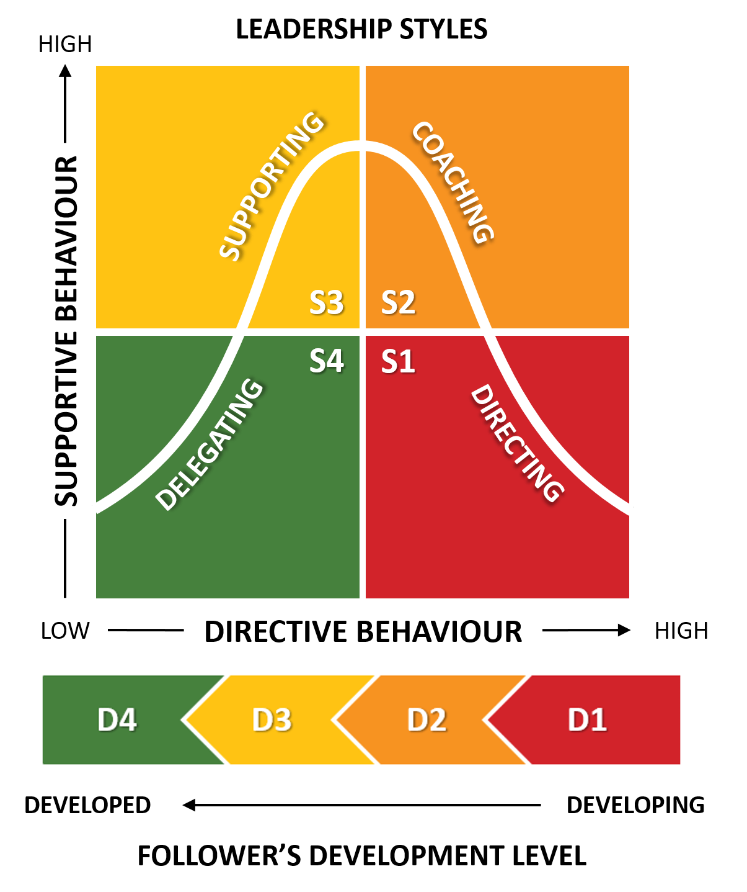
Figure 9. (Fiedler’s 2020).
Contingency theory interpreted in this way by Duty manager differently with replacement of Contingency theory to Model of Hersey and Blanchard that emphasizes on organization performance including the workplace behaviour.

16

6.0. Recommendations for Tesco’s challenges of post-COVID and resiliency in future.

Creating more changes and options for Tesco’s employees to work from home even the pandemic situation of Covid-19 restrictions has been changed, but the powerful impact of Covid-19 and the lockdown still influences Tesco’s environmental workplace because some of Tesco’s employees families had been affected negatively during and post-COVID pandemic situation, also Tesco’s must not neglecting the hygiene standards to keep on with coronavirus COVID-19 guidance - GOV.UK (gov.uk 2022). Tesco’s must enhancing customer services and drivers delivery systems that still operating slowly at the same level of the pandemic situation adding to that it can mitigate customers complaining, also on shop floors customers facing the problem of long hours queuing which should be solved in the future by extending Tesco’s staff. In this way Tesco’s can successfully winning customer’s satisfaction that ultimately increases the financial revenue, applying other theories to create more resilient in future such as Theory X and Theory Y, new systems of management theory according to Education Library (McGregor 2021).

17

7.0. Conclusion
Tesco’s is an international organization with a big responsibility and capacity, organization challenges will never end the diversity of employees culture make the situation more complex Tesco’s possess and develop the critical thinking concepts by utilizing theoretical models, the wisdom of Tesco’s strategy is to apply academic models and theories to face this business challenges market competitor’s with a balanced and moderated approaches controlling beliefs, attitudes, and value systems that affect the workplace behaviour which is the core idea of developing workplace critical thinking DWC.

18

Part 2- Reflective Journal.
Introduction.
During my learning lessons there were a lot of new academic workplace contexts that were unknown for me our lecturer helps us to understand it step by step by explaining lessons aim what are those abbreviation, words, theories, models ,books talking about and how to develop CT critical thinking in the workplace based on models theories as following:
Week 1. Introduction into the Module DWC.
Lesson title was so ambiguous developing workplace critical thinking what is the CT do mean after that came George Bernard Shaw explanation about progress is impossible without changing the way of thinking, then beliefs, attitudes, values ,emotions in workplace context from here thinks start to be clear when our lecturer started to explain management theories importance and how those theories can improve productivities we had classes discussions about this lesson , then started with two types of reasoning inductive and deductive also there was an educational research videos about the deference between inductive and deductive logic and some examples in the workplace that indeed created with theoretical models and management theories for me the fundamental critical concept of module at the first week aim of this learning the difference between inductive and deductive logic (Deductive & Inductive Research 2014). attracted my attention because my skills will develop by deductive reasoning that start with basic premise standards for the workplace knowledge related with decision-making and problem-solving also from my point of view inductive reasoning can be as an experience learned from conclusion’s, then our lecturer give us very important class activity and exercises about self-evaluation (Cottrell 2017, p13, and pp14-15).

19

Week 2: Developing Critical Thinking (CT).
The second learning lesson content core concepts definitions of beliefs, values, attitudes, emotions, these concepts definitions helped me to clearly understand the true meaning of beliefs when our lecturer started to explain that it is our internal feeling about something true even if it cannot be approved or illogical (Anderson et al. 2009).then we learned the following concepts about values, attitudes, emotions, after class discussion because there was questions form if I do agree or disagree made my mind thinking differently about my behaviour that will be more controlled and with wisdom. logically after this important lesson concepts I developed my critical thinking CT in the future I will think critically by applying skills of logical analysis and the importance of CT concepts also CT themes that really will be an example for my personal life and the workplace relationships, the next step was about reading exercise article available on UWTSD library (Topoi ,2018).This reading exercise article improved my academic understanding how to develop fundamentals arguments as a path of competence in framework to demonstrate essences of CT particularly in table 1 that expounding curriculum activity and cognitive goal (Kuhn et al. 2016). Then we learned about effective CT decision-making techniques as a video it is emphasising on five steps tools to increase numbers of our positive choices based on informed decisions Moodle (TED Talk).

20

Week 3: Developing Critical Thinking (CT).

This lesson defines CT by demonstrating with effective problem’s soling, how to discover the truth and how to communicate with efficiency, what is new for me was the large requests from employers and what do they want from employees to obtain high skills level, so transferable skills are highly requested to a professional employee also employee should be creative as a good critical thinker following the criteria and standards of a good reasoning in workplace life, next learning experience was an important stage of learning about human relation and how managers applying it to increases productivity’s with human relation such as JIT and Scanlon with strategy that concerning about producing just what is only needed to improve productivity, followed with Scanlon plan that reflecting on human relations theory to provide stability in the workplace by collaborating with organization managers, employees are allowed to participate to decision making stage to achieve organization goals, important theory with dynamic strategy improved my active learning cycles.

21

Week 4: Developing Critical Thinking (CT).
In this lesson our lecturer asked us about our groups members because we will start soon doing R.E.D. model of critical thinking as a class activity, R.E.D. model develop critical thinking this model applied in organizations at an international level after our lecturer explaining our this lesson and watching an important video which is a proof and evident that this R.E.D. model is a practical application for developing CT in organization as a fundamental competencies of problem solving, decision making, planning, risk management from here I started to reflect on the title of our lesson that explain business environment that changing organizations business strategy, with clarifications about what are the essential skills for a successful employee that are essential organizations requirements in 21st century, then we started discussions about logic, for me what was new that critical thinker applying different skills in problem solving stages and it has the ability for using deductive logic and inductive logic, relating learning incomes’ with the impact of scientific management theory on the organization’s and where it can be contrasted with social systems approach and scientific management process in this lesson which developed my understand to problem solving with logic stages in business environment changes by applying creative critical thinking, also learning the scientific management theory that will include my strategy in future in the workplace as an advanced skills.

22

Week 5. Enhancing Critical Thinking (CT ).
This lesson started with a new unknown theory it is De Bonos 6 thinking hats method it is a new challenge for me, but our lecturer started with a clear explanation for this theory then our lecturer divided every hat with a separated class groups discussions, as a new learning experience gained from this theory that improved my critical thinking understanding about the De Bonos 6 thinking hats, how to deal with problem’s challenges by separating them into six roles and functions with a symbolic colour to utilizing this theory in the organization and on staff meetings, our lecturer before introducing bureaucratic management theory started to explain what are function of public activities in different sectors such as the private sector, public sector, non-profit organizations, the scope was to understanding the law power administration and its segmentation so after that I gained the concept of Max Weber about centralism and rationalization of society,Max Weber bureaucratic management principle’s interact with power based in rules and the Hierarchy organization structure that possess control all over hierarchically organization structure, here I would like to mention how big is the importance of this exercise that we had in class activity, CT knowledge skills and attitudes (Critical Thinking Skills - Google Books). and the exercise results are attached in the appendix, analysing the above important theory and techniques methods that will be an important advantage for my future my management career in a long term.

23

Week 6: Report and Journal Drafts: Enhancing Critical Thinking.
In this session our lecturer started with a question that was an activity classes every group discussed individually what decision-making processes in the organization are, and the effectiveness of leadership style that interacting with organization structure with a new learning experiences of contingency theory which is related with organization of the external environment, a clear explanation of CT decision-making skills processes and how to be utilized it as an available effective alternative keys of decision-making criteria, these academic method’s and techniques helped me to understand how to apply these skills in organization workplace when challenges comes as a complex problems situations and there management implementation benefit’s as a CT skills, after that in our class we discussed assessment guidance structure exercise every student was asked separately and individually in a privet chat discussion about theories and modules that will be applied in final tasks assignment as a formative feedback progression , where our lecture advised me to include all classes activities and there practical relevance in my workplace efficiency, then we discussed PESTEL analysis factors of macro and micro environmental components before understanding the contingency theory that have relation completely with organization external environment and leadership management style a very important methods to fulfill organization goals.

24

Week 7: Enhancing Critical Thinking CT.
This lesson begins with important summary of CT concepts for beliefs, values, attitudes, emotions then how is CT process evaluates to generated ideas of creative thinking created from critical thinkers and the importance of CT raw materials then in class every student answered the question of the bird and the egg, after that we started with systems theory for me it is an academic platform of motivation for adapting CT with open mind , new educational experience gained from systems theory concepts particularly it is a new words that made me clarify the differentiation between reductionism and systems theory concepts, reasons that motivated me to develop a scientific research Under title the systems theory of management in modern day organizations (Chikere et al. 2010 p1). systems theory examination identifying the relation between output of external organization environment and inputs of transformation process forming the organization as a part from a large system in which it is belong in business (Weihrich et al, 2008).this lesson enhanced my CT skills and ability by understanding external organization environment to analyzing the appropriate decision making and wining stakeholders satisfaction.

25

Week 8: Enhancing Critical Thinking / Innovation.
Interacting with management theories within organization’s environments these organization’s needs innovation for me it is an important educational lesson that explaining in business environment how innovation can be manage, what are the changes in workplace that crate creativity, so any successful modification is an innovation doing any successful changes on a product for example substitute a small part from any product or take it out from production line is an innovation, another important innovation can be achieved by successful replacement employees putting the right person in the right place it is a management innovation any positive changing on time, place, products components is a critical thinking innovation, but my mind asking me what about organization’s potential innovation during this important lesson my knowledge developed by understanding the meaning of organization’s successful innovation characteristics, it is high a level gained skills that create creativity in organization environment, also the innovation definition clarified the practical methods how can this skills practically applied in my life as a professional practice in the workplace, what gives me the confidences as a pillars of success my complete understanding from this lesson the processes of technological innovation it is an opportunity which can be realized by R&D research and by new planning of strategy development, also applying a critical evaluation of market trends and its marketing tendency, that will establish a new changes focused on customers experiences, some of my new learning workplace experiences in my opinion it is the face mask as a health care innovation to stop spreading COVID-19 but asking myself what I should do to managing innovation where is the perfect methods to achieve my goals after our lecturer explanations and class discussions the answer is by starting to applying analyses and searching for any possibility of a new opportunities , by developing a questionnaire survey, focusing on products specifications achieving goal of an advanced market share position, also minimalizing market competitors opportunities with high strategy level and comprehensive planning as reasons of success in the future .

26

Week 9: Enhancing Critical Thinking CT.
Aims of this lesson is so wide because it covers world-wide global environmental situation and its relation to the industrial pollution including in the video of Johan Rockstrom that demonstrated these relations with earth pollution asking all world leadership if they now in what level of pollution our earth had arrived, global environmental sustainability then the answer came from our lecturer and lessons slides indicate that there is a logical relation proof for sustainable development that must meet alterations in human being values, attitudes, and behaviours, my critical thinking remained me about noble activities of UNICEF organization (UNICEF 2022). that has a part of this humanity pain with those whom suffering from hunger before and after pandemic COVID-19 UNICEF which trying to achieve all environmental sustainability and its positive central concepts, also we had in this lesson Ford organization is an example of green friendly global environmental with green ecosystem business that create sustainable products and vast principles of future proof related to changes in in human being values, attitudes, and behaviours one of the most important factors as a future fundamental reason of success.

27

References.
Importance of Beliefs, Attitudes and Values in the Frame ... [online] available at: https://www.researchgate.net/publication/319228393_Importance_of... (Accessed: 19 MAR 2022).
System of Beliefs - AnxietyCentre.com [online] available at: https://www.anxietycentre.com/articles/system-of-beliefs (Accessed: 19 MAR 2022).
The head office of Tesco is seen in Cheshunt, in southern England January 8, 2015. REUTERS/Toby Melville [online] available at:https://www.reuters.com/article/uk-tesco-internet-charge-idUKKBN0UL1V520160107?edition-redirect=uk (Accessed: 19 MAR 2022).
Our history - Tesco PLC [online] available at: https://www.tescoplc.com/about/our-history (Accessed: 20 MAR 2022).
Great Britain: Grocery market share 2022 - Statista [online] available at: https://www.statista.com/.../grocery-market-share-in-the-united-kingdom-uk (Accessed: 20 MAR 2022).
Tesco PLC Success Story [online] available at: https://successstory.com/companies/tesco-plc&gt (Accessed: 20 MAR 2022).
Motivational theory in practice at Tesco Case Study [online] available at:www.potentialunearthed.co.uk/wp-content/uploads/2017/09/Motivational-theory-in-…(Accessed: 20 MAR 2022).
Mayo's Motivation Theory - Hawthorn Effect. Motivation ... [online] available at:
https://expertprogrammanagement.com/2018/05/mayos-motivation-theory... (Accessed: 20 MAR 2022).
Herzberg's Motivation Theory (Two Factor Theory) [online] available at:
expertprogrammanagement.com/2018/04/herzbergs-two …(Accessed: 20 MAR 2022).
Human Relations Theory of Management - Explained - …[online] available at:
https://thebusinessprofessor.com/.../human-relations-theory-of-management (Accessed: 20 MAR 2022).
Max Weber Bureaucracy Theory - Definition, Advantages ... [online] available at: https://theinvestorsbook.com/max-webers-bureaucracy-theory.ht… (Accessed: 20 MAR 2022).
Fiedler's Contingency Model of Leadership EXPLAINED | B2U [online] available at: https://www.business-to-you.com/fiedler-contingency-model/(Accessed: 20 MAR 2022).

Models of Decision Making - National Forum [online] available at: www.nationalforum.com/Electronic Journal Volumes/Lunenburg, Fre… · PDF file /(Accessed: 20 MAR 2022).
(PDF) Contingency Theory: Science Or Technology? | …[online] available at: https://www.academia.edu/67558951/Contingency_Theory_Science_Or_Techn…(Accessed: 20 MAR 2022).
Contingency Theory of Leadership Explained | What is ... [online] available at: www.villanovau.com/resources/leadership/contingency-theory-leadership/(Accessed: 21 MAR 2022).
The Vroom-Yetton-Jago Decision Model - Free …[online] available at:www.free-management-ebooks.com/news/vroom-yetton-jago-de…(Accessed: 21 MAR 2022).
Our Code of Business Conduct. - Home - Tesco PLC [online] available at: https://www.tescoplc.com/media/1239/tesco-code-of-business-cond… · PDF file (Accessed: 22 MAR 2022).
Benefits | Tesco Careers [online] available at: https://www.tesco-careers.com/explore-our-world/benefits (Accessed: 22 MAR 2022).
Tesco Community Grants - Tesco PLC [online] available at: https://www.tescoplc.com/.../community-grants/tesco-community-grants (Accessed: 22 MAR 2022).
Tesco Management Hierarchy | Tesco Organizational …[online] available at: https://www.hierarchystructure.com/tesco-management-hierarchy (Accessed: 22 MAR 2022).
Corporate Governance - Tesco PLC [online] available at: https://www.tescoplc.com/investors/corporate-governance (Accessed: 23 MAR 2022).
Understanding the classical researches in contingency ... [online] available at: https://www.clausiuspress.com/conferences/LNEMSS/ICEMGD 2020… · PDF file(Accessed: 24 MAR 2022).
Tesco COVID-19 updates | Tesco Groceries [online] available at: https://www.tesco.com/help/covid-19 (Accessed: 23 MAR 2022).
Importance of Beliefs, Attitudes and Values in the Frame ..[online] available at:https://www.researchgate.net/publication/319228393_Importance_(Accessed: 24 MAR 2022).
The truth about “any color so long as it is black ...[online] available at: oplaunch.com/blog/2015/04/30/the-truth-about-any-color-so-long-as-it-is-black/ (Accessed: 24 MAR 2022).

Hersey and Blanchard Situational Leadership Model ...[online] available at: https://www.business-to-you.com/hersey-blanchard-situational-leadership-model(Accessed: 25 MAR 2022).
Coronavirus (COVID-19): guidance - GOV.UK [online] available at: https://www.gov.uk/government/collections/coronavirus-covid-19-list-of... (Accessed: 26 MAR 2022).
Theory X and Theory Y, Douglas McGregor - Education Library .[online] available at: https://educationlibrary.org/theory-x-and-theory-y-douglas-mcgregor (Accessed: 26 MAR 2022).
Management Theories - Corporate Finance Institute [online] available at: https://corporatefinanceinstitute.com/.../soft-skills/management-theories Accessed: 26 MAR 2022).
Deductive & Inductive Research - YouTube Deductive & Inductive Research - YouTube [online] available at: www.youtube.com/watch?v=gctAuZGrdbQ (Accessed: 15 February 2022).
Ex Libris Discovery - KUHN D. 2018. A Role for Reasoning in a Dialogic Approach to Critical Thinking. Topoi 37(1) pp. 121-128. (uwtsd.ac.uk) [online] available at: A Role for Reasoning in a Dialogic Approach to Critical Thinking (uwtsd.ac.uk) (Accessed: 25 February 2022).
KUHN, D., 2018. A Role for Reasoning in a Dialogic Approach to Critical Thinking. Topoi, 37(1), pp. 121-128. [online] available at: https://search-proquest-com.ezproxy.uwtsd.ac.uk/docview/2291274963?OpenUrlRefId=info:xri/sid:primo&accountid=130472 (Accessed: 25 February 2022).
Course: Developing Workplace Critical Thinking (BMSW5101_LON) (uwtsd.ac.uk) [online] available at: Samantha Agoos: 5 tips to improve your critical thinking | TED Talk(Accessed: 25 February 2022).
CriticalThinkingSkills:EffectiveAnalysis,Argumentand...https://books.google.com/books/about/Critical_Thinking_Skills.html?id=...[online] available at: Critical Thinking Skills - Google Books (Accessed: 25 February 2022).
The Systems Theory of Management in Modern Day ... www.ijsrp.org/research-paper-0915/ijsrp-p4554.pdf · PDF file [online] available at: The Systems Theory of Management in Modern Day Organizations - A Study of Aldgate Congress Resort Limited Port Harcourt (ijsrp.org) (Accessed: 5 APR 2022).
UNICEF https://www.unicef.org [online] available at: www.unicef.org/?msclkid=810ee2cdc22111ec8dd6eb983a323b9f (Accessed: 5 APR 2022).

Appendix.
week 1. Date: 17.02.2022.
Class activity and exercises:
Exercises 1
Critical thinking: Knowledge, skills, and attitudes
Self-evaluation
1- 2
2- 4
3- 3
4- 4
5- 2
6- 4
7- 4
8- 4
9- 4
10- 4
11- 4
12- 3
13- 4
14- 4
15- 4
16- 4
17- 4
18- 4
19- 4

a20- 4
21- 4
22- 4
23- 3
24- 3
25- 4
Scour out of 100 is 92.
Exercises 2

Priorities: Developing critical thinking abilities:

14-15

1- 5+ 5=10

2- 5+3=8

3- 5+4=9

4- 5+2=7

5- 5+4=9

6- 5+5=10

7- 3+3=6

8- 5+4=9

9- 5+=9

10- 4+=8

11- 5+5=10

12- 5+3=8

13- 5+3=9

14- 4+4=8

15- 5+3=8

16- 5+4=9

17- 5+3=8

18- 5+2=7

19- 5+3=8

20- 4+3=7

21- 5+4=9

22- 5+2=7

23- 3+2=5

24- 4+3=7

25- 4+2=6

26- 3+2=5

27- 3+1=4

28- 4+2=6

29- 4+2=6

30- 5+3=8

31- 3+2=6

32- 4+3=7

Week 2: Developing Critical Thinking (CT).
1-B
2-C
3-A
4-B
5-A
6-B
7-A
8-A
Is it healthy or unhealthy, neither, or both? social-media use
Social media used and applied by internet connections by phones APP or websites ,Facebook, Twitter which permit peoples to share their ideas and their opinions in present these ideas sometimes are right and sometimes are wrong this meanes healthy and unhealthy
Healthy social media uses:
Healthy social media uses don’t harm the peoples and society by adding a new correct scientific result that are very beneficial and valuable, even the young generation can receives a healthy information from the social media that help them to be creative for them and for the society.

Unhealthy social media uses:
Unhealthy social media negatively uses harm people and society in all categories and even in the society mantel infrastructures and cultures which will led to a huge conflict with malicious impacts in present and in the future.

