Molly Louise Neal
ECEY 4009
2418867

Final Portfolio Contents-
- Part One – PDP
- Part Two – Briefing Paper
- Referencing list for briefing paper
- Essay
- Essay referencing list

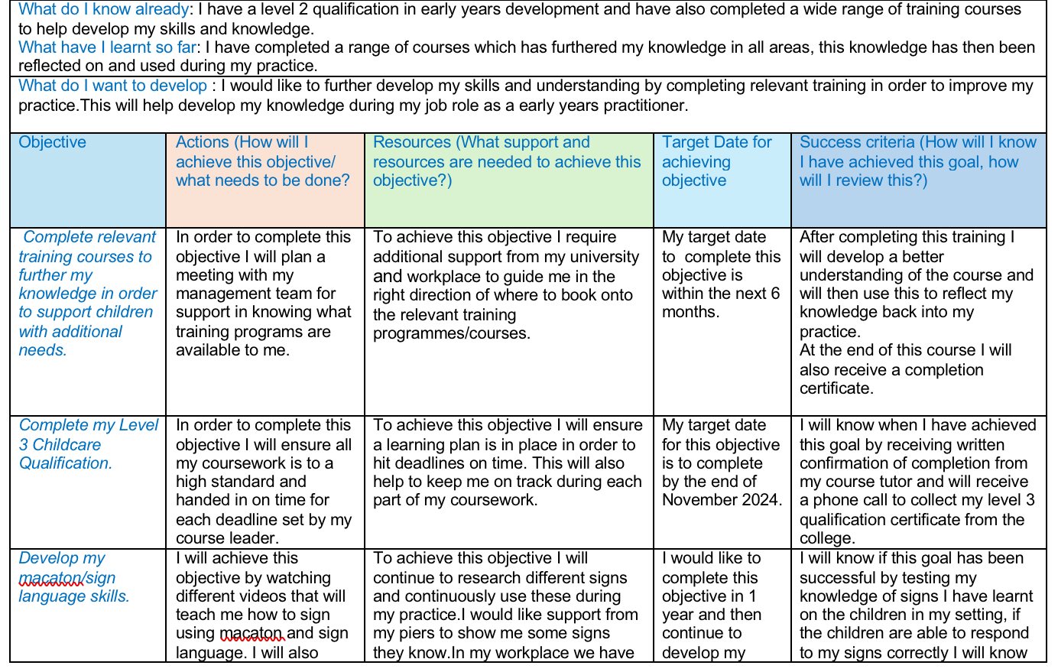
1-

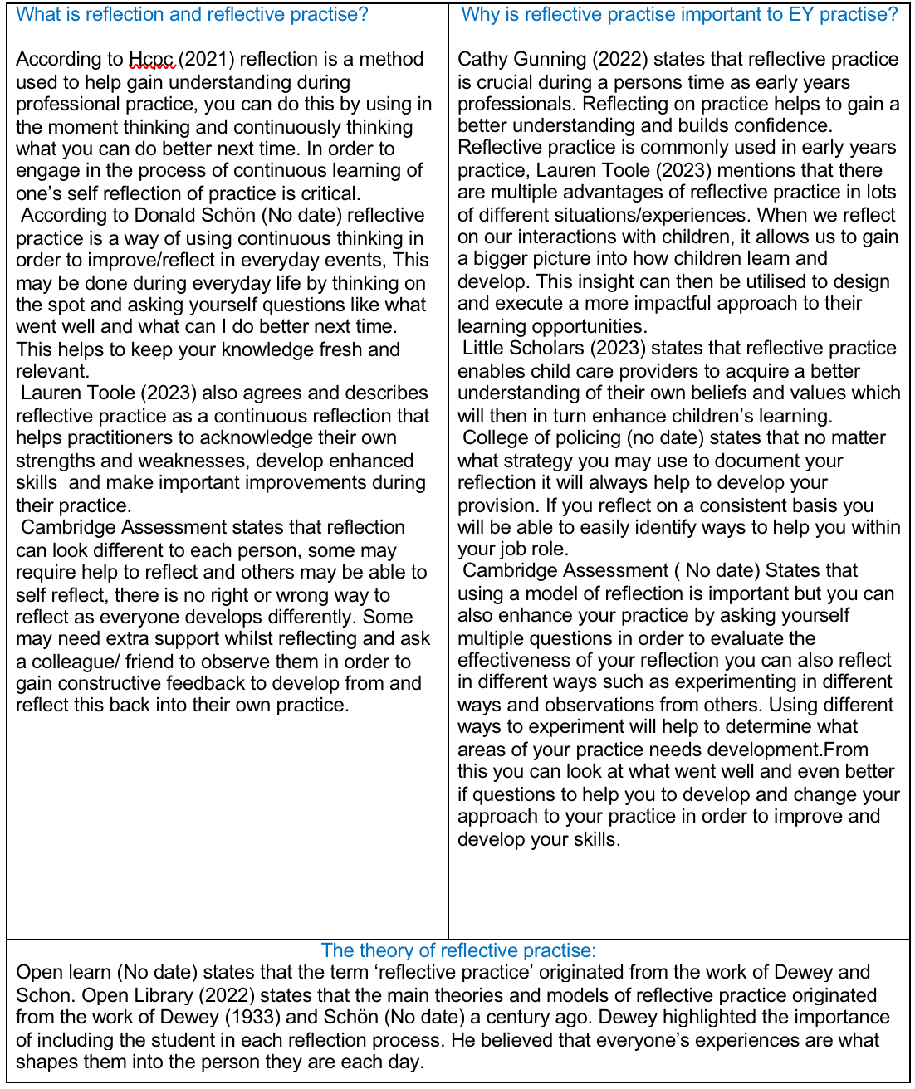
2- Word count- 917

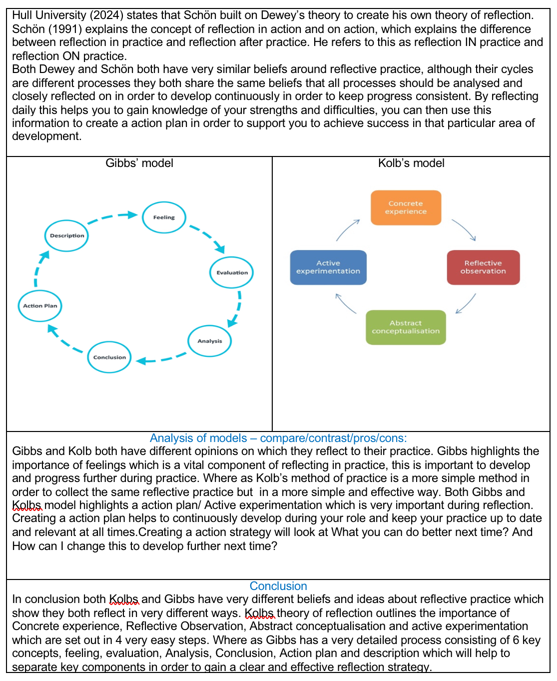
2-

3-

Donald Schon.(No date) what is reflective practice? Available at: https://libguides.cam.ac.uk/reflectivepracticetoolkit/whatisreflectivepractice (Accessed: 30 October 2024)

Hcpc (2021) what is reflection? Available at: https://www.hcpc-uk.org/standards/meeting-our-standards/reflective-practice/what-is-reflection/ (Accessed: 30 October 2024)

Cathy Gunning (2022) what is reflective practice? Available at:
https://early-education.org.uk/reflective-practice/#:~:text=Reflecting%20on%20our%20practice%20makes,and%20pedagogical%20growth%20and%20development. (Accesssed: 01 November 2024)

Little Scholars (2023) Reflective practice in early learning: what it is, examples, and why it’s important? Available at: https://mylittlescholars.com.au/reflective-practice-in-childcare/ (Accessed: 01 November 2024)

Gibbs (2020) Gibbs reflective cycle. Available at: https://www.ed.ac.uk/reflection/reflectors-toolkit/reflecting-on-experience/gibbs-reflective-cycle (Accessed: 01 November 2024)

Kolb (1984) kolbs reflective cycle. Available at: https://www.nicole-brown.co.uk/reflective-model-according-to-kolb/ (Accessed: 01 November 2024)

Open Learn (No Date) Refining reflective practice. Available at: https://www.open.edu/openlearn/education-development/learning-teach-becoming-reflective-practitioner/content-section-2.1 (Accessed: 01 November 2024)

Open Library (2022) The Beginning of Theories & Models of Reflective Practice – John Dewey. Available at: https://ecampusontario.pressbooks.pub/reflectivepracticeinearlyyears/chapter/3-2-beginning-theories/#:~:text=The%20fundamental%20theories%20and%20models,work%20of%20Dewey%20and%20Schön. (Accessed: 01 November 2024)

College of policing (No date) Resources for reflective
practice. Available at: https://assets.college.police.uk/s3fs-public/2020-11/Resources_for_reflective_practice_v1_0.pdf (Accessed: 01 November 2024)

Hull University (2024). Reflective writing: Schön Available at: https://libguides.hull.ac.uk/reflectivewriting/schon (Accessed: 01 November 2024)

Cambridge Assessment (No date) Getting started with Reflective Practice. Available at: https://www.cambridge-community.org.uk/professional-development/gswrp/index.html#:~:text=Reflective%20practice%20is%20'learning%20through,your%20students%20make%20maximum%20progress. (Accessed: 01. November 2024)

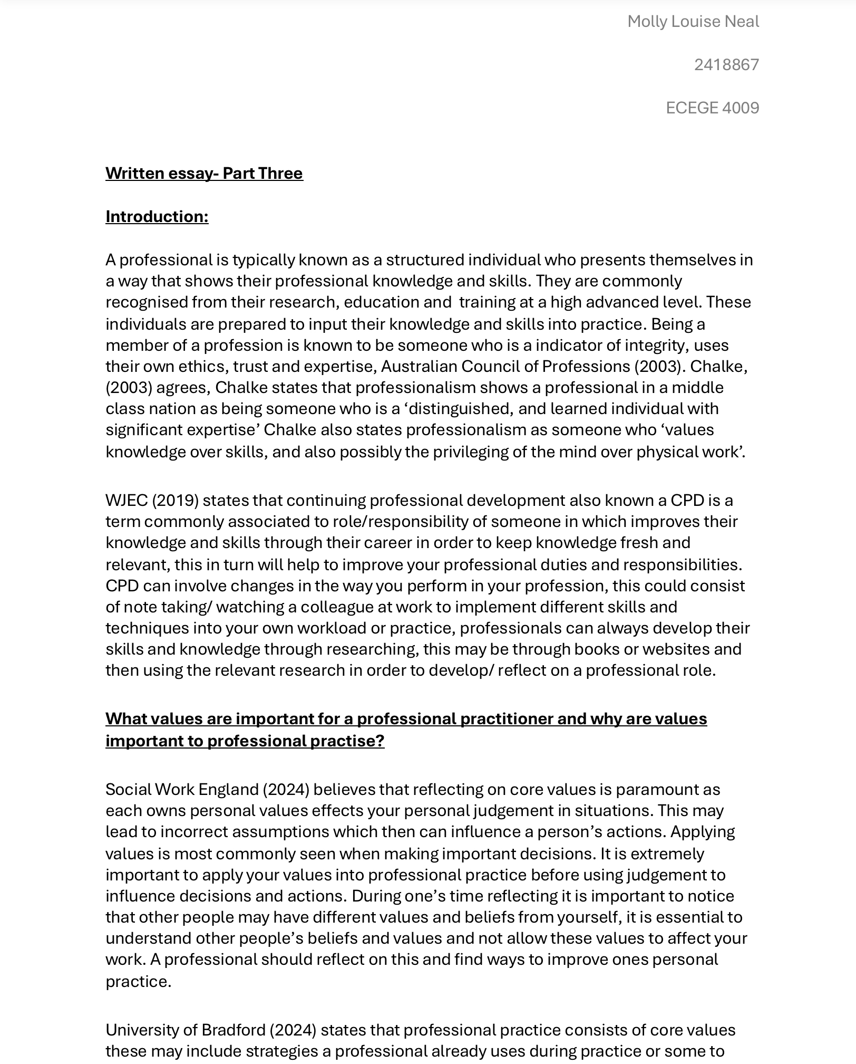
4- Word count- 1487
4-
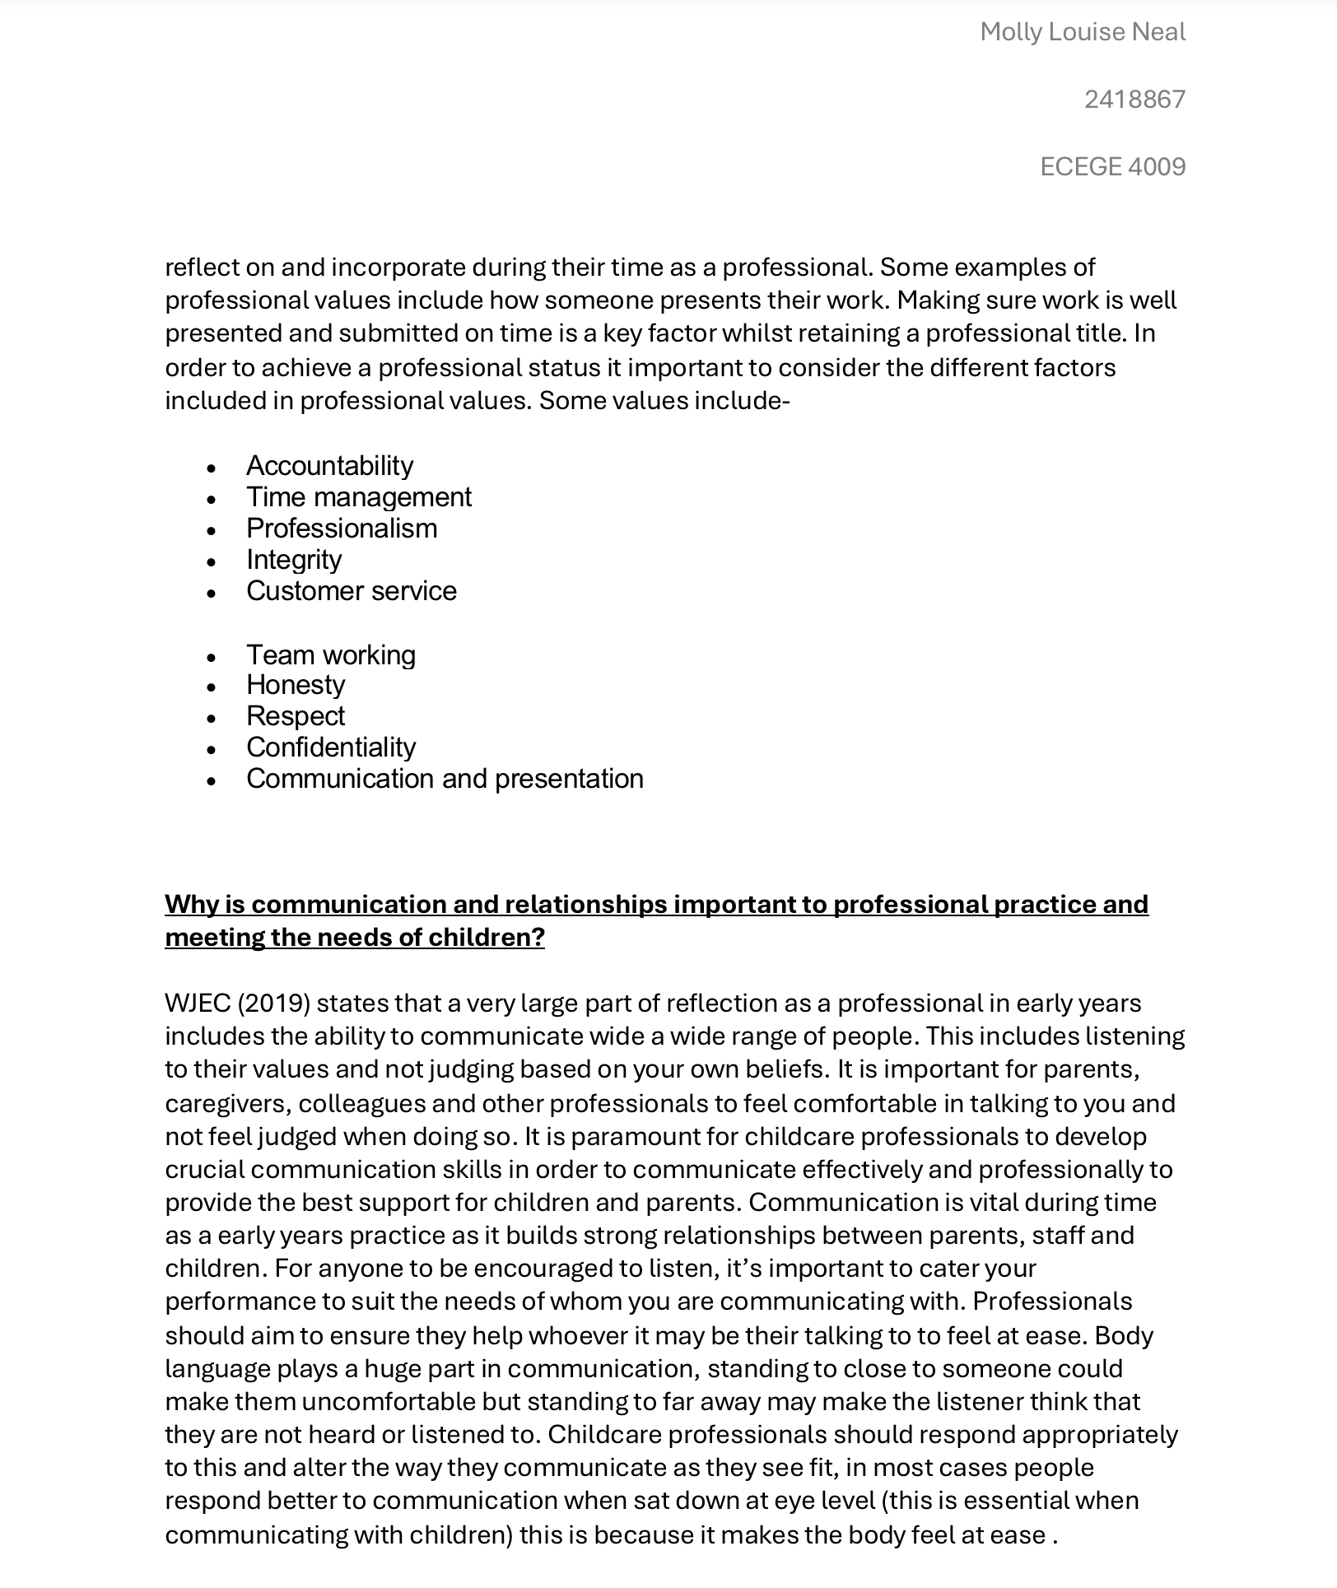

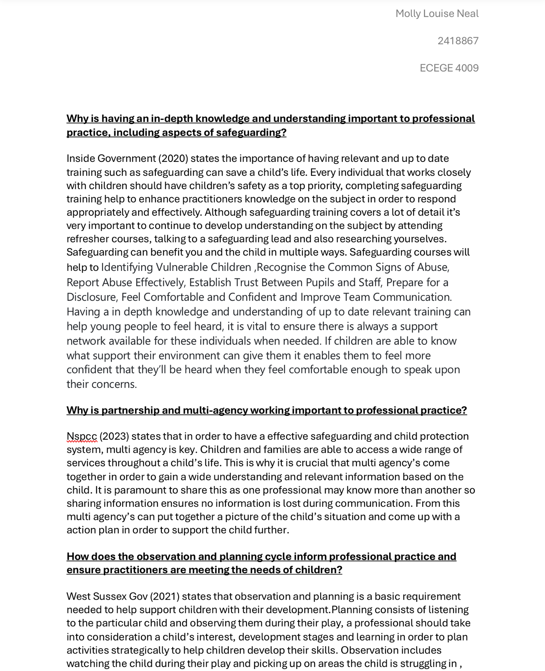
4-

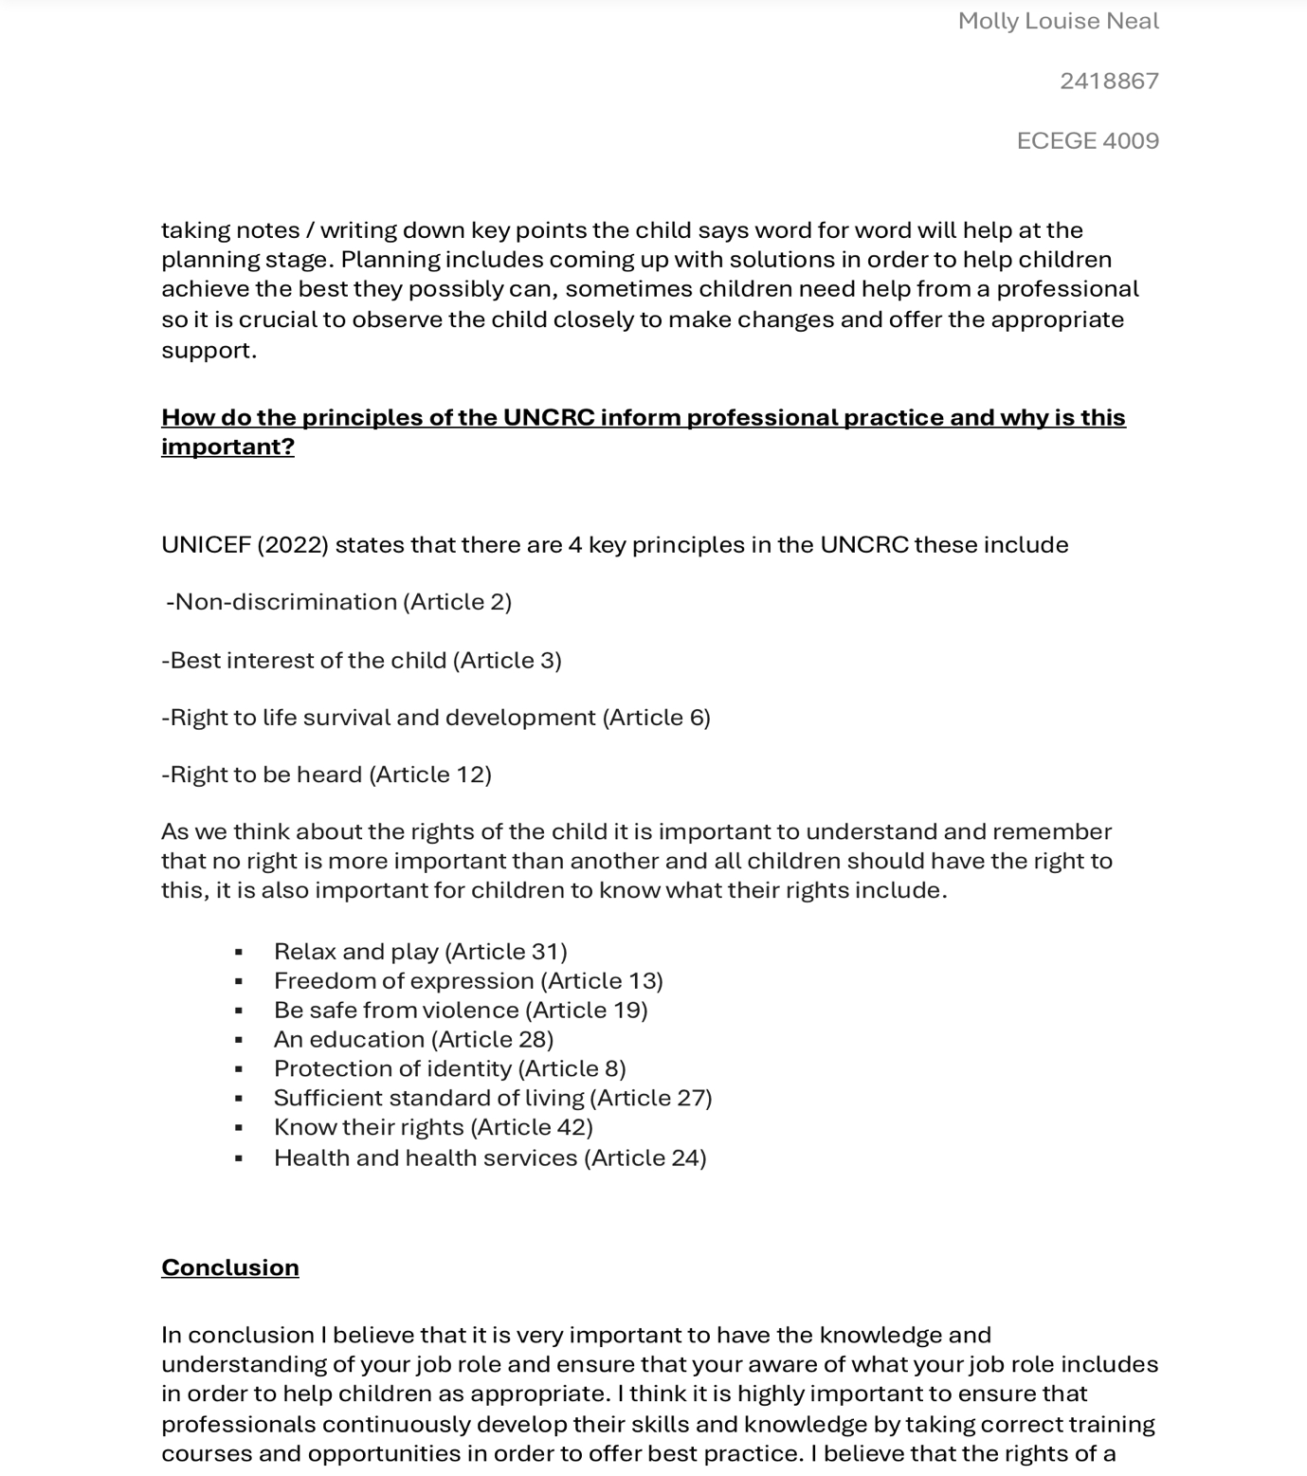
4-
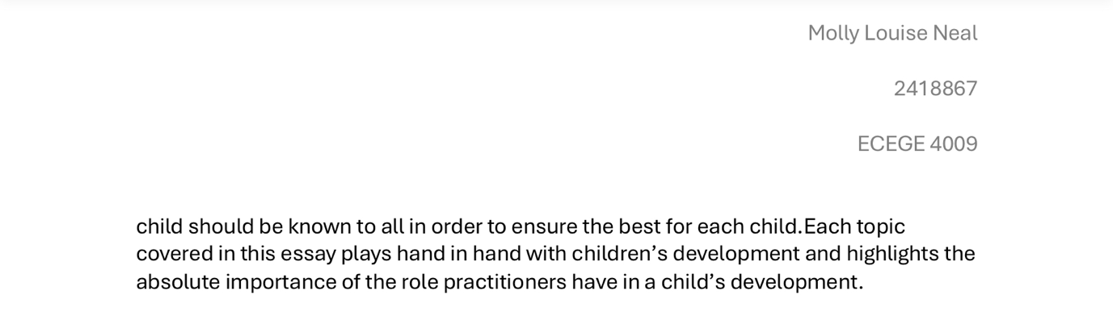
5-
Australian Council of professions (2003) what is a profession? Available at: https://professions.org.au/what-is-a-professional/ (Accessed: 01 November 2024)

Chalke, J. (2013) ‘Will the Early Years Professional Please Stand Up? Professionalism in the Early Childhood Workforce in England’, Contemporary Issues in Early Childhood. 14 (3) pp

WJEC (2019) Continuing professional development. Available at: https://resource.download.wjec.co.uk/vtc/2018-19/hsc18-19_3-3/_multi-lang/unit06/01-continuing-professsional-development.html (Accessed: 01 November 2024)

Social Work England (2024) Why reflecting on your values is important. Available at: https://www.socialworkengland.org.uk/cpd/ethics-and-values/ (Accessed: 02 November 2024)

University of Bradford (2024) What are professional values?. Available at: https://www.bradford.ac.uk/careers/develop-skills/professional-values/ (Accessed: 02 November 2024)

Inside Government (2020) How Can Training in Safeguarding Benefit You in Your Role?. Available at: https://blog.insidegovernment.co.uk/schools/how-can-training-in-safeguarding-benefit-you-in-your-role#:~:text=Regular%20training%20ensures%20they%20pass,right%20people%20will%20be%20told. (Accessed: 02 November 2024)

NSPCC (2023) Multi-agency working. Available at: https://learning.nspcc.org.uk/child-protection-system/multi-agency-working-child-protection. (Accessed: 02 November 2024)

West Sussex (2021) Effective Practice: Observation,Assessment and Planning. Available at: https://www.westsussex.gov.uk/media/5555effective_poa_and_planning.pdf . (Accessed: 02 November 2024)

UNICEF (2022) What is in the UNCRC?. Available at: https://www.unicef.org.uk/what-we-do/un-convention-child-rights/#:~:text=They%20are%3A,survival%20and%20development%20(Article%206). (Accessed: 02 November 2024)

