SHAUN GALSWORTHY 2218900
UNIVERSITY OF WALES TRINITY SAINT DAVID
BEng ELECTRICAL AND ELECTRONIC ENGINEERING
Power Electronics & Drives
Module Code: ACDA6004
Design Exercise
Lecturer: Steve Mosey

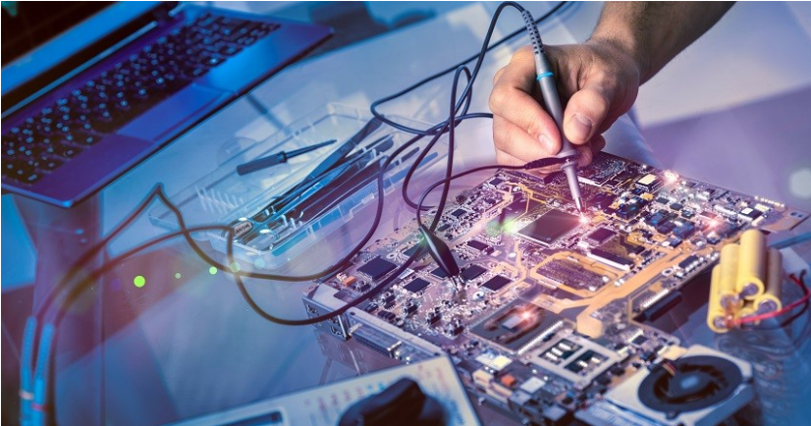

shaun.galsworthy@tatasteeleurope.com
Contents
Figures & Tables 3
1.0 Abstract 4
2.0 Task 1 5
2.1 Research Variable Frequency Drives 6
2.1.1 Description of the components of the VFD 8
2.1.2 Speed control 9
2.1.3 Dynamic braking 10
2.1.4 Active front end 11
2.2 Selection of Control Systems 12
2.2.1 Motor A - Rolling Mill 12
2.2.2 Motor B - Gantry Crane 16
Difference between single and multidrive systems 20
2.2.3 Motor C - Conveyor 24
2.2.4 Motor D - Cutting Machine 28
2.2.4 Motor E - Pumps / Fans 31
2.3 Conclusion 32
3.0 Task 2 33
3.1 Research 33
3.2 Harmonic Noise 35
3.3 Proteus Simulations 37
3.4 Conclusion 42
4.0 Datasheets 43
5.0 References 44

Figures & Tables

Figure 1 - Block Diagram of VFD 7
Figure 2 - Pulse Width Modulation 9
Figure 3 - Dynamic Braking Resistor 10
Figure 4 - Active Front End 11
Figure 5 - ACS880-07 Specifications 15
Figure 6 - ACS880-107 Specifications 19
Figure 7 - Illustration of Single Drive 20
Figure 8 - Circuit Layout of Single Drive 20
Figure 9 - Illustration of Multidrive 21
Figure 10 - Multidrive Suite 22
Figure 11 - ACS880-01 Specifications 27
Figure 12 - Harmonics Graph 35
Figure 13 - Circuit 1 (Diode) 37
Figure 14 - Analogue Analysis of Circuit 37
Figure 15 - Fourier Analysis 38
Figure 16 - Star Delta Configuration 38
Figure 17 - Star Star Configuration 39
Figure 18 - Line Analysis Graph 39
Figure 19 - Line Analysis Graph 40
Figure 20 - Line Analysis Graph 40
Figure 21 - Load Analysis Graph 41
Figure 22 - Load Analysis Graph 41
Figure 23 - Load Analysis Graph 42

Table 1 - Motor Specifications 5
Table 2 - VFD Components 8
Table 3 - Rolling Mill System 14
Table 4 - Gantry Crane System 18
Table 5 - Conveyor System 26
Table 6 - Cutting Machine System 29
Table 7 - Pumps / Fans System 32

1.0 Abstract

This concise written report research variable frequency drives and the resulting harmonics caused by the use of them. The information is then used to design and specify suitable technologies to control different motor systems.
The software Proteus will be used to carryout practical demonstrations to compare and contrast how different components can be used to minimise the effects of harmonics on the supply by rectifying the incoming mains.

Word Count: 3009 (tables do not count towards the overall word count)

2.0 Task 1

A factory is to refit its motor drive systems. There are five types of induction motor in the factory as shown in the table below:
 | Motor A | Motor B | Motor C | Motor D | Motor E
Power | 500KW | 80KW | 10KW | 5KW | 1KW
Phases | 3 | 3 | 3 | 3 | 1
Voltage | 400 | 400 | 400 | 400 | 230
Required to be Reversible ? | Yes | Yes | Yes | No | No
Variable Speed Required ? | Yes | Yes | Yes | No | No
Quantity Installed | 5 | 10 | 23 | 17 | 127
Example Application | Rolling Mill | Gantry Crane | Conveyor | Cutting Machine | Pumps / Fans
 | 2500kW | 800kW | 230kW | 85kW | 127kW
Table 1 - Motor Specifications
Specify a suitable technology for the motor drive system. You should consider things like the use of a common DC Bus, starters, protection, cost, flexibility of control system, information gathering ability, etc.

2.1 Research Variable Frequency Drives

‘’A variable frequency drive (VFD) is a type of motor controller that drives an electric motor by varying the frequency and voltage of its power supply. The VFD also has the capacity to control ramp-up and ramp-down of the motor during start or stop, respectively.
Even though the drive controls the frequency and voltage of power supplied to the motor, we often refer to this as speed control, since the result is an adjustment of motor speed.
There are many reasons why we may want to adjust this motor speed.
For example, to
- Save energy and improve system efficiency
- Convert power in hybridization applications
- Match the speed of the drive to the process requirements
- Match the torque or power of a drive to the process requirements Improve the working environment.
- Lower noise levels, for example from fans and pumps
- Reduce mechanical stress on machines to extend their lifetime Shave peak consumption to avoid peak-demand prices and reduce the motor size required

In addition, today’s drives integrate networking and diagnostic capabilities to better control performance and increase productivity. So, energy savings, intelligent motor control and reduction of peak-current drawn are three great reasons to choose a VFD as the controller in every motor-driven system.
The most common uses of a VFD are for control of fans, pumps and compressors, and these applications account for 75% of all drives operating globally’’.[1]

Figure 1 shows the block diagram for a variable frequency drive in its most basic form where it is supplied by a three phase supply. This AC supply then gets converted to DC onto the DC bus, where the next stage is the for the converter to create an output frequency using pulse width modulation so that the speed of the motor can be controlled.

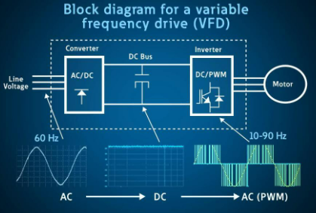
Figure 1 - Block Diagram of VFD
[6]

2.1.1 Description of the components of the VFD

Component | Description
Invertor Units | The inverter unit has capacitors built in to smooth the voltage of the DC busbars. The connections to the common busbars are fused, and the individual INU’s can be disconnected form the busbars via a switch, or a fused isolator.
IGBT | The ISU is used when the system is a regenerative one, and its purpose is to convert the three-phase AC supply voltage into a DC voltage. With the use of IBGT’s it means the motors can be operated in both motoring and generating modes.
Regen Rectifier Unit | The RRU is used when the system is a regenerative one, and its purpose is the convert the three-phase AC voltage into DC voltage. It is built up of IGBT’s which are switched once during each voltage cycle, which reduces switching losses and allows for a higher power.
Brake Unit | The brake unit is what takes care of the generated energy when the motor is decelerating. When the voltage in the circuit rises above a certain point, the breaking chopper brings the braking resistor into circuit.
DC – DC Converter | The DC-DC converter allows for the transfer of energy form the DC link, to an external storage, usually in the form of batteries or super capacitors.
Table 2 - VFD Components
[1]

2.1.2 Speed control

Variable frequency drives increase or decrease the speed of a motor by altering the frequency supplied to the motor. The technique these drives use is called pulse width modulation.
A pulse width modulation inverter works by varying the frequency and pulse widths of the supplied voltage to the induction motor. This is done by switching in and out the Insulated-gate bipolar transistors (IGBT) in the inverter. Below are two different examples of PWM signals that would be supplied to a motor. [2]

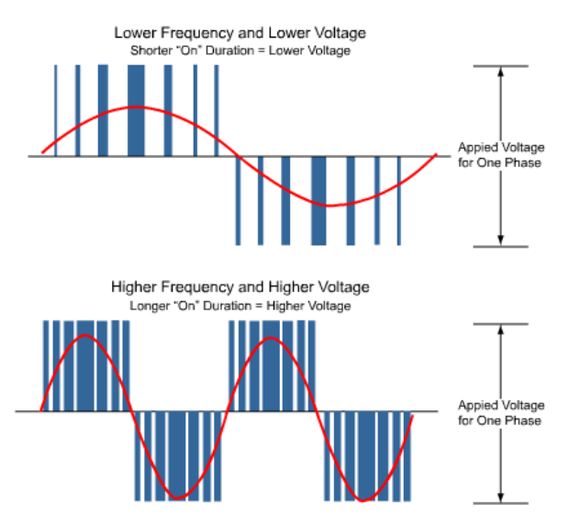
Figure 2 - Pulse Width Modulation
[2]

2.1.3 Dynamic braking

When the input bridge isn’t an active input bridge, power will have to be dissipated using dynamic braking resistors. When the motor slows down, the power will flow back to the inverter from the motor. Due to the input bridge being made up of diodes which are only single direction, the energy from the motor will not be able to flow back into the grid. This means all the power is stuck in the DC link, meaning an overvoltage trip will occur. The addition of a dynamic braking resistor and switch that’s usually a transistor means the energy can be dissipated. Once the voltage in the DC link rises above a certain level the switch will allow the voltage to be dissipated across the resistor. [2]
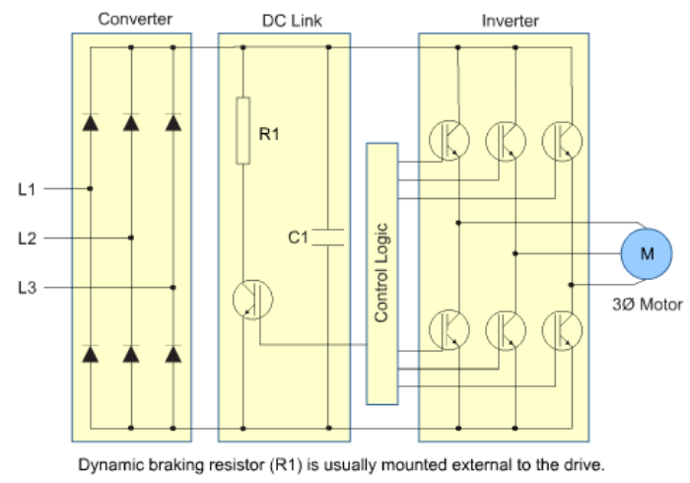
Figure 3 - Dynamic Braking Resistor
[2]

2.1.4 Active front end

An active input bridge or active front end removes the need for dynamic braking resistor circuit. Instead of using single direction diodes, it uses IGBT’s as they are bi directional. This will allow all the generated power from the slowdown to be fed back into the grid to dissipate the energy. When the voltage in the DC link rises to a certain level the transistors will switch allowing the energy created to flow In the reverse direction. [2]
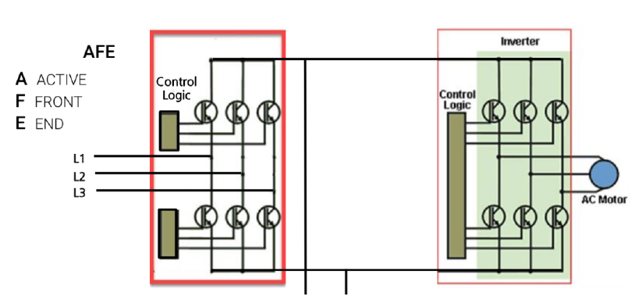
Figure 4 - Active Front End
[2]

2.2 Selection of Control Systems

2.2.1 Motor A - Rolling Mill
 | ABB VFD Drive | Schneider VFD Drive | VYBO VFD Drive
 | 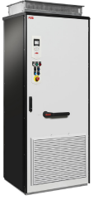 | 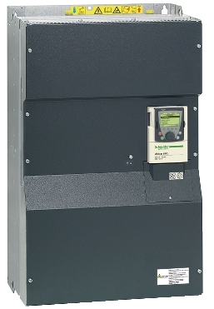 | 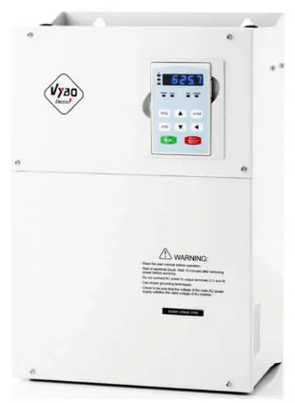
Type | ACS 880-07 Cabinet single drives | ATV61Q | V810
Voltage | 380 to 415V | 380...480 V - 15...10 % | 400V AC ± 15%
Power | 45 to 2800 kW | 500kW | 500kW
Variable Speed | Yes | Yes | Yes
Protection | • Safe torque off (STO)  • Safe stop 1 (SS1-t and SS1-r)  • Safe stop emergency (SSE)  • Safe brake control (SBC)  • Safely-limited speed (SLS)  • Safe maximum speed (SMS)  • Prevention of unexpected startup (POUS)  • Safe direction (SDI)  • Safe speed monitor (SSM)  • Safe motor temperature (SMT) | Against exceeding limit speed: drive  Against input phase loss: drive  Break on the control circuit: drive  Input phase breaks: drive  Line supply overvoltage: drive  Line supply undervoltage: drive  Overcurrent between output phases and earth: drive  Overheating protection: drive  Overvoltages on the DC bus: drive  Power removal: drive Short-circuit between motor phases: drive  Thermal protection: drive Motor phase break: motor  Power removal: motor  Thermal protection: motor | Motor short-circuit detection  output phase loss protection  overcurrent protection  overvoltage protection  live protection  overheat protection  overload protection
Reversable Motor Direction | Yes | Yes | Yes
Operating Temperature | 0°C to 50°C | 5…55 °C | – 10 ° C ~ 40 ° C (reduce power level if ambient temperature is between 40 ° C to 50 ° C)
Degree of Protection | IP22 Standard  IP42 & IP54 Options | IP00 conforming to EN/IEC 60529  IP00 conforming to EN/IEC 61800-5-1  IP30 on side parts conforming to EN/IEC 60529  IP30 on side parts conforming to EN/IEC 61800-5-1  IP30 on the front panel conforming to EN/IEC 60529  IP30 on the front panel conforming to EN/IEC 61800-5-1  IP41 on upper part conforming to EN/IEC 60529  IP41 on upper part conforming to EN/IEC 61800-5-1 | IP22
Connectivity | - 2 Analogue inputs  - 2 Analogue outputs  - 6 Digital inputs  - 3 Relay outputs  - Safe Torque off  - Drive to Drive link (EIA 485)  - Built in Modbus  - Assistant control panel (RJ45)  - Bluetooth | Communication card for APOGEE FLN  Communication card for BACnet  Communication card for CC-Link  Communication card for DeviceNet  Communication card for EtherNet/IP  Communication card for Fipio  Communication card for Interbus-S  Communication card for LonWorks  Communication card for METASYS N2  Communication card for Modbus Plus  Communication card for Modbus TCP  Communication card for Modbus/Uni-Telway  Communication card for Profibus DP  Communication card for Profibus DP V1  Controller inside programmable card  I/O extension card | 8 digital inputs  binary ON / OFF inputs  1 terminal X5 can support high speed pulse input  All terminals have optional PNP or NPN  2 analog inputs  one of which FIV supports -10 V / +10 V; or a 0-10 V input and the second FIC supports a 0-10V or 0-20mA (4-20 mA) input.  1 Programmable open collector output: provides 1 output terminal (open collector output or high speed pulse output)  2 relay outputs  2 analog outputs: FOV and FOC with optional 0 – 20 mA (4 – 20 mA) or 0 – 10 V output
Price
Table 3 - Rolling Mill System

The control system selected for the five rolling mill motors are the ABB ACS 880-07 which are cabinet single drives with each having their own 400V supply. Figure 5 shows that they will be R11 frame size code ACS880-07-0880A-5+C129.
As the e room where these will be housed is not restricted in space the control system will consist of six of these drives five will control five different motors which will need to have their own VFD’s due to running at different speeds for the rolling mill. The sixth drive will be a standby drive which can be switched in to run any of the motors in the case of any one of the drives going down or for carrying out maintenance on the other drives without taking the mill offline.

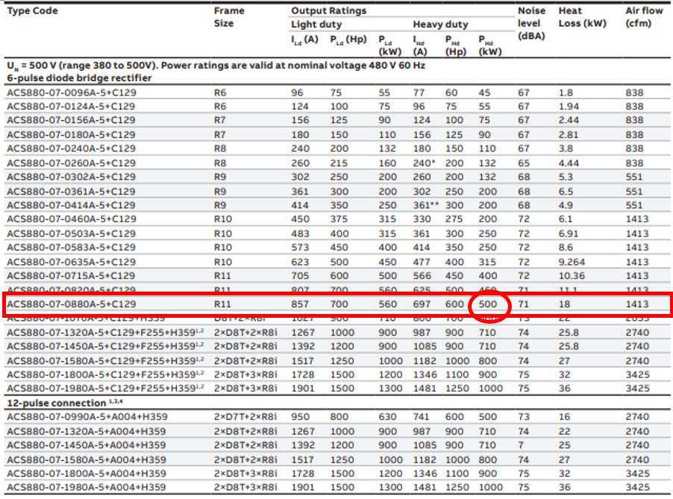
Figure 5 - ACS880-07 Specifications
[3]

2.2.2 Motor B - Gantry Crane
 | Vacon VFD Drive | ABB VFD Drive | Allen Bradley VFD Drive
 | 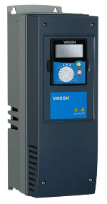 | 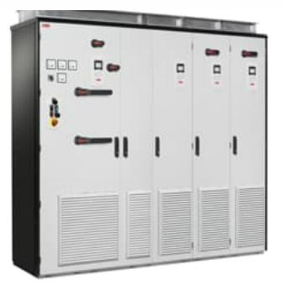 | 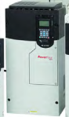
Type | NXP 0168 | ACS880 Multidrive | Power Flex 750-Series 20F1ANC205
Voltage | 380 -500V | 380 to 415V | 380 – 400V
Power | 90kW | 1.5 to 6000kW | 0.37 – 200kW
Variable Speed | Yes | Yes | Yes
Protection | Overvoltage  undervoltage  earth fault  mains supervision  motor phase supervision  overcurrent  unit overtemperature  motor overload  motor stall  motor underload  short-circuit of +24 V and +10 V reference voltages | • Safe torque off (STO)  • Safe stop 1 (SS1-t and SS1-r)  • Safe stop emergency (SSE)  • Safe brake control (SBC)  • Safely-limited speed (SLS)  • Safe maximum speed (SMS)  • Prevention of unexpected startup (POUS)  • Safe direction (SDI)  • Safe speed monitor (SSM)  • Safe motor temperature (SMT) | AC input overvoltage trip  AC input undervoltage trip  Bus overvoltage trip  Bus undervoltage shutoff  Nominal bus voltage (full load)  Drive overcurrent trip Software overcurrent trip Instantaneous current limit Hardware overcurrent trip  Line transients  Control logic noise immunity  Power ride-through  Logic control ride-through  Ground fault trip  Short circuit trip
Reversable Motor Direction | Yes | Yes | Yes
Operating Temperature | Maximum operating temperature of +35°C | 0°C to 50°C | 0 to 50°C
Degree of Protection | IP54 | - IP22 Standard  - IP42 & IP 54 Options | IP54
Connectivity | RS485 with screw terminal RS485 with screw terminal  PROFIBUS DP with screw terminal OPTE5  PROFIBUS DP with D9-connector  OPTE6 CANopen CANopen  OPTE7 DeviceNet DeviceNet  OPTE8 RS485 with D9-connector  RS485 with D9-connector  OPTE9 Dual-port Ethernet Dual-port Ethernet  OPTEA Advanced Dual-port Ethernet Advanced Dual-port Ethernet  OPTC2 RS485 with screw terminal  RS485 with screw terminal  OPTC3 PROFIBUS DP with screw terminal  OPTC4 LonWorks  OPTC5 PROFIBUS DP with D9-connector  PROFIBUS DP with D9-connector  OPTC6 CANopen CANopen  OPTC7 DeviceNet DeviceNet  OPTC8 RS485 with D9-connector  RS485 with D9-connector | - 2 Analogue inputs  - 2 Analogue outputs  - 6 Digital inputs  - 3 Relay outputs  - Safe Torque off  - Drive to Drive link (EIA 485)  - Built in Modbus  - Assistant control panel (RJ45)  - Bluetooth | BACnet/IP option module  Coaxial ControlNet option module  ControlNet communication adapter (coax)  DeviceNet option module  DeviceNet communication adapter  Dual-port EtherNet/IP option module  EtherNet/IP communication adapter  CANopen communication adapter  LonWorks communication adapter  Modbus/TCP communication adapter  Profinet I/O option module  Dual-port Profinet I/O option module  PROFIBUS DP communication adapter  ControlNet communication adapter  Remote I/O communication adapter  RS-485 DF1 communication adapter  External communication kit power supply
Price
Table 4 - Gantry Crane System

For the control system on the gantry crane the ABB VFD ACS880 multidrive system has been selected. The reason being the 10 motors being supplied from one 400V supply creating a common DC bus. This will be beneficial because the drive system will have to be installed on the crane where space is limited. Using the specification table in figure 6 the drive type to be installed in the multidrive housing will be the ACS880-107-025OA-3 frame size R6i. The drive is rated at 90kW which is slightly higher than the 80kW required. The reason for choosing this module is that due to the crane being classed as M8. This is the highest duty meaning the crane is a production crane and in service for 24 hours a day. So it is because of this the heavy duty section was used and the one below this model is only rated at 75kW.

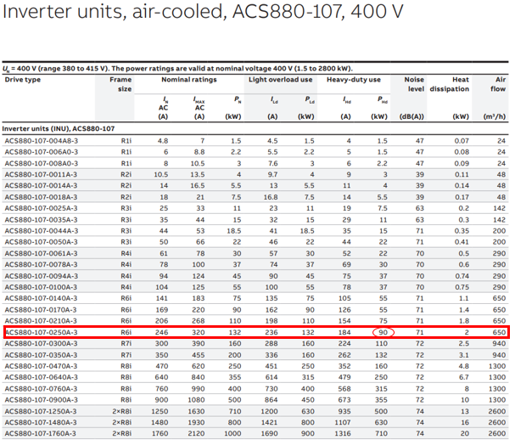
Figure 6 - ACS880-107 Specifications
[3]

Difference between single and multidrive systems

Single drives have a three phase input usually 415V 50Hz supply and produces a variable voltage but more importantly a variable frequency to the motor. This controls the speed and the torque of the motor.
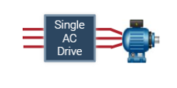
Figure 7 - Illustration of Single Drive
[2]
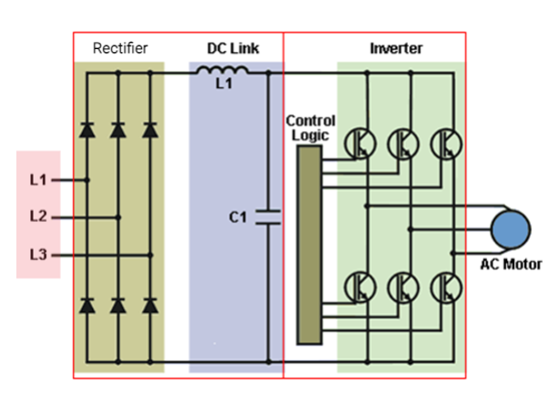
Figure 8 - Circuit Layout of Single Drive
[2]

Multidrives can control the speed and torque of multiple AC motors individually. A three phase supply is applied to the input bridge, which rectifies the AC supply to produce a common DC Bus. The multidrive then has an inverter module for every motor that uses the DC Bus supply to create variable frequency and variable voltage to control the individual motors.
The crane’s multidrive system means there is a common DC bus arrangement, enabling single power entry and common braking resources for several drives. There are several possibilities on the supply side starting from a simple diode supply unit up to highly sophisticated active IGBT supply units. Multidrives can be used wherever several motors form part of a single process. They come with a common DC bus arrangement, enabling single power entry for several drives. The energy circulating over the common DC bus results in energy and cost savings, as not all energy is taken from the supply network allowing the supply unit in the drive to have smaller dimensions. A single power line connection and a common supply unit reduces the need for cabling and floor space, saving investment and maintenance costs.
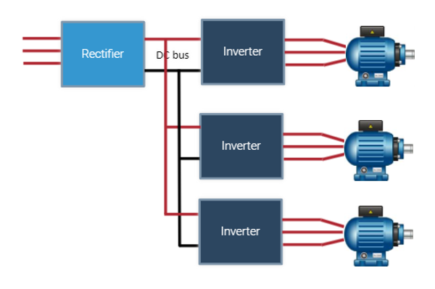
Figure 9 - Illustration of Multidrive
[2]

The image below in fig ?? shows a suite of cubicles for a multidrive system, the suite is split into two separate section, the supply units and the drive units. The supply units consist of an incomer followed by isolators and an MCB, then an active front end input bridge. The supply will be a three-phase supply, and the AFE will then convert it to DC and supply the DC bus.
The drive unit consists of the inverter modules to drive the individual motors, in the image below some cubicles have two inverter modules which are controlling separate motors, but it is possible to have one drive controlling multiple motors. The inverter modules will switch the DC back to AC ready to supply the motors. It is in the inverter modules where the frequencies are altered, this then changes the speed at which the motor turns.
The multidrive system is excellent because it has the facility to include spare drives in the cabinets, so if there is a fault on one of the drives, the spare one can be switched in, allowing for the maintenance to be planned for when production levels are low, i.e. on a plant stop day. [2]
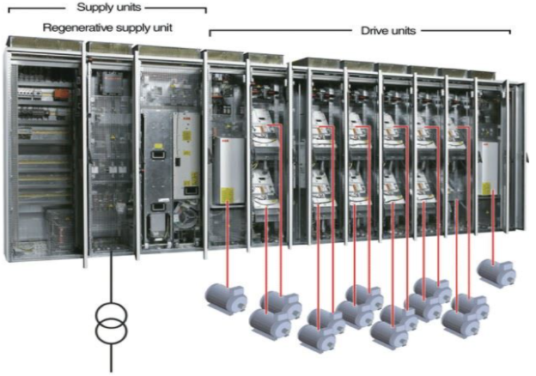
Figure 10 - Multidrive Suite
[2]

2.2.3 Motor C - Conveyor
 | Schneider VFD Drive | ABB VFD Drive | Mitsubishi VFD Drive
 | 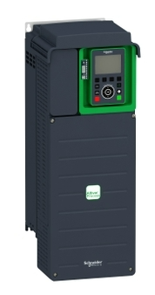 | 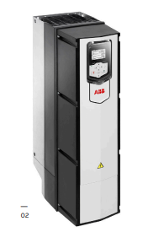 | 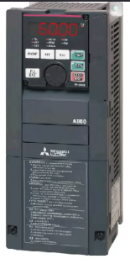
Type | Altivar Process ATV900 | ACS880-01 Wall Mounted | FR-A840-00310-E2-60
Voltage | 380...480 V - 15...10 % | 380 to 415V | 400V
Power | 15.0 kW for normal duty  11.0 kW for heavy duty | 1.5 to 6000kW | 11kW
Variable Speed | Yes | Yes | Yes
Protection | Against exceeding limit speed: drive  Against input phase loss: drive  Break on the control circuit: drive  Input phase breaks: drive  Line supply overvoltage: drive  Line supply undervoltage: drive  Overcurrent between output phases and earth: drive  Overheating protection: drive  Overvoltages on the DC bus: drive  Power removal: drive Short-circuit between motor phases: drive  Thermal protection: drive Motor phase break: motor  Power removal: motor  Thermal protection: motor | • Safe torque off (STO)  • Safe stop 1 (SS1-t and SS1-r)  • Safe stop emergency (SSE)  • Safe brake control (SBC)  • Safely-limited speed (SLS)  • Safe maximum speed (SMS)  • Prevention of unexpected startup (POUS)  • Safe direction (SDI)  • Safe speed monitor (SSM)  • Safe motor temperature (SMT)
Reversable Motor Direction | Yes | Yes | Yes
Operating Temperature | -15…40 °C (without derating)  40…50 °C (with derating factor) | 0°C to 50°C | 0°C to 50°C
Degree of Protection | IP55 | - IP22 Standard  - IP42 & IP 54 Options | IP55
Connectivity | Slot A: communication module for Profibus DP V1  Slot A: communication module for PROFINET  Slot A: communication module for DeviceNet  Slot A: communication module for EtherCAT  Slot A: communication module for CANopen daisy chain RJ45  Slot A: communication module for CANopen SUB-D 9  Slot A: communication module for CANopen screw terminals  Slot A/slot B/slot C: digital and analog I/O extension module  Slot A/slot B/slot C: output relay extension module  Slot B: 5/12 V digital encoder interface module  Slot B: analog encoder interface module  Slot B: resolver encoder interface module communication module for Ethernet Powerlink | - 2 Analogue inputs  - 2 Analogue outputs  - 6 Digital inputs  - 3 Relay outputs  - Safe Torque off  - Drive to Drive link (EIA 485)  - Built in Modbus  - Assistant control panel (RJ45)  - Bluetooth | 128 (input: 64 points  output: 64 points) 19 points built-in (input: 12 points, output: 7 points)  FR-A8AX (input: 16 points) FR-A8AY (output: 7 points)  FR-A8AR (output: 3 points)  3 input points built-in (Terminals 1, 2, and 4)  FR-A8AZ: 1 input point (Terminal 6)  2 output points built-in (Terminals F/C(FM/CA) and AM)  FR-A8AY: 2 output points (Terminals AM0 and AM1)  FR-A8AZ: 1 output point (Terminal DA1)
Price
Table 5 - Conveyor System
The Conveyor system will be controlled by 3 Wall mounted ACS880-01-302A-5 which will be housed inside control panels in a nearby contactor room. There is a total of 23 motors on the conveyor all operating at the same speed so one drive will control 12 motors and one drive will control 11 motors.
Each VFD respectively will need to control multiple motors so there should an extra 10% added on when selecting the kW rating of the drive.
Drive 1 10kW x 12 motors = 120kW + 10% = 132kW
Drive 2 10kW x 11 motors = 110kW + 10% = 121kW
The ACS880-01-302A-5 shown in fig ?? has a kW rating of 132kW so this will be used for both drive 1 & 2 and the spare drive so that there is interchangeability and commonality of spares.
The three drive’s parameters will be set up identically and normal operation will be to use the two drives and have the spare in standby so that it can be switched in remotely to prevent downtime on the conveyor. This will be done by switching a contactor arrangement supplying the drives.
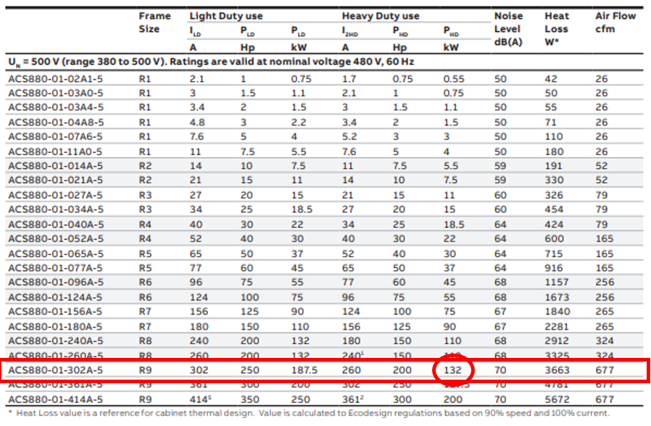
Figure 11 - ACS880-01 Specifications
[3]

2.2.4 Motor D - Cutting Machine
 | ABB Soft Starter | Telemecanique Soft Starter | Schneider Altivar ATS480
 | 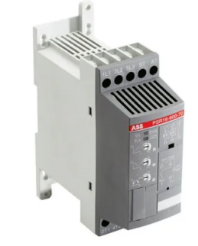 | 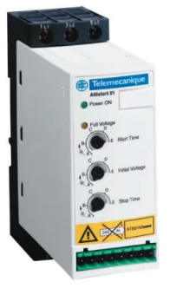 | 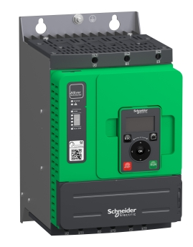
Type | PSR12 | ATS01N222LU | Altivar ATS480
Voltage | 208...600 V +10%/-15%, 50/60 Hz ±5% | 200….240V AC | 208...690 V - 15...10 %
Power | 5.5kW | 5.5kW | 7.5 kW at 400 V in the motor supply line normal duty  5.5 kW at 400 V in the motor supply line heavy duty
Variable Speed | Yes | Yes | Yes
Protection | External Switch fuse and thermal overload relay | External Switch fuse and thermal overload relay | Phase failure: line  Integrated thermal protection: motor  Thermal protection: starter  Current overload: motor  Underload: motor  Excessive starting time, locked rotor: motor  Motor phase loss: motor  Line supply phase loss: line  Line supply phase loss: motor  Thermal protection: motor
Reversable Motor Direction | No | No | NO
Operating Temperature | -25...+60 ºC | -10...+40 ºC | 40…60 °C (with current derating of 2 % per °C) -15…40 °C (without derating)
Degree of Protection | IP20 | IP20 | IP20
Connectivity | Output signal relays | n/a | Communication module for Profibus DP V1  Communication module for PROFINET  Communication module for Modbus TCP/EtherNet/IP  Communication module for CANopen daisy chain  Communication module for CANopen Sub-D  R1A, R1C, R3A, R3C : Sequence relay  STOP, RUN, DI3, DI4 : Digital inputs  AQ1 : Analogue output  PTC1/AI1, PTC2, PTC3 : PTC or PT100 connection  DQ1, DQ2, DQ+ : Digital outputs
Price | £203.92 | £291.88 | £743.18
Table 6 - Cutting Machine System
The system controlling the cutting machines does not have to be reversed or run at different speeds but does have to be switched on and off at different times. One VFD would not be suitable for this application so it would be costly to install 17 drives. To save on cost the Schneider Altivar ATS480 soft start unit has been selected. There will be 17 soft start units so each motor can be controlled individually. The motors are relatively small at 5kW but the soft start allows the current to be limited so that no expensive PLC system would need to be installed to prevent all 17 starting at the same time.
The Altivar ATS480 although being slightly more expensive than other soft start units has good motor protection built in so would not need more external equipment to be installed. It also has good communication input/outputs so that the plant can track usage of data such as machine running hours. This can be used to predict when the next planned maintenance is carried out.

2.2.4 Motor E - Pumps / Fans
 | Schneider | Newlec NLSTM | RS PRO DOL
 | 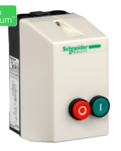 | 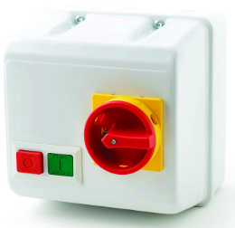 | 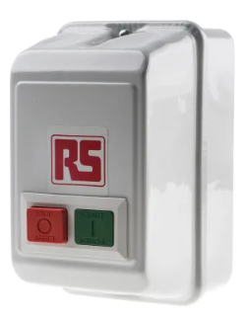
Type | Direct online starter | Direct online starter | Direct online starter
Voltage | 220/230 V AC 50/60 Hz | 230V | 240V
Power | 2.2 kW | 5.5kW | 1.1kW
Variable Speed | No | No | No
Protection | n/a | n/a | n/a
Reversable Motor Direction | No | No | No
Operating Temperature | -5 to +40°C | n/a | -5 to +40°C
Degree of Protection | IP65 | IP55 | IP55
Connectivity | n/a | n/a | n/a
Price | £52.06 | £123.15 | £80.15
Table 7 - Pumps / Fans System
The system which controls the 1kW pumps and fans will be individually started by a direct online starter the reason being that there will be low start up and running current with these motors. Due to the system consisting of 127 small motors there will be individual motor protection unit offering short circuit and overload protection. There will also be a small contactor in line with the direct online starters to enable remote starting the coil of this contactor will be 24V DC and these will be controlled via a PLC.
The code in the PLC will enable the fans and pumps to switch on when they are required and also prevent a high quantity of motors starting simultaneously causing a current spike in the system.
The one chosen was the RS PRO DOL because of the amount in service on plant if any failures were to occur this offers next day delivery and holds a large quantity on stock. It was also the mid-range for cost.

2.3 Conclusion

The majority of the drive control systems selected were manufactured by ABB the main reasons for this are as follows:
- Achieved a discounted cost due to purchasing more equipment with the same supplier.
- The maintenance teams would have better familiarity working on one type of drive reducing the need for extra training across different drives.
- Only required to purchase one drive software package.
- Would be able to stock spares which would be compatible in different areas of plant again saving costs.
An active front end was used on the gantry crane this will make this system much more efficient. This is due to the amount of times the motors on the crane will be regenerating when electrical braking after almost every movement. The active front end will discharge any unwanted power back onto the grid instead of being dissipated through a braking resistor.

3.0 Task 2

3.1 Research

‘’VFDs can reduce the starting inrush current and kVA to half of that of an across-the-line starter. The reduction of inrush current in an electrical distribution system has a number of advantages. Many utilities require some form of reduced voltage starting for all motors over 25 hp. On the downside, VFDs utilize silicon controlled rectifiers to chop up the ac waveform and will provide a nonlinear waveform. This nonlinear waveform will cause voltage distortion across the reactor of the generator or the utility transformer and can cause unacceptable transient performance. This will adversely affect the performance of the entire electrical system’’.[4]
‘’The combination of linear and nonlinear loads fed from a common power source can have a significant effect on the electrical distribution system. In situations where mostly linear loads are connected, a pure sinusoidal waveform current can flood the system with fundamental current. Significant linear load in the system will negate the effect of the nonlinear load. A system with primarily nonlinear loads will display a more distorted waveform at the power source’’.[4}

‘’All voltage-source-inverter-based VFDs have an ac to dc rectifier unit with a large dc capacitor to smooth the voltage ripple. The dc bus capacitor draws charging current only when it is discharged into the motor load. The charging current flows into the capacitor when the input rectifier is forward biased. This occurs when the instantaneous input voltage is higher than the dc voltage across the dc bus capacitor. The pulsed current drawn by the dc bus capacitor is rich in harmonics because it is discontinuous. The voltage harmonics generated by VFDs are due to the flat-topping effect caused by a weak ac source charging the dc bus capacitor without any intervening impedance. The distorted voltage waveform gives rise to voltage harmonics, which is of more importance than current harmonics. The reason is simple. Voltage is shared by all loads and it affects all loads connected in an electrical system. Current distortion has a local effect and pertains to only the circuit that is feeding the nonlinear load. Non-sinusoidal currents that draw from the ac source cause undue stress on power delivery equipment that results in poor overall efficiency’’.[4]
‘’By its nature, the VFD is a nonlinear load in the electrical system in the sense that it draws a non-sinusoidal current even if the applied voltage is perfectly sinusoidal. Modern VFDs are designed to minimize this nonlinearity by providing multi-pulse (12-, 18-, and 24-pulse) line converters, active front-end converters, or passive harmonic filters and line reactors at the input. Despite this, harmonic currents flow in electrical systems subjecting other equipment to non-sinusoidal voltages. Symptoms of serious harmonic problems are:
- Overheating of transformers, motors
- Incorrect operation of electronic instruments and various types of sensors and meters
- Excessive current in and failure of power factor correcting capacitors
- premature failure of circuit breakers’’.[4]
‘’Utility power harmonics are generated when a load draws nonlinear current from a sine wave voltage source. Harmonics are defined from the Fourier series that defines any periodic wave shape. Typically a three-phase, six-pulse VFD will draw nonlinear current that introduces the fifth and seventh harmonics on top of the fundamental frequency. A single phase, four-pulse VFD will produce the third harmonic or “triplen” harmonic. The symptoms of the VFD related harmonics are evident as a distorted line voltage. This harmonic voltage distortion can disrupt or stop operation of sensitive equipment’’.[4]
An example of how variable frequency drive harmonics can affect the supply is shown in fig 11.
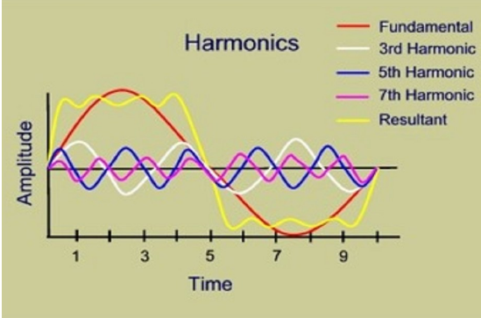
Figure 12 - Harmonics Graph
[5]

3.2 Harmonic Noise

When using non-linear loads such as Variable frequency drives unwanted frequencies are created. These frequencies which are much higher than the 50Hz supply will potentially be turned into heat due to them not being consumed by the appliance or the machine.
There are a variety of different technologies which have the ability to reduce these effects. Some examples of these are:
- Install higher rating transformers
- Smaller impedance in supply transformer
- More pulses in the rectifier
- Larger short circuit capacity of supply
- Connect filters into the circuit
- Drives with bigger DC inductors
Also another way is by rectifying the incoming mains using Diodes, Silicon controlled rectifiers (SCRs) or Insulated gate bipolar transistors (IGBTs).

3.3 Proteus Simulations

The circuit in figure 12 is constructed using diodes.

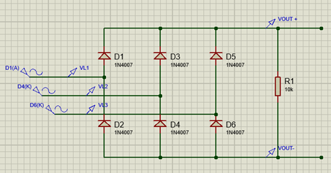
Figure 13 - Circuit 1 (Diode)
Analogue probes were placed on the incoming supply and on the output this data was used to make the graph in figure 13. Also in figure 14 demonstrate

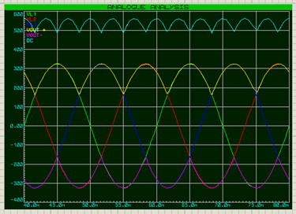
Figure 14 - Analogue Analysis of Circuit

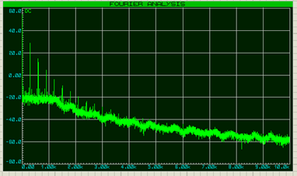
Figure 15 - Fourier Analysis

As an improvement transformers were added with star-delta and star-star coniguration was constructed as shown in figure 15 & 16.

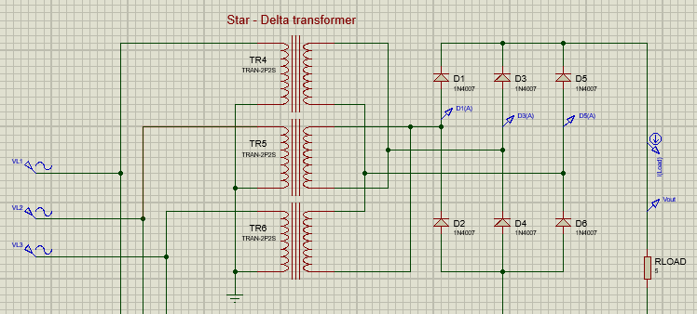
Figure 16 - Star Delta Configuration

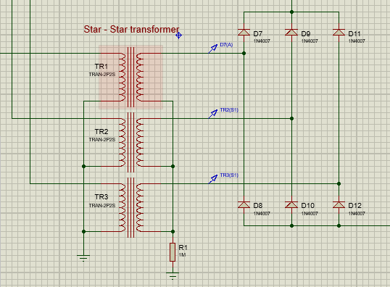
Figure 17 - Star Star Configuration

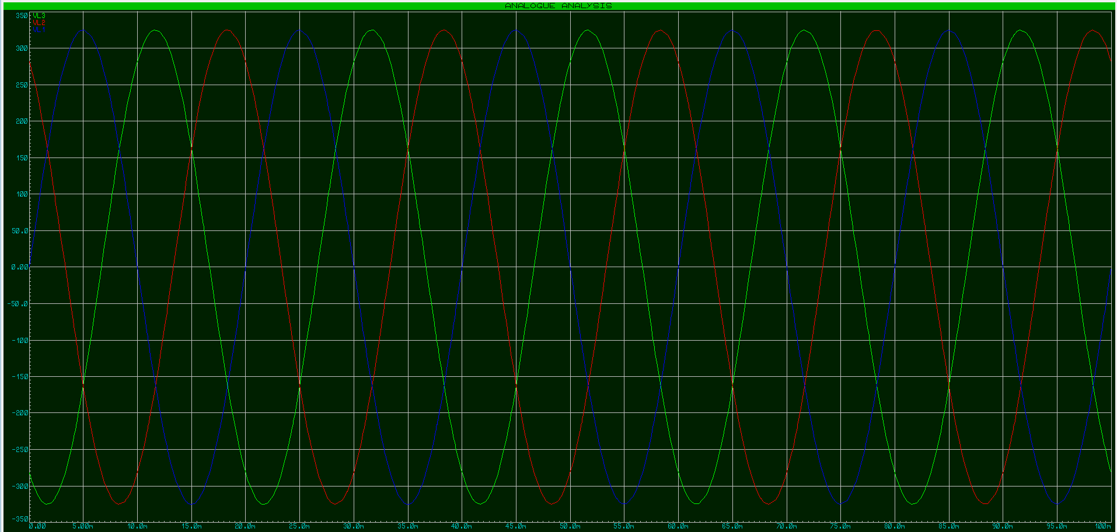
Figure 18 - Line Analysis Graph

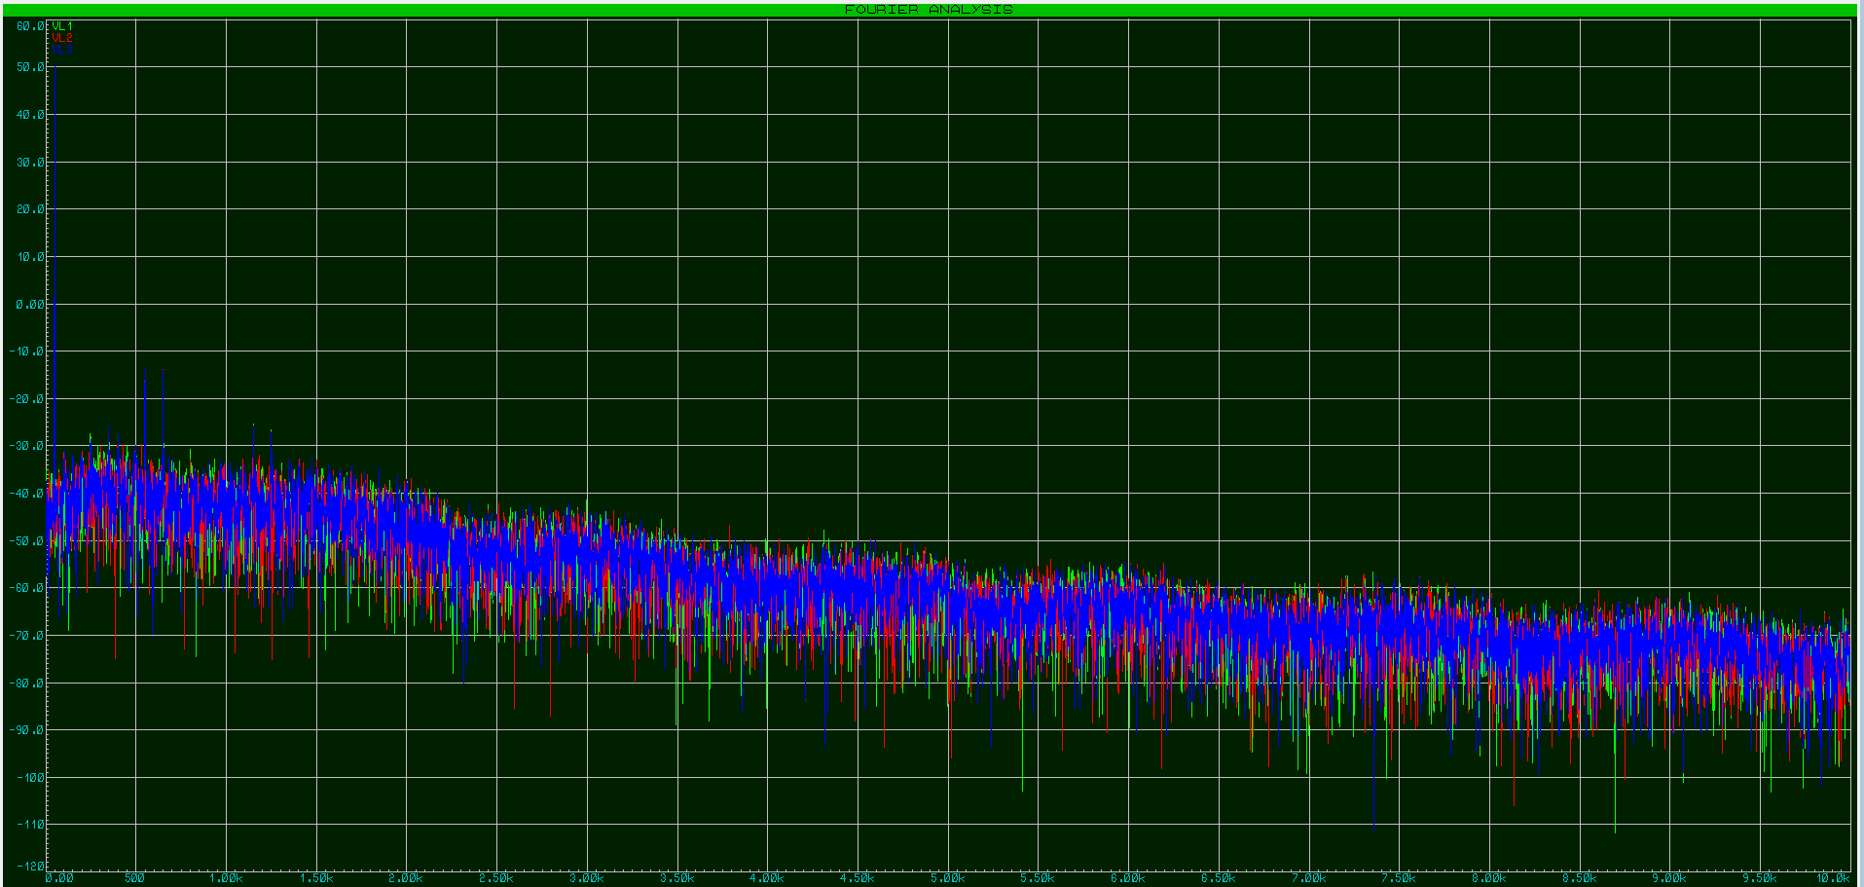
Figure 19 - Line Analysis Graph

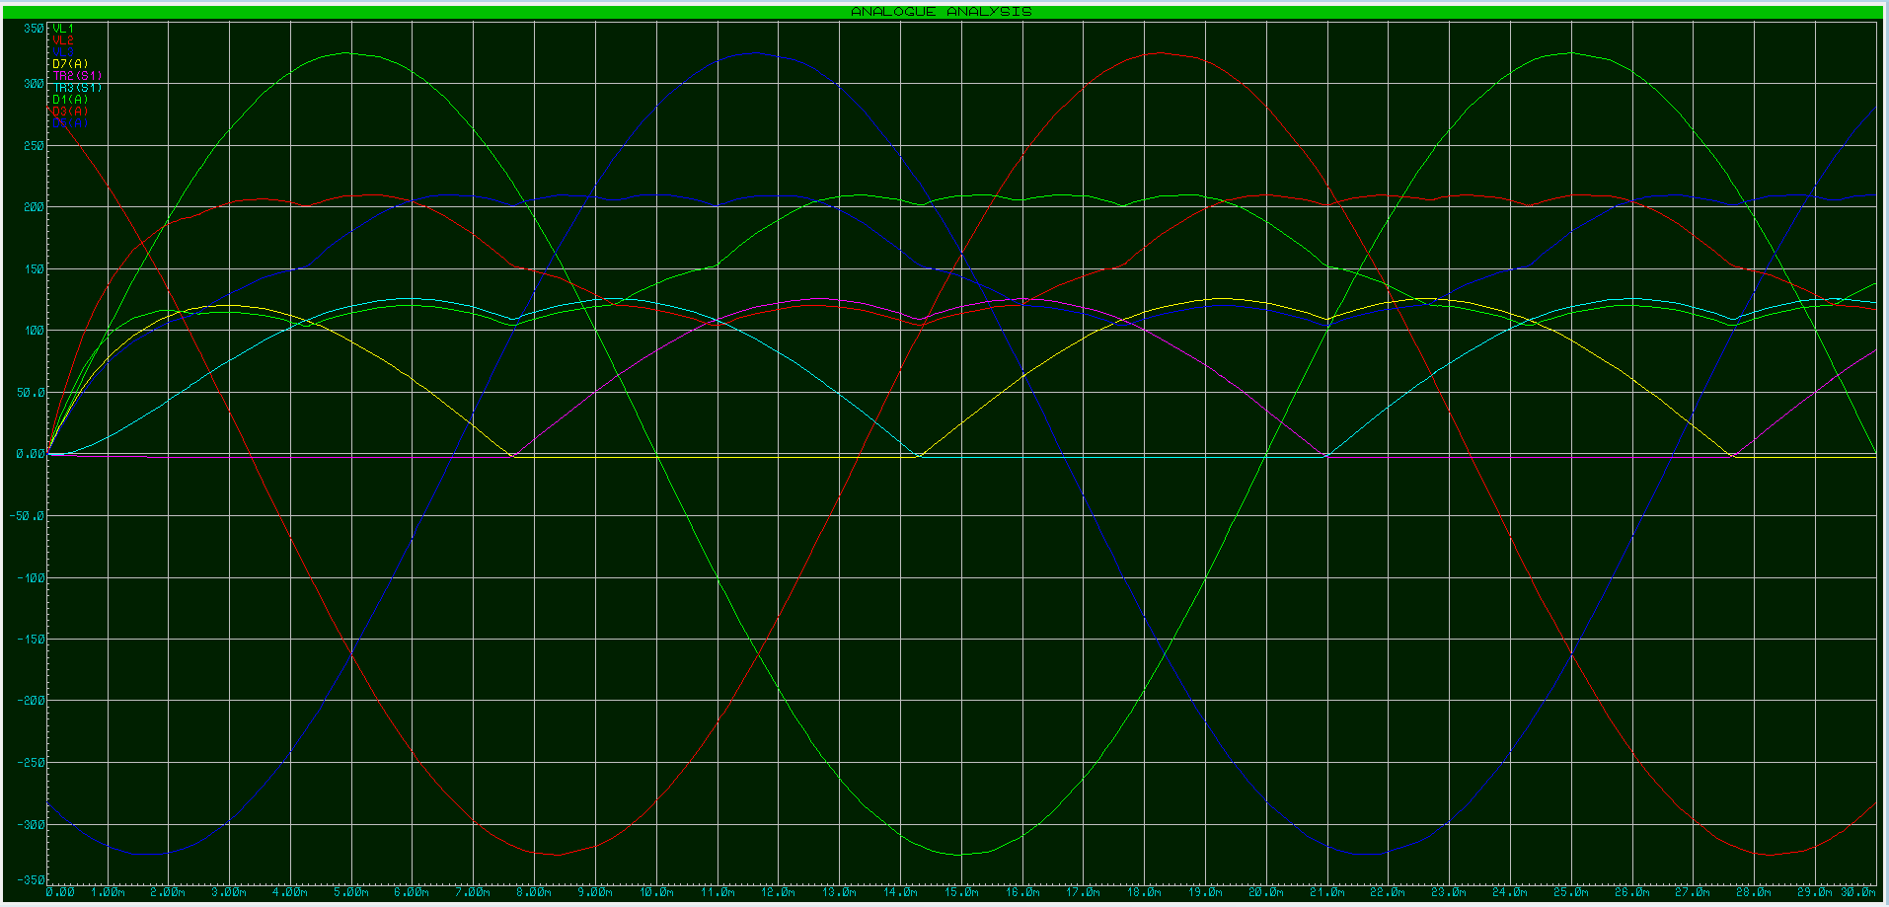
Figure 20 - Line Analysis Graph

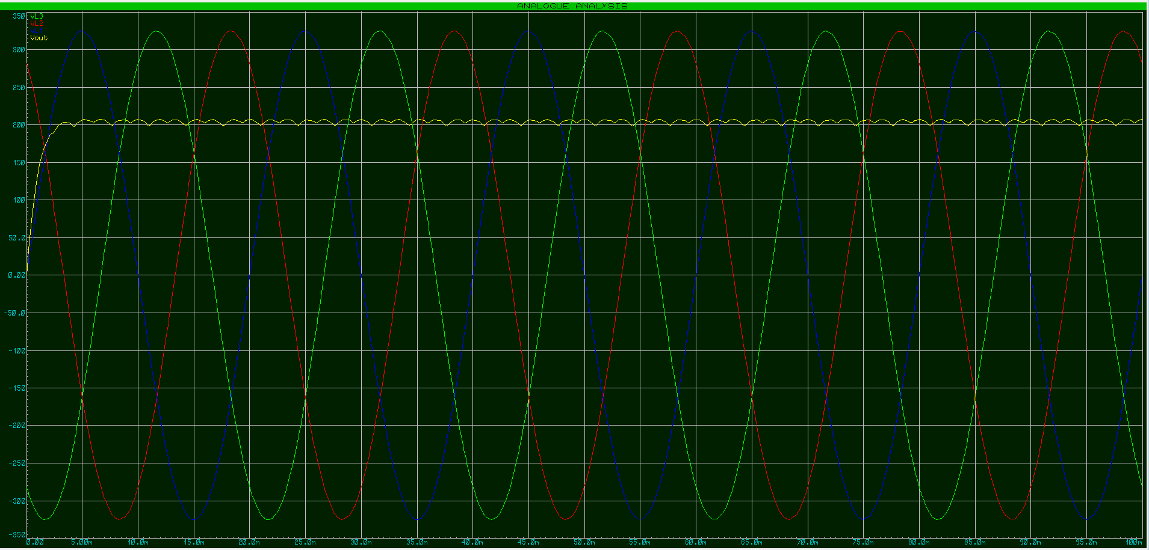
Figure 21 - Load Analysis Graph

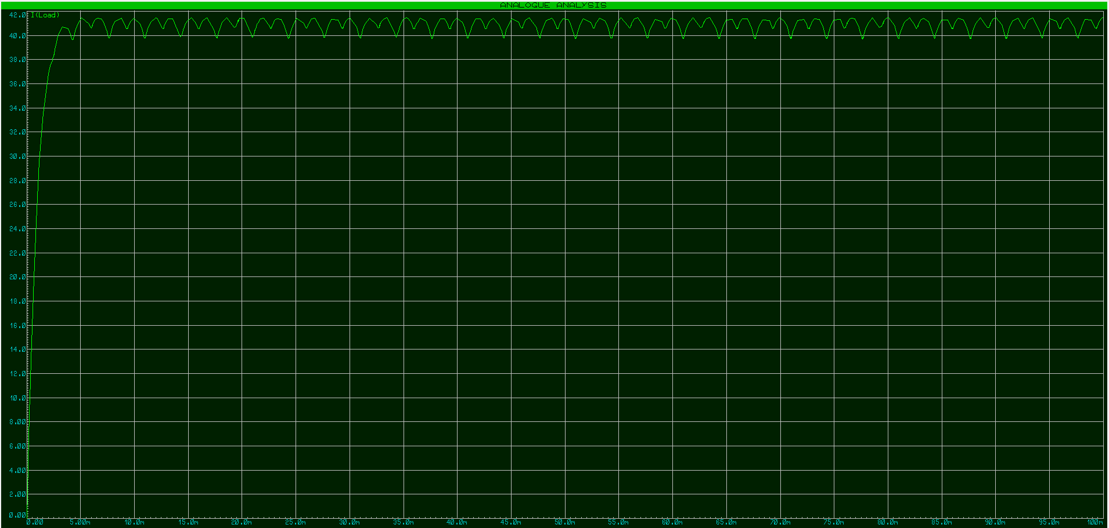
Figure 22 - Load Analysis Graph

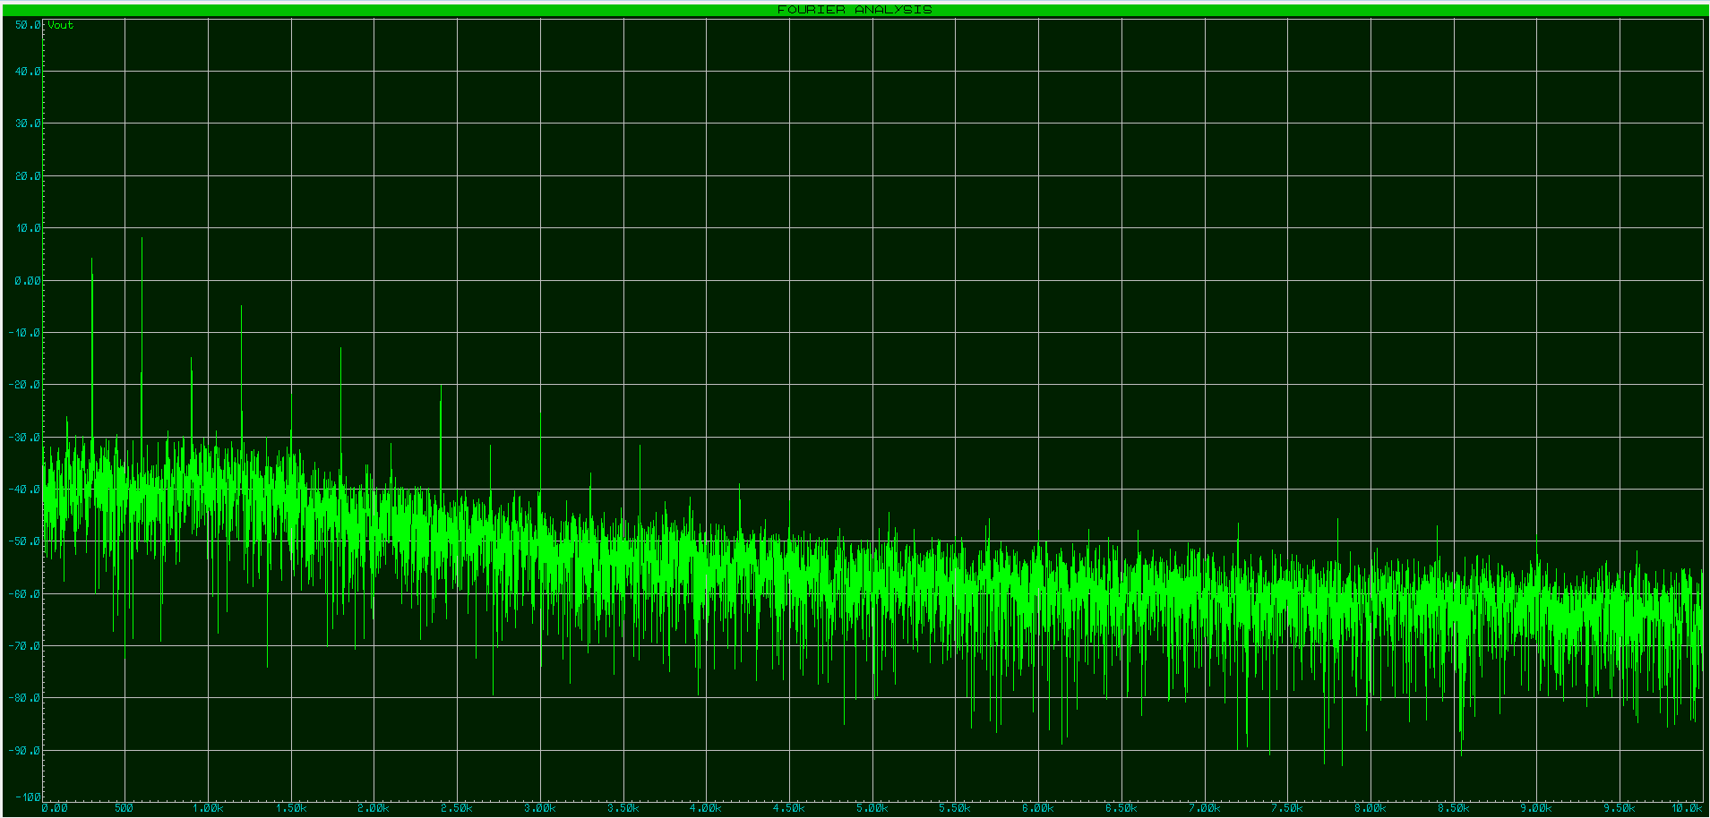
Figure 23 - Load Analysis Graph

The circuits were then constructed on Proteus using silicon controlled rectifiers (SCRs) and insulated gate bipolar transistors (IGBTs). Unfortunately there was an issue with these circuits and the graphs and data could not be gathered.

3.4 Conclusion

4.0 Datasheets

ABB ACS880 ACS880-107 Inverter modules (INU) - ACS880 multidrives (Industrial drives - unlimited possibilities for your business) | ABB
Schneider AT480 https://www.se.com/uk/en/product/download-pdf/ATS480D17Y
ABB PSR 12 https://docs.rs-online.com/63fb/0900766b8138b45b.pdf
RS Pro 1.1KW DOL Starter https://docs.rs-online.com/098a/0900766b81586117.pdf
Schneider ATV61Q https://www.se.com/ww/en/product/download-pdf/ATV61QC50N4
Schneider ATV900 https://www.se.com/ww/en/product/download-pdf/ATV950D15N4U
Vacon NXP0168 https://www.quantum-controls.co.uk/wp-content/uploads/product-sheets/variable-speed-drives/vacon/NXP/NXP-operating-guide.pdf
Allen Bradley Power Flex 750-Series PowerFlex 750-Series AC Drives Technical Data (rockwellautomation.com)
VYBO V810 Variable frequency drive 500kW 400V V810 VYBO Electric - VYBO Electric
Mitsubishi FR-A840 https://www.quantum-controls.co.uk/wp-content/uploads/product-sheets/variable-speed-drives/mitsubishi/A800/a800-catalog.pdf
Telemecanique ATS01N222LU https://www.se.com/ww/en/product/download-pdf/ATS01N222LU

5.0 References

[1] | danfoss, “danfoss.com/en/about-danfoss/our-businesses/drives/what-is-a-variable-frequency-drive/#:~:text=A%20variable%20frequency%20drive%20(VFD,during%20start%20or%20stop%2C%20respectively.,” 2021. [Online]. Available: https://www.danfoss.com/en/about-danfoss/our-businesses/drives/what-is-a-variable-frequency-drive/#:~:text=A%20variable%20frequency%20drive%20(VFD,during%20start%20or%20stop%2C%20respectively.. [Accessed 10 01 2022].
[2] | D. a. training, “dat.co.uk,” 2022. [Online]. Available: https://dat.co.uk/. [Accessed 05 01 2022].
[3] | ABB, “https://search.abb.com,” ABB, 2023. [Online]. Available: https://search.abb.com/library/Download.aspx?DocumentID=3AUA0000139403&LanguageCode=en&DocumentPartId=&Action=Launch. [Accessed 10 03 2023].
[4] | csemag, “www.csemag.com,” Consulting Specifying Engineer, 01 02 2009. [Online]. Available: https://www.csemag.com/articles/harmonics-vfds-prevention-analysis-resolution/. [Accessed 20 03 2023].
[5] | https://www.techelectro.in/harmonic-analysis/, “https://www.techelectro.in/harmonic-analysis/,” Tech Electro, 2023. [Online]. Available: https://www.techelectro.in/harmonic-analysis/. [Accessed 20 03 2023].
[6] | Eaton, “www.eaton.com,” Eaton, 2023. [Online]. Available: https://www.eaton.com/ca/en-gb/products/controls-drives-automation-sensors/variable-frequency-drives/how-to-select-a-variable-frequency-drive.html. [Accessed 25 03 2023].

