Michael Cunniffe (P148021)
Mcunniffe.148021@student.ac.uk

Alternative Powertrain technology
Series Hybrid Vehicle Part (b)



Series Hybrid Motor applied to the Beast Zetec Track Buggy

Student name: Michael Cunniffe (P148021)

Programme: BSc Motorsport

Module: Alternative Powertrain Technology

Lecturer: Mark Sandford

Internal verifier: Andrew Gibson

Table of Contents
1) Introduction 3
2) Research 4
2.1 Series Hybrid Technology 4
2.3 Series Hybrid: Advantages and Disadvantages 4
Advantages 4
Disadvantages 5
3) Series Hybrid Calculations for each part 6
Final Drive Ratio 6
Motor 7
Motor Controller 7
Generator 8
Energy Storage Device and Power Management 8
Conclusion 9
References 10

Introduction
In part (b) of the assignment we are to now select an adequate series hybrid conversion for our current ICE off road buggy and we are to update our duty cycle to get suitable components for the series hybrid version of the buggy. We are to select an electric motor for our combustion engine with sufficient power to provide average power at the wheels. The components included in the new powertrain of our buggy that are compulsory for it to function are A) Generator, B) Energy Storage Device and Power Management, C) Motor and Controller, D) Electric Motor and E) Final Drive Solution.

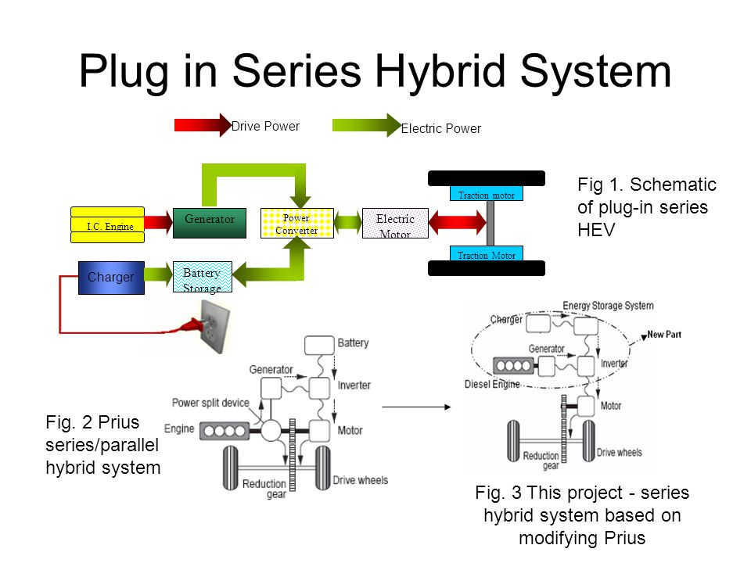
Figure 1: Photo, Plug in Series Hybrid System, online presentation By (S. Pragalathan, 2013)

Research

2.1 Series Hybrid Technology
A Hybrid electric Vehicle (HEV) is a complex system consists of many components. The necessary propulsion energy is generated and converted throughout the parts in the powertrain system. There are a vast range of configurations but the setup chosen for our Beast buggy is a series hybrid configuration.
The series hybrid has the simplest topology, it uses two power sources but only one of them sources is directly linked to the drivetrain which in this case is the electric motor. The series hybrid has an ICE but only the electric motor drives the vehicle so essentially the ICE acts like a generator to charge the battery. The idea of have the ICE as a generator is essential as excess power generated is then stored in the battery pack separately and the ICE can operate in the maximum efficiency range mostly (Singh, 2019). An example of this system being used in the industry can be seen in the BMW i3 PHEV, as an option a small 25Kw engine can be used to supply charge throughout the system or it can be a plug in electric vehicle. The series hybrid like this design of the BMW i3 have different electrical requirements than a conventional ICE. Like for example ‘’the electrical storage system have different cycles where they are derived as: shallow life cycle, high dynamic charge acceptance particularly for regenerative braking and robust service life in sustained partial state of charge’’ (Badin F Scordia J, 2006).

2.3 Series Hybrid: Advantages and Disadvantages

Advantages
The engine is not coupled to the wheels: The great thing about this is that, engines have small efficient power ranges of where they operate in the most efficient manner. So if you don’t have your engine coupled to your drivetrain, it dosnt have to operate through a large rev range and the engine can be kept running at the most efficient point and charge the battery pack.
Simple drivetrain: Compared to parallel hybrids where the transmission is a very complicated setup as the engine and motors are linked to the drivetrain.
Promotes Downsizing: ‘’Because the series hybrid isn’t connected to the drivetrain, it allows the ICE to run at optimal speeds resulting in more efficient smaller engines due to the demands of acceleration being provided by stored power’’ (Ehsani, 2004).
Motors are more efficient than an ICE: As stated by (Hannifin, 2014) the series hybrid system ‘’can achieve better fuel efficiency and a greater reduction in emissions’’ than an a parallel because a parallel design requires a larger engine with a ‘’transmission mechanism to allow both motors to be coupled to the drivetrain’’. Whereas a series hybrid setup can only need a small engine to be used as a generator to supply charge to the next component.
Can run purely as an electric vehicle: Therefore the engine can be shut off and eliminate the system of the engine, generator and charger working and the vehicle can just be ran the battery pack, controllers and motors. Once the battery gets low the engine can be turned back on again.
Energy Saving: Energy can be saved in a series hybrid design that uses a traction motor to provide braking torque at the wheels. Energy is saved by using the vehicles momentum to slow the vehicle by using the traction motors.

Disadvantages
All the power must come from the motors at the wheels: So you don’t have the option of using the ICE for more power when you need it.
Energy conversions meaning (efficiency) loss: So the engine, generator, charger, controllers and motors have certain efficiency therefore everytime energy is transferred from one component to the next, voltage transferred is less and less as it reaches the wheels to rotate. In actual fact current series hybrids do a very good job at this but with a parallel, the engine can directly put power to the wheels.
Weight Addition: All the components of a series hybrid add weight so the vehicle much heavier than current ICE vehicles.
Expensive: ‘’Series hybrids are more expensive than parallels because energy is converted twice between the ICE and the drive wheels’’ (Singh, 2019).

Series Hybrid Calculations for each part
The basics of how the series hybrid systems works with each component numbered is as follows: 1)The fuel from the fuel tank is sent to the ICE. 2) The ICE uses that fuel to power itself and power a Generator. 3) That Generator then sends a charge to a Charger or Inverter. 4) The Inverter charges the Battery Pack. 5) The Battery Pack takes that energy that was generated by the ICE and sends it to the Controller. 6) The Controller controls the voltage sent to the Motor. 7) The Motor will send then rotate the vehcles wheels. Then with the scenario where your regenerating frictional and heat energy through regenerative braking, then your motors will send that power back to the controllers an then to the battery pack to charge it.

Final Drive Ratio
Final drives in a conventional vehicle is normally worked out by the amount of teeth on the crownwheel gear and the pinion in the differential housing of the gearbox. They are simply the ‘’final drive of a drivetrain and the ratio has the greatest impact on speed for a given gear ratio’’ (Badin F Scordia J, 2006). In a front mounted engine, fwd design they are seen in a laterally mounted setup or with a rwd in a longitudinally mounted way with the diff housed in the centre of the back axle. But for our buggy we are using a simple two gear drive being done by a belt or chain, this is because our buggy is a laterally mounted rwd setup like a Tony Kart 125 (Tony Kart, 2020). In order to work out the motor and battery needed for the series hybrid conversion you must first find the buggies final drive ratio and this is done as follows:

Rolling Radius of the vehicle = 0.35m
Rolling circumference = 0.3 x 2 x Pi = 2.1m

Revolutions per minute of the rear wheels at the minimum velocity:
8 / 2.1 = 3.8 rev/sec
3.8 x 60 = 228.57 rev/sec

The above calculation of 228.58 rev/sec describes the rear wheels turning at a maximum rate of that when the motor is turning @2000rpm because that is the most efficient speed to run our chosen Emrax 288 motor below (Emrax, 2020).

Final Drive Ratio : 2000 / 228.57 = 8.7: 1
From here the losses of the belt can be calculated. (Borgwarner.com, 2017) states that belt drives have an efficiency of 95% when new therefore if the wheels are turning at 228.57rpm at 23kw and losing 5% efficiency:
23 x 0.05 = 1.15kw
23-1.15 = 21.85kw at the motor (Borgwarner.com, 2017).

Motor
The motor chosen for our Beast buggy is the emrax 228 model, this was chosen because of its robust and reliablilty as this motor is used in formula E and is a proven technology in the real world. The Emrax 288 was also chosen because of its continuous power level of 62Kw and continuous torque of 120nm. The problem faced when selecting this component is it weight because it weighs 12.4kg which is a lot in terms of our buggy and it isn’t very compact for our buggy but it was the only motor proven on the market that gives a 109Kw @6500rpm. Our vehicle currently uses a maximum of 82Kw for a second of its duty cycle but does use 50-72Kw also in its duty cycle for short periods of time. At maximum output the motor is powered by a 660 volt DC supply at 6500rpm by (Emrax, 2020). The buggy runs at 23.53kw average power but with drive losses it brings the power to 21.68Kw which is alot below the continuous power level of 62Kw but the buggy does run up to 82Kw for a second which is why the motor had to be 109Kw at max output. Therfore the motor is essential to be be that big for short bursts throughout the lap.

Looking at the figure above it shows that the motor is capable of a continuous power of 30kw which is much more than the buggy needs therefore it is capable of doing the work for the track and event. As stated by (Emrax, 2020)., the efficiency of the specific motor is 92%, taking another 8% out of the 21.85 kw (Emrax, 2020).

21.68 x 0.08 = 1.744Kw Lost through the motor
21.68 – 1.744 = 19.94Kw

Motor Controller
The motor Controller that is chosen for our buggy is the motor is a Sevcon Gen4 S10 controller due to its capabilities of 8 digital inputs and 2 analogue inputs along with plenty of more benefits. The controller is also able to fit into small tight spaces enabling it to be better protected from the weather. ‘’It has controlabilty at 48 Volts and has a multiple motor feedback options allowing the user to get the best reliablility ou of the vehicle’’ (motorsports, 2016)
According to (Taylor, 2015) the motor controller has an efficiency of 95% allowing the power to be reduced again before reaching the ICE (Taylor, 2015)

19.94 x 0.05 = 1.0 Kw loss of power
19.94 – 1 = 18.94 Kw

Generator
The generator that will be fitted into the buggy is a Bosch Gen3 generator that has been used within the production cars since 2016. It is 20% lighter than previous models and has an efficiency of 95% when regenerating mechanical power into electrical power. (Bosch, 2020)
18.94 x 0.05 = 0.95 Kw loss of power
18.94 – 0.95 = 17.99 Kw

Energy Storage Device and Power Management
Since the motor requires 660 volts DC current when running at maximum of 6500rpm, even through the motor will never be in this range ‘’because the power supply will still need to be up to specification of the motor company’’ (Emrax, 2020). Because of this the battery pack that wil be used is the ‘’MEM-975’’. ‘’This Battery pack has a battery bank that can produce up to 750 volts which is beyond the required amount of our motor when running at maximum output. Because of this high voltage and current the battery pack must be contained in a composite shell that rquires ventilation for cooling it. With this kind of voltage potential in our buggy it is lethal but is the a sufficient pack to contain the created charge. It consists of two 24volt deep cycle batteries and they are charged with a 27 amp battery charger’’ (Huzji, 2019). It should be noted that an external power source has to on nearby at the circuit as it must be connected to a 50Kva transformer, which powers the two 20Kw battery chargers that charge the lithium-ion battery pack . (Shen, 2015) This adds a lot of weight to our vehicle now and cost would skyrocket compared to the ICE buggy. The efficiency of the energy storage device is and powermanagement unit is 95%.

17.99 x 0.05 = 0.99Kw loss of power
17.99 – 0.99 = 17Kw Actual output at the Rear wheels.

Conclusion
For short bursts of power it is essential for the motor to be slightly overpowered and oversized so that multiple laps can be completed as this is a buggy designed for fun days out and corporate events. The speeds that the vehicle can achieve are very fast and it should be noted that a racing driver instructor should teach the competitors how to drive the track and use the buggy it would be too dangerous to let untrained drivers to tackle the circuit. It would be advised to let compoetitors to complete 2 laps before having to come back in as the tracks length is 1860m. Aside from the cell technologies, attention to the integration of the battery pack in our buggy would become a problem as it is so heavy and lethal with its high voltages contained, maybe in the forseable future when potential battery pack suppliers develop a safer systems that would be adequate for racing. The battery pack itself was taken from a large construction excavator as the voltage of the motor at maximum output is 660 volts and there wasn’t many batter pack options for this level of output. Since the average power used from our duty cycle was calculated as 23Kw and 17Kw through the powertrain, Then this gives the manufacturers to downsize there 120kw ford zetec engine because the engine only needs to supply average power at the wheels as it only acts as a generator to power the system.

References
Badin F Scordia J Trigui R et el Hybrid electric vehicles energy consumption decrease according to drivtrain architecture, energy management and vehicle use. [Conference] // IET Hybrid Vehicle Conference 2006. - Coventry : [s.n.], 2006.
Borgwarner.com www.Borgwarner.com [Online] // www.Borgwarner.com. - BorgWarner, 18th September 2017. - https://www.borgwarner.com/docs/default-source/investors/investor-events-presentations/investor-day-presentation---final.pdf?sfvrsn=228a883c_8.
Bosch Robert www.Bosch.com [Online] // www.Bosch.com. - Bosch automation, 2020. - https://www.bosch-ebike.com/en/products/active-line-plus/.
Emrax www.Emrax.com [Online] // www.Emrax.com. - Emrax, 5th March 2020. - https://emrax.com/e-motors/emrax-228/#1482059435741-232ed37a-accc.
Huzji Robert Modern Diesel Technology : Heavy equipment systems [Book]. - Dallas : ASE NATEF, 2019. - Vol. Third edition.
motorsports electric www.electricmotorsports.com [Online] // www.electricmotorsports.com. - Electic Motorsports, 2016. - https://www.electricmotorsport.com/ev-parts.
Shen Junyi An energy management strategy for an EV with two propulsion machines and a hybrid energy storage [Conference] // IEEE. - Dearborn : IEEE, 2015.
Taylor David G. Systematic approach to the modelling and control of hybrid electric powertrains [Journal]. - Dallas : IECON 2014 - 40TH Annual Conference of the IEEE Industrial Electronics Society, 2015.

