BA International Hotel Management
Management and Organisational Behaviour
Module code: BMIH5004
Student name: Mohammed Bilal Rehman
Student ID: 2013508

Table of Contents
Introduction 1
Organisational Overview 1
Organisational Structure 1
Organisational Culture 3
Organisational Goal 3
Recent Change Initiatives 4
Recent changes and the impacts 4
How the changes were managed 5
Strategic Direction and Current Business Performance of The Organisation 6
Conclusion 7
References 8

Introduction
Organisational behavior refers to the study of human behavior in the infrastructure of the organization settings (Mullins, 2020). The interaction of people in an organization along with the critical part of human resources defines organizational behavior. In order to generate a positive work environment, management, and organizational behavior are the most important and inseparable parts of an organization (Mullins, 2016). The report will be conducted on IHG Hotels & Resorts by demonstrating its organizational overview, the essential nature of its managerial work, and the behavioral approach to management in order to understand the nature of behavior within organisations.

Organisational Overview

Organisational Structure
A system that outlines the activities of the organisations which are directed within the organisations in order to achieve the goals of a company is known as organizational structure (Bloisi, et al., 2007). There are different types of organisational structures such as Functional structure, Divisional structure, Matrix structure, Team structure, Network structure, Hierarchical structure, and Flat organization structure (Huczynski, and Buchanan, 2013).
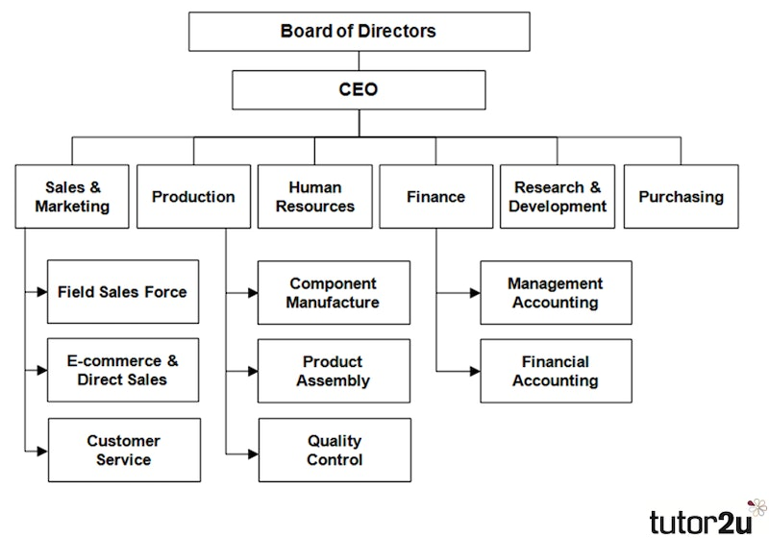
Figure 1: Functional Organisational Structure.
Source: (Cochran and Kleiner, 2018).
IHG Hotels & Resorts follows a functional organisational structure due to having a group of the company and here different groups of employees are employees into different departments which is based on areas of expertise. Elie Maalouf is the CEO of the company and Wayne Hoare is the executive committee. It has around 19 brands of hotels which are Candlewood Suites®, Six Senses Hotels Resort Spas, InterContinental® Hotels & Resorts, Vignette™ Collection, and many more (ihg.com, 2022). As a result, there are different managers as well as teams divided into different sectors of those hotels. Such as senior managers, human resources, finance, research, and marketing departments of different hotels according to the functions (Bloisi, et al., 2007). In those departments, there are different types of groups of employees based on their qualifications, workability, skills, or expertise which defines the structure of function. On the other hand, the company has poor communication a coordination due to maintaining functional structure (Huczynski, and Buchanan, 2013). As a result, there is a lack of understanding across the departments as well as different hotels.

Organisational Culture
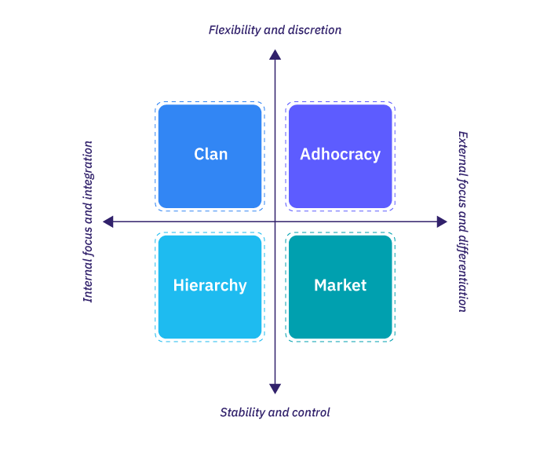
Figure 2: Organisational Culture.
Source: (Holyoak, 2022).
According to Boddy (2014), organizational culture defines the beliefs, values, and behavior of employees, and categories of goods or services. Therefore, it affects how people experience an organization. IHG Hotels & Resorts belong to the clan culture where the culture of the organization fosters a collaborative environment by valuing participation, commitment, and allegiance. Because there are more than 500 hotels and resorts in around 100 countries, they work collaboratively in order to accomplish the goal (ihg.com, 2022). Different hotels belong to different leader which is controlled by one CEO. There is strong teamwork in the organization along with higher job satisfaction. In different organizations, there are different types of groups of employees according to different job roles work to achieve the goal of the company collaboratively. As a result, IHG Hotels & Resorts has been recognized as a clan that has around 6,000 resorts and hotels (Holyoak, 2022).

Organisational Goal
IHG Hotels & Resorts is highly conscious of its reputation and goal. It not only focuses on gaining revenue but is also aware of its market value. According to the sources, the net of IHG Hotels & Resorts during 2022 was around £376 million and it is expected to increase in the following years as well (ihg.com, 2022).
Improved market share: In order to increase the share of markets, the organization needs to focus on its service, supply chain, appearance in the market, and the capabilities of employees. The service of each hotel needs to be innovative in order to grab the attention of the stakeholders (Cochran and Kleiner, 2018). In addition, the organization should build customer loyalty, employ a skilled workforce, and improve positive advertisement to gain market shares.
Increased number of hotels and resorts: There are more than 600 hotels and resorts of IHG Hotels & Resorts. The company is expecting to include more hotels and resorts. For this, the organization needs to gain its shareholders as well as economic sources to operate a higher number of hotels and resorts within 8 months (Mullins, and Dosser, 2013).
Becoming one of the most trending hotel groups: In order to gran the trend of this era, the organization needs to improve its digital marketing strategies. In this context, the organization can advertise according to the demand of the consumers along with providing satisfactory services and numerous occasional offers to become on-trend (Robbins et al., 2008).

Recent Change Initiatives

Recent changes and the impacts
Contactless Transaction: Due to the Covid-19 pandemic, people are maintaining social distancing which resulted in a rising contactless transaction system. For instance, Google Pay, Apple Pay, Blockonomics, PayPal, and so on (Afrianto, Sasmita, and Atin, 2021). In this context, IHG Hotels & Resorts allows PayPal, Google Pay, and card payment systems in order to operate the contactless transaction method successfully. However, it bothers some of the guests who do not have mobile banking. In this context, a few customers refused to check in.
Mobile App for Easy Access: In this busiest lifestyle, people prefer shortcuts of plan execution. On the other hand, in this technological era, the competition in the hotel industry has increased rapidly. In this context, IHG Hotels & Resorts launched its mobile app where people are able to evaluate the view, service along costs of each hotel and resort (Vishkaie, 2023). There are different types of mobile apps for different countries for pre-booking. It disappointed some of the regular clients due to most of the time remaining houseful for pre-booking facilities.
Influencer Marketing for Faster Reach: Since people have become addicted to social media as well as loving to imitate influencers or public figures, IHG Hotels & Resorts decided to promote via influencers. As a result, most of the influencers visit and promote different hotels and resorts via videography, live, and pictures according to their agreements with the company (Tiautrakul, 2019). It cost a large amount of money to collaborate which hampered other business operations of the organization.
Self-Check-In to Minimize Guests’ Waiting Time: IHG Hotels & Resorts has to remain competitive in the industry through modernization. In this context, the electronic kiosk is used by the guest which notifies the hotel staff. It helps to satisfy the customers by reducing unnecessary time on reception while check-in (Kokkinou and Cranage, 2019).
Free Medical Check-Up Facilities: One of the recent changes that IHG Hotels & Resorts implemented is including emergency and free medical check facilities. Due to the COVID-19 pandemic, people, as well as organizations, have to become more health-conscious (Briem, 2020). Guests do not need to worry anymore about staying for a long period.

How the changes were managed
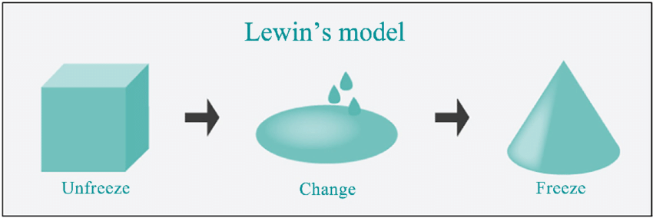
Figure 3: Lewin's Change Management Model.
Source: (Levasseur, 2018).
Stage 1: Unfreeze
In order to execute the changes in the organization effectively, IHG Hotels & Resorts arranged online meetings to communicate and exchange opinions with the board of directors as well as the senior managers of different hotels. It took a long period as IHG Hotels & Resorts belongs to a large corporation and the senior manager had to take the opinion of other employees in the hotels (Geller, 2020). Initially, the organizational message to the other hotels was to enhance the valuable terms and gain revenue. It highly encouraged the hotels as well as the resorts to appreciate the change. In this context, some of the resorts disagreed with the implementation of the change the company was able to manage by realizing the beneficial factors of the change (Levasseur, 2018). For instance, launching a mobile app will be able to make booking facilities easier for both guests and resorts.
Stage 2: Change
After moving forward with the support system of the hotels and resorts, IHG Hotels & Resorts implemented the change which took a while to cope with some of the employees. In this context, the company arranged a training system for the employees to know more and adopt new changes (Geller, 2020).
Stage 3: Refreeze
In order to sustain the changes, IHG Hotels & Resorts highly motivated the employees as well as recruiting a new team who are experts in IT sectors and hotel management. On the other hand, the company also hired digital marketing experts to improve and develop their marketing strategies continually which helps to gain more engagement by ensuring visibility and connecting with the stakeholders (Levasseur, 2018). As a result, a high number of guests helps to keep the employees motivated which is highly beneficial to maintain the sustainable development of the changes.

Strategic Direction and Current Business Performance of The Organisation
Diversification: According to Erasmus, Rudansky-Kloppers and Strydom (2019), diversification is the term of the Ansoff Matrix which defines to implementation of organizational growth strategies by grabbing the new markets with new goods or services. IHG Hotels & Resorts has implemented diversification strategies by generating new changes as well as services like launching the app, creating contactless transaction opportunities, and so on. Currently, IHG Hotels & Resorts has 500 hotels and resorts in around 100 countries which the company is extending gradually by including new services (ihg.com, 2022).
It will help the company to connect with new audiences in the new marketplace as well as gain revenue. On the other hand, it required a high amount of investment due to promotion, new recruitments, as well as interior design and operational change (Erich, 2019). In this context, there is a high risk of adopting a new service for the new society which might cause failure due to poor publicity. As a result, it can become a huge challenge for the organiusation to maintain.
Differentiation: In order to grab the competitive advantage, the organisation implements the approach of generating the services of the business distinct and unique from the competitors is known as the differentiation strategy (Butler, 2019). For example, free medical checkups for the guests of IHG Hotels & Resorts. This strategy is highly beneficial to attract numerous numbers of clients due to remaining busy in off sessions also.
A differentiation strategy will help to gain customer loyalty by providing services beyond providing rooms and so on (Mullins, 2020). On the other hand, a differentiation strategy increases the cost and it has been estimated that more than 20% of organisations are unable to afford a differentiation strategy which results in huge financial losses and generates a negative brand image (Vassileva, 2021). Because there are different types of demand according to cultural variation and economic stability.

Conclusion
It is highly important for large corporations to grab the demand as well as the adaptability while moving ahead for organizational development. In this context, organisational structure, goal, and culture play a vital role in business development and position in the market industry. It also depends on how the services of organisations are given to the community. Therefore, organizational change and implementing new changes can benefit the organisation in connecting with new audiences. In this period, the changes need to be based on the demand of the audience as well as the trend of the current generation and the societal changes such as COVID-19. However, different types of business strategies such as diversification and differentiation might help to lift the organisation and gain satisfactory revenue.

References
Adair, J. (2009) The Inspirational Leader (2nd Ed), London: Kogan Page.
Afrianto, I., Sasmita, M.H.H. and Atin, S. (2021). contactless transaction system to support the covid-19 physical distancing program. Bulletin of Electrical Engineering and Informatics, 10(6), pp.3303–3312.
Armstrong, M. (2012) Armstrong’s Handbook of Management and Leadership (3rd Ed), London: Kogan Page.
Arnold, J. (2005) Work Psychology (4th edition) Harlow: Prentice Hall.
Bloisi, W. et al (2007) Management and Organisational Behaviour, (2nd edition) Maidenhead: McGraw-Hill.
Boddy, D. (2014) Management: An Introduction (6th Ed), Harlow, Pearson.
Briem, H. (2020). Changes due to the COVID-19. Læknablaðið, 2020(03), pp.119–119.
Buchanan, D. And Huczynski, A. (2007) Organisational Behaviour: An Introductory Text (6th edition), Harlow: Prentice Hall.
Butler, D. (2019). Business Development. Routledge.
Cochran, T. and Kleiner, B.H. (2018). Effective Organisational Goal Setting. Management Research News, 15(9), pp.13–17.
Erasmus, B., Rudansky-Kloppers, S. and Strydom, J. (2019). Introduction to business management. 11th ed. South Africa: Oxford University Press Southern Africa (Pty) Ltd.
Erich (2019). Business Strategy. Journal of Business Strategy, 28(1).
Geller, E.S. (2020). Organizational Behavior Management and Industrial/Organizational Psychology. Journal of Organizational Behavior Management, 22(2), pp.111–130.
Holyoak, L. (2022). Organisational Culture. Leadership & Organization Development Journal, 23(6), pp.354–355.
Huczynski, A. & Buchanan, D. (2013) Organisational Behaviour (8th Ed), Harlow: Pearson.
ihg.com (2022). IHG Hotels & Resorts - Book hotels online at over 5,500 hotels. [online] IHG. Available at: https://www.ihg.com.
Kokkinou, A. and Cranage, D.A. (2019). Using self-service technology to reduce customer waiting times. International Journal of Hospitality Management, 33(1), pp.435–445.
Levasseur, R.E. (2018). People Skills: Change Management Tools—Lewin’s Change Model. Interfaces, [online] 31(4), pp.71–73.
Mullins, L & Dosser, P. (2013) Hospitality Management and Organisational Behaviour (5th Ed) Harlow, Pearson.
Mullins, L (2020) Organisational Behaviour in the Workplace (12th edition) Harlow:Pearson.
Mullins, L. (2016) Management and Organisational Behaviour (11th edition) Harlow: Pearson.
Robbins, S. Et al (2008) Organizational Behaviour (5th edition) Harlow: Pearson Education Limited.
Rollinson, D. et al (2008) Organisational Behaviour and Analysis (4th edition) Harlow: Addison-Wesley Longman.
Tiautrakul, J. (2019). Influencer Marketing Trends. SSRN Electronic Journal, 3(3).
Vassileva, B. (2021). Organizational evolution and strategies. Journal of Organisational Transformation & Social Change, 3(2), pp.157–172.
Vishkaie, R. (2023). Digital Technology. International Journal of Digital Literacy and Digital Competence, 10(1), pp.43–54.

