European Tourism Field Studies

Social Media Posts

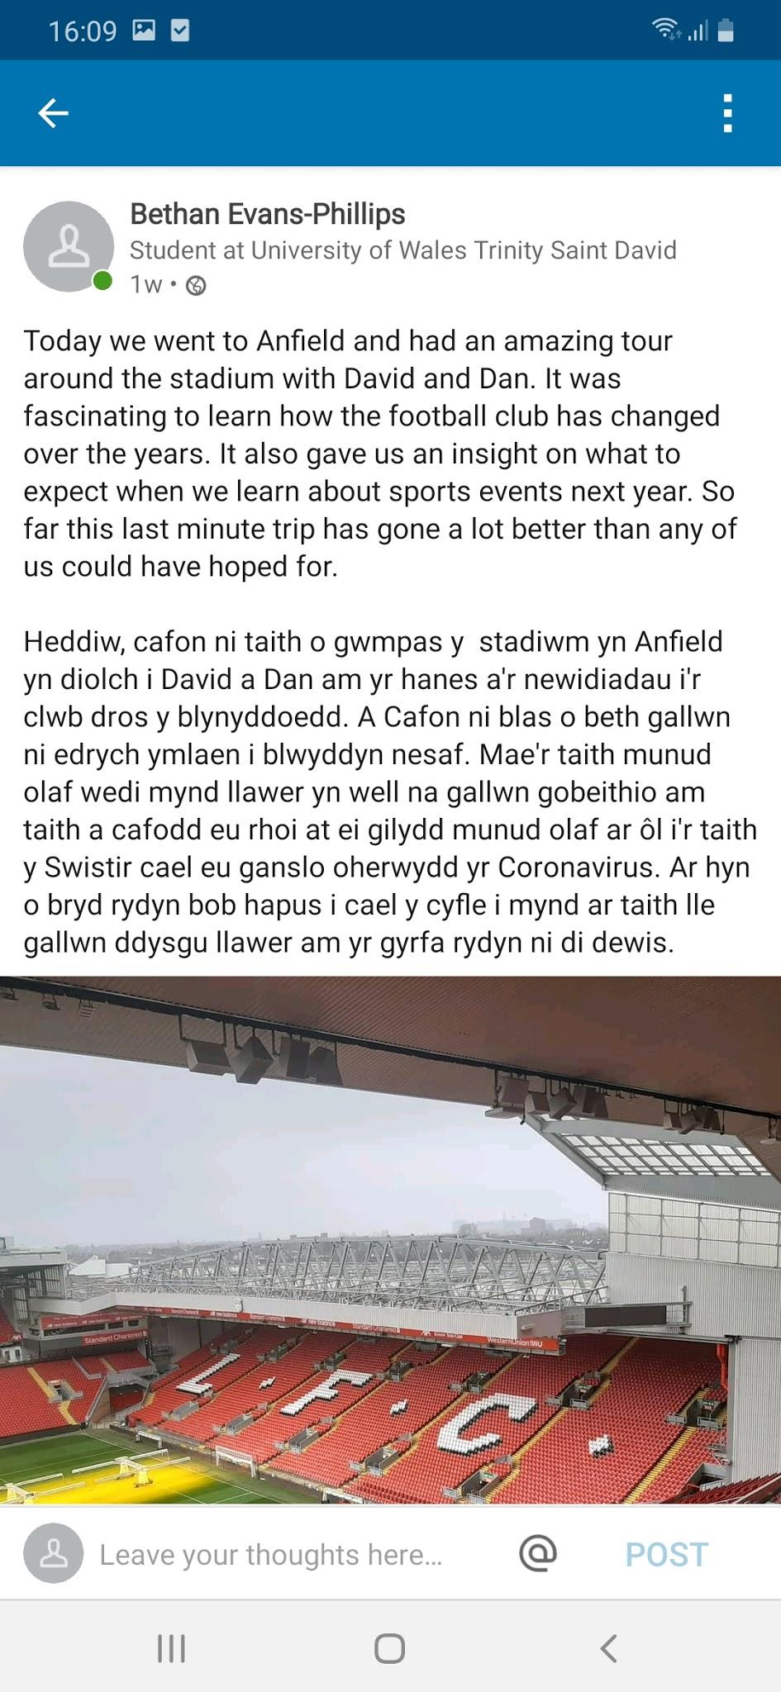
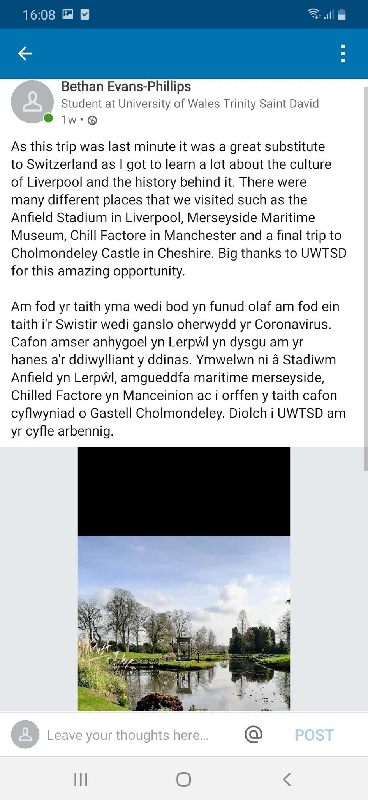
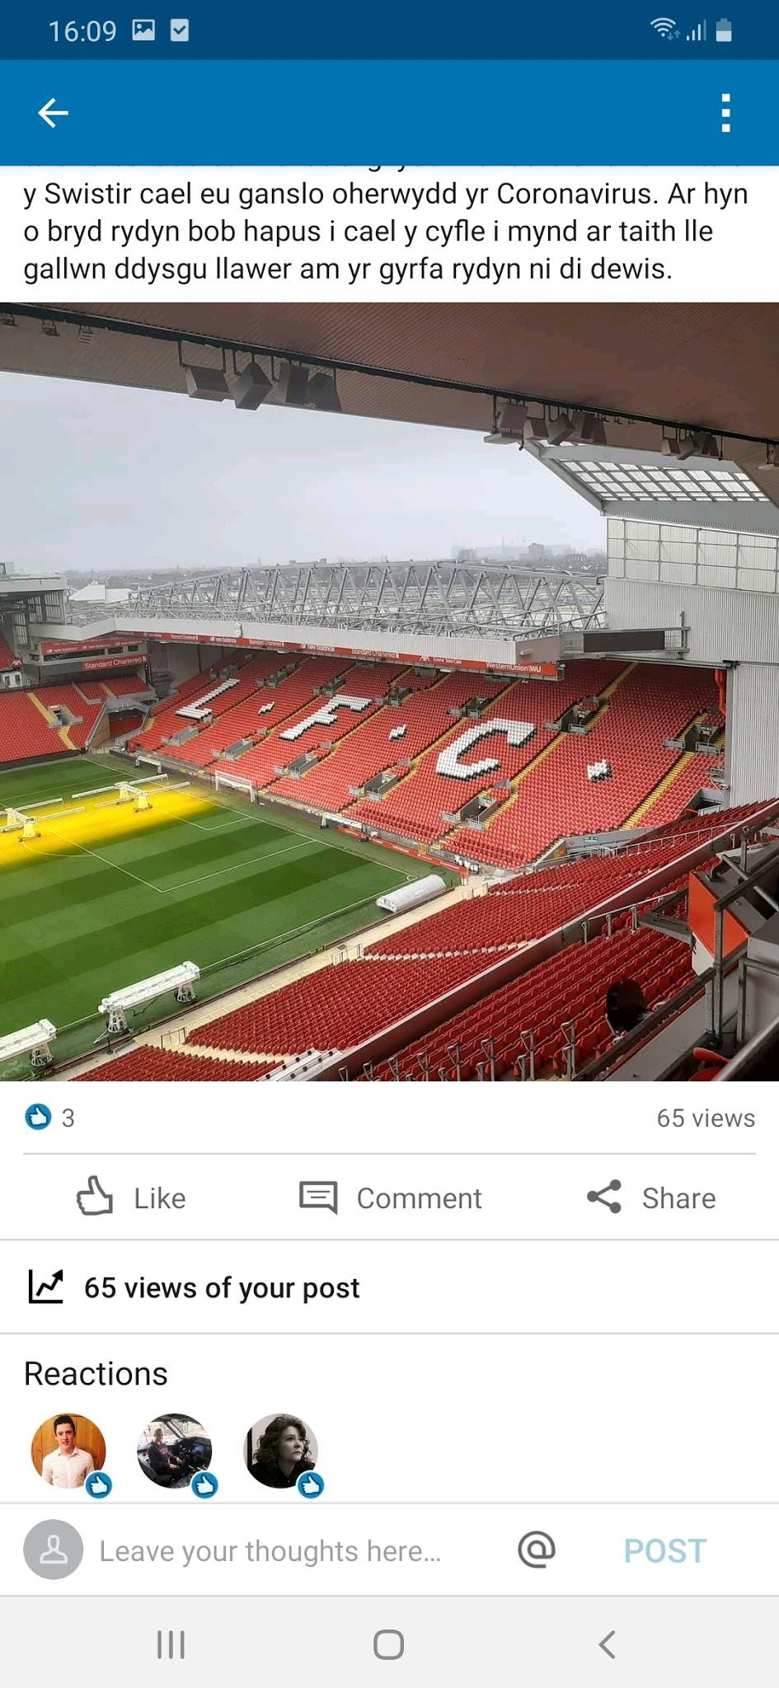
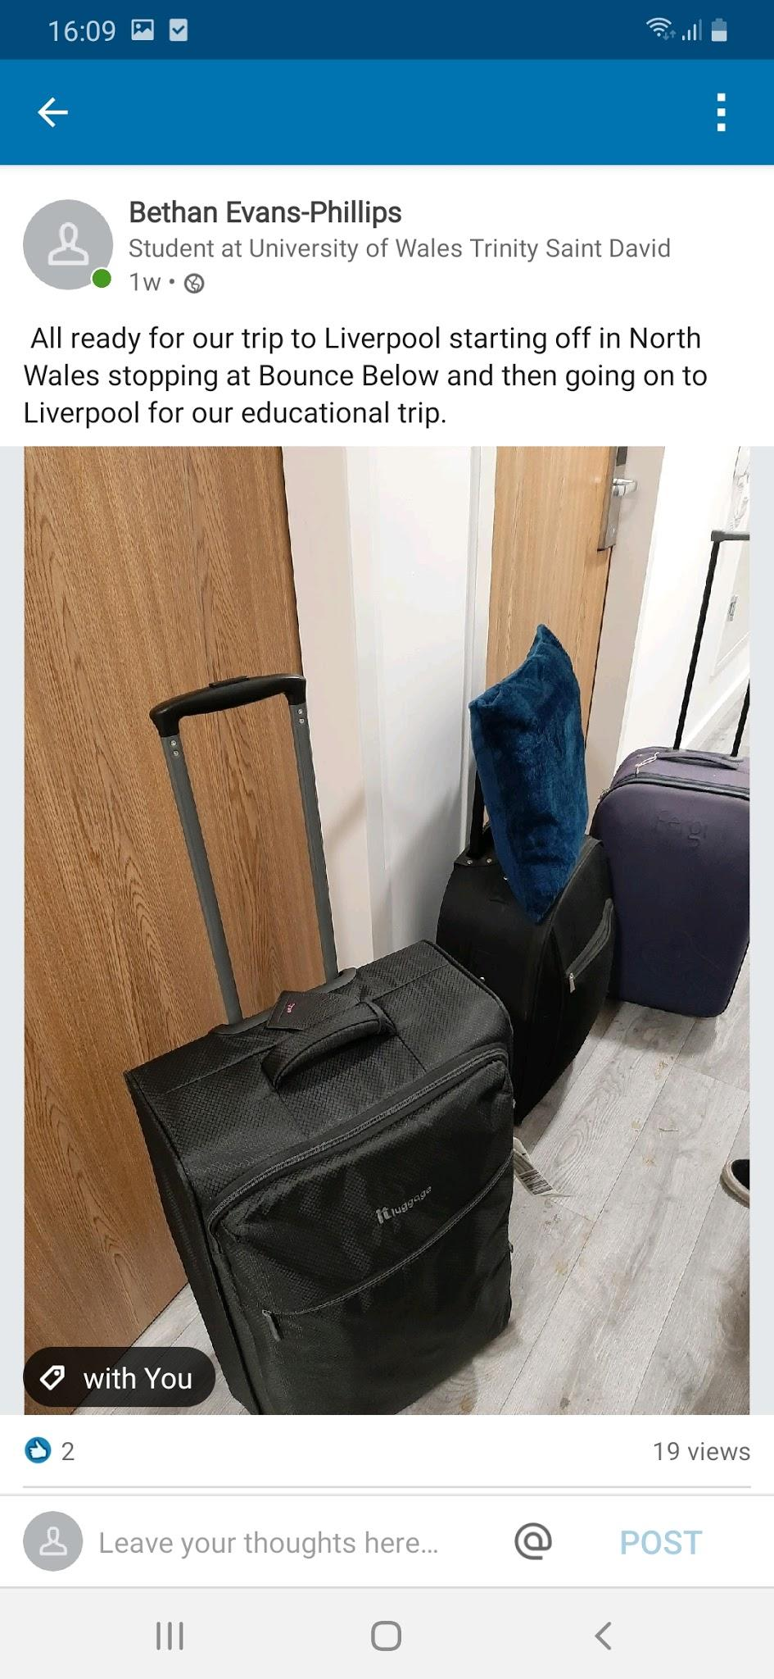

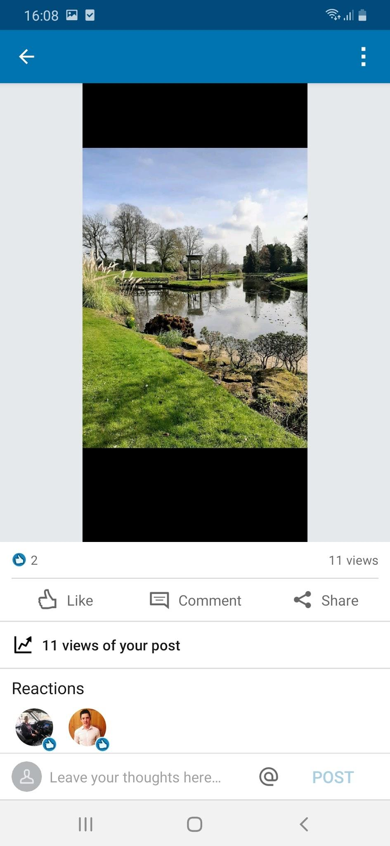
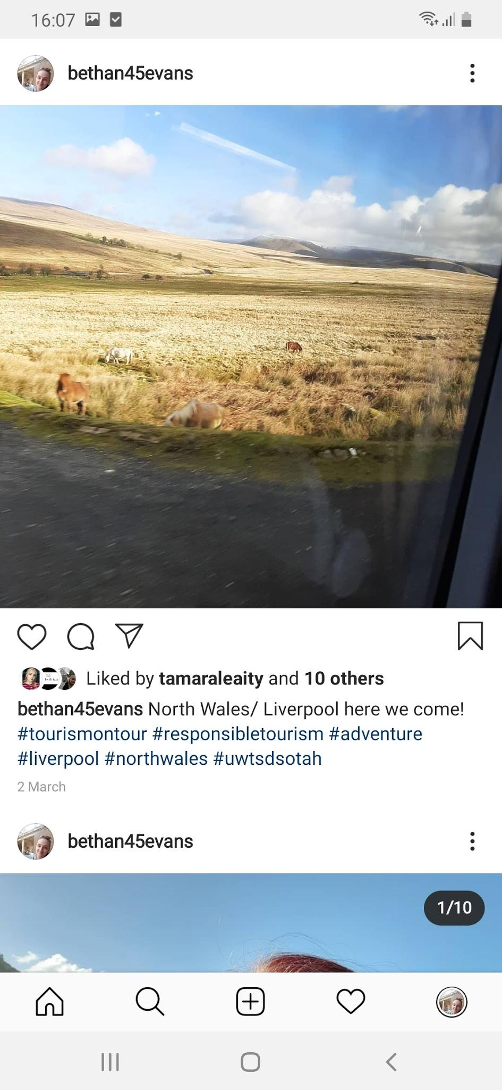

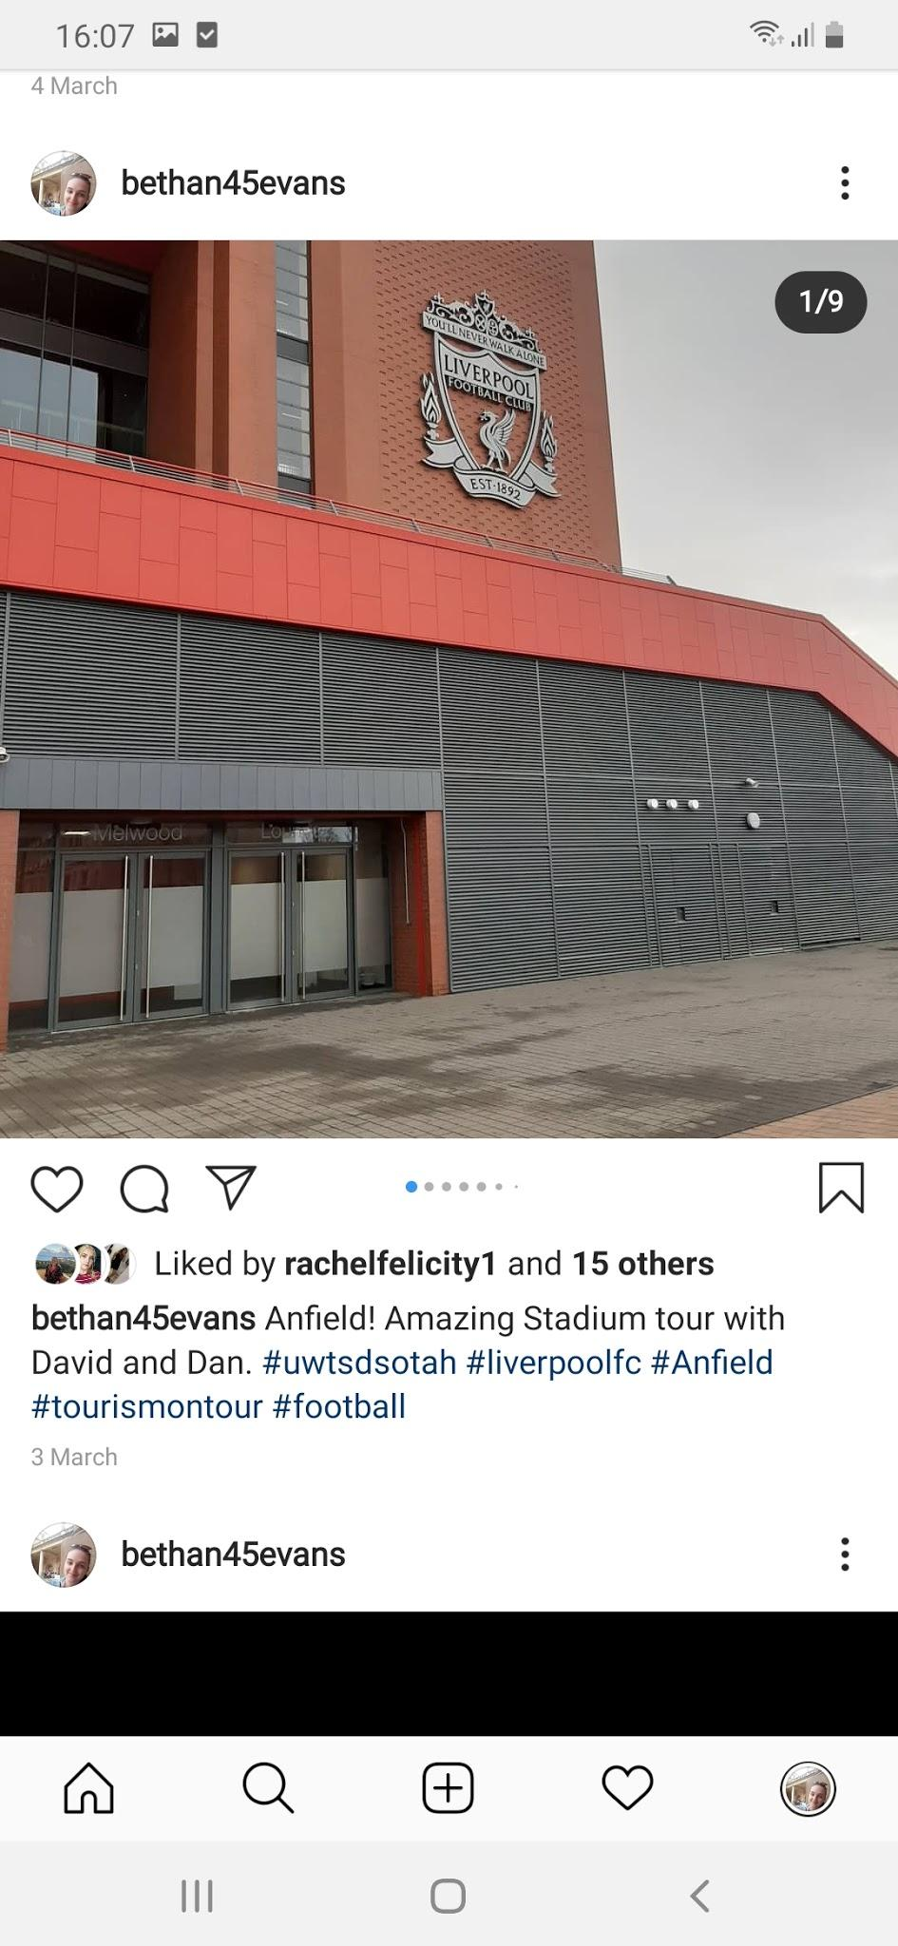
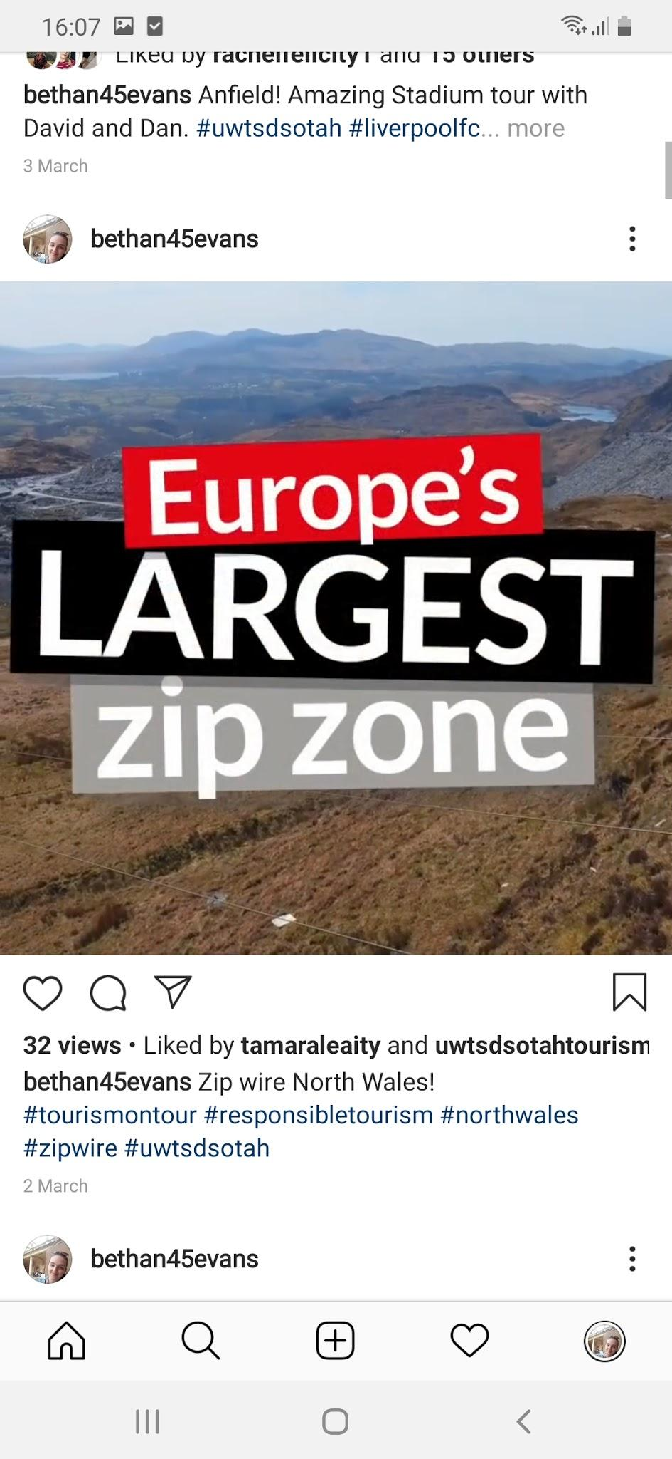
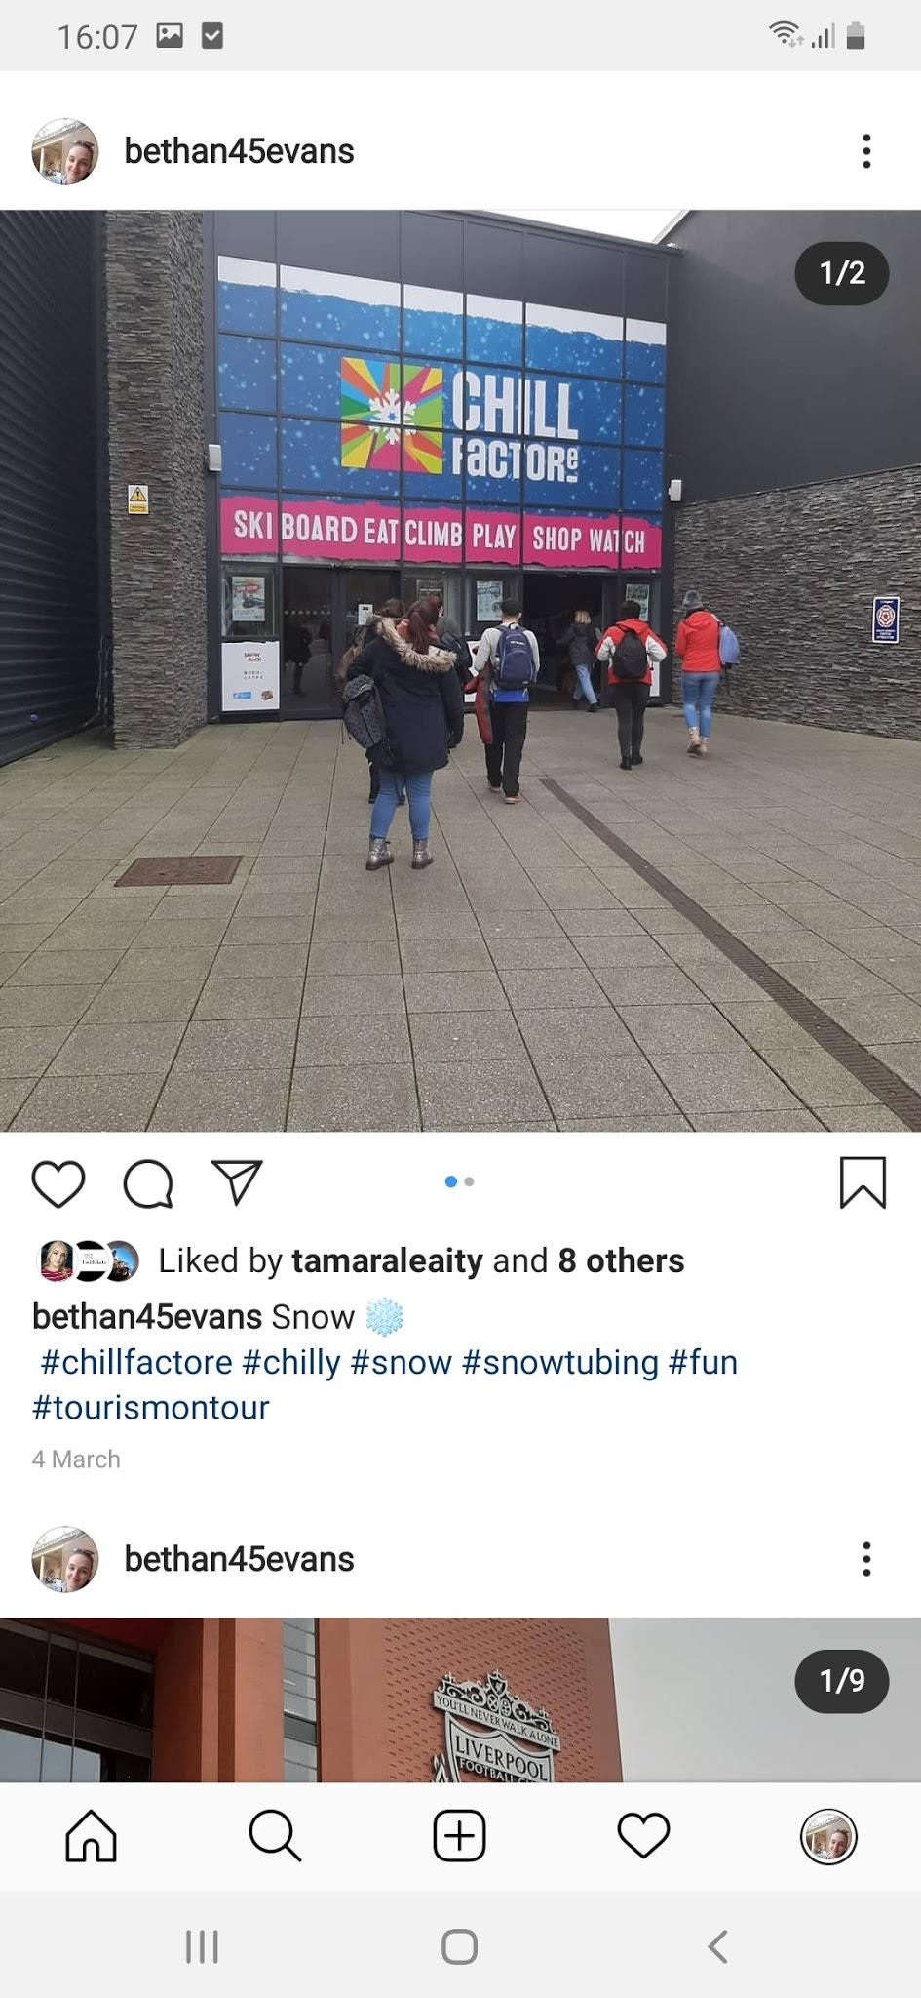
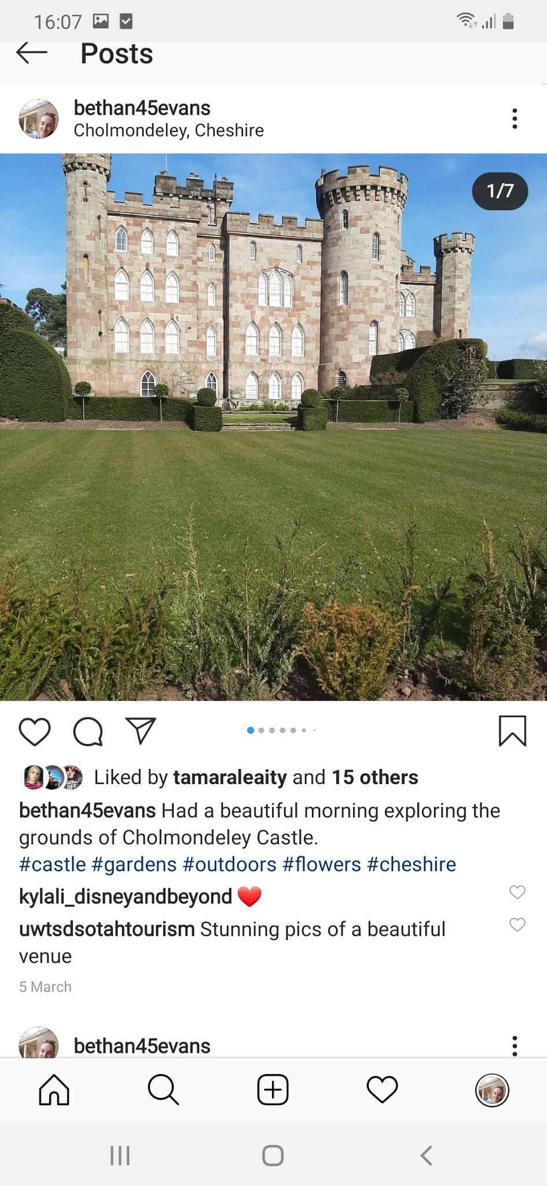

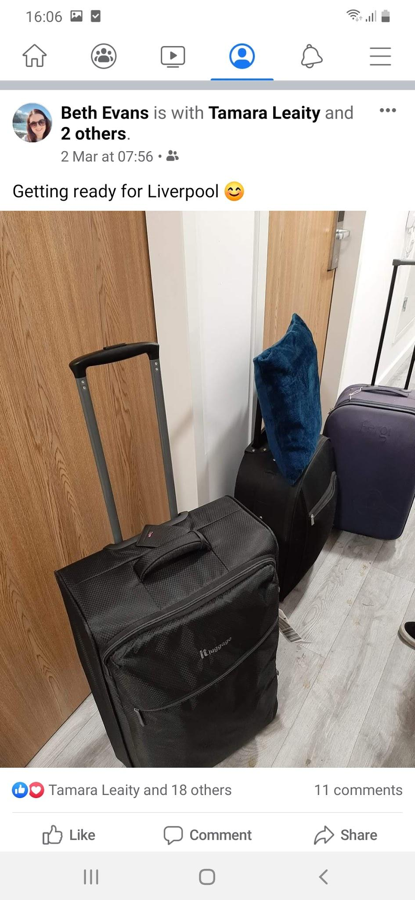
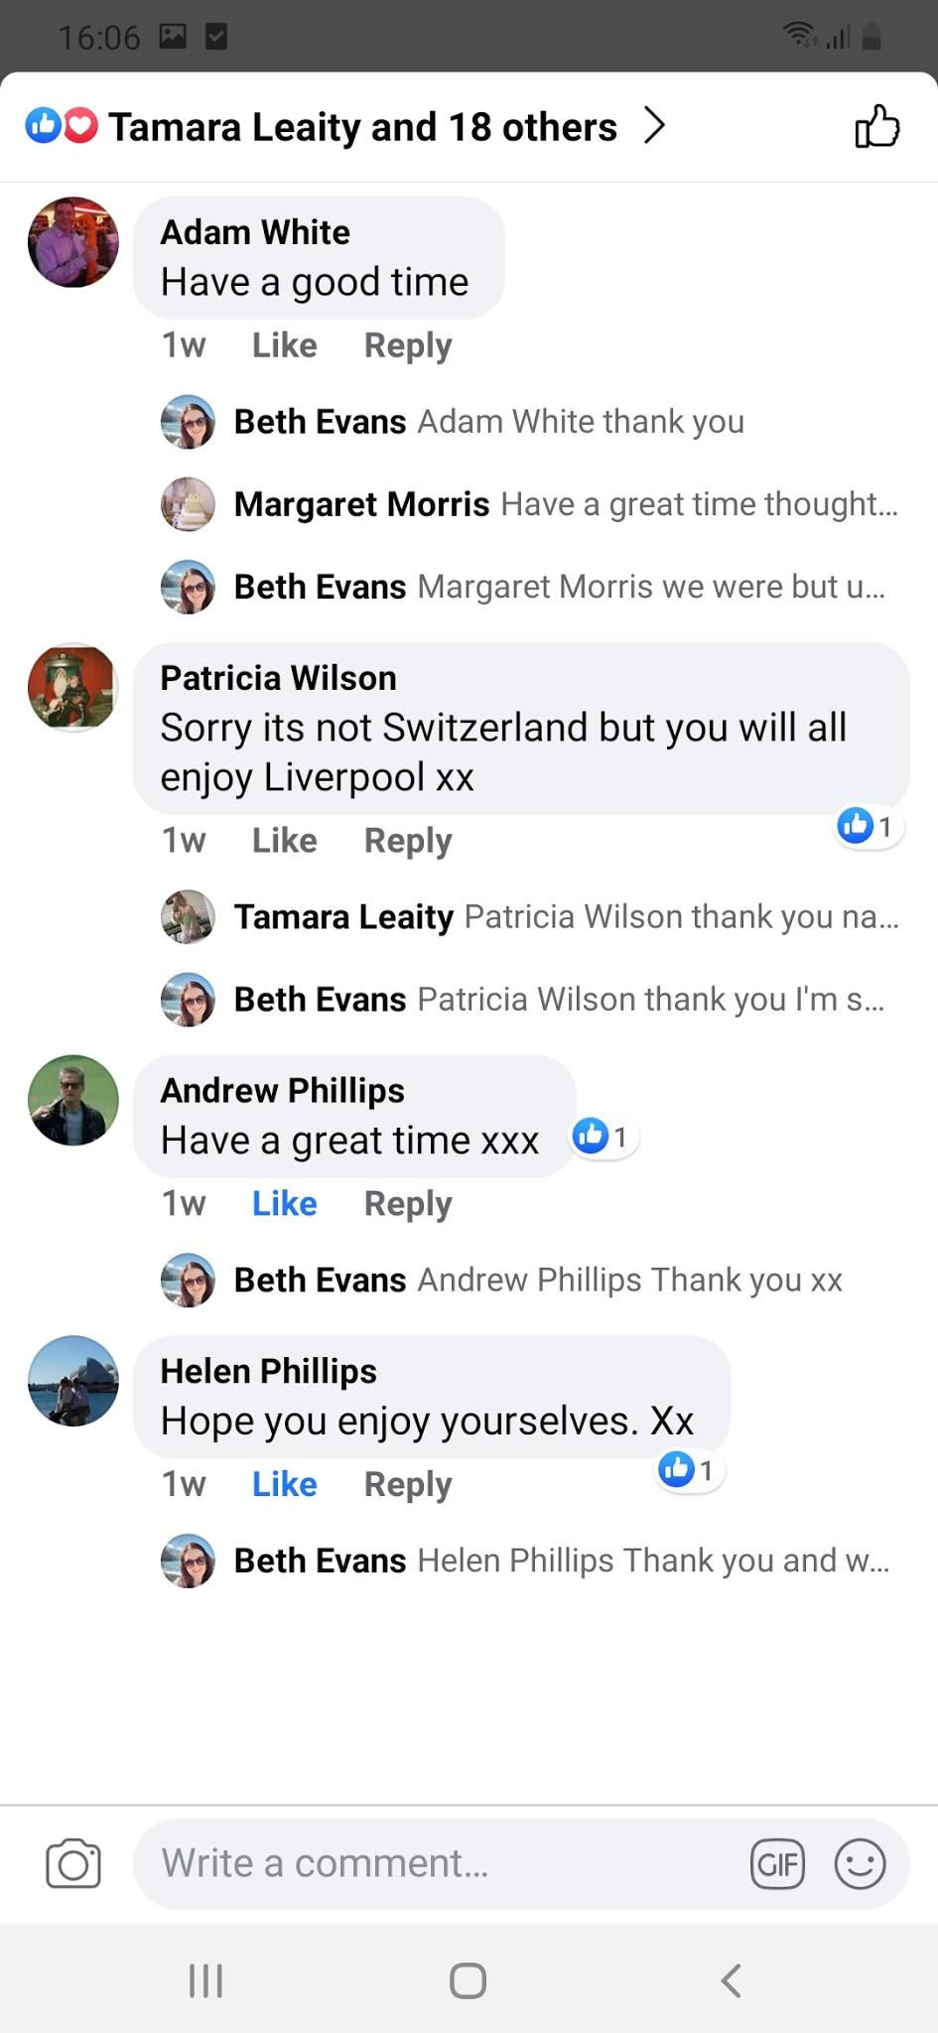

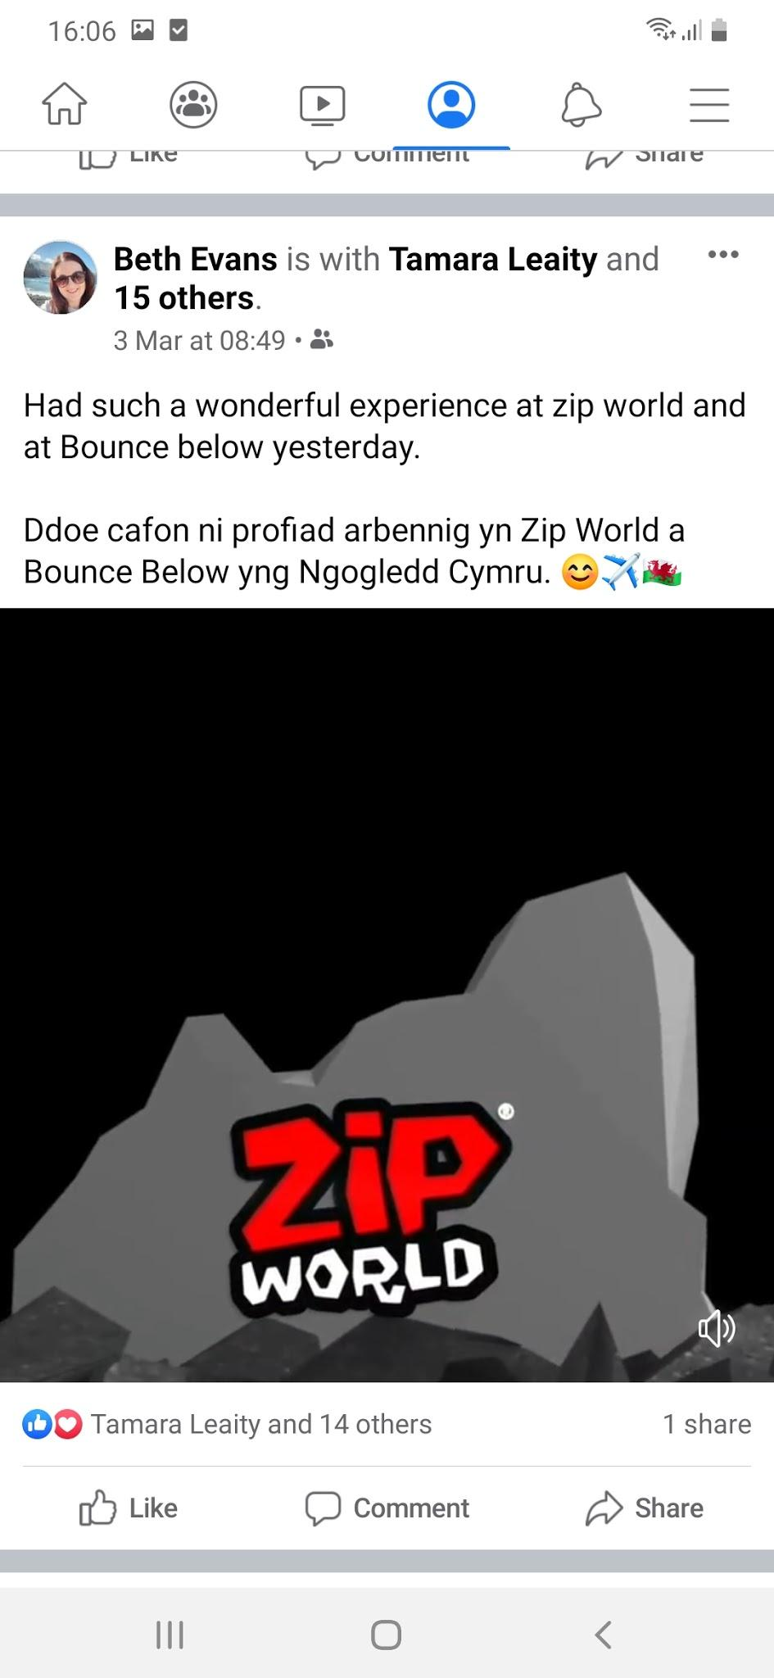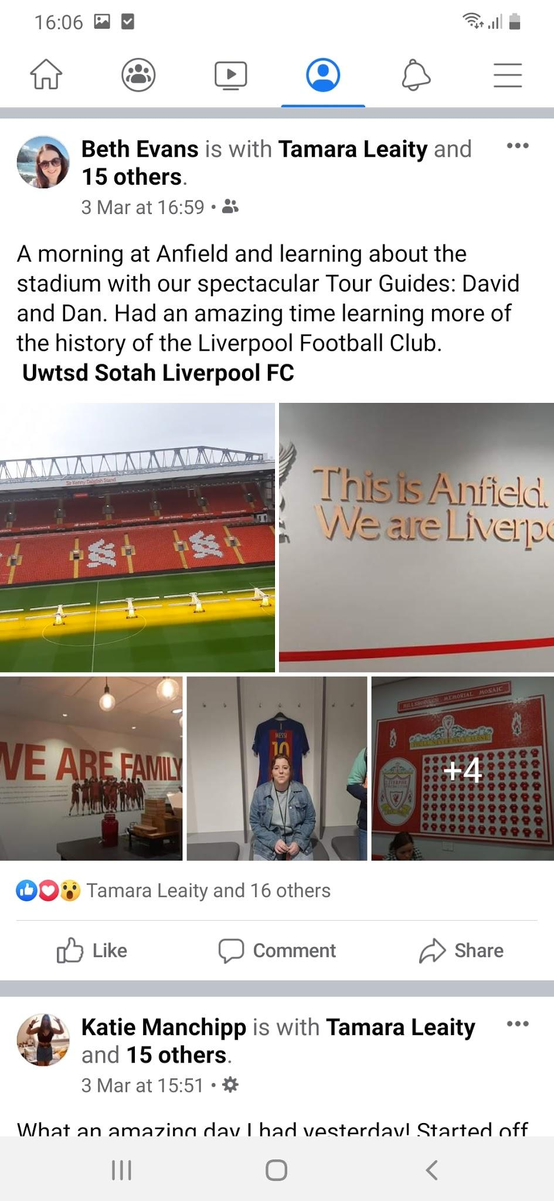

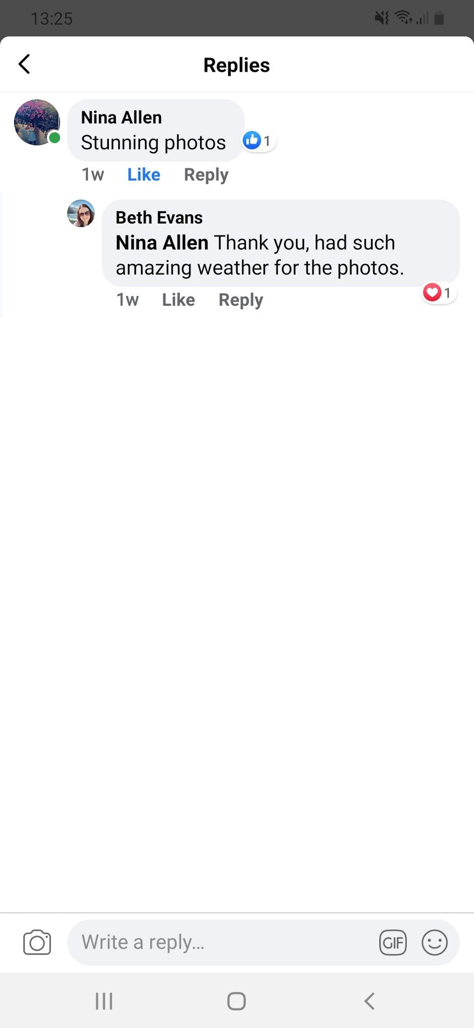
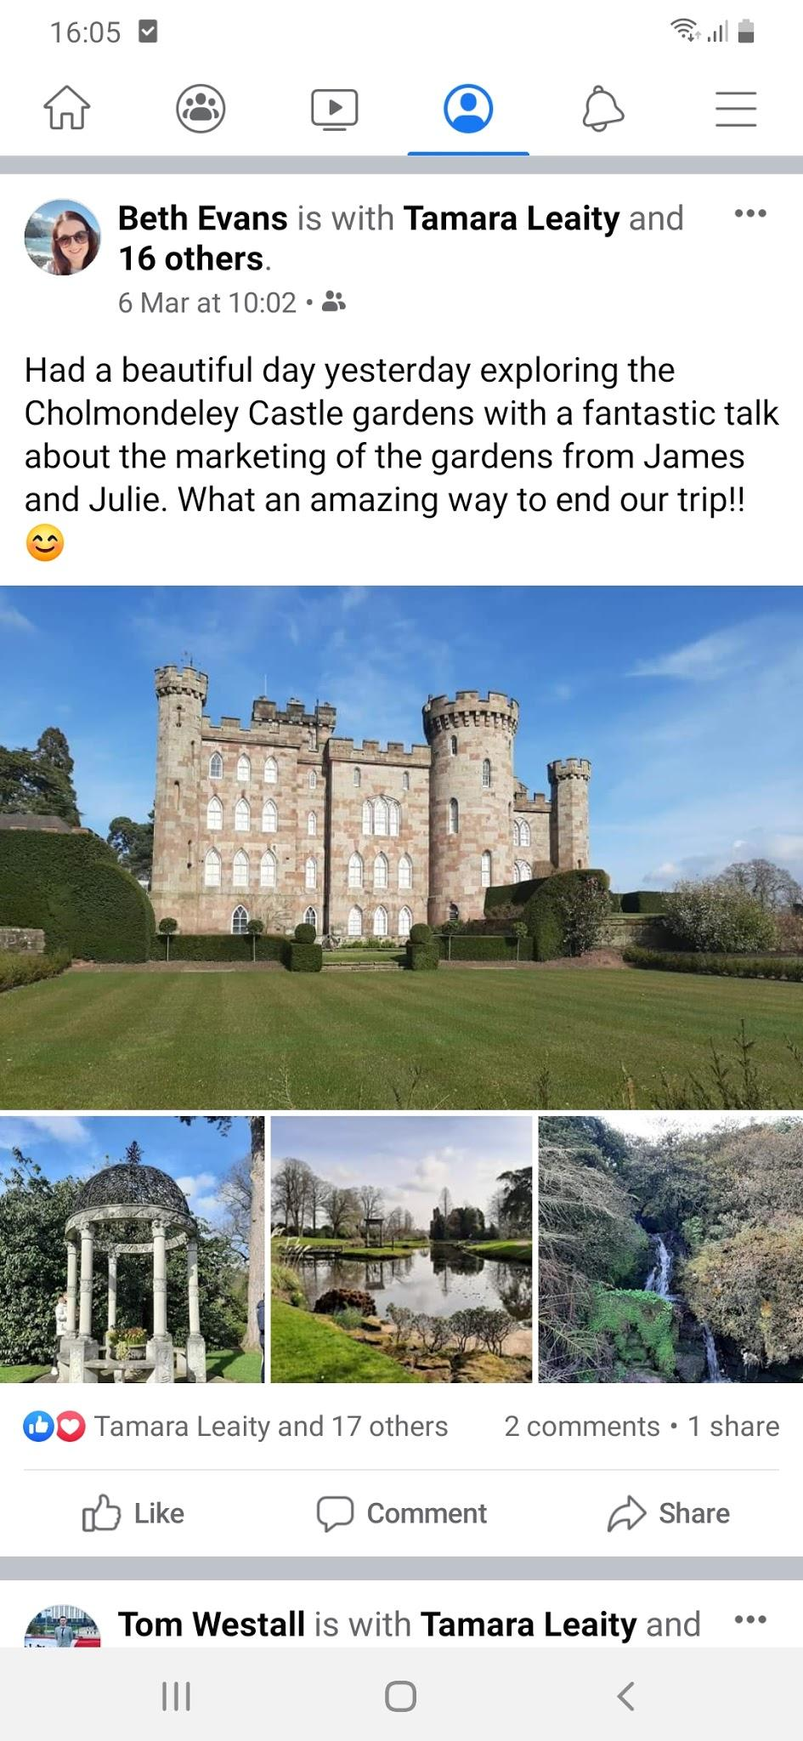

Strategy

My chosen niche tourism for this trip is dark tourism where I will focus on the dark moments of history that include deaths, illnesses and places of suffering as many people travel to places that have a dark history behind them. I will also be using hashtags to brand the experience of #tourismontour and to highlight the European Adventure Tourism Experience 2020. However, due to Covid-19 the destination was changed from Paris and Switzerland to North Wales, Liverpool and Manchester. These changes had an effect on my original niche tourism as I was originally going to do romantic tourism for France and adventure tourism for Switzerland. The reason for the change was due to safety reasons and Covid-19 seemed to be escalating leading up to the trip also because of this it was necessary to research the new destinations and alter my niche tourism. The reason I chose dark tourism is because I felt that there are many places in Liverpool that I could visit that link to my niche tourism.

Aims | Objectives
- Reach my target audience of people who are interested in the history of dark tourism.  - Use Facebook, Instagram and LinkedIn to be able to connect with the target audience and people of different age groups. | - Post every day on each social media platform that I have chosen using hashtags relating to dark tourism.  - I will use Facebook as one platform where I will be able to post pictures and give a little detail on the destination which will target the middle aged people that are on it as Facebook is a platform that the younger generation are turning away from. To attract the younger generation I will post on Instagram using a capturizing photo with a lot less words and focus on the hashtags for the posts. The final platform is LinkedIn which I can connect with professional businesses and go into a lot more detail of the destinations.

Reflection

Before going on the experience the destination was changed because of the Coronavirus and our safety came first and because of it we didn’t go to Paris and Switzerland instead we went to North Wales, Liverpool and Manchester which required me to change my strategy and excursions. This also included the change in my choice of niche tourism from romantic and adventure tourism to focus on dark tourism by visiting the different places around Liverpool with a dark history. I followed the strategy that I adjusted just before going to Liverpool and I also made sure to post on each social media platform.
The first post on Facebook about going to Liverpool seemed to have the most likes and interaction as there were many likes and comments which could be because I posted early in the morning. Instagram had quite a few likes but not many comments on my posts. Maybe I could have put up better wording to go with the pictures and use more hashtags relating to my niche tourism market and the next time I visit somewhere I will tag the location and company. The final platform that I used was LinkedIn and I didn’t have much likes or interactions on this platform as it could be because of the very few followers that I have and I should try to make more of an impact on the platform. This shows that my most successful platform was Facebook alongside Instagram and the platform with very little interaction was LinkedIn which I could try to build my profile for better connections.
In the future I would like to try and capture better pictures for my posts along with the right hashtags and also proofread my posts to check for spelling and grammar mistakes. Also, I believe that I should try to build my connections on each platform to be able to make the connections that could be helpful in the future.

References

Dark-tourism.com (2020) ‘What is ‘dark tourism’? Are you a ‘dark tourist’?’ [Online] Available:
http://www.dark-tourism.com/index.php/18-main-menus/mainmenussubpages/599-what-is-dark-tourism (Accessed: 20th March 2020).

