UNIVERSITY of WALES TRINITY SAINT DAVID
STACEY WALLER
1911557
BMSW5102-BRIM
RELATIONSHIPS AND WORKPLACE ACHIEVEMENT
LECTURE
SUJEEWA HERATH
2021

TABLE OF CONTENT
Page 1. Title
Page 2. Contents table
Page 3. Introduction
Page 3. Background information on University of Wales Trinity Saint David
Page 3. Engagement
Page 4. Engagement
Page 4. Job Autonomy
Page 4. Support and Coaching
Page 5. Support and Coaching
Page 5. Feedback
Page 5. Learn and Develop
Page 6. Task Variety
Page 6. Responsibility
Page 6. Rewards Management
Page 7. Reward Management
Page 7. Pay and Rewards
Page 7. Towers Perrin
Page 7. Benefits
Page 8. Benefits
Page 8. Learning and Development
Page 8. Work Environment
Page 8. Training and Development
Page 8. Systematic Training Model
Page 9. Systematic Training Model
Page 9. SWOT Analysis
Page 10. SWOT Analysis
Page 10. PDP Personal Development Plan
Page 11. PDP Personal Development Plan
Page 12. Reference
INTRODUCTION
This case study on the University of Wales Trinity Saint David will look how University of Wales Trinity Saint David uses these models to improve the organisation and the employees themselves the University of Wales Trinity Saint David need high performance, committed, engaged employees to deliver its learning programmes to its adult students in an effective way to enable understanding and progression in an academic setting. This case study will look at how employees engage with the job role if employees have job autonomy, support and coaching, feedback, learn and develop, task variety, responsibility, reward management, pay and rewards and benefits. This case study will look at the total rewards model TOWERS PERRIN and SYSTEMATIC TRAINING MODEL, within this case study will analysis a SWOT Analysis (PDP) personal development plan for the interviewee who is employed by the organisation University of Wales Trinity Saint David.
BACKGROUND INFORMATION ON UNIVERSITY of WALES TRINITY SAINT DAVID
‘The University of Wales Trinity Saint David was formed on 18 November 2010 through the merger of the University of Wales Lampeter and Trinity University College Carmarthen, under Lampeter’s Royal Charter of 1828. On the 1 August 2013, Swansea Metropolitan University became part of University of Wales Trinity Saint David. The University’s Royal Charter is the oldest in Wales and England after the universities of Oxford and Cambridge. In 2011 HRH the Prince of Wales became its Royal Patron’. (University of Wales Trinity Saint David, 2021). Since 1822 to present day University of Wales Trinity Saint David has expanded its university having two in Birmingham, “Sparkhill Centre opened in March 2018 and Quay Place Centre in January 2020”. (University of Wales Trinity Saint David, 2021).
ENGAGEMENT
(Macey, 2009) who made the taking in the wake of working definition: 'Commitment is a person's explanation and focused imperativeness, obvious to others inside the demonstration of individual movement, flexibility, effort and assurance facilitated towards hierarchical objectives' (University of Wales Trinity Saint David, 2021). The role and importance of engagement is for the employee to be fully engaged with the job and organisation without the 3 elements of commitment, motivation, and organisational (SHRM, 2021)citizenship the employee would not have total engagement. ‘Feeling drew in is obviously useful for laborers. Most meanings of commitment portray representatives who are better, more joyful, more satisfied or more inspired. For associations, research has over and again shown that proportions of commitment go along with better. More comprehensively, different investigations show that positive connections between parts of representative commitment and other business measurements, including consumer loyalty, usefulness, development, staff maintenance, proficiency and wellbeing and security execution’ (CIPD, 2021). Employee’s engagement is the degree to which workers feel enthusiastic about their positions, are focused on the association and put optional exertion in other work (custominsight.com, 2021). Employee commitment goes past exercises, games, and occasions connected with representatives take a gander at the entire of the organisation and comprehend their motivation, where, and how they fit in (custominsight.com, 2021). Engagement is apparent to other as conduct and we need to zero in on that conduct on the grounds that, at last, this is the thing that produces results. Importantly, we realize that employees can fill in as powerful and legitimate journalists of what is happening in the association. In this way, it is helping to consider what a connected with labour force resembles to the individuals who really accomplish the work inside the association (Macey, 2009). To for fill total job engagement employees must have all 3 elements combined to have full engagement. Employees who are fully engaged are more likely to have less absence and are more likely to stay with that organisation. Engagement comes from going the extra mile for the organisation or the customer. Employee engagement is your energy, effort, pride, dedication, the absorption you take from your role at the organisation job engagement will be filled if the job has interesting, challenging work.
Question 1.
JOB AUTONOMY
Do you have job autonomy at University of Wales Trinity Saint David?
The idea of occupation self-governance can be characterized as the level of control an employee has over their own quick booking and undertakings (Liu, 2011). University of Wales Trinity Saint David have according to the interviewee job autonomy to its employees 100% independent work with very limited supervision. University of Wales Trinity Saint David believe in its employee capability and trust its employees. University of Wales Trinity Saint David have a very good recruitment process, so they look for high eligibility and suitability University of Wales Trinity Saint David look for individuals with PhD and other qualification to have passed exams, have higher education fellowship so therefore, University of Wales Trinity Saint David provide good job autonomy to its employees at University of Wales Trinity Saint David.
Question 1.2
SUPPORT AND COACHING The signs of instructing are that it is customized constantly and that it is normally done one-on-one and throughout some undefined time frame, and in view of a particular business objective. Instructing is like, however unmistakable from, tutoring. The last is a vocation improvement technique whereby less experienced representatives are coordinated with more experienced partners for direction either through formal or casual projects. Training is oftentimes used to help people as they plan for or move into new tasks, further develop work propensities, adjust to a changing climate or conquer explicit impediments (SHRM, 2021).Does University of Wales Trinity Saint David offer support and coaching to its employees’?
According to the interviewee University of Wales Trinity Saint David have a brilliant support and coaching system 100% good training. Training involves Moodle Training, Data protection Training, Health and Safety Training they have Senior Higher Education Fellowship Mentor. The support and coaching at the University of Wales Trinity Saint David for its employees are very good. University of Wales Trinity Saint David offering its employees support and coaching will have certain benefits for the individual employee.
Question 1.3
FEEDBACK
Does University of Wales Trinity Saint David provide feedback for their employees?
Feedback at University of Wales Trinity Saint David according to the interviewee the feedback is low they conduct performance management just once a year. University of Wales Trinity Saint David collect feedback from students on lectures performance at the end of each module. According to the interviewee they have no access to the feedback what was collected from the students who attend University of Wales Trinity Saint David to help them improve their teaching methods the only feedback they get if they ask students how they are performing. Feedback is a must, but the employees do not receive it. organisation put resources into formal human asset programs in which input is consolidated, like execution the executives, formalized preparing programs, up, and 360-degree criticism and instructing (Janine van der Rijt, 2012).
Question 1.4
LEARN AND DEVELOP
Instructor advancement is a mind-boggling measure whose achievement relies on both an ideal setting for learning and functional, connecting with activities. Availability of assets, adaptable working conditions, backing, and acknowledgment can have a significant effect in the craving of educators to refine their training. (Loucks-Horsley, 1987). (Lim, 2020)
Does University of Wales Trinity Saint David offer opportunities to learn and develop?
University of Wales Trinity Saint David provide its employees with senior fellowships if the employees where to take this opportunity it would cost the employee between £6000-7000 the University of Wales Trinity Saint David offer this facility to its employees. The University of Wales Trinity Saint David provide annual training.
Question 1.5
TASK VARIETY Given that task assortment requires an expansion in the measure of information expected to learn in finishing their tasks, people with Learning Goal Orientation see these errands as significant and think about them as learning openings.
Does University of Wales Trinity Saint David have task variety in the workplace?
University of Wales Trinity Saint David employees have 100% task variety Teaching different levels. Level four and level five. Teaching different modules each term employed lectures could teach Effective Team Working, Problem Solving and Decision Making, Academic Employability Skills job variety is available at University of Wales Trinity Saint David.
Question 1.6
RESPONSIBILITY
Does University of Wales Trinity Saint David give its employees job responsibility?
According to the interviewee they have 100% responsibility they can talk to students arrange one-to-one meetings being able to create module contents and create new activities.
Question. 2
REWARD MANAGEMENT
Working environment reward frameworks are impetus programs that energize worker commitment and efficiency by offering rewards, expanded compensation, extra downtime or different honours for a job done the right way. Prize frameworks perceive staff individuals who dominate in regions, for example, client assistance, dedication and deals capacity. (Scott, 2019). ‘Award the executives is about the plan, execution and upkeep of remuneration frameworks that expect to fulfil the requirements of both the association and its partners and to work decently, even handed and reliably’ (University of Wales Trinity Saint David, 2021) ‘This is vital award, a methodology dependent on the convictions that prize, and business technique ought to be incorporated and that it is important to be forward looking – to prepare and get the plans going’ (University of Wales Trinity Saint David, 2021). Rewards are important to the employee and organisation in helping to retain its employees promoting high performance, ‘reward people according to the value they create. Help to draw in and hold excellent individuals’ (University of Wales Trinity Saint David, 2021). ‘Award technique is a statement of purpose that characterizes what the association needs to do in the future to create and carry out remuneration approaches, practices and cycles that will assist the accomplishment of its business objectives and address the issues of its partners’ (University of Wales Trinity Saint David, 2021).
Based on the Total Reward Model Towers Perrin, University of Wales Trinity Saint David PAY/REWARDS
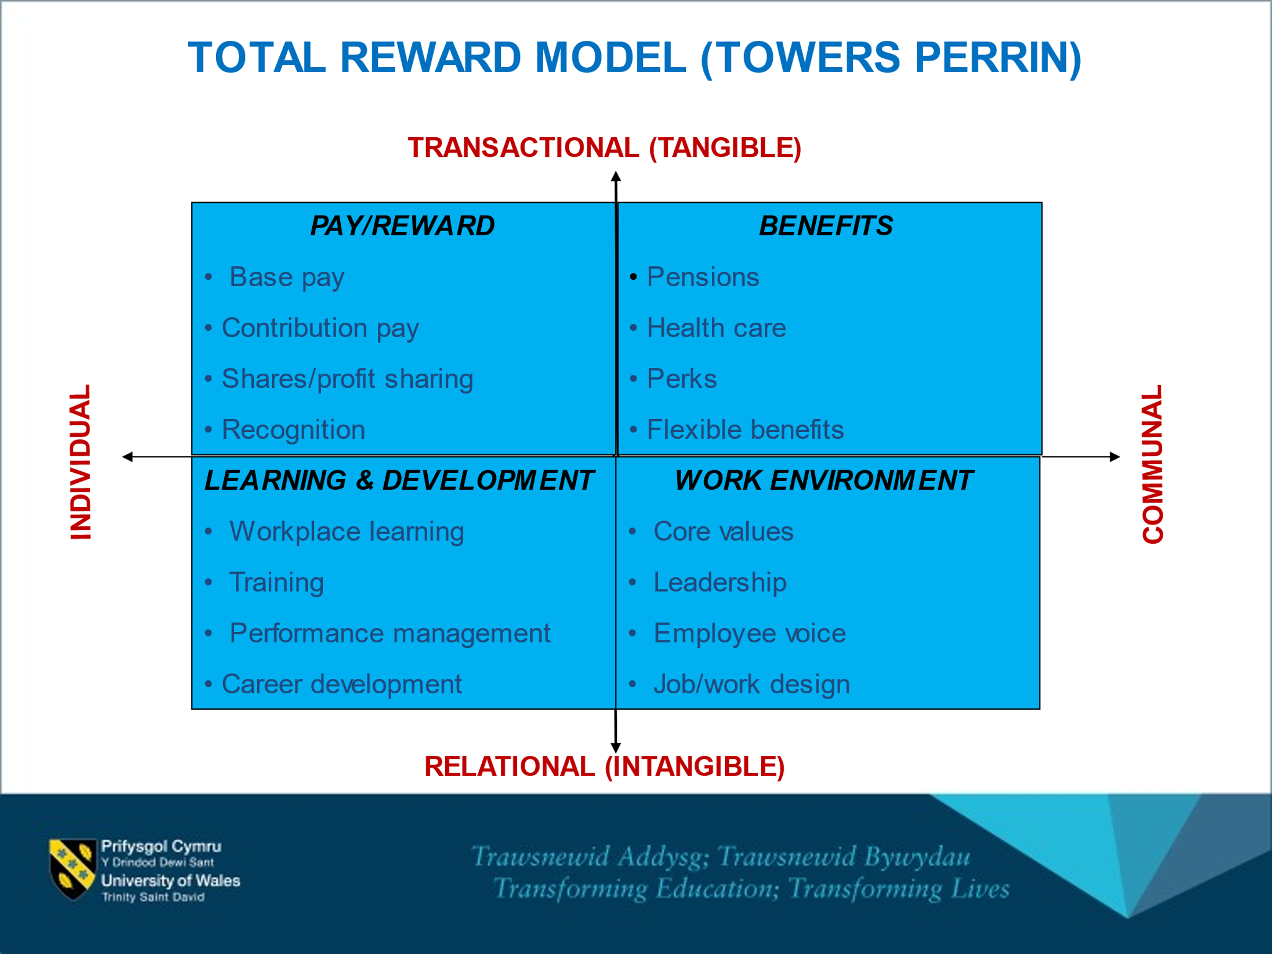
(University of Wales Trinity Saint David, 2021).
Employees receive base pay and contribution pay University of Wales Trinity Saint David do not have any shares or profit sharing available to the employees comparing that to JD Weatherspoon and their employees being able to buy shares in their organisation brings a sense of belongingness like Maslow Hierarchy of Needs. University of Wales Trinity Saint David do not provide that option for their employees. For any organisation to enable that facility would help employees having that sense of belongingness. Recognition of the employees at University of Wales Trinity Saint David based on performance employees can become module co-ordinates programme managers.
BENEFITS
University of Wales Trinity Saint David have a very good pension according to the interviewee they get 3 times what they pay into the pension with a large lump sum at the end of that contract. Health care University of Wales Trinity Saint David do not have any health care according to the interviewee they are an hourly paid employee, so they do not receive any health care perks or flexible benefits.

LEARNING AND DEVELOPMENT
University of Wales Trinity Saint David. Have good workplace training, periodic training performance management according to the interviewee is not happy on the level of feedback from the University of Wales Trinity Saint David level of performance management is low and the employee does not receive any good feedback. The University of Wales Trinity Saint David need to have a systematic system approach to giving its employees feedback. Career development the employees have very good opportunities for career development at University of Wales Trinity Saint David.
WORK ENVIRONMENT
Leadership is very high the interviewee is very happy with the leadership from the operation managers and the main University of Wales Trinity Saint David based in Swansea. Employee voice University of Wales Trinity Saint David have regular meetings once a month before term in the middle of term and every six months if their employee has any concerns, the employee can put their concerns across if the employee is not happy the employee can voice the concerns. Job Design is very good at the University of Wales Trinity Saint David.
TRAINING AND DEVELOPMENT
University of Wales Trinity Saint David provide their employees off the job training they do not provide on the job training and the employees have access to E-learning with the situation with Covid-19 most things have moved to online training. On a regular basis the employees have training University of Wales Trinity Saint David do not have any type on manual handing training. University of Wales Trinity Saint David offer IT skills in Moodle training, team leader, supervisor, leadership and management, health and safety, diversity policy and practice, equal opportunities, on how the employee should treat the student personal skills, e.g., communication, coaching, time management the University of Wales Trinity Saint David provide all of them types of training methods.
SYSTEMATIC TRAINING MODEL
University of Wales Trinity Saint David ‘identify training needs what the employee needs then they will plan the training programme Just in time training programme is relevant for people by its association with immediate work’ (University of Wales Trinity Saint David, 2021). The training needs to be transferable and useful to the employee and organisation. Training would take place Quay Place in a building with professional trainers the techniques they would use is bite size training in a short time with one topic the implementation of the bite size or just in time training is evaluated to see if the employee has learnt anything from the training evaluation that has taken place.

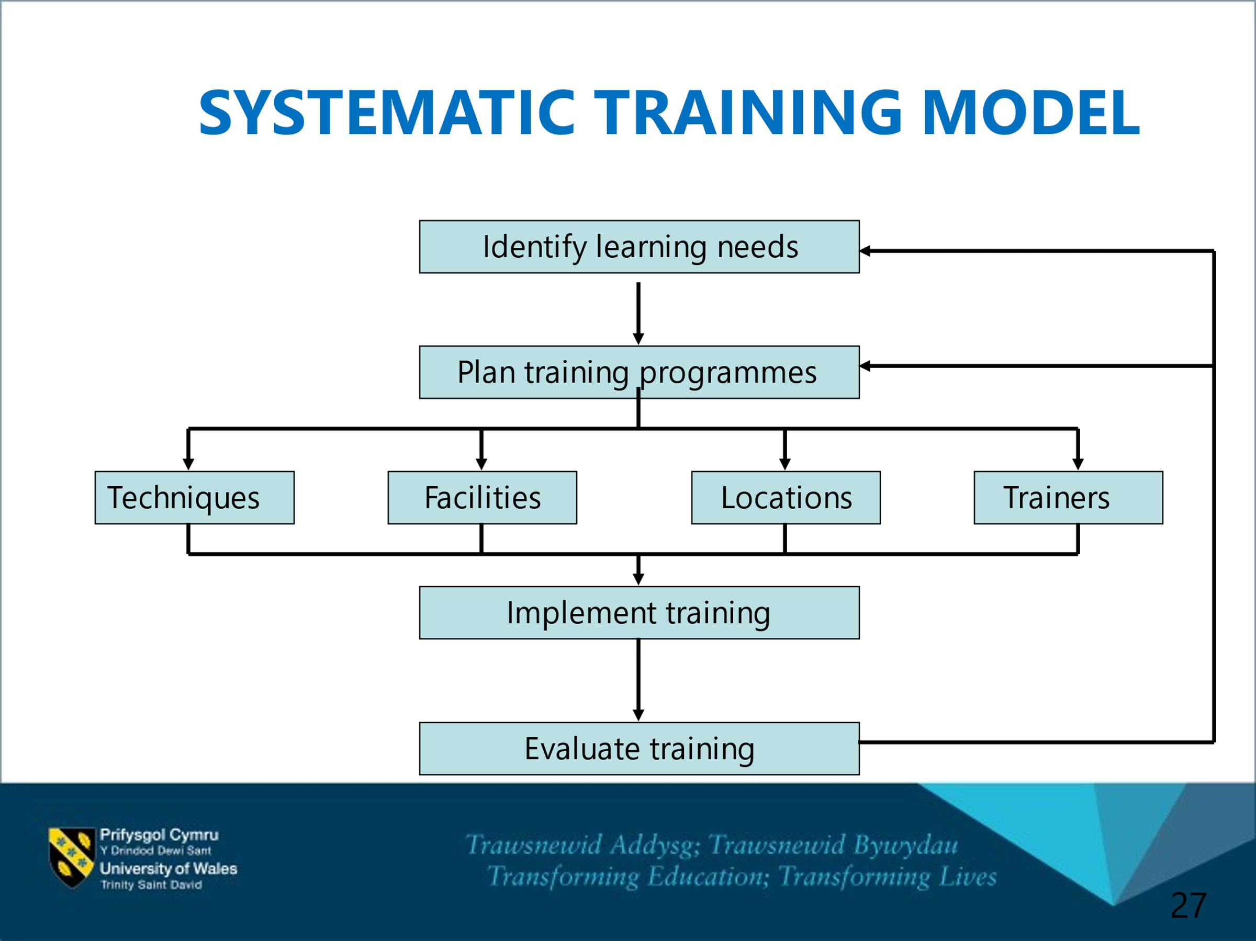
(University of Wales Trinity Saint David, 2021).

SWOT ANALYSIS

STRENGTHS | WEAKNESS
Qualification: BA Degree, Master’s Degree, PhD IN Business Management.  Experiences: 3 years, I work as a research fellow, I work at other university in the UK.  Skills: Time management, academic writing (peer reviewed published articles). | My communication: not a native speaker.  Not very organized.  Shy.
THREATS | OPPORTUNITIES
More qualified native speaker.  Covid-19, restriction of mobility.  My children | Access to training and development from the university.  A network of professional as friends and my PhD supervisor.  Resources and funds available from the university.

PERSONAL DEVELOPMENT PLAN
Miss: Interviewee. Department: Education. Organisation: University of Wales Trinity Saint David.
What do I want to learn? | What do I have to do? | What support and resources will I need? | How will I measure success? | Date review
I want to learn Accent softening and public speaking | Subscribe to online YouTube Webinar or online Webinar on English language to improve your communication skills. Sign up to a course on public speaking and accent softening for a 1-year course. | The staff at the online sessions. All session online so will need a laptop or smart phone good working microphone headphone/earphones support from family and friends. audio and video online would be of help also. | When my accent becomes soft, and I feel more confident at public speaking. Informal and formal appraisal. | 27th August 2021.  7th October 2021.  26th July 2022.  25th July 2023
I want to be more organised | Do a to do list with most important at the top what not so important in the middle of the lists with the least important at the bottom. It is an effective way to help you organise what is most important to do in a systematic order. | Hard back Dairy to note down daily task. Post it notes on wall to help organise priorities in order. Calendar on your phone to remind you on the important and not so important task what need doing. Alarm on your phone and computer/laptop synchronise your daily task. | Success will be straight away when you organise well you will benefit from that order what comes with organising. | 15th August 2021.  14th October 2021  13th December 2021
To overcome shyness | Find a counsellor who specialises in Psychology for the best outcome. Counselling would be an effective way to try and overcome shyness. Join a gym. Do not tell people you are shy. | My counsellor, family and friends, work colleagues. Record myself on my phone and play it back to myself to check for mistakes |  | 7th August 2021.  7th September 2021.

Short Term Goal (Next 6 months)
To have 3 public speaking session to build confidence, accent is softer, and I feel happy where I am in my public speaking.
Medium Term Goal (Next 1-18 months)
Confident in my ability to perform 9 public speaking in the next 18 months and my accent is clearer and easier for people to understand my accent. That will boost my confidence to know I have nearly reached my goal in what in set out to achieve.
Long Term Goal (Next 18-3 years)
I have reached my goal in confidence in public speaking my accent is so clear people can understand everything. I communicate with them I feel more able to show my speaking skills and I can do 20 public speaking now with easy after all the training I have put myself through to get where I am now.

References
Bates, A. B. M. a. B. L., 2007. Preparing students for the professional workplace:. Who has responsibility for what? Asia Pacific , 8(2), pp. 121-129.
Bedarkar, M. P. D., 2015. A Study on the Drivers of Employee Engagement Impacting Employee Performance. Procedia - Social and Behavioral Sciences, Volume 133, pp. 106-115.
CIPD, 2021. Employee engagement and motivation. [Online]
Available at: https://www.cipd.co.uk
[Accessed 28 July 2021].
custominsight.com, 2021. What is Employee Engagement?. [Online]
Available at: https://www.custominsight.com
[Accessed 28 July 2021].
Goldschein, E., 2011. Businessinsider. [Online]
Available at: https://www.businessinsider.com/
[Accessed 16 July 2021].
Janine van der Rijt, M. W. J. v. d. W. P. V. d. B. M. S. R. S. W. H. G., 2012. Human Resource Development Quarterly. Contextual antecedents of informal feedback in the workplace, 23(2), pp. 233-257.
Kim, H. S. M., 2008. Burnout and Turnover Intention Among Social Workers: Effects of Role Stress, Job Autonomy and Social Support. Administration in social work, 12 October, pp. 5-25.
Lim, H. S. S., 2020. Effect of Learning Goal Orientation on Performance: Role of Task Variety as a Moderator. Journal of Business and Psychology, 2 July, p. 3.
Liu, C. S. P. J. S., 2011. The relation of job control with job strains: A comparison of multiple data sources. Occupational and Organizational Psychology, 78(3), pp. 325-336.
Loucks-Horsley, S. H. C. M. L. D. C. W. M., 1987. Continuing to Learn: A Guidebook for Teacher. 1st ed. Andover, MA: The Regional Laboratory for Educational Improvement.
Macey, W. H. S. B. B. K. M. a. Y. S. A. M. M., 2009. Employee Engagement. 1st ed. Malden, MA: Wiley-Blackwell.
Scott, S., 2019. Why Create a Workplace Reward System?. [Online]
Available at: https://smallbusiness.chron.com
[Accessed 28 July 2021].
SHRM, 2021. Coaching in a Business Environment. [Online]
Available at: https://www.shrm.org
[Accessed 28 July 2021].
University of Wales Trinity Saint David, 2021. Developing Relationship and Workplace Achievement. [Online]
Available at: https://www.uwtsd.ac.uk
[Accessed 28 July 2021].

