
Project Initiation Document
Connor Stock - 1801401

December 6, 2019
Project Management and Research Methods
Sue Maw

Contents
1. Introduction/Background: 1
2. Objectives: 1
3. Scope: 2
4. Constraints: 2
5. Authority: 2
5.1. Project Sponsor: 2
5.2. Project Manager/Leader: 2
5.3. Project Organisation Diagram: 2
6. Resources: 3
7. Initial Project Plan: 3
8. Conclusion: 4
9. References: 5

Introduction/Background:
Project Initiation Documents (PIDs) are incredibly important for establishing a baseline guide for how the creation of a project will be carried out. Stettner [1] discussed the importance of PIDs by mentioning “A Project Initiation Document helps guide the team early on – to a successful project start…”. Stettner also stated “The PID can be a living document that the team can fall back on”. To summarise these points, PIDs allow team members to have a document that guides their decisions throughout the project, preventing negative differences in the work.
The author of this report is taking part in a group project focusing on a ‘General Medical Information’ (GMI) wristband. This wristband will have the wearers medical and contact information stored on it, which can then be accessed by the NHS and other health professionals. The GMI band will be created to help people with health complications, with the goal of making wearers worry less when it comes to them getting their required treatment.

Objectives:
The GMI wristband will be practical in many scenarios, but it was specifically conceived with health emergencies in mind. One of the main objectives is that if the wearer needs immediate medical attention, paramedics or other health professionals will be able to scan the wristband and access the details of the wearers medical complication. This will allow the health professionals to better understand what the necessary approach would be, such as the treatment the wristband wearer requires. This would apply even more-so to wearers who are unresponsive or somehow unable to communicate the help they require.
Additionally, another objective would be for the GMI band to provide help to people with dementia or other health complications that can result in short or long-term memory loss. These people may struggle to remember their health and emergency contact information, so the wristband can keep it stored for them.

Scope:
There do not seem to be many clear boundaries for this project that would have a significant negative impact on the success of the product in the future. However, there are some boundaries for the type of client that would use this product. The main client-base for the GMI band would be people with long lasting health conditions, especially things like dementia or something that could cause the wearer to become unresponsive and require treatment. Some people with specific health conditions may feel no need to purchase and wear the GMI band, as they are capable of communicating their information themselves.

Constraints:
One of the main constraints is that the schedule could be impacted by group members being unavailable for durations of time. This could lead to these members falling behind on their tasks, which puts the group behind on the overall schedule. This can be managed by members filling in and carrying out certain tasks if members are unavailable, or by editing the schedule to account for these absences.

Authority:
This section of the document will cover various topics relating to authority, such as the project sponsor, project manager and a project organisation diagram.

Project Sponsor:
The people with the main authority and control over the implementation of this product will include the module lecturers, the industry representatives who the final pitch will be presented to, and the team leader.

Project Manager/Leader:
The project manager for the GMI band is Kaylie Shoulder. Kaylie presented the original idea to the group, and as a result has been the team leader since the start of the project. Kaylie is responsible for managing and aiding the other group members, making principal decisions and ensuring the project is on schedule.

Project Organisation Diagram:
The following diagram shows the levels of authority for people in the project team:

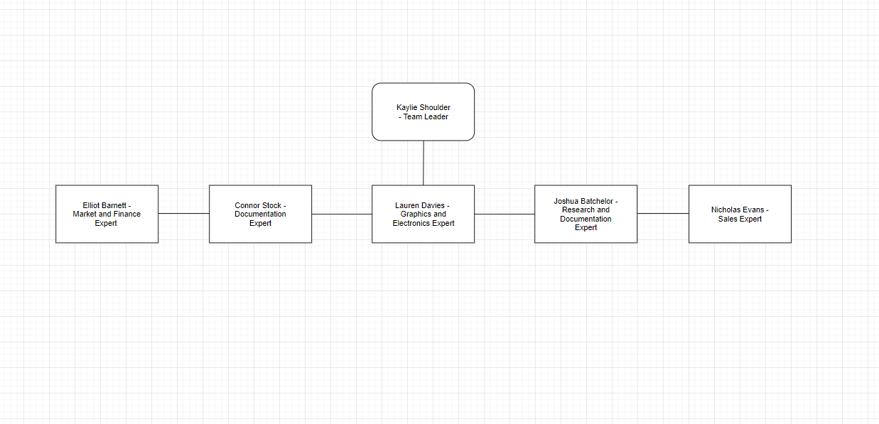

As shown in the diagram, Team Leader ‘Kaylie Shoulder is on the highest level. All 5 remaining members are on the level below.

Resources:
The team for this project consists of six people. Team Leader ‘Kaylie Shoulder’, Graphics and Electronics expert ‘Lauren Davies’, ‘Research and Ideas expert ‘Joshua Batchelor’, Market and Finance expert ‘Elliot Barnett’, Documentation expert ‘Connor Stock’ and Sales Expert ‘Nicholas Evans’.
The equipment for this project will involve a silicone wristband, an RFID chip, a metal wrist clasp and additional protection material for the RFID chip. Software will include Visual Studio, which will be used to test programming information onto the RFID chip.
In terms of finances, the group will have to purchase the above equipment. For the most part it will be fairly low expense, but it is difficult to provide an estimate cost for wristband as the price of the RFID microchip can vary so massively.

Initial Project Plan:
The final section of this document will contain a Gantt Chart showing the project schedule for the GMI band. Gantt Charts are incredibly important for defining and sticking to a clear schedule. Mind Tools [2] mentioned “To complete a project successfully, you must control a large number of activities, and ensure that they’re completed on schedule”. Gantt Charts are one of the best ways for achieving this, as they provide a clear and easy-to-edit schedule diagram.

The following screenshots show the completed Gantt Chart by group member Elliot Barnett [3]:
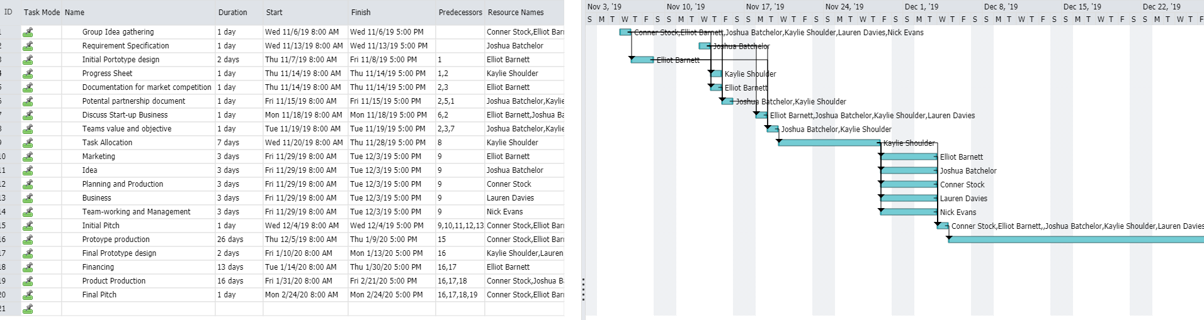

Figure 1: Gantt Chart
Source: [3]
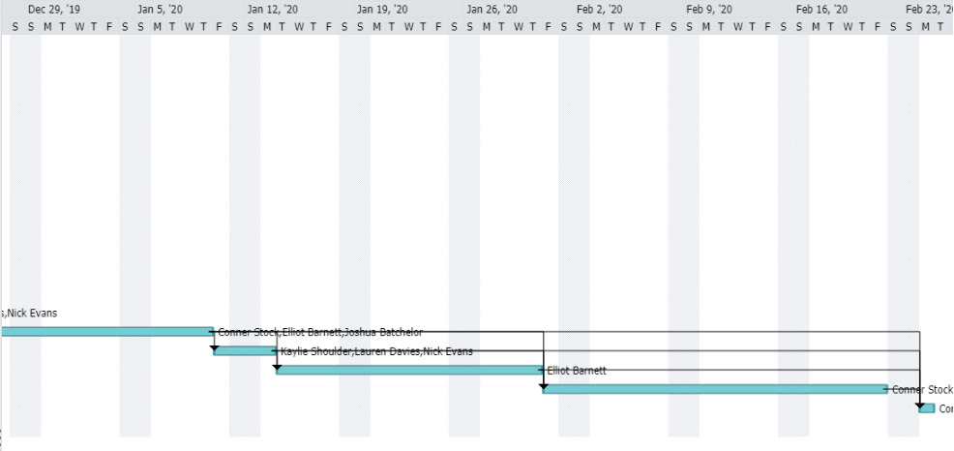

Figure 2: Gantt Chart continued
Source: [3]

As can be seen in the screenshots, the project schedule runs from Wednesday 6th November 2019 to Monday 24th Feburary 2020. This gives the group 110 days between the initial idea gathering and the final pitch. The main milestones during this time are the initial idea meeting, the initial pitch, the prototype production and final design, and the final pitch.

Conclusion:
To conclude this document, the topic of the GMI band project was explored. This included the objectives, scope, constraints, authority and resources relating to the project development. An authority diagram was produced along with a Gantt Chart, which showed who has more or less authority over the project and the start-to-finish schedule for the development of the GMI band. The end goals of the GMI band were also explored, with details relating to the types of people it will help and the ways in which it will help being covered.

References:
[1] M.Stettner. (2018, May. 8). “Make a Project Initiation Document in a Flash (Here’s How!)” [Online]. Available: https://www.thedigitalprojectmanager.com/how-make-project-initiation-document/
[2] Mind Tools. “Gantt Charts Planning and Scheduling Team Projects” [Online]. Available: https://www.mindtools.com/pages/article/newPPM_03.htm
[3] Elliot Barnett. GMI Band Project Gantt Chart.

