Management Economics
Module code: LCBB5008

Table of Contents
Introduction 2
Description of the company 2
Identification of demand and market equilibrium 3
Factory affecting the demand 3
Prize of the complements 5
Income of the customer 6
Preference and taste of the customer 7
Consumers' expectations of prize 7
Demographics 8
Analysis of the demand curve 8
Impact of income effects 8
Impact of substitute effects 9
Pricing Strategy of Burger King 10
Conclusion 11
Reference 12

Introduction
The purpose of the business project is to select a firm from the available divisions and examine the components of demand and how they affect the market's equilibrium. In the concluding section, the market's elasticity is discussed in light of demand's price elasticity. The microeconomic foundations of a firm are demand and market equilibrium. These elements primarily assist a company in understanding its market stability and in providing consumers with prepared pleasure. The price elasticity, also known as the inelastic price or elastic pricing, indicates how customers will react to price adjustments.

Description of the company
Name and the sector of the chosen company
The Burger King corporation will be analyzed in this research. The primary reason for Burger King's fame is their burgers. Burger King is a fast-food firm that makes a wide variety of other items in addition to burgers. One of the most well-known street food chains in the world is Burger King. It all began in Miami, Florida, in the United States, in 1954. With additional food discoveries in the modern period, the corporation is present everywhere in the world. The company's cuisine is reasonably priced and rather tasty. In the UK, there are about 530 stores accessible, out of about 18000 outlets worldwide, according to global sources. The second most popular food in the world is Burger King. Burger King's merchandise sales throughout the United Kingdom have generated significant money. The corporation also intends to create more fresh locations in the UK in the future since they think it would improve client traffic (Verdict Food Service, 2022.).
Behind the reason for selecting Burger King
One of the primary factors in choosing the firm is the number of companies that are mentioned. Burger King belongs to the fast-food industry and is among the most impacted business segments in the current epidemic. During that time, the company faced difficulties in operating its business and opening stores due to several lockdowns and severe rules. It will be considerably more difficult to handle the problems that arise in the company in 2020 and 2021. Numerous people experienced job loss, and the sales rate significantly decreased. The corporation and its personnel have encountered several challenges inside the divisions. The business is now operating in the UK following the conclusion of the COVID period. However, the selling percentage is not as high as anticipated. A multitude of microeconomic factors impact not just Burger King's burgers but also other products.
It is one of the primary reasons Burger King has become the subject of more investigation, as doing so would improve our comprehension of the many microeconomic concepts, such as market equilibrium and demand elasticity.
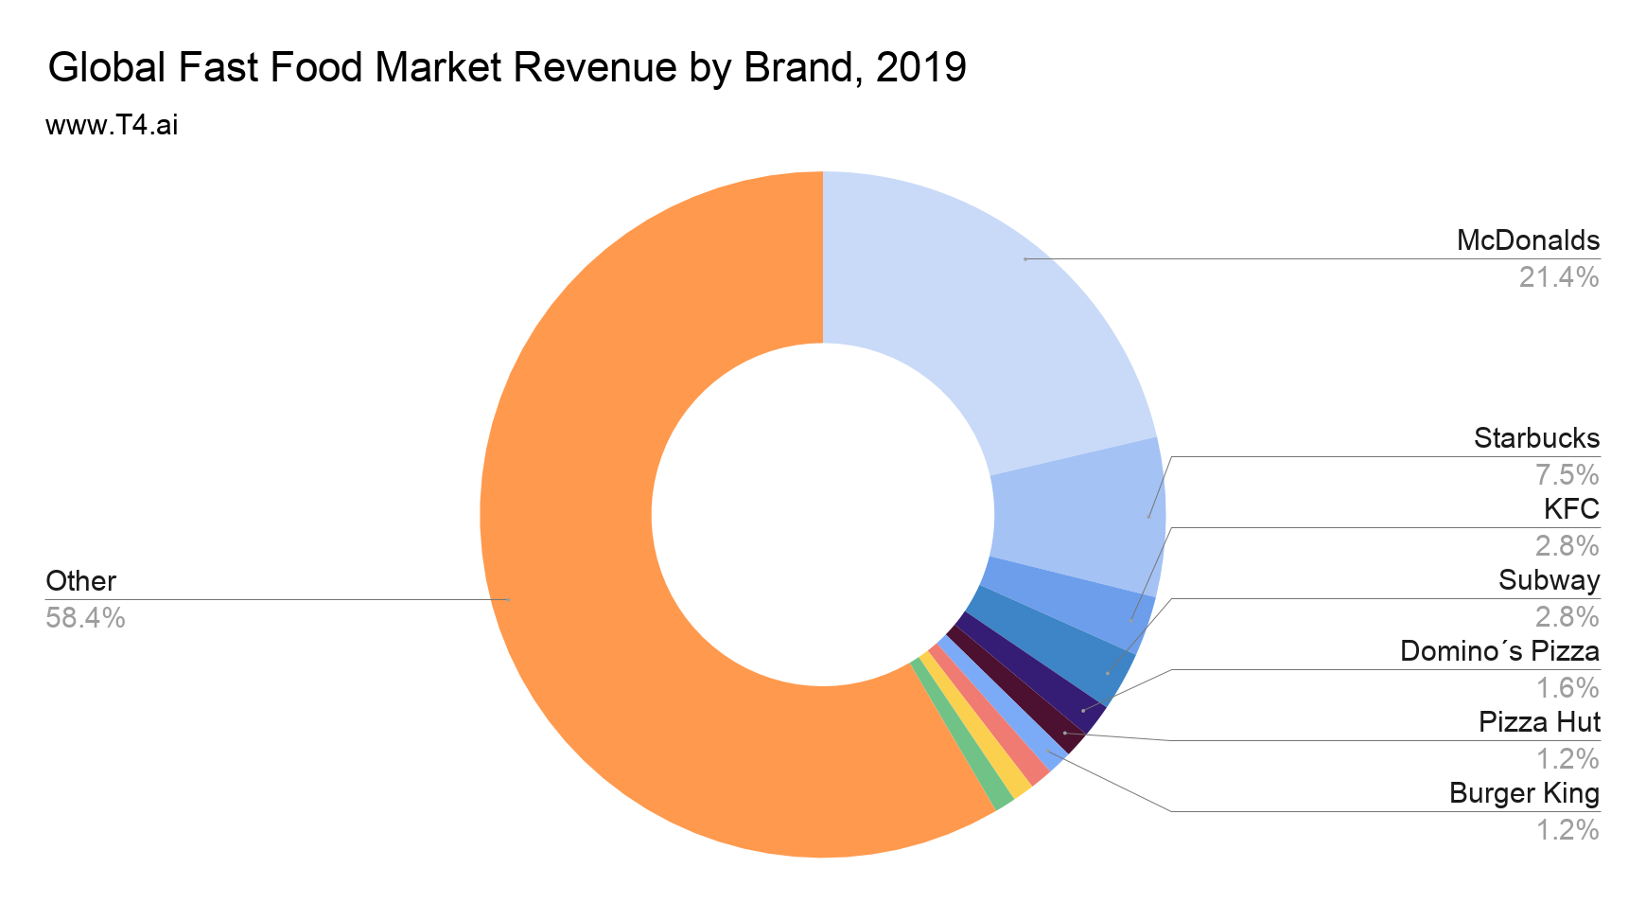

Identification of demand and market equilibrium

Factory affecting the demand
Price affecting the substitute
A burger may be made using a variety of delectable components. Because consumers are receiving the same features at a reduced cost, an increase in the burger's ingredient rate will likewise boost demand for the product as a whole. McDonald's is a firm that regularly raises the price of their cheeseburger in the street food market. Previously, the cheeseburger was 99p, but it is now 1.19 euros.
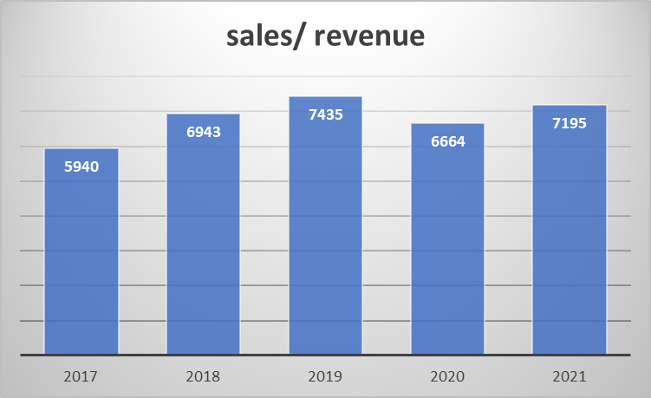
Flg 1: Sales and revenue
(Source: self-report, 2022)
This was the first time it occurred in the last fourteen years. According to the corporation McDonald's, the cost of a cheeseburger is increasing due to the growing rate of fuel. One of the primary causes of rising rates is not the price of gasoline, but instead the price of components and the rate of hyperinflation.
year | sales/ revenue
2017 | 5940
2018 | 6943
2019 | 7435
2020 | 6664
2021 | 7195
Table 01: sales /revenue
(Source: The Wall Street Journal, 2023)
Similar to McDonald's, Burger King is a burger firm that is raising prices in response to the latter's anticipated strong demand for its goods. Due to the growing demand for Burger King, the firm will be raising the price of its burgers by a small amount. Despite this, the burger's price hasn't gone up yet, which offers the company a leg up in terms of growing.
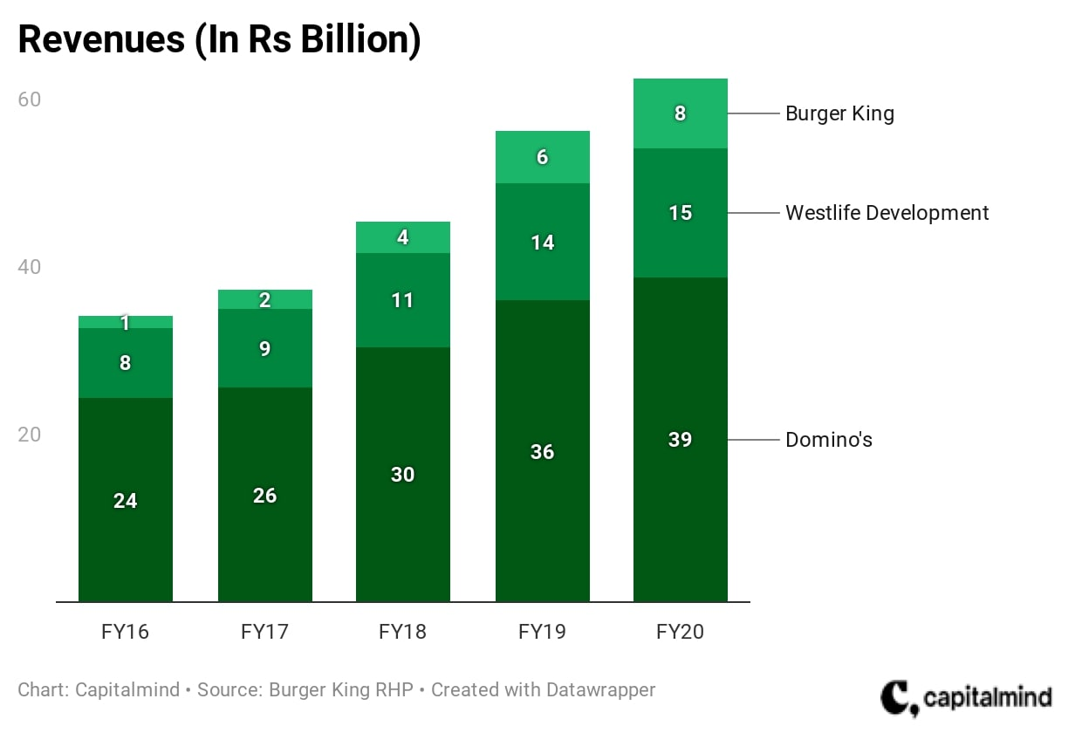
Flg 2: revenues of Burger King
(Source: self-report, 2022)

Prize of the complements
French fries and cold beverages are offered with Burger King burgers as a better complement to the meal. The demand for the good decreases in tandem with the product's growing price (Bughio et al, 2021). Customers can feel as though the meal they are consuming does not offer sufficient utility which can be used to write the related items. Burger prices are growing in the modern period due to increased ingredient costs. However, the cost of icy beverages has increased in the UK in the modern age; the price is listed here.
Years | % Change in RPI
2017 | -1.6
2018 | 4.9
2019 | 5.1
2020 | 2.7
2021 | 0.4
Table 02: % chance pf RPI soft drinks
(Source: Ons, 2022)
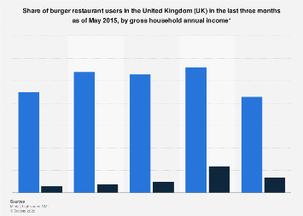
Flg 3: share of burger restaurant user
(Source: self-report, 2022)
Customer requests have decreased as a result of Burger King's increasing prices due to the rising cost of the components used in their products (Cranfield, 2020). According to the reporters, the average price of materials like cheese from well-known retailers like Tesco, Waitrose, and Sainsbury's has increased by 50%. This might potentially result in Burger King's ratings falling short of expectations.

Income of the customer
The company's operational process and the level of product demand are impacted by the customer's income rate. For most items, growing income rates will enhance consumer demand; nevertheless, if the good or service is subpar, there's a potential that rising income rates will result in fewer demands from customers. For five years running, data on the standard basis of the household's disposable income in the UK has been provided.
year | Mean equivalized disposable income | Median equivalized disposable income
2016/17 | 36621 | 30026
2017/18 | 36017 | 29308
2018/19 | 36397 | 29548
2019/20 | 37839 | 30762
2020/21 | 37622 | 31385
Table 03: Average and median disposable income of the UK households
(Source: Emily Andrews, 2023)

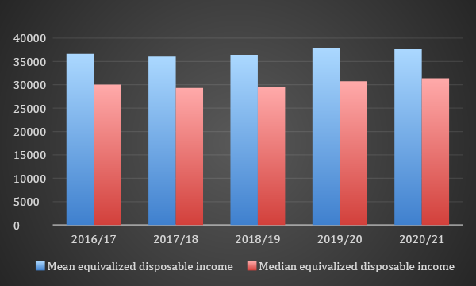

Flg 4: Bar graph of disposable income
(Source: Self-report, 2022)
The decline rate as observed in in revenue has shown that the demand of Burger King is declining at a slower rate.

Preference and taste of the customer
Customers' tastes have shifted for a few items. Customers' perspectives have shifted as a result of pricing changes, modifications to other items, and adjustments to product quantities. Additionally, quality, branding, and customer behaviour have all indirectly affected taste. Customer preferences and tastes shift, which necessitates product changes. For example, Burger King is now far more well-known than it was seven years ago, but its product tasted poorly and didn't live up to the company's values. As a result, the value of its goods kept declining and the share price fell, devaluing the business (Cranfield, 2020).
After a few years, the business was able to modify the conditions. It began to accept customer evaluations and offered consumers an incentive in exchange for an honest rating. Burger King's income has been generated by such a business model. The transparency method was also employed by the company. As a result of their actions in response to the unfavourable remarks made by customers, the company introduced a variety of new and improved machinery models to enhance the production process. In this way, the production pattern has assisted Burger King in growing its revenue. Burger King is the second-most popular fast food chain worldwide in the modern period.

Consumers' expectations of prize
The company's costs have been anticipated and the prices of its products have been adjusted in response to client demands for appropriate modifications. If people start to believe that the product's price will rise in the future, demand will rise along with it. However, if the cost price is predicted to fall rather than grow, consumer interest in the product will quickly decline. According to the perspective, Burger King has forecast that food prices would rise in the future, meaning that prices will rise in tandem with increases in the production of food. Burger King's goods will be impacted by both the rising rate of inflation and the increasing expense of gasoline. Additionally, the firm has been informed that the anticipated price increases have been made due to the ongoing increases in the cost of meat, cheese, wheat, spices, and various other grains. According to the company's prediction, the cost of the Burger King mega box would increase from 8% to 10%. One of the primary factors driving up the overall price of the goods is the ongoing rise in labour and sales costs. The prediction that Burger King's product prices would rise will encourage customers to buy burgers going forward. Because of this, the items are in high demand, as would be predicted (Alzoubi et al, 2020).

Demographics
Demographics that primarily illustrate the kinds of consumers it has affected and the needs for a certain commodity. The demand rate rises steadily as the number of consumers increases; conversely, a decline in client demand indicates a decrease in the rate. The corporation has been concentrating on advertising Burger King for over a year since it can draw in the majority of customers (Frye et al, 2020).
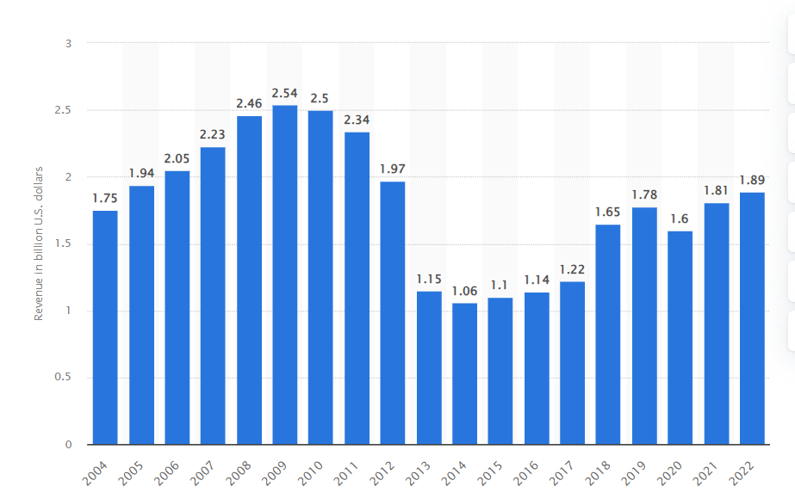
Flg 5: sales in the Burger King in the UK from 2013 to 2021
(Source: Statista, 2023)

Analysis of the demand curve

Impact of income effects
The term "income effect" describes how a company's customers influence the demand for particular items, for typical categories of commodities, The rate that demand rises will rise in tandem with an increase in the product's rate. With certain other items, consumers are making fewer demands as their money grows. At that point, they perceive themselves as wealthy, even when the product fails to live up to their expectations. Demand for free products is dependent on income for necessary items as well, therefore a little change in the income rate also affects product demand.
Burgers from Burger King are considered a form of opulent cuisine, and for individuals with lesser incomes, this is an instance of a product that they consume regularly. Therefore, as an individual's monthly wage increases, they will be able to obtain availability more easily, and as a result, consumer demand for the goodwill naturally rises at that time as well. The impact of UK customers' income on customer demand for Burger King is seen below.

Years | 2021 | 2020 | 2019 | 2018 | 2017
Group revenue(£m) | 7195 | 6664 | 7435 | 6943 | 5940
Dividends per share (Pence) | 9.8 | 9.1 | 9.76 | 9.5 | 9
Sales growth in the UK (%) | 29.74 | 17.67 | 26.34 | 21.75 | 30.20
Table 04: Revenue vs Dividend vs sales growth comparison
(Source: WSJ.com, 2022)
The table above displays Burger King's earnings for the last five years in the United Kingdom. The revenue rate was lower in 2020 due to the lockdown, and other factors included a slight decline in people's tie income and an increase in the unemployment rate in 2021. The company's dividend per share also decreased during 2020 and 2021. However, after 2021, there had been an enormous rise in demand for Burger King's products, as evidenced by the company's highly elastic sales growth. Pizza is an aspect of premium cuisine for a certain demographic, although the price isn't all that much more. Therefore, this will continue to be accurate and grow considerably higher if the income level has been declining along with a tiny portion of the client demand. Another component of this situation is the Burger King discount that was given. The rise in demand for Burger King's products has been significantly impacted by all of the above.

Impact of substitute effects
Burger King is a form of lavish but required meal; unlike wheat, rice, vegetables, and oats, numerous individuals do not eat it regularly. Even if the cost of the burger is somewhat affordable for those with lesser incomes, this is still an expensive meal. Since there are more options available than just burgers, there is an elastic increase in demand for Burger King. When Burger King offers extra promotions or discounts on its burgers, the demand for their food increases (Russell et al, 2019). The primary cause of this might be that consumers are unable to locate any comparable goods at identical prices as burgers. Therefore, the person believes that burgers are more readily available than other foods like pizza or burritos. Therefore, prices will rise in tandem with a decline in demand.
Years | Shares (%)
2017 | 75
2018 | 79
2019 | 82
2020 | 94.3
2021 | 96.4
Table 05: Share of Burger King sales ordered online in the UK between 2017-2021
(Source: Statista, 2022)
as seen in Table 5 Burger King's online sales rate has grown in the last several years. When the COVID-19 pandemic struck in 2020, the share percentage jumped to 94.3, which is a significant rise from the previous year's 82%. As to the company's statement, the primary cause of this was the increasing demand for commodities during the lockdown times on the internet. At the time, products from other businesses like McDonald's and Domino's did not offer the same level of enjoyment as a Burger King burger. One of the main causes of the price increase by the final day of the year 2021—the pie is shrinking—has been because of the business's increasing demand. During the COVID-19 pandemic, the UK's reduced VAT rates have not only helped businesses satisfy client needs but also improved sales rates.

Pricing Strategy of Burger King
There exist three distinct categories of pricing methods. They are skipping, entry, and neutral. The corporations aim to establish an amount that the client may accept based on neutral pricing. The need for items that are less expensive than those of competitors is highlighted by the penetration pricing procedure. The primary goal of the pricing skimming approach is to observe the highest price a client may pay for a product by looking at the price list (Teoh et al, 2023).
In the UK, Burger King is a corporation that manufactures hamburgers. The goods produced by the business are significantly more delicious and affordable. Burger King has a price penetration approach. In this approach, the method of selection is contingent upon the state of the market's supply, consumer demand, and the organization's rivals.
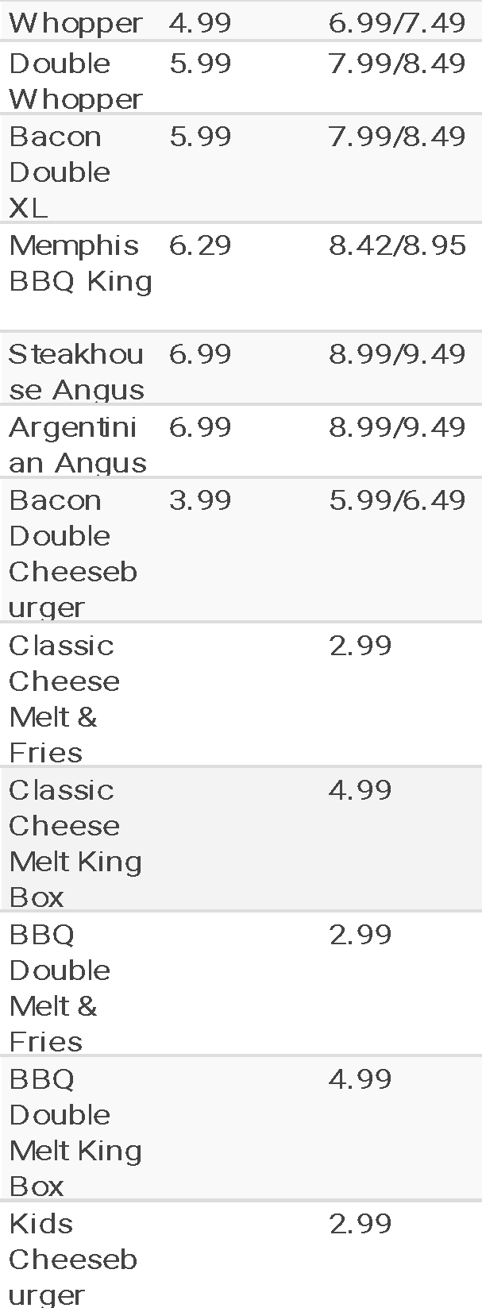
Table 06: Price list of Burger King UK
(Source: Burgerlad, 2022)

Conclusion
Some of the factors in this study have an impact on Burger King's demand, as evidenced by various numbers including sales and revenues among many other things. by working hard and developing stronger marketing abilities in recent years. With all these factors, the corporation has been able to produce a reliable client base that continues to desire more even after the time of Corona. Another factor that has contributed to the cost elasticity approach and the elasticity of income for demand is the impact of income. The business has benefited greatly, and with its current approach, it will rank among the top street food businesses globally.

Reference
Alzoubi, H., Alshurideh, M., Kurdi, B. and Inairat, M.J.U.S.C.M., (2020). Do perceived service value, quality, price fairness and service recovery shape customer satisfaction and delight? A practical study in the service telecommunication context. Uncertain Supply Chain Management, 8(3), pp.579-588.http://m.growingscience.com/beta/uscm/3932-do-perceived-service-value-quality-price-fairness-and-service-recovery-shape-customer-satisfaction-and-delight-a-practical-study-in-the-service-telecommunication-context.html.
Bughio, M., Khan, M.S., Mahar, W.A. and Schuetze, T., (2021).. Impact of passive energy efficiency measures on cooling energy demand in an architectural campus building in Karachi, Pakistan. Sustainability, 13(13), p.7251.https://www.mdpi.com/2071-1050/13/13/7251.
Burgerlad. (2023). Burger King menu prices - [updated] March 2023 - BK UK, Burger Lad®. Available at: https://burgerlad.com/burger-king-menu-prices-uk/ (Accessed: 14 December 2023).
Cranfield, J.A., (2020). Framing consumer food demand responses in a viral pandemic. Canadian Journal of Agricultural Economics/Revue canadienne d'agroeconomie, 68(2), pp.151-156.https://onlinelibrary.wiley.com/doi/abs/10.1111/cjag.12246.
Cranfield, J.A., (2020). Framing consumer food demand responses in a viral pandemic. Canadian Journal of Agricultural Economics/Revue canadienne d'agroeconomie, 68(2), pp.151-156.https://onlinelibrary.wiley.com/doi/abs/10.1111/cjag.12246.
Emily Andrews, (2023). Average household income, UK: Financial year ending 2022, Average household income, UK - Office for National Statistics. Available at: https://www.ons.gov.uk/peoplepopulationandcommunity/personalandhouseholdfinances/incomeandwealth/bulletins/householddisposableincomeandinequality/financialyearending2022#:~:text=Median%20household%20disposable%20income%20in,(ONS)%20Household%20Finances%20Survey. (Accessed: 14 December 2023).
Frye, W.D., Kang, S., Huh, C. and Lee, M.J.M., (2020). What factors influence Generation Y’s employee retention in the hospitality industry?: An internal marketing approach. International Journal of Hospitality Management, 85, p.102352.https://www.sciencedirect.com/science/article/pii/S0278431918310910.
Greenspan, R., (2022). Burger King’s Marketing Mix (4Ps) Analysis - Panmure Institute. [online] Panmore Institute. Available at: <https://panmore.com/burger-king-marketing-mix-4ps-analysis> [Accessed 14 December 2023].
Russell, C.A., Schau, H.J. and Bliese, P., (2019). Brand afterlife: Transference to alternate brands following corporate failure. Journal of Business Research, 97, pp.257-267.https://www.sciencedirect.com/science/article/pii/S0148296318303734.
Statista. (2023). Burger King’s revenue 2022, Statista. Available at: https://www.statista.com/statistics/266462/burger-king-revenue/ (Accessed 14 December 2023).
Teoh, K.B., Lew, T.Y., Gupta, S., Ang, J.W., Ang, H.H., Bong, A.L.L., Nazira, A., Zhafira, A., Chauhan, S., Pandey, S. and Liem, G.S., (2023). A Study of Customers’ Satisfaction at Burger King in Asian Countries. Journal of The Community Development in Asia, 6(3), pp.96-108.http://ejournal.aibpmjournals.com/index.php/JCDA/article/view/2545.
The Wall Street Journal. (2023). The Wall Street Journal. Available at: https://www.wsj.com/market-data/quotes/MCD/financials/annual/income-statement (Accessed: 14 December 2023).
Verdict Food Service. (2022). Burger King UK buys 12 new restaurants from franchise partners. [online] Available at: <https://www.verdictfoodservice.com/news/burger-king-uk-buys-restaurants-franchise-partners/#:~:text=The%20chain%20currently%20has%20around,are%20 majority%2Downed%20by%20 franchisees> [Accessed 14 December 2023].

