MSc Policing (Operational & Strategic Leadership)
Dissertation proposal 2023/2024
BMPO7007D

Student Name: Simon Belcher
Student Number 2116972
__________________________________________________________________
Research Question:
What are the most effective approaches that South Wales Police should adopt to address the effect of social media on policing incidents of serious disorder.
____________________________________________________________________________________
Research Aim:
This study seeks to research the nature and trends of social media posts on sites such as twitter and Facebook in relation to serious incidents of disorder in South Wales, with a focus on the riot in Ely, Cardiff in 2023. This will identify the impact that social media has had on the policing response of these events, including the use of social media platforms by the police themselves. The final critical aim will then be to identify the methods that South Wales Police and other police forces should use in the future, in relation to responding to social media commentary linked to events of significant disorder.

Research Objectives:
- Establish the content and volume of social media posts in relation to the Ely riot and how did South Wales Police respond to these posts in relation to their policing approach and communications strategy.
- Evaluate the effectiveness of the police response to the social media commentary and their own use of social media during times of disorder.
- Examine and assess approaches to responding to social media that are seen as being successful in England and Wales that have or could be applied to policing such events.
- Recommend effective approaches that South Wales Police and other forces should undertake in order to ensure that they maintain the confidence of the communities when dealing with incidents of serious disorder, where social media activity is significant.

__________________________________________________________________
Literature Review:
Although social media platforms are a twenty first century phenomenon, there are numerous journals and books that have been written in relation to the effective use of such platforms. Google scholar has over four million articles in relation to social media (Kaplan, A. and Haenlein, M., 2020 ). With sites, such as Facebook and Twitter (now known as X), becoming ever more prevalent and the police service relying on them to better engage with their communities and exploit intelligence opportunities, further research might identify how these platforms can effectively be used by the police to support their aims (Akhgar, 2019). Social media platforms, on many occasions, replace the formal press releases and have been used as two-way communication during times of crisis or critical incidents to both receive and give information in order to reassure communities and resolve the situation (Information Resources Management Association, 2019).

The police service has been effective at producing positive stories enhancing their reputation and confidence with the public but times of crisis, such as serious disorder, can undermine this confidence (Chermak, 2006) and the narrative is harder to control. The dynamic nature of social media has created difficulties for police in maintaining legitimacy and public confidence, which has resulted in significant investment in their media departments. However, this new kind of media management, as opposed to the traditional methods, can be more complicated and the police are having to manage a number of stakeholders, with different perspectives who are using and viewing social media through their own lens, (Greer, 2010).

There continues to be misinformation on social media that causes significant concerns and impacts on democratic establishments and bodies such as the police (Allcott, 2019). Platforms like twitter have facilitated the ability for the police to have two way dialogue with the public answering concerns in time of crisis and police forces have looked for direct feedback on their use of twitter during times of public disorder such as in the riots in 2011 in Manchester ,where Greater Manchester produced tweets which led to feedback being sought from Twitter users, who were positive around the way that the force embraced the platform but also showed areas for improvement. (Gascó, 2017).

An initial literature review, has negated initial concerns around lack of research that could be referred to on the subject matter, as there is evidence of a good volume of academia available to assist studying the use of social media linked to policing, some of which specifically focuses in on the policing of riots and public order.

____________________________________________________________________________________

Methodology:
The research methodology will be based on the “research onion” (figure 1) as described by Saunders et al (2019) .
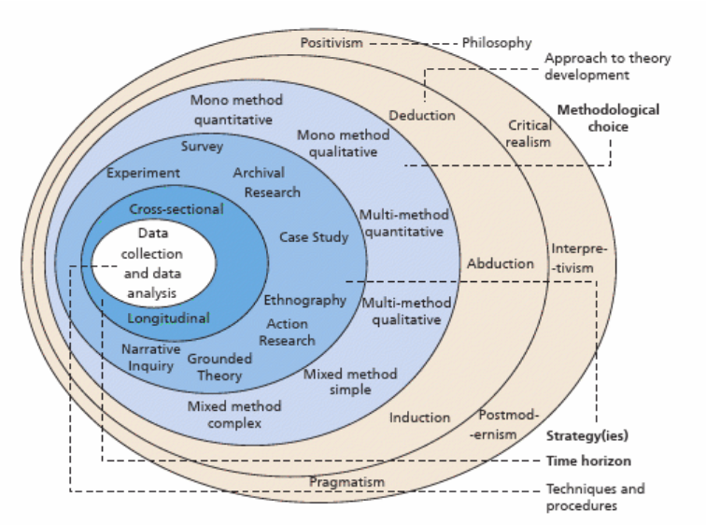
Figure 1.

This methodology will be adopted due to the onion being “an all-inclusive framework, it forces researchers and academia to address all relevant research dimensions in their research endeavours in a simple, clear and logical way” (Steenkamp, 2020, p. 313).

The overriding philosophy will be one of pragmatism. Interpretivism was a serious consideration, due to this research having a focus on social media users and perceptions, which Interpretivism lends itself to looking at in relation to relationships, language and viewpoints (Kincaid, 2023). However, this study aims to recommend specific actions and tactics for police forces to use going forward, operating in a fast pace dynamic environment of social media. The pragmatic approach revolves around intervention as opposed to observation and using knowledge to recommend actions that will lead to change on organisations. (Goldkuhl, 2012). There will be elements of interpretivism, but the overriding philosophy will be one of pragmatism.

The approach taken will be an inductive one, as the area is still relatively new and the aim of this research is to recommend effective use of social media when dealing with serious disorder, and being open to what those recommendations are, as opposed to starting with a fixed view. The work will use a mixed method technique , which complements the pragmatist philosophy as the combining of qualitative and quantitative methods allows for practical issues and ever changing demands to be accounted for (Denscombe, 2008), which as previously noted is applicable to policing riots and social media impact. There is a danger that in using this mixed method that the quantitative approach could become dominant and not give due regard to the qualitative approach, but this should be negated by framing the right research question (Baran, 2020).

The mixed method approach will consist of the use and analysis of academic research in relation to wider communications between the public and police in times of disorder but will also specifically focus in on the last fifteen years, where social media has been more prevalent in the context of riots in England and Wales since 2011.

The analysis of academia studies will be supplemented by a case study of the Ely riot in 2023, which will include interviews with decision makers and staff involved, within the police service. The riot developed after the tragic death of two young persons with social media being a prominent theme, and also included posts from South Wales Police and senior stakeholders. By using this case study as a central component of the research, there will be no manipulation of instances, which can happen in experiments and a case study will give powerful real-life context that other methods could not obtain (Dul, 2008).

However quantitative research will also be utilised to ensure that all relative stakeholders are able to contribute, as time pressures will not allow all involved in the case study to be interviewed. There will be stakeholders such as corporate communication officers, local policing inspectors and senior community representatives who may not have been directly involved in the case study but would have insightful views on either the riot in Ely or indeed wider suggestions on what approaches should be taken in the future.

The questionnaires will also be sent to public order commanders and communication leads in forces throughout the England and Wales, to ascertain if experiences are consistent across England and Wales. Although it is important to understand how participants feel in relation to the police use of social media, it is hoped that the results will show a consensus of support for certain actions or recommendations and as such the questions will be designed so that they are easily understood but also take out any bias that participants may have about social media, as the study is about the effect of social media and how police should respond, not about the platforms themselves.

Due to the short timescale since the Ely riot, there will need to be awareness when conducting the research on the different perspectives of those involved and ensuring that the questions are respectful (Bickman, 2009) and not apportioning any blame.
The research will not focus on the incident that led to the causes of the riot but on social media during that riot, and indeed on other riots that have occurred since 2011.

___________________________________________________________
Proposed timeline:
Activity | Duration (weeks) | Month and Abstractions
Preparation around structure and clarity around aims and objectives | 3 | December-January 2024  (Excluding Christmas Week)
Literature Review | 6 | January/February  (I am away and on leave for 1 week in February, my wife’s 50th Birthday). Also, Gold commander for Six Nations Rugby fixture in addition to day role.)
Preparation of Research Methods | 2 | March  (Also, Gold commander for Six Nations Rugby fixtures in addition to day role.)
Case Study | 4 | March/ April  (I am on leave on first week of April and will build this in as a rest period)
Data Collection via Questionnaires and Interviews | 4 | April/May
Analyse Data and Findings and Conclusion | 4 | May/June  (Abroad 2 weeks beginning of June)
Proofread and finalise study with recommendations | 2 | June
Submission due | N/A | 3rd July 2024

__________________________________________________________________
Anticipated Outcomes:
This project is seeking to produce clear recommendations on what approaches should be considered by South Wales Police in relation to how to manage social media in relation to dealing with serious public disorder. The aim is that this work will produce evidence-based guidance available to social media teams and police public order commanders, that they can utilise as part of their strategies or tactical options. It would also be a positive outcome if this guidance assisted other police forces and if also the College of Policing adopts findings from the study.

__________________________________________________________________
References

References
Akhgar, B. B. P. a. L. G., 2019. Social Media Strategy in Policing From Cultural Intelligence to Community Policing. First ed. s.l.:Springer International.
Allcott, H. G. M. a. Y. C., 2019. ‘Trends in the diffusion of misinformation on social media’,. Research & politics, 6(2).
Baran, M., 2020. Applied social science approaches to mixed methods research.. Pennsylvania: IGI Global.
Bickman, L. a. R. D., 2009. The SAGE handbook of applied social research methods. 2nd ed. Los Angeles : Sage.
Chermak, S. M. E. a. G. ,. J., 2006. Media coverage of police misconduct and attitudes toward police.. Policing, 29(2), pp. 261-281.
Denscombe, M., 2008. ‘Communities of Practice: A Research Paradigm for the Mixed Methods Approach’. Journal of mixed methods research,, 2(3), p. 270–283.
Dul, J. a. H. T., 2008. Case study methodology in business research. Oxford: Butterworth-Heinemann.
Gascó, M. e. a., 2017. ‘What do citizens communicate about during crises? Analyzing twitter use during the 2011 UK riots’. Government information quarterly, 34(4), p. 635–645.
Goldkuhl, G., 2012. ‘Pragmatism vs interpretivism in qualitative information systems research’. European journal of information systems, 21(2), pp. 135-146.
Greer, C. a. M. E., 2010. ‘WE PREDICT A RIOT?: Public Order Policing, New Media Environments and the Rise of the Citizen Journalist. British journal of criminology, 50(6), pp. 1041-1059.
Information Resources Management Association, 2019. Police science : breakthroughs in research and practice (2019). .. Pennsylvania: IGI Global.
Kaplan, A. and Haenlein, M., 2020 . ‘Rulers of the world, unite! The challenges and opportunities of artificial intelligence’. Business horizons, 63(1), p. 37.
Kincaid, H. a. B. J. v., 2023. The Oxford handbook of philosophy of political science- Chapter 11. New York,: Oxford University Press..
Saunders, M. L. P. a. T. A., 2019. Research methods for business students. 8 ed. . Eighth edition.: Pearson..
Steenkamp, N. E. H. a. P., 2020. A Methodological Blueprint for Social Sciences Research – The Social Sciences Research Methodology Framework. The International Conference ‘The European Integration - Realities and Perspectives, 15(1), pp. 304-325.

