Religious Significance of Ancient Artefacts in
The Nok Culture of Nigeria
Introduction
Sub-Saharan Africa is home to a rich diversity of ancient cultures, each with unique worldviews, religious systems, and material expressions of belief. Among these, the Nok culture of central Nigeria is one of the earliest known civilisations in the region, renowned for its sophisticated terracotta sculptures, dating from approximately 1000 BCE to 200 CE (Baum, 2024, p. 175). These artefacts are among the earliest examples of figurative art in Africa, reflecting early African societies’ spiritual and cosmological beliefs (Rupp, et al., 2005, p. 284). The symbolism and stylistic features of Nok artefacts suggest a profound religious importance, rooted in ancestral worship and ritual practices (Baum, 2024, p. 176).
Historical Background of the Nok Culture
The Nok culture first came to scholarly attention in 1944, when British archaeologist Bernard Fagg discovered a series of extraordinary terracotta sculptures near the village of Nok, located in central Nigeria (Franke, 2016, p. 258). These early findings marked the beginning of systematic archaeological interest in one of West Africa’s most ancient and artistically sophisticated cultures.
Subsequent excavations at sites such as Taruga, Samun Dukiya, and Katsina-Ala revealed that the Nok culture extended far beyond the original discovery site. These areas yielded not only additional terracotta sculptures, often similar in style and form, but also tools, pottery, and metallurgical debris (Rupp, et al., 2005, p. 284). Fagg’s discovery not only unveiled a lost artistic tradition but also revealed new insights into early settled societies, technological innovation, and the cultural complexity of sub-Saharan Africa (Rupp, et al., 2005, p. 284).
The village of Nok is located at the base of the western escarpment of a chain of granite hills on the Nassarawa Tableland, also known as the Kafanchan Plateau. This region, rich in iron ore and other natural resources, provided an ideal setting for the development of early iron smelting technologies, which the Nok people are believed to have pioneered (Fagg, 1969, p. 44). The use of radiocarbon dating and thermoluminescence analysis has aided in establishing the culture’s broad chronological span, confirming its place as a formative Iron Age society in West Africa (Rupp, et al., 2005, p. 284).
Although no written records from the Nok period exist, material evidence has inferred that the Nok culture likely had a complex social structure based on the sophistication of their artistic and technological achievements. The remarkable craftsmanship of the terracotta figures, combined with evidence of specialised labour and long-distance trade, suggests the presence of social hierarchies and a ritual or spiritual dimension to everyday life. However, the social and political organisation of the Nok remains largely speculative, with no definitive evidence to confirm such structures (Rupp, et al., 2005, p. 284).
Nok history remains incomplete, largely due to extensive looting of archaeological sites during the mid-20th century, where numerous artefacts were removed without proper documentation and sold into private collections or international museums. This loss has made it extremely difficult for researchers to accurately reconstruct aspects of Nok society, including its belief systems and social organisation (Franke, 2016, p. 260).
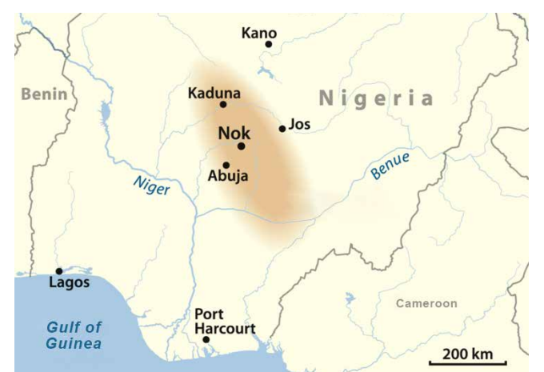
Nevertheless, despite these challenges, ongoing excavations and interdisciplinary research continue to shed light on Nok society’s innovation and cultural expression. The significance of the Nok tradition lies not only in its contributions to early West African art and spirituality but also in its role in the broader narrative of Iron Age developments across the continent (Rupp, et al., 2005, p. 289).
Figure 1: Map depicting the location and spread of the Nok Culture in Nigeria (Breunig, 2022).
Ancient Artefacts of the Nok Culture
The sophistication of Nok society is most vividly captured in its surviving artefacts, particularly its terracotta sculptures. The culture's use of iron smelting technology provides crucial insights into the society’s artistic, technological, and religious practices. The Nok culture is renowned for its distinctive terracotta sculptures, primarily crafted from clay. The Nok people are credited with being among the earliest African societies to master iron smelting and blacksmithing, which allowed them to create tools and striking works of art (Baum, 2024, p. 175).
These terracotta sculptures take the form of humans and animals, though human figures are the most prominent. The figures vary in size, ranging from small fragments to life-sized heads and bodies, and often exhibit exaggerated facial features such as large triangular eyes, elaborate hairstyles, and prominent lips and noses (Shaw, 1981, pp. 155-157). These figures are fascinating due to the unique treatment and placement of their facial features, such as the perforations for pupils, geometric representations of eyes and eyebrows, and the distinct rendering of the head, nose, nostrils, and mouth (Fagg, 1994, p. 82). These facial features may reflect aesthetic preferences and hold symbolic significance, with the large eyes representing spiritual vision or the ability to perceive the spiritual realm (Baum, 2024, p. 25).
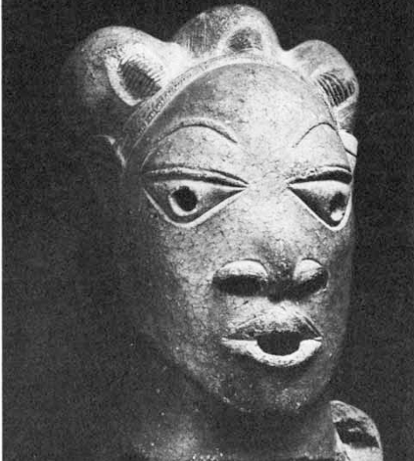
Many of these sculptures also display intricate body adornments, including jewellery and patterned garments, possibly representing individuals of social or spiritual importance (Lei, 2024, p. 3). These adornments could signify spiritual leaders or ancestors, linking the figures to practices of ancestor worship. These figures may have served as mediums for connecting with the spirit world, helping to maintain a spiritual balance and inviting the protection of ancestral spirits (Baum, 2024, p. 32).
Figure 2: Human terracotta figure from the Nok culture in Nigeria (Shaw, 1981, p. 160).
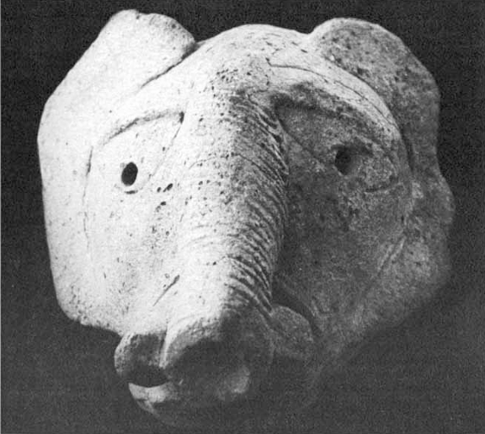
Although less common, Nok terracotta art sometimes includes animal figures. The animal figures are often integrated with human figures, suggesting a potential spiritual or symbolic connection. Such figures may have been associated with specific qualities like strength, wisdom, or protection, further deepening the spiritual significance of the figures (Baum, 2024, p. 174).
Figure 3: Animal head terracotta figure from the Nok culture in Nigeria (Shaw, 1981, p. 166).
The postures of the figures take different forms, sometimes seated, kneeling, or standing, which may add another layer of symbolic meaning, potentially denoting roles in rituals or representing different levels of spiritual hierarchy (Shaw, 1981, p. 160).
Though the exact purpose of these figures remains ambiguous, the design and quality of these objects suggest that they were valued for more than just their practical use in everyday life. These figures were likely used in religious ceremonies, possibly related to ancestor worship, fertility or the natural world, highlighting the intimate relationship between art and religion in Nok society. The combination of clay figures, iron tools, and ritual objects illustrates a society where art and religion were deeply intertwined, with material culture serving both as a means of artistic expression and a tool for spiritual engagement (Baum, 2024, pp. 174-175).
Fertility, Healing, and the Natural World
The religious practices of the Nok culture likely centred on maintaining harmony between the human, spiritual, and natural realms. Although direct evidence is limited due to the culture’s reliance on oral tradition, the symbolic characteristics of terracotta sculptures and their archaeological contexts suggest that these artefacts likely played a role in broader religious practices concerned with fertility, healing, and the natural environment.
Thurstan Shaw has proposed that the Nok terracotta figures may be best understood as ritual objects used in fertility-related cults, concerned with promoting the productivity of the land (Baum, 2024, p. 175). During this period, fertility, including male and female, was likely a central concern of Nok spiritual life as successful crop growth, reproductive health, and community continuity were critical for survival. Some of the terracotta sculptures, specifically those depicting robust human figures or exaggerated reproductive features, may have been used in rituals dedicated to fertility deities, ancestral spirits, or mediators believed to influence the forces of nature (Baum, 2024, p. 178). Fertility deities, often conceptualised as gods or goddesses, may have held particular symbolic importance to represent childbirth, abundance, and the generative power of the earth. These artistic representations suggest a spiritual emphasis on life-giving forces, aligning with broader African traditions in which fertility is closely linked to divinity and ancestral blessing (Baum, 2024, p. 182).
Healing likely held spiritual and physical significance in Nok society, reflecting a holistic worldview in which physical health, spiritual balance, and environmental harmony were deeply connected. In many African religious systems, illness was often interpreted not solely as a physical condition but as a disruption in the spiritual or social order, affecting the individual and the community. Healing rituals may have involved offerings, invocations, or the use of symbolic objects to appeal to ancestral spirits or deities associated with restoration and protection (Baum, 2024, p. 174).
The natural world was a vital force woven into the Nok people’s spiritual and religious practices. The fertility of the land, the cycles of the seasons, and the relationship between humans and the earth were fundamental to the Nok community. Archaeological evidence suggests that they may have believed in the sacredness of certain natural features, such as rivers, mountains, and forests, which were often seen as inhabited by spirits or deities (Baum, 2024, p. 175). These landscapes were likely integral to Nok rituals, with sacred spaces possibly marked by terracotta figures or other symbolic objects. Representing humans and animals, the terracotta figures may have symbolised the living forces of nature, placed in agricultural fields or near natural features to invoke protection and ensure the continued fertility of the soil. The Nok people’s understanding of the natural world was not only ecological but deeply spiritual, with the earth acting as both a provider and a powerful spiritual entity (Baum, 2024, p. 25). Together, fertility, healing, and nature formed an interconnected triad within Nok religion, invoked through rituals, symbolic representations, and spiritual mediators to ensure the well-being of individuals and the community as a whole.
The Nok culture of central Nigeria offers significant insights into early African spiritual and artistic traditions. Renowned for its distinctive terracotta sculptures, the Nok people crafted figures that likely served religious purposes, deeply intertwined with their beliefs in ancestor worship, fertility, healing, and the natural world. Despite challenges in fully reconstructing their social structure, ongoing research continues to illuminate the profound cultural and religious contributions of the Nok culture to the broader history of Africa.

For Further Reading
Baum, R. M. (2024). Ancient African Religions: A History. New York: Oxford Academic.
Boyi, J. M. (2025). Nok Terracotta Sculptures: A Reflection of Ancient Ideology and Philosophy Found in the Earlier and Recent Discovered Sculptures. International Journal of Innovative Research in Arts, Education and Technology, 3(1), pp. 10-21.
Fagg, A. (1994). Thoughts on Nok. African Arts, 27(3), pp. 79-83+103.
Fagg, B. (1969). Recent Work in West Africa: New Light on the Nok Culture. World Archaeology, 1(1), pp. 41-50.
Franke, G. (2016). A Chronology of the Central Nigerian Nok Culture 1500 BC to the Beginning of the Common Era. Journal of African Archaeology, 14(3), pp. 257-289.
Lei, Y. (2024). An Archaeological Overview of Nok Terracotta Sculptures. SHS Web of Conferences, Volume 193, pp. 1-4.
Rupp, N., Ameje, J. & Breunig, P., (2005). New Studies on the Nok Culture of Central Nigeria. Journal of African Archaeology, 3(2), pp. 283-290.
Shaw, T. (1981). The Nok Sculptures of Nigeria. Scientific American, 244(2), pp. 154-167.

