
ACBA6010_CW2
Development Appraisal Joseph Goodrum

March 13, 2026

Contents
Introduction 2
Development plot 2
Proposal 4
Desktop survey 4
Proposed development risk register 5
Proposed development opportunities 7
Case studies 8
Appraisal 9
Ground internal floor area. 9
Demolition costs. 10
Building costs. 10
Professional fees. 10
Land purchase. 11
Surveys. 11
Landscaping. 11
Planning application. 12
Overheads and Profit. 12
Contingency/risk. 12
Marketing. 13
Finance. 13
Sale price. 14
ROI. 14
Opportunities. 15
Appraisal conclusion 16
Appendix 18
References. 33

Introduction

This report aims to produce a positive or negative appraisal of a proposed two-building residential development located in Gower, Swansea. The appraisal evaluates whether the development should be undertaken based on the risks, costs and potential opportunities associated with the development.
The report reviews case studies of similar developments and assesses the development risks and opportunities to reinforce the appraisal outcome.

Development plot

The proposed development plot is in the village of Slade, Gower, Swansea SA3 1NA. The current building plot consists of an existing three-bedroom dwelling named Haere-Mai, shown in Figures 1 and 2, and is currently listed for sale at £600,000.00. This value is used in the calculations within this document. The condition of the existing building is poor, and the plot is overgrown with a variety of plants and trees (Zoopla, no date a).
Figure 3 below shows historical sale prices for the village of Slade, indicating that properties in the area achieve a premium price, with very few properties being sold in the village. This suggests strong demand for higher-value properties in the area.

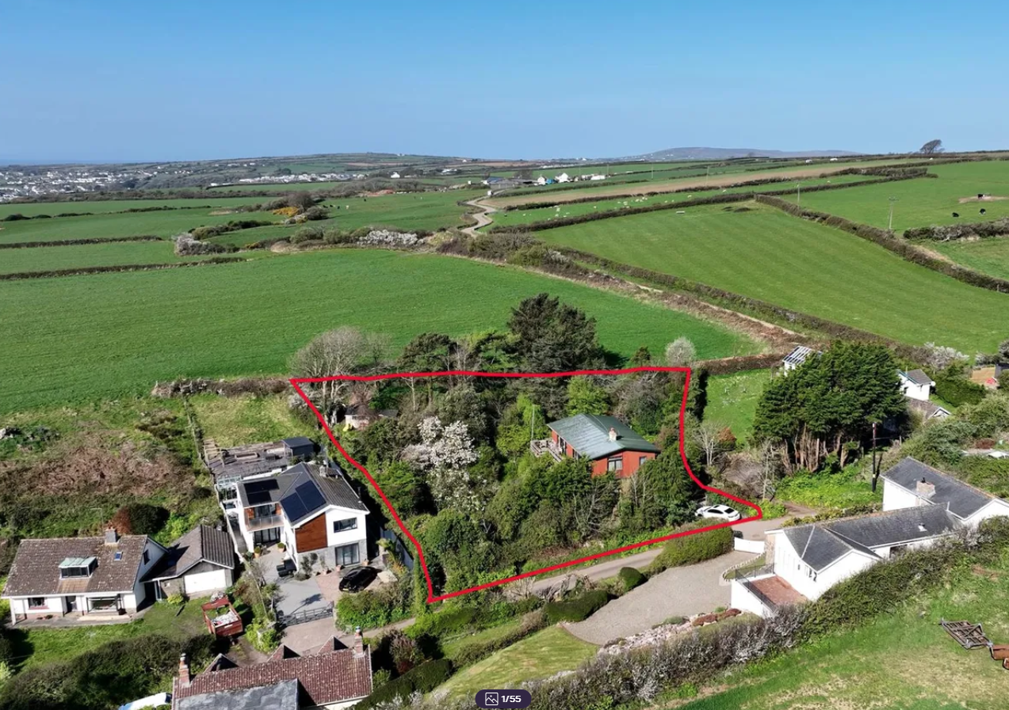
Figure 1. View of proposed building plot (Zoopla, no date b).

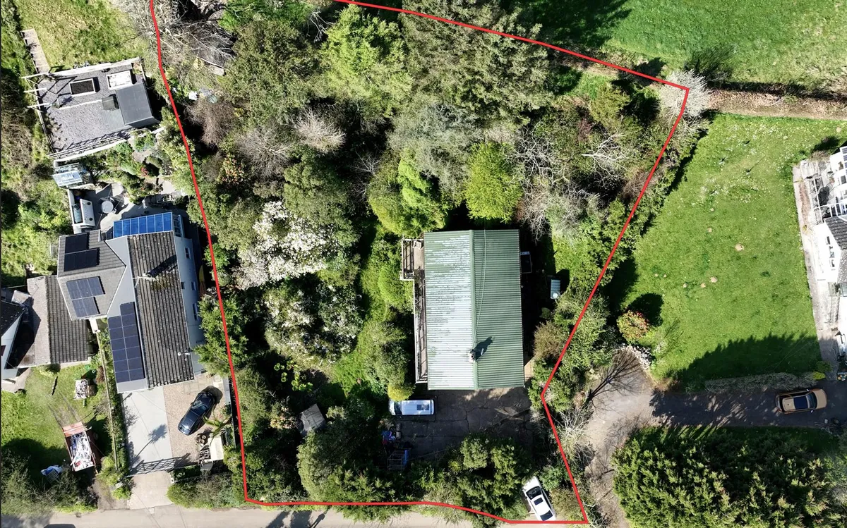
Figure 2. plan view of building plot (Zoopla, no date c).

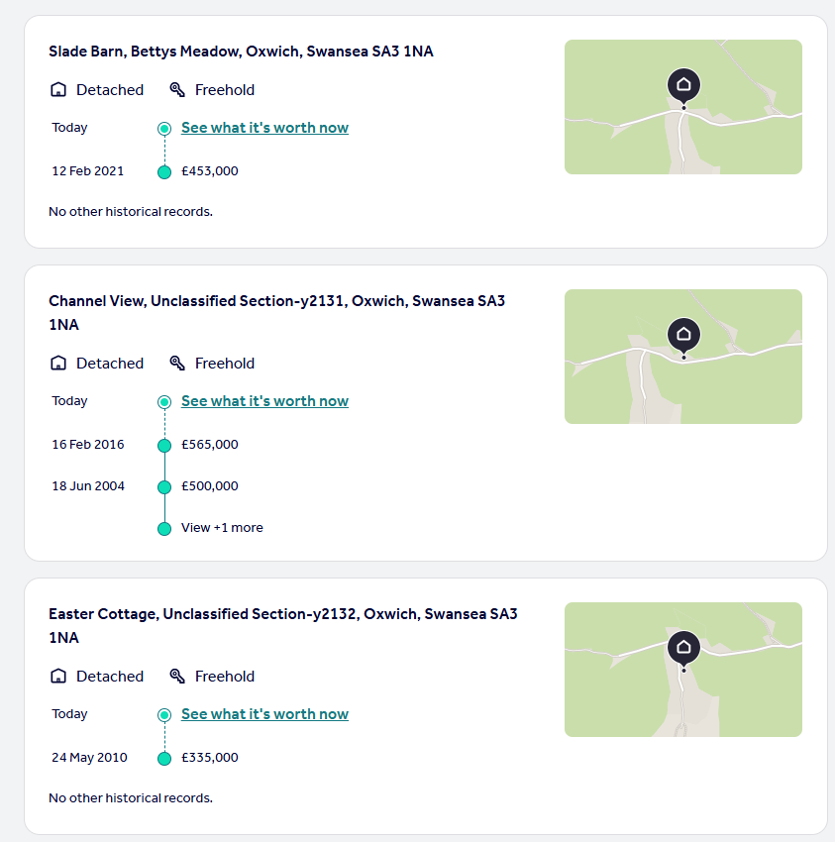
Figure 3. Sold house prices in Slade, Gower (Rightmove, no date a).

Proposal

The proposal requires the existing building to be removed, including the disposal or reuse of demolition waste. The works also include levelling the land for the new structures, constructing two new high-value residential dwellings and outbuildings, and landscaping the two new plots.

Appendix A shows the proposed new building orientations along with the outlines of the new plots on the existing single plot. Each building is proposed to be offset from each other to maximise the south sea views to attract a premium price point.

Appendix B shows the architect’s proposal for the exterior and layout of each building. The new residential buildings will be contemporary-style detached properties. The plans and elevations demonstrate the modern architecture of each building.

Each property will be two storeys high with a flat roof and will consist of four bedrooms. Each property will also feature a detached timber single-storey outbuilding/garage located to the north.
The design of each property will include timber cladding, a slate roof and aluminium windows. Each property will be finished to a high standard in terms of performance and materials to attract a premium price that reflects the exclusivity of the area.

Desktop survey

The proposed plot has undergone a desktop survey to evaluate the potential costs and risks to the development, which are discussed later in this document. Appendices D to K show the data obtained during the survey.

Appendices D & E highlight that the development plot is located within the Gower Area of Outstanding Natural Beauty (AONB).
The plot is outside any conservation area; however, a conservation area is located nearby.
There are no tree preservation orders (TPOs) within or adjacent to the development.

Appendices F, G and H indicate that the site was not previously developed or used for non-residential purposes prior to the existing building.
The geology of the plot comprises till rather than artificial deposits, and the plot lies in the vicinity of historical mine workings that are common in the Gower area.

Appendices I, J, K, show that the plot is located within a high Radon area with a higher-than-average annual rainfall but with a low to medium flood risk.

Proposed development risk register

Table 1 below shows the risk matrix for the proposed development. It assesses the data obtained from the desktop survey and known construction activity risks and provides mitigation measures for each risk.

Risk Number | Risk | Risk description | Risk H/M/L | Action | Post action risk H/M/L
1 | Planning application | Currently only pre-app submitted to the LPA and returned, appendix C. request for design changes. | H | Conduct surveys and action requested design changes submit full plans to the LPA. Engage with local planning officer to build relations. | M
2 | AONB | The development is located within the AONB potential delays to planning, opposition to the development and opposition to the proposed design. | H | Early engagement with the neighbours and stakeholders, share designs and potentially offer improvements to neighbours’ properties. | M
3 | Conservation area | Adjacent to a conservation area, planning policy HC2 design of the building may conflict with this policy highlighted appendix C. (Welsh government, 2024) | H | Same actions as risks 1 & 2. | M
4 | Local mine workings | Potential for subsidence during construction. | M | desktop survey indicates stable ground, undertake trial borehole to confirm geology, speak to neighbours to confirm if there has been any subsidence. | L
5 | Demolition of existing building | Potential for asbestos to be present throughout existing structure, potential complaints from neighbours. | M | Undertake refurbishment and demolition survey of the building include costs in the appraisal calculation, allow contingency costs to remediate potential asbestos. | L
6 | Ecology | potential for protected species, plants/trees in overgrown garden. | M | conduct ecological survey of the plot follow pre app guidance on species and trees. | M
7 | Radon | Development is within a high radon area. | M | Include Radon control measures in the design phase of the building. Include costs in appraisal. | L
8 | Weather | Development is in a coastal area with high rainfall, potential delays due to inclement weather, building materials need protecting from elements. | M | Ensure project planning has productivity factor included for bad weather, secure an undercover material storage area, engage local farmer for use of land for storage and coordinate deliveries with the project programme. | L
9 | Access | constrained site access/egress due to the rural location of the development. | L | coordinate deliveries and work fronts to not overload site, negotiate with farmer for site welfare and logistics storage on land adjacent to the construction site. | L
10 | Finance | Purchase price of the land is £600,000.00 plus development costs risk to project profitability depending upon the finance required to fund the development. | H | explore different finance models, sell in advance of construction to repay loans early, sell plots with planning and do not develop, factor in interest payments into appraisal | L
11 | Housing market | Development will take two years to complete, potential for housing market to stall or decline. | H | Include housing market forecasts in appraisal. | L
12 | High quality specification | increase in building material costs, potential specialist resources required to complete the property, delays to the completion due to high quality standards, greater build quality monitoring required. | M | early engagement with specialist contractors, identify critical resources and build resources and install times into the project programme. Allow sufficient management time to conduct inspections of work being completed. | L
13 | Neighbours | constrained site leading to conflict with neighbours over access, overlooking development leading to objections, complaints for dust and noise during construction. | M | early engagement with neighbours, do not overload site with material and resources, utilise storage away from site and time deliveries to not overload local roads. Employ dust suppression methods and limit working hours with high noise activities. | L

Table 1. Risk matrix.

Proposed development opportunities

Table 2 below shows the opportunity matrix for the proposed development. It assesses the data obtained from the desktop survey and potential construction opportunities, and captures these in a table format.

Risk Number | Opportunity | Opportunity description | Opportunity H/M/L | Action | Post action opportunity H/M/L
1 | LPA relationships in Gower AONB. | Fostering collaborative relationships with the local LPA from working together to deliver a successful development in a sensitive area. | M | Engage with LPA, look to adopt suggestions and provide all necessary documentation for review. Accommodate elements that are sensitive to the AONB | H
2 | Further developments. | chance to complete further developments if the project is successful. | M | Use project as advertising, update company website using the development as a case study. Promote the ability to build high specification properties using various media platforms. | H
3 | Welsh housing market. | Strong performance in the Welsh housing market compared to the rest of the UK. | M | Analyse market data on the performance of the Welsh housing market to forecast the likelihood of desirability and performance of sales compared to the rest of the UK. | H
4 | Alternatives to traditional business model | Raising income from the development in alternative ways. | H | Explore alternatives such as selling the plots with planning permission and not building, selling the buildings before starting construction. | H
5 | Green development grants. | opportunity for funding for sustainable developments in Wales. | L | Explore various grants for incorporating sustainable elements in the developments. | M

Table 2. opportunities matrix.

Case studies

Shearwaters, Northcliffe, shown below in Figures 4 and 5, is a premium new-build development in West Wales and demonstrates an appetite for high-end residential properties. The property is located within the wider area of Northcliffe, which features multiple modern buildings that are not in keeping with the local vernacular (Carreg, 2026a; Carreg, 2026b; Carreg, 2026c). Although the area is not within an AONB, it is within the Pembrokeshire Coast National Park, where planning applications are subject to stricter controls.
This provides confidence that the risk of planning rejection is low, provided the local planning authority (LPA) is engaged throughout the project lifecycle, as highlighted in the risk register.
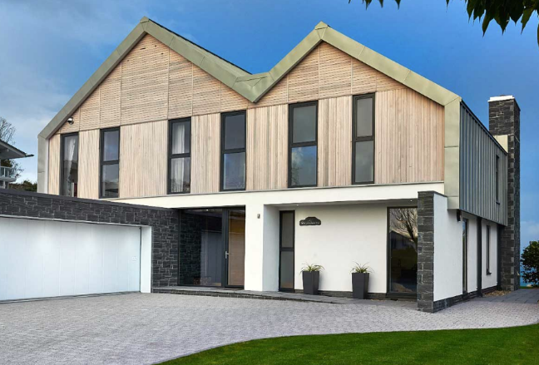
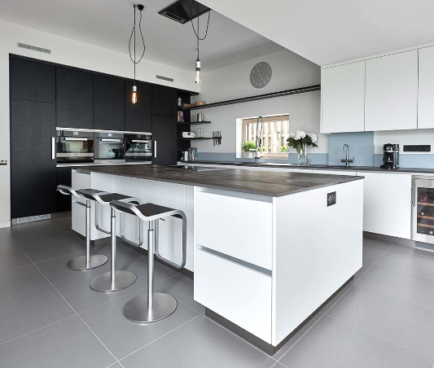
Figure 4. Shearwaters exterior. Figure 5. Shearwaters interior

Compass Cottage, Reynoldston, shown below in Figures 6 and 7, is located in the immediate vicinity of Slade within the Gower AONB. The property has been completed to a high standard and is similar in size to the proposed development in terms of occupancy and floor area (Rightmove, no date b; Rightmove, no date c).
The property is currently advertised for a sale price of £750,000.00. Using this information, together with the projected sale price of Shearwaters, a reasonable assessment of potential returns for the proposed development can be made (The Move Market, 2025a).

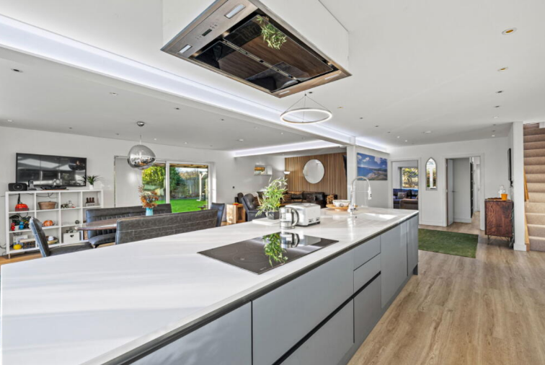
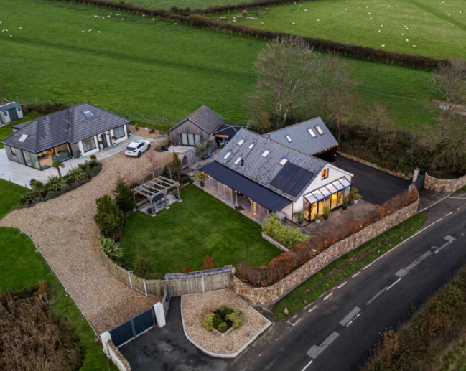
Figure 6. Compass Cottage exterior. Figure 7. Compass Cottage interior

Appraisal

The appraisal for the development is set out below. It considers the known financial costs, risks and opportunities to provide an informed recommendation on whether to proceed with the development, together with any recommendations for the project.

The order of cost estimate is based on RICS NRM guidance. As the project is at RIBA Plan of Work Stage 0, the Floor Area Method is used to calculate the order of cost estimate (RICS, 2021).

The calculation for the floor area method is.

Building works estimate = Gross internal floor area x cost/m² of GIFA for building works.

Ground internal floor area.

The costs per m² of GIFA are taken from the Spon’s Architects’ and Builders’ Price Book (2023 edition). The calculation adjusts for regional variation and inflation to 2025. The cost per m² includes preliminaries but excludes demolition, professional fees, risk allowances, finance and developer profit. These items are added separately within the appraisal (SPONS, 2023a).

Using data from the Office for National Statistics on building output price indices (Appendix N), Table 3 shows the inflation figures used to adjust the SPONS data.

Year | Average %
2023 | 6.6%
2024 | 2.7%
2025 | 3%
2026 | No data available
Table 3. inflation Year on Year (ONS, 2026).

- GIFA existing building = 185m²
- GIFA new buildings = 200m² each

Demolition costs.

The demolition costs are based on Spon’s demolition rates with regional variation applied (0.88) (SPONS, 2023b).

- GIFA existing building = 185m²
- 185 x 2.5m (ceiling height) = 462.5m³
- 463m3 x £37.67m³ x 0.88 regional variation = £15,348.27 (2023)
- £15,348.27 x 1.066 = £16,361.26 (2023)
- £16,361.26 x 1.027 = £16,803.01 (2024)
- £16,803.01 x 1.03 = £17,307.10 (2025)

Total demolition cost = £17,307.10

Building costs.

The building costs are based on Spon’s building rates per square metre. The higher rate has been selected to reflect the premium specification assumed for the development (SPONS, 2023c).

- GIFA = 400m²
- 400 x £2650m² x 0.88 regional variation = £932,800.00 (2023)
- £932,800.00 x 1.066 = £994,364.80 (2023)
- £994,364.80 x 1.027 = £1,021,212.65 (2024)
- £1,021,212.65 x 1.03 = £1,051,849.03 (2025)

Total building costs for two buildings = £1,051,849.03

Professional fees.

Quantity surveyor, architect, structural engineer and services engineer fees are based on Spon’s guidance for professional services. The mean value is used, as recommended for the complexity of the development (SPONS, 2023d).

- Quantity surveyor = 2.2%
- QS = (2.2% of £1,051,849.03) x 0.88 regional variation = £20,363.80

Total quantity surveyor costs = £20,363.80

- Architect = 4.5%
- A = (4.5% of £1,051,849.03) x 0.88 regional variation = £41,653.22

Total architect costs = £41,653.22

- Structural engineer = 2.5%
- SE = (2.5% of £1,051,849.03) x 0.88 regional variation = £18,917.50
- Total structural engineer costs = £18,917.50

- Services engineer = 2.5%
- SE = (2.5% of £1,051,849.03) x 0.88 regional variation = £23,140.68

Total Services engineer costs = £23,140.68

Professional fees total cost = £104,075.20

Land purchase.

The land is currently advertised at £600,000.00 open to offers; however, this calculation will use the full listing price as a worst-case scenario (Zoopla, no date e).

Total Land purchase price = £600,000.00

Surveys.

The proposed development will need to undertake a full ecological survey and an asbestos refurbishment and demolition survey (Ecology by design, 2021) (Checkatrade, 2024).

- Desktop survey cost = £375
- Phase 1 ecological survey cost = £1,200.00
- Bat survey cost = £500.00
- Reptile, badger, dormouse and bird survey cost = £9,850.00
- Report cost = £1,100.00
- Biodiversity impact assessment cost = £1,000.00
- Asbestos R&D cost = £400.00

Total costs of surveys = £14,425.00

Landscaping.

Soft landscaping costs are taken from Spon’s and are based on the net plot area (m²) shown in Appendix M, less the GIFA of the two new buildings (SPONS, 2023e).

- Plot size = 1663m² – 400m²
- Plot size = 1263m²
- Landscaping = (1263m² x £11.00) x 0.88 regional variation = £12,225.84 (2023)
- £12,225.84 x 1.066 = £13,032.75 (2023)
- £13,032.75 x 1.027 = £13,384.63 (2024)
- £13,384.63 x 1.03 = £13,786.17 (2025)

- General planting = (1263m² x £34.00) x 0.88 regional variation = £37,788.96 (2023)
- £37,788.96 x 1.066 = £40,283.03 (2023)
- £40,283.03 x 1.027 = £41,370.67 (2024)
- £41,370.67 x 1.03 = £42,611.79 (2025)

Total landscaping costs = £56,397.96

Planning application.

To construct the development a full planning application will need to be submitted (Planning portal, 2025).

- Planning application fee per residence = £667
- Planning application total fees = £667 x 2 = £1,334.00

Total planning application fees = £1,334.00

Overheads and Profit.

Overheads are included within the Floor Area Method calculation used to determine building costs. In line with industry benchmarks, the company targets a 15% developer profit on total build costs (demolition, building works, professional fees, surveys, landscaping and planning) (RICS, 2019).

- 15% of £1,245,388.29 (total build cost)
- £186,808.24
Total Profit @15% = £186,808.24

Contingency/risk.

The contingency allowance is based on the project definition level according to the RIBA Plan of Work. As the project is currently at Stage 0, a percentage is added to the current total costs. If the project progresses, a more detailed risk analysis can be undertaken to determine a more accurate contingency allowance (University of Leicester, 2018).
The contingency is calculated using the total build costs which includes the demolition, building costs, fees, surveys, landscaping and planning fees.

- Contingency = 10% of £1,245,388.29 (total build costs)

Total Contingency = £124,538.83

Marketing.

Marketing costs include estate agent fees, conveyancing fees and EPC costs (Kerr, 2026).

- Estate agent fees = 1.42% x 1,856,400 (sale price) = £26,360.88

- Conveyancing fees = £950.00 x 2 = £1,900.00 (2026)
- £1,900.00 x 1.03 = £1957.00 (2027 with 3% inflation)
- £1,957.00 x 1.03 = £2015.71 (2028 with 3% inflation)

- EPC certificate = £120.00 x 2 = £240.00 (2026)
- £240.00 x 1.03 = £247.20 (2027 with 3% inflation)
- £247.20 x 1.03 = £254.62 (2028 with 3% inflation)

Total sales and marketing fees = £28,631.21

Finance.

To finance the development, two models are considered. First, the company secures a bridging loan; a worst-case interest rate of 1.5% per month is applied over a two-year period. Second, the company takes a repayment loan at 9% annual interest, repaid over two years (ABC Finance, no date).

Second where the company will take a repayment loan with 9% annual interest and pay off the loan over the two years (ABC Finance, no date).

- Total development cost including profit = £1,954,737.81
- (£1,954,737.81 x 0.015) x 24 = £703,705.61 interest payments
- £703,705.61 + £1,954,737.81 = £2,658,443.42

Total bridging loan funding required £2,658,443.42

- Total development cost including profit = £1,954,737.81
- Total interest = £190,285.38
- Total loan cost = £2,145,023.19 (Experian, 2025).

Total repayment loan cost = £2,145,023.19

For the appraisal the lower figure of £2,145,023.19 will be used.

Sale price.

Based on the case studies previously discussed, Shearwaters, Northcliffe, Tenby is currently estimated to be valued at £748,000.00 (2026) and Compass Cottage, Reynoldston is valued at £750,000.00 (2026) (The Move Market, 2025b; Rightmove, no date e).

Based on these case-study valuations, the exclusive location of Slade, the lack of similar properties available locally, and the premium build quality assumed for the development, this appraisal assigns each property a market value of £850,000.00 (2026). This is an estimate for the purposes of the appraisal.

Sale price = £850,000.00 x 2 = £1,700,000.00 (2026)

The development is likely to last 1-2 years from start to finish with projected completion in 2028 based on the current available information. Table 4. Below shows the projected housing market growth that will need to be added to the above total sale price.

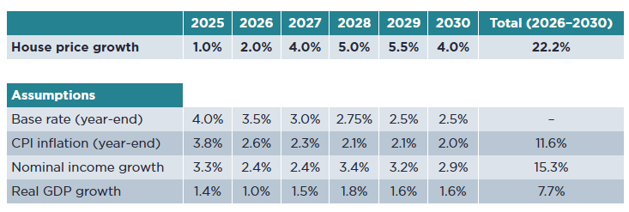
Table 4. year on year projected price increase (Savills, 2024).

Total sale price = £1,856,400 (2028)

ROI.

The return on investment has been calculated without profit and excluding finance to fund the development.

- Gross Development Value (GDV) = £1,856,400.00
- Total development cost (excluding finance and developer profit) = £1,767,929.57

- Profit = £1,856,400.00 − £1,767,929.57 = £88,470.43

- ROI = Profit / Total development cost = £88,470.43 / £1,767,929.57 = 0.0500
- 0.0500 x 100 = 5.00%

Based on a Gross Development Value of £1,856,400.00 and total development costs of £1,767,929.57 (excluding finance and developer profit), the scheme generates a profit of £88,470.43, equating to a return on investment of approximately 5.00%.

Opportunities.

Regional housing market.

Table 5 below indicates that the housing market in Wales is expected to outperform the rest of the UK, meaning the sale price may exceed the base-case figures.

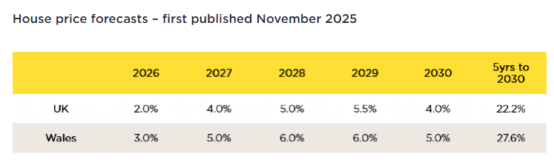
Table 5. Welsh housing market forecast (Savills, 2025).

Sale price = £850,000.00 x 2 = £1,700,000.00 (2026)

Total sale price Wales = £ 1,948,863.00 (2028)

With this new sales price the updated profit is £180,933.43 and the updated ROI is 10.24% (calculated as £180,933.43 / £1,767,929.57).

Alternatives to traditional business model.

Rather than purchasing the land, developing the plots and selling the completed homes, the company could purchase the land, obtain planning permission, demolish the existing building and sell the plots as serviced sites ready for development.

- The total cost to complete this would be £722,459.90
- Total cost for each plot £361,229.95 + 15% profit
- £415,414.44 sale price per vacant plot with planning including 15% profit.

Alternatively, the company could secure sales for the completed development before starting construction. This would reduce the amount borrowed and the interest paid; however, it may also reduce the achievable sale price.
These methods would not generate ongoing work over the lifespan of the development and may reduce the potential for further work, as outlined in the opportunities matrix.

Green development grants.

The Development Bank of Wales offers new-build developers a reduction in loan fees of up to 2%, provided the scheme meets EPC A or Passivhaus standards, uses no fossil fuels for heating, and adopts lower-carbon construction methods (Development Bank of Wales, no date).

Assuming a Development Bank of Wales interest rate of 7% (consistent with the earlier calculation), the total loan amount required would reduce by £45,011.04, excluding any additional costs associated with meeting the eligibility criteria.

To be eligible for the fee reduction, development costs may need to increase. For example, achieving Passivhaus certification would require additional design considerations, higher build quality and better-performing building elements, leading to an approximate 8% increase in build costs (an £82,846.72 increase) (Palmer, 2021).
Appendix N shows a premium Passivhaus property in a coastal location that is currently for sale in the region. Its price point is lower than the earlier case studies, and there is limited published evidence evaluating whether Passivhaus certification generates higher sales values for residential property.

The current reduction in interest does not meet the increase in costs associated with being eligible for the reduction.

Appraisal conclusion

This appraisal has assessed the viability of the development. On a base-case basis (excluding finance and developer profit), the scheme generates an ROI of approximately 5.00% (profit of £88,470.43). When regional Welsh housing market performance is applied to the sale value, the ROI increases to 10.24% (profit of £180,933.43). In both scenarios, the scheme does not achieve the target 15% developer profit.
These figures are based on market forecasts and may be affected by unforeseen macroeconomic and global economic changes. Small movements in costs or values can severely impact the viability of the project.
The development includes a significant contingency allowance (£124,538.83) because the project remains at the appraisal stage, in line with the RIBA Plan of Work.
With careful planning and execution, the contingency allowance could be reduced; however, at this stage it cannot be evaluated.
The development viability is highly susceptible to the finance required to complete as the interest repayments can erode any positive ROI.
It is this report’s recommendation that the development exposes the company to a high level of risk for potentially marginal returns and, as such, should not proceed in its current form. The report recommends exploring the potential to negotiate the land value to increase ROI and identifying further opportunities to reduce overall build costs before completing another appraisal.

Appendix

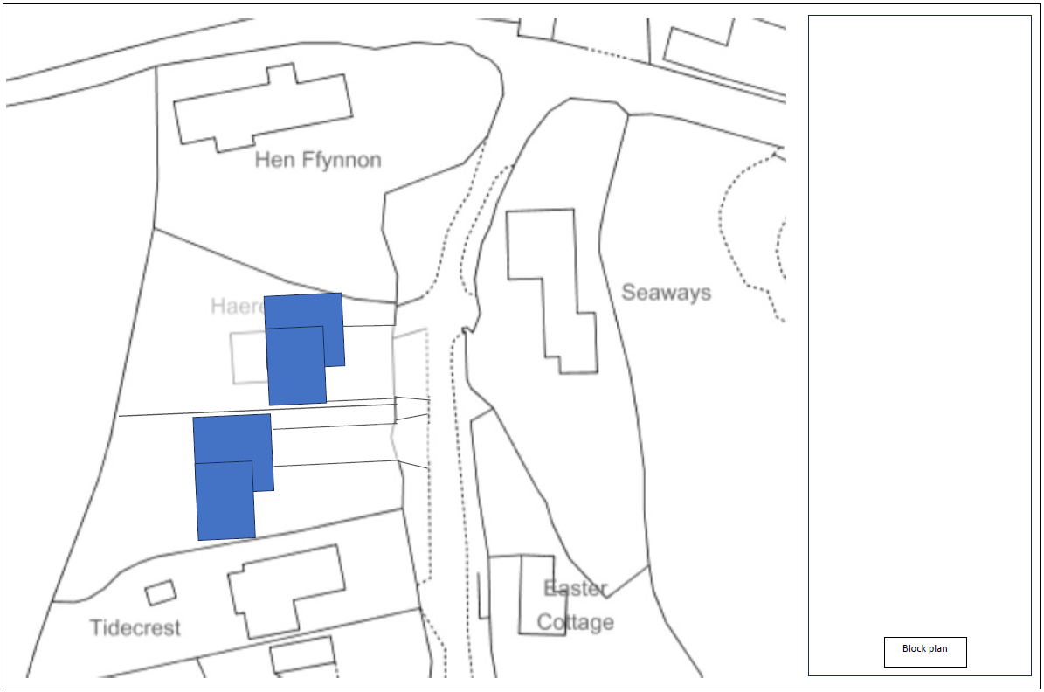
Appendix A, Plan of proposed site showing outlines of new buildings and orientation.

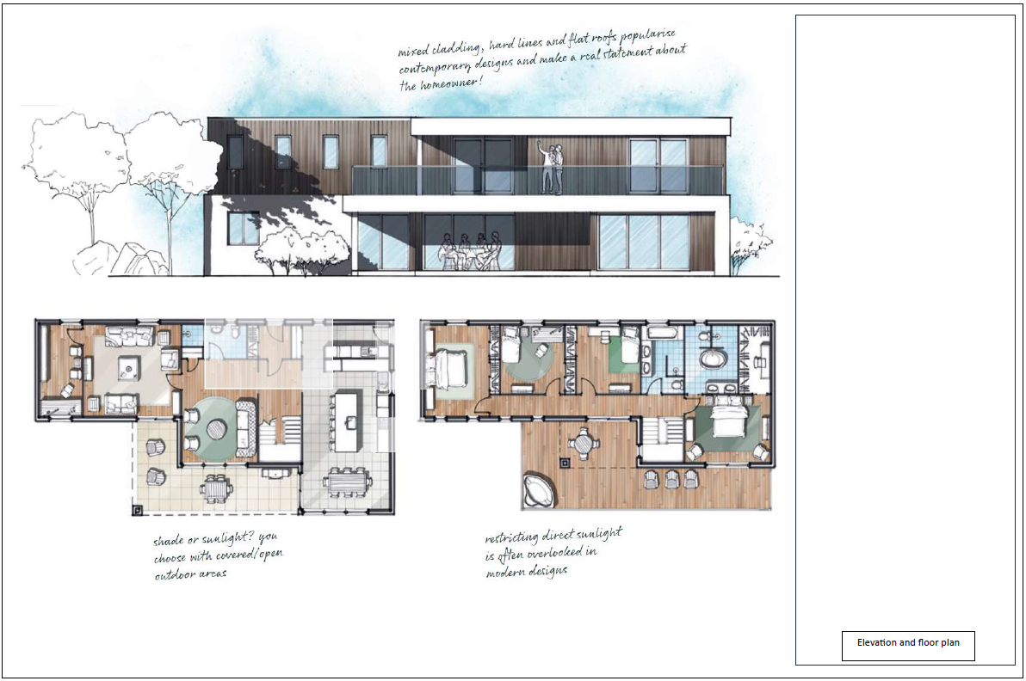
Appendix B, Proposed building plans and elevations.
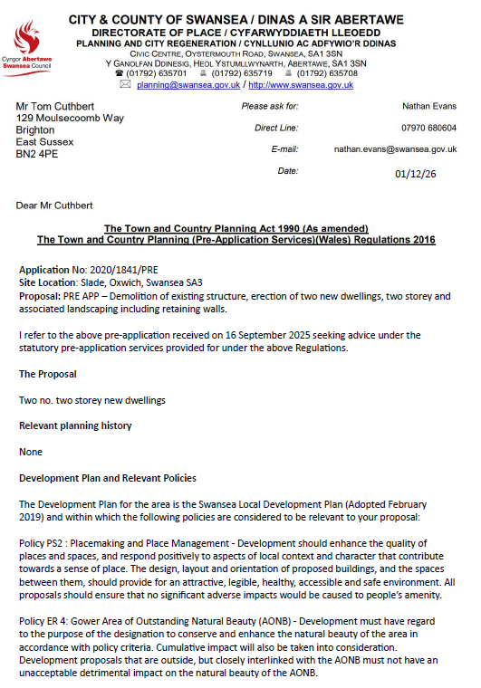

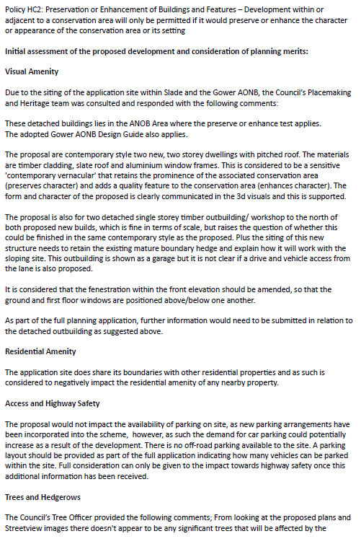

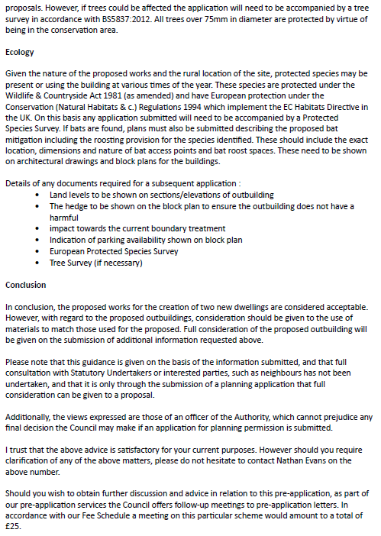
Appendix C, Pre-Planning application letter.

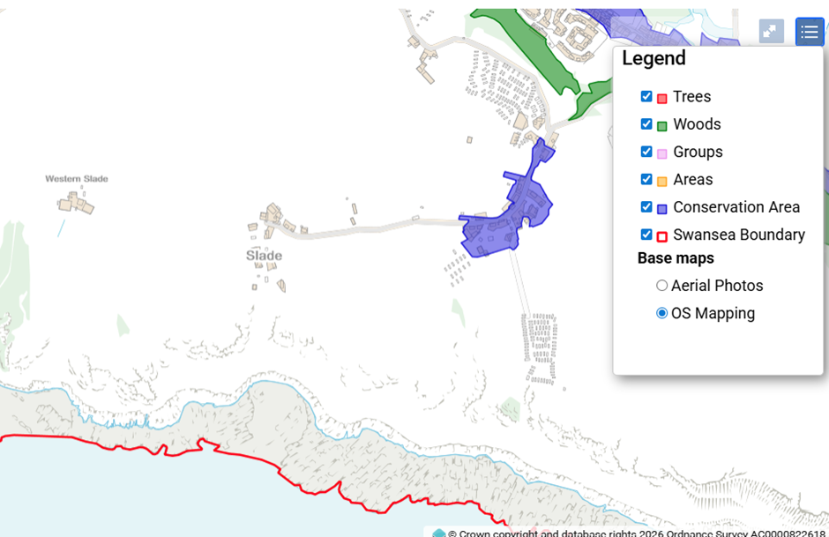
Appendix D, Designated areas, Slade (Datamapwales, 2026a).

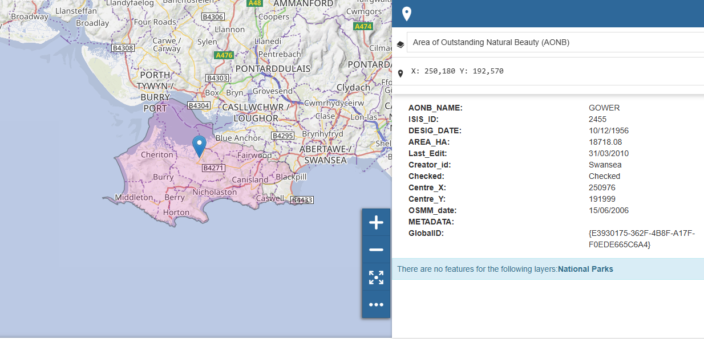
Appendix E, AONB map, Slade (Datamapwales, 2026b).

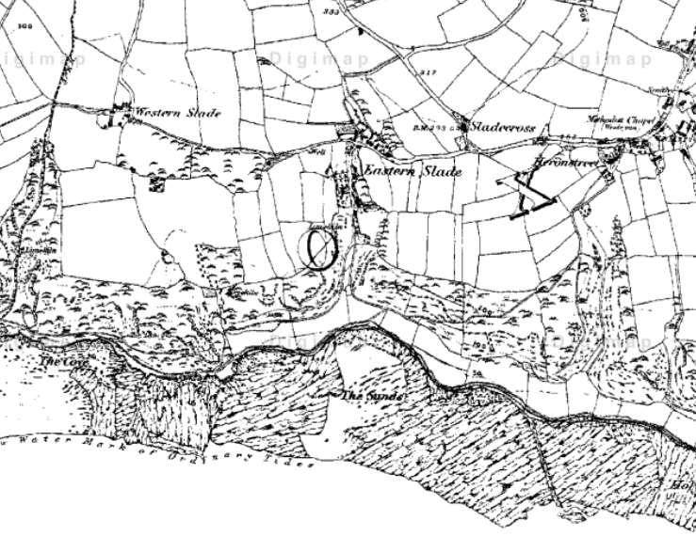
Appendix F. Historical map of Slade (Edina, no date a).

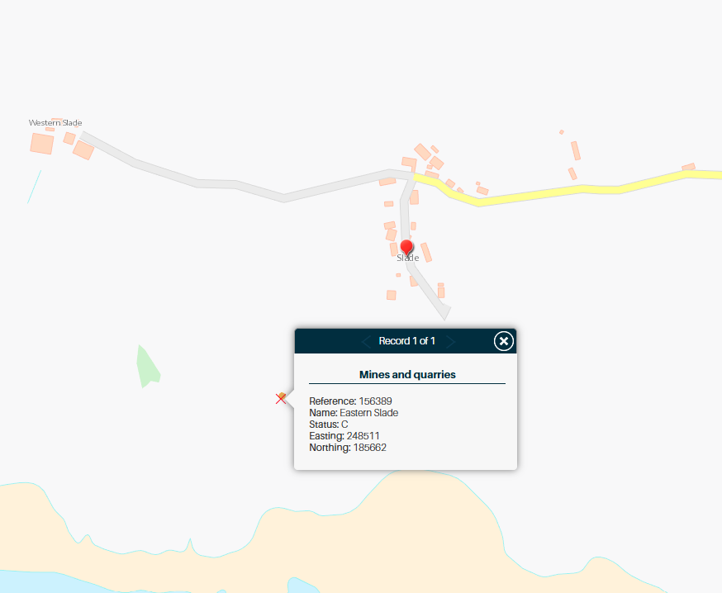
Appendix G. map showing the area was previously mined or quarried (British Geological Survey, no date).

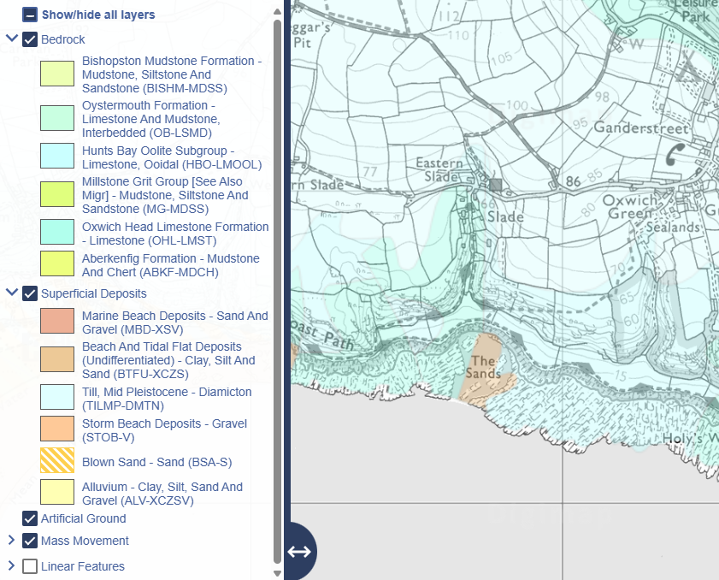
Appendix H. Geology map for Slade (Edina, no date b).

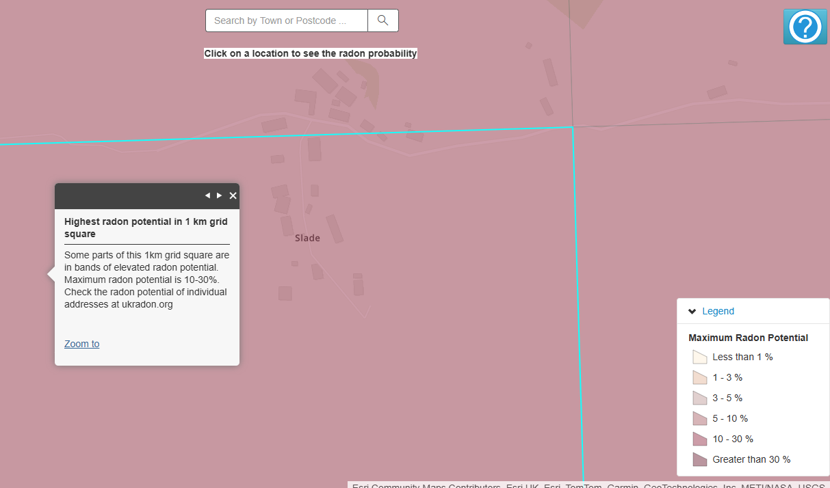
Appendix I. Radon risk map for Slade, Gower (UK Health security agency, 2025).

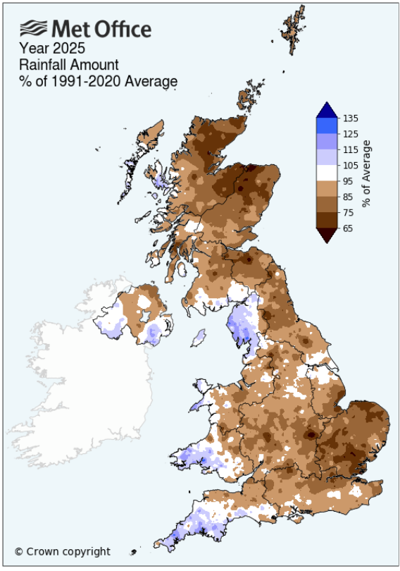
Appendix J. Average rainfall 1991-2020 (Met office, no date).

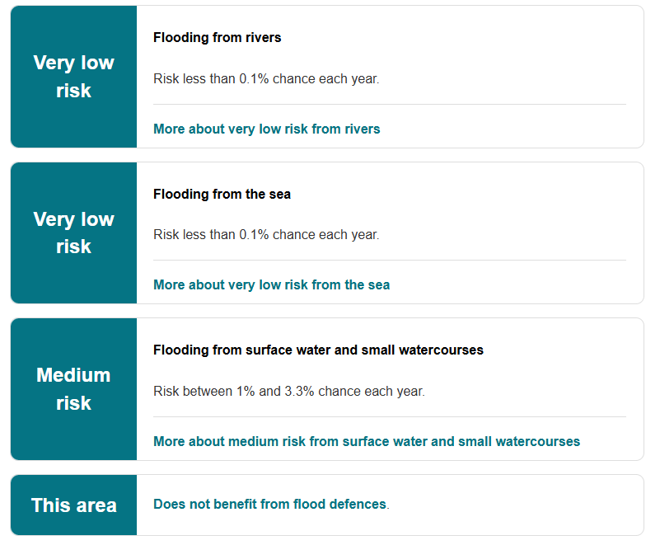
Appendix K. Flood risk for Haera-mai SA31NA (Natural resources Wales, 2025).

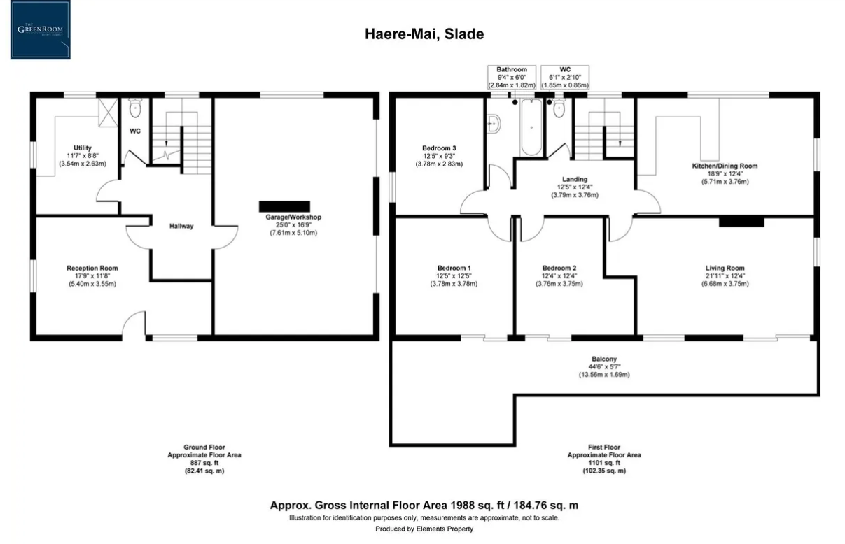
Appendix L, Existing building GIFA (Zoopla, no date d).

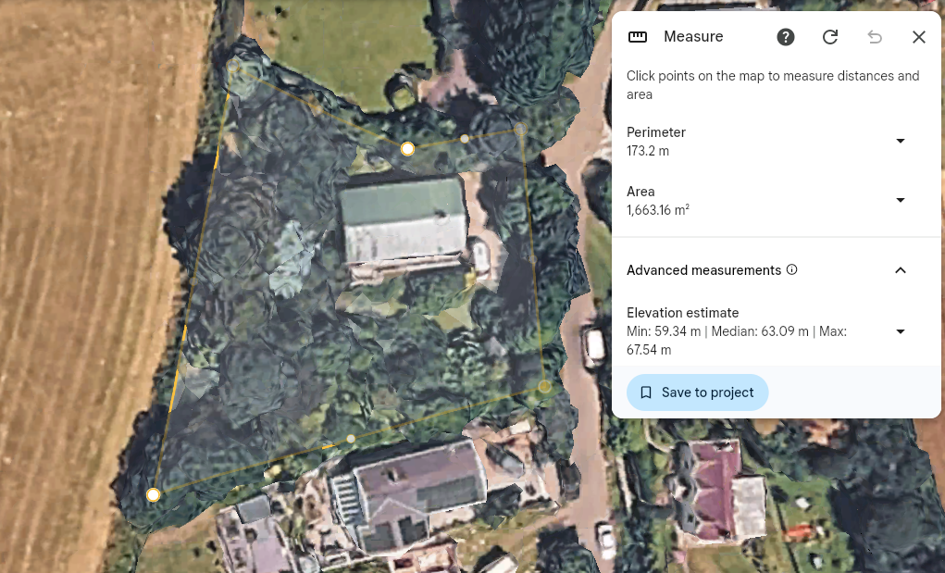
Appendix M, Existing plot m2 (Google, no date).

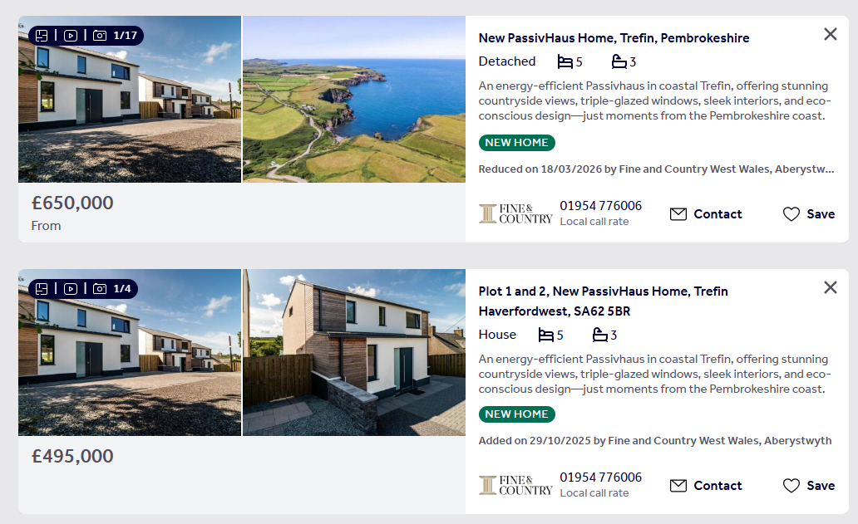
Appendix N, Passivhaus homes for sale within the region (Rightmove, no date f).

References.

ABC Finance. (no date) Bridging loan for a self-build. Available at: https://abcfinance.co.uk/bridging-loans/for-a-self-build/ (Accessed: 1 May 2026).

British Geological survey (no date) GeoIndex (Onshore) [Screenshot]. Available at: https://mapapps2.bgs.ac.uk/geoindex/home.html?layer=BGSMinAM (Accessed: 1 May 2026).

Carreg Construction Ltd. (2026a) Luxury property build: Shearwaters, Tenby [Portfolio page]. Available at: https://www.carregconstruction.co.uk/portfolio/luxury-property-build-shearwaters-tenby/ (Accessed: 1 May 2026).

Carreg Construction Ltd. (2026b) Luxury property build: Shearwaters, Tenby [Screenshot, shearwaters exterior]. Available at: https://www.carregconstruction.co.uk/portfolio/luxury-property-build-shearwaters-tenby/ (Accessed: 1 May 2026).

Carreg Construction Ltd. (2026c) Luxury property build: Shearwaters, Tenby [Screenshot, shearwaters interior]. Available at: https://www.carregconstruction.co.uk/portfolio/luxury-property-build-shearwaters-tenby/ (Accessed: 1 May 2026).

Checkatrade (2024) Asbestos survey cost [Cost guide]. Available at: https://www.checkatrade.com/blog/cost-guides/asbestos-survey-cost/ (Accessed: 1 May 2026).

Datamapwales (2026a) View map: Designated Landscapes of Wales [screenshot Designated areas, slade]. Available at: https://datamap.gov.wales/maps/designated-landscapes-of-wales/view#/ (Accessed: 1 May 2026)

Datamapwales (2026b) View map: Designated Landscapes of Wales [screenshot AONB, slade]. Available at: https://datamap.gov.wales/maps/designated-landscapes-of-wales/view#/ (Accessed: 1 May 2026)

Development Bank of Wales (no date) Green Development Incentive. Available at: https://developmentbank.wales/get-business-finance/property-development-finance/green-development-incentive (Accessed: 1 May 2026).

Ecology by Design (2021) Costs of an ecological impact assessment. Available at: https://www.ecologybydesign.co.uk/ecology-resources/costs-of-an-ecological-impact-assessment (Accessed: 1 May 2026).

EDINA (no date a) Digimap Roam: Historic map [Screenshot]. Available at: https://digimap.edina.ac.uk/roam/map/historic (Accessed: 1 May 2026).

EDINA (no date b) Digimap Roam: Geology map [Screenshot]. Available at: https://digimap.edina.ac.uk/roam/map/geology (Accessed: 1 May 2026).

Experian Ltd. (2025) Getting a business loan: Expert guide and free calculator. Available at: https://www.experian.co.uk/blogs/latest-thinking/small-business/business-loan-calculator/ (Accessed: 1 May 2026).

Google (no date) Google Earth web (51.55219324, -4.18454834) [Screenshot]. Available at: https://earth.google.com/web/@51.55219324,-4.18454834,68.90943045a,157.86645354d,35y,0.89898749h,0t,0r/data=CgRCAggBQgIIAEoNCP___________wEQAA (Accessed: 1 May 2026).

Kerr, Angela (2026) Cost of selling a home [Guide]. Available at: https://hoa.org.uk/advice/guides-for-homeowners/i-am-selling/cost-selling-home/ (Accessed: 1 May 2026).

Met Office (no date) UK actual and anomaly maps [Climate maps]. Available at: https://www.metoffice.gov.uk/research/climate/maps-and-data/uk-actual-and-anomaly-maps (Accessed: 1 May 2026).

money.co.uk (2026) The average business loan interest rates for 2026. Available at: https://www.money.co.uk/business/business-loans/average-business-loan-interest-rate (Accessed: 1 May 2026).

Natural Resources Wales (2025) Check your flood risk by postcode [screenshot]. Available at: https://naturalresources.wales/flooding/check-your-flood-risk-by-postcode/?lang=en (Accessed: 1 May 2026).

Office for National Statistics, (ONS) (2026) Interim construction output price indices [Dataset]. Available at: https://www.ons.gov.uk/businessindustryandtrade/constructionindustry/datasets/interimconstructionoutputpriceindices (Accessed: 1 May 2026).

Palmer, John (2021) Passivhaus benefits (2021)[PDF]. Available at: https://passivhaus.uk/wp-content/uploads/2024/10/PHT_PH-Benefits-Summary_Full-report_5.0_Double-Page.pdf (Accessed: 1 May 2026).

Planning Portal (2025) Welsh application fees [PDF]. Available at: https://ecab.planningportal.co.uk/uploads/welsh_application_fees.pdf (Accessed: 1 May 2026).

Rightmove (no date a) New homes for sale in Trefin. Available at: https://www.rightmove.co.uk/new-homes-for-sale/Trefin.html (Accessed: 1 May 2026).

Rightmove (no date b) Property for sale: Compass Cottage, Reynoldston [Screenshot, Compass cottage exterior]. Available at: https://www.rightmove.co.uk/properties/169378373#/media?activePlan=1&id=media17&channel=RES_BUY (Accessed: 1 May 2026).

Rightmove (no date c) Property for sale: Compass Cottage, Reynoldston [Screenshot, Compass cottage interior]. Available at: https://www.rightmove.co.uk/properties/169378373#/media?activePlan=1&id=media17&channel=RES_BUY (Accessed: 1 May 2026).

Rightmove (no date d) Sold house prices: Slade (Screenshot sold house prices). Available at: https://www.rightmove.co.uk/house-prices/slade-90904.html (Accessed: 1 May 2026).

Rightmove (no date e) Property for sale: Compass Cottage, Reynoldston [Screenshot, Compass cottage interior]. Available at: https://www.rightmove.co.uk/properties/169378373#/media?activePlan=1&id=media17&channel=RES_BUY (Accessed: 1 May 2026).

Rightmove (no date f) New PassivHaus Home, Trefin, Pembrokeshire [Property listing]. Available at: https://www.rightmove.co.uk/properties/165462179#/?channel=RES_NEW (Accessed: 1 May 2026).

Rightmove (2026) Property for sale: Slade, Oxwich, Swansea (Haere-Mai) [Property listing]. Available at: https://www.rightmove.co.uk/properties/87722721 (Accessed: 1 May 2026).

Royal Institution of Chartered Surveyors (RICS) (2021) NRM1, pp. 19, 23 and 25. (PDF).

Royal Institution of Chartered Surveyors (RICS) (2019) Performance metrics required returns and achieved returns for UK real estate development. pp 17 London: RICS. (PDF).

Savills (2024) Welsh Housing Market and Supply Update – April 2024. Available at: https://www.savills.co.uk/research_articles/229130/358506-0 (Accessed: 1 May 2026).

Savills (2025) Welsh Housing Market and Supply Update – November 2025 [Screenshot]. Available at: https://www.savills.co.uk/research_articles/229130/382451-0 (Accessed: 6 May 2026).

SPONS (2023a) SPON’s Architects’ and Builders’ Price Book 2023, pp 41, 46, 79, 191. (PDF).

SPONS (2023b) SPON’s Architects’ and Builders’ Price Book 2023, pp 46, 195. (PDF).

SPONS (2023c) SPON’s Architects’ and Builders’ Price Book 2023, pp 79. (PDF).

SPONS (2023d) SPON’s Architects’ and Builders’ Price Book 2023, pp 615, 616, 617, 619. (PDF).

SPONS (2023e) SPON’s Architects’ and Builders’ Price Book 2023, pp178. (PDF).

The move market (2025a) Shearwaters, North Cliffe, Tenby, Pembrokeshire, SA70 8AT. Available at: https://themovemarket.com/tools/propertyprices/shearwaters-north-cliffe-tenby-sa70-8at (Accessed: 1 May 2026).

The move market (2025b) Shearwaters, North Cliffe, Tenby, Pembrokeshire, SA70 8AT. Available at: https://themovemarket.com/tools/propertyprices/shearwaters-north-cliffe-tenby-sa70-8at (Accessed: 1 May 2026).

UK Health Security Agency (2025) UK maps of radon [screenshot]. Available at: https://www.ukradon.org/information/ukmaps (Accessed: 1 May 2026).

University of Leicester (2018), PMO handbook 2018, pp 70. (PDF)

Welsh Government (2024) Planning Policy Wales: Edition 12. Cardiff: Welsh Government. (PDF provided).

Zoopla (no date a) Property for sale details: Slade, Oxwich, Swansea SA3 (ID: 72727373). Available at: https://www.zoopla.co.uk/for-sale/details/72727373/?search_identifier=f8a3cee2b7d082031c6ba4d59701ea42ec4986d60ba14a9267be6eb6c0500837 (Accessed: 1 May 2026).

Zoopla (no date b) Slade, Oxwich, Swansea SA3: 3 bed detached house for sale (Listing ID: 72727373) [Screenshot view of proposed building plot]. Available at: https://www.zoopla.co.uk/for-sale/details/72727373/?search_identifier=f8a3cee2b7d082031c6ba4d59701ea42ec4986d60ba14a9267be6eb6c0500837 (Accessed: 1 May 2026).

Zoopla (no date c) Slade, Oxwich, Swansea SA3: 3 bed detached house for sale (Listing ID: 72727373) [Screenshot plan view of building plot]. Available at: https://www.zoopla.co.uk/for-sale/details/72727373/?search_identifier=f8a3cee2b7d082031c6ba4d59701ea42ec4986d60ba14a9267be6eb6c0500837 (Accessed: 1 May 2026).

Zoopla (no date d) Slade, Oxwich, Swansea SA3: 3 bed detached house for sale (Listing ID: 72727373) – Floor plan [Screenshot]. Available at: https://www.zoopla.co.uk/for-sale/details/72727373/?search_identifier=f8a3cee2b7d082031c6ba4d59701ea42ec4986d60ba14a9267be6eb6c0500837&console=open&tab=floor_plans (Accessed: 1 May 2026).

Zoopla (no date e) Property for sale details: Slade, Oxwich, Swansea SA3 (ID: 72727373). Available at: https://www.zoopla.co.uk/for-sale/details/72727373/?search_identifier=f8a3cee2b7d082031c6ba4d59701ea42ec4986d60ba14a9267be6eb6c0500837 (Accessed: 1 May 2026

