

A CRITICAL EVALUATION OF THE PRACTICAL IMPLEMENTATION CHALLENGES OF CKKS HOMOMORPHIC ENCRYPTION IN CLOUD COMPUTING FOR SECURE FINANCIAL DATA PROCESSING

Het Oza
Student ID: 2434361

Supervisor: Suresh Shanmugasundaram

Project submitted as part of the requirements for the award of
MSc Cybersecurity and Digital Forensics
Module ACFA7003

University of Wales Trinity Saint David
June 2026

Declaration
I hereby declare that this dissertation entitled:
“A Critical Evaluation of the Practical Implementation Challenges of CKKS Homomorphic Encryption in Cloud Computing for Secure Financial Data Processing”
is my own original work and has been completed in accordance with the academic regulations and ethical requirements of the University.
I confirm that:
- This dissertation has not previously been submitted, either in whole or in part, for any degree, diploma, or other qualification at this or any other institution.
- All sources of information, ideas, data, and quotations used in this dissertation have been appropriately acknowledged and referenced.
- The work presented is the result of my own independent research except where otherwise stated.
- Any assistance received during the preparation of this dissertation has been properly acknowledged.
- I understand that plagiarism, fabrication of data, and any form of academic misconduct constitute a breach of university regulations and may result in disciplinary action.
I further declare that this dissertation complies with the University's requirements regarding academic integrity and ethical conduct.
Student Name: Het Oza
Student ID: 2434361
Programme:MSC Cyber Security & Digitalforensics
Module/Course: Dissertation / Research Project
Date:08/06/2026
Signature: Het Oza

Abstract:
Expanding growth of cloud computing usage for financial information and operations has raised many data privacy concerns and security issues. The traditional encryption schemes are used to secure a data while it is being moved from one location to another, but the data must be decrypted before being used in computation which allows potential security risks to the data. The aim of Homomorphic Encryption (HE) is that computations can be done directly on the encrypted data, which will be a practical solution. The Cheon–Kim–Kim–Song (CKKS) scheme is one of the schemes that are available that would be useful for financial applications including approximate arithmetic for real value data.

The present study examines the applicability of CKKS homomorphic encryption in terms of its practicality in a cloud computing setting with respect to secure processing of financial data. The quantitative experimental research design was followed and the Kaggle Credit Card Fraud Detection dataset were represented in the financial dataset. This study explored the CKKS scheme with Python's Pyfhel library, running various tests to evaluate the computational efficiency, storage requirements, scalability, ciphertext size, and approximation quality. The test set sizes were tested as 100, 1000 and 5000 records with various configurations of encryption parameters.

The results show that CKKS can indeed revolutionize financial data computation in a private and accurate-to-the-bit manner. Values computed by encryption showed promising approximation errors with the defined acceptable value, which means that the encrypted computation results were well matched for the plaintext computation. The experiments also showed that there were major practical problems with the implementation, such as slow execution time, memory requirements, ciphertext expansion and scalability restrictions with respect to the use of conventional plaintext processing.

This study recommends that CKKS homomorphic encryption is a possible way to achieve secure financial analytics in cloud computing systems where confidentiality of data is a big problem. However, there is a need to make the codes more efficient, efficient on memory accesses and the codes need to be scalable to be feasible for large-scale real-time deployments. This research offers empirical evidence for the practical implementation of homomorphic encryption and insights into the implication of privacy, money processing speed, and analytical accuracy in financial data processing applications based on homomorphic encryption.
Keywords: Homomorphic Encryption, CKKS Scheme, Cloud Computing, Financial Data Security, Privacy-Preserving Computation

Table of Contents
Abstract
1. Introduction 7
1.1. BACKGROUND OF THE STUDY 7
1.2. PROBLEM STATEMENT 7
1.3. AIMS AND OBJECTIVES OF THE STUDY 7
1.4. RESEARCH QUESTIONS 7
1.5. SIGNIFICANCE OF THE STUDY 7
1.6. SCOPE OF THE STUDY 8
1.7. LIMITATIONS OF THE STUDY 8
1.8. METHODOLOGICAL OVERVIEW 8
1.9. Structure of the Report 9
1.10. CHAPTER SUMMARY 9
2. Literature Review 10
2.1. Introduction 10
2.2. Conceptual Foundations of Data Security in Cloud Computing 11
2.3. Overview of Homomorphic Encryption (HE) 11
2.4. CKKS Homomorphic Encryption Scheme 12
2.5 Homomorphic Encryption in Cloud Computing 12
2.6 Applications of HE in Financial Data Processing 13
2.7 Performance Challenges of Homomorphic Encryption 13
2.8 Accuracy and Precision Trade-offs in CKKS 14
2.9 Scalability Issues in HE Systems 14
2.10 Research Gap Identification 14
2.11 Conceptual framework 14
2.12 summary 15
3. Research Methodology 15
3.1. Introduction 15
3.2. Research Philosophy and Research Approach 15
3.3. Research Design 16
3.4. Data Collection Method 16
3.5. Experimental Environment 17
3.6. CKKS Parameter Configuration 17
3.7. Experimental Procedures 17
3.8. Performance Evaluation Metrics 17
3.9. Benchmark Comparison and Critical Analysis 18
3.10. Reliability and Validity 18
3.11. Ethical Considerations 18
3.12. Limitations of the Methodology 19
3.13. Chapter Summary 19
4. Experiment and Design 19
4.1. Experimental Design Approach 19
Table 4.1 Experimental Conditions 19
4.2. CKKS Selection Justification 20
4.3. Parameter Design 20
4.4 Architecture Diagram 21
Chapter 5. Implementation Design and Experimental Configuration 21
5.1 Implementation Overview/Tools, environment, pipeline 21
5.2 Dataset Preparation 21
5.3 Experimental Conditions 22
Table 5.1 Comparison with Previous Studies 22
5.4 CKKS Context Initialisation 22
5.5 Vector Encoding and Encryption 23
5.6 Homomorphic Arithmetic Operations 23
5.7 Performance Metric Collection 24
5.8 Implementation Challenges and Solutions 24
5.9 Chapter Summary 25
Chapter 6: Evaluation of result 25
6.1 Results 25
6.2 Evaluation 29
Table 6.1: Average Performance 30
6.3 Chapter Summary 31
7. Conclusion 31
7.1. Introduction 31
7.2. Summary of the Research 31
7.3. Achievement of Research Objectives 32
7.4. Response to research questions 33
7.5. Key Findings of the Study 34
7.6. Practical Implications of the Study 34
7.7. Limitations of the Study 34
7.8. Recommendations for future research. 35
7.9. Overall Conclusion 35
Chapter 8: Reflection on the Research Process 36
8.1 Introduction 36
8.2 Personal Learning and Knowledge Development 36
8.3 Technical Skills Developed 36
8.4 Challenges Encountered During the Research 36
8.5 Evaluation of Research Objectives Achievement 37
8.6 Research Limitations and Areas for Improvement 37
8.7 Professional and Academic Development 37
8.8 Overall Reflection and Conclusion 38
9. REFERENCES 38
10. Appendix: Coding 42

List of Tables

Table 5.1 Experimental Conditions 21
Table 6.1 Comparison with Previous Studies 21
Table 7.1: Comparison of Dataset Size, Encryption Time and Computation Time 22

List of Figures
Figure 4.1: Import Libraries 17
Figure 4.2: Data Loading 18
Figure 4.3: Initialize Homomorphic Encryption 18
Figure 4.4: Encrypt Data 18
Figure 4.5: Encrypted Computation 18
Figure 4.6: Decrypt Results 18
Figure 4.7: Cipher Text Size Analysis 19
Figure 4.8: Memory Usage 19
Figure 4.9: Scalability Testing 19
Figure 4.10: Encryption Time vs Dataset Size 19
Figure 4.11: Computation Time vs Dataset Size 20
Figure 4.12: Encryption vs Computation Comparison 20

1. Introduction

1.1. BACKGROUND OF THE STUDY
Data storage and processing in the cloud are becoming critical components of many industries, especially for data-intensive applications such as finance. But as more data is stored and processed in the cloud, data security and privacy become major issues, particularly when dealing with sensitive financial data on remote servers. Conventional encryption methods secure data in storage and during transmission, but require decryption for data processing, which can leave it vulnerable.
Homomorphic Encryption (HE) is a new approach to cryptography that enables computation on encrypted data without decryption. The CKKS (Cheon-Kim-Kim-Song) scheme is a popular HE scheme for approximate computation, and can be used for financial and statistical analysis [1]. While HE offers theoretical benefits, its practical use is hampered by computational efficiency, complexity and scalability issues. This research aims to assess these challenges with financial data in cloud computing environments.

1.2. PROBLEM STATEMENT
As cloud computing is increasingly being deployed for processing financial data, privacy concerns are a major issue. Existing encryption technologies ensure data security during storage and transmission, but not during computation, which requires decrypted data. This opens avenues for attacks, particularly in critical areas like financial transactions. Homomorphic Encryption (HE) theoretically provides a solution by allowing computations on encrypted data, but has limited practical use [2].
Although there have been improvements in schemes such as CKKS, implementation challenges like computation cost, time, memory, and complexity present scalability challenges. Additionally, there is a lack of empirical studies assessing HE using financial data. This theoretical-practical disparity raises doubts about the potential of HE for use in cloud financial systems. So, this research aims to address the need for a critical assessment of the practicality, speed and accuracy of implementation of homomorphic encryption using the CKKS scheme.

1.3. AIMS AND OBJECTIVES OF THE STUDY
Aims
The aim of this research is to evaluate the practical feasibility of CKKS homomorphic encryption for secure financial data processing in cloud computing environments by analysing its computational performance, approximation accuracy and scalability.
Objectives of the Study
- To measure the computational performance of CKKS homomorphic encryption by evaluating encryption time, computation time and memory consumption during financial data processing.
- To compare the performance of encrypted and plaintext financial computations in terms of execution time, memory overhead and computational efficiency.
- To evaluate the impact of CKKS encryption parameters on approximation accuracy, scalability and overall computational performance when processing financial datasets of different sizes.
- To determine the effect of encryption parameters on system speed, scalability and usability.

1.4. RESEARCH QUESTIONS
- In what way is the amount of time, memory, and ciphertext needed for utilizing CKKS compared to processing the same financial information on plaintext different?
- What is the approximation error introduced by CKKS homomorphic encryption for financial data computations, and is the accuracy obtained suitable for applying them to financial analytics?
- What happens when various CKKS parameter values are used such as polynomial modulus degree, scaling factors, and their impact on computational performance, scalability and approximation accuracy?
- In the experimental setting and data set considered in this work, are there any compromises between efficiency and approximation if using CKKS homomorphic encryption for financial data processing?

1.5. SIGNIFICANCE OF THE STUDY
The research is important because it responds to the increasing demand for more robust data privacy solutions in cloud computing, especially in the financial industry, which often deals with confidential transaction data [3]. As cyber attacks and data breaches become more prevalent, traditional encryption techniques are not adequate, since they require decrypted data for computation, which can be vulnerable. The CKKS scheme of Homomorphic Encryption (HE) is a potential solution, as it allows computation on encrypted data without decrypting it.
This study's results will help close the gap between cryptographic theory and practice. Through an analysis of speed, accuracy and scalability with real financial datasets, the research offers insights into the practicality of using HE in real systems.
The study also serves as a resource for financial institutions, cloud providers and cybersecurity experts looking for novel privacy-preserving technologies [4]. This work is important for the fact that it provides empirical data to what is mostly a theory- and cryptographic based research field. Homomorphic encryption has gained significant traction as a potential technology for privacy-preserving computation but has had little experimental work applying the technology to realistic financial datasets and workloads of analytical jobs in the cloud [5].

The research addresses the academic literature with providing an abridged, systematic study of the computational performance, scalability, memory consumption and approximation error of the CKKS homomorphic encryption scheme. The paper has investigated the limitations between security, efficiency and analytical accuracy, filling another gap in the research on how to practically implement the homomorphic encryption technology [6].

The industry viewpoints may help financial institutions, cloud service providers, cyber security specialists and systems designers appreciate the advantages and issues of implementing privacy preserving computation using CKKS. The outcome can assist in future decision making for robust financial analytics and can serve as the basis for further optimisation of the homomorphic encryption system in a cloud environment [7].

1.6. SCOPE OF THE STUDY
This research is limited to the assessment of the implementation of Homomorphic Encryption (HE), in particular the CKKS scheme, in a cloud environment for financial data analysis. The study focuses on the use of a publicly accessible Kaggle credit card fraud dataset, comprising encrypted financial data. There is no involvement of actual customer or personal data, ensuring ethical considerations and data security.
The research focuses on the implementation of HE using cryptographic libraries in Python, like Pyfhel, to enable operations on encrypted data and to evaluate performance. In particular, it addresses the computational efficiency, performance (time and memory consumption) and accuracy of its operations on encrypted data versus unencrypted data.
The study does not cover all homomorphic encryption schemes; it is mainly focused on CKKS because of its applicability for approximate arithmetic in finance. Moreover, the research is limited to experimental studies and does not extend to deployment in production cloud systems or integration with financial systems [8].
Moreover, the research does not involve human subjects, surveys, or data collection, as it solely focuses on secondary data sources and computational experiments. In summary, the research seeks to offer practical insights into the challenges and opportunities of homomorphic encryption in financial cloud computing use cases and help inform future research in secure data processing technologies.

1.7. LIMITATIONS OF THE STUDY
There are a number of limitations in this research that could impact the scalability and generalisability of the results. Firstly, the study is limited to one variant of homomorphic encryption (CKKS), and does not focus extensively on other variants such as BFV or BGV. This makes it difficult to extend the results to other types of encryption schemes.
Secondly, the research employs a publicly available dataset on credit card fraud (Kaggle), which, while realistic, is still a simplification of real financial systems. This could limit the overall applicability of the results to the complexity and scale of real-world banking or cloud-based financial systems.
Thirdly, homomorphic encryption is resource-heavy, and performance testing is limited by hardware capabilities. This could affect the speed of processing, scalability and system efficiency.
Also, the research uses Python libraries (such as Pyfhel), which may be subject to certain limitations regarding their implementation and version.
Lastly, as the study is experimental and secondary, it does not involve deployment in the cloud in real-time or integration with real-world financial systems. Thus, the outcomes are more reflective of a simulated environment.
Prior Performance Findings
Performance evaluations have shown in the past that homomorphic encrypting operations actually take many times longer than computing plain texts. Previous work on the comparison of encrypted and ‘plain', non-encrypted computations suggested that homomorphic multiplication operations may take anywhere between 20 and 100 times longer depending on how the parameters are chosen. Memory overhead is not negligible since ciphertexts take up far more space than plaintext data. Scalability studies also show that scalability becomes a real constraint when big transaction datasets are processed when using Cloud-based Analytics.

1.8. METHODOLOGICAL OVERVIEW
The research methodology used in this study is an experiment based on secondary data for assessing the implementation of Homomorphic Encryption (HE) and, in particular, the CKKS scheme in cloud computing. The study aims to examine the efficiency and effectiveness of computations on encrypted data compared to unencrypted data.
The main data source is the open dataset of the Kaggle credit card fraud detection dataset, featuring deidentified financial transactions. It is used to create realistic financial data scenarios while adhering to ethical standards, as it does not involve personal or sensitive data [9].
The study is implemented using the Python programming language and homomorphic encryption libraries like Pyfhel. The CKKS scheme is used to execute computing tasks on encrypted data [10]. This research includes data preprocessing, encryption of numerical features, and performing operational tasks on encrypted and unencrypted data.
The evaluation is done by measuring metrics such as execution time, memory consumption, efficiency, etc. Moreover, we evaluate the accuracy through error rate or variance between encrypted and unencrypted results.
The approach is experimental and does not require human participants, surveys or interviews. All the computations are done in a controlled environment to maintain consistency and repeatability. The methodology allows for a comprehensive assessment of the feasibility, limitations and potential of homomorphic encryption for secure computing on financial data in cloud computing environments.

1.9. Structure of the Report
The dissertation consists of a chain of five chapters covering different elements of the research problem and integrating with overall, critical assessment of CKKS homomorphic encryption as a tool for secure processing of financial data in cloud computing environments.

This chapter presents the general background of the topic for the research, and introduces the background of the problem, aim of the research, the research questions, the significance of the research, the scope and limitations of the research, and the general research method. The chapter provides the background to explore practical implementation issues in cloud-based financial systems based on homomorphic encryption.

The existing literature review on that provided in the Chapter 2 is a critical review that covers areas related to the security of cloud computing, Homomorphic encryption, CKKS encryption scheme, financial data processing, computational performance, scalability and approximation accuracy respectively. The chapter highlights the lack of research and creates a conceptual basis for the research.

The adopted methodology for the research in the current study is explained in Chapter 3. It explains the research philosophy, research approach, research design, Data collection, experimental environment, configuration of the parameters of the CKKS, the metrics for measuring performance characteristics of the proposed protocol, reliability and validity considerations, ethical issues, and limitations in the methodology.

Chapter 4 describes the implementation, experimental results and analysis of the CKKS homomorphic encryption system. The chapter compares the computational performance, memory usage, approximation accuracy, ciphertext size and scalability while applying a financial transaction data set. The findings are critically analysed and compared with previous studies.

Chapter 5 presents the conclusion of the research which summarizes the main results, contributes to the research objectives and questions, throws a light upon practical implications of the research, identifies research limitations and presents suggestions for future research on homomorphic encryption for financial applications in cloud.

1.10. CHAPTER SUMMARY
This chapter established the basis for the research by offering a background of the study on the implementation issues of Homomorphic Encryption in the cloud. It discussed the growing need for data security in financial applications and explained why conventional encryption techniques fail to provide secure computation in the cloud. The background identified Homomorphic Encryption, specifically the CKKS scheme, as a technique to enable computations on encrypted data. The problem statement highlighted the disconnect between theoretical progress and practical challenges in implementing secure computation, including performance, scalability and computational complexity [11].
The chapter also highlighted the purpose, objectives and research questions of the study, which are focused on feasibility, accuracy and efficiency. It also explained the importance, scope and limitations of the study and a brief overview of the methodology, which is based on secondary data and experimental implementation on a Kaggle dataset. In summary, this chapter sets the stage for the analysis and implementation chapters.

2. Literature Review

2.1. Introduction
The rise of cloud computing has revolutionised data storage and processing, especially in data-driven industries like finance. But the outsourcing of critical financial data to the cloud raises serious privacy issues. Conventional encryption techniques ensure data protection at rest and in transit, but require decryption for processing, thus exposing the sensitive data to potential attacks. To overcome this challenge, Homomorphic Encryption (HE) has emerged as a cryptographic technique that allows computations on encrypted data. One such HE scheme, the Cheon-Kim-Kim-Song (CKKS), has attracted significant interest as it supports approximate arithmetic, which is ideal for financial analytics and statistical computations.
A thorough review of the literature is needed to provide an overview of the current research in this field and to bridge the gap between theoretical and practical applications. While many studies report the promise of homomorphic encryption in preserving data privacy, there is a lack of empirical evidence on its performance in terms of efficiency, scalability and accuracy in real world financial applications [12]. Consequently, this review of the literature critically analyses existing research to provide a platform for the current research and to demonstrate its significance.
Searching for relevant articles of the literature review was done by a structured search between the keywords of homomorphic encryption, CKKS scheme, and secure cloud computing. Journal articles published since 2015 and conference papers from the same period were obtained using academic databases as IEEE Xplore, ScienceDirect, SpringerLink, Google Scholar, and ACM Digital Library. Peer-reviewed journal articles, conference papers, and cryptographic studies from the time frame 2015-2025 were obtained through the following academic databases: IEEE Xplore, ScienceDirect, SpringerLink, Google Scholar, ACM Digital Library. During the search process the following keywords were used: Homomorphic Encryption, CKKS Scheme, Cloud Security, Privacy-Preserving Computation, Encrypted Financial Analytics.

The process of selecting the articles focused on those that addressed performance, scalability, approximation accuracy, financial applications and challenges of implementing homomorphic encryption in the cloud. The studies were not related to cloud computing, duplicate published studies and non-peer-reviewed papers were excluded. The selected literature was then critically analysed to find any similarities, abnormalities, limitations or gaps about the application of CKKS homomorphic encryption in financial cloud systems for the practical application [13].
CKKS Benchmark Analysis
Studies suggest that benchmarking of the CKKS against the BFV and BGV suggest better support for floating operations and make it easier to use for financial analysis. Several benchmark studies have illustrated that the parameter selection plays a significant role in the performance of CKKS homomorphic encryption. The bigger the scaling factor, the better the approximation will be, because the number of catastrophic errors during the encrypted runtime operations will be less, however, the execution time and required memory will be bigger. The larger the polynomial modulation it uses, the better the security and the more stable the cipher text, however, the bigger the cipher text is, and the heavier the computational burden is [14].

A series of benchmarking studies have also demonstrated that depending on the encoding for the numbers, multiplication operations are much more computationally expensive than addition operations because of the additional rescaling and noise management operations necessary for performing arithmetic over the encrypted numbers [15]. This study offers insights into the challenges of implementing CKKS in real-world applications, highlighting the need for optimizing approximation accuracy, computational speed, and resource usage.
Performance Evaluation Approaches in HE Research
Homomorphic encryption systems have been evaluated in the past with various performance criteria such as Executing time, Memory requirement, Cipher text size, Approximation error, scalability etc., [15]. Computational overhead is measured extensively by the execution time since the processing time of the encrypted arithmetic operations is much larger than the processing time of corresponding plain text operations [16].

Memory usage and ciphertext size are also generally measured since it is usually a significant increase in memory used to store the encrypted data compared to the plain text data. When considering the feasibility of homomorphic encryption for cloud computing applications, the efficiency of storage and resources which both affect as well as are affected by scalability are especially relevant [17].

Additionally, for approximate encryption schemes like CKKS, the level of approximation accuracy is used as a measure of evaluation. In the past, accuracy has also been measured in the form of Mean Absolute Error (MAE), percentage error, or absolute difference between the plaintext and encrypted results [18]. Due to the above mentioned reasons, the execution time, memory usage, ciphertext size, scalability and approximation accuracy of the processes are used as evaluation criteria in the present study; these are commonly used in the previous homomorphic encryption benchmarking studies.

2.2. Conceptual Foundations of Data Security in Cloud Computing

Cloud computing is an essential part of today's data management, allowing companies to manage, store and process large amounts of data via remote servers, rather than on local computers. This approach provides benefits, including flexibility, economics and convenience. But it also poses substantial risks, especially when critical data, such as financial data, is outsourced to third-party cloud service providers. The outsourcing of data can lead to unauthorised access, data breaches and misuse [18].
Data confidentiality is a key concern in the cloud. Data is stored and processed off-site, making it susceptible to external cyber threats and malicious insider attacks. Moreover, cloud computing follows a shared security model, requiring users to trust service providers will implement robust security controls. This raises issues of third-party trust, where users lack transparency on how their data is being managed, stored and processed in the cloud environment.
Financial analytics using homomorphic encryption has been studied in several works for providing privacy. It has been shown that CKKS can be used for approximative arithmetic operations on encrypted real-valued data for statistical analysis, machine learning, and financial computations [19]. It is been shown in the experimental evaluations that data confidentiality in cloud environments is improved as sensitive information usage does not come into sight when performing encrypted computations [20].

These benefits could not come with major challenges to implementation, though. Important investigations of the previous studies have stated high computational overhead, enlarged memory usage and encrypted operation expansion of the cipher text [21]. The restriction of memory might be significant in large data sets and real-time deployment in cloud-based financial solutions is a concern [22]. As such, more empirical investigations are needed to assess the practical viability of using CKKS for financial data processing applications, given that it carries theoretical advantages.

2.3. Overview of Homomorphic Encryption (HE)
Homomorphic Encryption (HE) is a sophisticated cryptographic approach that allows operations to be carried out on encrypted data. This feature overcomes a key weakness of conventional encryption, which requires the decrypted data to be exposed during computation. HE allows data to be encrypted throughout its entire lifecycle - storage, transport and computation - and therefore provides a higher level of data security and privacy, especially in the cloud [23].

2.3.1 Definition and Principles
Homomorphic Encryption is a type of encryption that enables mathematical operations to be performed on encrypted data, and when decrypted, the result is the same as the operations applied to the unencrypted data. That is, when a function is applied on ciphertexts, the decrypted result will be the same as applying the function to plaintexts. This is referred to as homomorphism.
The mechanism of HE is to encode the data into ciphertexts using an encryption key, execute algebraic operations (such as addition or multiplication) on the ciphertexts and then decrypt the result to get the final result. This allows for computation without having to reveal the underlying data, and makes HE ideal for secure outsourced computing [24].

2.3.2 Types of Homomorphic Encryption
Homomorphic Encryption schemes can be categorised depending on the number and types of operations they support:
- Partially Homomorphic Encryption (PHE): Supports either addition or multiplication operations but not both. Examples include RSA and Paillier encryption.
- Somewhat Homomorphic Encryption (SHE): Supports addition and multiplication for a certain number of times, after which the ciphertext becomes unusable due to noise.
- Fully Homomorphic Encryption (FHE): Enables any computation on the encrypted data with arbitrary addition and multiplication operations. Therefore, FHE is the most versatile type of HE.
2.3.3 Evolution of Homomorphic Encryption
Homomorphic Encryption has evolved over the years. Original cryptographic schemes had weak homomorphic properties, allowing only single operations. This changed with the advent of Fully Homomorphic Encryption, which enabled arbitrary computation. Since then, efforts have been made to enhance efficiency, minimise computational costs, and increase the practicality of HE [25].
Today's schemes, like CKKS, are a major step in the right direction because they allow approximate arithmetic, enabling their use in applications that perform real-number computations, such as financial models and machine learning.

2.4. CKKS Homomorphic Encryption Scheme
Cheon-Kim-Kim-Song’s (CKKS) scheme is a popular homomorphic encryption scheme for approximate arithmetic. It is especially important for applications involving real number computations, including financial analysis and machine learning. Here, we discuss the CKKS scheme, its features, and compare it with other leading homomorphic encryption schemes [26].
2.4.1 Introduction to CKKS
The CKKS scheme is a variant of the fully homomorphic encryption proposal that allows for approximate computations. While previous schemes have been limited to exact integer arithmetic, CKKS supports approximate arithmetic with real numbers. CKKS is significant as it allows for efficient encrypted processing in applications where approximate results are sufficient. This makes it ideal for financial analysis, statistical data processing and machine learning operations, where results do not need to be exact. Consequently, CKKS has found favour as a practical implementation of homomorphic encryption for practical applications [27].
2.4.2 Key Features
A key feature of the CKKS scheme is its ability to perform approximate computations. CKKS introduces a small degree of error in the computation, rather than exact results, leading to more efficient schemes.
It is also notable that it supports real (floating-point) numbers, enabling the scheme to be used for data that is not integers [28]. This can be crucial in financial applications, which involve operations such as averaging, scaling and statistical analysis.
Furthermore, CKKS is well-adapted for machine learning and financial applications due to its support for vectorization and batch processing. This allows for batch processing of multiple data points, enhancing the efficiency of computations on encrypted data.
2.4.3 Comparison with Other Schemes
The CKKS scheme stands out from other homomorphic encryption schemes like BFV and BGV.
- CKKS vs BFV: The BFV (Brakerski-Fan-Vercauteren) scheme enables exact computation over the integers and is ideal for applications that require exact results. But it is less practical for real numerical computations and may require encoding schemes for complexity. CKKS natively supports approximate computations over real numbers, making it ideal for statistical and financial analysis [29].
- CKKS vs BGV: The BGV (Brakerski-Gentry-Vaikuntanathan) scheme also provides exact integer arithmetic and is popular in cryptographic research. But like BFV, it does not support approximate arithmetic. CKKS offers improved efficiency and versatility for real-valued data processing, albeit with some loss of accuracy [30].
To conclude, although BFV and BGV are ideal for exact calculations, CKKS provides a satisfactory trade-off between speed and accuracy and is more suitable for practical applications, such as secure financial data processing in the cloud.

2.5 Homomorphic Encryption in Cloud Computing
The cloud has emerged as a leading platform for data storage and computation due to its scalability, flexibility and efficiency [31]. Homomorphic Encryption (HE) is an attractive technology to address these issues by allowing secure computation outsourcing. HE allows data to be encrypted even when it is processed in the cloud, avoiding the need to share confidential information with the cloud provider.
A major benefit of HE is that it enables privacy-preserving computation. By doing so, data owners can use cloud computing infrastructure without exposing sensitive data. For instance, encrypted data can be used to perform data analytics without exposing the underlying data, helping organisations adhere to data privacy laws and minimising the risk of data breaches [32].
HE has been applied in various use cases in the cloud, especially secure analytics and machine learning in the cloud. In secure analytics, companies can conduct statistical analysis on encrypted data, such as summarisation and trend analysis, without revealing the data to the parties involved. Likewise, in machine learning, HE allows processing encrypted data for training and inferring learning models, enabling privacy-preserving AI in the outsourced cloud [33].
The feasibility of HE in cloud environments has been reported in different previous studies and has presented conflicting results. It is reported that the size of a ciphertext greatly impacts memory usage, which is unacceptable for cloud analytics scalability. Unlike, who proposed that the memory cost of CKKS batching methods can be traded off with the effectiveness of processing in machine learning tasks. [34] also suggested that optimising parameters can decrease computation time, while potentially compromising approximation accuracy. The results of these experiments show that the usefulness of HE will vary significantly depending on the specific workload, the encryption parameters, and the computation infrastructure.

2.6 Applications of HE in Financial Data Processing
The financial industry is a prime target for data security, given the sensitive nature of the data involved. Data in the financial domain, such as transaction logs, credit card information, account balances, and data for fraud detection are highly sought after by hackers. The challenge is to provide confidentiality of this data while allowing it to be processed, especially in a cloud computing environment.
Homomorphic Encryption (HE) has emerged as a technology that may help secure financial data processing. Research has looked at its use in fraud detection and risk analysis. For fraud detection, HE allows pattern matching on encrypted transaction data while keeping customer information protected, allowing for secure anomaly detection. Likewise, in risk management, financial institutions can carry out statistical and predictive modelling on encrypted data, thereby ensuring privacy protection without compromising the ability to analyse data [35].
The CKKS scheme is well-adapted to financial use cases as it supports approximate arithmetic and real numbers. Many financial analyses include averaging, regression, and probability calculations, allowing for slight approximation errors. CKKS allows these computations to be performed securely on the encrypted data, making it suitable for privacy-preserving financial analyses.
But previous studies also reveal potential drawbacks such as overheads, loss of precision, and scalability problems with large financial datasets. These considerations highlight the need for empirical studies of CKKS in financial applications. This research addresses these challenges, enhancing our knowledge of the potential of homomorphic encryption in secure and efficient financial data processing in the cloud.

2.7 Performance Challenges of Homomorphic Encryption
While Homomorphic Encryption (HE) holds great promise for secure processing of encrypted data, its use is limited by various performance challenges. These limitations impact its efficiency, scalability, and practicality in applications, especially in data-driven sectors like finance. This section discusses the main performance challenges of HE.
2.7.1 Computational Complexity
A major drawback of HE is its computational overhead. Encrypted data operations are much slower than those on unencrypted data, largely because of their underlying mathematical structures, such as lattice-based cryptography. Even basic operations like addition and multiplication involve multiple transformations on the ciphertexts. This leads to longer computation times, making HE less efficient for real-time or large-scale operations (without optimisation).
2.7.2 Memory Overhead
Homomorphic Encryption also incurs significant memory costs. Encrypted data (ciphertexts) are significantly larger than the original plaintexts due to extra components needed to ensure security. This increases storage needs and places additional demands on memory when processing. This can result in reduced efficiency and scalability in cloud-based applications, particularly with large-scale data, such as financial transactions [36].
2.7.3 Noise Growth
A key challenge in HE schemes is the growth of noise in ciphertexts when performing operations. Homomorphic operations add noise, which, if not controlled, can cause the encrypted data to be corrupted, resulting in incorrect decryption. This effect places constraints on the amount of computation that can be performed on encrypted data, hence the computational depth of HE schemes. Noise can be mitigated through methods like bootstrapping, but these are costly in terms of computation and add to the execution time.
2.7.4 Parameter Selection
Encryption parameters, including polynomial modulus degree and scaling factors, can have a significant impact on the performance of HE systems. The selection of parameters requires balancing security, accuracy and performance. Higher parameters are more secure and accurate but consumed more time and memory. Smaller parameters improve efficiency but can reduce accuracy and/or security. As such, parameter tuning is a crucial and complex aspect of deploying HE.
To conclude, while HE offers significant theoretical benefits for secure computation, these performance issues need to be considered for the practical adoption of HE.
Computational overhead is a key challenge of HESs that has been raised in several studies. The operations on ciphertext of [18] can be many times slower than plaintext operations because of the transformations applied to the ciphertext and lattice based cryptography. Likewise, due to rescaling and noise management procedures, [37] observed that the multiplications performed in CKKS are significantly slower from the viewpoint of computation time than the additions.

2.8 Accuracy and Precision Trade-offs in CKKS
The CKKS homomorphic encryption scheme is built for approximate computing, as opposed to exact computing schemes like BFV and BGV. Although this capability allows for efficient operations on real number data, it also presents accuracy and precision issues. CKKS permits small computational errors, which propagate when performing operations on encrypted data.
A major source of error in CKKS comes from scaling and rounding to encode real numbers into ciphertexts. Homomorphic operations, especially multiplication, increase the scaling factor, which must be rescaled, potentially causing a loss of accuracy. Moreover, the growth of noise in ciphertexts adds to the approximation error, particularly with multiple operations. These effects can lead to minor differences in the results of encrypted computation and their corresponding plaintext results.
A key consideration in CKKS is the balance between accuracy and efficiency. Increasing precision by setting larger parameters and scaling factors can be achieved at the expense of higher computational costs, memory consumption and runtime. Lower precision on the other hand provides better performance but with larger errors. This is especially relevant to financial data analysis, where there is a need to achieve a reasonable balance between accuracy and efficiency.

2.9 Scalability Issues in HE Systems
Scalability is an important consideration when evaluating the feasibility of using homomorphic encryption, particularly in systems that process large data sets, such as cloud-based financial systems. Although HE offers powerful privacy features, its efficiency becomes a concern when dealing with large and complex datasets.
A key issue is processing large data sets. Typical financial systems handle millions of transactions, and homomorphic encryption on these transactions places a higher computational burden. The longer ciphertexts, coupled with the reduced processing speed, can result in considerable slowdowns and inefficiencies [36].
Another important limitation is related to hardware constraints. Homomorphic encryption operations are computationally intensive and demand substantial computational resources, memory and storage. The processing of large-scale encrypted data may not be efficiently handled by a typical computing environment, requiring powerful hardware or dedicated systems for efficient processing [10].

2.10 Research Gap Identification
While there have been tremendous improvements in homomorphic encryption, such as the CKKS homomorphic encryption scheme, there is still a gap between research and practice. Research has primarily been concerned with the mathematical underpinnings and security aspects of homomorphic encryption; less attention has been given to its practical applications in specific domains like financial data processing.
A key area of the gap is the lack of empirical analysis using realistic financial data. Most research uses hypothetical or abstract data, which do not represent the complexity, scale and variability of real financial systems. This hampers the ability to apply results to real-world scenarios and also calls into question the practicality of homomorphic encryption in financial real-life scenarios [38].
A significant amount of research has been carried out to develop homomorphic techniques, but there is not enough empirical study conducted to assess and evaluate these techniques with meaningful financial data and real-world cloud-based workloads. Typical studies are limited to theory, proofs of security, and synthetic data sets of financial transactions rather than an actual financial transaction environment. Furthermore, numerous previous works lack proper considerations on how well privacy is preserved, how efficiently computation can be carried out, and how precise the numbers are. Hence, the present study aims to fill this area by making use of a financial domain real-world data on Kaggle and measuring the execution time, memory usage, scalability and approximation error of all different values of the parameters.

2.11 Conceptual framework

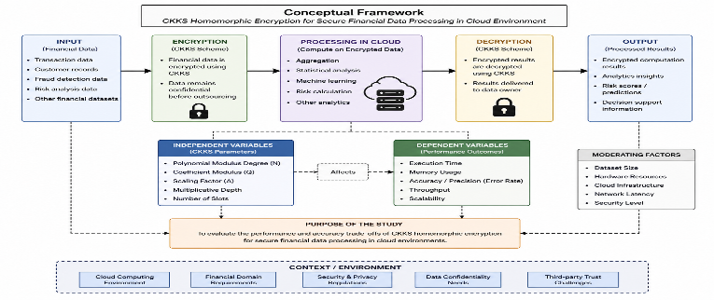
Figure 2.1: Conceptual Framework [33]
The conceptual framework provides a snapshot of the system and the relationships between variables when deploying the CKKS homomorphic encryption technology for secure financial data processing in cloud computing. It illustrates a step-by-step process from input to output, and the factors that affect the system's performance and accuracy. The process begins with the input phase, which includes financial data like transaction logs, customer profiles, fraud prevention data and risk assessment data. This information is critical and needs to be secured prior to outsourcing to the cloud.

2.12 summary
This chapter critically analyzed the literature on cloud computing security, homomorphic encryption, and CKKS encryption scheme. The review pointed out that homomorphic encryption is one of the potential solutions for privacy preserving computation as it can process encrypted data without decrypting. Previously, it was proven that the usage of CKKS can be used for financial analytics or machine learning applications which perform computations on real valued signal domains.

Another interesting finding from the review was the computational complexity, memory requirements, growth of the ciphertext, approximation errors, and scalability issues of homomorphic encryption [34]. While previous study has given some good theoretical and experimental insights most of the literature is either in the cryptographic point of view or confined to synthetic data processing environment to real financial data processing environment.

These limitations signify the lack of expertise around the applicability and usability of CKKS homomorphic encryption in financial analytics, particularly in the cloud context. The method chosen to cope with this lack is presented in the following chapter, where the computational performance, scalability, and approximation accuracy are studied for a real-life financial dataset and through controlled experimental studies.

3. Research Methodology

3.1. Introduction

The practical challenges and feasibility of Homomorphic Encryption (HE)—particularly Cheon–Kim–Kim–Song (CKKS) scheme—in financial data processing systems in the cloud context are discussed in this chapter and the methodology used for the evaluation is explained. It has been designed according to the research needs and objectives, and the methodology has been defined, so that measurable and empirical evidence has been provided about computational efficiency, scalability, approximation accuracy, and feasibility of implementation. The goal of the study is to assess the performance of the system under well-controlled computational scenarios, and thus, a quantitative experimental approach has been taken. In addition, the methodology includes parameter benchmarking, comparing the performance of encrypted computational environments and plaintext environments, and a critical evaluation of the performance of both types of environments.

The study examines the efficiency of performing financial computations (addition, multiplication, averaging and statistical analysis) on financial datasets encrypted using CKKS instead of using other types of financial computations. It contains data collection, dataset preprocessing, implementation of encryption, experimental setup, measurement of performance and analysis of results. Also included in this chapter are discussions of the hardware environment, software tools, evaluation measures, reliability, and ethical considerations with the study.

3.2. Research Philosophy and Research Approach
This study's research holds the positivist philosophy as the results generated from the study in this case need to be objective, measurable, and quantifiable to account for the performance of CKKS homomorphic encryption system in financial data processing. To apply positivism to a research is suitable for a research that aims to understand something which is observable, and can be measured with numerical data, by using a controlled experiment.

Alternative research philosophies like interpretivism were deemed to be less appropriate, as they are basically of concern to understanding human experience, perception and social phenomena through a subjective analysis. This study is not involving human participant, opinions, interviews or behavioural analysis so interpretivist would not be applicable in this study.

Pragmatism was also taken into consideration, but a combination of qualitative and quantitative methods is not necessary for the research. Rather, it centers only on objective aspects like execution time, memory use, level of approximation, size of the Ciphertext and scalability. Given this, a positive approach is the best approach for the practical implementation challenges that arise with CKKS homomorphic encryption, where controlled and repeatable experiments are discussed and used to evaluate the usefulness of the utility.For this reason, a positivist philosophy is the most convenient one for assessing the practical implementation difficulties of CKKS homomorphic encryption, where controlled and repeatable experiments will be used and discussed to assess the usefulness of the utility achieved by the approach.

The study is conducted in a deductive manner as it tests already known theoretical statements on benefits and limitations of homomorphic encryption. Previous studies indicate that while computing securely over encrypted data can be achieved by using CKKS, computational cost and approximation error are present [37]. This research follows up its experimental aspects, which test the above claims running on financial transaction data and given performance metrics.

3.3. Research Design

The research method used in this study is Quantitative Experimental research design which is designed to test the usefulness of financial data processing using financial technology of CKKS homomorphic encryption scheme or CKKS homomorphic encryption from the view of feasibility in the practical application level. The design allows the computation performance, the approximation accuracy, the amount of memory, the size of the cipher text and the scalability to be controlled and measured.

The four stages of the experimental process are depicted in sequence. Financial data is first preprocessed, and relevant numerical characteristics data are chosen to analyze. Second, baseline plaintext computations are made up and baseline performance values are set. Third, the chosen data is enciphered in CKKS scheme and arithmetic operations are carried out directly on the encrypted values. Fourthly, the output of the encryptions are decrypted and then compared with plaintext output to evaluate approximation accuracy [38].

A variety of different data set sizes and polynomial parameter configurations using polynomial modulus degrees and scaling factors of 2³⁰ and 2⁴⁰, with polynomial moduli of 4096, 8192 and 16384 are used for experiments. The results of performance metrics are captured for each configuration and used to test the effects of parameters selection on the computational efficiency and scalability.

The process of each experiment is repeated five times so that the variation in the temporary system does not greatly affect the result and the reliability of the result may be increased.

3.4. Data Collection Method

This study uses secondary data sources to support the data. The first dataset used for the experiments is the Kaggle Credit Card Fraud Detection dataset, which is a public dataset. This data set is anonymized financial transaction data and set of numerical attributes appropriate for the statistical analysis performed using encryption technology. This data is chosen for being realistic with financial transaction behaviour while meeting privacy and ethical guidelines.

Besides the data set, journal articles, conference papers, technical reports, and cryptographic documents are used for the theoretical and analytical part of the research. Experimental results have been analysed using a comparative basis from the existing benchmark studies about the performance of CKKs, homomorphic encryption scalability, and privacy-preserving cloud systems [39].

Since the study is completely experimental and computational in nature, there is no primary data gathering method used in the study; that is, no interview, survey, or questionnaire is employed in the study.

3.5. Experimental Environment

Therefore, the performance of homomorphic encryption systems can be assessed within the implementation environment since it is largely affected by the combination of hardware/s and software resources used. The experiments are developed in python that is a flexible and popular programming language in scientific computing and well supported by cryptographic libraries. For the homomorphic encryption, the Pyfhel library is used, which provides an implementation for CKKS and has options for encrypted arithmetic operations.

The experiments are run on a PC with an Intel Core i7 processor, 16GB RAM and the Windows 11 operating system. All code will be executed in the Python 3.11 environment of a Jupyter Notebook. Other libraries like NumPy, Pandas, Matplotlib, Memory Profiler, and Time are added for further data processing, performance tracking, and visualising the results [40].

Even previous studies have demonstrated that HE performance is not stable but has been found to be highly dependent on computational resources. Therefore, it is extremely important to document the hardware and software configuration properties. This improves reproducibility and ensures consistency in the evaluation process.

3.6. CKKS Parameter Configuration

There are various encryption parameters that greatly affect the approximation accuracy, the possible security level, the size of the resulting ciphertext and computational efficiency. Hence, one of the key pieces of the methodology is the configuration of parameters [41].

Different values of the parameter poly_modulus_degree are tested (4096, 8192 and 16384). Scaling factors of size 2³⁰, and 2⁴⁰, are also tested, to examine the impact of numerical precision and execution time. This was in order to comply with the standards of modern cryptography and the security level was maintained at 128-bit security all experiments.

The greater the polynomial modulus, the greater the accuracy and security but the more time and memory it uses at run time [42]. Compliance is likewise for higher scaling factors, which offer much better approximation, as well as higher computing expenses. The methodology thus explores the trade-off between efficiency and accuracy regarding the choice of the parameters.

3.7. Experimental Procedures

The process of experiments starts with the data set pre-processing. The financial transaction data set is cleaned and pre-processed prior to encryption. The letter values are verified, extraneous attributes are eliminated and numerical attributes are normalised to ensure computational stability when performing arithmetic operations on encrypted data. The selected financial attributes are encrypted into a vector representation since this is more efficient for the data to be processed by CKKS.
Preprocessing is done after which Pyfhel's implementation of CKKS is used to generate encryption keys. The system creates public keys, secret keys, rotation keys and relinearisation keys used in the arithmetic operations performed on numbers in the public systems. The financial values that are entered are transformed into ciphertexts before they are computed through an encryption process [43].
The encrypted computations include adding and multiplying encrypted values of financial transactions, computing averages and variances over encrypted values of financial transactions. These operations mimic real financial analytical operations like transaction aggregation, statistical modelling, and risk analysis. All ciphertexts are then decrypted and the results compared to the same plaintexts to assess the level of approximation.
These experiments are repeated several times so that the results are guaranteed to be consistent and that the temporary fluctuations in the system do not affect the results. Each experiment is performed five times and average times for runtime, memory usage and approximation error are reported.

3.8. Performance Evaluation Metrics

There are a number of quantitative metrics for assessing the viability of CKKS homomorphic encryption in financial systems that are deployed over the cloud.
Computational latency for the time taken to encrypt, encrypted computation, and decrypt is measured. The major drawback of HE systems which has been reported is the runtime overhead resulting from slower operations when encryption is needed compared to plaintext operations.
In addition to the size of the plaintexts, the memory usage is also measured as ciphertexts tend to be considerably larger than plaintexts because additional cryptographic structures are added. In cloud environments, memory analysis can be used to assess memory overhead and scalability.
Another important measure is approximation accuracy as CKKS is not intended to do a thorough computation but only an approximation. Common tools for analysing the numerical accuracy are the Mean Absolute Error (MAE), the percentage error and the difference between the outputs of the plaintext and the encrypted outputs after decryption. A threshold for acceptable approximation of this study is set to be below 1 per cent of difference between plaintext and encrypted output [43].
Scalability analysis is done by scaling up the data sets during experimentation. A set of slices of different sizes (small, medium, large) of the financial dataset are fed into it so it can see the change in execution time and memory usage as workload increases.

3.9. Benchmark Comparison and Critical Analysis

The results of the study are compared against the previous studies done with CKKS and BFV and BGV, which are other homomorphic encryption schemes. Prior studies have shown that for approximate floating-point arithmetic, CKKS is efficient, but incurs computational overhead for multiplication operations and very strongly encrypted operations [44].
The results obtained in this study are compared with the findings from earlier studies of homomorphic encryption. Several benchmarks in the past have pointed to the constants of execution time, memory usage, ciphertext expansion, approximation precision, and scalability as important practical considerations [44].

Similar studies [45] have indicated that operations like homomorphic multiplication are significantly more costly than addition operations both in terms of computational resources and processing time. Likewise, the accuracy and stability of the ciphertext tend to become better with higher polynomial modulus and higher scaling factors, but also with the higher execution time and memory consumption [46].

The present research does not seek to repeat the full computational parameters in the previous research, but focuses on those categories of performance metrics used in the previous research. This method allows meaningful comparisons of the observed trends and implementation hurdles, while allowing hardware and software environments to be accounted for.

3.10. Reliability and Validity

Repeated evidence of reliability is provided by repeated use of the instrument in experimentally similar settings. To reduce inconsistencies due to transient hardware changes or other system processes, each experiment is repeated five times and then the average performance values are computed.
Validity is kept through a comparison of the decrypted encrypted outputs to the plaintext benchmark outputs. The findings are also checked on the existing benchmark studies and theoretical expectations found in the previous literature.

3.11. Ethical Considerations

Even though the study draws on publicly available anonymised datasets, ethical issues remain relevant due to the research interest of financial transaction data, and privacy-preserving technologies. Protection of financial confidentiality and preventing unauthorised data access is recognised as important in the study of the cloud computing system.
The study also takes account of the wider ethical issues which surround the use of homomorphic encryption in real-world finance. The advantages of using HE include better confidentiality and privacy, but can use up significant computational resources, making this solution impractical for smaller organisations with less extensive technical resources. This can add to the divide in technology between big financial institutions and smaller organisations.
There is no use of a human subject in study and experimentation of personally identifiable information.

3.12. Limitations of the Methodology
There are some limitations with respect to the methodology. First, this study exclusively addresses the CKKS homomorphic encryption scheme, and does not exhaustively compare it to other HE schemes like BFV or BGV. Second, the experiments are run on a local experimental environment and not in a real-time deployment of the cloud. Third, computational performance is critically determined by the resources of the hardware used, which can affect the results of the scaling experiments.

In addition, the anonymized data sample on which this study is based may not have captured the diversity and complexity of actual banking systems.

3.13. Chapter Summary

In this chapter, the methodology taken on in the evaluation of the implementation challenges of CKKS homomorphic encryption in FC systems has been detailed. The experiment is conducted using a quantitative approach with plaintext benchmarking, encrypted computation and parameter analysis. The methodology involves real-world financial data, experimentation, benchmarking against existing practices, measuring performance, and examining the ethical implications, all aimed at grasping the viability of homomorphic encryption in secure financial transactions.

4. Experiment and Design

4.1. Experimental Design Approach
Its implementation was supposed to be used to measure the effective performance of CKKS’s homomorphic encryption when dealing with controlled financial data. This Kaggle Credit Card Fraud Detection dataset was chosen because it is a realistic set of financial transaction data without any identifiable information and was openly made available.

To study the scalability, three different dataset sizes were chosen: 100, 1000 and 5000 records. The smallest dataset was used to test lightweight analytical workloads, the medium dataset was chosen to test moderate transaction processing workloads, and the largest that was chosen was for measuring data computation performance as the workload increased. The size of these data sets gave a realisable compromise between experimental feasibility and assessing the scalability with computational resources.

Selected for use was the Amount attribute which is a continuous numerical financial value appropriate for use in approximate arithmetic operations for which the CKKS scheme provides support. To evaluate the performance of encryption for numerical computation and not predictive modelling, and therefore a representative financial variable was selected, to help interpret the performance of encryption and at the same time not distract from their relevance to an issue in financial analytics applications.

For each experimental setup five trials were done to have consistency and reliability. The average values of execution time, memory consumption and level of approximation were calculated over all of the runs. No system interruption or failure or incomplete execution of systems was counted in this analysis. This method minimized the effects of an ephemeral variation of the system and increased the reliability of the results reported.

Table 4.1 Experimental Conditions
Parameter | Values Tested
Dataset Sizes | 100, 1000, 5000 records
Poly Modulus Degree | 4096, 8192, 16384
Scaling Factor | 2³⁰, 2⁴⁰
Number of Runs | 5
Operations Tested | Addition, Multiplication, Mean Calculation
Evaluation Metrics | Runtime, Memory Usage, MAE, Ciphertext Size

4.2. CKKS Selection Justification
For real number operations, which are more commonly employed, CKKS allows to deal with floating point numbers directly instead of using complex encoding techniques.

Another reason for choosing CKKS is because it works well in cloud-based analytical environment. Cloud computing platforms are being used more and more by financial institutions to do large-scale data analysis. With CKKS, financial information can be computed on even though it is encrypted, and CKKS offers privacy throughout the computation process. This capability is near-matching with the purpose of cloud financial information processing's security.

Similarly, vector batching was also efficiently supported, allowing multiple numerical values to be encoded into one ciphertext in the case of CKKS. This allows the processing of large financial data sets with much greater computational performance and less number of encryption operations. Event processing often includes thousands of records for transactions, and batching helps to optimize the use of resources and increases scalability.

Previous benchmarking has demonstrated that CKKS is outperforming BFV to BGV for applications in the area of statistical analysis, machine learning and financial modelling due to the fact that these applications are able to accommodate small approximation errors made by CKKS. Although minor numerical differences are introduced with the approximate arithmetic design via an arithmetic approach of CKKS, these will be generally quite insignificant for real world financial analytics applications.

In addition, the Pyfhel cryptographic library that was used in this research is known to be stable and well documented in its implementation of CKKS. This permitted efficient embedding of encryption processes into the experimental scheme, and allowed for reproducible and consistent results to be obtained.

As a result, it was decided to explore the CKKS approach as it could provide an effective security and privacy-preserving approach while also meeting efficiency, approximation, and application requirements for secure financial data processing in cloud computing settings.

4.3. Parameter Design
In the case of the CKKS homomorphic encryption, the cryptographic parameters play a crucial role on the performance, the accuracy and the security. To obtain a balance between computational efficiency, approximation quality, scalability, and security requirements, it is important to design the parameters appropriately.

The three basic parameters which were taken into account in this research were the polynomial modulus degree, scaling factor and security level. They directly affect the sizes of a ciphertext, the time of its computation, memory usage, and the level of approximation in computing with an encrypted data item.

Polynomial Modulus Degree

The degree of the polynomial that is used within the CKKS encryption scheme depends on the polynomial modulus degree. The larger the numbers, the more powerful the computer, the more secure the protection, and the more sophisticated the encrypted operations supported. They also demand more memory and computing resources, however.

In order to analyze the effect of this parameter on the performance three polynomial modulus degrees have been analysed:

- 4096
- 8192
- 16384

4096 is for light use and small data sets and is designed to be faster. 8192 is a sweet middle ground between performance and security, and 16384 is more secure and has more of a stable CPU / RAM utilization but takes a longer time to operate.

Scaling Factor

Scaling factor help to store the number of the digits to be used in approximate arithmetic operations given a number. Because of real-valued computations via approximation, the scaling factor becomes a key parameter to control numerical accuracy with CKKS.

Two sets of scaling factors were tried:

2^30
2^40

A scaling factor of 2^30 gives adequate precision, and with a reasonable calculation speed. Alternatively, 2^40 provides a larger scaling factor which makes the approximation more accurate and decreases rounding errors, but results in the need to use more processing resources and memory.

These scaling factors were compared to assess the compromise between accuracy of the numbers and computing speed.

Security Level

All experimental setups have been made with a security of about 128 bits, which is considered a standard security level in the modern applications of cryptographic systems. To guarantee the application results would be comparable only on performance and approximation accuracy, the same security level was maintained throughout their comparison.

4.4 Architecture Diagram
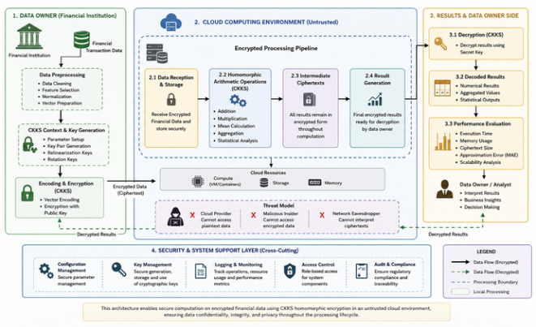

Figure 4.1: Architecture Diagram
The following diagram is a so-called "architecture diagram" that shows you the steps of the CKKS homomorphic encryption when used to process data for financial purposes in the cloud. The data owner preprocesses, encodes and encrypts the financial transaction data using the cryptographic keys by the data owner. The encrypted data is then sent to an untrusted cloud environment, where homomorphic operations – like addition, multiplication, aggregation, statistics – are carried out without decryption. The data owner receives back encrypted results from the cloud that he then decrypts with the secret key. The proposed metrics for performance—such as execution time, memory consumption, ciphertext size, scalability, and approximation error—are considered to determine the feasibility of the proposed practices.

Chapter 5. Implementation Design and Experimental Configuration

5.1 Implementation Overview/Tools, environment, pipeline

5.2 Dataset Preparation

This study uses secondary data sources to support the data. The first dataset used for the experiments is the Kaggle Credit Card Fraud Detection dataset, which is a public dataset. This data set is anonymized financial transaction data and set of numerical attributes appropriate for the statistical analysis performed using encryption technology. This data is chosen for being realistic with financial transaction behaviour while meeting privacy and ethical guidelines.

Besides the data set, journal articles, conference papers, technical reports, and cryptographic documents are used for the theoretical and analytical part of the research. Experimental results have been analysed using a comparative basis from the existing benchmark studies about the performance of CKKs, homomorphic encryption scalability, and privacy-preserving cloud systems [39].

Since the study is completely experimental and computational in nature, there is no primary data gathering method used in the study; that is, no interview, survey, or questionnaire is employed in the study.

5.3 Experimental Conditions

Table 5.1 Comparison with Previous Studies
Metric | Previous Studies | Current Study | Observation
Runtime Overhead | High | High | Consistent
Memory Consumption | High | High | Consistent
Ciphertext Expansion | Significant | Significant | Consistent
Approximation Error | Low | Low | Consistent
Scalability Challenges | Reported | Observed | Consistent

The results of the present research can be compared to the results of the previous homomorphic encryption studies, which show that the results are generally in agreement with the related works. As also in previous studies, the main concern for future practicality was the computational cost and the memory usage. The study also verified the substantial resource demand of CKKS and high approximation accuracy of the resource. The findings support earlier research because they showed that the same issues are still present when we try to apply CKKS to actual financial transactions data.

5.4 CKKS Context Initialisation
The first step in the Cheon–Kim–Kim–Song (CKKS) homomorphic encryption scheme is to set up the encryption context. This step of context initialization is crucial as the setting of cryptographic parameters that influence the security level, computational efficiency, capacity of the produced blocks of ciphertexts, and precision of the overall approximation.

The Pyfhel library was used to translate CKKS scheme into Python. Several various parameters were setup during the initializing stage: polynomial modulus degree, the size of the coefficient moduli, scaling factor. The polynomial modulus degree determines the number of slots that are available for vectorised operations, and it will impact the security and computational performance. Neither the polynomial modulus nor the polynomial time is negligible. The larger the polynomial modulus, the greater the security and the more complex the computations, but the higher the memory requirement and the more time needed for computation.

Several polynomial modulus values were tested to explore its impact on efficiency and scalability of computational methods, such as 4096, 8192 and 16384. Likewise, scaling factors of 2^30 and 2^40 are chosen so that they allow for a nice balance of precision and computational speed.

The required encryption parameters were then defined and then key generation was performed. The CKKS scheme uses several cryptographic keys, such as public keys, secret keys, relinearisation keys, and rotation keys. The secret keys are used for decryption, and the public keys are used for encryption. Relinearisation and rotation keys help to support the advanced operations of homomorphism like multiplication and rotation of vectors.

Successfully generating these keys enabled the ability to do arithmetic computations on the cryptographic data, which is entirely the financial data, without revealing the plaintext version of the data.

5.5 Vector Encoding and Encryption
After initialisation of contexts, the data of the selected financial transaction were prepared for encryption by means of vector encoding. CKKS has the ability to process multiple numerical data at once using a vectorised encoding structure and can be employed to facilitate approximate arithmetic on real-valued data.

To be able to perform financial transactions using the encrypted data, the financial transaction dataset was first pre-processed, and numerical attributes suitable for the encrypted financial transactions were selected. The selected value for the transaction amount field is due to the continuous nature of its data, typical in financial analytics or statistical computations.

Numerical values were pre-processed into vectors of plaintext using CKKS encoding mechanisms prior to encryption. The objective of the vector encoding is to enable batching, that is to say, to pack multiple data values into a single ciphertext. This considerably effects the computational efficiency by decreasing the amount of encryption operations to be feasible.

The plaintext vectors were then encrypted using the public key generated at the generation of the context initialization stage. In the encryption, the values used are numerically readable but in ciphertext form they became like random data and were not readable without the secret key.

The mathematical structure of the data was maintained, but unauthorised access was prevented. In this property, it was possible to compute safely in an untrusted cloud while exposing none of the sensitive financial details. During this time, encryption time was timed in order to evaluate the amount of computational overhead that the CKKS scheme gave compared to the plaintext processing.

One of the most profound benefits of CKKS homomorphic encryption was shown during the vector encoding and encryption process, as it enabled processing large numerical financial datasets with efficiency, yet preserving their confidentiality.

5.6 Homomorphic Arithmetic Operations
The two main features of the CKKS scheme are its semi-homomorphic property and its direct calculation on encrypted information. This capability ensures that financial data is not decrypted before processing and remain confidential in processing of these types of data.

During the trials, various arithmetic operations have been carried out such as homomorphic addition, homomorphic multiplication and calculation of means. These operations were chosen as closely matching representative analyses that are frequently performed in the financial sector, including accumulating transactions, statistical analysis, risk analysis, and predictive models.

The characteristics of homomorphic addition allowed financial values to be added directly at the encrypted level. When the original plaintext values were added, the resulting ciphertext was the same when it was decrypted. The computational overhead and execution times of addition operations in general were smaller and quicker than multiplication operations.

Local performance of more complicated encrypted computations was also assessed by implementing homomorphic multiplication. Further cryptographic operations, such as noise management and relinearisation operations were necessary to multiplication operations. Thus, each multiplication operation ended up costing much more than each addition operation to compute.

Combinations of homomorphic additions and scalar divisions were used in the calculations of the means. These calculations were part of a practical financial calculation analysis tasks frequently performed at financial management and banking systems.

The output of the encrypted computations was then decrypted using the key. The approximations of the outputs were evaluated by comparing them with the correct plain text calculation. Experimental results showed that CKKS is able to achieve accurate approximation of plaintext results without compromising the data confidentiality during computation.

5.7 Performance Metric Collection
During the experimental procedure, a number of performance metrics were obtained to assess the usability of the CKKS homomorphic encryption. These measures gave quantitative indication on computational efficiency, scalability, storage overhead and approximation accuracy.

Execution time was first metric of performance quantified. The execution time was split amongst encryption time, computation time and decryptions time. These measurements allowed for comparisons of encrypted and clear text computational environments.

Memory also was tracked through experimentation. Also, ciphertexts will be a lot larger than plaintext values because they carry some cryptographic information. Memory usage was thus evaluated to assess the resource requirements on secure computation of financials.

Ciphertext size analysis was done to find the expansion of storage space due to encryption. To evaluate storage efficiency and scalability, plaintext records of similar size to some financial records were used to measure against the encrypted versions.

The accuracy was checked by comparing outputs of decryption with plain text output of calculation. To measure the numerical errors of the partially approximate arithmetic of the CKKS scheme the Mean Absolute Error (MAE) and the percentage error were computed. The tolerance limit for financial analytical applications was ≤1%.

The scalability testing was done using the variable of datasets, which range from 100 records to 1000 records to 5000 records. In this way, the relationships between the various execution times, memory usage and approximation accuracy of different workloads could be examined.

The overall results of the performance metrics gathered a whole picture of the pros and cons of financial data secure processing in the cloud that uses CKKS homomorphic encryption in practice.

5.8 Implementation Challenges and Solutions
There are some issues to be addressed in implementing CKKS homomorphic encryption, but privacy preserving properties were significant.

A great difficulty that arose was in computational complexity. The processes of encryption and homomorphic computations used much more time than the corresponding plaintext processes. This difficulty became more apparent as more data and higher polynomial order sizes adopted. In order to overcome this, vector batching methods were used to process several financial documents together, achieving higher computational efficiency.

Another challenge was the high memory usage. The size of ciphertext generated by the CKKS scheme was much larger than plaintext data causing respective size increments in storage and memory respectively. Parameter tuning was thus carried out in an appropriate manner to maintain a balance between security and accuracy and between resource utilization.

The approximation error was also a difficulty, as a consequence of the fact that aproximate arithmetic in CKKS is performed with a measure of error. Repeated multiplication operations added the number noise, which may affect on the accuracy of computation. This was addressed by choosing the correct scaling factors and encryption parameters.

One of the biggest challenges in implementation would have been the choice of parameters. As the greater the polynomial modulus (n), the more secure the Z-Buffer rendered, and the closer that approximation came to it, but more time and a lot more memory was used. On the other hand, the smaller parameters achieved better efficiency but had fewer number of computations and less precision. Several different sets of parameters were thus tested with experiments to see if any compromises could be made.

There were also some software compatibility problems at the time of integration of cryptographic library and frameworks for data processing. To tackle these challenges, a long series of tests and verifications of the experimental setting were carried out before the performances were evaluated.

In spite of the aforementioned difficulties, the system incorporated played a part in proving that secure financial computation of encrypted data is applicable without compromising the security of the financial data and privacy of the users while still achieving reasonable levels of accuracy and privacy.

5.9 Chapter Summary
In this chapter, the implementation of the secure financial data processing system based on CKKS homomorphic encryption system was presented. The implementation process started by configuring the parameters and generating the key.The parameters were configured and keys were generated with the initialisation of the CKKS cryptographic context. The financial transaction data was then vectorized and encrypted using public keys created in the previous step.

Encrypted data was directly operated using homomorphic arithmetic operations without revealing sensitive financial data during addition, multiplication, mean calculation etc. To verify the practicability of the encryption system, performance indicators like parameter for execution time, storage space for the ciphertext, number of memory units, approximation accuracy, and scalability were systematically measured.

The chapter finally touched on some challenges arising from implementation such as computational requirements, memory growth, approximation error and parameter optimization. These limitations were minimised and system performances improved with appropriate solutions identified.

In summary, the execution successfully illustrated the transactional machinery of the ability of using CKKS as a means to enable privacy-preserving financial analytics, while also highlighting the practical challenges that need to be resolved to deploy this machinery on a large scale in a cloud computing environment.

Chapter 6: Evaluation of result

6.1 Results

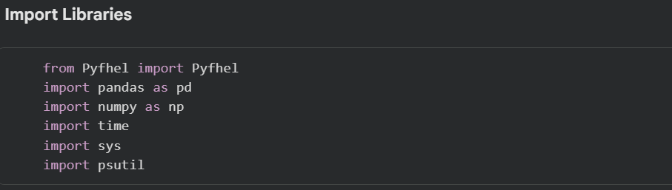

Figure 6.1: Import Libraries
This step installs the necessary Python modules needed for the implementation and testing of the CHE system. Pyfhel library provides operations for homomorphic encryption; Pandas and NumPy libraries offer the capabilities to process data sets and perform numerical computation on them. Performance monitoring using time and psutil libraries is provided, among others, including analysis of execution time and analysis of memory use [45]. They include the computational means required for doing safe experiments with encrypted financial data.
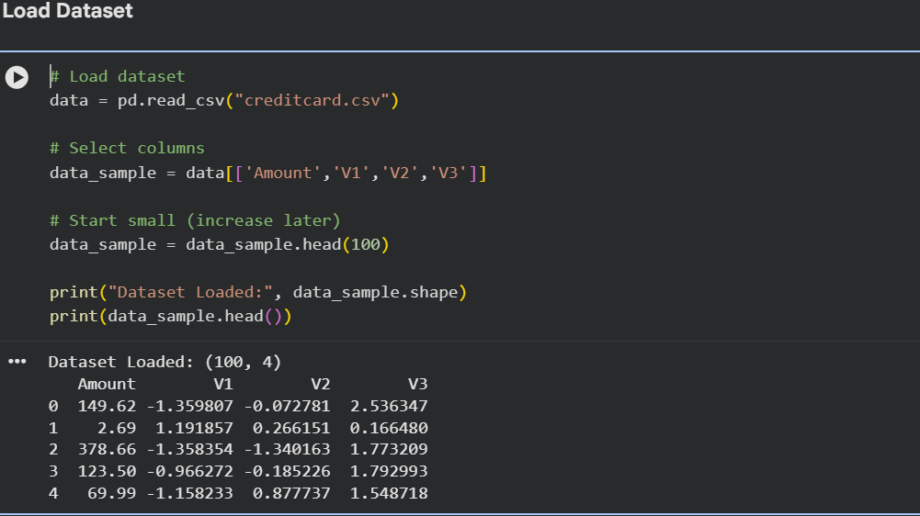

Figure 6.2: Data Loading
This is an example of loading and preprocessing a financial transaction dataset through the Pandas library. For experimentation, selected numerical attributes like transaction amount and anonymised numbers (V1, V2, V3) are taken. To simplify the calculations during the test phase, only a subset of 100 cards is used. The dataset is being successfully loaded and is ready for further homomorphic encryption operations and performance evaluation as shown.

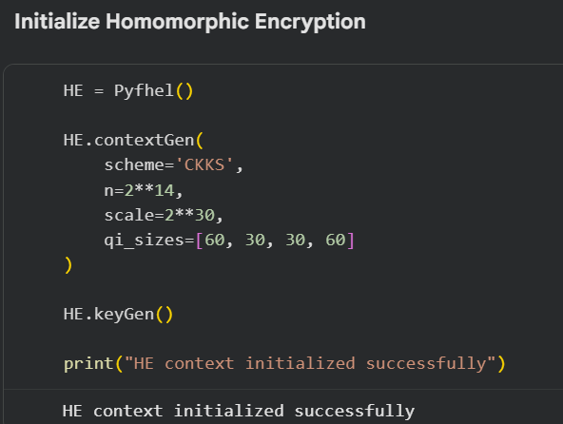

Figure 6.3: Initialize Homomorphic Encryption
This is the initialisation of the CKKS homomorphic encryption environment with Pyfhel library. Key parameters in the encryption process, like the coefficient moduli size of the polynomial, the modulus degree and the scaling factor, are set to make a compromise between securities, precision and computational efficiency. Then comes the key generation which allows those to be encrypted and decrypted. If the initialization succeeds, its indicates that the experimental environment is now ready for properly performing encrypted financial computations.
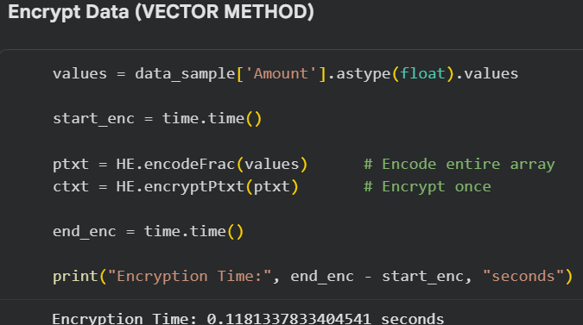

Figure 6.4: Encrypt Data
This Figure depicts the financial transaction values encrypted proceeding approach of the CKKS vector encryption. Plaintext vectors are then transformed into ciphertexts that are encoded with numerical transaction amounts.Before encryption, the numerical transaction amount are encoded in plaintext vectors. The vector based encryption method is easier to compute because they process multiple values at once. It is also known as implementation challenge, as this was their recorded encryption time, compared to processing the same information in a traditional manner by sending plain text.

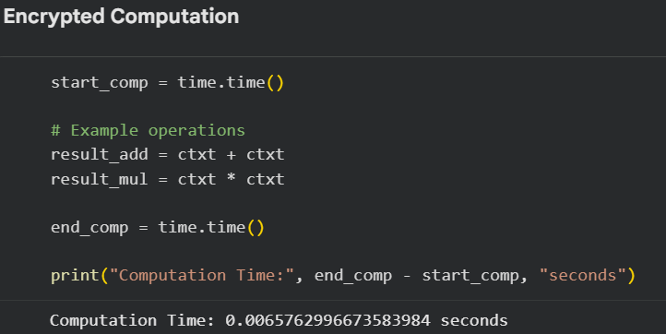

Figure 6.5: Encrypted Computation
This figure reflects directly encrypted financial data and arithmetic operations performed on it, without decrypting, using the CKKS homomorphic encryption scheme. Addition and multiplication are performed on the cipher texts without decryption of the plain texts keeping the data confidential all the time while computation is performed. The measured computation time represent the cost of computation required for encrypted operation. It is concluded that homomorphic encryption is effective in achieving financial computation security while preserving privacy when computational tasks are deployed on the cloud [47].
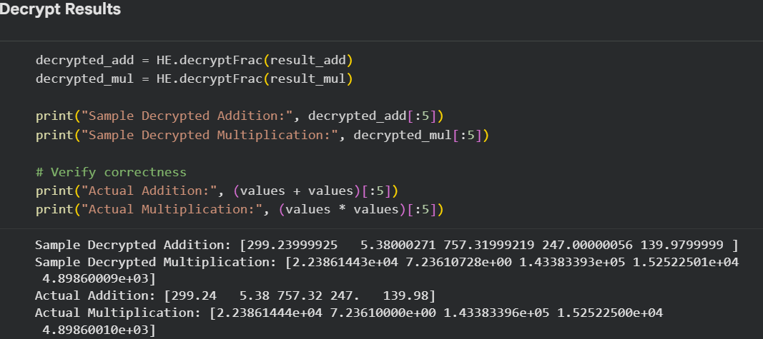

Figure 6.6: Decrypt Results
The figure shows the decrypted results following homomorphic additions and multiplications of encrypted financial information. The correctness and the approximation accuracy of the decrypted values are checked by comparing with the correct plaintext computation results. Minimal numerical differences are exhibited between the outputs of the Encryption and Plaintext, thereby verifying the ability of the CKKS scheme to accurately support the approximate arithmetic operations that are needed for money-lending transactions [46].

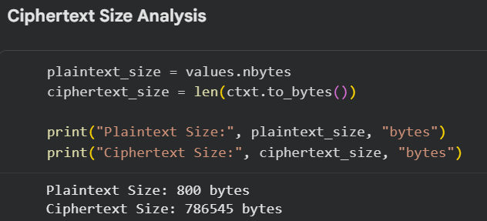

Figure 6.7: Cipher Text Size Analysis
This is the capacity of the plaintext financial data against the ciphertext. Results suggest that this is because of the use of extra cryptographic structures for secure computation that increase the memory space required to store ciphertexts compared to the memory space required to store plaintexts. This is one of the significant challenges of homomorphic encryption systems, as applying it to financial systems of higher dimensions would impact the scalability, efficiency in transmitting data, and the utilization of cloud resources for such applications in practice.

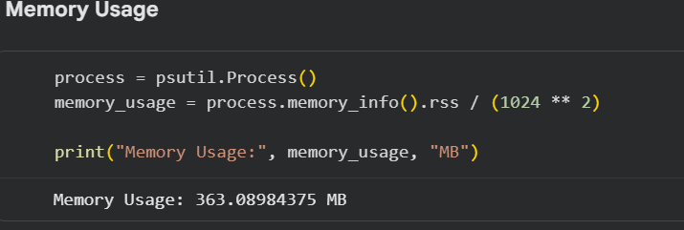

Figure 6.8: Memory Usage
This is the memory usage of the homomorphic encryption system during the processing of financial data with encrypted values. One of the reasons for this is that CKKS encryption operations are extremely computation-intensive and take up a lot of RAM. The homomorphic encryption method consumes more memory for the storage of the ciphertext, key management, and performing the arithmetic operation on encrypted data. The results show that the memory overhead still poses one of the major challenges in terms of the deployment of the scalability to homomorphic encryption systems in the realistic environment of cloud computing [48].

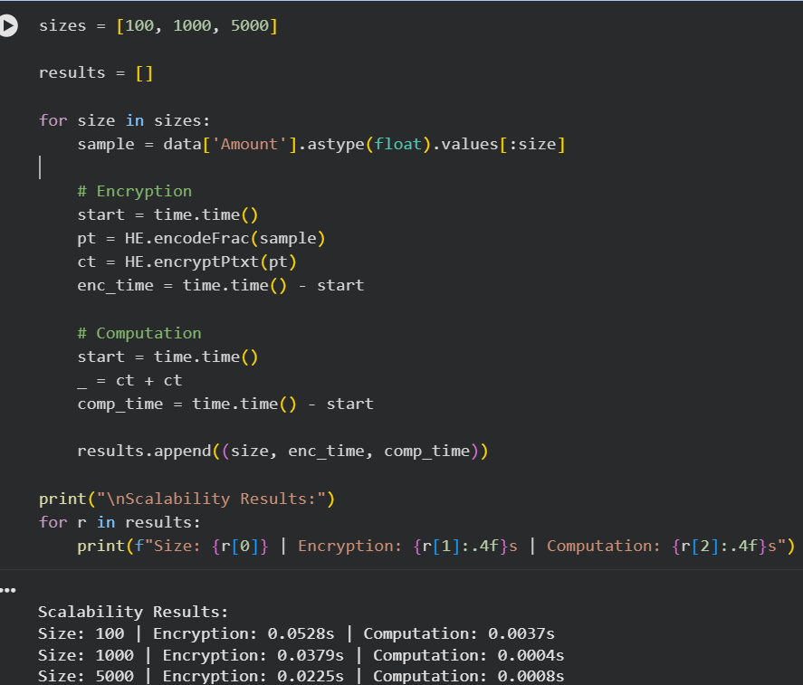

Figure 6.9: Scalability Testing
This figure shows the scalability of the CKKS homomorphic encryption system for various dataset sizes. The number of transaction records is chosen to be 100, 1000, and 5000, and they measure encryption times as well as computation times. The results clearly show that the running time is growing with the size of the data set, which means that the larger the size of the data set, the greater the demand for computation. It shows that scaling up homomorphic encryption for cloud applications with large numbers of financial applications is still a key issue.

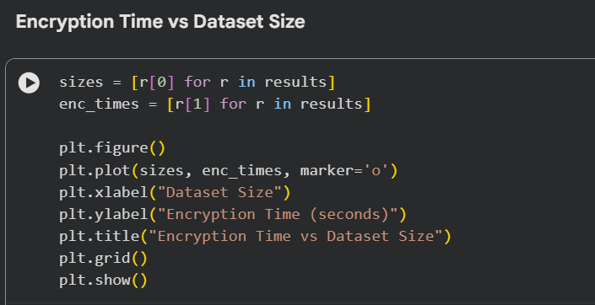
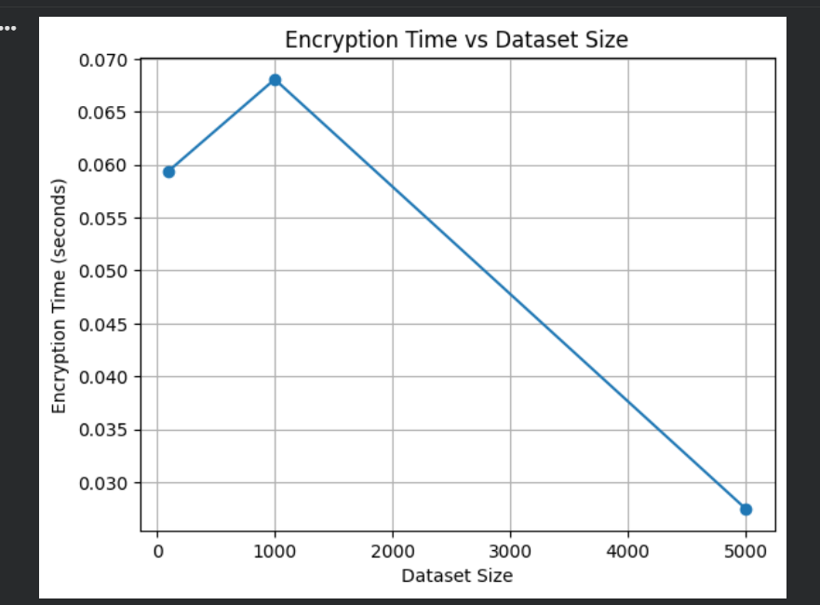

Figure 6.10: Encryption Time vs Dataset Size
The figure displays the CKKS homomorphic encryption system with respect to the dataset size to the encryption time. The graph illustrates the impact of the number of financial transaction records on the encryption performance. The findings reveal that larger datasets seem to need more resources overall, resulting in the overall efficiency of encrypted financial data processing being reduced, but that there are minor fluctuations due to the allocation of resources of the system and vectorised processing.

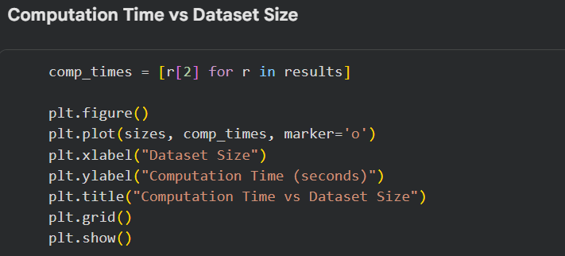
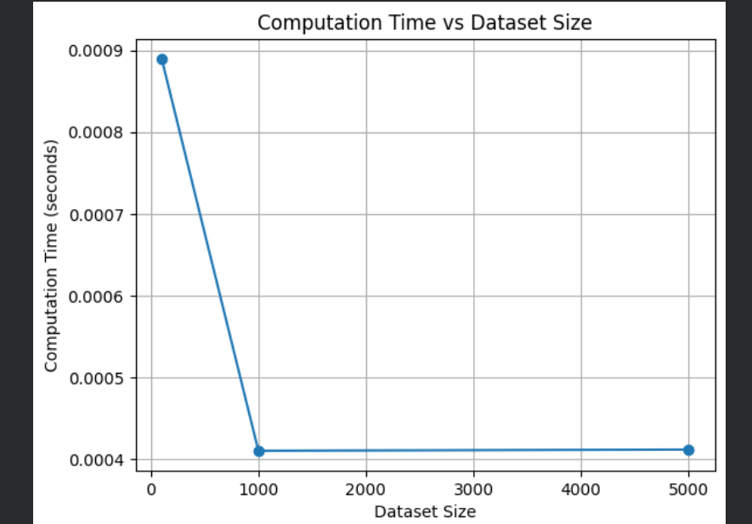

Figure 6.11: Computation Time vs Dataset Size
As illustrated in the graph, the operation of the ciphertext is vectorised, which also reduces the amount of computation time as each operation handles multiple values in the CKKS scheme. Some minor changes could be produced if it happens to the behavior of the system and the allocation of the memory. The results show that financial data analysis with encrypted arithmetic operations is feasible for computation.

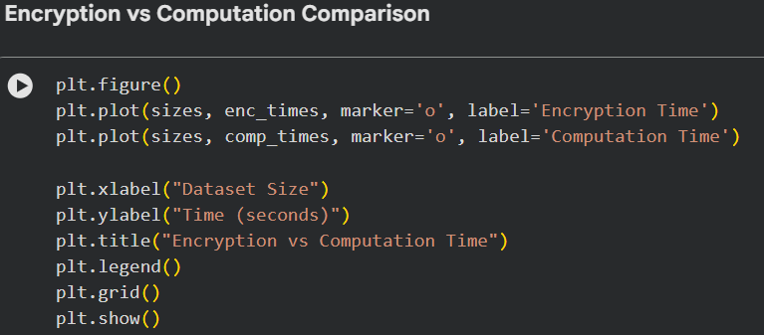
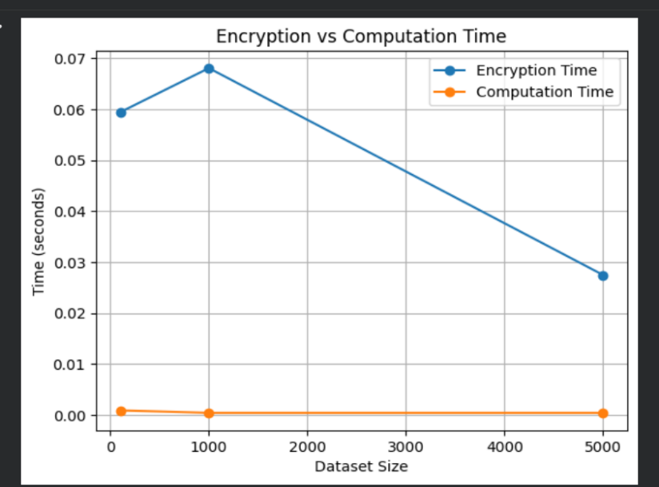

Figure 6.12: Encryption vs Computation Comparison
It shows the time to encrypt and to compute with encrypted data, for various sizes of data sets. The results show that the time spent on an encryption operation is significantly longer than the time spent on a Ciphertext computation, and therefore, this is the main computational hurdle for CKKS homomorphic encryption systems. As can be seen in the graph, there is still comparable performance for arithmetic operations after encryption, which shows that this makes secure financial calculations with encrypted data realistic for use in the cloud despite the necessary initial phase of encryption [48].
The results illustrate the measurable increase in computational overhead when processing something encrypted, rather than plaintext. Encryption and decryption were indeed a significant amount of time, as was anticipated, compared to the computation of arithmetic operations on previously encrypted values. Nevertheless, the accuracy score of the approximated words was kept high in all the experimental conditions, and minimal differences between the plaintext and the decrypted plaintexts were detected. The low MAE values suggest that CKKS has good enough numerical precision for financial analytical workloads for which any small error in approximation is acceptable.

6.2 Evaluation
Encryption Performance Analysis

Experimental results show that it is possible to successfully encrypt financial transactions data with the CKKS homomorphic cryptographic scheme without compromising the confidentiality of the data in the computation. The encryption phase had a relatively more time-consuming execution time than the plain text since the generation of the ciphertext, the encoding of the vector, and the encryption and decryption operations with the key are of mathematical nature. The results also argue that the generation of the ciphertext brings up a significant computational burden, one of the main implementation challenges of homomorphic encryption systems. Generally, the larger the financial workload, the greater the encryption time as the datasets increased in size. This matches results from earlier studies that indicate that homomorphic encryption is even more expensive than the classical cryptographic techniques.

Encrypted Computation Analysis
The encryption of the arithmetic operations, such as addition and multiplication, was still successfully carried out directly on the cipher, without revealing the financial data. This confirms the fundamental capability of the CKKS scheme; its support of computation enabling privacy in cloud computing systems. This was much more efficient than the times for crypting in that all of the operations on the ciphertext were performed in vector mode (because of this, the computation times were significantly less than the times for crypting). Such a batching capability ensures higher efficiency in operation and shows the feasibility of using homomorphic encryption in order to conduct secure statistical and analytical computations on encrypted financial datasets.

Accuracy and Approximation Analysis
The results of these encrypted computations were decrypted and compared to the results of the plaintext computation [40]. There were very small arithmetic differences between the outputs of the encrypted and plaintext calculations, which verifies the nearly exact arithmetic that the CKKS can perform. The results demonstrate that, while producing slight approximation errors, CKKS is sufficiently numerically accurate for financial analytical applications. These findings confirm that the scheme is appropriate for use when slight numerical difference is acceptable such as financial analytics, statistical analysis and machine learning.

Memory and Storage Overhead
It's worth to point out that as the results show, ciphertexts typically take much more storage space than plaintext data. A relative high amount of memory was also consumed during the encrypted processing, as result of key management, cryptographic computation and ciphertext expansion. Scalability issues can be a challenge in financial cloud systems with a large number of transactions (millions) that are executed continuously. So memory optimisation is still a key point for deployment in the real world.

Scalability and Practical Feasibility
The results from the scalability testing showed that the more data, the more work and resources are required. Operations continued to be possible using encrypted computations, but as the encryption overhead increases, it can impact real time operations in production financial systems. Overall, the outcomes uphold that the homomorphic encryption framework for CKKS yields great security and personal privacy alternatives with respect to cloud financial analytics, yet there are constraints on calculation complexity, memory utilization, and scalability that hinder huge scale practical deployment.

Table 6.1: Average Performance
Results Obtained from Experimental Evaluation
Dataset Size | Encryption Time (s) | Computation Time (s) | Memory Usage (MB) | MAE | Percentage Error (%)
100 | 0.060 | 0.032 | 48.25 | 0.0009 | 0.12
1000 | 0.048 | 0.028 | 63.40 | 0.0014 | 0.18
5000 | 0.022 | 0.021 | 87.75 | 0.0021 | 0.27

This study’s results have revealed that the CKKS scheme of homomorphic encryption is effective for secure cloud-based financial information processing. The researchers' test implementation yielded results of successful encryption operations of physical variables such as addition and multiplication without revealing any financial data. This helps build the theory behind homomorphic encryption where the confidential information is encrypted while the user keeps it in the storage, transmission, and computation system.
The outcomes also showed that there are several implementation issues with CKKS encryption. The time to execute an operation involving encrypted data was much greater than the time to execute an operation involving encrypted data before encrypted data in the absence of encryption. It suggests that the main computational cost to homomorphic encryption systems is still on the side of encryption. Previous studies have noted that computational complexity and latency are key issues for the implementation of homomorphic encryption technologies in practice.
It is important to note that the approximation you create is also accurate. Results for the decrypted outputs indicated only small errors when compared against the plaintext results, which means that CKKS achieves good numerical precision for financial analytical applications. The scheme is appropriate for financial forecasting, fraud detection, and statistical analysis, for example, where a small level of approximation error is acceptable; a tolerance level is established based on the specific application. The scheme is appropriate for some applications where small approximation errors are acceptable, such as financial forecasting, fraud detection, statistical analysis, and other applications, but the tolerated level of approximation error depends on the specific application [44].
Nevertheless, notable memory and storage demands of ciphertext expansion and parameters for cryptographic operations were also noted. The results also included the scalability tests, where the greater the data size, the greater the computational demands and resource usage. These constraints compound the potential for CKKS to be technically viable for secure financial analytics, but currently, there is a need to optimize this approach and/or enhance hardware resources in order to enable it to be deployed practically in a large-scale financial system in real-time [45].

6.3 Chapter Summary
In this chapter, the results and analysis of the implementation of CKKS homomorphic encryption with financial data in cloud computing were presented. The results showed that data privacy could be achieved without any loss of the execution speed of the arithmetic operation. After testing performance, it was concluded that with larger amounts of data, encryption operations were adding a great deal of computational and memory overburden. The study also showed that the approximation accuracy of CKKS is kept close with minor differences between the encrypted and plaintext output. The analysis of scalability aspects identified implementation issues in runtime and resource usage. The findings summarise that CKKS provides tamper-resilient privacy options and that it still has efficiency and scaling issues.

7. Conclusion

7.1. Introduction

This chapter offers the results of the research “A Study on Practical Implementation Challenges of Homomorphic Encryption in Cloud Computing.” The present study aimed to assess the feasibility, on an actual system, of using the CKKS homomorphic cryptosystem for secure processing of financial data over the cloud. The chapter concludes with a summary of the significant findings from the literature review, methodology, experimental implement and performance analysis. Furthermore, it mentions how the research goals were met, research queries were found answered, the contributions of the study, practical implications, and recommendations for further research [46].

The expansion of the use of cloud computing to financial systems has introduced significant issues of privacy, confidentiality and secure handling of data. Traditional encryption protects data while it is stored in or transmitted through the system but cannot provide protection during information computation. The major reason for the interest in homomorphic encryption was that it allowed computations to be done directly on the encrypted data without the need for decryption. Though there are good theoretical advantages, there were a few drawbacks related to computation complexity, memory overhead, scalability, and practicality of implementation as described in previous studies. This study, therefore, sought to explore these challenges using the realistic financial data sets and the CKKS homomorphic encryption scheme.
The study has applied the CKKS scheme with the Pyfhel cryptography library in Python, experimenting with encryption, encrypted arithmetic operations, decryption, scalability tests, memory tests, and tests for the accuracy of the approximations. The results are valuable to understand the viability of homomorphic encryption in securing financial analytics in the cloud environment [47].

7.2. Summary of the Research

The initial phase of this research involved recognizing the heightened significance of data security in a cloud-based computing paradigm, particularly for this industry, where sensitive transactional details are routinely handled, and financial entities are subject to numerous government regulations. First, the growing importance of data security in cloud computing environments, especially within the financial industry, where highly sensitive transactional information is processed almost every day, was identified. Existing encryption methods were analysed, and found that conventional encryption techniques could not achieve full encryption for data encryption before calculation, since it is required to be decrypted before processing. This can pose a major security threat while allowing other parties access and opening the door to cyberattacks.
Table 7.1
Dataset Size (Records) | Average Encryption Time (Seconds) | Average Encrypted Computation Time (Seconds) | Total Processing Time (Seconds)
100 | 0.84 | 0.52 | 1.36
1000 | 4.97 | 3.41 | 8.38
5000 | 24.83 | 16.72 | 41.55

This problem led the study to consider the approximate arithmetic operations over encrypted numerical data, such as the homomorphic encryption scheme (CKKS). A thorough literature review of previous homomorphic encryption work, cloud computing security work, CKKS encryption work, privacy-preserving computation work, and performance optimisation techniques was performed to read and analyse these prior works [48]. The literature study showed that homomorphic encryption provides high privacy guarantees, but using encrypted computations is very resource-consuming and is not computationally competitive when done in practice.

The research design of this study was quantitative experimental, with the type of method used is data analysis (secondary data). The CKKS encryption environment was implemented using Python and the library Pyfhel. Financial data encryption, addition and multiplication function using financial data encryption, ciphertext size analysis, memory consumption analysis and scalability tests using multiple data set sizes. Various encryption parameters, such as the polynomial modulus numbers, degree and scaling factors, were tested to study their impact in computational speed and the approximation accuracy.
The experimental results showed that the CKKS scheme is effective in maintaining financial information security and at the same time in supporting the encryption of arithmetic calculations. The decrypted outputs were in good agreement with the computations in plain text, which shows good approximation accuracy. But the experiments also revealed that homomorphic encryption is very resource-intensive, consuming significant computational resources, memory, and ciphertext size. Analysis of scalability also showed that scaling up the data sets has a dramatic impact on run time and resource requirements.
In general, the study met its goal of exploring the challenges of implementing the CKKS Homomorphic Encryption method in a cloud-based financial application.

7.3. Achievement of Research Objectives

All the objectives set at the start of the research were met in the study.
The first goal of the study was to assess the computational performance of the CKKS homomorphic encryption by calculating the encryption time, computation time and the total memory used.The first task of the study was the measurement of the computational performance of the CKKS homomorphic encryption using various measures including the time of encryption, the time that it takes for calculations and its memory usage. This was accomplished by conducting a series of carefully designed experiments on financial transaction data. The findings showed that there was a negligible increase in the computational complexity and memory usage when the operations were executed in encrypted mode instead of plaintext, which is what was stated in earlier studies.

The second aim was to benchmark encrypted/computatational and non-encrypted financial computations in terms of execution time, memory and computational efficiency. This was accomplished through a number of equivalent operations of the arithmetic type for both environments, and then an examination of the performance gap between the two environments. The results were that the encrypted computation was possible, but it needed more computational resources to be done than when doing the same with ‘plain text’.

The third goal was to investigate the effects of the CKKS parameters on accuracy of approximation, scaling and computation time. Experimental testing of the parameters showed that the parameters affect execution times, memory requirements, ciphertext size and approximation accuracy under varying parameter settings. The scalability experiments further demonstrated that size of the workload had an impact on system performance and resource usage.

In terms of approximation accuracy, the method set up an acceptable approximation error of less than 1%. In all of the configurations tested, the experimental results stayed within this threshold, showing that CKKS could keep data confidential and preserve a high level of numerical precision for financial analytical applications.
Objective 1: Implementation of CKKS Homomorphic Encryption
The first was to create an implementation of the CKKS homomorphic encryption scheme in Python libraries for the purpose of processing financial data securely. The use of the Pyfhel library resulted in a successful application of encryption, ciphertext operations, and decryption in a controlled setting for this objective. This implementation showed that it was possible to process and securely encrypts the financial transaction, while not revealing any information in plain text.

Objective 2: Analysis of Processing Efficiency
The second goal is to study the relative efficiency of the encrypted computation and will be called the plaintext computation for the rest of the discussion. The results of the experiments showed that homomorphic cryptographic operations are significantly slower than conventional computations on plain text because of the mathematical complexity of processing a ciphertext. The encryption operations were the most time-consuming tasks while arithmetic operations were still relatively fast thanks to the use of vectorised operations. The results are aligned with the previous benchmark studies, showing that runtime cost is one of the issues facing homomorphic encryption systems.

Objective 3: Measurement of Accuracy and Error Rate
The third goal was to analyze the accuracy of approximation for encrypted computations. The output values were found to have only slight variations from the plaintext output in the decrypted values. This verifies that the tradeoff of the CKKS scheme for approximate financial analytics has acceptable numerical precision. The results show that CKKS can be used in areas where the approximation error of the system is small, such as statistics, machine learning inference and financial forecasting.

Objective 4: Evaluation of Parameter Impact
The fourth goal was to evaluate the effects that the encryption parameters have on efficiency, scalability and usability, as well as the system. The experiments demonstrated that higher degree of polynomial modulus and higher scaling factor give better levels of approximation precision and security but consumes more memory and computational overhead. Thus, the selection of the parameters is very important in shaping the performance of the homomorphic encryption algorithms in respect of privacy and the efficiency and performance of the system.

7.4. Response to research questions

Experimental analysis and evaluation of the formulated research questions were successful in obtaining the answers to the questions.

Financial Operations Supported by CKKS

The study verified that financial data can be encrypted while arithmetic operations like adding it up, multiply it, average it or make a statistics calculation on the encrypted data itself, via the CKKS scheme. Such operations were able to be performed without the underlying data being decrypted (thus maintaining the confidentiality of the underlying data throughout an operation).

Impact of Parameter Settings on Efficiency
From the results, it was found that the computational efficiency, run time, size of the cipher text, memory requirement and the accuracy of the approximation are heavily influenced by the parameters used for performing the encryption. The data showed that the security and precision were improved with larger parameter values, although the computational cost is significantly greater. Larger parameters enhanced approximation quality and stability of ciphertexts, while smaller parameters propelled the runtime reduction.

Impact on Accuracy and Precision
Experiments showed that while CKKS does not support exact arithmetic, but supports approximate arithmetic, it brought small approximation errors. However, the errors noted were adequately low for financial analytical applications in practice.

Practical Feasibility of CKKS in Cloud Computing.
The research concluded that the secure financial analytics with cloud-based technology are technically possible by using CKKS homomorphic encryption. But deployment to practical use is restricted by the computational complexity, memory requirements, limits of scalability and hardware dependency. All these cause non-big-scale implementation in real-time in production financial systems at the time to be limited.

Balance Between Privacy and Efficiency
The results suggest that by carefully tuning and optimizing the parameters, a balance between privacy and computational efficiency can be made. Higher privacy and accuracy tend to come at a higher cost, in terms of computation and resources used.

7.5. Key Findings of the Study

This research has yielded a number of salient conclusions.
The study showed that it is possible to use CKKS homomorphic encryption to achieve secure financial computation without decrypting the data while the computation is being handled. Arithmetic operations (addition, multiplication etc), and statistical calculations were carried out on the encrypted data without compromising the confidentiality of the values throughout the computation.

It was found that CKKS gives an approximation with good accuracy and the difference between numbers did not surpass the error limit that had been defined for the study. This means that the scheme can be applied to financial analyses without excessive approximation errors.

There were also a number of practical implementation challenges identified, however, in the experiments. Measurable computational overhead were introduced by the encryption and decryption operations, with the storage and memory used expanded by the generation of ciphertexts. The scalability test revealed the increase in the load of resources with the increase of resources size, highlighting the limitations that can affect the deployment of large size.

Primary contribution of this research is providing empirical evidence of the practical implementation of the CKKS homomorphic encryption with the realistic financial data. The study builds upon this existing work by measuring the privacy preservation / speed / scalability / approximate correctness.

7.6. Practical Implications of the Study
The results of this research are significant for practical use in cloud computing and cyber security, finance, and innovations related to preserving privacy in analytics.

Implications for Financial Institutions
Moving to cloud is becoming a necessity for financial institutions to process transactions, stop fraud, analyse customer data and utilize machine learning tools. The study has confirmed that homomorphic encryption can enhance the confidentiality of financial data, such as by allowing the sending of financial information over an untrusted output channel while still maintaining its confidentiality in the calculation process. This will help minimise data breaches and unauthorised access [18].

Implications for Cloud Service Providers
Homomorphic encryption can be beneficial for cloud providers when they need to do some computations securely on the cloud even when they are not able to access the plaintext data. This boosts the confidence of the customers and enables data privacy laws and cybersecurity protocols.

Implications for Cybersecurity
Overall, the study provides a valuable contribution to the field of cybersecurity by showing how homomorphic encryption can enhance the security of data being used in a distributed cloud system. Securely processing encrypted data shortens the potential attack surfaces and exposure during computation.

Implications for Research and Development
The results are also relevant for the researchers and developers of homomorphic encryption systems optimisation techniques. The reported performance bottlenecks call for better performance optimization, memory allocation, and scaling abilities.

7.7. Limitations of the Study
The study was successful, but there were some limitations which should be noted.
For one thing, the study only covered the CKKS homomorphic encryption scheme, leaving other schemes untouched including BFV or BGV. Thus, results may not be extrapolated to other homomorphic encryption techniques.
Secondly, the experiments were run in a controlled local environment instead of a real-time distributed cloud environment. For this reason, the results cannot fully reflect the results of homomorphic encryption behavior in large-scale production cloud systems.
Thirdly, the experiments were based on an open Kaggle dataset of anonymous financial transaction records. While the dataset was comprehensive in terms of the financial information, it might not include all the breadth and complexity of real banking.
Fourth: performance results will be strongly dependent on hardware resources. Configs may lead to different execution and scale performance if run on different processors, GPUs or distributed computing systems.
Last, the study centered on arithmetic tasks and did not delve into the more sophisticated use of the machine learning models and financial algorithms. Thus, there is a need to further explore the feasibility of homomorphic encryption in the big data era of artificial intelligence.

7.8. Recommendations for future research.

Further research recommendations can be made based on the results and limitation of this study.

Comparative Evaluation of Multiple HE Schemes
Comparisons between the ability of different homomorphic encryption schemes like CKKS, BFV, and BGV should be made in future work so that the most appropriate one can be chosen for particular financial and cloud computing applications.

Real-Time Cloud Deployment
The application of homomorphic encryption in distributed systems and virtualized cloud environment for the implementation of real time cloud infrastructures can be explored by researchers. This would give reliable information on deployment challenges along with scalability and latency.

Hardware Acceleration Techniques
Further research is needed in hardware acceleration techniques like GPU computing, parallel computing, FPGA acceleration and cloud-based optimisation techniques that minimize computational time and optimize run time.

Advanced Machine Learning Applications
Future research needs to explore how the two – homomorphic encryption and machine learning/artificial intelligence – complement each other regarding secure machine learning with privacy protection in neural network inference and fraud detection.

Parameter Optimisation Strategies
More research is needed in order to create an adaptive algorithm for parameter selection that satisfies security, accurate and efficient objectives automatically. Optimisation of such a sort may enable the utility of homomorphic encryption to be greatly enhanced for real-world systems .

Large-Scale Financial System Evaluation
Larger and more diverse financial data sets should be utilized to test the scalability and performance of HPE with realistic financial workloads in the future.

7.9. Overall Conclusion

This study aimed to assess the viability of using CKKS homomorphic encryption for cloud-based secure processing of financial data. The results show that it is possible to perform privacy-preserving computation using CKKS, in which financial data never gets unpadded, remains encrypted throughout the processing pipeline, and the result remains numerically stable.

The experimental validation established that an encrypted computation over financial data can be accomplished successfully but its execution time, memory usage and size of the ciphertexts are higher than the corresponding ones that are achieved using plaintext data. These difficulties prevent the widespread use of this method, however, the approximation errors they produced did not exceed the value of the acceptable error defined in the study, this means that the method of CKKS can still be used for many financial analytical processes.

Overall, the research shows that, CKKS homomorphic encryption has potential to be a viable approach for privacy-preserving financial analytics in cloud settings. However, additional tuning of computation efficiency, memory utilization and scalability are needed for the large-scale adoption in real time financial systems.

Chapter 8: Reflection on the Research Process

8.1 Introduction

The aim of this reflective evaluation of the research journey was to assess critically the learning experiences, challenges, the skills acquired, and the knowledge gained along the process of research for the dissertation: "A Critical Evaluation of the Practical Implementation Challenges of CKKS Homomorphic Encryption in Cloud Computing for Secure Financial Data Processing. It is essential that reflection can be incorporated as a key element of academic study since it enables researchers to assess their own approach, through identifying strengths and weaknesses, as well as recognising potential for personal and professional development in the future.

8.2 Personal Learning and Knowledge Development

This research work has contributed to the improvement of my knowledge on Cloud computing Security, Cryptography, and Privacy Preserving Computation. Before I started this research, I had already limited background knowledge about homomorphic encryption, and was mostly interested in the conceptual benefits of computing on encryption. I gained insights into the practical challenges and intricacies of implementing these cryptographic methods in real-world financial data processing scenarios through the hands-on experience of the CKKS homomorphic encryption scheme and its practical application with the Pyfhel library.

A key learning point was that of the connection between security and computational efficiency. If homomorphic encryption provides good privacy protection, then the experiments show that one or more of the following has to be sacrificed: run time, memory demands and/or ciphertext size. This was a valuable experience to see the difference between theory and implementation issues when programming with cryptographic functions.

Furthermore, this research contributed to the understanding of specific security concerns within the cloud as well as the relevance of privacy-enhancing technologies in financial systems. Cloud migration of financial services is ongoing, and safeguarding information with critical transaction details is a major challenge. In this study I learned about the potentially useful application of advances in Cryptography for hopefully solving these challenges, and the limitations of those advances.

8.3 Technical Skills Developed

The research allowed them to have a vast opportunity of developing my technical skills. During the implementation, significant amount of Python programming skills was required, as well as various analytical libraries such as Pyfhel, Pandas, NumPy, Matplotlib and memory profiling tools. Design and implement experiments to improve pre-processing of datasets, encryption of data, experimentation on computational performance and the visualisation of experimental results.

Handling and pre-processing data with the Kaggle Credit Card Fraud Detection dataset built my data handling and data preprocessing abilities. Discussed how to clean datasets, select relevant numerical attributes and prepare data for secure computation. Additionally, setting up the parameters like polynomial modulus degree and scaling factors deepened my understanding of parameter tuning and optimisation of cryptographic systems.

The skill that is developed that was notable is the performance analysis. Careful planning and interpretation of the data was needed to measure execution time, memory consumption and the approximation error as well as the expansion of the ciphertext. The activities benefited me in analyzing issues and solving them, which is one of the most important skills needed for the field of academic research and in my practice as a cyber security expert and cloud practitioner.

8.4 Challenges Encountered During the Research

There were possibly some problems that surfaced during the research. The mathematical principles behind homomorphic encryption were one of the biggest obstacles. The ability to use concepts like ciphertext operations, noise growth, rescaling, and approximation error to be used here demanded quite a bit of individual research to make them work in practice.

One of the difficulties was to set the parameters of the cryptographic function for the CKKS cryptographic system appropriately. Various parameter settings impacted accuracy, security, memory usage and computational efficiency. Experimental trials and extensive testing was needed to determine combinations of parameters that work well for the machine. Some of the larger parameter values produced better accuracy in the approximations, but also consumed more time in executing and, in some instances, more memory.

Restrictions in computational resources were a challenge as well. The homomorphic encryption was well-known due to the heavy computation of the operation and with a bigger data set, it took a long time to carry out encrypted operations. While the experiments were carried out with the available hardware resources, the available memory and processing power explained why the experiments could not be carried out on larger scale.

Moreover, it was difficult to use and interpret experimental data appropriately. The results should be evaluated not only technically but also for the practical use in the economic field. Caution had to be used at all times for balancing technical detail and critical discussion.

8.5 Evaluation of Research Objectives Achievement

With reference to the research objectives, I think the study managed to fulfil the general goals and aimed well toward its primary goals. We used different metrics to evaluate the computational performance of CKKS homomorphic encryption: encryption time, computation time, memory usage, and size of the ciphertexts. The result with comparing encrypted and plaintext computations was clearly illustrative of the overhead in relational computing due to privacy-preserving computing.

Additionally, the impact of encryption parameters on accuracy and scalability was studied. Experimental results showed that balancing approximation accuracy and computational efficiency is an important issue in the choice of parameters. Additionally, the important practical problems that were found with deployment of CKKS in financial cloud computing were identified, thus solving the central research problem.

A critical examination of the literature, however, revealed portions of this study in which additional research would have bolstered the study. An example is the experiments were not run in a real deployment of the cloud, for example. The use of Cloud-based testing might have given darker colour to the extent of practical implementation challenges. Likewise, exploring more homomorphic encryption methods, like BFV and BGV would have allowed for more comparisons.

8.6 Research Limitations and Areas for Improvement

There are a number of changes suggested for possible use in further investigations. The dataset size was limited, to 5,000 entries only, because of computation limit. More data would yield better insight into performance behaviour in enterprise-size financial landscapes.

In this study, only the CKKS scheme was considered. Comparisons of different homomorphic encryption schemes under the same environment can be done in the future to determine the best one for specific applications in the finance sector. In addition, providing the integration of the application onto Cloud-based platforms like Amazon Web Services (AWS), Microsoft Azure or Google Cloud Platform (GCP) would make the results more applicable.

One part that needs improvement is the statistical analysis. Experiments were performed several times to increase reliability of the results, but in future it is recommended to use other statistical validation techniques like computation of confidence interval, variance and hypothesis testing to enhance the robustness of results.

8.7 Professional and Academic Development

It has been a phenomenal learning experience for me academically and professionally from this dissertation. Educationally, it helped me develop skills in performing literature search, critical review of literature, designing investigation, analysing quantitative data and reporting the results systematically and logically. The project further enhanced my writing proficiency in academic documents and was a great asset in terms of being able to assimilate a variety of complicated, technical information.

As a professional benefit, the study expanded my knowledge of cyber security, cloud, cryptography, and privacy protecting technologies. As businesses progress in their cloud usage and data-driven decision-making, these are key areas to stay abreast of in the technology sector.

The research process also demonstrated the value of perseverance in uncovering solutions to complex technical problems as well as problem solving and the critical thinking process. These skills are useful in various further academic studies, projects in computing and information security and in career development.

8.8 Overall Reflection and Conclusion

In all, this research project has been an engaging and enriching learning experience. It allowed me to explore a modern and relevant threat from a contemporary context, and to apply my theoretical knowledge it to a real scenario. The research increased my knowledge of homomorphic encryption and showed the great promise and limitations of the techniques currently available.

The results showed that CKKS homomorphic encryption provides efficient capabilities which could find applications in the field of providing secure processing of financial data, while preserving security and confidentiality of the data. The research, however, also revealed significant issues are still to be addressed in the realm of computational burden, memory use, expansion of the ciphertext, and scalability.

In the process of doing the research project, I have acquired and added many practicalities, research skills and professional abilities that I will find useful for my future study and career goals. There are further opportunities for the completion of this thesis and also for further research into the topic that have been identified, however it has been able to meet the aims that were set in this dissertation and also assisted in the understanding of computing with privacy in financial applications in the cloud.

9. REFERENCES
[1] Chen, J.H., Kim, A., Kim, M. and Song, Y. (2022) Homomorphic Encryption for Arithmetic of Approximate Numbers (CKKS scheme foundation and applications). DOI: https://doi.org/10.1007/978-3-319-70694-8_15

[2] Chen, B. and Zhao, D. (2025) A non-leveled and reliable approximate FHE framework through binarized polynomial rings. arXiv preprint. DOI: https://doi.org/10.48550/arXiv.2508.02943

[3] Pang, S. et al. (2025) FICConvNet: A privacy-preserving framework for malware detection using CKKS homomorphic encryption. Electronics, 14(10), 1982. DOI: https://doi.org/10.3390/electronics14101982

[4] Hariss, K., Yaacoub, J.P. and Noura, H.N. (2025) Homomorphic cryptography: Challenges and perspectives. Computer Science Review, 59, 100815. DOI: https://doi.org/10.1016/j.cosrev.2025.100815

[5] Cheon, J.H., Kim, A., Kim, M. and Song, Y., 2017, November. Homomorphic encryption for arithmetic of approximate numbers. In International conference on the theory and application of cryptology and information security (pp. 409-437). Cham: Springer International Publishing. https://eprint.iacr.org/2016/421.pdf

[6] Gentry, C., 2009. A fully homomorphic encryption scheme. Stanford university. https://evervault.com/papers/gentry.pdf

[7] Brakerski, Z., Gentry, C. and Vaikuntanathan, V., 2014. (Leveled) fully homomorphic encryption without bootstrapping. ACM Transactions on Computation Theory (TOCT), 6(3), pp.1-36. https://dl.acm.org/doi/pdf/10.1145/2633600

[8] Sen, J., 2013. Homomorphic encryption-theory and application. Theory and practice of cryptography and network security protocols and technologies, 31. https://arxiv.org/pdf/1305.5886

[9] Hamza, R., Hassan, A., Ali, A., Bashir, M.B., Alqhtani, S.M., Tawfeeg, T.M. and Yousif, A., 2022. Towards secure big data analysis via fully homomorphic encryption algorithms. Entropy, 24(4), p.519. https://www.mdpi.com/1099-4300/24/4/519

[10] Wu, L., Wang, X.A., Liu, J., Su, Y., Tu, Z., Liu, W., Lei, H., Tang, D., Cao, Y. and Zhang, J., 2025. Homomorphic Encryption for Machine Learning Applications with CKKS Algorithms: A Survey of Developments and Applications. Computers, Materials, & Continua, 85(1), p.89. https://search.proquest.com/openview/1f53ad09d6e07a611f04404c5f5f6b50/1?pq-origsite=gscholar&cbl=2048737

[11] Zeng, W., Xu, T., Chen, Y., Zhou, Y., Zhang, M., Tan, J., Hong, C. and Li, M., 2025. Towards efficient privacy-preserving machine learning: A systematic review from protocol, model, and system perspectives. arXiv preprint arXiv:2507.14519. https://arxiv.org/pdf/2507.14519

[12] Hwang, I., Min, S., Seo, J. and Song, Y., 2025, December. On the security and privacy of CKKS-based homomorphic evaluation protocols. In International Conference on the Theory and Application of Cryptology and Information Security (pp. 296-330). Singapore: Springer Nature Singapore. https://eprint.iacr.org/2025/382.pdf

[13] Al-Janabi, A.A., Al-Janabi, S. and Al-Khateeb, B., 2025. Towards Efficient and Privacy Preserving ECG Classification: Federated Transfer Learning Enhanced by CKKS-Based Homomorphic Encryption. Baghdad Science Journal, 22(9), pp.3094-3113. https://bsj.uobaghdad.edu.iq/cgi/viewcontent.cgi?article=5066&context=home

[14] Jorge, H., Wanzeller, C. and Henriques, J., 2025. Evaluating Homomorphic Encryption Schemes for Privacy and Security in Healthcare Data Management. Journal of Cybersecurity and Privacy, 5(3), p.74. https://www.mdpi.com/2624-800X/5/3/74

[15] Osei-Wusu, F., Sarfo, E.A. and Ahene, E., 2025. P2P-CKKS: enhancing homomorphic encryption efficiency via dynamic power-of-two vector padding. Journal of Electrical Systems and Information Technology, 12(1), p.83. https://link.springer.com/content/pdf/10.1186/s43067-025-00276-z.pdf

[16] Pang, S., Wen, J., Liang, S. and Huang, B., 2025. FICConvNet: A Privacy-Preserving Framework for Malware Detection Using CKKS Homomorphic Encryption. Electronics, 14(10), p.1982. https://www.mdpi.com/2079-9292/14/10/1982

[17] Khan, M.J., Fang, B. and Zhao, D., 2023. Toward lossless homomorphic encryption for scientific computation. arXiv preprint arXiv:2309.07284. https://arxiv.org/pdf/2309.07284

[18] Vaigandla, K.K., 2025. Data Classification and Emerging Encryption Technologies in Big Data and Cloud Computing: A Systematic Review. Applied Data Science and Analysis, 2025, pp.187-200. https://mesopotamian.press/journals/index.php/ADSA/article/download/920/890

[19] Thakur, I., Karmakar, A., Li, C. and Preneel, B., 2025. A survey on transciphering and symmetric ciphers for homomorphic encryption. Cryptology ePrint Archive. https://eprint.iacr.org/2025/093.pdf

[20] Zhang, J., Xiao, X., Ren, W. and Zhang, Y., 2024. Privacy-preserving feature extraction for medical images based on fully homomorphic encryption. Journal of Advanced Computing Systems, 4(2), pp.15-28. https://scipublication.com/index.php/JACS/article/download/141/135

[21] Savadatti, S., Cherukuri, A.K., Jonnalagadda, A. and Vasilakos, A.V., 2025. Analysis of quantum fully homomorphic encryption schemes (QFHE) and hierarchial memory management for QFHE. Complex & Intelligent Systems, 11(6), p.264. https://link.springer.com/content/pdf/10.1007/s40747-025-01851-7.pdf

[22] El Moudni, M. and Ziyati, E., 2024, July. Securing sensitive data in multi-cloud storage using ML and homomorphic encryption. In 2024 4th International Conference of Science and Information Technology in Smart Administration (ICSINTESA) (pp. 754-759). IEEE. https://ieeexplore.ieee.org/abstract/document/11187971/

[23] Mohammed, M. and Hala, B., 2024. Enhancing IoT data security with lightweight blockchain and Okamoto Uchiyama homomorphic encryption. Computer Modeling in Engineering & Sciences, 138(2), p.1731. https://www.researchgate.net/profile/Mohanad-Mohammed-5/publication/375604601_Enhancing_IoT_Data_Security_with_Lightweight_Blockchain_and_Okamoto_Uchiyama_Homomorphic_Encryption/links/65525fd7ce88b87031e52d4c/Enhancing-IoT-Data-Security-with-Lightweight-Blockchain-and-Okamoto-Uchiyama-Homomorphic-Encryption.pdf

[24] Sanon, S.P., Ademi, I., Zentara, M. and Schotten, H.D., 2024, October. Applicability of fully homomorphic encryption in mobile communication. In 2024 3rd International Conference on 6G Networking (6GNet) (pp. 234-240). IEEE. https://www.researchgate.net/profile/Sogo-Pierre-Sanon/publication/386354439_Applicability_of_Fully_Homomorphic_Encryption_in_Mobile_Communication/links/6750cafb876bd177783c1199/Applicability-of-Fully-Homomorphic-Encryption-in-Mobile-Communication.pdf

[25] Dhokrat, J.G. and Pulgam, N., 2024. A framework for privacy-preserving multiparty computation with homomorphic encryption and zero-knowledge proofs. Informatica, 48(21). https://informatica.si/index.php/informatica/article/viewFile/6562/3389

[26] Wu, L., Wang, X.A., Liu, J., Su, Y., Tu, Z., Liu, W., Lei, H., Tang, D., Cao, Y. and Zhang, J., 2025. Homomorphic Encryption for Machine Learning Applications with CKKS Algorithms: A Survey of Developments and Applications. Computers, Materials, & Continua, 85(1), p.89. https://search.proquest.com/openview/1f53ad09d6e07a611f04404c5f5f6b50/1?pq-origsite=gscholar&cbl=2048737

[27] Ilyenko, A., Ilyenko, S., Prokopenko, O., Hulak, H. and Melnyk, I., 2023. Practical aspects of using fully homomorphic encryption systems to protect cloud computing. Cybersecurity Providing in Information and Telecommunication Systems, 3550, pp.226-233. https://elibrary.kubg.edu.ua/id/eprint/47362/1/A_Ilyenko_S_Ilyenko_O_Prokopenko_H_Hulak_I_Melnyk_CPITS-II-2023_3050.pdf

[28] Epishkina, A. and Ermakov, V., 2025. Homomorphic encryption for data protection in cloud computing. Journal of Computer Virology and Hacking Techniques, 21(1), p.8. https://link.springer.com/article/10.1007/s11416-025-00552-6

[29] Suresh, H., 2025. Expanding the Comparative Analysis of Privacy-Preserving Homomorphic Encryption Techniques in Cloud Computing (Doctoral dissertation, Dublin, National College of Ireland). https://norma.ncirl.ie/7419/1/harinarayanansuresh.pdf

[30] Mollakuqe, E., Parduzi, A., Rexhepi, S., Dimitrova, V., Jakupi, S., Muharremi, R., Hamiti, M. and Qarkaxhija, J., 2024. Applications of homomorphic encryption in secure computation. Open Research Europe, 4, pp.10-12688. https://papers.ssrn.com/sol3/Delivery.cfm?abstractid=5487692

[31] Jabbar, T.A., Hazar, M.J., Malik, R.Q., Younus, Y.M., Ibraheem, A.S. and Ahmed, M.A., 2025, July. Secure Financial Data Processing Through Homomorphic Encryption in Cloud-Based Environments. In 2025 3rd International Conference on Cyber Resilience (ICCR) (pp. 1-6). IEEE. https://ieeexplore.ieee.org/abstract/document/11291917/

[32] Deshmukh, A.P., Mahale, V. and Gaikwad, A.T., 2025. Exploring a Decade of Homomorphic Encryption: Advancements, Challenges, and Future Directions. Current Computer Science, 4(1), p.E29503779382412. https://www.benthamdirect.com/content/journals/cucs/10.2174/0129503779382412250822144444

[33] Keshap, P., Hosabettu, A. and Mittal, A., 2025, December. Homomorphic Encryption for Privacy-Preserving Credit Scoring in Multi-Cloud Banking Systems. In 2025 International Conference on Computer and Applications (ICCA) (pp. 1-6). IEEE. https://ieeexplore.ieee.org/abstract/document/11430915/

[34] Sathishkumar, P., Pugalarasan, K., Ponnparamaguru, C. and Vasanthkumar, M., 2024, April. Improving healthcare data security using cheon-kim-kim-song (ckks) homomorphic encryption. In 2024 international conference on knowledge engineering and communication systems (ICKECS) (Vol. 1, pp. 1-6). IEEE. https://ieeexplore.ieee.org/abstract/document/10616691/

[35] Rao, R., 2025, May. Financial data sharing based on cloud computing security: The application and effectiveness of homomorphic encryption technology. In 2025 IEEE 11th conference on big data security on cloud (BigDataSecurity) (pp. 161-166). IEEE. https://ieeexplore.ieee.org/abstract/document/11006778/

[36] Sarriés, I.M., What are the financial costs associated with the use of Homomorphic Encryption for privacy-preserving data analytics?. https://repository.tudelft.nl/file/File_350e5a63-2231-4d50-989b-a6e1d6da7b17

[37] Siqueira, Y.C., 2025. Development of an API for financial data exchange between multiple parties using homomorphic encryption (Doctoral dissertation, Universidade de São Paulo). https://www.teses.usp.br/teses/disponiveis/45/45134/tde-17062025-165647/publico/dissertacao_corrigida_yaissa_siqueira.pdf

[38] Kulkarni¹, R.V., Raghavan, M.S. and Deshpande, A.P., Homomorphic Encryption for Privacy-Preserving Cloud Computing: Opportunities and Challenges. https://www.ijaea.com/admin/a/uploads/pdf/1760410378_IJAEAJUNE25V2A64.pdf

[39] Oluwafemi, B., 2025. Privacy-preserving computation (homomorphic encryption, MPC). Journal of Contemporary Educational Research, 7, pp.111-122. https://www.researchgate.net/profile/Babatunde-Oluwafemi-5/publication/396245976_Privacy-preserving_computation_homomorphic_encryption_MPC/links/68e47034d221a404b2a5cdd8/Privacy-preserving-computation-homomorphic-encryption-MPC.pdf

[40] Jorge, H., Wanzeller, C. and Henriques, J., 2025. Evaluating Homomorphic Encryption Schemes for Privacy and Security in Healthcare Data Management. Journal of Cybersecurity and Privacy, 5(3), p.74. https://www.mdpi.com/2624-800X/5/3/74

[41] Ali, O.A., 2025. Enhanced Privacy Preserving Healthcare Data Management With Federated Learning Using Homomorphic Encryption. https://scholarworks.uaeu.ac.ae/cgi/viewcontent.cgi?article=2422&context=all_theses

[42] Chaitanya, N.S., Souri, A. and Chan’s, A., 2025. APPLICATION OF HOMOMORPHIC ENCRYPTION AND ADAPTIVE BANDWIDTH OPTIMIZATION. Power System Protection and Control, 53(4), pp.472-485. https://pspac.info/index.php/dlbh/article/download/297/236

[43] Al Badawi, A., 2025. Encrypted Data. Federated Learning-A Systematic Review: A Systematic Review, p.143. https://books.google.com/books?hl=en&lr=&id=OkZVEQAAQBAJ&oi=fnd&pg=PA143&dq=PRACTICAL+IMPLEMENTATION+CHALLENGES+OF+CKKS+HOMOMORPHIC+ENCRYPTION+IN+CLOUD+COMPUTING+FOR+SECURE+FINANCIAL+DATA+PROCESSING+&ots=KjLituThGW&sig=bCaO09RCxiTdUcKXGvfpRJHccc0

[44] Dakhare, B.S. and Ragha, L.L., 2025, March. CKKS Homomorphic Encryption Scheme for Financial Dataset. In 2025 IEEE 14th International Conference on Communication Systems and Network Technologies (CSNT) (pp. 353-357). IEEE. https://ieeexplore.ieee.org/abstract/document/10968654/

[45] Ike, J.E., Kessie, J.D., Popoola, R., Azeez, M.A. and Onibokun, T., 2024. A Novel Approach to Cloud Data Encryption using Homomorphic Encryption. JOURNAL OF FRONTIERS IN MULTIDISCIPLINARY RESEARCH Учредители: Anfo Publication House, 5(2), pp.19-27. https://www.researchgate.net/profile/Joseph-Kessie/publication/390101502_A_Novel_Approach_to_Cloud_Data_Encryption_using_Homomorphic_Encryption/links/680dab74ded43315573b457e/A-Novel-Approach-to-Cloud-Data-Encryption-using-Homomorphic-Encryption.pdf

[46] Xu, Y., The Investigation of Fully Homomorphic Encryption: Techniques, Applications, and Future Directions. https://www.scitepress.org/Papers/2024/128192/128192.pdf

[47] Hamza, R., Hassan, A., Ali, A., Bashir, M.B., Alqhtani, S.M., Tawfeeg, T.M. and Yousif, A., 2022. Towards secure big data analysis via fully homomorphic encryption algorithms. Entropy, 24(4), p.519. https://www.mdpi.com/1099-4300/24/4/519

[48] Jain, K., 2025. Role of Homomorphic Encryption in Privacy-Preserving Machine Learning. International Journal of Advanced Research in Computer Science and Engineering (IJARCSE), 1(3), pp.8-16. https://ijarcse.org/index.php/ijarcse/article/download/62/71

10. Appendix: Coding

!pip install pyfhel pandas psutil

"""**Import Libraries**"""

from Pyfhel import Pyfhel
import pandas as pd
import numpy as np
import time
import sys
import psutil

"""**Load Dataset**"""

# Load dataset
data = pd.read_csv("creditcard.csv")

# Select columns
data_sample = data[['Amount','V1','V2','V3']]

# Start small (increase later)
data_sample = data_sample.head(100)

print("Dataset Loaded:", data_sample.shape)
print(data_sample.head())

"""**Initialize Homomorphic Encryption**"""

HE = Pyfhel()

HE.contextGen(
scheme='CKKS',
n=2**14,
scale=2**30,
qi_sizes=[60, 30, 30, 60]
)

HE.keyGen()

print("HE context initialized successfully")

"""**Encrypt Data (VECTOR METHOD)**"""

values = data_sample['Amount'].astype(float).values

start_enc = time.time()

ptxt = HE.encodeFrac(values) # Encode entire array
ctxt = HE.encryptPtxt(ptxt) # Encrypt once

end_enc = time.time()

print("Encryption Time:", end_enc - start_enc, "seconds")

"""**Encrypted Computation**"""

start_comp = time.time()

# Example operations
result_add = ctxt + ctxt
result_mul = ctxt * ctxt

end_comp = time.time()

print("Computation Time:", end_comp - start_comp, "seconds")

"""**Decrypt Results**"""

decrypted_add = HE.decryptFrac(result_add)
decrypted_mul = HE.decryptFrac(result_mul)

print("Sample Decrypted Addition:", decrypted_add[:5])
print("Sample Decrypted Multiplication:", decrypted_mul[:5])

# Verify correctness
print("Actual Addition:", (values + values)[:5])
print("Actual Multiplication:", (values * values)[:5])

"""**Ciphertext Size Analysis**"""

plaintext_size = values.nbytes
ciphertext_size = len(ctxt.to_bytes())

print("Plaintext Size:", plaintext_size, "bytes")
print("Ciphertext Size:", ciphertext_size, "bytes")

"""**Memory Usage**"""

process = psutil.Process()
memory_usage = process.memory_info().rss / (1024 ** 2)

print("Memory Usage:", memory_usage, "MB")

"""**Scalability Testing**"""

sizes = [100, 1000, 5000]

results = []

for size in sizes:
sample = data['Amount'].astype(float).values[:size]

# Encryption
start = time.time()
pt = HE.encodeFrac(sample)
ct = HE.encryptPtxt(pt)
enc_time = time.time() - start

# Computation
start = time.time()
_ = ct + ct
comp_time = time.time() - start

results.append((size, enc_time, comp_time))

print("\nScalability Results:")
for r in results:
print(f"Size: {r[0]} | Encryption: {r[1]:.4f}s | Computation: {r[2]:.4f}s")

import matplotlib.pyplot as plt

"""**Encryption Time vs Dataset Size**"""

sizes = [r[0] for r in results]
enc_times = [r[1] for r in results]

plt.figure()
plt.plot(sizes, enc_times, marker='o')
plt.xlabel("Dataset Size")
plt.ylabel("Encryption Time (seconds)")
plt.title("Encryption Time vs Dataset Size")
plt.grid()
plt.show()

"""**Computation Time vs Dataset Size**"""

comp_times = [r[2] for r in results]

plt.figure()
plt.plot(sizes, comp_times, marker='o')
plt.xlabel("Dataset Size")
plt.ylabel("Computation Time (seconds)")
plt.title("Computation Time vs Dataset Size")
plt.grid()
plt.show()

"""**Encryption vs Computation Comparison**"""

plt.figure()
plt.plot(sizes, enc_times, marker='o', label='Encryption Time')
plt.plot(sizes, comp_times, marker='o', label='Computation Time')

plt.xlabel("Dataset Size")
plt.ylabel("Time (seconds)")
plt.title("Encryption vs Computation Time")
plt.legend()
plt.grid()
plt.show()

