AKASHDEEP
STUDENT ID 2223250
MARKET MANAGEMENT
25%
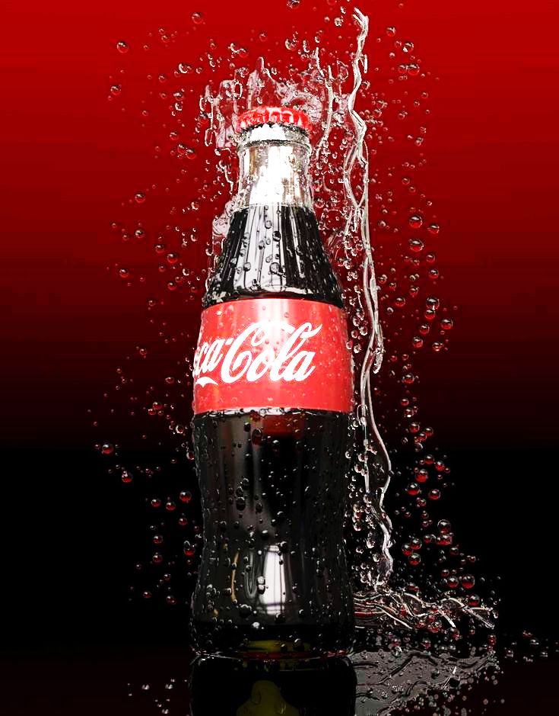  COCA-COLA INTERNAL AND EXTERNAL ENVIRONMENTAL MARKETING ANALYSIS | STUDENT NAME/ID: AKASHDEEP/2223250  MODULE: MBA MARKETING MANAGEMENT  LECTURER: TUSHERA BALENDRAN
Table of Contents
1 INTRODUCTION………….
2 PESTLE Analysis 4
2.1 Political Factors: 5
2.2 Economical factor 6
2.3 Social factor 6
2.4 Technological factor 7
2.5 Environmental factor 7
2.6 Legal factor 7
3 FIVE PORTERS 5 FORCES analysis 8
3.1 Threat from potential entrants/competitors: 9
3.2 Substitute Threat: 9
3.3 Bargaining power of buyers: 9
3.4 The bargaining power of suppliers: 9
3.5 Rivalry between existing companies: 10
4 SWOT ANALYSIS 11
4.1 STRENGTHS 11
4.2 WEAKNESSES 11
4.3 OPPORTUNITIES 12
4.4 THREATS 12
5 ADVANTAGES AND DISADVANTAGES OF SWOT ANALYSIS 13
5.1 ADVANTAGES 13
5.2 DISADVANTAGES 14
6 STP Strategies 14
6.1 SEGMENTATION: 16
6.2 TARGETING: 16
6.3 POSITIONING: 17
7 4PS OF MARKETING MIX 17
7.1 PRODUCT 18
7.2 PRICE 20
7.3 PLACE 20
7.4 PROMOTION 22
8 CONCLUSION 23
9 RECOMMENDATIONS 24
10 REFERENCES 26

Table of figures
Figure 1Beverage’s consumption in US 5
Figure 2 The amount of money that Coca Cola allocated to its supplier diversity program is presented in millions. 10
Figure 3 Marketing expenses as of December 31, 2016 (in US Billions) 25
hfjh
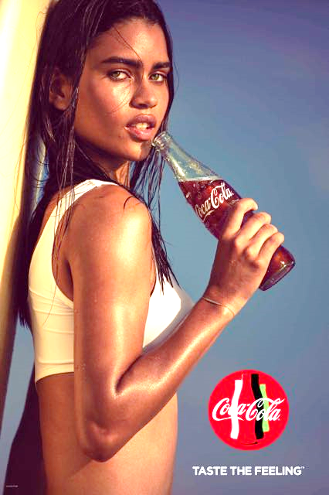
INTRODUCTION
Coca Cola company is the largest producer of cold drinks in the world. Throughout its existence, Coca Cola company has focused on operational processes and ensuring maximum production efficiency to meet growing demands. Coca-Cola has made more than five hundred products available on the world market. 94% of the world's population recognizes Coca Cola by its distinctive red and white logo (Woker, 2022). Therefore, in order to maintain this positive image and achieve its goals, the organization must ensure the proper use and procurement of resources. Coca Cola presently sells more than 3,900 merchandise globally and as such wishes to carefully plan and monitor its operational strategies to secure its 21 million stores (Woker, 2022). The company has enjoyed tremendous success over the last century and has become an icon American Culture. Coca Cola is not involved in all of the processes by which its products reach recipients consumer hands. According to the company's website, Coca Cola has entered a partnership with bottlers around the world.
The website states: “Our Company produces and sells concentrates, beverage bases and syrups for bottlers, own brands and is responsible for marketing initiatives for consumer brands. Our bottlers produce to package, sell, and distribute outlet beverages to our customers and vending machines partners who then sell our products to consumers”.
In this report I am going to focus on internal and external analysis on a Coca-Cola company and focus on future recommendation.

PESTLE Analysis
PESTLE evaluation of Coca-Cola analyzes the brand in its business strategies. Coca Cola's PESTLE analysis examines the various external factors such as Political, Economic, Social and Technological (PESTLE) affecting the business along with legitimate and environmentally friendly factors.
POLITICAL  - political stability  - corruption  - tax policy  - funding grants | ECONOMICAL  - interest rates  - inflation  - labor costs  - economic growth | SOCIAL  - consumer views  - age distribution  - workforce trends  - cultural barriers
TECHNOLOGICAL  - copyrights and patents  - maturing technologies  - production  - distribution | LEGAL  - regulation  - employment laws  - tax policies  - consumer protection laws | ENVIRONMENTAL  - climate  - environment policies  - availability of input  - corporate  - social responsibility

Political Factors:
The performance of Coca Cola is affected by political factors, both domestically and internationally. These factors encompass the political stability of the country, the role of international interest groups and domestic market lobbyists, as well as the government's outlook towards industry and commerce (Mehta, 2020). There are some notable instances that demonstrate how political factors have influenced Coca Cola's operations. For example, during the 2014 Israeli attacks on Gaza, certain companies in Turkey and over one hundred hotels in Mumbai ceased selling Coca Cola products (Mehta, 2020),

Economical factor
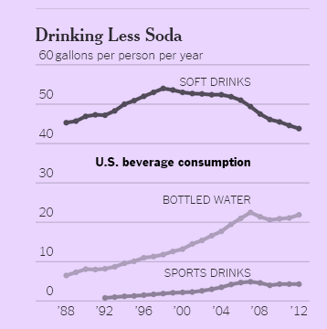
There are various economic factors that affect Coca-Cola's sales, which are beyond the company's control. These factors consist of the level of economic growth in the country and industry, tax rates, currency exchange rates, labor costs, and more. As stated by (Mehta, 2020), Coca-Cola has maintained an industry-leading operating margin of 22%, but the dividend yield has been reduced to 2.6%. However, the most significant economic factor that has adversely impacted Coca-Cola's performance in recent years is changes in exchange rates. For instance, due to a significant currency devaluation in Venezuela, Coca-Cola's profits were reduced by 55% in the fourth quarter of 2014, and there are similar instances around the world (Mehta, 2020).
Figure SEQ Figure \* ARABIC 1 Beverage’s consumption in US

Social factor
One of the most significant societal shifts that directly affects the performance of Coca-Cola is the growing emphasis on leading a healthy lifestyle and the increasing levels of consumer apprehension towards obesity, which are often linked to sugary and carbonated drinks. As shown inFigure1, the amount of soft drink consumption in the US has steadily decreased over the past 15 years, even as the number of bottled water and sports drinks consumed has significantly increased (Mehta, 2020).

Technological factor
The Coca-Cola Company also employs several smart agricultural techniques and water harvesting techniques. They are essential for the business to retain its low raw material costs and to make sure that its high-water demand does not result in a water crisis.

Environmental factor
The largest global consumer of freshwater is reportedly Coca-Cola. The corporation has received a great deal of criticism from environmental groups just for this reason. Coca-Cola is being blamed for entirely emptying significant regions of groundwater in nations like India (Endfre, 2015).

Legal factor
The main legal issue that Coca-Cola must deal with is adhering to local regulations in the nations where it operates. When it comes to caffeine and sugar requirements, many nations have distinct legislation. Everywhere its products are offered, the brand must make sure that it complies with all applicable laws. Coca-Cola has previously been sued for having excessive amounts of caffeine added to their products in numerous nations.

FIVE PORTERS 5 FORCES analysis
Since its inception in 1979, Michael Porter's Five Forces has evolved into that framework for industry analysis. The five forces measure the competitiveness of the market deriving its attraction (Porter, 2015). The following is a reasoning of the Five Forces of The Coca-Cola Company in connection with their Coca-Cola brand.

THREATS OF NEW ENTRANTS
BARGAINING POWER OF BUYERS

THREAT OF SUBSTITUTE PRODUCTSOR SERVICES
BARGAINING POWER OF SUPPLIERS

RIVALRY BETWEEN EXISTING COMPANIES

Threat from potential entrants/competitors:
Medium pressure Barriers to entry are relatively low for the beverage industry: there are none Switching Costs and Zero Capital Requirement (Porter, 2015). There are more and more new brands appearing on the market with prices like Coca-Cola products.

Substitute Threat:
Medium to High Pressure The market is saturated with various energy drinks, sodas, and juices. Coca Cola's flavor, however, is not entirely distinct. In fact, individuals are unable to discern the difference between Coca-Cola and Pepsi in a blind taste test. (Porter, 2015). Some examples of substitutes of Coca-Cola are Pepsi, Mountain dew, sprite, red bull.

Bargaining power of buyers:
Low pressure: The individual buyer exerts no pressure on Coca-Cola. Large retailers such as Wal-Mart have bargaining power due to the large number of orders quantity, but bargaining power is reduced by end-user branding loyalty (Porter, 2015).

The bargaining power of suppliers:
Low pressure Soft drinks typically consist of carbonated water, phosphoric acid, sweeteners, and caffeine as the main ingredients. The suppliers of these ingredients are not centralized nor distinguishable from one another.. Coca-Cola is probably a major customer or the largest of these suppliers. As the following Figure2 shows, the investment volume in supplier diversity has increased steadily over the past four years (Porter, 2015).

Rivalry between existing companies:
high pressure's main competitor now is Pepsi, which also has a wide range of drinks products under its brand. Both Coca-Cola and Pepsi are the predominant ones.
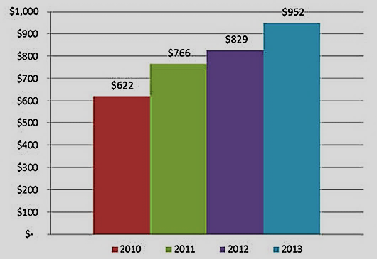
Figure 2 The amount of money that Coca Cola allocated to its supplier diversity program is presented in millions.

SWOT ANALYSIS

STRENGTHS
- High brand equity: According to (Camilla, 2022), Coca-Cola benefits from a superior brand impartiality despite operating in a marketplace with similar products. It was recognized as Interbrand's highest brand value in 2011.
- Global Presence: Company maintains a strong global presence, with a product or manufacturing footprint in nearly all the world's 196 countries, surpassing even McDonald's and Subway (Camilla, 2022).
- Markets of Scale: With 1.9 billion drinks served daily, or 3.2% of the world's total beverage market, Coca-Cola leverages economies of scale to achieve low production costs across its hundreds of brands(Camilla, 2022).

WEAKNESSES
- Dependence on Soft Drinks: Although Coca-Cola is highly diversified, it still relies on cold drinks for most of its sales. In fact, "Coca-Cola" sales accounted for 78% of total sales (Camilla, 2022). This dependency can eat away at profits as consumers switch to healthier beverages.
- Water management: Drink-focused companies like Coca-Cola trust heavily on water as a key part in their results. Water security and water quality are contentious issues, especially in the developing world. Therefore, it can be difficult for the company to secure enough water to meet demand.

OPPORTUNITIES
- Diversification: To maintain its sales amid a significant decline in carbonated beverage consumption, Coca-Cola needs to diversify its product offerings. To this end, the company has made substantial investments in Keurig Green Mountain. In addition, expanding into developing countries that demand clean water, tea, and coffee provides Coca-Cola with a promising opportunity to diversify (Camilla, 2022).
- Improving Supply Chain: Given Coca-Cola's status as a international brand, its supply chain is subject to elevated shipping and distribution costs. By utilizing existing soft drink networks, the company can sell higher-margin products and improve its supply chain (Camilla, 2022).
- Sustainability: Coca-Cola has a responsibility to address pollution caused by single-use plastics. To position itself as an environmentally conscious brand, Coca-Cola can invest in innovative and recyclable packaging solutions (Camilla, 2022)

THREATS
- Competitor: While Coca-Cola concentrates on expanding its spreading and brand recognition, its main rival PepsiCo is highlighting an e-commerce strategy that emphasizes premium products. If consumer purchasing preferences shift, Coca-Cola could face a competitive disadvantage.
- Regulation: Increasing concerns from health professionals regarding the potential health risks of sugary drinks have led to government discussions about introducing sugar taxes, which could have a noteworthy impact on Coca-Cola's core product lineup (Camilla, 2022).
- Modernization: Coca-Cola is susceptible to economic changes in developing countries by extensive global reach . As laborers demand higher wages and others seek better pay elsewhere, the company may face challenges in modernizing its operations.

ADVANTAGES AND DISADVANTAGES OF SWOT ANALYSIS

ADVANTAGES
- Because of its size, The Coca-Cola Company can influence suppliers by charging lower prices. A firm can also use its size of it, to influence competition by underpricing some of its products, buying up smaller competitors, or saturating the market with many of its products (Jurevicius, 2023).
- The Coca-Cola Company's delivery network enables it to reach more customers than its competitors (Jurevicius, 2023). According to the company, the company serves 1.9 billion servings a day, more than any competitor worldwide.

DISADVANTAGES
- If you look at Coke's product line, you'll see that the company has little product diversification compared to Pepsi.
- The beverage Coca Cola is so popular around the world that a company may not need many products to serve it, but in this competitive market, relying on just one product could be a bad decision (Angela, 2023).
- Drinking Coca-Cola regularly is not an innovative idea as it poses a health risk. Coke consumption can increase the risk of developing type 2 diabetes (Angela, 2023).

STP Strategies
The company had great success with its campaign, which cemented its status as an icon of American culture. Most companies typically classify their marketing strategies into various categories. As with Coca-Cola, market segmentation, targeting and positioning are three key factors that have helped the company successfully meet the needs of its target customers.
The following examines these three variables in Coca-Cola's promoting strategy. It can also serve as a guide for startups when formulating a marketing approach.
COCA-COLA

Target market

10-50
Males and females
Professional, students, employees
Average, above average, high income

Positioning

Refreshing products
Thrust quenching.
Promote happiness and positivity.

Market Segmentation

Geographical
Demographic
Behavioral
physiographic

SEGMENTATION:
Segmentation examines the practice of dividing population markets into groups or subcategories with specific characteristics and needs. Coca-Cola's geographic marketing segmentation strategy targets customers across various geographic regions, encompassing cities, suburbs, and rural areas, among others, to better serve their diverse needs and preferences.
Analyze the factors influencing the attitudes of a specific population towards Coca-Cola. Coca-Cola gains insight into customer attitudes and responds with a modified product portfolio that meets these needs.

TARGETING:
Targeting involves selecting specific groups identified through segmentation and then analyzing their preferences, get appropriate products for them. The targeting strategy involved Coca-Cola making various products to meet different needs, wants, and preferences. According to (Sroychow, 2018), the target customers include young customers between the ages of 10 and 25 as well as customers of the older generation between the ages of 25 and 50. The Coca-Cola company uses differentiated targeting strategies. The company offers a range of products to cater to different segments of the market, including regular Coke, Diet Coke, Coke Zero, and many other soft drinks. Each of these products targets a different consumer segment with unique needs, preferences, and interests. For instance, Diet Coke is marketed towards health-conscious individuals who want to reduce their calorie intake, while Coke Zero is marketed towards men who prefer a sugar-free beverage. By using differentiated targeting, Coca-Cola can appeal to a broader customer base and increase its market share. The glass-bottled regular cola is designed for customers who enjoy bold flavors with a high sugar content, as it has a strong taste. By using this targeting strategy, the aim is to create a sense of identity and connection with the intended market.

POSITIONING:
In marketing, choosing the most suitable promotion mix for a particular customer segment is critical. Positioning, on the other hand, enables a company to distinguish itself from competitors who provide similar products or services. Coca-Cola has successfully implemented a multi-segment positioning strategy, positioning itself as the ultimate thirst-quencher and body refresher, as demonstrated in their video advertisement featuring people drinking Coca-Cola and experiencing an instant energy boost.

4PS OF MARKETING MIX
Coca-Cola's global empire spans over two hundred countries and offers a wide range of still and carbonated beverages. While the popularity of soft drinks may decline slightly due to growing demand for health drinks and other health trends, Coca-Cola has also focused on optimizing its product line to meet the changing tastes of its global target market (Mind, 2021). Coca-Cola invests large sums in advertising and marketing each year to sustain growing brand awareness and foster customer loyalty.

PRODUCT
COCACOLA
SPRITE
FANTA
DIET COKE
COCACOLA ZERO
MINUTE MAID
POWERADE
DEL VALUE
FRESCA
POWERADE ZERO
SIMPLY ORANGE

PRICE
PRICE DISCRIMINATION
SKIMMING
COST PLUS
STRATEGIES

PLACE
CONVIENCE STORES
STREET VENDORS
MOVIE THEATRE
GROCERY STORES
RESTAURANT
AMUSEMENT PARKS

PROMOTION
TELEVISON ADS
SOCIAL MEDIA CHANNELS
BILLBARDS
PRINT MEDIA
COPERATE SOCIAL RESPONSIBILITY

PRODUCT
Coca Cola boasts a vast product portfolio, with ownership and sales of over 500 different brands, offering customers more than 3,500 different beverage options. The company adopts a client-centric approach, consistently developing its product line to meet consumer needs and adapt to changing lifestyles. Coca-Cola products come in various packaging and sizes, such as 200 ml, 500 ml, 1 liter, 1.5 liter, and 2-liter bottles, as well as cans and glass and plastic flasks, with the Coca-Cola logo prominently displayed to differentiate them from other brands (M.B.A.S, 2021). Furthermore, Coca-Cola employs distinct bottle designs that are closely associated with its brand. Although Coca-Cola, Sprite, and Fanta hold significant market shares in their specific categories, their progress has reached a plateau, generating a considerable source of income for the company. However, Minute Maid boasts a high market share and a strong growth rate. Coca-Cola employs several branding strategies to promote its products and maintain brand identity, some of which include:
- Emotional Branding: Coca-Cola has built a strong emotional connection with its consumers by associating its brand with happiness, sharing, and togetherness. Its advertising campaigns often feature people having fun, laughing, and enjoying life, with Coca-Cola playing a central role in those moments.
- Brand Extension: Coca-Cola has extended its brand to a variety of products such as Diet Coke, Coca-Cola Zero Sugar, Sprite, Fanta, and others. By extending its brand, Coca-Cola can leverage its strong brand equity and expand into new markets.
- Co-Branding: Coca-Cola has collaborated with several companies to create co-branded products such as Coca-Cola and McDonald's, or Coca-Cola and Disney. By teaming up with other brands, Coca-Cola can reach new audiences and create new revenue streams.
- Sponsorship: Coca-Cola sponsors several events and organizations such as the Olympic Games, FIFA World Cup, and NASCAR. By associating its brand with high-profile events and organizations, Coca-Cola can increase brand awareness and reach a wider audience.

PRICE
Another element in Coca-Cola's marketing mix is ​​price. The firm uses a price discrimination approach in its marketing mix. This method allows the corporation to set different prices for its products in different sections.
An oligopoly is a market structure characterized by a minor number of firms that act independently regarding production and pricing policies. In the beverage industry, there are only a limited number of producers and few buyers, which creates an oligopoly (Mind, 2021). Coca-Cola has different pricing levels for its products, depending on the type of consumption, and its pricing power is influenced by factors such as product usage and location. In price-sensitive markets, Coca-Cola typically lowers its prices relative to competitors when entering the market. Additionally, before entering a new market, the company adjusts its premium branding strategy and uses various promotional activities.

PLACE
Its extensive distribution network demonstrates the importance of "location strategy" in the company's marketing mix to expand and capture greater market share and increase sales. Thanks to Coca-Cola's success, it's no secret that the company has multiple worldwide locations where its target market has easy access to all its products. It has a large and comprehensive distribution system and sells around 1.9 billion allocations per day.
Traditionally, Coca-Cola has relied on global bottling partners for its packaging and distribution processes. The system works on channels. Coca-Cola produces and sells syrups, concentrates and beverage bases to bottlers. The company owns all brands and is responsible for brand marketing initiatives (Mind, 2021). Rather than establishing multiple retail outlets around the world, Coca-Cola maximizes the ability of its licensed bottlers to package, sell, and distribute beverages to the company's retail customers and partners. Licensed bottlers also work closely with restaurants, grocery stores, convenience stores, street vendors, amusement parks and movie theaters to distribute Coca-Cola products. Together they effectively execute the company's localized marketing strategy.
As Coca-Cola is a globally recognized brand, its channels of distribution may vary depending on the region or country. However, in general, Coca-Cola uses a combination of the following distribution channels:
- Direct Store Delivery (DSD): In this channel, Coca-Cola delivers its stuff directly to retail stores, vending machines, restaurants, and other outlets. This channel is commonly used in urban areas and for larger accounts.
- Wholesalers and Distributors: Coca-Cola also uses wholesalers and distributors to reach smaller retailers or outlets in more remote areas. These wholesalers purchase Coca-Cola products in bulk and distribute them to retailers in their region.
- E-commerce: Coca-Cola has an online store where consumers can order its products directly. This channel has gained significance in recent years, as more consumers are shopping online.
- Supermarkets and Hypermarkets: Coca-Cola also partners with supermarkets and hypermarkets, where consumers can find its products on shelves among other consumer goods.
- Convenience stores: Coca-Cola products are also available in convenience stores, such as 7-Eleven or Circle K.

PROMOTION
Coca-Cola adopts an aggressive marketing approach through various channels, including television, radio, print media, and sponsorships. Through event funding, the company aims to enhance brand recognition, visibility, and customer loyalty. Given the intense competition in the soft drink industry, companies often allocate substantial funds to support various advertising and promotional endeavors. In 2016, Coca-Cola invested $4 billion in marketing, a figure that increased to $4.1 billion in 2018. In addition, the company introduced the Taste the Feeling campaign in 2016, which marks a significant deviation from its previous marketing strategy. (Mind, 2021).
Offline Promotion: Company has extended its advertising efforts to various social media platforms in addition to traditional TV and outside ad campaigns. In today's world, digital marketing is a cutting-edge way to promote a product, and businesses are utilizing social media accounts to engage with followers, retain customers and build a loyal fan base (Mind, 2021). As per Mind (2021), Coca-Cola's YouTube account claims over 1,250 publicity videos that customers can watch.

Online Promotion: Competition becomes more intense, Coca-Cola is focusing on enhancing its industry reputation. While digital marketing has become a crucial aspect of modern marketing, Coca-Cola has always remained committed to its advertising initiatives as part of its marketing strategy. The company consistently delivers a familiar message to its customers, which is happiness. Coca-Cola runs various campaigns while ensuring that each advertisement maintains a common thread that aligns with the company's history.
In addition to sales promotion, Coca-Cola also invests in company social responsibility.This approach helps to enhance the company's reputation and appeal to customers who prioritize ethical and sustainable business practices.
.

CONCLUSION
In conclusion, the world's leading cold drink maker, Coca-Cola, must consider key elements, but most importantly, it must enforce consistency in its production process and operations.The Coca-Cola Company owes its success to people who work hard to get their jobs done. In this way, Cola-Cola takes care of its employees by creating a good working conditions and working with unions and government agencies to ensure the safety of its employees. The Coca-Cola Company recognizes that in today's business environment, technology is essential to running a great company like Coca-Cola (zin, 2020).
As such, Coca-Cola uses various kinds of technology, such as building databases and data warehouses for its customers and suppliers, conducting business with consumers and other businesses over the Internet. The Coca-Cola Company knows that no business can function without a plan. Because Coca-Cola has managed to build a very high barrier to entry in the beverage industry, new companies are discouraged from competing with Coca-Cola. In addition, The Coca-Cola Company has agreements with many of its suppliers (mainly bottlers) to provide exclusive services to Coca-Cola. As a result, it's nearly impossible for new entrants to keep up with Coca-Cola and similar competitors with established industry names like Pepsi. Coca-Cola's success did not come overnight. It has been many years since John Pemberton invented the secret formula of Coca-Cola in 1886 (zin, 2020).

RECOMMENDATIONS
After completing our project, we have finalized some recommendations for the Coca-Cola Company which are as follows.
- Portfolio diversification: Coca-Cola's current portfolio of stills is sizable, with 14 stills generating more than $1 billion in annual sales while Coca-Cola owns just 18.1% market share. Another factor driving the sale of Coca-Cola's spirits portfolio is the overall growth in the spirits market (Bailey, 2022). Coca-Cola Company has employed two strategies from the Ansoff Matrix, which are explained below:

Source: Coca-Cola expenses as of December 31, 2016
Company | Advertising expenses | Total revenue | % of total revenue
The Coca-Cola Company, Inc | $4.00 | $41.83 | 9.56%
PepsiCo, Inc | $4.20 | $62.80 | 6.69%
Dr. Pepper Snapple Group, Inc | $ 0.48 | $6.44 | 7.41%
Nestle | $21.49 | $89.47 | 24.01%

Figure 3 Marketing expenses as of December 31, 2016 (in US Billions)

- Use marketing to increase sales and product awareness: Also, Coca-Cola should increase marketing spending. The Coca-Cola Company's annual ad spend was $4.004 billion, $3.976 billion, and $3.9 billion, respectively.499 billion in 2016, 2015 and 2014 (The Coca-Cola Company, 2017) (Bailey, 2022). Coca-Cola's ad spends, shown in Figure 3, accounted for 6.9% of total revenue each year. Only PepsiCo uses its marketing budget more efficiently, spending just $4.2 billion to generate $62.80 billion (Coca-Cola growth potential and dividends analysis, 2017 (Bailey, 2022).
- Market Penetration: Market penetration strategy focuses on increasing sales of existing products in current markets. Coca-Cola has been using this strategy by creating new flavors for its existing products and introducing them in different markets worldwide. For instance, Coca-Cola launched Coca-Cola Zero, which is a sugar-free version of the original Coca-Cola. They have also introduced Coca-Cola Vanilla, which is a vanilla-flavored version of Coca-Cola. These product innovations help Coca-Cola to attract new customers and retain its existing ones by providing them with a wider range of options. Coca-Cola also uses various marketing strategies such as price discounts, promotions, and advertising to increase its market share and sales.
- Product Development: Product development strategy involves the creation and introduction of new products in existing markets. Coca-Cola has been using this strategy by expanding its product line beyond carbonated soft drinks. For example, Coca-Cola introduced Dasani, which is a bottled water brand, and Minute Maid, which is a fruit juice brand.

REFERENCES
Worku, D. (2022, October 5). Coca Cola Wallpapers - HD wallpapers, background images. Retrieved March 12, 2023, from https://wall.alphacoders.com/by_sub_category.php?id=43596
Woker, Philips (2022). Coca Cola assignment official - table of contents 1. STUDOCU. Retrieved March 11, 2023, from https://www.studocu.com/en-us/document/university-of-washington/general-microbiology/coca-cola-assignment-official/9376833
Mehta, V. (2020, March 8). Coca Cola Pestle analysis. MBA Skool. Retrieved March 11, 2023, from https://www.mbaskool.com/pestle-analysis/companies/18043-coca-cola.html#:~:text=Coca%20Cola%20PESTLE%20Analysis%20examines,along%20with%20legal%20%26%20environmental%20factors .
ENDFRE, A. (2015, July 28). Coca Cola Pestel Analysis - Research-Methodology. Research. Retrieved March 11, 2023, from https://researchmethodology.net/coca-cola-pestel-analysis/
Fred, E. (2015, July 28). Coca Cola Pestel Analysis - Research-Methodology. Research. Retrieved March 11, 2023, from https://research-methodology.net/coca-cola-pestel-analysis/
Porter, M. (2015, July 28). Coca Cola Porter's five forces analysis - research-methodology. Research. Retrieved March 12, 2023, fromhttps://research-methodology.net/coca-cola-porters-five-forces-analysis/
Gennaro, C. (2022, August 23). Coca-Cola Swot Analysis briefly. FourWeekMBA.
Retrieved March 12, 2023, from https://fourweekmba.com/coca-cola-swot-analysis/Coca-Cola
Jurevicius, O. (2023, March 27). Coca Cola SWOT analysis (6 key strengths in 2022). Strategic Management Insight. Retrieved March 28, 2023, from https://strategicmanagementinsight.com/swot-analyses/coca-cola-swot-analysis/
Angela. (2023, January 24). Coca Cola Swot Analysis 2023: A thirst quenching report. SWOT Hub. Retrieved March 28, 2023, from https://swothub.com/coca-cola-swot-analysis/
Rahman, M. (2023, January 12). Marketing mix of Coca-Cola (4ps of Coca-Cola). www.howandwhat.net. Retrieved March 23, 2023, from https://www.howandwhat.net/marketing-mix-coca-cola-coca-cola-marketing-mix/
Endraw Mind. (2021, July 6). Coca-Cola Marketing Mix (4PS) analysis. Edrawsoft. Retrieved March 28, 2023, from https://www.edrawmind.com/article/coca-cola-marketing-mix-analysis.html
Team, M. B. A. S. (2021, July 6). Coca Cola Marketing Strategy & Marketing Mix (4PS). MBA Skool. Retrieved March 28, 2023, from https://www.mbaskool.com/marketing-mix/products/16786-coca-cola.html#:~:text=Marketing%20Strategy%20of%20Coca%20Cola,pricing%20approach%2C%20promotion%20planning%20etc
Z, S. (2020, January 20). Conclusion. Retrieved March 28, 2023, from http://team7coca-cola.blogspot.com/2010/11/conclusion.html
Bailey, S. (2022, July 27). Competitive analysis of Coca-Cola and strategic recommendations. UKDiss.com. Retrieved March 28, 2023, from https://ukdiss.com/examples/competitive-analysis-of-coca-cola.php
BINA NUSANTARA | Library & Knowledge Center. Retrieved March 12, 2023, from http://library.binus.ac.id/eColls/eThesisdoc/Bab5/RS1_2015_1_1348_Bab5.pdf

