

Student Name: Talaviya Vivek
Student ID: 2509583
Master of Business Administration (MBA)
Module name: Financial Management
Module code: LCMB7002
Assignment component: Financial performance and management
(Toyota Motor Company)

Lecturer’s name: MD Kalam
Submission Date: 24th April,2026
Word Count: Approx.5000

Term 1

Table of Contents
1. Introduction 4
2. Financial Health Check 4
2.1 Overview of Toyota’s five-year financial performance 5
2.2 Profitability analysis 6
2.3 Liquidity analysis 7
2.4 Efficiency analysis 8
2.5 Gearing and solvency analysis 9
2.6 Cash flow and investment indicators 9
2.7 Key strengths, weaknesses, and threats 9
3. Working Capital Management Analysis 10
3.1 Toyota’s cash operating cycle 10
3.2 Assessment of Working Capital Performance 11
3.3 Proposed Working Capital Reform Suggestions. 11
3.4 Short-Term versus Long-Term Financing Options 12
4. Strategic Financial Restructuring Plan 13
4.1 Need for Financial Restructuring at Toyota 13
4.2 Portfolio Rationalisation and Selective Divestiture 14
4.3 Portfolio Rationalisation and Selective Divestiture 14
4.4 Internal Funding and Balanced Debt Structure 15
4.5 Impact on Shareholder Value, Debt Structure, and Flexibility 16
4.6 International and Ethical issues. 16
5. Investment Appraisal and Capital Budgeting 17
5.1 Project overview and appraisal assumptions 17
5.2 Payback Period analysis 18
5.3 ARR analysis 19
5.4 NPV, PI, and IRR analysis 19
5.5 Best single project decision 19
5.6 Capital rationing under £100m 20
5.7 Final investment recommendation linked to Toyota’s financial position 20
6. Conclusion 21
Reference List 22

1. Introduction
The worldwide automobile enterprise is experiencing a structural transformation driven with the aid of rapid technological advancement, sustainability regulations, and the increasing shift towards electric powered automobiles (EVs). Toyota Motor Corporation, a main multinational automobile manufacturer, has traditionally dominated the hybrid vehicle section whilst progressively increasing its presence in complete electric mobility. Operating throughout a couple of international markets, the employer faces growing competitive strain, fluctuating financial conditions, and sizable capital requirements related to innovation and electrification.
This file is ready from the perspective of a Chief Financial Officer (CFO) to seriously compare Toyota’s financial performance and strategic direction. The number one aim is to analyse the organization’s financial role during the last 5 years, discover key monetary strengths and weaknesses, and develop strategic tips to beautify lengthy-time period financial sustainability and shareholder cost. In addition, the document assesses potential investment opportunities and the use of capital budgeting techniques to help powerful selection-making.
The analysis in addition considers the broader industry context, including regulatory pressures, global delivery chain challenges, and the transition in the direction of low-emission transportation. By integrating financial assessment with strategic insights, this record offers a comprehensive assessment of Toyota’s potential to keep competitiveness and attain sustainable growth in an increasing number of dynamic global environments.

2. Financial Health Check
Financial evaluation performs a crucial function in assessing an organisation’s operational efficiency, profitability, and economic stability. It allows stakeholders to evaluate how effectively an employer utilises its sources, manages expenses, and generates returns. In this file, a comprehensive monetary analysis of Toyota Motor Corporation is performed using facts derived from its consolidated economic statements over a five-yr duration.
The use of a 5-yr analysis presents a longitudinal angle, allowing for the identity of key traits, overall performance fluctuations, and rising monetary risks. This technique is especially applicable for Toyota because of its large-scale international operations, publicity to currency volatility, and big investments in research and development, particularly in electric powered car technology (Potharla, 2025). By analyzing financial overall performance over a couple of periods, it will become viable to distinguish among quick-time period variations and lengthy-term strategic patterns.
The evaluation will include a number of economic ratios, which includes profitability, liquidity, performance, and gearing indicators, to offer integrated information of the company’s economic fitness. These metrics will assist the identity of strengths and weaknesses, forming the idea for next strategic hints and funding decisions.

2.1 Overview of Toyota’s five-year financial performance
The financial performance of Toyota over the five-year period indicates a wide growth in the revenue, profit, asset base, equity, and shareholder earnings. Net sales increased 21,18,302 of FY 2021 to 40,84,984 of FY 2025 with robust market demand and scale. The operating profit rose by 1,18,159 to 2,21,695, and net profit also increased by 1,41,435 to 2,71,247 during the same period. Total assets increased to 94,03,481 as compared to 65, 03,986 showing an increase in operating capacity and investment (Xinyao et al., 2023). The total equity increased by 33,22,550 to 50,15,246 which indicated that the increase was not only with the help of liabilities but also a more sound equity base. There was a strong growth in earnings per share, and this showed growth in returns to shareholders, since these rights shot up to 856.96 where it was 440.28. In general, Toyota is headed in the right financial direction between FY2021 and FY2025. Greater scale, better returns and a better capital position were also exhibited by the company, but there are balance sheet and cash flow patterns that indicate that growth has also placed strains on operations and capital sources that require more of its management.
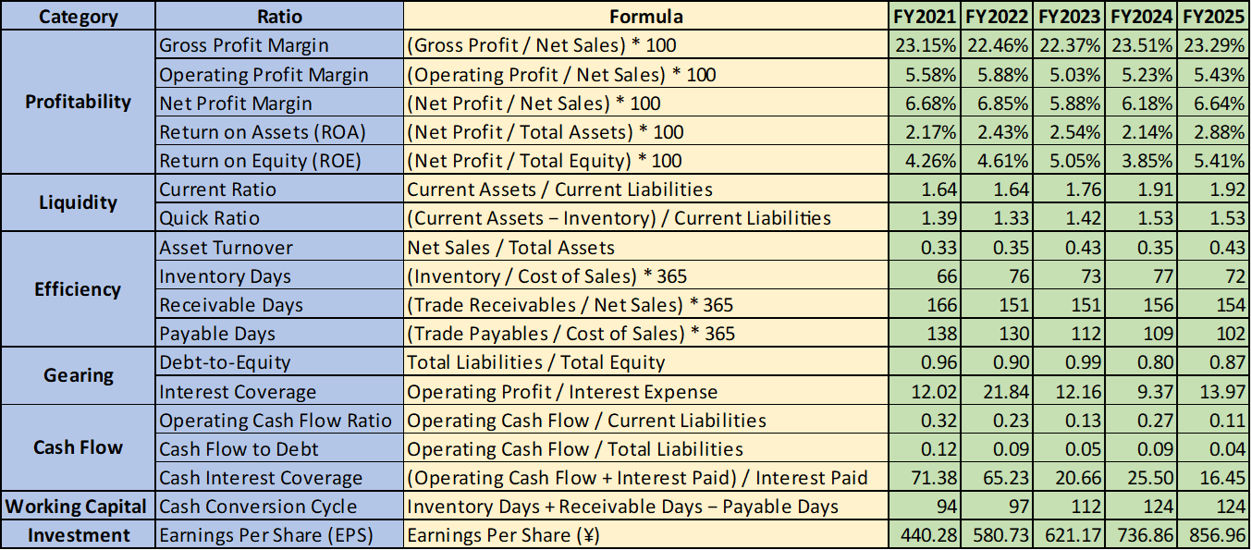
Table 1: Ratios analysis
(Source: Self-Created)

2.2 Profitability analysis
The profitability of Toyota was relatively stable during the FY2021-FY2025, but certain stress was observed in between the years. The gross profit margin remained constant, with it going up 23.15 in FY2021 to 23.29 in FY2025 indicating that the costs of production were put in a reasonable check despite the increase in sales and possible input inflation. The operating profit margin was ranging between 5.03 percent to 5.88 with the final position of 5.43 but this is a good operating performance yet we can see that increasing selling and administration costs have decreased some of the proceeds made due to increase in revenue (Bhattacheryay, 2023). Net profit margin also exhibited a similar trend with the two years of FY2023 showing a decline and then a reversal to the 6.64 percent in FY2025. The ratio of return on assets advanced to 2.88 against 2.17, and return on equity to 5.41 against 4.26, proves increased earnings efficiency.
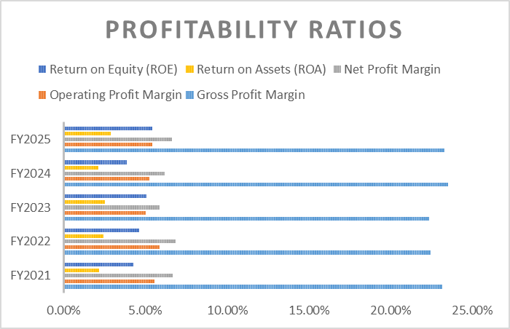
Figure 1: Profitability Ratios
(Source: Self-Created)

2.3 Liquidity analysis
The liquidity position of Toyota was healthy and as per the five years, it improved with time. As compared to FY2021, the current ratio has been extended to 1.64 in FY2025, indicating that current assets continued to be well above current liability over the two years. It implies that temporary requirements might be fulfilled without significant liquidity pressure. The quick ratio also rose as it stood at 1.39 and rose to 1.53 which implies that at the end of the day even without taking into consideration the inventory, the liquid assets were sufficient to meet near-term payments (Feddaoui, 2024). These findings indicate that Toyota reinforced its short term financial stability as the business grew. Good liquidity is also significant in the growing business since increased sales in the business normally puts strain on the working capital. On the whole, the balance sheet of Toyota is characterized by good short-term liquidity, but reduced liquidity is influenced by the slower cash flow.
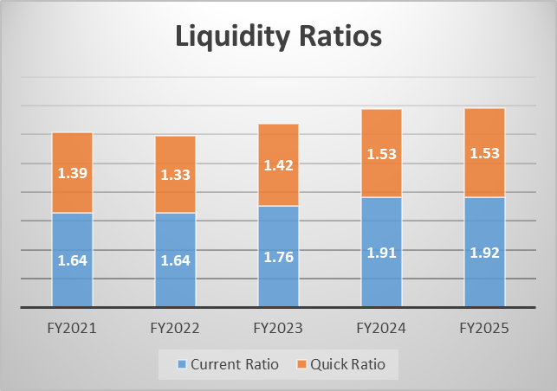
Figure 2: Liquidity Ratios
(Source: Self-Created)

2.4 Efficiency analysis
The efficiency ratios of Toyota depict a conflicting trend within the five years. The ratio of asset turnover increased in FY2025 to FY2021 to 0.43, indicating that the company was more efficient in creating sales by use of its assets. The working capital indicators are, however, not as good. Inventory days increased to 72 and 77 in FY2024 and 2023, respectively, indicating that there was more inventory held up in the operating cycle and within the cash. Receivable days remained high ranging between 166-154 which has been still a weak figure of collecting cash as a result of sales. The number of days payable decreased drastically to 102 as compared to 138 indicating that Toyota was utilizing less supplier credit (Mishra and Celestin, 2025). On the whole, the work of assets was better, whereas the work of weaker working capital was straining cash management and operation discipline.
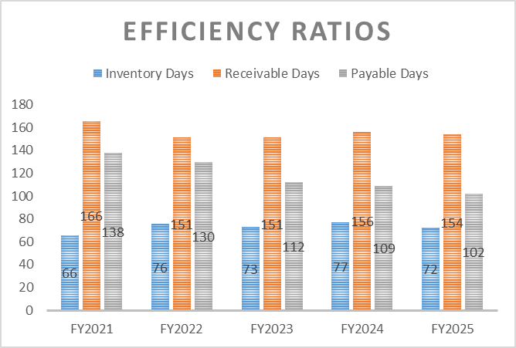
Figure 3: Efficiency Ratios
(Source: Self-Created)

2.5 Gearing and solvency analysis
The gearing position and the solvency position of Toyota were manageable over the period of five years. The debt to equity ratio remained in the moderate range, fluctuating between 0.96 in FY2021 and 0.87 in FY2025, with an intermediate high of 0.99 in FY2023. It means that liabilities were high but not extreme compared with equity and the FY2025 outcome is an indication of a marginally lower leverage burden. Interest coverage was also good with values between 9.37 times and 21.84 times indicating that operating profit was adequate to cover the interest expenses in all the years (Ma et al., 2022). These findings indicate that there was a constrained solvency risk and Toyota still had the capacity to borrow in the future to invest in strategic projects. Debt is however not a wise choice and must be applied selectively and very carefully because the support of the cash flow is weak and the pressure in working capital is increasing.

2.6 Cash flow and investment indicators
The cash flow indicators used by Toyota show a lower picture as compared to its accounting profitability. The ratio of operating cash flow decreased to 0.11 in FY2025, indicating that the operating cash was less effective to cover current liability as in the case of FY2021. The cash to debt ratio also decreased by 0.12 to 0.04 which means that the liabilities rate was higher than the operating cash generation rate. The cash interest coverage was also quite high, although it decreased dramatically (71.38 to 16.45), indicating that the interest payments have been still afforded by less cash cushion (Boyer and Panot, 2025). These trends depict discrepancies between reported profit and cash-based strength. Conversely, earnings per share increased by 440.28 to 856.96, which is good to shareholders. Generally, Toyota was not losing its profit, but the cash discipline was paid more and more attention.

2.7 Key strengths, weaknesses, and threats
The core strength of Toyota includes constant profitability, rising liquidity, controllable gearing, good interest coverage and huge EPS growth. These are signs of a company that is financially diverse and well-established in the market. Nevertheless, there are also some weaknesses. The cash flow support has been reduced, the cash conversion cycle has risen to 124 days (up 94 days) and the receivable days are high, and the inventory days are higher than the FY2021 benchmark (Ortega, 2026). These trends indicate that an increase in cash is held up in the operations. The key risks are thus the pressure on working capital, cost inflation, strong competition among the EVs and exposure to the exchange rates in various international markets.

3. Working Capital Management Analysis

3.1 Toyota’s cash operating cycle
Cash operating cycle (CCC) analyses the effectiveness with which working capital is turned into cash by a company. This can be computed as:
CCC=Inventory Days+Receivable Days- Payable Days
According to analysed data, the CCC of Toyota Motor Corporation is increasing consistently over the five-year period and increases by 94 days in FY2021 up to 124 days in FY2025. The following elements drive this growth:
- Inventory Days: the days have increased to 72 days up to 66 days.
- Receivable Days: it was quite high and stable (166 days 154 days)
- Payable Days: dropped to 102 days reduced to 138 days.
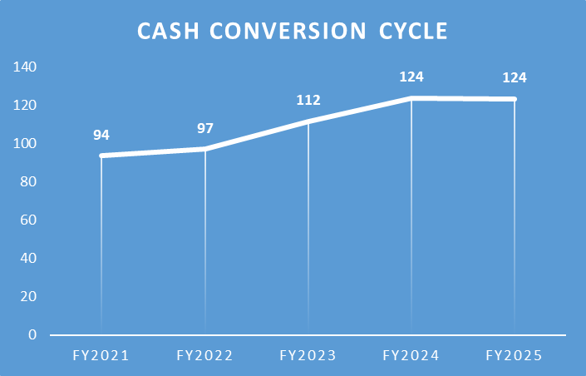
Figure 4: Cash conversion cycle
(Source: Self-Created)
The increase in CCC also shows that Toyota is not transforming its investments to cash as fast, which is a decline in working capital efficiency (Laskin, 2024). The biggest contributor is the reduction in the number of payable days, in that, the company is paying suppliers at a faster rate, yet still, it is taking quite a long period to collect the outstanding.

3.2 Assessment of Working Capital Performance
The working capital performance of Toyota also shows a mixed performance, which is both strong in operations and also beginning to be inefficient. On the positive side, it is not that intense since there are comparatively stable inventory management rates, only going up by 66 to 72 days. This has been a positive sign of the persistence of the lean manufacturing system in Toyota. Nevertheless, the positive trend indicates the existence of inefficiencies, which may be associated with supply chain disruption and the changing EV demand trends (Chen & Koul, 2025). A worse problem is that of receivables management. The days outstanding are also quite consistent (exceeding 150 days in all years), which means that Toyota gives dealers and distributors a long duration of credit. Although it helps in growing the sales and market penetration, it slows the inflows and exposes the enterprise to higher credit risks. A reduction in the payable days is the greatest issue because it would have decreased to 102 days in FY2025 as compared to 138 days in FY2021. This means that Toyota is paying faster to its suppliers and hence financial gain of trade credit becomes less efficient (Sari & Fuadah, 2022). Although this can enhance the relationship with the suppliers, it hurts the liquidity as it increases cash inflows at a rapid rate. Combination of these effects has increased the length of the CCC by a very high figure of 124 days in FY2025. This also indicates the increased capital that is locked up in operations hence low working capital efficiency. This decline can also be justified by indicators of cash flows. The operating cash flow ratio went down as 0.32 to 0.11 and cash flow to debt ratio changed to 0.12 to 0.04 which showed the short-term liquidity decreased, and the capacity to meet the liabilities by using the operational cash generation ability is also diminished.

3.3 Proposed Working Capital Reform Suggestions.
To begin with, Toyota ought to work on enhancing the management of receivables. Since the number of days outstanding receivable is still relatively high, the company ought to introduce tighter control measures of its credit limits and cut-down the credit periods where applicable and introduce incentives like discounted receipt of payment (He, 2025). Digital invoicing and automated collections systems can further make it more effective and increase faster cash flow.
Secondly, Toyota needs to streamline its payable strategy. The reduction in the payable days is an indicator of poor utilisation of supplier credit. The company ought to seek longer payment terms or embrace the solutions of supply chain financing, which will enable it to continue having good relationships with its suppliers besides enhancing its liquidity.
Thirdly, the optimisation of inventory will be necessary, especially when EV transition will occur (Fantozzi et al., 2025). Even though the inventory days have grown by a relatively modest degree, further optimizations are possible with the help of sophisticated demand projections, live inventory management, and versatile production methods.
Toyota should also consider incorporating the management of working capital in the financial planning as it would mean greater synchronization of procurement, production, and sales. This will enable the reduction of inefficiencies and enhance the stability of cash flow through this holistic approach.
Lastly, the company can look at the option of using working capital financing options (factoring or inventory financing) to unlock cash locked in operations without interfering with the core operations.

3.4 Short-Term versus Long-Term Financing Options
Temporary means of financing, which include trade credit, overdraft, bank overdraft, and short-term loans, are flexible and are used to deal with the day-to-day operation needs. But the fact that the payable days are going down implies that Toyota is not maximising on the use of the trade credit as a source of financing (Vollert, 2024). Greater dependence on short term borrowing might put the company at risk of refinancing risk and changes in interest rates.
The other funding sources such as corporate bonds and retained earnings, in turn, are more stable and strategic investments. The fact that Toyota has a relatively low debt-to-equity ratio (its decrease is observed by the decline of the debt-equity ratio to 0.87) and a good interest cover suggests that this company can increase long-term debt at favourable conditions.
Toyota can take a balanced approach to financing because of its financial position, where short-term financing can be used to cater to the operational liquidity needs and long-term funding can be used to make strategic investment, especially EV development and technological innovation.

4. Strategic Financial Restructuring Plan

4.1 Need for Financial Restructuring at Toyota
Toyota Motor Corporation, though having a strong presence and financial stability throughout the world, is progressively experiencing structural and financial difficulties which are threatening to compel the company to undergo strategic restructuring of its finances (Sampaio, 2023). This brief analysis of the financial performance of the company through the period of five years demonstrates the existence of various emerging concerns that, unless addressed, may limit the growth and competitiveness in the long term.
Despite comparatively constant profitability, the net profit margins fluctuate within a range of 5.88 to 6.85, there is not significant indication of high increase in returns. This stability, though a sign of operational resiliency, may be an indicator that the company is not making the full use of its asset base. This can be further corroborated by the return on assets (ROA) that has been having a consistently low rate standing between 2.14 and 2.88. These figures suggest that the large asset base of Toyota does not bring returns that would be commensurate and needs to be concerned about capital efficiency.
Even more importantly, the efficiency of working capital has worsened as time goes on. The cash conversion cycle is expanding as compared to FY2021; it is going up to 124 days in FY2025, indicating that the operational investments are slowing down in terms of conversion to cash (Bundy & Howard, 2025). The major driver of this trend is the continued high levels of receivable days and significant decline in the number of payable days, which accelerated the outflows of cash. This will cause a higher ratio of capital encircling day-to-day activities and minimizes liquidity effectiveness.
Besides that, the cash flow indicators show that there is a decreasing ability to create liquidity internally. The operating cash flow is reduced tremendously, and the ratio has decreased to 0.11; cash flow to debt ratio has fallen to 0.04 as compared to 0.32 to 0.11. These tendencies imply that even though Toyota is still earning revenues, it is no longer able to turn these revenues into cash usable activities (Mio et al., 2025). This is most worrying because the transition to electric vehicles is energy-intensive and hence requires a substantial amount of investment.
Although Toyota still has a conservative capital structure with the decrease of the debt to equity ratio (0.96 to 0.87) and the stability of the interest coverage, this conservatism might not allow the company to adjust to the changes in the industry as aggressively. Therefore, financial reorganization is needed to bolster capital efficiencies, liquidity management as well as strategic investment.

4.2 Portfolio Rationalisation and Selective Divestiture
Among the best restructuring policies that can be applied on Toyota is portfolio rationalisation by selective divestiture. With the comparatively low returns on assets and steady, yet not spectacular profitability rates, the company needs to take a new look at the performance of the current portfolio.
Toyota is a widely operating company with numerous lines of products, numerous geographical markets and some of these markets might not add great value to the overall profitability (Bhattacheryay, 2023). The company can free up capital invested in non-core business areas by finding and selling them, as well as identifying those with a low level of performance. This redistribution of resources would enhance general capital efficiency as well as allowing the management to concentrate on areas that will grow.
The reason behind such rationalisation is also enhanced by the growing cash conversion cycle. The larger the capital is tied up in the manufacturing process the more that can be done to decrease the size of operations that are less efficient to increase cash flow dynamics (Mahmoud et al., 2022). Diversifying would not only create short-term liquidity but it would also decrease operational involvement cost in managing a diversified portfolio.
Moreover, the funds of divestiture may be wisely invested in such areas that have better growth prospects, such as electric vehicle technology and battery development. This would increase the financial resources of Toyota in the future industry trends and increase long term value creation.

4.3 Portfolio Rationalisation and Selective Divestiture
Strategic alliances and joint ventures should be considered as one of the essential elements of the financial restructuring plan of Toyota, in the context of growing investment demands and growing complexity of technological issues. The decreasing cash flow ratios of the company suggest that internal funding might not be adequate in funding the massive innovation and growth. Strategic partnerships enable Toyota to share financial and operational risks that it is involved in research and development especially in the electric vehicle industry (Rahman, 2024). Through the partnership with the technological companies and specialised production, Toyota can decrease investment capital and expedite the creation of new technologies.
These partnerships also become especially useful in the field of battery technology where quick advancements are vital to stay competitive. Since Toyota is quite conservative with full electrification than some other rivals, alliances can assist in the closing of technology gaps as well as enhancing speed to market. On the financial aspect, joint ventures are more efficient since they prevent duplication of resources and share the cost (Bhattacheryay, 2023). This enhances the general payback of investment and it saves the company the financial cost. Further, joint ventures have access to new markets and potentials which have boosted the global competitive ability of Toyota.

4.4 Internal Funding and Balanced Debt Structure
The restructuring of the financial structure of Toyota should also entail the optimisation of Toyota capital structure by financing it with internal funds or a mixture of both debt and equity. This approach has a good potential of being supported by the company, considering its present financial status.
The decreasing debt to equity ratio along with the high percentage of constant interest cover ratios is an indication that there is a big borrowing capacity in Toyota, which has not exposed the company to a lot of financial risk (Tolegen, 2022). This shows that the company could be using debt as a source of finance inefficiently.
But the shrinking of the operating cash flow ratios indicate the constriction of utilizing only internally generated funds. Although Toyota is still profitable, the dwindling cash flow efficiency implies that internal source might not be enough to finance its future investment requirements.
A mitigation strategy would be for growth of long-term debt as a financing strategy of the strategic plans and keeping adequate internal reserves to ensure liquidity. This would make it possible for Toyota to have financial stability of Toyota to invest in capital intensive ventures such as EV development (Minh, 2023).
Besides, the strategic application of debt may optimize the returns to shareholders by reducing the overall cost of capital, in so far as the returns to investments exceed the cost of capital. This will enable Toyota to use its good credit profile and stay financially disciplined.

4.5 Impact on Shareholder Value, Debt Structure, and Flexibility
The shareholder value is likely to improve because both the financial performance and strategic positioning will be positively affected by the proposed restructuring strategies. The rationale behind portfolio rationalisation improvements in returns is the deletion of poor performing assets and the utilisation of funds in more constructive activities. This contributes to better turnover of assets and higher effectiveness in the use of capital.
Strategic alliances play a role in long-term development because it facilitates innovation and mitigates the risk of costs (Feddaoui, 2024). The fact that Toyota would share its investment costs helps it seek expansion opportunities without straining its financial resources. This helps in creating sustainable values and increased investor confidence.
The optimisation of the debt structure also strengthens the financial performance. Through moderate leverage, Toyota will be able to enjoy reduced financing costs and retain its financial health at the same time. This stability helps the company to stay afloat in the backdrop of economic uncertainty.
Besides this, the better working capital management, especially the cash conversion cycle, will free up cash locked in the operation. This increases the liquidity and it has more financial flexibility so that Toyota can react more to market developments and investment opportunities.
On the whole, all these restructuring steps endorse an improved, more versatile and more development-focused financial system.

4.6 International and Ethical issues.
The financial restructuring strategy should also consider international and ethical effects on Toyota since the company operates on a large scale internationally. Currency fluctuations exposure is one of the major challenges since revenues and costs are in several currencies. Risk management approaches such as the hedging and geographical diversification strategies are necessary to reduce these risks.
The inflationary pressures and an increase in the cost of inputs especially of raw materials and battery components pose great challenges too. This may affect profitability, which has to be solved by the increase of cost control and supply chain optimization. Ethically, Toyota needs to make sure that the financial decisions taken by the company comply with the environmental and social responsibilities. Electrification of vehicles is a step that is vital in the cut down of carbon emissions and the establishment of long-term sustainability goals in the world. Restructuring of finances should hence put more emphasis on investments that lead to environmental sustainability. Simultaneously, the company should maintain proper and responsible relations with suppliers. Although it may be tempting to increase the time to pay, it should be noted that these measures should not adversely affect the stability of the suppliers or break ethical principles. Lastly, transparency and adherence to international financial standards is also crucial in ensuring investor confidence. By applying ethical considerations to its financial strategy, Toyota will be able to increase its corporate image and value creation in the long term.

5. Investment Appraisal and Capital Budgeting

5.1 Project overview and appraisal assumptions
Toyota should consider three investment projects that have been suggested within the capital budgeting section of the case. At Year 0, every project demands investment of 50 million pounds. Project A provides cash flows of £10 million, £12 million, £14 million, £10 million and 8 million in Years 1, 2, 3, 4 and 5 respectively. Project B is even making inflows in the form of the average annual of £11million in the next five years. The trend of project C generates a less smooth trend of with less even 5 million, 10 million, 20 million, 25 million and 5 million. The discount rate of 10 percent is used in the appraisal, which is the actual rate of discount that is needed on investment decisions (Potharla, 2025). The five years are taken as the straight-line depreciation to zero and the annual depreciation is thus assumed to be 10million pounds per project. Moreover, the company has a maximum capital budget amounting to 100 million pounds meaning that two projects can be chosen in case the entire budget is exhausted. Payback Period, Accounting rate of return, Net Present Value, profitability index and internal rate of return should therefore be used to evaluate the investment decision after which capital rationing should be compared.
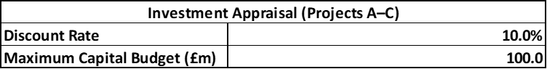
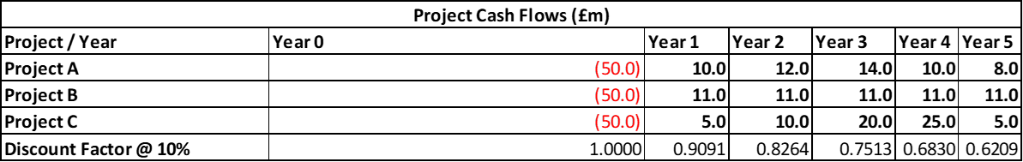
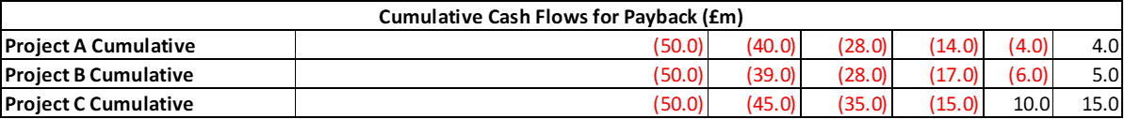
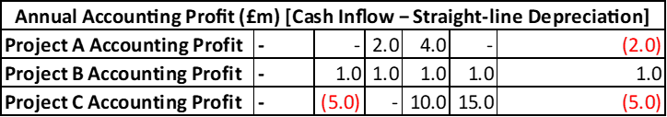
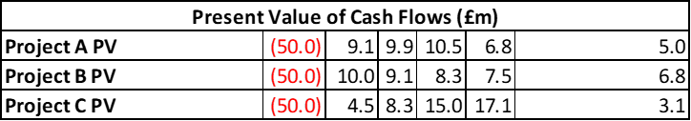
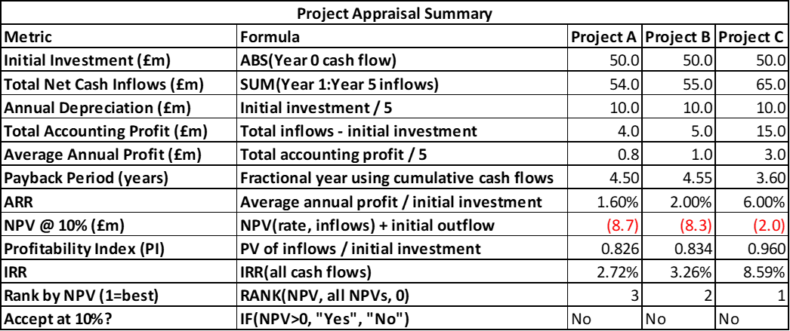
Table 2: NPV, IRR, PBP, PI
(Source: Self-Created)

5.2 Payback Period analysis
The Payback Period demonstrates the speed at which the cash inflow of investment is covered by the cash inflows of a project. It aids in the determination of liquidity recovery and short-term risk; however, it does not take into account the time value of money and future cash flows obtained after payback. The payback period of Project A will be 4.50 years in this appraisal, Project B will be 4.55 years and Project C will be 3.60 years. This implies that Project C has the shortest payback period of any period and the other projects, Projects A and B, have a long payback period and are closely related (Khan et al., 2025). The importance of this outcome is that the support of cash flow of Toyota is weakened and the cash conversion cycle is worsened. Better cash recovery should be fast then. Thus, the payback approach obviously gives an advantage to Project C.

5.3 ARR analysis
Accounting rate of Return determines the proportion of accounting profit of average earnings of an investment on an annual basis. The ARR of Project A is 1.60, Project B is 2.00 and the ARR is 6.00 in this instance. This leaves Project C as the most strong project in terms of accounting returns as compared to Project B and then Project A. The ranking is in line with the cumulative accounting profit created by the life span of 5 years of every project. ARR is effective since it is a straightforward and easy-to-use method of associating the performance of a project with reported profit. Nevertheless, it has definite weaknesses (Chen and Koul, 2025). It does not take into consideration the time value of money and relies on accounting profit but not a discounted cash flow. It nonetheless is useful as a second measure and is in support of Project C again.

5.4 NPV, PI, and IRR analysis
The most effective appraisal method is the Net Present Value since it indicates the value creation at the end of taking into consideration the value of time. Here all three projects have negative NPVs at a discount of 10 percent: Project A (- 8.7m), Project B (- 8.3m), and Project C (- 2.0m). This implies that none of them will yield the necessary payoff thus should be discarded on a strict financial basis. This is supported by the Profitability Index, all of which are less than 1, and hence returns are not sufficient (He, 2025). On the same note, the values of IRR of all the projects are less than 10% validating their rejection. Nevertheless, Project C is the least unattractive considering that it has the highest IRR, positive PI and also, it has the lowest negative NPV.

5.5 Best single project decision
The financial strict response is that the three projects need to be thrown out. None of them has a positive NPV or PI ratio less than 1 and all have IRR that are lower than the 10 percent required rate of return. Because the point of capital budgeting is to choose the investments which generate value to the shareholders, under such circumstances any of the three projects would not be financially reasonable to accept (Sampaio, 2023). This is the best academic conclusion and must be the principal response of the report.
Nevertheless, when one project has to be selected due to strategic reasons, Project C is the most promising. It possesses the largest NPV though that is still negative, the largest IRR 8.59 percent, the greatest ARR 6.00 percent and the shortest payback period 3.60 years. This ensures that it is excellent in any of the significant appraisal techniques (Kumar, 2024). This trend in terms of cash inflows also makes it more appealing since higher inflows in the middle of the year enhance faster recovery as opposed to Projects A and B.
The project C also is of the best strategic fit in case investment is inevitable. The financial position of Toyota is profitable and liquid, although support in cash flow is weak, and, thus, a project with quicker recovery and comparatively better characteristics of returns is more appropriate compared to slower and weaker projects. Thus the most suitable single project choice would be to reject all on a pure financial basis, but to be able to implement Project C in case of strategic need that would compel them to make a single investment.

5.6 Capital rationing under £100m
Table 3: Capital Rationing
(Source: Self-Created)
The capital rationing decision presupposes a budget of 100 million pounds of which only two projects may be selected. The combinations are possible, namely, A + B, A + C, and B + C. The cumulative NPVs are equal to -17.0 million, -10.7 million and -10.3 million respectively. Even though all combinations are financially viable in the budget, none of them is acceptable as they all give a negative NPV. This shows that it is not the lack of capital that is a problem but rather lack of returns at the 10 per cent discount rate (Stenman et al., 2025). Thus, the financial decision that is strict is the rejection of all combinations. B + C, however, should be the choice in case investment is necessary, due to strategic reasons, as it has the greatest cumulative NPV, and is the least value-destroying option.

5.7 Final investment recommendation linked to Toyota’s financial position
The larger financial position of Toyota is critical in the consideration of the investment outcome. Ratio analysis reveals that the performance of profitability, liquidity, leverage, and EPS performance is generally good. Nonetheless, the efficiency of working capital deteriorated during the period because cash conversion cycle increased 94 to 124 days, receivable and inventory ate up more cash and operating cash flow support melted away (Kumala Sari and Fuadah, 2022). This implies that Toyota is financially healthy, but the cash discipline has become a critical aspect. Projects with a negative NPV therefore should not be adopted as they would lower the long term shareholder value and may restrict future flexibility. The appropriate finance action is to eliminate any project and a combination at the 10 percent hurdle rate. In case a strategic investment is inevitable, the single preferred choice would be Project C and the best pair of projects would be B and C.

6. Conclusion
In FY2021-2025, Toyota continued to hold a favorable financial position. Sales, profit, equity and EPS were all on the upswing, and liquidity was comfortable and leverage was within good control. This speaks of a stable firm whose operating strength is strong. Yet, performance deteriorated in the working capital, the cash conversion cycle increased, the receivable days remained at high levels, the inventory days also grew, and the operating cash flow support was lower in comparison with the liabilities. Thus, strategic and not rescue-related restructuring with the help of selective divestiture, focused alliances, retained earnings, and balanced debt is the most appropriate. All the projects need to be rejected at a strict 10% hurdle rate, but if compelled, then Project C and then B + C.

Reference List
Journals
Bhattacheryay, S., 2023. Distinguished competency and efficacy of working capital management ensuing firm survival, liquidity, solvency and profitability: a study on automotive industry. American Business Review, 26(1), p.3.
Bhattacheryay, S., 2023. Multinational working capital management a study on Toyota Motor Corporation. International Journal of Finance & Economics, 28(1), pp.236-256.
Boyer, M. and Panot, M., 2025. Compensation of CEOs–New Perspectives and New Metrics.
Bundy, S.C. and Howard, B., 2025. Managing Inventory During Disruptions. Strategic Finance.
Chen, R. and Koul, S., 2025. Strategic Resilience During Trade Policy Volatility: A Capability-Based Framework for Competitive Advantage. Available at SSRN 5882145.
Fantozzi, I.C., Colleluori, L. and Schiraldi, M.M., 2025. A Quali-Quantitative Analysis Model Integrating Fuzzy Analytical Hierarchy Process and Cost–Benefit Analysis for Optimizing KPI Implementation: Insights from a Practical Case Study Application. Eng, 6(3), p.56.
Feddaoui, A. (2024). Evaluating Earnings Quality Using The Performance-Adjusted Discretionary Accruals Model Case Study Of Toyota Motor Company During The Period 2008-2023. El-Wahat Journal for Research and Studies, 17(1).
Feddaoui, A., 2024. Evaluating Earnings Quality Using The Performance-Adjusted Discretionary Accruals Model Case Study Of Toyota Motor Company During The Period 2008-2023. El-Wahat Journal for Research and Studies, 17(1).
He, Y., 2025. The Impact of ESG Performance on Corporate Debt Financing. Finance & Economics, 1(6).
Khan, M.M., Audi, M. and Ali, A., 2025. Data analytics capability and financial performance: evidence from a panel data perspective. Qualitative Research Journal for Social Studies, 2(2), pp.1917-1933.
Kumala Sari, I. and Fuadah, L.L., 2022. CEO narcissism, company value and earnings management in the industrial sector of Indonesia.
Kumar, S., 2024. Advancing sustainability: A conceptual review for 21st century corporations. International Journal of Economics & Business Administration (IJEBA), 12(2), pp.176-211.
Laskin, A.V., 2024. Organizational reputation management: A strategic public relations perspective. John Wiley & Sons.
Ma, L., Chen, X., Zhou, J. and Aldieri, L., 2022. Strategic management accounting in small and medium-sized enterprises in emerging countries and markets: A case study from China. Economies, 10(4), p.74.
Mahmoud, S., Iraqi, I., Ahmad, S., Maarouf, A., Mahmoud, R., Saleh, B., Mohammed, I. and Nobanee, H., Working Capital Management Analysis of Volkswagen, Toyota, and General Motors.
Minh, N. D. (2023). Toyota's production efficiency improvement management: best practice for productivity evaluation and operation improvement. Journal of Advances in Management Research, 20(3), 385-408.
Mio, C., Scarpa, F. and Signori, S., 2025. Corporate Tax Disclosure Strategies in Sustainability Reporting. Accounting Horizons, pp.1-15.
Mishra, A.K. and Celestin, M., 2025. Strategic Cost Accounting: How LargeCorporations Use Costing Methods to DriveLong-Term Decision-Making. NOLEGEIN Journal of Financial Planning and Management, 8(1), pp.1-17.
ORTEGA, R.R.D.S., Market Analysis and Investment Thesis on the Leading Industrial Gases Company in the United States: Air Products (NYSE: APD).
Potharla, S., 2025. Financial and strategic analysis of Tata Motors: Insights from corporate finance perspectives. Available at SSRN 5294575.
Rahman, A., 2023. Working capital management efficiency using the index method. Journal of Economics and Management, 3(1), pp.75-85.
Sampaio, M.I.L., 2023. Business in Practice: Performance Analysis of IXOR Automotive Company and My Personal Reflection on a Simulated Business (Master's thesis, Universidade NOVA de Lisboa (Portugal)).
Sari, I.K. and Fuadah, L.L., 2022. CEO Narcissism, Company Value and Earnings Management in Industrial Sector of Indonesia. Journal of Accounting, Finance & Auditing Studies, 8(4).
Stenman, L., Vinterskog Danielsson, O. and Enocson, K., 2025. Driving Through Disruption: An Analysis of Automotive Supply Chain Resilience Across Three Global Crises.
Tolegen, T. (2022). Cost Analysis: Toyota, the Kaizen Vehicles. Available at SSRN 4195995.
Vollert, J.D., 2024. A Strategic, Operational, and Financial Review of Proxima's Performance in the Automotive Industry Simulation and Corresponding Personal Reflections (Master's thesis, Universidade NOVA de Lisboa (Portugal)).
Xinyao, D., Wen, X., Jingjing, X., Xiaohui, W. and Loang, O.K., 2023. Financial and Non-Financial Analysis of Toyota and Ford: A Comparative Study. Journal of Islamic, Social, Economics and Development, 8(52), pp.203-214.

