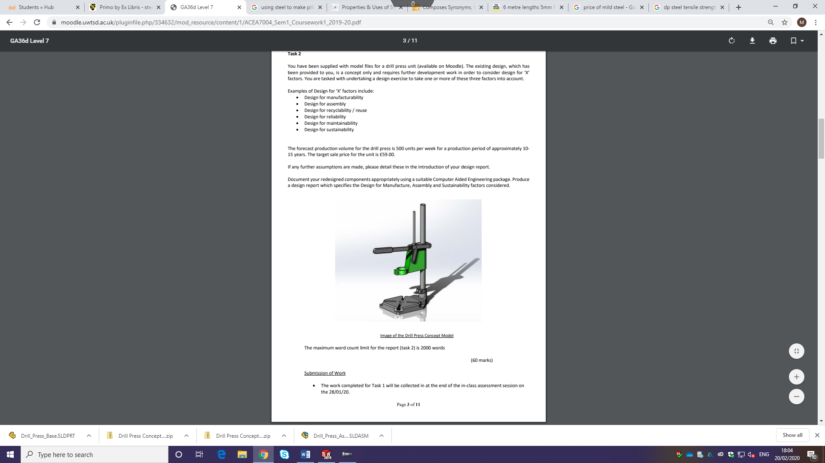

Figure 1 - Initial Drill Press

Design for Manufacture
  - Design for manufacture exercise – drill press
Mitchell Watson | MSc Lean and Agile Operations | 28/02/20

Contents
Table of Figures 1
Introduction 2
Material Selection 2
Machining and finishing 3
Design Criteria 4
Adjusting the tool holder height 5
Rack and Pinion 7
MAINTENANCE AND REPAIR 8
Conclusion 8
Bibliography 10

Table of Figures

Figure 1 - Initial Drill Press 0
Figure 2 - Recycling Cast Iron Process 3
Figure 3 - Initial base of drill press 4
Figure 4 -Milled cut 5
Figure 5 - Handle of initial dress press design. 5
Figure 6 - Initial drill press design main sliding unit 6
Figure 7 - Re-designed main sliding unit 6
Figure 8 -Individual tool parts for re-designed drill press 8
Figure 9 - Adjusting tool holder height (Support Lock) 8
Figure 10 - Rack and Pinion 9
Figure 11 - Exploded Diagram 10
Introduction
This report shows the development of a drill press unit. It highlights potential factors that should be considered when designing a product.
Drill press is predominantly used to drill or expand a cylindrical hole in a workpiece or component. The drill press has other applications than just drilling, it can carry out operations such as reaming, counterboring, countersinking and tapping.
There are multiple end users for this tool such as large industrial manufacturing workshops or small job shops for basic operations. There are some key elements to consider when purchasing a drill press.
- Accuracy – This is a key reason why woodworkers use drill presses, the ability to produce standard identical holes exceeds the less costly operation of using traditional hand-held drills.
- Speed – The ability to recreate any type of hole faster than before with minimal effort compared to a hand drill. Other advantages allow you to set the appropriate depth and angle of each hole possesses a far more efficient process in terms of throughput, which has alternative benefits by potentially reducing lead times which goes hand in hand with continuous improvement removing waste and better improve the supply chain.
- Functionality – The main purpose of the drill press is to hold an electric drill in an aligned position while applying pressure. Holes can be drilled through various materials such as metal, wood and plastic. Other advantages which the drill press attains is the ability to drill holes in unbalanced wooden pieces like furniture parts.
- Versatility - The drill clamp should be made such that it accommodates the widest range of suitable drills that have multifunctional uses such as rotary sanding disc.
- Safety - Adjusting the speed of the tip allows better control of the operation, which lowers the potential risk in breaking the tip of the tool. Clamps can be used to secure work pieces to the tabletop to reduce the chance in the workpiece slipping.

Material Selection
The material selected to manufacture the drill press component will consist of cast iron for the base and aluminum alloy for the shaft. Cast iron possesses some attractive mechanical properties which are important for the drill press function and application. Cast iron is particularly known for its hardness, toughness, ductility and elasticity (H.T.Angus, 1976).
Cast iron is the chosen material is not only from its impressive mechanical properties but its high machinability, wear resistance and vibration damping along with it being cheap and easy to form. Another advantage of using cast iron to form the part is it’s uniquely sustainability because once it is made it can be used as iron forever making it infinitely recycled. Therefore, the investment in choosing iron can be capitalised on by future generations. The manufacturing route for Cast iron is eco-friendly to a certain degree because of its reusability; it can be recycled indefinitely without any deterioration in its mechanical properties. Cast iron offsets its production ‘costs’ due to the materials longevity and value, cast iron products are notoriously known for their durability and long life cycle
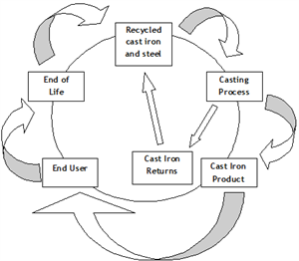

(Hargreaves Foundry Castings, 2015)
Figure 2 - Recycling Cast Iron Process
Aluminium alloy is chosen for the shaft and handle as it possesses desirable properties such as light weight and strength making it a reliable and durable material. The quality of aluminium is preserved due to having an effective control of the scrap stream, this allows the recycling operation to have a compositionally closed loop without any significant changes in the chemical composition from the initial input to output (Dimos Paraskevas, 2015).

Machining and finishing
One of cast irons desirable properties for this application is hardness which demands careful selection of machine tool materials. Materials are continuously developing as technology improves but coated carbides are an effective method in production machining environments. There are a variety of surface finishing methods for cast iron products which depend on the application of the part. A few common applications:
- Hot-Dipping
- Thermal Spraying
- Electroplating
- Conversion coating
- Dry powder organic coating
- Painting
It is important to coat the cast iron to enhance the life of the product, exposure to oxygen and water will lead to corroding parts, for this parts purpose it is critical that the cast iron is coated for its protective functions. Paint is the selected coating method because of the constraints on cost. There are a few initial steps in the coating procedure to ensure best results such as:
- Removing any initial rust with sandpaper.
- Preparing the surface by degreasing the part and rubbing down with emery paper.
- Use an oil-based oxide metal primer.
- Apply an oil-based undercoat.
- Paint the cast iron part.

Initial design:
The base requires the initial slots to perform clamping duties, this is an important part to the drilling operation. Without the sufficient clamping of a material may cause the workpiece to jolt or spin uncontrollably when pressure is applied from the drill.
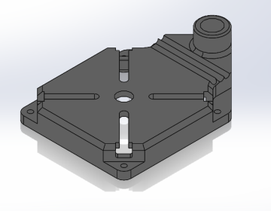
Figure 3 - Initial base of drill press
Modifications could potentially be made to reduce the amount of machining required, by using a milled cut instead of individual cuts between the base and shaft of drill press which can be seen in Figure 4.
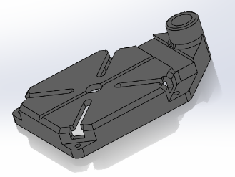

Figure 4 -Milled cut

The handle of the initial dress press design seen in Figure (5), looks uncomfortable and has no mechanical aid to assist performing a drilling operation. The danger of this is without adequate pressure on a harder material you may not be able to penetrate the surface of the material. There are also unnecessary screws needed to attach it with additional processing to shape the handle, a much simpler design of a straight bar that slots into an angle clamp rotator would be more appropriate.

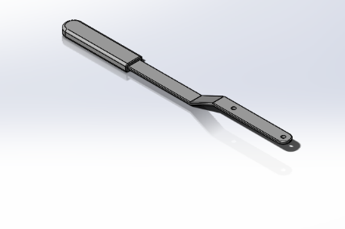

Figure 5 - Handle of initial dress press design.

The initial dress press main sliding unit is excessive (Figure 6), the cost of material and the weight of the part can again be reduced by using less material but still accommodates the same drilling operation (Figure 7).
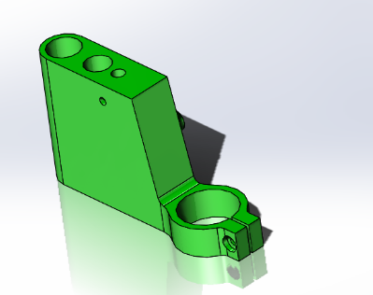

Figure 6 - Initial drill press design main sliding unit

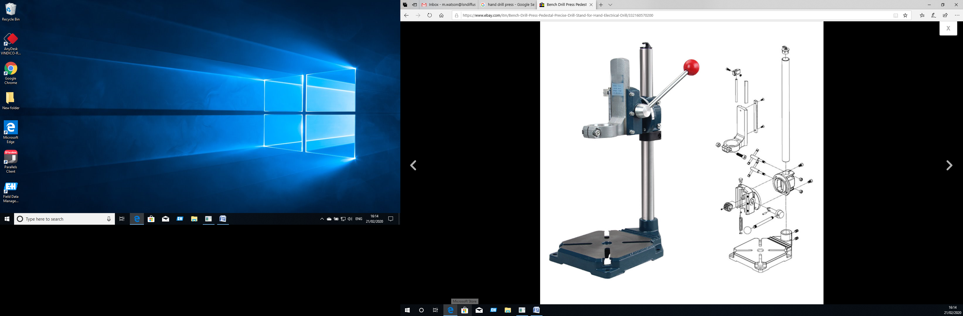

Figure 7 - Re-designed main sliding unit

Design Criteria

Material: Cast Iron + Aluminium alloy
MaxclampDia:43MM
The Angle of clamp rotation:0-90 degree
Weight:4KG
This drill stand is having a multifunctional purpose as a fundamental tool for electric drill and grinder, therefore no need to buy a bench drill.
Features of the drill:
- 90 Degree rotatable design to drill slant hole.
- Copper plug readjustment to confirm the precision and durability.
- Clamping range: 38mm-43mm, easy to fix the electric drill or grinder.
- Precise scale for better working & precise drilling, transparent pointer & spacing function.

The main functioning parts of the re-designed drill press consist of:
- Roller bearings : Specifically chosen to permit rotation between parts
- Heavy duty cast iron base – To secure the part to the workbench for greater rigidity and for a more permanent fixture.
- Handle – Used for the prevision movement of the tool holder
- Tool holder – To fix electric drill or grinder for drilling operation
- Pillar – This is to accommodate the press mechanism
Standard screws are used so only necessary tool for assembling/ dissembling the tool is a set of Allen Keys.

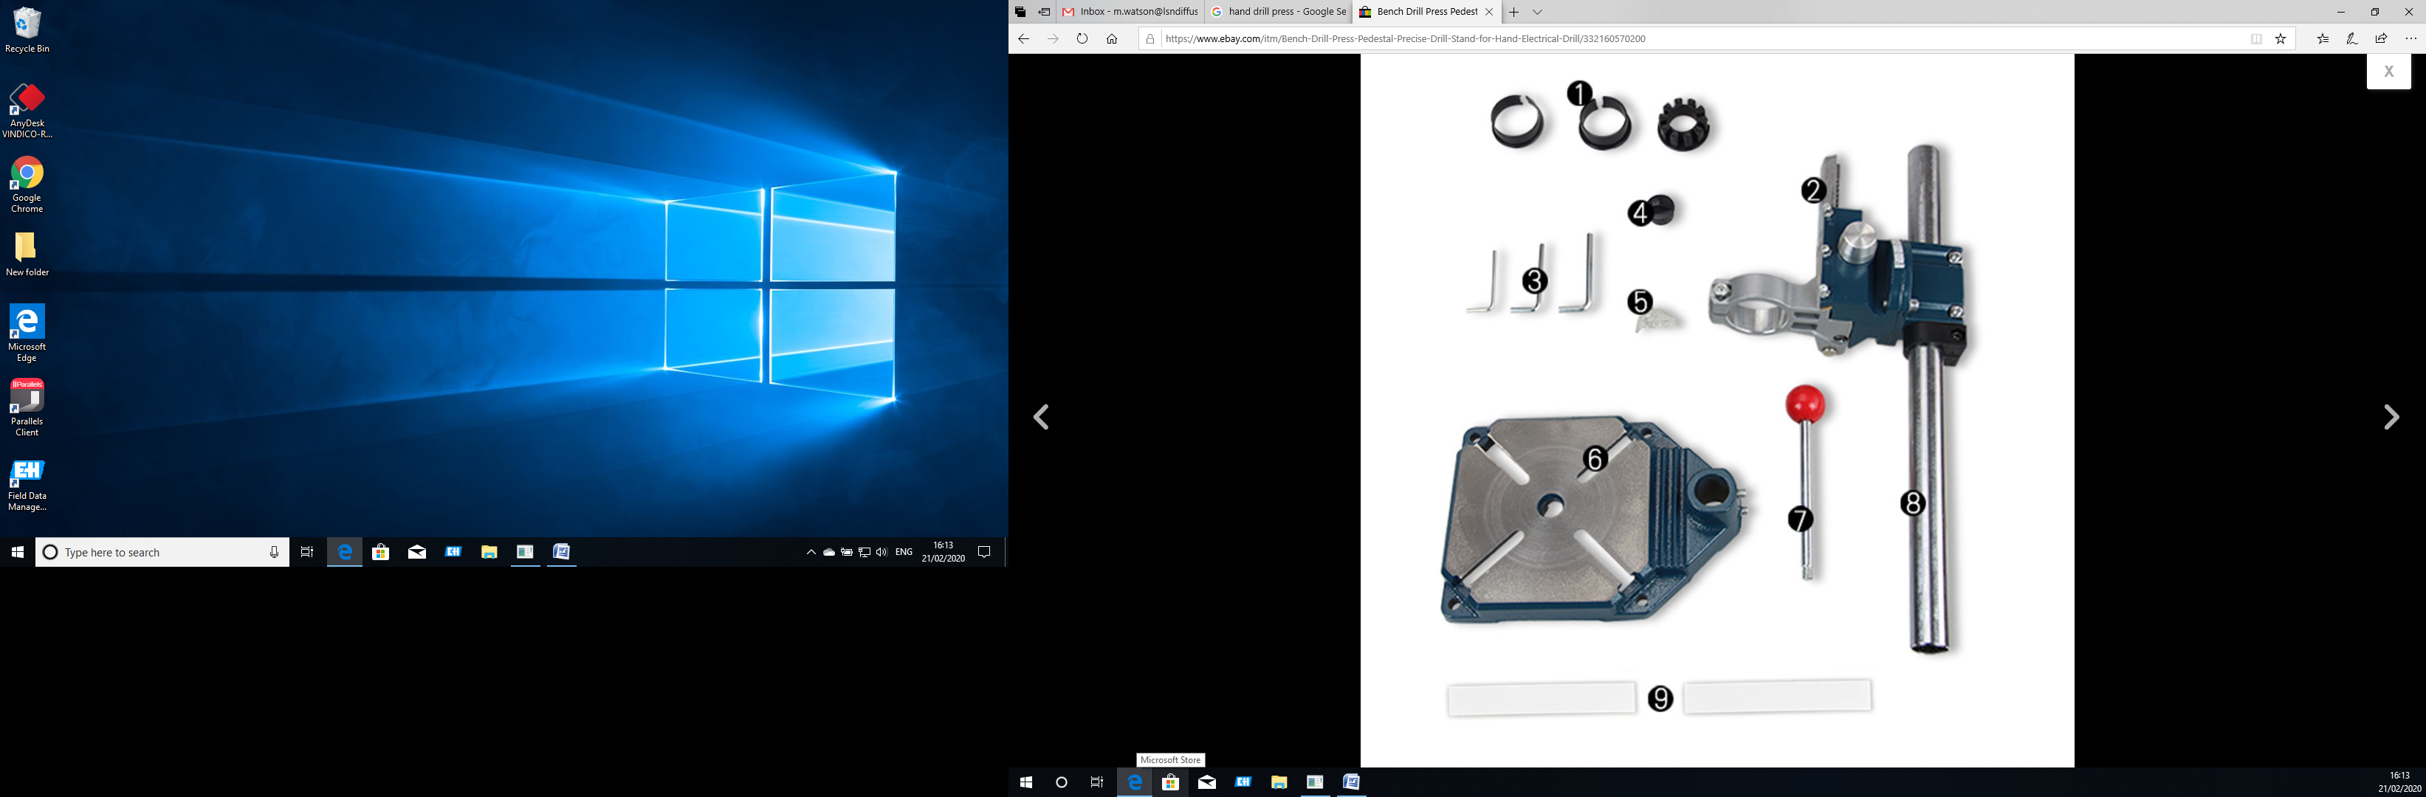
1

2

3

4

5

111
1
1

Figure 8 -Individual tool parts for re-designed drill press

Adjusting the tool holder height
This can be achieved by slackening the support lock located under the handle which allows you to get to the desired height. Which can be seen circled in figure 4.
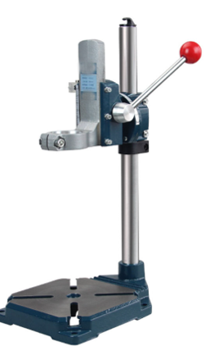

Figure 9 - Adjusting tool holder height (Support Lock)
Once at the desired height, to get to the appropriate feed depth use the handle to activate the rack and pinion arrangement of the gear wheel, which allows the rotary motion to be converted to linear motion, in this case the tool holder will move up and down.
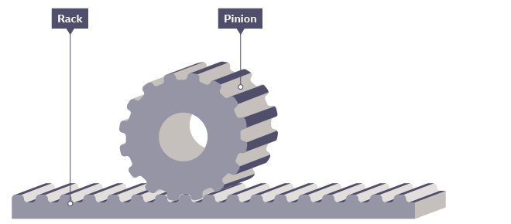

Figure 10 - Rack and Pinion
(BBC, 2020)

Rack and Pinion
Advantages:
- Cheap
- Robust
- Compact
- Simplest way to convert rotational motion into linear motion

Disadvantages:
- Most outdated method which requires extensive amounts of energy
- Friction can be an issue, prone to accelerated wear and tear than other methods
- Inherent friction causes constant wear, potentially requiring replacement after a certain amount of time.
Alternative methods:
There are other types of gears that could be used such as “Worm Wheel” but is significantly more expensive material with low efficiency due to considerable sliding action and can produce a lot of heat (Paranavithana, 2020).

Figure 11 - Exploded Diagram

MAINTENANCE AND REPAIR
Cast iron structures require regular repainting to ensure optimum protection. The aluminium parts should be lightly oiled on a periodic inspection and stored in a vertical position to allow appropriate air circulation across all surfaces to maintain a relatively good standard of appearance. The frequency of cleaning with some water, a sponge and fairy liquid can depend on the severity of the environment it inhabits. For example, in mild industrial environments perhaps once a month will be adequate to retain a reasonable surface appearance.
General inspection that all the fixing screws are tight as the vibrations from the drill may loosen them over time. When conditions that are likely to accumulate dust, dirt or waste, frequent visual inspections should be made, once the machine is cleaned, a light coat of grease can be applied to the gear rack along with a dust sheet over the drill if there is prolonged idle time.
The rack and pinion require periodic greasing for smoother movement.

Conclusion
The main focus of this redesign is to reduce the number of parts and make the tool more user friendly by adding rack and pinion to maximise pressure with minimal strenuous effort and at a steady rate. The ability to reduce the number of parts has multiple benefits in terms of production costs, less parts can lead to less inventory storage, handling and processing time. This re-designed part reduces the assembly difficulty by just using basic standard grub screws, the only necessary tool to assemble or strip needed is Allen keys.
The base is identical to the initial drill press concept model, this cast iron is a robust base where a flat horizontal surface has been machined, that is bolted securely to the base which secures the drilling press to a bench top.
The chosen mechanism is relatively cheap, easy to manufacture due to using minimal parts. The rack and pinion mechanism is user friendly and more efficient with the appropriate pressure. By simplifying the skills needed to for the serviceable design parameters and using minimal hand tools, the part is easy to maintain and is also hardwearing with visual inspection process of wear, tear and failure identification.

Bibliography
BBC. (2020). Mechanical devices. Retrieved from Bitesize: https://www.bbc.co.uk/bitesize/guides/z7gyb82/revision/4
Dimos Paraskevas, K. K. (2015). Environmental modelling of aluminium recycling: a Life Cycle Assessment tool for sustainable metal management. Journal of Cleaner Production, 357-370.
H.T.Angus. (1976). Cast Iron: Physical and Engineering properties 2nd Edition. Butterworth & Co Ltd.
Hargreaves Foundry Castings. (2015). The Sustainability of Cast Iron and its use as a modern building material. Retrieved from Recycling Cast Iron: https://www.hargreavesfoundry.co.uk/blog/blogview/48/the-sustainability-of-cast-iron-and-its-use-as-a-modern-building-material
Paranavithana, C. (2020). Worm and Wheel Gear Mechanism 2. Sri Lanka.

