_____________________________________________________________
Designing a Data Security, Governance and Compliance Framework for NatureGreen (NG)
______________________________________________________________


Name: Nisarg Jani
Id number: 2431451
Module: Data Security, Governance and Compliance
Code: ACCA7028

Section | Title | Description / Purpose
1. | Abstract | A summary of the report outlines the research focus, frameworks reviewed, the proposed design for NatureGreen (NG), and key findings.
2. | Introduction | Introduces the global importance of data security, governance, and compliance; explains the assignment purpose and connects it to the NatureGreen scenario.
3. | Literature Review: Security Frameworks and Models | (Task 1) Research and analysis of established frameworks such as ISO 27001, NIST CSF, COBIT, ITIL 4, CIS Controls, PCI DSS, SOC 2, and Zero Trust includes tables, figures, and comparisons.
4. | Design Approach for NatureGreen (NG) | (Task 2A) Application of knowledge from frameworks to design a custom data security, governance, and compliance model for NG includes diagrams, tables, and justifications.
5. | Critical Discussion: Importance of Updated Regulations and Standards | (Task 2B) Analysis of why continuous updates to security standards are essential; evaluates impact on organisations like NG.
6. | Implementation Plan | Outlines a practical phased roadmap for deploying NG’s proposed security framework and controls.
7. | Conclusion | Summarises findings, lessons learned, and key recommendations for NG’s information security and compliance posture.
8. | References | A full list of peer-reviewed journals, conference papers, books, and credible web sources used throughout the report, formatted according to academic referencing standards.
INDEX TABLE

Designing a Data Security, Governance and Compliance Framework for NatureGreen

1. Abstract
NatureGreen (NG) operates mainly through cloud platforms and wireless networks, “which makes the company vulnerable to modern cyber threats. The pressure to support personal devices, combined with weak governance and the absence of formal security policies, creates several risks for customer data, staff information and NG’s intellectual property. This report reviews key security frameworks such as ISO 27001, NIST CSF, COBIT 2019, ITIL and Zero Trust, comparing their strengths and limitations to understand how each can help stabilise NG’s security posture. Using this research, the report proposes a practical, combined approach designed around governance, policies, risk management and technical controls.
The study also explains why updated standards and regulations are important, especially as threats, technologies and compliance requirements continue to evolve. An implementation plan is included to show how NG can apply these ideas in a realistic 180-day timeline. Overall, the report aims to offer a clear and workable direction for improving NG’s security, compliance and long-term resilience.

2. Introduction
The growth of cloud services, wireless networks and mobile devices has changed how organisations manage information. While these technologies improve flexibility, they also introduce new security challenges, especially for companies with large global operations. NatureGreen (NG) relies heavily on online platforms and wireless connectivity, with around 95% of its network being wireless. However, NG currently lacks formal governance structures, policies and controls, making it difficult to protect sensitive data and manage cyber risks effectively [1]. Recently, NG has faced increasing pressure to allow its staff and customers to use personal devices to access company systems. Although this approach may improve flexibility and user convenience [2]. This report explores established security frameworks such as ISO/IEC 27001, NIST Cybersecurity Framework, COBIT 2019, ITIL 4, CIS Controls, and Zero Trust Architecture. It analyses how these frameworks operate and how they can be applied to NG’s environment [2].
The report also examines the importance of continually updating security standards and concludes with an implementation plan aimed at strengthening NG’s overall security posture.

2.2 Scope
Reviewing recognised frameworks such as ISO 27001, NIST CSF, COBIT 2019, ITIL, CIS Controls and Zero Trust. Designing a layered security approach for NG.
Discussing the importance of updated standards. Proposing a 180-day implementation plan. The report does not cover financial auditing, software development lifecycle (SDLC) processes in detail, or physical building security.

3. Literature Review: Security Frameworks and Models
This section reviews well-known security frameworks and models that organisations commonly used to manage risks, improve governance and stay compliant with regulations. Each framework is explained with its strengths, limitations and relevance to NG’s current challenges, especially its cloud-based operations, wireless network use and BYOD pressures.

3.1 Importance of Security Frameworks
Security frameworks and models provide structured methods for managing risks, enforcing data protection, and ensuring compliance with legal and ethical requirements. They guide organisations in implementing consistent policies, controls, and monitoring practices. For NatureGreen (NG), frameworks are vital because the company operates globally, uses cloud services, and maintains a wireless and Bring-Your-Own-Device (BYOD) environment [3]. A well-chosen combination of frameworks helps NG create an integrated system of governance, risk management, and technical control to protect its intellectual property and customer data [4].

3.2 ISO/IEC 27001 – Information Security Management System (ISMS)
ISO 27001 is one of the most recognised standards for building an Information Security Management System (ISMS). It provides a structured way to manage risks, develop policies, implement controls and encourage continuous improvement. A key strength of ISO 27001 is its focus on governance and documentation, which helps companies like NG formalise their security practices and make responsibilities clear[4]. The standard also works well with cloud services and supports data protection laws such as GDPR.
However, ISO 27001 can be time-consuming to implement, especially for organisations with limited security maturity. Its documentation requirements can feel overwhelming, and certification can be costly [5]. For NG, the relevance is high because the company currently lacks formal policies and governance structures. ISO 27001 would help NG build a foundation for decision-making, risk assessments and control selection [6].

3.3 NIST Cybersecurity Framework (CSF)
The National Institute of Standards and Technology (NIST) Cybersecurity Framework (CSF) offers a structured, flexible method for managing cybersecurity risk. The NIST CSF is widely used for improving cybersecurity risk management. It is built around five core functions: Identify, Protect, Detect, Respond and Recover [6]. One major strength is that it is flexible and easy to tailor to different environments, including cloud and wireless systems. It also provides detailed guidance for technical controls, which fits well with NG’s need to strengthen device security, wireless protection and monitoring.
A limitation of the NIST CSF is that it is not a certifiable standard, so some organisations may struggle to show formal compliance. It also lacks strong governance coverage compared to COBIT. Still, for NG, the CSF is useful because it provides clear [7], practical steps to address operational risks like cloud misconfigurations, weak wireless controls and BYOD threats.

3.4 COBIT 2019 – Governance of Enterprise IT
COBIT (Control Objectives for Information and Related Technologies), developed by COBIT 2019 is a governance framework designed to help organisations align their IT systems with business goals. It focuses on high-level management processes, strategic decision-making, and accountability within the company. COBIT ensures that IT investments deliver value, risks are managed effectively, and responsibilities are clearly assigned [8].

3.5 ITIL 4 – Information Technology Infrastructure Library

ITIL 4 focuses on efficient and reliable delivery of IT services. In security contexts, ITIL is useful for processes such as incident management, change control and service continuity (Author, 2020). This helps NG manage wireless outages, cloud service failures or BYOD-related security incidents more effectively [9].
However, ITIL is not a security framework by itself and does not provide deep technical controls. It is best used alongside ISO 27001 or NIST CSF [10]. For NG, ITIL strengthens operational processes and ensures that incidents are handled consistently.

3.6 CIS Critical Security Controls
The CIS Controls are a set of technical best practices designed to reduce common cyberattacks. They include asset inventories, vulnerability management, secure configuration and access control . These controls match NG’s immediate needs because they directly address wireless security, BYOD risks, endpoint protection and cloud misconfigurations.
A limitation is that CIS Controls focus mostly on technical areas and do not cover governance or compliance. They must be supported by frameworks like ISO 27001 [11]. For NG, CIS Controls can serve as quick wins to strengthen technical defences during early implementation stages.

3.7 Zero Trust Architecture (ZTA)
Zero Trust is a modern security model based on “never trust, always verify.” It requires strict identity checks, device validation and continuous monitoring. This makes it highly relevant for NG since the company relies on wireless networks and BYOD devices, which naturally increase attack surfaces [12]. Zero Trust also aligns well with cloud environments by treating every connection as untrusted.
The limitation of Zero Trust is that it requires cultural changes, investment in identity systems and upgraded networks. It may also increase complexity in global companies. For NG, Zero Trust should be introduced gradually, starting with identity management and network segmentation [13].

3.8 PCI DSS and SOC 2
The Payment Card Industry Data Security Standard (PCI DSS) applies to organisations that handle payment information, while SOC 2 (Service Organisation Control 2) provides independent assurance of security, availability, and confidentiality controls. If NG processes online payments or works with external vendors, these standards help demonstrate accountability and increase customer trust [14].
Framework | Focus Area | Key Strengths | Relevance to NG
ISO/IEC 27001 | ISMS / Risk Management | Global standard; continuous improvement [15] | Core governance and compliance framework
NIST CSF 2.0 | Risk and Governance | Clear structure; adaptable to cloud | Maturity assessment and communication tool
COBIT 2019 | IT Governance | Strategic alignment and accountability | Executive governance and performance management
ITIL 4 | Service Management | Operational excellence; continual improvement | Secure service delivery and incident response [16]
CIS Controls | Technical Safeguards | Quick, actionable steps | Rapid baseline protection for wireless systems
Zero Trust | Access Control | Continuous verification | Essential for BYOD and remote access
PCI DSS / SOC 2 | Assurance & Compliance | Trust and auditability | Supports regulatory and partner confidence [17]

3.9 Summary of Framework Relevance to NG
For NG:
- ISO/IEC 27001 - should serve as the management foundation.
- NIST CSF 2.0 - provides measurement and communication.
- COBIT 2019 - ensures strategic alignment and governance.
- ITIL 4 - manages service operations.
- CIS Controls - deliver rapid technical hardening.
- Zero Trust - secures wireless and BYOD environments.
- PCI DSS and SOC 2 - provide compliance and assurance where required.

4. Design Approach for NatureGreen (NG)

4.1 Purpose of the Design
“NatureGreen is a global company that operates in a complex digital environment where most services depend on cloud computing and a 95 percent wireless network [18]. This section presents a practical security, governance and compliance approach for NatureGreen (NG), based on insights from the literature review. The approach combines elements from ISO 27001, NIST CSF, COBIT 2019, CIS Controls and Zero Trust to address NG’s unique challenges, such as wireless dependence, cloud usage and BYOD access[19]. The design is divided into layers so that NG can implement controls in a structured and manageable way.

4.2 Governance and Strategic Planning
A strong governance foundation is needed because NG currently lacks clear roles, accountability and decision-making structures. Using COBIT 2019 and ISO 27001, NG should establish:
An Information Security Governance Board (ISGB), A Chief Information Security Officer (CISO) role, Clear reporting lines for audits, compliance and incident management, Policy approval and review procedures, Security awareness responsibilities
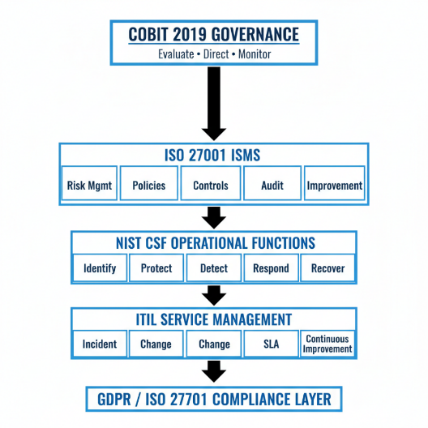
figure 1

Figure 1 shows how governance, policies, operational controls and compliance requirements work together as a single structure. COBIT establishes strategic direction, ISO 27001 manages documented controls, NIST CSF handles operational guidance and ITIL supports incident and service processes. GDPR and ISO 27701 ensure privacy and legal compliance. For NG, this layered structure creates clarity and prevents the confusion caused by having no formal governance.

4.3 Risk Management Approach
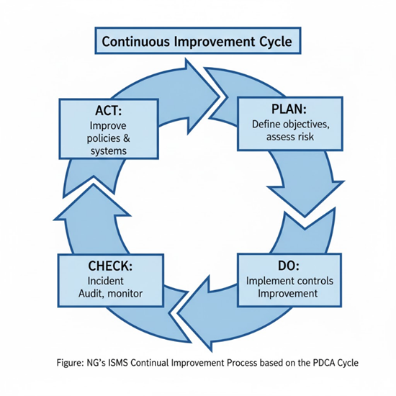
Using ISO 27005 and NIST CSF, NG should adopt a continuous risk cycle to identify threats, assess impacts and select controls.
Figure 2: PDCA Continuous Improvement Model
This model shows how NG can repeatedly assess risks, apply controls, check their effectiveness and improve over time. It highlights that information security is not something done once but a continuous cycle. NG can use PDCA to update policies, respond to incidents and refine controls as the company grows or new threats emerge. This method supports both ISO 27001 and modern cloud security needs.

4.4 Security Policies
Policy Area | Objective | Implementation Examples
Access Control Policy | Grant least-privilege access; verify every user/device | Multi-Factor Authentication (MFA); Role-Based Access Control (RBAC); device certificates.
BYOD Policy | Secure personal devices accessing corporate data | Mobile Device Management (MDM); conditional access; data containerisation.
Wireless Security Policy | Protect 95% wireless network | WPA3-Enterprise; EAP-TLS authentication; Network Access Control (NAC).
Data Protection Policy | Safeguard personal and intellectual property data | Encryption (AES-256); Data Loss Prevention (DLP); data classification labels.
Incident Response Policy | Provide a structured response to cyber incidents | NIST IR cycle (Prepare–Detect–Contain–Eradicate–Recover–Review); SOAR playbooks.
Third-Party / Vendor Policy | Ensure supplier compliance | Due-diligence questionnaires; security clauses in Service Level Agreements (SLAs) [20].

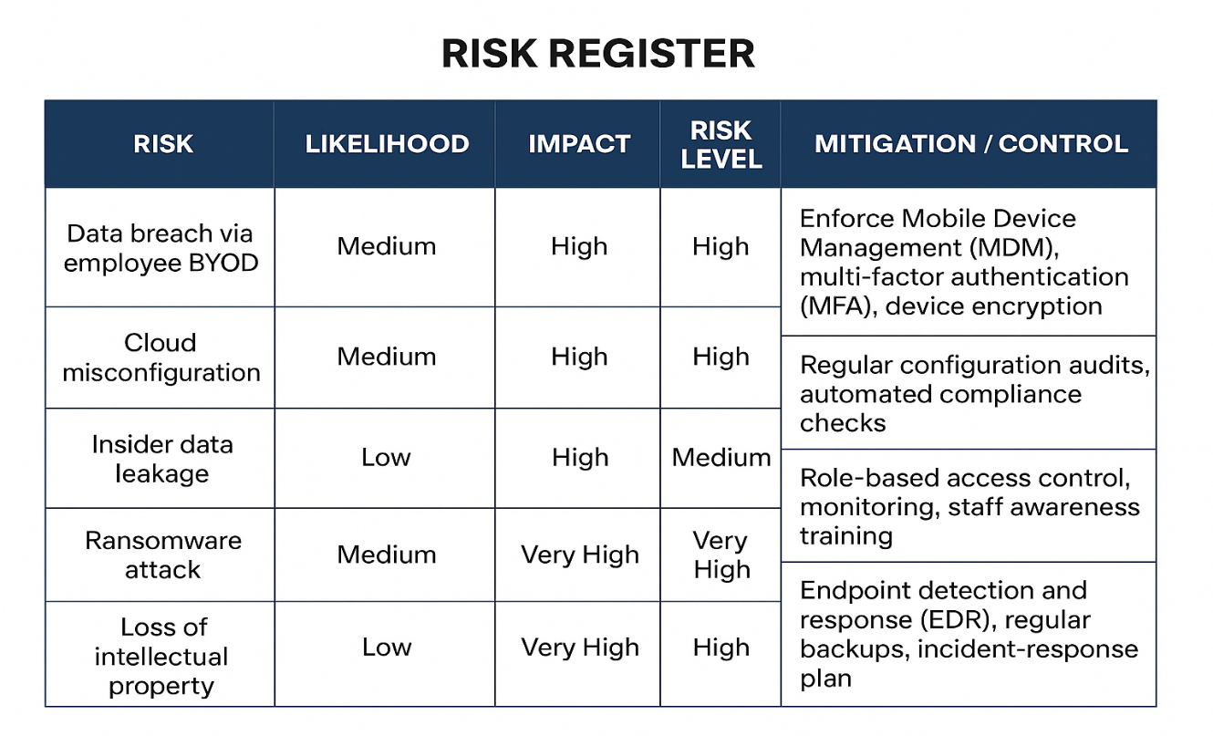
4.5 Risk Register
Figure 3
Risk ownership is assigned to data owners and reviewed quarterly by the IT Governance Committee.

4.6 Protection Mechanisms
NG should implement a defence-in-depth approach combining technical, administrative, and physical controls.
Technical Measures
- Firewalls, intrusion prevention, and endpoint detection. Encryption of data at rest and in transit. Security Information and Event Management (SIEM) with real-time alerts [21],[22]. Cloud Security Posture Management (CSPM) for misconfiguration detection.
Administrative Measures
- Mandatory security awareness training. Regular access reviews and audit trails. Documented incident-handling procedures.
Physical Measures
- Controlled server room access with CCTV monitoring. Secure disposal of hardware and portable storage devices.

4.7 Technical Control Layers
These controls focus on protecting NG’s wireless network, cloud services and BYOD environment.
- Network Security: Upgrade all wireless networks to WPA3-Enterprise. Use Network Access Control (NAC) to block unauthorised devices. Segment guest networks from internal networks.

- Identity and Access Management (IAM): Mandatory multi-factor authentication (MFA). Privileged Access Management (PAM) for sensitive systems. Role-based access for staff and minimum required access for customers.

- Zero Trust Architecture: “Never trust, always verify” model. Continuous authentication and device posture checks. Enforce least privilege for cloud and wireless access.

- Cloud and Application Security: Enable encryption for data in transit and at rest. Apply CIS benchmarks to cloud systems. Regular vulnerability scanning and patch automation.
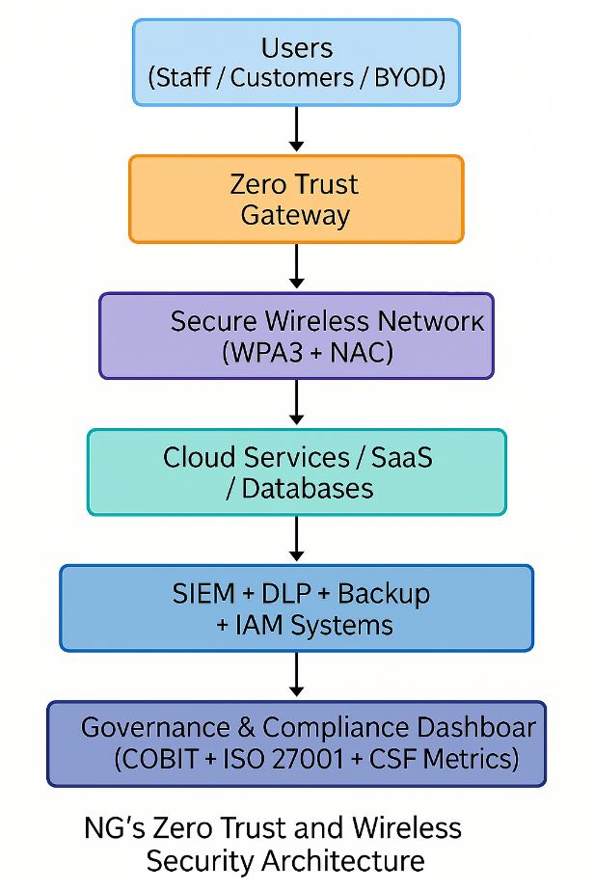
N G’s Zero Trust and Wireless Security Architecture
Figure 4

This figure shows how users, devices and cloud services connect through a Zero Trust gateway, with wireless networks secured through WPA3 and NAC. Monitoring systems such as SIEM and DLP sit below to detect unusual activity and protect sensitive data. At the top is the governance dashboard, which helps NG track compliance and risk. The layered flow ensures every connection is validated and monitored.

4.8 Compliance and Ethics
NG operates globally and must comply with multiple regulations:
GDPR for protection of EU customer data. UK Data Protection Act 2018 and equivalent regional laws. Intellectual Property laws to safeguard brand assets. PCI DSS v4.0 if processing payment information. Ethical compliance goes beyond legislation by promoting transparency, fairness, and accountability. Employees should sign acceptable-use agreements and confidentiality clauses to maintain trust [16]. ”

5. Critical Discussion: Importance of Updated Regulations and Standards
This section evaluates why it is important for organisations like NatureGreen (NG) to adopt updated security frameworks, follow current regulations and regularly revise their policies. The fast pace of technology and the growing range of cyber threats make older practices less effective. NG’s environment 95% wireless, heavily cloud-based and influenced by BYOD pressure requires security controls that match today’s risks, not those from several years ago.
5.1 Opening Critical Perspective
Cybersecurity technology evolves far faster than most security standards, leaving organisations exposed when frameworks do not keep [17]. Outdated controls such as WPA2 wireless encryption or traditional on-prem Active Directory models are no longer suitable for cloud-first environments. For NatureGreen (NG), which operates 95% of its network wirelessly and relies heavily on cloud services and BYOD access, older standards fail to address core risks like identity misuse, cloud misconfiguration and continuous monitoring gaps. As a result, organisations that depend on outdated frameworks quickly find that attackers exploit weaknesses long before standards are updated.

5.2 Comparative Analysis of Old and Updated Standards
A) Older Standards Miss Cloud, Wireless and BYOD Risks
Earlier versions of key frameworks were not designed for modern environments.
ISO 27001:2013 lacked cloud-specific controls and provided limited guidance on shared responsibility or SaaS platforms [18]. NIST CSF 1.1 did not include the new “Govern” function, which is crucial for assigning risk ownership. Older standards also assumed perimeter-based security, which does not work in wireless and BYOD environments. These gaps directly affect NG, because the company currently operates without formal governance roles or a defined structure for risk ownership.
B) Updated Standards Improve Coverage but Still Have Limitations
ISO 27001:2022 introduced new controls for cloud services, threat intelligence, and secure configuration [20], helping address NG’s cloud-driven risks. NIST CSF 2.0 expanded governance and added updated identity guidance [21]. However, both still contain limitations. ISO remains documentation-heavy and resource-intensive, while NIST CSF is not certifiable. CIS Controls v8 strengthen technical safeguards but ignore governance and ethics. These limitations mean NG cannot rely on a single framework and must instead combine several approaches to cover all security layers.
5.3 Real-World Incidents Driven by Outdated Controls
Recent high-profile breaches show the danger of relying on outdated security models.
The SolarWinds attack (2020) occurred partly because organisations lacked modern supply-chain monitoring and zero trust validation [20]. Updated NIST guidance on identity and segmentation could have reduced lateral movement.
The Capital One cloud breach (2019) happened due to a misconfigured AWS firewall, highlighting the risks of misunderstanding the cloud shared responsibility model [28]. Updated cloud configuration controls in ISO 27001:2022 directly address this issue.
The Marriott breach (2018–2020) showed how outdated identity practices and weak logging enabled data theft for years without detection.
These events demonstrate that cloud-dependent organisations like NG cannot rely on generic, outdated controls. As cloud misconfiguration is now one of the leading causes of data breaches [21], NG must adopt updated standards that emphasise secure configuration and continuous monitoring.

5.4 Regulatory Pressure and Legal Expectations
Regulators require organisations to apply “state-of-the-art” security measures under GDPR Article 32, meaning outdated policies can be legally non-compliant. Penalties have increased significantly; for example, the £20 million GDPR fine issued to British Airways for poor security controls shows the cost of insufficient updates. For NG, which handles international customer data across cloud platforms, using outdated standards risks non-compliance[22]. Updated frameworks like ISO 27701 and SOC 2 strengthen privacy governance and help NG demonstrate due diligence for wireless, BYOD and cloud environments.

5.5 Zero Trust and Modern Security Models
Traditional perimeter security does not work in environments where staff connect from personal devices or public Wi-Fi. Zero Trust (NIST SP 800-207) introduces continuous verification, device posture checks, and micro-segmentation. These are essential for NG’s wireless-first environment, where user identity and device health must be validated at every access attempt[23]. However, Zero Trust also has limitations: it requires strong IAM systems, cultural change and investment in device management. NG must plan adoption carefully to avoid resistance or implementation gaps.

5.6 Emerging Threats and Their Implications
Modern threats evolve too quickly for outdated frameworks to remain effective.
AI-generated phishing and deepfake-based social engineering attacks make traditional awareness training less effective [24]. Automated vulnerability scanning tools can detect misconfigured cloud systems within minutes. Ransomware-as-a-service has lowered the skill barrier for attackers, while IoT and remote devices introduce new entry points that older standards never anticipated. For NG, these threats reinforce the need for the latest controls, continuous monitoring and regular framework updates.

5.7 Limitations of Updated Standards
Even updated standards have weaknesses. They still lag behind attackers and require careful interpretation, meaning organisations must tailor them to their own environment. Updated frameworks often demand large amounts of documentation, staff training and organisational change, which may challenge NG due to its current lack of governance maturity. Adoption across multiple regions may lead to inconsistency if not carefully coordinated[25]. Therefore, NG should view standards as guidance, not complete solutions, and must supplement them with its own risk-based decisions.

5.8 Critical Conclusion
Updated security standards are essential for NG, but they must be supported by continuous improvement, strong governance and a willingness to adapt to new threats. Relying on outdated frameworks exposes organisations to modern cloud, wireless and identity-based attacks, while updated frameworks provide stronger methods for managing today’s risks[26]. However, even updated standards have limitations, meaning NG must combine them with Zero Trust principles and ongoing PDCA based reviews. Looking ahead, emerging risks such as AI-driven attacks and potential future regulations will require NG to maintain a long-term commitment to keeping its security framework up to date. A limitation of this discussion is that it cannot predict future threat trends fully, but it highlights the critical importance of adopting and maintaining modern standards.

6. Implementation Plan
The implementation of NatureGreen’s (NG) integrated security, governance, and compliance framework must be structured, measurable, and aligned with business objectives. The plan below outlines a phased 180-day roadmap that ensures smooth adoption, minimal disruption, and sustainable improvement in security maturity.
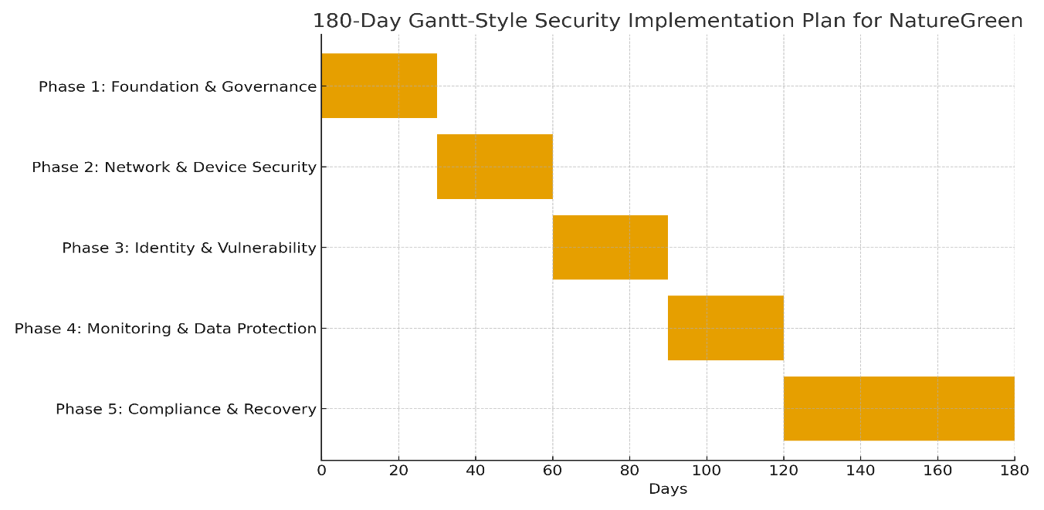
Implementing the security and governance model for NatureGreen (NG) requires a structured, phased approach. NG is currently at a low maturity level, with no formal policies, no governance structure, and a heavy reliance on wireless and cloud services. For that reason, the plan prioritises governance, identity, and risk management before deploying more advanced security controls like Zero Trust. A phased rollout also allows NG to manage costs, train staff effectively, and avoid operational disruption.
Figure 5

Figure 7 illustrates the 180-day security implementation roadmap designed for NatureGreen, showing the sequential progression of the five major phases. The timeline highlights how tasks are distributed evenly to ensure steady progress without overwhelming resources. This visual layout makes it easier to understand the order, duration and dependency of activities required to strengthen NG’s security posture. Overall, the chart provides a structured and realistic plan for improving governance, technical controls and regulatory compliance.

7. Conclusion

This report has examined the critical need for effective data security, governance, and compliance within NatureGreen (NG), a global company operating in a highly digital and wireless environment. Through the review of recognised frameworks such as ISO/IEC 27001, NIST Cybersecurity Framework (CSF), COBIT 2019, ITIL 4, CIS Controls, and Zero Trust architecture key principles for developing a robust and integrated security approach were identified.
Using insights gained from this research, a tailored framework was designed for NG that combines governance, risk management, and technical controls to protect its intellectual property and personal data while ensuring regulatory compliance. The proposed design promotes accountability through governance structures, strengthens operational resilience through risk-based controls, and establishes measurable standards of performance and assurance.
The critical discussion highlighted that continuously updating frameworks and regulations is essential to stay ahead of evolving threats and maintain global compliance. Finally, a 180-day phased implementation plan was outlined to support NG in transitioning from reactive measures to a proactive, standards-based security posture.
By following this approach, NG can achieve a secure, compliant, and resilient information environment that supports business growth and customer trust in the digital era.

8. References “
- Radanliev, Petar, et al. "Integration of cyber security frameworks, models and approaches for building design principles for the internet-of-things in industry 4.0." Living in the Internet of Things: Cybersecurity of the IoT-2018. IET, 2018.

- Irshad, Mohammad. "A systematic review of information security frameworks in the internet of things (iot)." 2016 IEEE 18th International Conference on High Performance Computing and Communications; IEEE 14th International Conference on Smart City; IEEE 2nd International Conference on Data Science and Systems (HPCC/SmartCity/DSS). IEEE, 2016.

- Shariati, Marzieh, Faezeh Bahmani, and Fereidoon Shams. "Enterprise information security, a review of architectures and frameworks from interoperability perspective." Procedia computer science 3 (2011): 537-543.

- Singh, Arunabh, et al. "Cyber security frameworks." International Journal for Research in Applied Science and Engineering Technology 10 (2022): 590-599.

- Almuhammadi, Sultan, and Majeed Alsaleh. "Information security maturity model for NIST cyber security framework." Computer Science & Information Technology (CS & IT) 7.3 (2017): 51-62.

- Möller, Dietmar PF. "NIST cybersecurity framework and MITRE cybersecurity criteria." Guide to Cybersecurity in Digital Transformation: Trends, Methods, Technologies, Applications and Best Practices. Cham: Springer Nature Switzerland, 2023. 231-271.

- Nachrowi, E., Nurhadryani, Y. and Sukoco, H., 2020. Evaluation of governance and management of information technology services using Cobit 2019 and ITIL 4. Jurnal RESTI (Rekayasa Sistem Dan Teknologi Informasi), 4(4), pp.764-774.

- Agutter, C., 2020. ITIL Foundation Essentials ITIL 4 Edition-The Ultimate Revision Guide. IT Governance Publishing Ltd.

- Dabade, T.D., 2012. Information technology infrastructure library (ITIL). In Proceedings of the 4th National Conference (pp. 25-26).

- Al-Safwani, N., Fazea, Y. and Ibrahim, H., 2018. ISCP: In-depth model for selecting critical security controls. Computers & Security, 77, pp.565-577.

- Stafford, V., 2020. Zero trust architecture. NIST special publication, 800(207), pp.800-207.

- Teerakanok, S., Uehara, T. and Inomata, A., 2021. Migrating to zero trust architecture: Reviews and challenges. Security and Communication Networks, 2021(1), p.9947347.

- Richards, M.A., 2024. Regreening the built environment: Nature, green space, and Sustainability. Routledge.

- Obaidat, Muath A., et al. "A comprehensive and systematic survey on the internet of things: Security and privacy challenges, security frameworks, enabling technologies, threats, vulnerabilities and countermeasures." Computers 9.2 (2020): 44.

- Perera, Daminda. "ISO/IEC 27001, Information Security Management System." (2008).

- Gillies, Alan. "Improving the quality of information security management systems with ISO27000." The TQM Journal 23.4 (2011): 367-376.

- Susanto12, Heru, Mohammad Nabil Almunawar, and Yong Chee Tuan. "Information security management system standards: A comparative study of the big five." International Journal of Electrical Computer Sciences IJECSIJENS 11.5 (2011): 23-29.

- Fernandes, Leão José, and F. Saldanha da Gama. "Contingency planning–a literature review." SCM Competitiveness. Macmillan, India (2008): 457-467.

- Hopkin, Paul. "Achieving enhanced organisational resilience by improved management of risk: Summary of research into the principles of resilience and the practices of resilient organisations." Journal of business continuity & emergency planning 8.3 (2014): 252-262.

- Marin, G.A., 2005. Network security basics. IEEE security & privacy, 3(6), pp.68-72.

- Stafford, V., 2020. Zero trust architecture. NIST special publication, 800(207), pp.800-207.

- Myers, Kenneth N. Total Contingency Planning for Diasters: Managing Risk... Minimizing Loss... Ensuring Business Continuity. John Wiley & Sons, Inc., 1993.

- Flowerday, Stephen V., and Tite Tuyikeze. "Information security policy development and implementation: The what, how and who." Computers & Security 61 (2016): 169-183.

- Wachter, J., Gröll, L. and Hagenmeyer, V., 2023. Survey of real-world grid incidents–opportunities, arising challenges and lessons learned for the future converter dominated power system. IEEE Open Journal of Power Electronics, 5, pp.50-69.

- Hooper, Val, and Jeremy McKissack. "The emerging role of the CISO." Business Horizons 59.6 (2016): 585-591.

- Ratchford, M., Wang, P. and Sbeit, R.O., 2017, July. BYOD security risks and mitigations. In Information Technology-New Generations: 14th International Conference on Information Technology (pp. 193-197). Cham: Springer International Publishing.”
“

