Module Code and Title
BMIH4002 – Food and Beverage Operations

Project Title
Assignment 2 Menu Engineering

Student Name: Georgiana Camelia Otesanu
Student ID:2239363
Modul Leader:Ka Po Chong
Module Title: BMIH4002 – Food and Beverage Operations

Table of Contents
Part One: Restaurant Concept 3
Basic Idea of Restaurant Concept 3
Target Audience 3
Logical Reasons of creating Menu 3
Part Two: Menu Design 4
Selection of Food and Beverage: 4
La Carte of the Restaurant 4
Nutrition and Special Dietary Requirements: 4
Reference 6

Part One: Restaurant Concept

Basic Idea of Restaurant Concept
In this project "Tasty Cafe & Restaurant" concept is provided by connecting with Hotel Trinity Chain. The title of my restaurant is set as "Tasty Cafe & Restaurant". The main objective of this restaurant is to provide the most demanding restaurant food and dishes as per the needs of UK customers. This restaurant will be careful about its food and dish quality to achieve customer satisfaction (Filimonau et al., 2017). The entrepreneur has created the establishment of this restaurant very attractively. The lighting and seating environment of the restaurant will be very pleasant where the customers will be able to enjoy the food. The entrepreneur will organize birthday parties or other parties in the restaurant as per the demand of the customers.

Target Audience
The potential customers of "Tasty Cafe & Restaurant" are those customers who are used to eating at restaurants all the time. STP analysis can be done to determine the potential customers of this restaurant. It is possible to determine the potential customers of this restaurant by analyzing the purchasing power, preferences and eating habits of typical UK customers (Baimy et al., 2019). The potential customers of "Tasty Cafe & Restaurant" are 16 to 50 years old. Students, businessmen, sportsmen, politicians, government people, bankers and movie people are the potential customers of the restaurant.

Logical Reasons of creating Menu
Menu design is very important for "Tasty Cafe & Restaurant". A menu is a list of all the products of a small restaurant that can attract customers. The menu contains all the information about the product price and accessories. The menu should be designed in a way that is understandable to all types of customers. "Tasty Cafe & Restaurant" heritage information must be included in the menu which will attract customers more (Chark et al., 2023). The dishes and food that are most in demand in this restaurant should be added to the menu list. The menu of "Tasty Cafe & Restaurant" will be designed by selecting the countries and cuisines with the highest demand.
Menu design is a means of providing product information and attracting customers. Attracting customers is not possible without menu design. That is, menu design is an important method of every restaurant that provides product information and attracts customers. Customers choose food and dish by looking at the menu.

Part Two: Menu Design
Menu design is the responsibility of every restaurant to make food and beverage selections. Menu design is done by selecting the appropriate dishes for the cafe or restaurant. The dishes selected for the food and beverage menu list must be reputable and familiar.

Selection of Food and Beverage:
For menu design of "Tasty Cafe & Restaurant" food will be selected according to current trends and demand. For example: Grilled Cheese, Avocado Toast and Soup can be some perfect foods for menu design (Thomas, 2016). Vegetarian and non-vegetarian dishes must be mentioned in the menu. Special lunch and dinner dishes for customers should be added in the menu.

La Carte of the Restaurant
La Carte refers to a restaurant's menu. The entrepreneur of this restaurant has prepared the menu according to the needs of the customers of the particular region. The restaurant's heavy meals include cheeseburgers, cheese sandwiches, spicy chicken and spicy burgers. Some of the restaurant's other items are cheese, cake pasta, ice cream and French fare. In addition, some other items are ice tea, lemon tea, cold coffee and orange juice.

Nutrition and Special Dietary Requirements:
Foods and dishes selected while designing the menu must be healthy and nutritionally rich. The dishes in the menu design must be suitable for the typical customer's diet. No unhealthy food or menu design will be included in this restaurant. The raw materials used in the preparation of restaurant food and this must be hygienic (Gunawardena & Sarathchandra, 2020). Tasty Cafe & Restaurant provides absolutely fresh food and healthy food for customers. Every food and dish in this restaurant is prepared in a pleasant atmosphere and fresh raw materials are used.

Menu Design

TASTY CAFÉ

Heavy Food
Cheese Burger……………….. £12.99
Cheese Sandwich…………….. £15.99
Spicy Chicken………………... £10.99
Spicy Burger………………….. £7.99
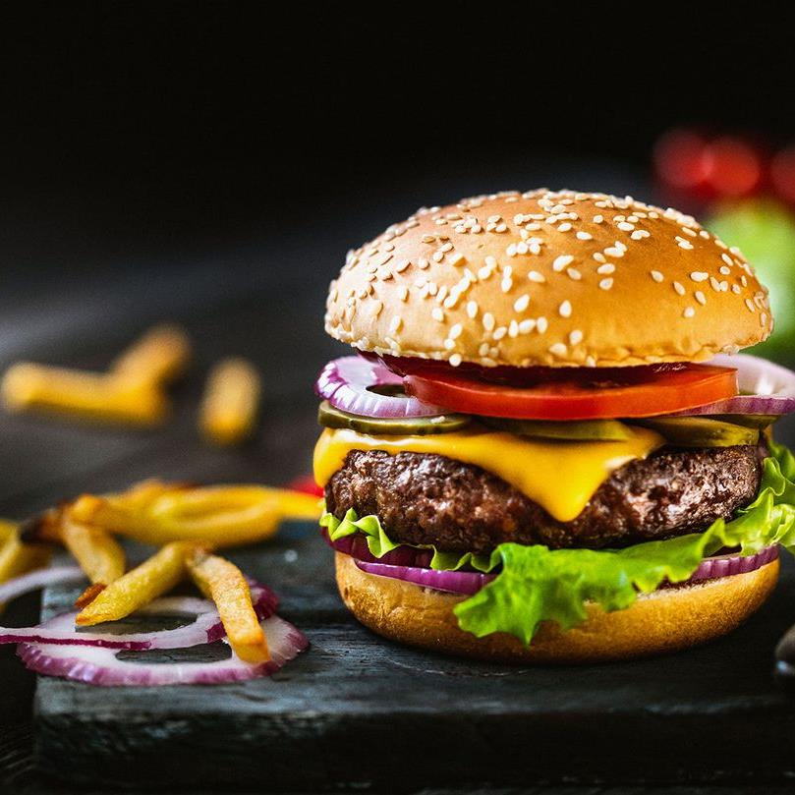

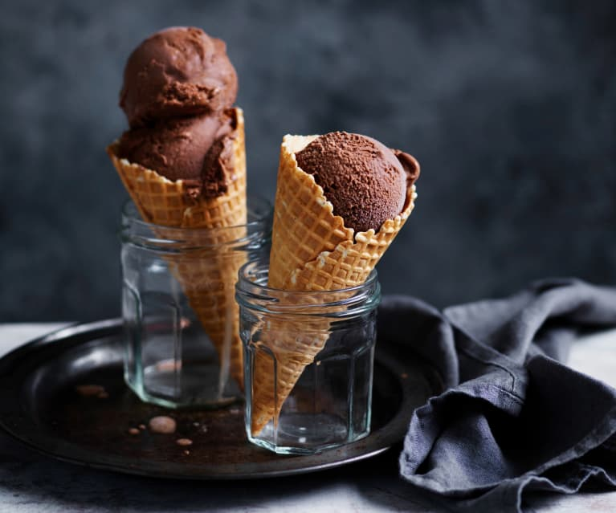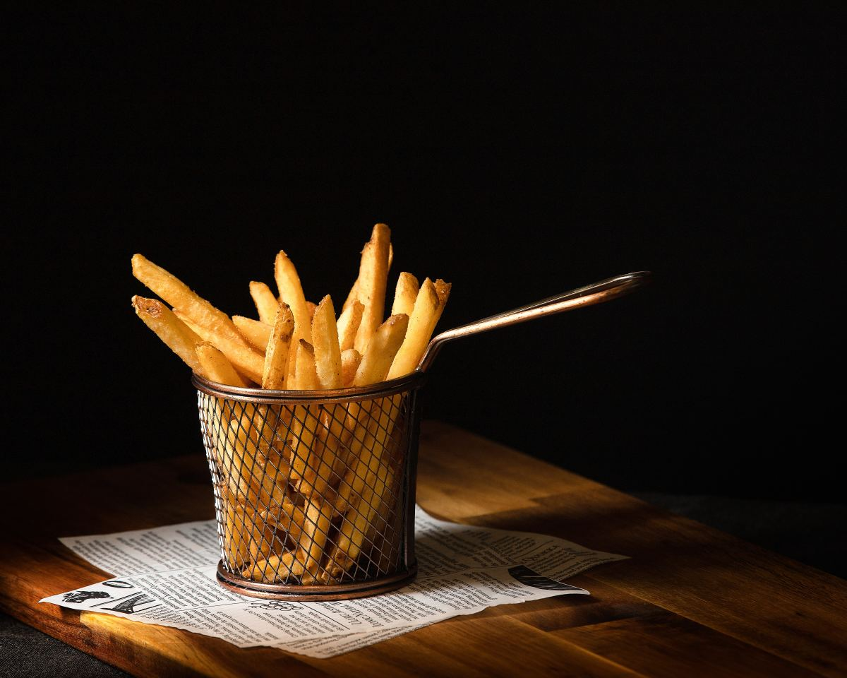
Appetizers
French Fries…………… £9.99
Ice Cream………………£8.99
Cheese Cake……………£7.99
Pasta……………………. £8.99

Drinks
Ice Tea…………………… £4.99
Orange Juice……………… £3.99
Lemon Tea……………….. £2.99
Cold Coffee………………. £3.99
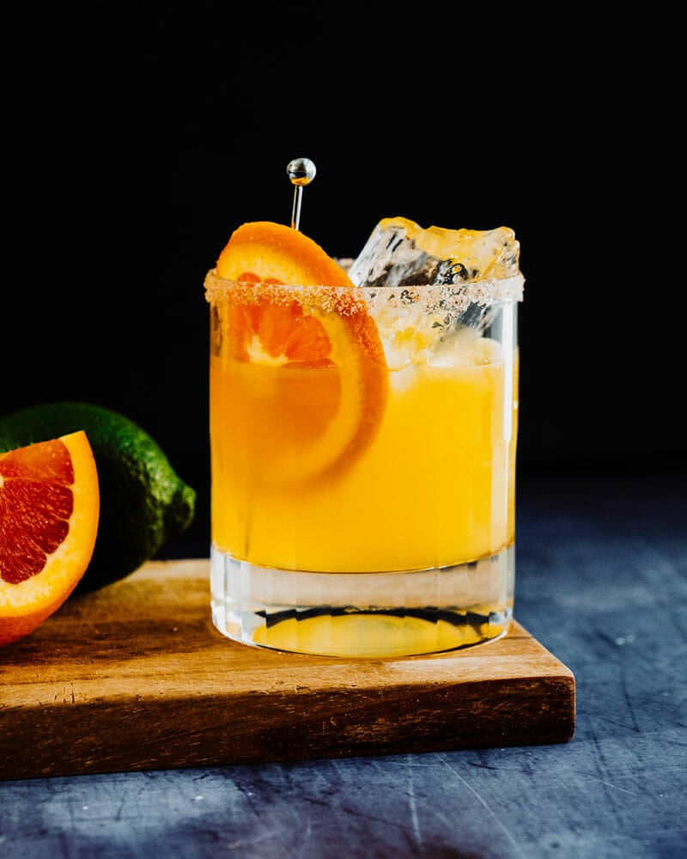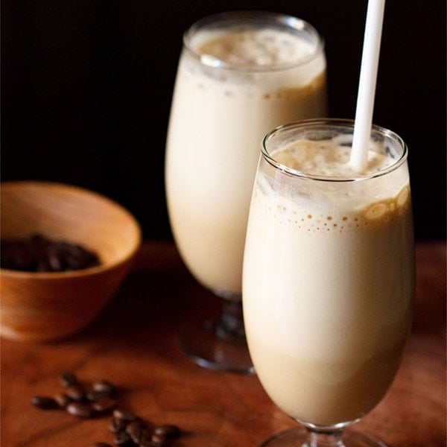

Reference
Baiomy, A.E., Jones, E. and Goode, M.M., (2019). The influence of menu design, menu item descriptions and menu variety on customer satisfaction. A case study of Egypt. Tourism and Hospitality Research, 19(2), pp.213-224.
Chark, R. and IP, M.M.H., (2023). Is menu design effective? A p-curving analysis. International Journal of Hospitality Management, 108, p.103378.
Filimonau, V. and Krivcova, M., (2017). Restaurant menu design and more responsible consumer food choice: An exploratory study of managerial perceptions. Journal of cleaner production, 143, pp.516-527.
Gunawardena, D. and Sarathchandra, K., (2020), March. Bestdish: A digital menu and food item recommendation system for restaurants in the hotel sector. In 2020 International Conference on Image Processing and Robotics (ICIP) (pp. 1-7). IEEE.
Kedas, S. and Sarkar, S., (2023). Putting your money where your mouth is–the role of rewards in a value-based understanding of restaurant crowdfunding. International Journal of Contemporary Hospitality Management, 35(1), pp.92-114.
Lai, H.B.J., Karim, S., Krauss, S.E. and Ishak, F.A., (2019). Can restaurant revenue management work with menu analysis?. Journal of Revenue and Pricing Management, 18, pp.204-212.
Thomas, E., (2016). Food for thought: obstacles to menu labelling in restaurants and cafeterias. Public health nutrition, 19(12), pp.2185-2189.

