

BA Business Management

Data Handling and Business Intelligence
(Essay)

Module code: LCBB5000
Lecturer: Xavier Matieni
Written by: Deyvid Krumov
Student number: 2125371

Table of Content:
Executive Summary: 3
Part 1 4
Case – Hotel Reservation Dataset 4
Use of Excel: 4
Data Preprocessing: 5
Step 1: 5
Step 2: 5
Step 3: 6
Step 4: 7
Excel Functions 8
Benefits: 11
IF Function: 11
Interpretation: 12
Part 2: 12
Answer 1 – Gender Distribution: 12
Answer 2 – Statistics for Qualification: 13
Answer 3 – Mean and Median Value 14
Answer 4 – Pretest and Post test scores 14
Answer 5 – Methods of Data mining and text mining: 15
Answer 6 16
SPSS: 16
Excel: 17
References: 19

Executive Summary:
The analysis of a hotel's room reservation data from 2017 to 2021 provides valuable insights. Utilizing Microsoft Excel, the study employs visual elements such as bar graphs to depict trends. The examination of student scores uncovers average pre-test and post-test scores. Clustering using K-means segmentation identifies two clusters with distinct characteristics. The data mining and text mining section explores techniques like clustering, association, and visualization.
Comparing SPSS and Excel in statistical analysis, while Excel's strengths lie in data manipulation. Both tools have advantages and disadvantages. Additionally, the report touches upon mining other methods for advanced data visualization.

Part 1

Case – Hotel Reservation Dataset
The Hotel Reservation dataset serves as a repository of booking information for guests arriving at a hotel over a six-year period (2017 to 2022). This dataset consists of diverse variables. These include booking id, demography, room type, meal Type, parking required, arrival, market type, repetition, lead time, and many more other variables. The aim of this analysis of datasets is to extract meaningful insights. The analysis employs the capabilities of Microsoft Excel for data preprocessing.
Use of Excel:
Microsoft Excel stands as a key tool in the world of data management. It provides a number of features that contribute to its indispensable role across diverse industries (Ose, 2016). Excel provides a user-friendly interface for organizing and manipulating data at its core. The purpose of excel is to facilitate tasks ranging from basic calculations to complex statistical analyses. Its structured spreadsheet format allows users to store and manage datasets efficiently. There are several good qualities of excel. It has a vast array of functions available for its users (Barreto, 2015). These functions include mathematical, statistical, and financial formulas. As a result, calculations of vast data become easier.
Excel serves as a data analysis tool beyond its data manipulation capabilities. Its powerful charting and graphing functions enable users to visually represent data trends and patterns. It also provides the ability to create a variety of charts, such as line charts, bar graphs, scattered graphs, histogram, and pie charts. Excel's conditional formatting features further enhance data visualization by allowing users to highlight specific data points. These are not the only qualities such as Excel's support for pivot tables and data tables. These tables show the process of summarizing large datasets.
Moreover, Excel enhances financial analysis and budgeting. Financial professionals utilize its built-in financial functions to perform calculations such as net present value (NPV) and internal rate of return (IRR) (Balik, 2009). The platform's versatility extends to project management through features like Gantt charts. Other qualities of excel include its compatibility with other Microsoft Office applications. It provides easier access and collaboration of these software all in one. Microsoft Excel's capabilities make it an essential tool for professionals across sectors.

Data Preprocessing:
There are several phases in excel itself. Data preprocessing is one of the critical phases that involves refining raw data for analysis. The initial step includes the establishment of the original dataset. (Guerrero, 2019) The next step is the elimination of unnecessary cell formatting. This step enhances the clarity of the dataset for subsequent analysis. Sorting and filtering are then applied to identify inconsistencies in specific columns. The last step is removal of null values. Following are the steps explained in detail:

Step 1:
The first step begins by collecting the raw data and storing it in a spreadsheet format. As we already have the spreadsheet, we need to investigate its variables which are Booking, Demography, Room Type, Meal Type, Parking Required, Arrival, Market Type, Repetition, Lead Time, Special Requests, Average Price, and Booking Status.

Step 2:
In step 2, remove unnecessary cell formatting. Select the entire dataset, and under the home section, click on "Autofit Row Height" and "Autofit Column Width" in the Format options. This ensures that the rows and columns are appropriately sized for readability.
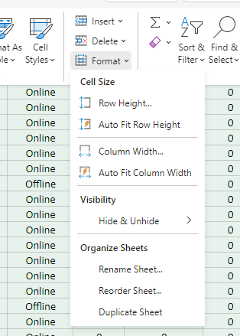
Image 1: auto fit

Step 3:
Step 3 is about sorting. In this step, we utilize the Sort and Filter option under the Home section. Select the header row and apply sorting to columns relevant to the analysis for Arrival Year and Average Price. This step helps in identifying potential issues. For sorting, click on the Sort and Filter option. It will help sort data either in ascending or descending order based on the selected column. For applying filters, the same process will be used. It helps the isolation of specific subsets of data.
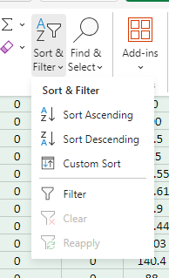
Image 2: Sorting

Step 4:
Step 4 is to eliminate any null values in columns or rows. In my case, the column of Average Price contains missing values. Therefore, I used the filtering option to select and delete rows with null values. This step is essential to prevent incomplete data (Morrin and Diamond, 2022). For selection null column, use the dropdown list in the column header to filter and select only the rows where the price is zero. After selecting the null values, delete the corresponding rows to create a dataset free from missing data.
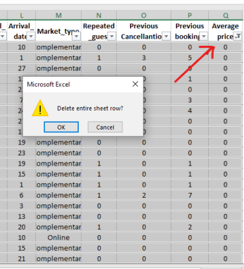
Image 3: deleting null row
Excel Functions
Pivot Table:
Pivot Tables are an excellent tool for analytical functions. It offers users an efficient way to distill vast datasets into actionable insights. Pivot Tables helps individuals to explore and visualize complex information with ease. There could be any easier or typical information, such as sales trends, financial data, survey answers, statistics, or demographic information (Desmarais, 1996). Pivot Table can help with any of these statistics in excel. It provides a structured framework. Furthermore, Pivot Table enables users to analyze data in a tabular format. The datasets become comprehensive with pivot table. The flexibility of this feature lies in its ability to swiftly reorganize data by dragging and dropping fields. It is a very easy function to use in excel and can be used in simple steps. Following are the steps explained:
Step 1:
In step 1, first we select the entire dataset from the column we want to summarize using a Pivot Table. However, it is important here to ensure the data is well-organized with clear headers. These headers will help Excel identify the different fields.
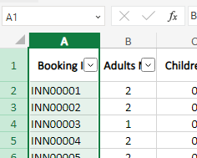
Image 4: selecting column
Step 2:
In step 2, we use the "Insert" tab in the Excel ribbon. Click on the "PivotTable" option. A dialog box will appear. It will prompt you to select the range for your PivotTable. make sure that the selected range contains your entire dataset.
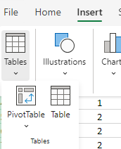
Image 5: pivot table

Step 3:
In Step 3, we create the pivot table. After clicking "OK" in the dialog box, a blank grid will appear along with a new pane on the right side of the Excel window. This is the PivotTable Fields pane. Here, you will find the fields from your dataset.
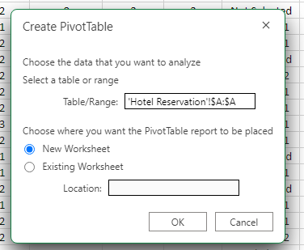
Image 6: how to create pivot table
Step 4:
Step 4 is another easy step. Now, Drag and drop the fields from your dataset into the areas provided in the PivotTable Fields pane. For instance, if you are analyzing hotel reservation data, you will now place "Arrival Year" in the Rows area and "Average Price" in the Values area. Excel will automatically perform the aggregation (e.g., sum or average) based on the numerical fields.
Step 5:
Pivot table is fully customizable. Next step is to customize. You can further customize the Pivot Table by dragging fields into different areas of the PivotTable Fields pane. You can now add "Room Type" to the Columns area and use "Filter" to focus on specific criteria.

Step 6:
In step 6 you can further make any changes to the data if needed. You can easily update the Pivot Table by right-clicking anywhere within the Pivot Table and selecting "Refresh." This ensures that your analysis remains current with the latest data set.
Benefits:
Pivot Tables provides multiple benefits. It is a flexible tool. Its flexibility allows users to quickly rearrange and pivot fields. Pivot Tables excel in condensing large volumes of information into concise. With their robust aggregation capabilities, you can have ease of customization (Grech, 2018). You can also make informed decisions while using pivot table.
IF Function:
The IF function is a powerful tool designed to help users perform conditional calculations. This function plays a significant role in automating decision-making processes within Excel formulas. The structure of the IF function involves evaluating a condition. However, it is important to consider whether the condition is true or false (Gordon, 2016). One can carry out different calculations using the IF function in excel. This branching capability makes the IF function an excellent tool for a wide range of applications. It is commonly used for data analysis, reporting to financial modeling, complex spreadsheet automation, simpler or difficult calculations, and many more. Users can also enhance the efficiency of their Excel worksheets through using the IF function. Experts call it a layer of intelligence. Following is how we use IF function:
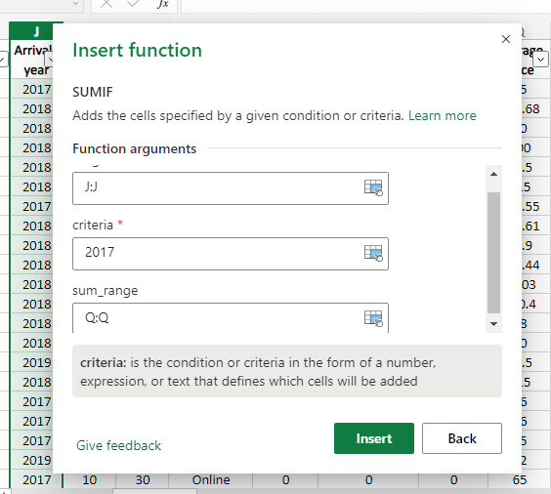
Image 7: IF function

Interpretation:
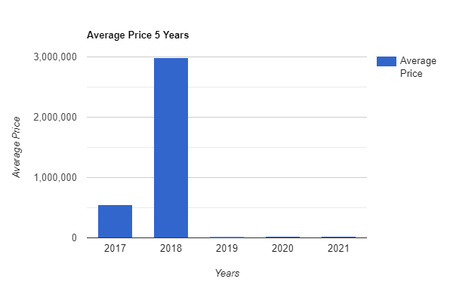
Graph 1: interpretation of average price
The bar graph highlights the fluctuating trends in average room reservation prices from 2017 to 2021. Notably, there was a substantial rise from 2017 to 2018, peaking at over four times the initial value. However, subsequent years witnessed a consistent and remarkable decline, with the most significant drop occurring between 2018 and 2019, reaching nearly 99.3%. The years from 2019 to 2021 showed modest growth.
Key milestones include the peak average price in 2018 at £2984k and the lowest in 2019 at £18k. The bar graph indicates a compelling 96% decrease in average prices from 2017 to 2021.
Part 2:
In this world of globalization and increasing use of statistical data, data analysis is becoming more crucial than ever (Arkkelin, 2014). It is a strategic initiative used across diverse industries. The aim of this report is to provide data analysis of the datasets. It will focus on 2133 school students and their pre-test and post-test scores, with a specific emphasis on the students' eligibility for reduced/free lunch. Following is the analysis:
Answer 1 – Gender Distribution:
First of all, we will investigate the number of students specific to gender. It is an important aspect for finding out students’ datasets. Gender distribution will shed light on the demographic makeup of the 2133 students under analysis.
Table 1: Frequency Distribution of the Gender of Students
Gender | Number of Students | Percentage
Male | 1077 | 49.5%
Female | 1056 | 50.5%
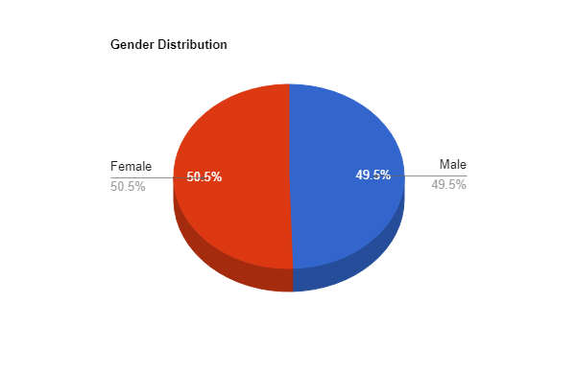
Chart 1: gender distribution
This dataset consists of a near-balanced representation of male and female students. As we can see through the pie chart, a slight majority of 50.5% being female. The nearly equal distribution ensures a comprehensive analysis that accounts for gender-specific variations in pre-test and post-test scores. Understanding the gender distribution lays the foundation for analyses that explore relationships between gender, eligibility for reduced/free lunch, and academic achievements.

Answer 2 – Statistics for Qualification:
Table 2: Distribution of Qualified and Disqualified Students for Reduced/Free Lunch
Qualification | Number of Students | Percentage
Qualified | 918 | 43%
Disqualified | 1215 | 57%

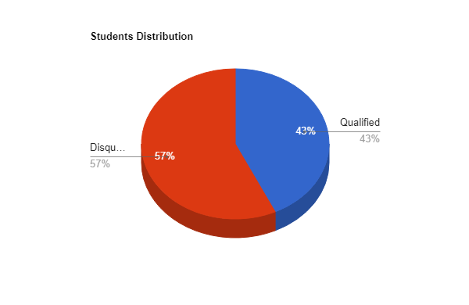
Chart 2: student distribution

Out of the total 2133 students in the dataset, approximately 57% do not qualify for reduced/free lunch which is a significant data. It indicates most students come from families with relatively higher income levels. Conversely, 43% of students qualify for reduced/free lunch. This data suggests a segment of the student population facing economic challenges. Understanding the distribution based on lunch qualification provides context for subsequent analyses.

Answer 3 – Mean and Median Value
Following are the values to calculate the mean and median for the total number of students who qualified and did not qualify for reduced/free lunch:
- Mean: (918+1215)/2=1066.5
- Median: 21 (Number of Students with Free Lunch + Number of Students without Free Lunch) =1066.5
This information provides a tendency measure for the distribution of students based on their qualification status.

Answer 4 – Pretest and Post test scores
Table 3: Mean and Median Differences between Pre-test and Post-test Scores
Test Type | Mean | Median
Pre-test | 54.96 | 56
Post-test | 67.10 | 68

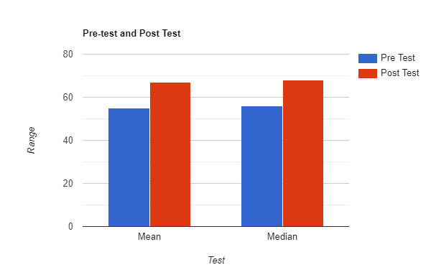
Graph 2: pretest and post test results
The mean pre-test score of 54.96 highlights the average performance of students across the dataset before any intervention. Similarly, the mean post-test score of 67.10 indicates an improvement in the average academic achievement after the intervention.
Median values represent the middle point of the dataset. It further supports these observations. The median pre-test score of 56 and the median post-test score of 68 align with the mean values. These statistics collectively provide a quantitative overview of the students' academic performance.
Answer 5 – Methods of Data mining and text mining:
Clustering:
There are several methods of mining and clustering is one of the times. Clustering is used to segment customers based on purchasing behavior. Retailers identify distinct customer groups with similar preferences. It helps them target marketing strategies. For example, a clothing retailer uses cluster customers based on their preferences for certain styles or brands.
Regression Analysis:
In finance, regression analysis is used to predict stock prices based on various financial indicators. Analysts develop models that consider factors like earnings and market trends to forecast future stock values.
Visualization:
Social media platforms utilize visualization techniques to present engagement metrics. Graphs and charts visually represent user interactions. It allows businesses to analyze trends and optimize their social media strategies for better user engagement.
Automatic Document Classification
It is an important tool for industries, such as the news industry. News organizations employ automatic document classification to categorize news articles. By classifying articles into topics editors can efficiently organize content on their websites.
Sentiment Analysis:
It is another method of text mining. Customer service departments utilize sentiment analysis to evaluate customer feedback on social media. Companies can identify areas for improvement by analyzing sentiments expressed in comments and messages.

Answer 6

SPSS:
SPSS stands for Statistical Package for Social Sciences. It is a powerful software application for statistical analysis. It was originally developed to cater to the needs of social science researchers (Field, 2013). SPSS has evolved into a tool employed across various disciplines for data management and advanced statistical analysis. Its various capabilities make it a solution for professionals seeking to derive meaningful insights from their datasets. SPSS supports both quantitative and qualitative data analysis (Pallant, 2020).
Advantages | Disadvantages
SPSS is known for its user-friendly graphical interface. It makes SPSS accessible to users without extensive statistical expertise. | The user interface feels outdated for beginners.
Provides a comprehensive set of statistical tools for data analysis | Does not offer the same level of sophistication in certain advanced statistical techniques compared to specialized software.
Offers a range of visualization options, including charts and graphs for more effective use. | Visualizations are limited compared to data visualization tools.
Efficiently handles large datasets and supports various data formats. | Advanced features require additional training, and some users find the learning curve steep for certain complex analyses.
Well-suited for predictive modeling. | Customizing and formatting output reports are not very flexible.
Generates clear and structured output reports that facilitate the interpretation of statistical results. | It does not integrate with the few data sources or platforms outside statistical analysis.
SPSS is compatible with various file formats for better integration of datasets with other statistical software and databases. | Licensing costs, especially for commercial use, can be relatively high, making it less accessible for smaller organizations.
IBM is the current owner of SPSS. It provides reliable customer support and regular updates to users for assistance when needed. | Not suitable for industries that require more specialized data analysis approaches, such as machine learning or big data.

Excel:
Excel serves as a data analysis tool beyond its data manipulation capabilities. Its powerful charting and graphing functions enable users to visually represent data trends and patterns. It also provides the ability to create a variety of charts, such as line charts, bar graphs, scattered graphs, histogram, and pie charts. Excel's conditional formatting features further enhance data visualization by allowing users to highlight specific data points (Cainas, Tietz and Miller-Nobles, 2020). These are not the only qualities such as Excel's support for pivot tables and data tables. These tables show the process of summarizing large datasets. Moreover, Excel enhances financial analysis and budgeting. Financial professionals utilize its built-in financial functions to perform calculations such as net present value (NPV) and internal rate of return (IRR).
Advantages | Disadvantages
Excel is widely recognized for its user-friendly interface | Handling large datasets or complex analyses becomes difficult due to the limited processing power.
Offers a broad range of functions and features, including data entry, calculation, data visualization, and chart creation, catering to diverse business needs. | Advanced statistical analysis capabilities are limited compared to specialized statistical software.
Provides a structured environment for organizing and storing data. It enables users to create and manage complex datasets efficiently. | Collaboration on large projects becomes challenging as Excel lacks robust version control.
Supports various chart types and graphical representations. It allows users to create visualizations. | Users may face challenges when transitioning to more advanced features and complex data analysis tasks, requiring additional training for proficiency.
Virtually universal accessibility due to widespread usage and compatibility across different platforms | Advanced functionalities often require the purchase of additional add-ins or specialized software.
Provides password protection and encryption options for securing data. | Performing complex calculations on very large datasets leads to slower performance.
It comes pre-installed with Microsoft Office suites, making it a cost-effective solution. | Collaborative features are not as advanced as those in specialized data collaboration tools

References:
Arkkelin, D. (2014). Using SPSS to Understand Research and Data Analysis. Psychology Curricular Materials. Book, [online] 1(1). Available at: https://scholar.valpo.edu/cgi/viewcontent.cgi?article=1000&context=psych_oer.
Balik, R.J. (2009). Excel best practices. Managerial Finance, 35(5), pp.410–426. doi:https://doi.org/10.1108/03074350910949781.
Barreto, H. (2015). Why Excel? The Journal of Economic Education, 46(3), pp.300–309. doi:https://doi.org/10.1080/00220485.2015.1029177.
Cainas, J.M., Tietz, W. and Miller-Nobles, T. (2020). KAT Insurance: Data Analytics Cases for Introductory Accounting Using Excel, Power BI and/or Tableau. Journal of Emerging Technologies in Accounting. doi:https://doi.org/10.2308/jeta-2020-039.
Desmarais, B. (1996). Using The Microsoft Excel Pivot Table For Reliability Applications | IEEE Conference Publication | IEEE Xplore. [online] ieeexplore.ieee.org. Available at: https://ieeexplore.ieee.org/abstract/document/618962/ [Accessed 23 Dec. 2023].
Field, A. (2013). Discovering Statistics Using IBM SPSS Statistics. [online] Google Books. SAGE. Available at: https://books.google.com/books?hl=en&lr=&id=c0Wk9IuBmAoC&oi=fnd&pg=PP2&dq=SPSS+&ots=LdzkKHZx5D&sig=rWN3pW6FzwX0v41d4Y183w68d38 [Accessed 23 Dec. 2023].
Gordon, S. (2016). FUNCTIONING IN EXCEL - ProQuest. [online] www.proquest.com. Available at: https://search.proquest.com/openview/a00f10e9b9613f3d60af0181d655fca9/1?pq-origsite=gscholar&cbl=35418 [Accessed 23 Dec. 2023].
Grech, V. (2018). WASP (Write a Scientific Paper) using Excel – 2: Pivot tables. Early Human Development, 117, pp.104–109. doi:https://doi.org/10.1016/j.earlhumdev.2018.01.003.
Guerrero, H. (2019). Excel Data Analysis. Cham: Springer International Publishing. doi:https://doi.org/10.1007/978-3-030-01279-3.
Hossain, E. (2021). MS Excel Functions and Formulae. Springer eBooks, pp.117–141. doi:https://doi.org/10.1007/978-3-030-71036-1_3.
Morrin, A. and Diamond, D. (2022). Spreadsheet Applications in Chemistry Using Microsoft Excel: Data Processing and Visualization. [online] Google Books. John Wiley & Sons. Available at: https://books.google.com/books?hl=en&lr=&id=EV1-EAAAQBAJ&oi=fnd&pg=PR7&dq=data+processing+in+excel&ots=xCEIH96_3s&sig=IN9CsIOFvWBzOniR81-xPeF3Stk [Accessed 23 Dec. 2023].
Ose, S.O. (2016). Using Excel and Word to Structure Qualitative Data. Journal of Applied Social Science, 10(2), pp.147–162. doi:https://doi.org/10.1177/1936724416664948.
Pallant, J. (2020). SPSS Survival Manual: A Step by Step Guide to Data Analysis using IBM SPSS. [online] Google Books. McGraw-Hill Education (UK). Available at: https://books.google.com/books?hl=en&lr=&id=CxUsEAAAQBAJ&oi=fnd&pg=PP1&dq=SPSS+&ots=n40BwIFc1W&sig=UotTFjWBFucC3l6ZURlFXDy4TcM [Accessed 23 Dec. 2023].

