BMIH6004 – Level 6 Hotel Placement
Managing Hotel Administration

Student Name: Md Zahirul Haque
Student ID: 2109025
Lecturer: Natalie Brailsford

Table of Contents
Introduction 3
Front Office Operations of Holiday Inn, Sunderland 3
Objectives 3
Reflection on Experience and Personal Development 4
Gibbs reflective cycle 4
Critical Analyses of work-based and technical skills 6
Reflection on an organisational issue 7
Action plans for future 7
Conclusion 8

Introduction

Front Office Operations of Holiday Inn, Sunderland
The Front Office of Holiday Inn Sunderland plays a critical role in attracting guests. Before experiencing any service, clients get front desk service. Front office employees welcomed guests in a warm and friendly manner (Hu et al., 2022). Determines their housing and purchasing needs. Front office staff also assists guests in a branded, courteous, proactive, and efficient manner, including appropriate follow-up as needed (Park and Kim, 2021).
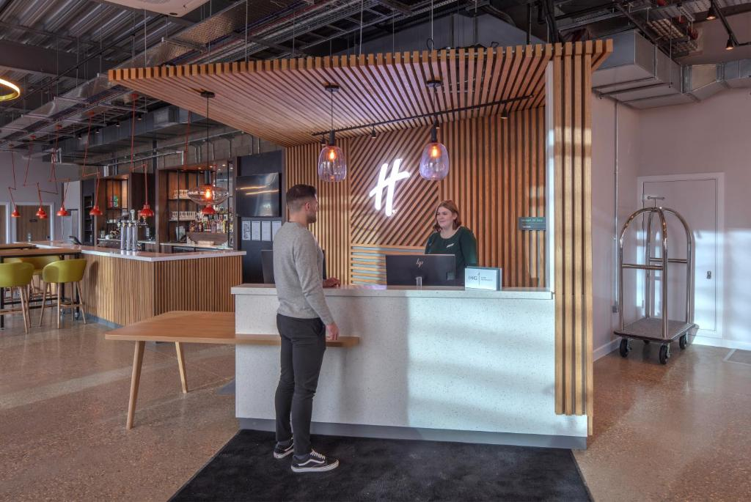

Objectives
- How satisfy the guest and their needs via excellent effective front office
- Increase the critical understanding, interpersonal and technical skill on an individual.
- How to provide a high standard service in the front office department.

Reflection on Experience and Personal Development

Gibbs reflective cycle
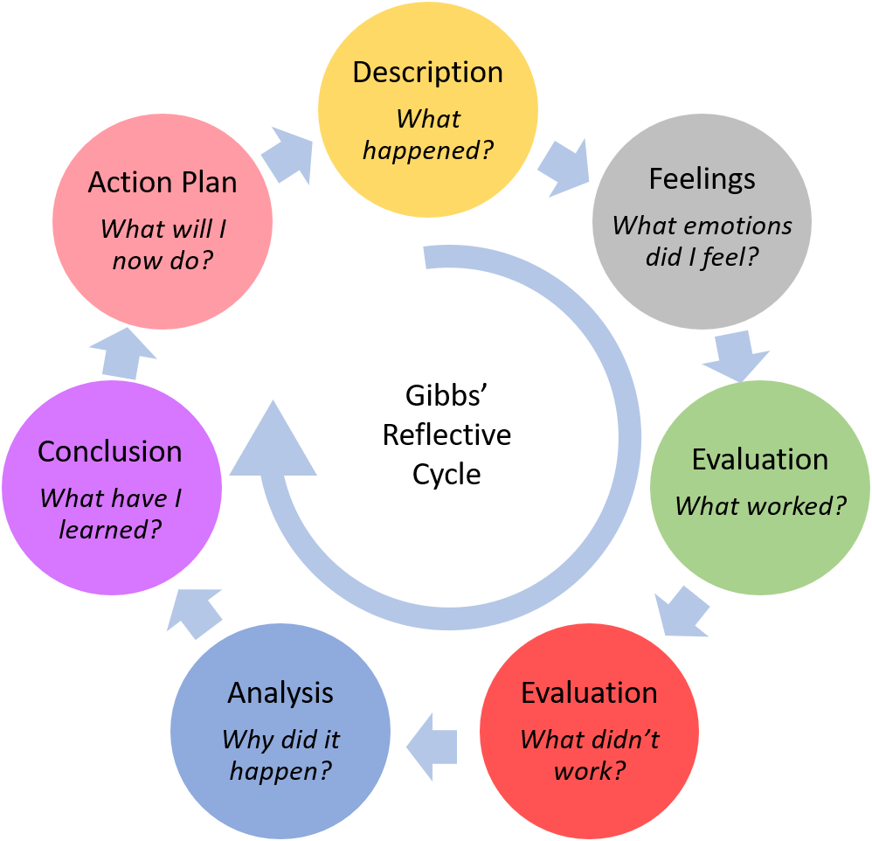
Figure: Gibbs Reflective Model
Source: Tawanwongsri and Phenwan (2019)
My experiences in the supervisory position of the “Front-Office” are given below via Gibb cycle-
Description: The front office is the first place where guest talks physically with the customers, so it is important for them to ensure a positive vibe and behave politely (Shin et al., 2019). As a supervisor of the front office, I try to maintain all the responsibilities of this company. Still, we face many problems.
Technology has made human life easy but sometimes when customers book rooms over the phone because of poor connection miscommunication occurs (Melián-González and Bulchand-Gidumal, 2017). It made the situation vulnerable in real life. Another problem is miscommunication with other functions. At present it become a common problem in this Hotel. According to other employees the front office does not provide information clearly but it is not true. This type of misunderstanding decreases good relationships among the employees.
At the front office, the hotel needs to select those personnel who are good at presentation skills (Sayin and Karaman, 2019). But during recruitment HR professionals of this hotel made mistakes. I made many changes here, still, some indifferent employees do not know presentation skills, but they do not provide information properly to the guests.
Feeling: I have mixed feelings in my position but I have learnt so many things. First of all, I learnt how to deal with different cultures, castes and languages. We receive many customers but many of them cannot speak English, some of our employees are language experts, they handle those issues. From the front office, we need to maintain an effective, strong and clear relationship with another department because we get the first information of guest arrival (Giudici and Filimonau, 2019). Working here, I have developed many work-based skills like communication, teamwork, time management, listening skills, analytical skills and technical skills. For example, data analysis has helped me to recruit the correct number of employees for example now I know in which season most of the tourists visit England based on it we inform in inventory.
But I have some negatives thought too. The authorities always wanted to go with cheap things. It reduces the quality of service. Another problem is with the authorities because they want to use cheap products, which may reduce the service quality of the Hotel Holiday Inn Sunderland.
Evaluation: I made some major changes in this organisation, in this department half of the employees are permanent and the other half are contractual. We hire extra people seasonally. It reduced employee management costs. I have improved my communication and team management skills which are mandatory in my position but my self-control is not improving. Sometimes I do not understand why employees get misinformation.
Analysis: Data analysis is an essential quality that has helped me to make a proper decision in this company. My information has helped other departments to reduce operational costs.
Continuous connections with the employees, guests, and suppliers improved my communication skills. Now I know how business management works.
Conclusion: To solve the current issue, I have decided to arrange some special training programs to improve all the lacking. I have also decided to recruit employees of diverse qualities. It will help others to know another culture and people. The working environment controls employees' performance, which is why I will try to keep the environment more comfortable.
Action plan: If this problem arises again, I will arrange better training programs. I will try to increase the wage rate of employees to hold talented employees. I will provide phone and internet service to them to ensure effective communication during important meetings. Sometimes employees from geographical distances do not attend important meetings because of poor connection (Zeng et al., 2016).

Critical Analyses of work-based and technical skills
Quick problem-solving skills: Holiday Inn Sunderland played a critical role in my career. At the front office, I have resolved many cases quickly for example, a customer booked five rooms for a night stay but when they arrived there were no bookings for them, even the rooms were not ready. I apologise and ask you to wait one hour, within this time I have arranged rooms according to their recruitment. It has improved my problem-solving and decision-making skills. During tourist season I faced a shortage of employees at the front office, so I started to recruit employees for those time contractually.
Communication: I always try to maintain communication with all of my employees to ensure that they know what I want from them. It has improved both communication and leadership skills. I conduct some technical work too and inform other departments about those things. It has helped me to build a strong relationship with them.
Emotional intelligence: Sometimes employees show poor performance, which is not worthy. I personally talked with them about their problems and issues. If it is financial, I try to resolve it as quickly as possible. It has developed my emotional intelligence.

Reflection on an organisational issue
Many people thought that front office work was easy and the online booking system made it easier (Jung and Yoon, 2016). But the real-life scenario is different. It is difficult for them to deal with customers, in a rush they sometimes want to leave the job. I have to motivate them to stay.
Sometimes employees want to change schedules immediately, it becomes a problem sometimes in the supervisory position to arrange other employees quickly because there are no extra employees (Hayes et al., 2017).
Many employees are not happy with the existing wage rate. Even if there is no commission for them to work in pressure and challenging situations.
One incident that occurred to me was last year when 7 employees decided to leave their jobs suddenly, it was very difficult to hire employees who would conduct those work without any training or information. I have motivated them to stay and increased employees' wages rate by 10%. The recruitment process at the front office was lengthy which led to extra costs. I have taken many unnecessary steps to reduce recruitment costs.

Action plans for future
This is a very reputable hotel around the world. I have learnt so many things and tried to contribute to organisational development. I faced many challenging situations, which are a common thing for every supervisor in an organization. I made many mistakes during challenging situations which were effective in learning and taking risks for new innovative ideas. Some action plans for future are-
- We need to hire more employees from diverse communities because it will help us to deal with guests from all around the world. Time management is an important thing for this department, most of the time employee mismanagement delays work. To resolve this issue, I will suggest they start everything early, delegate tasks, follow my deadlines and focus on SMART goals.

Conclusion
As a supervisor of the department of Front office I have always focus to improve existing employee skills. Sometimes personal or physical problem create negative impact in their behaviour that is why I have always tried to strength my relationship with them. I think, it has helped to develop my interpersonal skills and technical skill which I will help to improve my career.
References
Giudici, M. and Filimonau, V., 2019. Exploring the linkages between managerial leadership, communication and teamwork in successful event delivery. Tourism Management Perspectives, 32, p.100558.
Hayes, D.K., Ninemeier, J.D. and Miller, A.A., 2017. Hotel operations management. Pearson.
Hu, F., Trivedi, R. and Teichert, T., 2022. Using hotel reviews to assess hotel frontline employees’ roles and performances. International Journal of Contemporary Hospitality Management, 34(5), pp.1796-1822.
Jung, H.S. and Yoon, H.H., 2016. Why is employees’ emotional intelligence important? The effects of EI on stress-coping styles and job satisfaction in the hospitality industry. International Journal of Contemporary Hospitality Management, 28(8), pp.1649-1675.
Melián-González, S. and Bulchand-Gidumal, J., 2017. Information technology and front office employees’ performance. International Journal of Contemporary Hospitality Management, 29(8), pp.2159-2177.
Park, K.H. and Kim, D.K., 2021. Understanding the relationships among emotional exhaustion, job satisfaction, and emotional intelligence of hotel front office employees. Asia Pacific Journal of Tourism Research, 26(5), pp.504-515.
Sayin, O.G.K. and Karaman, A., 2019. Communication and productivity with guests at front office; A qualitative study on hotels. Journal of International Management and Social Researches, 6(11), pp.186-196.
Shin, H., Perdue, R.R. and Kang, J., 2019. Front office technology innovation in hotels: A managerial perspective. Tourism Management, 74, pp.310-318.
Tawanwongsri, W. and Phenwan, T., 2019. Reflective and feedback performances on Thai medical students’ patient history-taking skills. BMC medical education, 19, pp.1-8.
Zeng, Y., Zhang, R. and Lim, T.J., 2016. Wireless communications with unmanned aerial vehicles: Opportunities and challenges. IEEE Communications magazine, 54(5), pp.36-42.

