Workplace Culture and its Impact on Organisational Efficiency

Culture and Organisation
According to Cartwright, Culture means the control of an organisation, which is system of management authority where the cultural values increase the power and the employees
- Accept the rules, agree to do the things when it is right to do.
- Internalise the orgasational values when they believe they are right and
- Motivate to achieve the organisational objective.
Organisational culture
An organisational culture means this is a collection of values, beliefs, policies and attitude of pervasive context what we agree to do and think in an organisation.
(Mullins, 2011)
Cultural Web

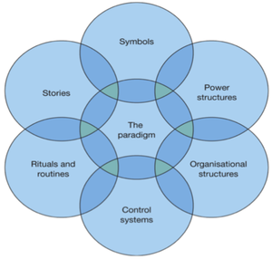
Gerry Johnson and Kevan Scholes developed the cultural web in 1992, while using this different aspect expose the cultural assumptions and strategies practices in the organisation.
The cultural web are together six elements such as
Stories: A key event in the organisation’s history such as major recognition. What it values and perceives as great behaviour.
Rituals and Routines – The behaviour and actions of people determines what is expected to happen in given situations and is valued by management.
Symbols – The visual representations of the company including logos, how plush the offices are, and the formal or informal dress codes.
Organizational Structure – Which reflects power structure, management positions defined by the organization chart, and the unwritten lines of power and influence that indicate whose contributions are most valued.
Control Systems – The ways that the organization is controlled. Such as include financial systems, quality systems, and rewards.
Power Structures – The real power in the company, the key is that people have the greatest amount of influence on decisions, operations, and strategic direction.

(Mindtools, 2019)

Other cultural model:

Charles Handy (1999) also presents organisational cultures as classified into four major types: the power culture, the role culture, the task culture, and the person or support culture.
(OpenLearn, 2019)
Deal and Kennedy’s corporate cultural model includes six elements such as History, Values and Beliefs, Rituals and Ceremonies, Stories, Heroic Figures and The Cultural Network.
(Mindtools, 2019)

Tesco culture

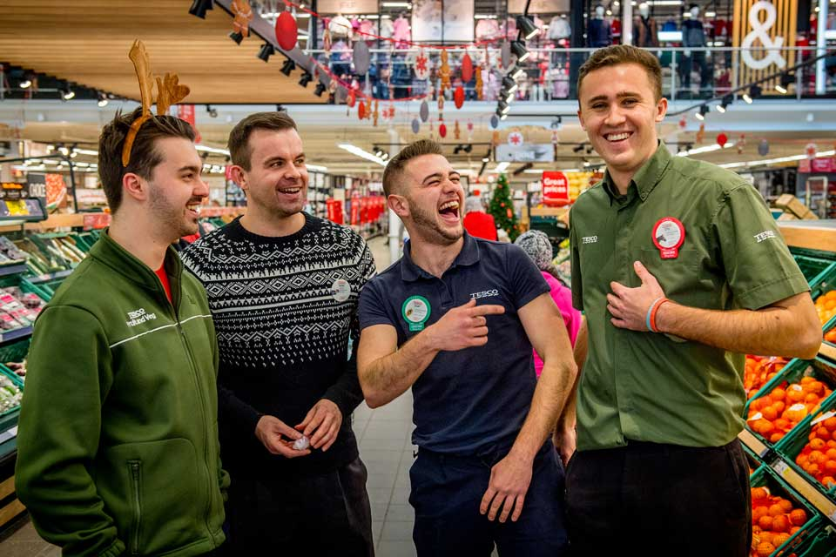
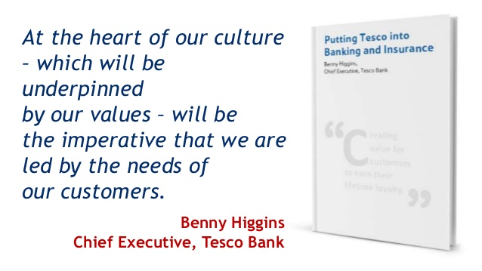

Core Purpose and Values of Tesco
Purpose:
Serving shoppers, a little better every day.

Values:

No one tries harder for customers
We treat people how they want to be treated
Every little help makes a big difference

Since Tesco has first introduced the values, they have become a vital part of their culture – and an essential underpinning of their growth and success. They ensure that every person at Tesco understands what is important – about how they work together in a team and the customer is always at the centre of what they do. They are universal values, which have helped guide the people as Tesco has grown into new markets and new countries.

(Our Tesco, 2019)

Stories: Tesco was established in 1919 or almost a century ago. It was founded by Jack Cohen
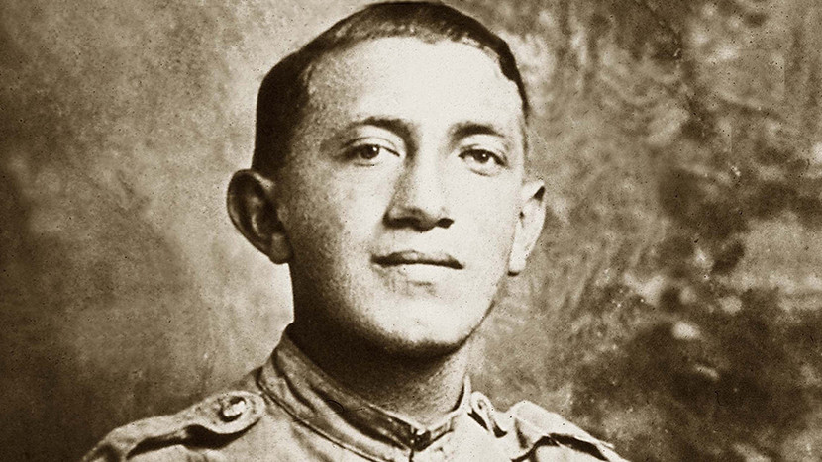 Who came from a market stall. Tesco was founded by Jack Cohen when he began to sell extra groceries. His first day's profit was £1 from sales of £4. Jack Cohen. ‘Jack’s’ brings customers great-tasting food at the lowest possible prices. 450,000
Colleagues at year-end
Over 6,800
Shops around the world

(Tesco plc, 2019)

Symbols

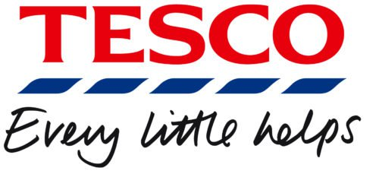
The Tesco brand first appeared five years later in 1924 when he bought a shipment of tea from a Mr T. E Stockwell. The initials and letters were combined to form Tes-co and in 1929 Mr Cohen opened the flagship Tesco store in Burnt Oak, North London.
(Clark, 2019)

its early years, the company used a simple black wordmark logo “Tesco Stores LTD” featuring a plain all-cap font. As the supermarket chain was growing, it went through a succession of typographic logotypes. Starting from 1970, red has been the dominating colour of the Tesco logo. The current version of the emblem introduced in 1995 sports a bright red wordmark with a blue horizontal bar placed under each letter, give an impression of belongings.
(1000logos, 2019)

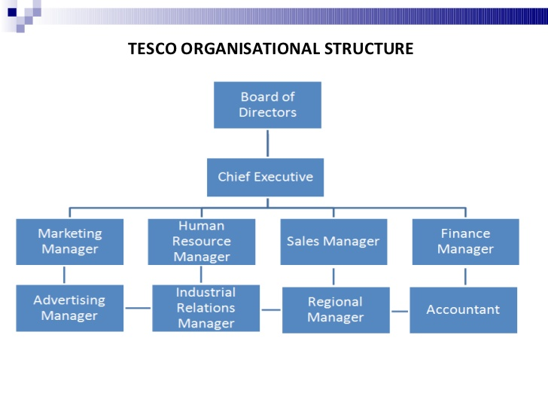
Tesco’s Structure Tesco follows a tall hierarchical structure where the functions are specifically divided in a long chain of commands.
Tesco is divided into two parts. Board comprises the Chairman, Group Chief Executive, Chief Financial Officer and a number of Non-executive Directors.
Executive Committee comprises the Tesco PLC Executive Directors and a number of senior executives.

(Tesco plc, 2019)

Control Systems,
The Board Committees
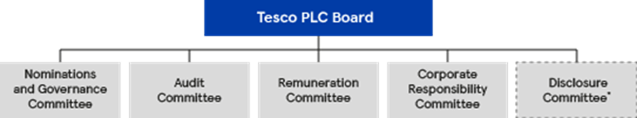

The Board is supported in its work by five key committees. The work of the Committees is essential to the effective operation of the Board. The Committees consider in greater depth and detail, on behalf of the Board, issues relevant to their Terms of Reference, and report to the Board after every meeting. The current members of the Committees can be found in the Board and Executive Committee page.​
(Tesco plc, 2019)

GovernanceissuesatTesco
The food retailer, Tesco, has rarely been out of the news in the last month. The company’s admission that it had over-stated its half-year profits by £250m, has raised questions about the composition of the company’s board of directors and the use of inappropriate accounting policies
(Williams, 2019)
As regards to Power Structures, Tesco-careers.com (2013) explains that Tesco applies Talent Planning for vacancies. Accordingly, more than eighty percent of management positions come from Tesco’s employees.

(Milotmorinablogspot, 2014)

Jason Tarry, the chief executive of Tesco’s UK and Irish business, said the market remained challenging and Tesco needed to adapt to remain competitive: “We’re making changes to our UK stores and head office to simplify what we do and how we do it, so we’re better able to meet the needs of our customers.”
(Butler, 2019)

Rituals and Routines
Tesco helping to equip our colleagues with the skills they need to develop their long-term careers, such as digital and management skills. Tesco’s five diversity networks support our colleagues to be themselves at work: Out at Tesco, Women in Tesco, Black Asian Minority Ethnic Network, Tesco Armed Forced Network and Disability Network.
(Tesco plc, 2019)
Jo Hickson joined Tesco as the new Head of Tesco Labs says,
‘The scale of Tesco means there is a huge opportunity for innovation to make a real impact on the retail industry, globally’.
(Tesco labs, 2019)

Tesco has established coherent and cohesive organizational culture an example workplace for staff, working in respected and trusted environment. their mission is “To create value for customers to earn their lifetime loyalty”. Using their business model, Tesco converted its mission into their strategy.

References:

Mullins, J. L. (2011). Management & Organisational Behaviour. 11th edition. Harlow: Person.

Mindtools. (2019). The Cultural Web: Aligning Your Organization's Culture with Strategy. [online] Available at: https://www.mindtools.com/pages/article/newSTR_90.htm [Accessed 17 Jun. 2019].

OpenLearn. (2019). Management: perspective and practice. [online] Available at: https://www.open.edu/openlearn/money-business/leadership-management/management-perspective-and-practice/content-section-3.5.2 [Accessed 23 Jun. 2019].

Mindtools. (2019). Deal and Kennedy's Cultural Model: Understanding Rites and Rituals in Corporate Culture. [online] Available at: https://www.mindtools.com/pages/article/newSTR_86.htm [Accessed 23 Jun. 2019].
Our Tesco. (2019). Our Core Purpose and Values. [online] Available at:https://www.ourtesco.com/working-at-tesco/our-company/our-values/ [Accessed 16 Jun. 2019].

Tesco plc. (2019). About us. [online] Available at: https://www.tescoplc.com/about-us/ [Accessed 17 Jun. 2019].

Clark, T. (2019). A history of Tesco: The rise of Britain's biggest supermarket. [online] Telegraph.co.uk. Available at: https://www.telegraph.co.uk/finance/markets/2788089/A-history-of-Tesco-The-rise-of-Britains-biggest-supermarket.html [Accessed 23 Jun. 2019].

1000logos. (2019). Meaning Tesco logo and symbol | history and evolution. [online] Available at: https://1000logos.net/tesco-logo/ [Accessed 17 Jun. 2019].

Tesco plc. (2019). Executive Committee. [online] Available at: https://www.tescoplc.com/about-us/board-and-executive-committee/executive-committee/ [Accessed 17 Jun. 2019].

Tesco plc. (2019). Our corporate governance framework. [online] Available at: https://www.tescoplc.com/investors/corporate-governance/our-corporate-governance-framework/ [Accessed 23 Jun. 2019].

Williams, D. (2019). Governance issues at Tesco. [online] Lfhe.ac.uk. Available at: https://www.lfhe.ac.uk/en/governance-new/resource-bank/previous-news-alerts/Governance-issues-at-Tesco.cfm [Accessed 23 Jun. 2019].

Butler, S. (2019). Tesco confirms 9,000 jobs at risk as it axes fresh food counters. [online] the Guardian. Available at: https://www.theguardian.com/business/2019/jan/28/tesco-jobs-fresh-food-counters-supermarket--staff [Accessed 23 Jun. 2019].

Tesco PLC. (2019). Our position. [online] Available at: https://sustainability.tescoplc.com/sustainability/people/our-position/ [Accessed 17 Jun. 2019].

Tesco labs. (2019). Culture – Tesco Labs. [online] Available at: https://www.tescolabs.com/category/culture/ [Accessed 17 Jun. 2019].

