Evidence-Based Policing & Applications
Report

Table of Contents
1. Introduction 3
2. Evidence-Based Policing Models 3
2.1. ATLAS Model and Its Strengths and Weaknesses 3
2.2. SARA model and Its Strengths and Weaknesses 5
2.3. Comparison of evidence-based policing models is real-life incidents 7
3. Conclusion 8
4. References 9

Introduction
Evidence-based policing is the general term used to define the involvement of different researches and evidence which is available. It helps in the collection of data best available for the police department to work proficiently and sharply (Boulton et al., 2021). Moreover, evidence-based policing is best used by the investigation department to reduce the crime rate and related factors. The main objective of evidence-based policing is to understand the priorities of policing by calculating the weight of the data and research gathered about crime and other resources. The aim of this report is to discuss and examine the concept of evidence-based policy and understand its different models as well. In regards, the report shed light on two specific models which describe the nature of evidence-based policing and also assess the strengths and weaknesses of the models. Along with this, the report highlights the real-life incident of and interpretation of these models in these incidents.

Evidence-Based Policing Models
The evidence-based policing model can be defined as a unique and helpful problem-solving approach that helps police officers, investigation departments, staff and other members to use and create authentic evidence with the help of the best available research (Piza et al., 2021) as well as test the policies, decisions and practices made for any criminal case. Different models are used in evidence-based policing, including; Critical Incident Decision-Making, ATLAS, SARA, POP, Hotspot and many more. The current report highlights ATLAS and SARA models to understand the core concept of the topic. With the help of evidence-based policing models, it becomes easy for the police departments and crime investigation departments to guide them with research and emphasise what they identify into the practice. However, the implementation of evidence-based policing models requires a strong emphasis under that analysis and decision-making approach. In order to properly use evidence-based policing models, the collaboration of academic and other partners is a necessary requirement (Huey et al., 2021). All the models of evidence-based policing are important in different ways; however, the core agenda of these models is to provide effective tools to police and make them understand research data and determine how the problem can be analysed.

ATLAS Model and Its Strengths and Weaknesses
Within evidence-based policing, one highlighted approach used by police is ATLAS, which is basically designed to motivate police officers and practitioners to investigate the case or any research with the help of four elements. Moreover, the core principle behind this model is to evaluate the case in a specific manner and systematic way. The very first element is Ask, which is used to test, learn and adopt the whole situation. The element highlighted that the start of the problem-solving cycle must be initiated by asking phenomena (Kassotis et al., 2021) like it is important for the Police Department or professionals to ask questions to the other person in order to understand the viewpoint and perception. This will help to understand the basic problem and the whole scenario at the very start of research. Similarly, by understanding the ask element, it becomes possible for evidence-based policing to approach the solution and develop a theory or hypothesis according to the knowledge gained by the viewpoint of the other person. This will also help in doing things within a different approach and different way. The second element is the Test which is a great way to explore and evaluate new ideas, approaches, and hypotheses. According to Pereira et al. (2022), this stage assists police in understanding the situation and the response that is taken against it and decides whether the response is aligned and effective or not. This phase explores new ideas and helps in deciding what amendments are further needed to precede the case and measure outcomes in a better way.
Similar to this, the Learning stage helps in introducing new interventions that are needed to measure the possible outcomes. It also helps in identifying the ways in which practices and policies can work in the real world. This Phase is used in evidence-based policy to major how quickly the response will take to implement and how to vary the intervention can be effective in solving the case (Abrahamson, 2021). The fourth stage is Adapt, which helps in measuring the outcomes and estimating what should adapt against the response and reflecting what the police have found. Like if the staffs feel that the interventions they have implemented do not have any positive effect on the case, then they can be stopped using those resources and modify the direction of the entire case according to the situation. It also helps in planning the proper way to not repeat the same problems and same mistakes in a similar area.
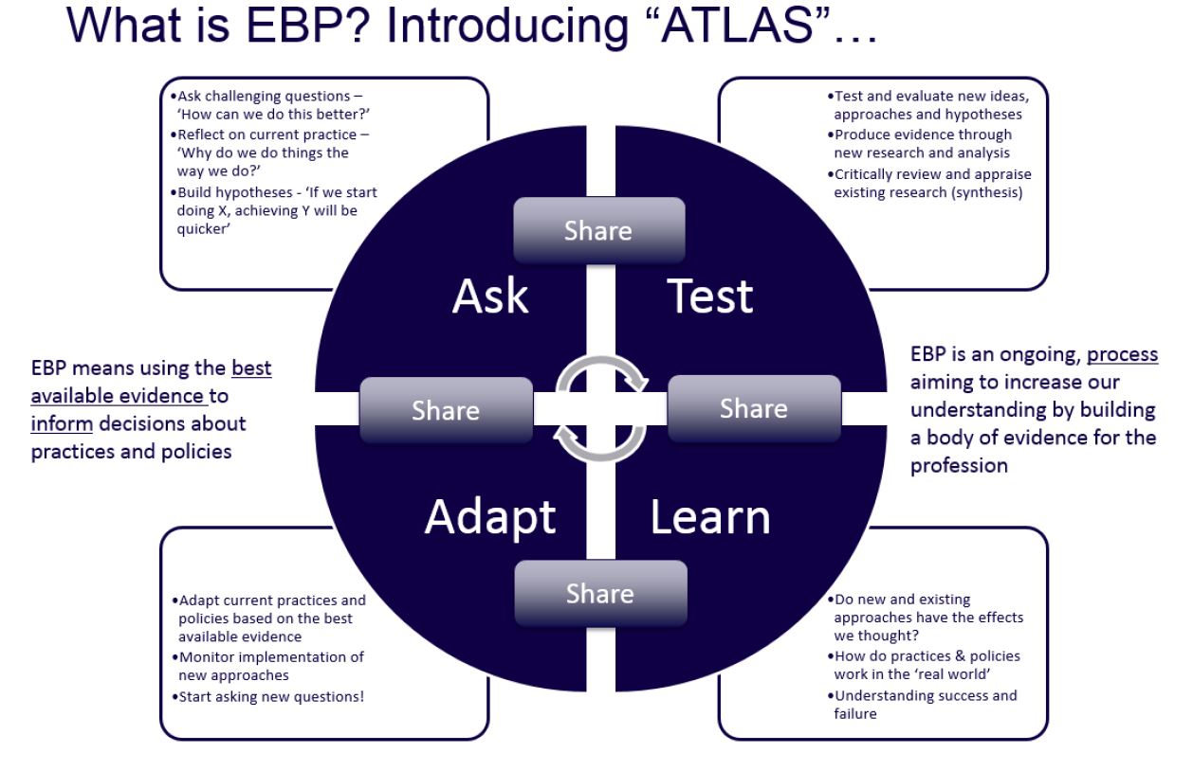
Figure 1: ATLAS policing model
(Source: Buil-Gil et al., 2020)
This model is beneficial in evidence-based policing as this provides a proper framework to the department to evaluate the whole solution and allow making positive outcomes. The very first strength of this model is that they allow the police to ask questions in a better manner (Pereira et al., 2022), like within days, a particular time, or particular locations, and there is no bound in these aspects. It is also used to analyse the collected data according to the feasibility and convenience of the police officer or practitioner. With the help of this model, it is possible to test different responses and work accordingly (Buil-Gil et al., 2020). Moreover, when one intervention is implemented police department can measure the outcomes and break down or modify the intervention according to the situation. Similarly, when the measure is done regarding outcomes, the practitioner can be able to adapt the responses and share the findings with other forces which are involved in the case analysis.

SARA model and Its Strengths and Weaknesses
SARA model is also an effective and commonly used approach in evidence-based policing. The word SARA comprises four elements; scanning, analysing, responding, and assessment. It can be said that this model becomes the main basis for different police departments, training centres and problem-solving efforts for police practitioners. The very first element of this model is Scan which is used to collect different perspectives and enough data to understand the problem from different angles (Hinkle et al., 2020). However, it is important to keep the group small in order to avoid discrimination and analysis paralysing. Moreover, it is important to consider the problem from the best angle the police suggest. Like in the department, some may agree that drug in the house is an issue or crime, but others take it as a simple thing, not a big crime, so it is important to scan the problem first before proceeding to further steps. The second element is Analyse which is beneficial as it allows everyone to take time to look at the main problem instead of the extra ones (Weisburd et al., 2019). For example, it provides a solution to the problem instead of identifying the problems, like it is common that street drinking is a crime or issue, but the main problem here which can be identified with the help of this model is that there is a large availability of beer containers, because of which this problem occurs. So this model helps police practitioners and related departments to consider the main cause of the problem and take measures accordingly. Consequently, it is important to analyse that who, why and when are involved in the problems instead of just focusing on the problem. This is the major strength of the SARA model.
In addition to this, Respond is another element of this model, which basically comprises three forms; enforcement, engineering, and education. Enforcement helps in targeting the worst offenders and arresting them, creating new ordinance new regulations, and asking justice with the help of conditions and probations. On the other hand, engineering helps in adding light to the root cause of the problem and focus on minimising these in a possible manner (Bullock et al., 2021). Lastly, education allows publishing problems to aware other communities and departments with the help of workshops, videos, preventions, and different pieces of training. This provides enhanced services and new interventions to the entire crime investigation department as well as help in developing an action plan thoroughly. Access is the last element of this model, which is used to evaluate how well the actions were taken by the department, is worked and what changes are needed. Like it is advantageous for the organisation and police department to have an idea of which actions are properly implemented and worked and what changes or modifications are needed with the passage of time (Bond-Fortier and Nader, 2022). Furthermore, police can be able to evaluate the actions every week and identify why and when the actions are completed and which are in progress and which are dropped out so that it will also help in dealing with the problems and solving the issues that occurred in different cases analysis.

Comparison of evidence-based policing models is real-life incidents.
It is true that both the models are well-effective and beneficial for the analysis of criminal cases, but according to the nature of the problem, the preferences of model implementation decide. For example, in the case of gang and graffiti was once handled by the mid-city police division. In order to analyse the case and deal with the problem, the police department uses the SARA model to be able to better understand the problem and develop a scenario. Like it is concluded that the improvement in monitoring chronic offenders provides ways to remove graffiti, and other alternative approaches also assisted in reducing the crime rate in the area. Similarly, the officers used different approaches to respond towards a strategy like; some said to use psychological counselling programs for chronic juvenile offenders (Mannocchi et al., 2020), whereas some suggested helping supervise juniors with the help of laws and offences exercises. After this, the implementation of the strategy was monitored by the department, and it has been observed that there is an 80% reduction in the graffiti crime rate in the area and chronic offenders who received counselling programs stop to paint graffiti on the walls and different areas. The overall use of the SARA model helped the judges and police department to deal with the issue and analyse the root cause of the problem, which is the main strength of this model (Bertol et al., 2018).
In contrast with this one real-life case in which three boys were involved in drug addictions activities. In order to identify the problems and deal with the case, the Police department used the ATLAS model; as discussed above, this model helped in identifying the main problem in a systematic way. The police firstly asked individual questions to every person regarding their problem and the crime they committed (Hughes et al., 2021). While questioning each individual, it becomes easy for police departments and professionals to judge the nature of each person and evaluate different approaches and responses accordingly to solve their issue, like the case solved with implementing new ideas, approaches and hypotheses based on the provided evidence. By using the ATLAS model, the police department critically reviews the cases of these individuals and conclude on one approach that they all need some practice to understand the consequences and complexities of drugs (Wolff et al., 2020). Similarly, with some sessions and counselling programs, they can be able to learn what they are doing, and the police also identify the success and failure of the approaches from time to time. Undoubtedly, this only became true with the help of the ATLAS evidence-based policing approach.

Conclusion
The overall report concluded that the development and understanding of the case is the key element in solving the issue. Evidence-based policing models are the best approaches used by police practitioners in the complex and challenging phase of time. Moreover, evidence-based policing is one beneficial idea to use available researchers and data to generate possible outcomes and implement different guidelines to deal with the main problem. ATLAS and SARA models were used in this report to understand the strengths and weaknesses of evidence-based policing models and applied them to some real-life case examples as well as compared them on the basis of their strengths and weaknesses.

References
Abrahamson, D. 2021. Evidence-Based Policing: The Impact of Organisational Context and Leadership on Programmatic Adoption. In Enhancing Police Service Delivery (pp. 405-428).
Bertol, E. Di Milia, M.G. Fioravanti, A. Mari, F. Palumbo, D. Pascali, J.P. and Vaiano, F. 2018. Proactive drugs in DFSA cases: Toxicological findings in an eight-years study. Forensic science international, 291, pp.207-215.
Bond-Fortier, B.J. and Nader, E.S. 2022. Testing the Effects of a Problem-Solving Policing Strategy on Crime Outcomes: The Promise of an Integrated Approach. Police Quarterly, p.10986111211060025.
Boulton, L. Phythian, R. Kirby, S. and Dawson, I. 2021. Taking an evidence-based approach to evidence-based policing research. Policing: A Journal of Policy and Practice, 15(2), pp.1290-1305.
Buil-Gil, D. Moretti, A. Shlomo, N. and Medina, J. 2020. Applying the spatial EBLUP to place-based policing. Simulation study and application to confidence in police work. Applied Spatial Analysis and Policy, 13(4), pp.901-924.
Bullock, K. Sidebottom, A. Armitage, R. Ashby, M.P. Clemmow, C. Kirby, S. Laycock, G. and Tilley, N. 2021. Forty years of problem-oriented policing: A review of progress in England and Wales. Policing: A Journal of Policy and Practice, 15(4), pp.2001-2014.
Hinkle, J.C. Weisburd, D. Telep, C.W. and Petersen, K. 2020. Problem‐oriented policing for reducing crime and disorder: An updated systematic review and meta‐analysis. Campbell systematic reviews, 16(2), p.e1089.
Huey, L. Kalyal, H. Peladeau, H. and Lindsay, F. 2021. ‘If You’re Gonna Make a Decision, You Should Understand the Rationale’: Are Police Leadership Programs Preparing Canadian Police Leaders for Evidence-Based Policing?. Policing: A Journal of Policy and Practice, 15(1), pp.197-207.
Hughes, L.A. Schaible, L.M. and Kephart, T. 2021. Gang graffiti, group process, and gang violence. Journal of quantitative criminology, pp.1-20.
Kassotis, C.D. Hoffman, K. Völker, J. Pu, Y. Veiga-Lopez, A. Kim, S.M. Schlezinger, J.J. Bovolin, P. Cottone, E. Saraceni, A. and Scandiffio, R. 2021. Reproducibility of adipogenic responses to metabolism disrupting chemicals in the 3T3-L1 pre-adipocyte model system: An interlaboratory study. Toxicology, 461, p.152900.
Mannocchi, G. Di Trana, A. Tini, A. Zaami, S. Gottardi, M. Pichini, S. and Busardò, F.P. 2020. Development and validation of fast UHPLC-MS/MS screening method for 87 NPS and 32 other drugs of abuse in hair and nails: application to real cases. Analytical and Bioanalytical Chemistry, 412(21), pp.5125-5145.
Pereira, A.R.P. Rosado, D.P. and Lopes, H.S.C. 2022. From the Traditional Police Model to Intelligence-Led Policing Model: Comparative Study. In Information and Knowledge in Internet of Things (pp. 457-473).
Piza, E.L. Szkola, J. and Blount-Hill, K.L. 2021. How can embedded criminologists, police pracademics, and crime analysts help increase police-led program evaluations? A survey of authors cited in the evidence-based policing matrix. Policing: A Journal of Policy and Practice, 15(2), pp.1217-1231.
Weisburd, D. Hinkle, J.C. and Telep, C. 2019. Updated protocol: The effects of problem‐oriented policing on crime and disorder: An updated systematic review. Campbell Systematic Reviews, 15(1-2).
Wolff, K.T. Baglivio, M.T. Klein, H.J. Piquero, A.R. DeLisi, M. and Howell, J.C. 2020. Adverse childhood experiences (ACEs) and gang involvement among juvenile offenders: Assessing the mediation effects of substance use and temperament deficits. Youth violence and juvenile justice, 18(1), pp.24-53.

