TASK 1

- Summary of essential skills for study and employment.
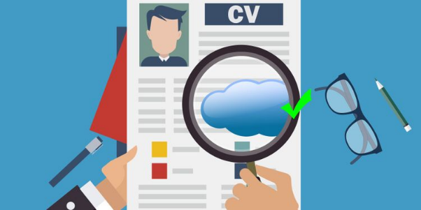

Employability, according to Lee Harvey [1] is a collection of experiences and attributes gained through higher-level learning, thus employability is a process of learning for life.

I opted to analyse Time Management and Digital Literacy as important academic and work skills.

Time Management

Good time management relates to how I organise my study time so that I can finish all my tasks on time. It also requires predicting, planning, and preparing for future events such as assignment due dates, career choices, and graduate employment opportunities [2] .

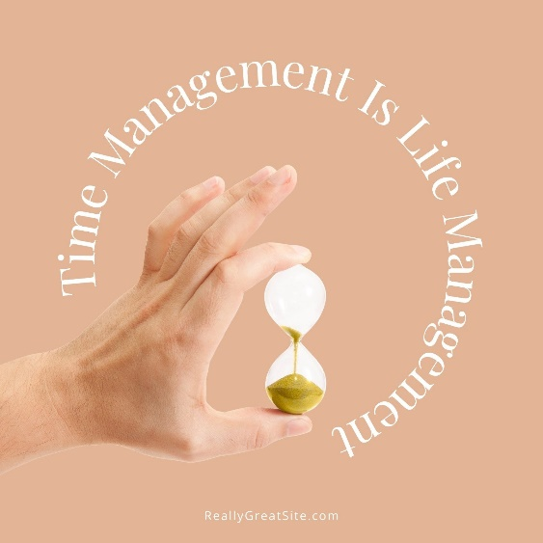

[3] Stella Cottrell recites the following ten steps to good time management: being organised; determining your time requirements; clarifying how you now utilise your time; deciding how you wish to spend your time; prioritize what is most important; plan what you will do when; follow through on your plan; use time management skills; manage distractions and procrastination; monitor and check that everything is running well.
As a student, good time management entails balancing study with a healthy lifestyle, learning at my best without undue pressure or stress, organising unscheduled study time, making time for everything I need to do, attending all scheduled classes, arriving on time, staying until the end, using class time as intended with focused attention, planning out assignments.
The employer will be interested in how I used my study time, resources, and opportunities available; these can make the difference in being considered for the job most wanted.
In summary, by effectively managing my time, I will be able to obtain considerably greater control over my personal life, performance, and achievement of my career goal.

Digital Literacy
Information literacy, according to Eisenberg [4], is a combination of skills and knowledge that lets us find, assess, and apply the information we need while filtering out the information we do not.
Reading, writing, document use, numeracy, computer use, critical thinking and problem solving, oral communication, collaborating with others, and ongoing learning are all key literacy skills.
As a student, the ability to listen, converse with lecturers and peers, and express me coherently in writing (assignments) are critical skills for expressing my point of view, learning, adapting, and using my digital skills in various contexts, as well as having the confidence to choose what is best for me.

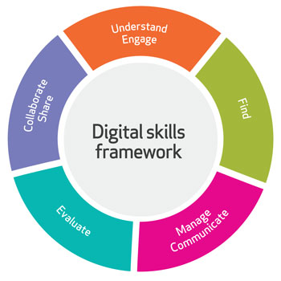
The Open University [5] has developed a digital skills framework that categorises digital skills into five groups: find information is about knowing what sources are accessible and how to access and use them; evaluate information is about knowing who and what to trust online; managing and communicating information is about working ethically and safely with digital information; understand and engage, to understand what digital information is and what you can do with it; collaborate and share, learn from others and exchange best practises.
The development of digital literacy skills, will assist me in solving problems, making decisions, thinking critically, learning new skills, communicating effectively, increasing my confidence, and planning and organising job tasks in my future career.
According to current research, companies who invest in digital literacy training see a decrease in errors, absenteeism, and workplace injuries, as well as an increase in productivity and the formation of a more flexible, adaptive workforce [6].

In conclusion, the development of such skills involves both my life and work, these skills will support me in my chosen career after I graduate, and I will also use these skills to make changes in my life.

References:
[1] Harvey L.’’On Employability’’. [Online]. Available: http://qualityresearchinternational.com/esecttools/esectpubs/harveyonemp.pdf
[Accessed Jul. 12, 2021].

[2] S. Cottrell, 50 Ways to Manage Time Effectively. Macmillan International Higher Education, 2019, Contents, xii. [E-book]. https://books.google.co.uk/books?hl=en&lr=&id=QtmUDwAAQBAJ&oi=fnd&pg=PP1&dq=Skills+for+Success+:+Personal+Development+and+Employability+Stella+Cottrell&ots=UsLkYnyHT8&sig=bbCpy9u6J9CkNllJx_jmod8VqR8#v=onepage&q&f=false [Accessed Jul. 05, 2021].

[3] Cottrell, Stella. The Study Skills Handbook, Macmillan Education UK, 2019, pg.127, [E-book], http://ebookcentral.proquest.com/lib/trinity/detail.action?docID=6234945, [Accessed Jul. 05, 2021].

[4] Eisenberg, M. B. (2008). Information literacy: Essential skills for the information age. Journal of Library and Information Technology, 28(2), 39-47.
[5] https://www.open.edu/openlearn/ocw/mod/oucontent/view.php?id=105154&section=3 [Online], [Accessed Jul. 05, 2021].

[6] Alberta and Career and Workplace Resources, Assessing you: the first step in career planning: what am I good at, what do I want to do, where do I start. Edmonton, Alta.: Alberta Employment and Immigration, Career and Workplace Resources, 2008.

