

BA Education Studies

Level 4: Learning Theory and Practice

ECES4010

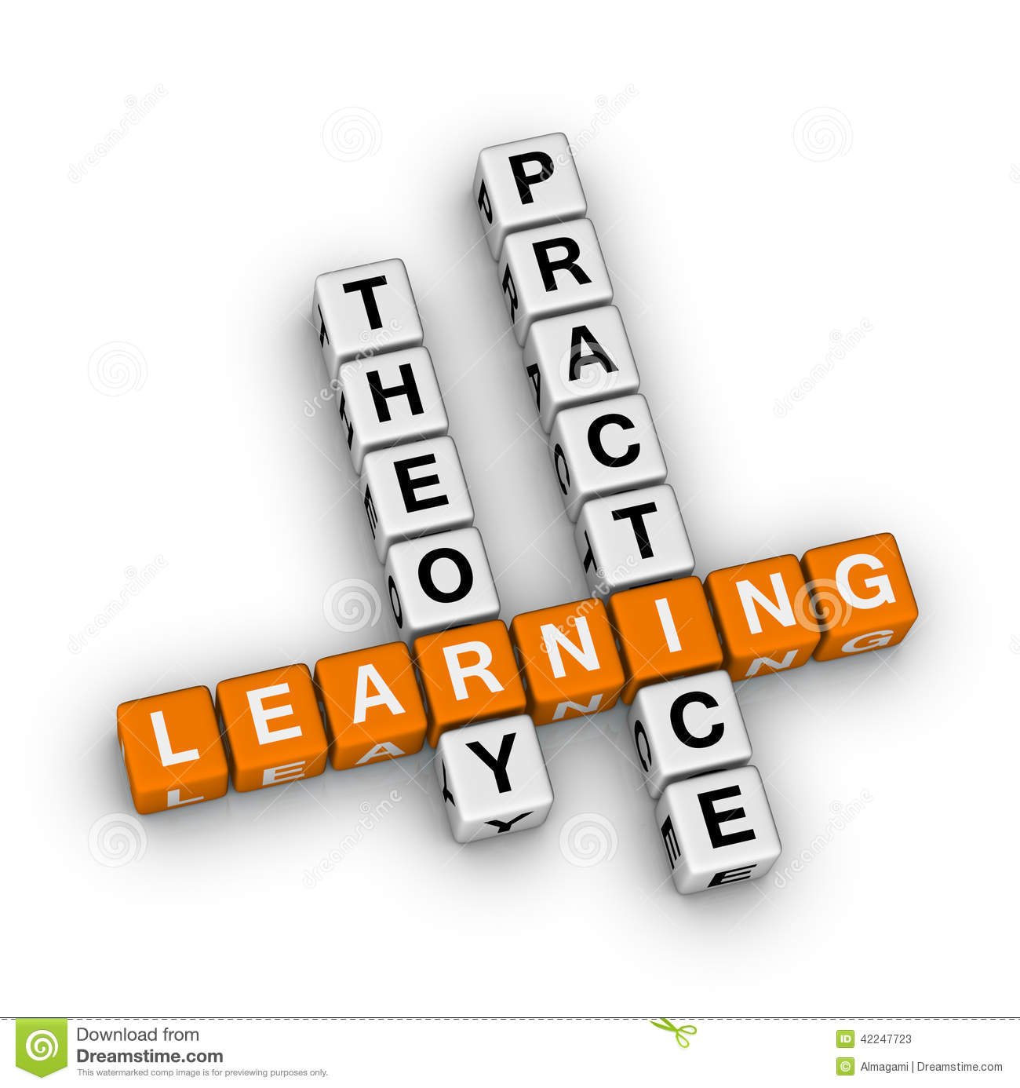

Module Co-ordinator: Helen Griffiths

Lecturer (Swansea): Laura Hutchings

Lecturer (Carmarthen): Helen Griffiths

How to contact:

Email: laurahutchings@uwtsd.ac.uk

Email: helen.a.griffiths@uwtsd.ac.uk

Module Aims:

The aims of the module are:

- To explore key theories which underpin effective learning.

- To introduce students to a range of learning contexts that facilitate and support learning.

Learning Outcomes:

Upon the successful completion of this module, the student should be able to:

- Demonstrate an understanding of effective teaching and learning.

- Demonstrate knowledge of a range of learning theories and understand how these schools of thought influence current models of effective educational practice.

- Evaluate different learning contexts.

- Understand how different contexts promote learning.

Teaching and Learning Strategy

The module aims to maintain a balance between the theory and practice of education through a range of strategies. Discussion, lecture, group work and self-directed study are used to meet this need. Tutorials also give the students the opportunity to discuss relevant issues and to gain individual, formative feedback regarding their work and assignment.

The sessions for this module will consist of face to face lectures, synchronous learning and asynchronous activities. The lectures will give students the opportunity to develop the skills of careful listening, reflecting, summarising and analysing. They will cover the major theories, debates and areas of research critical to the module.

The tasks and reading provided need to be completed in order to support your knowledge and understanding of the topics covered in this module. It is vitally important that students study the reading and complete these tasks as they will be used in the seminar. The strategies in this module have been selected on the basis that they will not only help you to learn but provide models for different approaches to learning.

Teaching and Learning Tools

Moodle

This is our central repository for all module materials you will need for this module. Please ensure that you check this regularly.
Microsoft Teams

This is the platform we will use to support your online learning with us. All students have access to Teams as part of their Office 365 student subscription and module tutors will allocate you into a team ahead of you beginning your studies with us on the module. We will use this primarily for any synchronous online teaching sessions as well as for any online tutorials or additional apps we would like you to have access to. We may also use the chat function of Teams to communicate with you and we also encourage you to use this as a way of peer support also.

MODULE SCHEDULE

BLOCK 3

Wythnos/  Week | Sesiwn /  Session | Topic
1 | 1 | Introduction and overview
 | 2 | Piaget
 | 3 | Vygotsky
 | 4 | Asynchronous task – see Moodle
2 | 5 | Froebel, Dewey and Montessori
 | 6 | Skinner, Bruner and Bloom
 | 7 | Learning Contexts: Educational Theory in Practice in the Foundation Phase
 | 8 | Asynchronous task – see Moodle
3 | 9 | Virtual Workshop: Museum Wales (KS2)
 | 10 | Planning workshop and group tutorials
 | 11 | Virtual Workshop: Museum Wales (FPh)
 | 12 | Asynchronous task - see Moodle

Please note: All materials for the sessions will be available via Moodle (Please familiarise yourself with these before and after each session), online teaching sessions will take place via TEAMS

MODULE ASSESSMENT:

Assessment Component 1 – 100%

Course Work: Group presentation (10 minutes each +/- 10%)

Demonstrate how learning theories can support effective teaching and learning.

Reading:

It is important to remember that you are reading for a degree in education. The more you read, the more the concepts and ideas will make sense to you. Teaching sessions are not exhaustive; they are designed to provide you with an insight into a particular aspect of the topic and will not give you all the answers. It is up to you as a student to maximise your learning experience by reading around the subject in addition to regular attendance in class.
In addition to this, you may be asked to come to sessions having read particular material or having undertaken certain tasks. When this occurs, it is essential that this is done.

INDICATIVE READING LIST

Module Code | ECES4010
Module Title | Learning Theory and Practice
Classification | Reading List entry | Electronic*
Essential | Arthur, J. & Peterson, A. (eds) (2012) The Routledge Companion to Education. Abingdon: Routledge. | ☒
Essential | Barnes, J. (2015) Cross-Curricular Learning 3-14. 3rd edn. London: Sage Publications. | X☐
Essential | Gray C. & Macblain S. (2015) Learning Theories in Childhood. 2nd edn, London: Sage. | ☒
Essential | Pritchard, A. (2014) (3rd edn) Ways of Learning Abingdon: David Fulton. | ☒
Further | Bayley, R., Broadbent, L. and Featherstone, S. (2011) Outdoor Play, England: Featherstone Publishers. | ☒
Further | DCELLS (2008) Framework for Children’s Learning 3-7 year olds in Wales, Cardiff: WAG also available online at http://learning.gov.wales/resources/collections/foundation-phase?lang=en | ☒
Further | DCELLS (2009) Foundation Phase Outdoor Learning Handbook, Cardiff: WAG also available online at http://learning.gov.wales/resources/collections/foundation-phase?lang=en | ☒
Further | Doherty, J. and Hughes, M. (2013) Child Development: Theory and Practice 0 – 11, 2nd edition London: Longman. | ☒
Further | Halfpenny AM & Pettersen J (2014) Introducing Piaget. Abingdon: Routledge. | ☒
Further | Isaacs, B. (2012) Understanding the Montessori Approach. Abingdon: Routledge. | ☒
Further | Macblain S. (2014) How Children Learn. London: Sage. | ☒
Further | Miller, L. & Pound, L. (2011) Theories and Approaches to Learning in the Early Years. London: Sage. | ☒
Further | Smidt S. (2011) Introducing Bruner. Abingdon: Routledge. | ☐
Further | Smidt S. (2009) Introducing Vygotsky. Abingdon: Routledge. | ☐
Further | Wales: Welsh Government (2015) Successful Futures- The Donaldson Review. HMSO: Cardiff. Available at https://hwbplus.wales.gov.uk/schools/6714052/Documents/Donaldson%20Report.pd | ☒
Further | Wood, E. (eds) (2008) The Routledge Reader in Early Childhood Education. Abingdon: Routledge. | ☐
Further | Wood, K. (2011) Education: The Basics. Abingdon Routledge. | ☐

Additional Material
Students will be directed towards current publications as they become available and towards appropriate electronic resources.

