Assignment Title: User Requirement and Prototype
Programme: …………… BSc Applied Computing
Module:…………………. Usability Engineering
Module Code: ……………………. ACCB6017
Lecturer: …………………………. Fahad Ahmed
Submitted By: Md Gulam Hafiz
Student ID:2232603


LONDON
University of Wales Trinity Saint David London

UWTSD CAMPUS CRISIS
Initial users research,
Usability & Low fidelity wireframe Storyboard report:
Pandemic inspired UWTSD cooperative strategic Mobile Game.
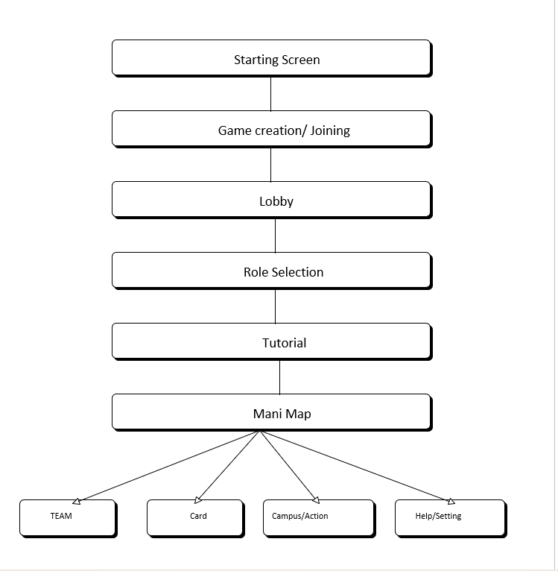
Fig 1: FIG High Profile Architecture of the Proposed Game.

Statement of Academic honesty and Integrity:
In this report for UWTSD primary research based cooperative strategic game design has been presented.
The personas are designed artifacts based on evidence, relevant users’ groups and human- computer interaction literature but quotation of the participants, questionaries, total and pair evaluation power should be collected from the real participants. Therefore, in section 7 and 8 a clear format for evaluation process, for example structure for result record has been given which needs to be updated after completing the research. Presenting invented feedback of the participants as a real research result is inappropriate academically.
Table of Contents:
Statement of Academic honesty and Integrity: 3
1.Introduction & Game Idea: 6
2. Gathering information to create personas: 7
2.1Proposed Research Questionaries: 8
3.Four experimental personas, scenario & experience requirements: 8
3.1 Farah Ahmed — Mature International Computer Student 8
Design implications (provisional): 9
3.2 David Morgan — Experienced Young Strategy Gamer 9
3.3 MS Rehman Siddique— Part-time Lecturer and Occasional Gamer 11
3.4 M Islam — Postgraduate Student Using Alternative Input 12
Persona validation and traceability: 13
4. Consolidated users and experience requirements: 13
General Functional Requirements are………... 13
Main Experience requirements…………. 14
5. Usability and accessibility Design: 15
5.1 Keeping System status visible: 15
5.2 Recognition rather than recall 15
5.3 Error prevention and recovery 15
5.4 Mobile accessibility 15
5.5 Emotional Experience: 15
Designing Low-fidelity storyboard: 18
7. Prototype and process of feedback collection: 19
8. Feedback analysis & development plan. 20
8.1 Probable positive result: 20
8.2 Probable Negative result: 20
8.3 Proposed correction: 20
8.4 Judging Peer feedback: 20
9. Conclusion: 21
References 22
Appendixes: 23
Appendix 1: MoSCoW 24
Appendix 2. Full Low-Fidelity Wireframe Storyboard(A). 25
Appendix 3: Full Low-Fidelity Wireframe Storyboard (B) 29
Appendix 4: Full Low-Fidelity Wireframe Storyboard(C) 30
Appendix 5: Full Low-Fidelity Wireframe Storyboard (D) 31
Appendix 6: Full Low-Fidelity Wireframe Storyboard (E). 32
Appendix 7: Full Low-Fidelity Wireframe Storyboard (F) 33
Appendix 8: Survey questionaries and users’ responding record. 34

1.Introduction & Game Idea:
Pandemic is a cooperative strategic Board Game, in which leading expert players using limited resources travel different places, contain escalating outbreak and work collectively to find out the solutions before the time finishes [1]. The value of the origin game of this project is not its visual identity which will not be copied but the underline pattern that means interpersonal dependency, specialized role, uncertainty, limited action and combined win or loss interaction will be used [15].
The proposed name of the computer game is “UWTSD Campus Crisis”. This is a mobile-first cooperative strategy game, where maximum number of players will be six and they will perform different roles in different departments. In the map of this game there will be Swansea, Carmarthen, Cardiff, London and Birmingham campus beside that campus there will be an imaginary Learning Hub [2]. The role of the players will be;
1.Student Representative,
2.lecturer,
3.It Services specialist,
4.Wellbeing Adviser,
5.Facilities Officer and
6.Library & Learning Resources Officer.
Instead, four types of university diseases will be used: Cyber failure, resource shortage, wellbeing pressure and transport disruption. The players will move in the campus, remove the disruption maker, distribute support cards and will create four resilience plans before the crisis reaches its peak. As a result the UWTSD crisis Game will be independent and relevant though it uses the theme of the Pandemic Game [1],[15].
The main objective of this game design is to make it faster understandable, clear feedback, stay cool & take decision in the intense pressure and keep doing the teamwork. This game will be not only for under aged or Expert gamers; this needs to be effective for all the people including mature learner, commuter, international student, staff members, casual gamer and assistive technology users. According to
ISO 9241-210 in a human-centered design, users, work, user environment and analysing repetition should be considered in full life cycle of the design [3],[4].

2. Gathering information to create personas:
The persona designer is not an imaginary person; it is way of presenting briefly in the context of various behavior and limitations [5],[16].
So that before finalising the four personas real information needs to be collected from real users. For this task using online questionnaires and semi-structured interviews is appropriate. In the questionary; age range, relation with UWTSD, campus or study model, mobile and board-game experience, gaming frequency. Preferred device, accessibility requirements, preferred session length, opinion regarding cooperative gameplay and problems of learning new application related question can be asked [6]. Unnecessary sensitive information should not be gathered and there should be an option for skipping the question for the participant.
Nearly 10-15 questionary respondents and 5-6 interview participants can be realist sample tasks for this project.

Using purposive sampling should include residential students, commuters, mature students, international learners, staff members, experienced gamers, non-gamer and accessibility features. The persona diversity will be weaker if same age and friends of the same course are used. Questionary data can be saved by numbers, percentage, and by general chart. The questionary can be divided by using Interview note thematic coding, learnability, collaboration, pace, accessibility, emotional pressure, confidence & trust [6]. Contradictory opinion should be kept also because the experienced gamer may ask for informative interface quickly on the other hand novice user may ask for an explanation step by step.

2.1Proposed Research Questionaries:

Topic | Question | Uses in Design
Game experience | How frequently do you play mobile or board game? | tutorial & information density
Seeking helps | How do you prefer to communicate to receive the team decisions? | quick message and proposal tool
Accessibility | What problem creates small target, drag, timer or animation? | alternative input and adjustable settings
Emotion | What makes the game exciting but pressure free? | feedback tone ও event presentation

3.Four experimental personas, scenario & experience requirements:

3.1 Farah Ahmed — Mature International Computer Student
Persona type: Provisional behavioral cluster; research validation required
Indicative context: London Campus computing student; part-time employment and caring responsibilities.
Tech comfort: Medium
Game experience: Low
Primary device/context: Android smartphone; short sessions while commuting or between study and family duties and she says,
“I like to work in a team and simple instruction.”
Primary Goal:
Complete a valid turn of the game only understanding own role not reading the long and boring rule book
Secondary Goal:
After family or work interruption-easily re-join in the game without losing game state
Context and scenario:
Farah takes the role of a Wellbeing Advisor consisting of 4 people group by the invitation of her classmate. English may be her additional language, and available play time is limited. After coming from an important phone call, she needs to understand quickly shared objectives, current crisis and remaining actions.
Pain points and behaviors to validate through research:
- Does long onboarding, unfamiliar terminology and dense text make her delay starting her turn.
- Instead of reading instructions completely does she follows example, icon label or step-by-step prompt
- Does she depend on the help of the other players, if there is no recap after the Interruption.
Design implications (provisional): Two-minute progressive tutorial, plain language, persistent shared objective, session-duration estimate, safe reconnection and before using rare card needs clear confirmation.
User story: “As Farah I would like to understand quickly my role and available actions so that I can contribute to my team without embarrassment with experienced players”

3.2 David Morgan — Experienced Young Strategy Gamer
Persona type: Provisional behavioral cluster; research validation required
Indicative context: Young learner living near Swansea Campus.
Tech comfort: High
Game experience: High; regular mobile and tabletop strategy player.
Primary device/context: Smartphone or laptop; planned multiplayer sessions with classmates. His expectation of game is as he says,
“I would improve the graphics, make the control more responsive”
Primary Goal:
Using detailed game information plan team strategy before couple of turns.
Secondary Goal:
Adding new role combinations in repeated play and getting meaningful challenge from higher difficulty.
Context and scenario:
Creating an advanced game of 6 people David advanced game selects Digital Services Specialist role during the Cyber disruption he is comparing campus routes, action consequences and available resources by proposal tool sends plan to his team.
Pain points and behaviors to validate through research:
Does un-skippable tutorial, slow animation and hidden numerical effects disturb him or not.
Dose he compares the decisions by opening statistics, forecast and action history.
Does he try to control the turn of other players due to his high experience.
Design implications (provisional): Skippable onboarding, fast navigation, advanced optional statistics, action preview, adjustable difficulty and post-game team summary should be kept. Proposal feature will give advice but will not select the action of other players.
User story: “David, I would like the game to include different emergency scenarios, clear objection and hints for new player.”

3.3 MS Rehman Siddique— Part-time Lecturer and Occasional Gamer
Persona type: Provisional behavioral cluster; research validation required.
Indicative context: Part-time lecturer at Carmarthen Campus
Tech comfort: Medium with familiar applications
Game experience: Low; limited familiarity with gaming conventions.
Primary device/context: Smartphone or university laptop during an induction or staff–student activity. She says,
“I would like simple controls and instruction”
Primary Goal:
Only understanding the role; taking confident decisions without knowing Gaming jargon.
Secondary Goal
Observing the changes in interface and following the system feedback do meaningful contribute to socially.
Context and scenario: In an induction session Ellin took the role of a lecturer. She witnessed a suggested action and asked for help to know why a campus is flashing. Without blaming her for making mistakes will make her understand the current state and available recovery option.
Pain points and behaviors to validate through research:
- Does Small text, unlabeled icons and unexpected screen changes reduce her confidence!
- Does she want other players confirmation before doing any action or read all instructions.
- Does she miss any important information due to time pressure or color only warning!
Design implications (provisional): need Scalable text, large targets, labelled icons, consistent navigation, visible contextual help &non-judgmental error messages. Essential information will be on the main screen; additional details will be open on demand.
User story: “As Elin I want plain-language explanation and predictable controls so that I can finish my turn though gaming experience is less.”

3.4 M Islam — Postgraduate Student Using Alternative Input
Persona type: Provisional accessibility-focused behavioral cluster; research validation required
Indicative context: Postgraduate student joining remotely
Access context: Limited fine-motor control; may use Android accessibility settings, voice control or switch access
Game experience: To be established through research
Primary device/context: Android device with personalized accessibility settings.
He says, “I would like good navigation, visible icons and Text”
Initial Goal:
Complete all the core game action independently without depending on Drag gesture or small hotspot.
SECONDARY GOAL
control of team communication and timing settings should be done without the help of others.
Context and scenario: M Islam as a Student Representative join the game remotely. Without dragging map, he uses campus list, opens action menu by logical focus order, gives confirmation, sends predefined messages and changes timer and animation according to his own needs.
Pain points and behaviors to validate through research:
Does it influence small or closely spaced targets, drag-only interaction & strict timer task completion!
Screen-reader labels, switch focus order & voice commands are all consistent in action. Does he get same information as visual map if he uses alternative map list.
Design implications (provisional): All drags’ tap alternative, logical focus order, screen-reader labels, adjustable timing, large, separated targets, reduced motion and color-independent crisis indicators will be used as mandatory design constraints [1,1], [12]
User story: “As Islam I want to use alternative input to control actions so that without the help of other players I can complete my game.”

Persona validation and traceability:
Finalisation rule: After completion of the research, it needs to be validated with age/context, descriptive detail and participant cluster. Every final persona should have at least one anonymised direct quotation, primary and evidence of secondary goal, observed behavior, pain point and reliable, related traceability note of design implication. Un- validated details need to be deleted or be kept as hypothesis.

4. Consolidated users and experience requirements:

General Functional Requirements are………...
- Game creation or Join
- Specialist role selection
- Checked shared objective
- Use list or campus map
- Complete valid action
- exchange cards
- teammate communication
- watch team status
- understand pause/reconnect and victory/defeat.

Main Experience requirements………….
- Clarity
- Inclusion
- Competence
- Teamwork
- Manageable tension and
- Trust
David wants faster and dense on the other hand Farah and Islam want instruction. This conflict will be resolved by progressive disclosure. In the main there will be essential information but detail, forecast and explanation can be opened when required [7], [8].
Timer will be optional; tutorial can be skipped and there will be alternative button for gestures, so that no need to make separate games for the new and expert gamer rather than the interface can be made simple. In the appendix requirement priority will be given by MoSCoW method.

5. Usability and accessibility Design:

5.1 Keeping System status visible:
In the header active player, remaining actions, connection status, crisis track and complete plan will be seen permanently. Map will be updated after each action, and the result will be shown in a short sentence. It supports visibility of system status, feedback and consistency [8], [10], [17].

5.2 Recognition rather than recall
Need to reduce dependency on remembering of role power, card rules and symbol. unavailable action will be disabled but reason will be given for unavailability. campus name map will be written in same way in card and notification. [17].

5.3 Error prevention and recovery
There will be a confirmation option before using rare card, finishing the turn early or leaving the active game. Undo will be possible until hidden random event becomes visible. message will be in positive way like” these 2 cars may be needed for planning-do you want to play this now?” there will be no blaming word like “Bad move” [9].

5.4 Mobile accessibility
Primary target will be bigger and separated. Name, symbol and pattern will be used with color. Control will not be hidden if text is resized. Screen reader, voice access, switch input, reduced motion, caption and link on the map list will be alternative. in WCAG 2.2 perceivable, operable, understandable and robust policies need to be followed [11], [12].

5.5 Emotional Experience:
In the game there will be high tension but no visual chaos or public blame. Collective message such as “Team resilience plan completed” will be used proposal tool will give suggestion but not take control the turn of others. So that relatedness will improve and individual competence remains as it is [14], [15]

5.6 Explanation of Main mobile screen De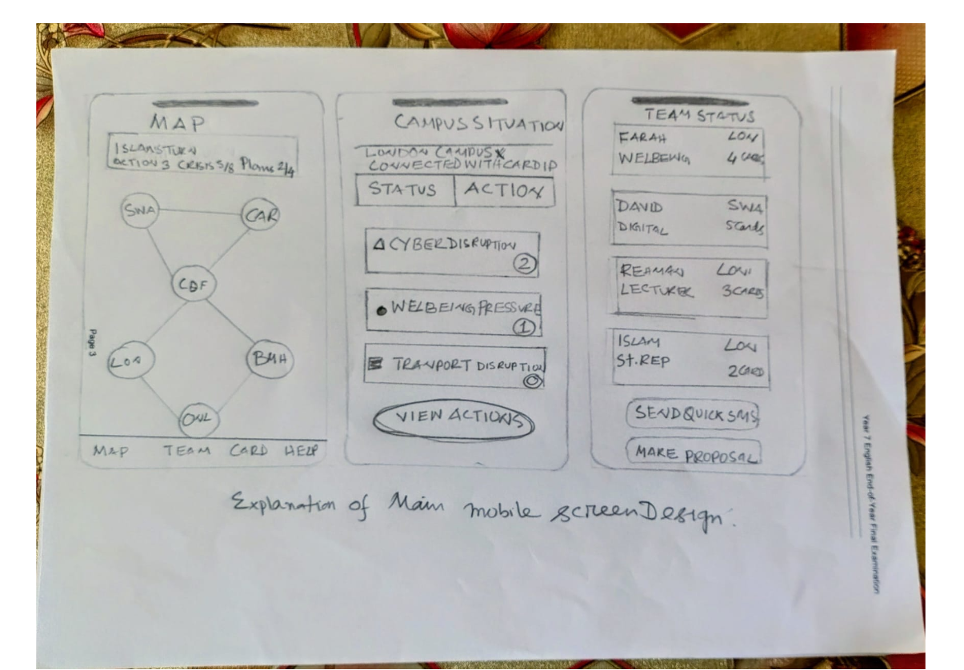
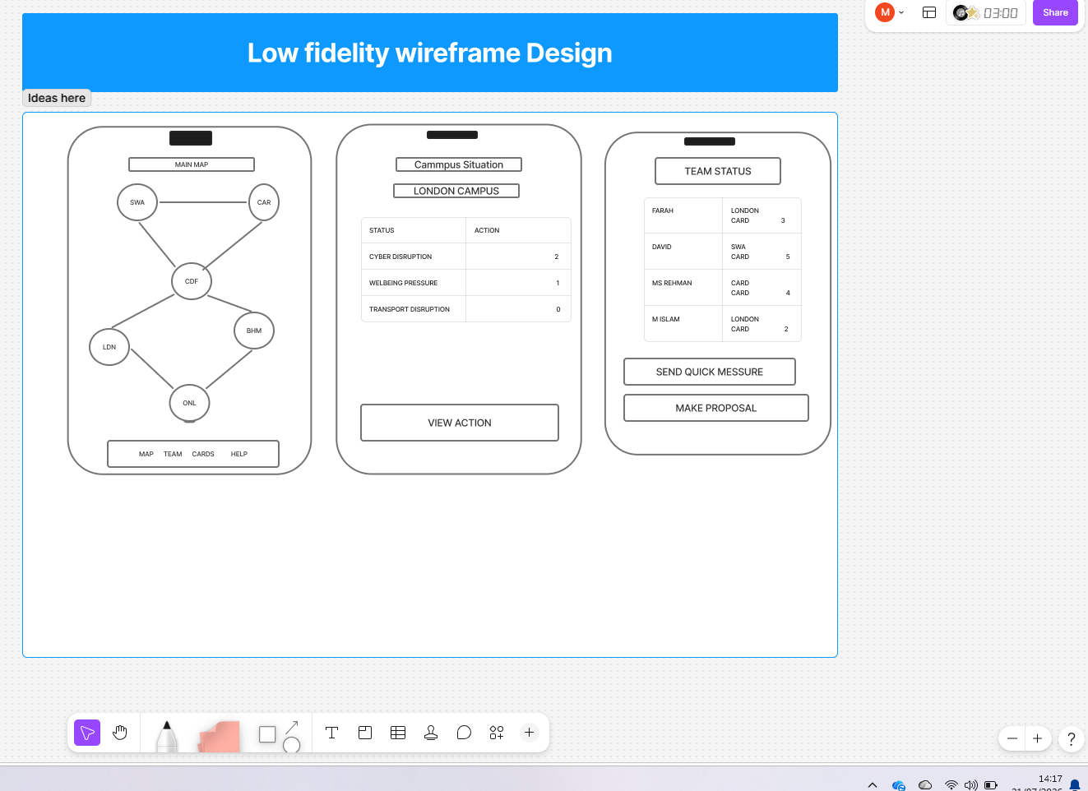
In the main map shared state, campus risk and navigation button have been displayed together. Location sheet reduces the cognitive load by dividing the information between Status and action. Team panel helps by showing every role, location, card count and quick communication.6,

Designing Low-fidelity storyboard:
In low-fidelity wireframe intentionally color, brand illustration and final typography have been removed, so that evaluator can give attention on layout, information hierarchy, navigation task flow. Paper prototyping and low-fidelity prototype can help with important usability problems before implementation [7].
Storyboard A shows entry flow: Launch → Accessibility → Create/Join → Code Entry → Lobby → Role Selection, Storyboard B shows role preview, in three stages tutorial and reaching in main map, gives guidance to new gamer but experience gamer can skip the tutorial.
Storyboard C displays a full turn: campus select → status inspect → action choose → confirmation → map update → event card → turn summary. Before and after every turn system status has been kept visible.
Storyboard D shows collaboration: team status → quick message → proposal → resource share. Story board E includes map list alternative, contextual help, pause & reconnect. Storyboard F shows collective victory, explanatory defeat & non-competitive contribution summary. Complete storyboards are in Appendix B.

7. Prototype and process of feedback collection:

Wireframes should be tested by 6 to 8 participants so that 4 catachrestic can be identified. Every participant will be given same introduction and will do 5 tasks joining in existing game, identifying shared objective role selection & interpretation, disruption resolve and sending team proposal.
Moderator will tell the participants to think aloud & will record the task completion, error, help request & emotional reaction. Think-aloud method helps to differentiate between users’ mental model and expected design [6[,[13].
After finishing the task, it can be measured by scale of 5 points based on ease of use, confidence, visual pressure and enjoyment. System Usability scale can be used if interactive prototype is enough but in small sample scores need to be explain carefully [18],[19].
Peer evaluation should be done separately. 4 Partners can inspect prototypes by Nielsen heuristic, mobile accessibility, storyboard completeness and according with persona alignment [17],[20]. Severity 0-4 will be used where 4 means problems that create obstacles to complete the task. In the appendixes the completed form has been given.

8. Feedback analysis & development plan.

8.1 Probable positive result:
Participant may like specialist role, persistent objective, labelled action & quick-message control. Experienced user action preview & new novice user optional suggestion may be evaluated positively. If such evidence is available then role ability, shared progress, action preview & predefined communication will be kept.

8.2 Probable Negative result:
Unclear crowded map, unfamiliar symbol, active turn, not finding collaboration control, in location Sheet more text & in a large-text mode may create problems in cramped control. As reduced dexterity participant campus node is small, that is why it is hard to identify.

8.3 Proposed correction:
Campus target will be made bigger and will add list view. Active-player banner will stay permanently at the top. Crisis name, symbol, pattern will be expressed in color. Team bottom will be at the navigation. Location Sheet will be divided between Status & Actions tab. Every time only one event will be shown, and location map will be on.

8.4 Judging Peer feedback:
After back & Close’s consistency, arrow’s completeness, disabled buttons’ explanation, reconnect flow and large-text representation related suggestion will be accepted. As propose of individual leaderboard is against the cooperative experience that will be converted into team contribution summary.
 | Severity | Design change | Justification
Hard to select Campus node. | 3 | Target Big and list view | Motor accessibility
Un clear Active player | 3 | Persistent turn banner | System visibility
Crisis only color based. | 4 | Name, symbol and pattern | WCAG-aligned perception
Hard to find Team panel | 2 | Team is on Bottom navigation. | Collaboration
Leaderboard proposal | 1 | Team contribution summary | Keeping the Cooperative goal.

9. Conclusion:
UWTSD Campus Crisis converts the Pandemic cooperative structure for up to six mobile players’ university -resilience individual game. Its initial interface design is done by diverse persona, progressive disclosure, accessible mobile interaction, visible team status and based on iterative low-fidelity evaluation.
Most important principle is not to consider any persona specially. novice support, scalable information, alternative input and clear feedback improve whole group experience. In the future high-fidelity interactive prototype will be created by revising wireframe with real feedback visual identity, colour system and typography.

References

[1] M. W. Jaspers, "A comparison of usability methods for testing interactive health technologies: methodological aspects and empirical evidence," Int.J.Med.Inf., vol. 78, no. 5, pp.340–353, 2009,
[2] A. Bangor, P. T. Kortum and J. T. Miller, "An empirical evaluation of the system usability scale," vol. 24, no. 6, pp.574–594, 2008,
[3] J. Brooke, "SUS-A quick and dirty usability scale," vol. 189, no. 194, pp.4–7, 1996,
[4] J. Nielsen, "Usability heuristics for user interface design," 10,
[5] J. Pruitt and J. Grudin, "Personas: practice and theory", in Proceedings of the 2003 conference on Designing for user experiences, pp. 1–15.
[6] E. C. Anania, J. R. Keebler, K. M. Anglin and J. P. Kring, "Using the cooperative board game pandemic to study teamwork", in Proceedings of the Human Factors and Ergonomics Society Annual Meeting, pp. 1770–1774.
[7] M. Hassenzahl, S. Diefenbach and A. Göritz, "Needs, affect, and interactive products–Facets of user experience," Interact Comput, vol. 22, no. 5, pp.353–362, 2010,
[8] M. W. Jaspers, T. Steen, C. Van Den Bos and M. Geenen, "The think aloud method: a guide to user interface design," Int.J.Med.Inf., vol. 73, no. 11-12, pp.781–795, 2004,
[9] S. Vítor Philip, "O Explorador: desenvolvimento de um jogo mobile audio-first em Unity para pessoas cegas ou com baixa visão," 2026,
[10] P. Acosta-Vargas, B. Salvador-Acosta, S. Novillo-Villegas, D. Sarantis and L. Salvador-Ullauri, "Generative artificial intelligence and web accessibility: Towards an inclusive and sustainable future," vol. 8, no. 4, pp.1602–1621, 2024,
[11] A. Norman Donald, The design of everyday things, MIT Press, 2013.
[12] J. Nielsen, Usability engineering, Morgan Kaufmann, 1994.
[13] C. Snyder, Paper prototyping: The fast and easy way to design and refine user interfaces, Morgan Kaufmann, 2003.
[14] J. Lazar, J. H. Feng and H. Hochheiser,Research methods in human-computer interaction, Morgan Kaufmann, 2017.
[15] J. Pruitt and T. Adlin,The persona lifecycle: keeping people in mind throughout product design, Elsevier, 2010.
[16] M. A. Chavarria et al., , "Challenges and opportunities of the human-centered design approach: case study development of an assistive device for the navigation of persons with visual impairment," vol. 12, pp.e70694, 2025,
[17] Y. Rogers, H. Sharp and J. Preece, "Interaction Design: Beyond Human-Computer Interaction, 6/E." 2023,
[18] B. Andrade and M. B. Dodig, "A Gaia‐Inspired Framework for Geogames: Bridging Theory and Practice to Design and Assess Games," vol. 11, 2026,

Appendixes:

Appendix 1: MoSCoW
Class | Need | Importance & why?
Must Have | Create/join; 2–6 players; role selection; shared objective; map and list; active turn; valid-action guidance; confirmation; communication; pause/reconnect; screen-reader label; scalable text; non-colour identification; tap alternative; adjustable timer; clear outcome | Main task completion, accessibility is very important for cooperative play.
Should Have | Skippable tutorial; optional suggestion; limited undo; difficulty; reduced motion; high contrast; captions; preview; session duration | Increase usability and learner confidence.
Could Have | Solo practice; campus information; haptic feedback; replay history; private invite; Welsh interface; team achievement | After the first release can add value.
Won't Have (first release) | AR, GPS tracking, stranger chat, real emergency data, in-app purchase, individual leaderboard | Save the Scope, privacy, safety and cooperative aim.

Appendix 2. Full Low-Fidelity Wireframe Storyboard(A).

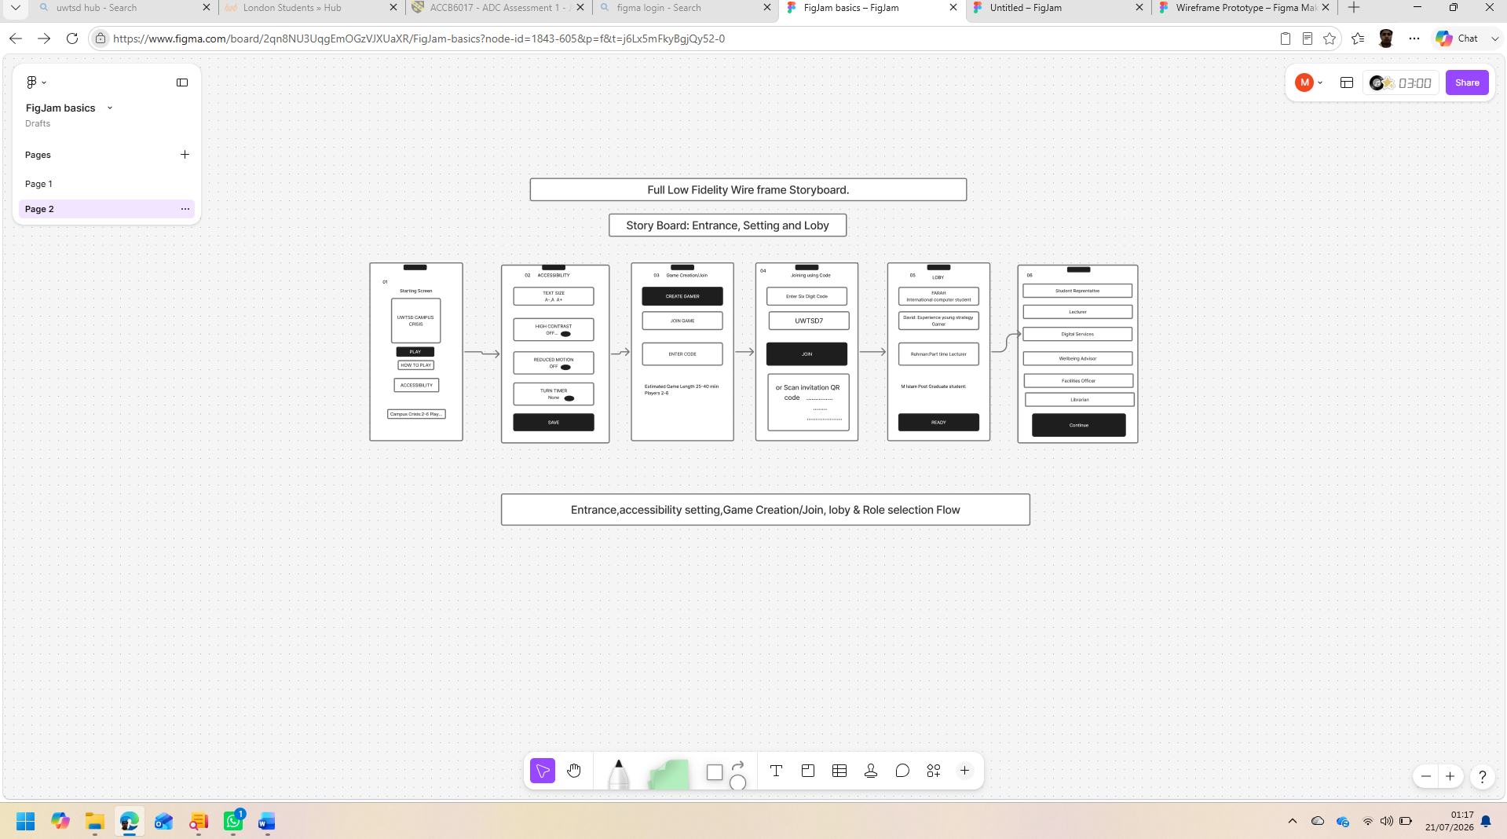

Entrance accessibility setting, game creation/join. Lobby and role selection flow (Story Board A).

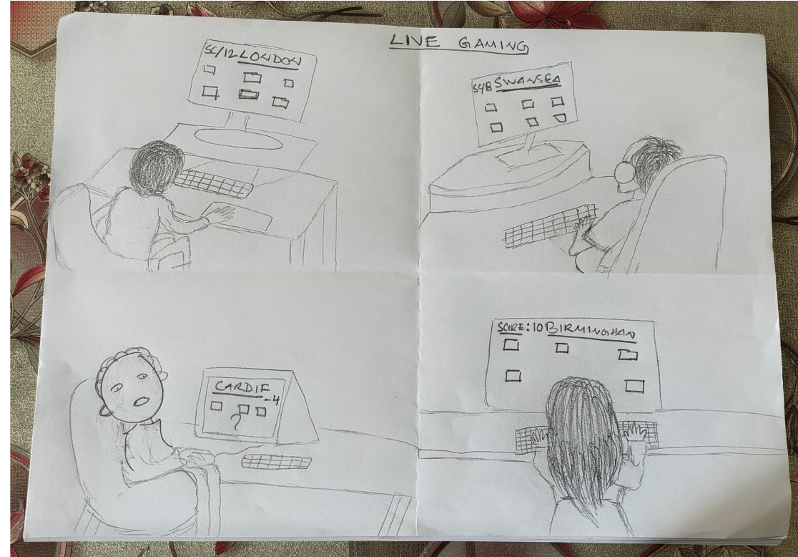
Mock Live Gaming Image.

Main Mobile Screen Design.

Appendix 3: Full Low-Fidelity Wireframe Storyboard (B)
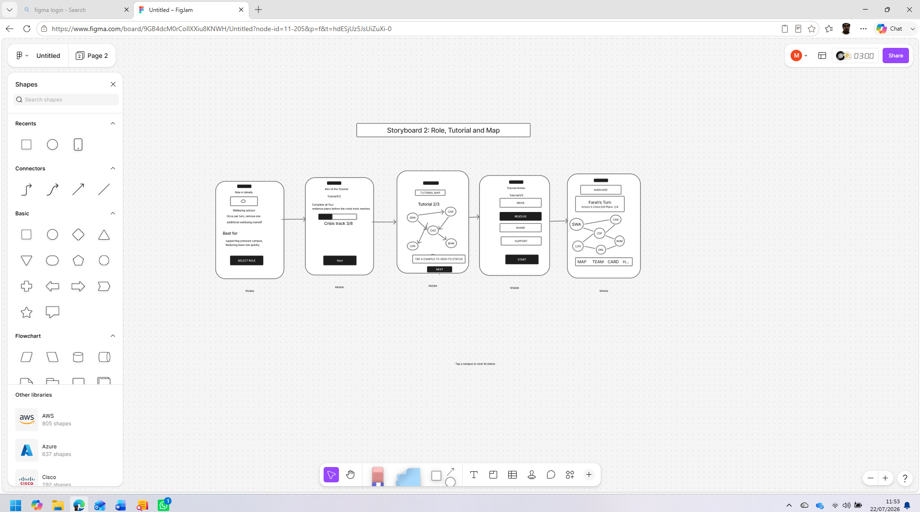
Role preview, three step tutorial and main map.

Appendix 4: Full Low-Fidelity Wireframe Storyboard(C)
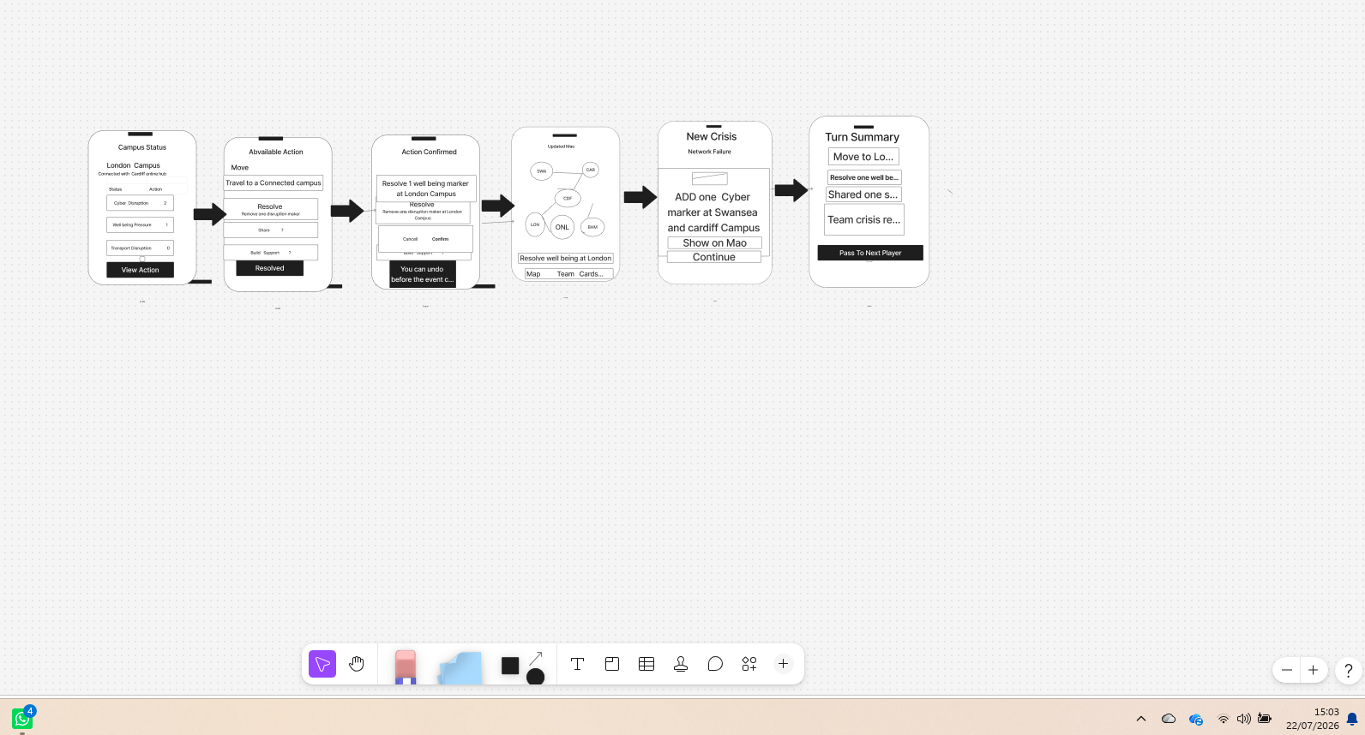
Starting from Campus status, action confirmation, event and turn summary a complete turn.

Appendix 5: Full Low-Fidelity Wireframe Storyboard (D)
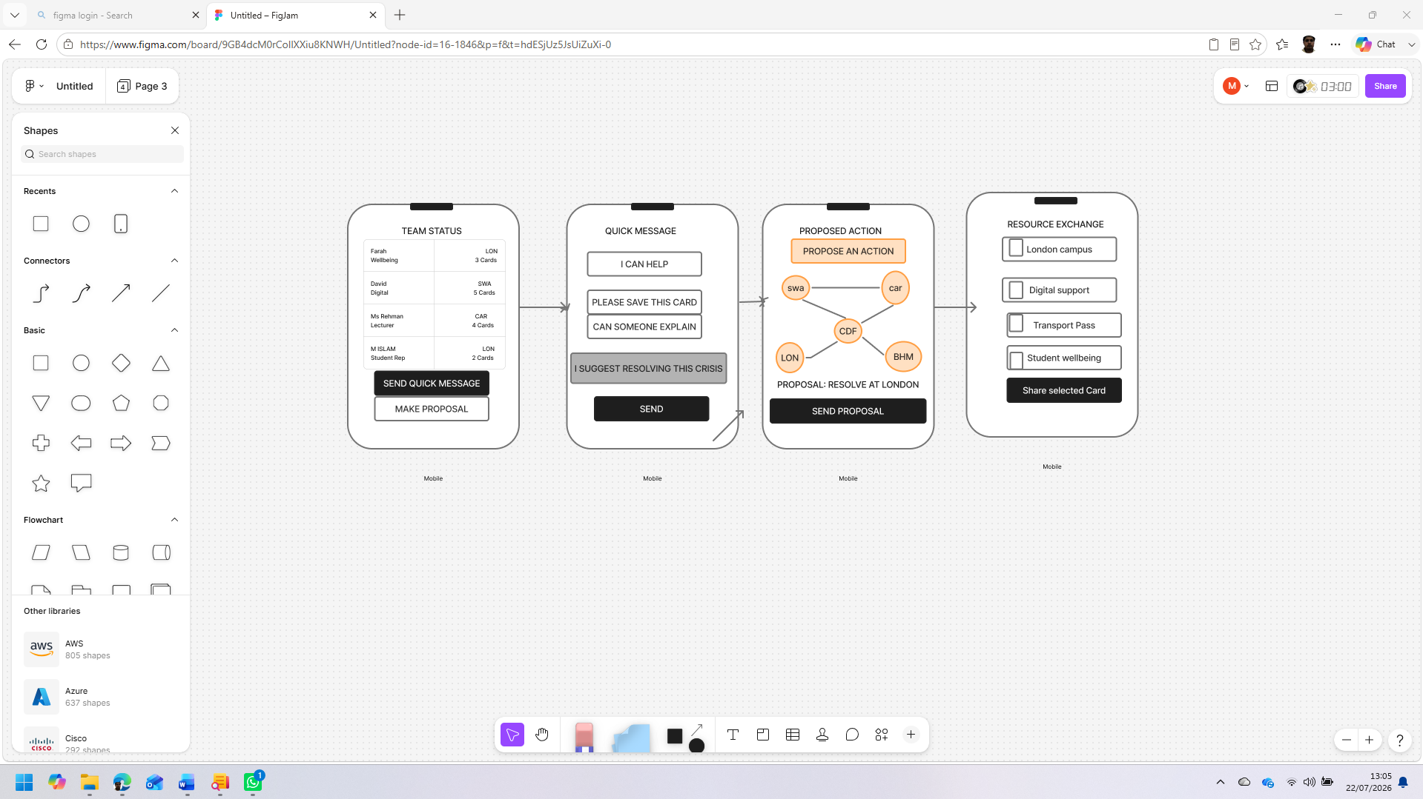
Team status, quick message, proposal and card sharing collaborative flow.

Appendix 6: Full Low-Fidelity Wireframe Storyboard (E).
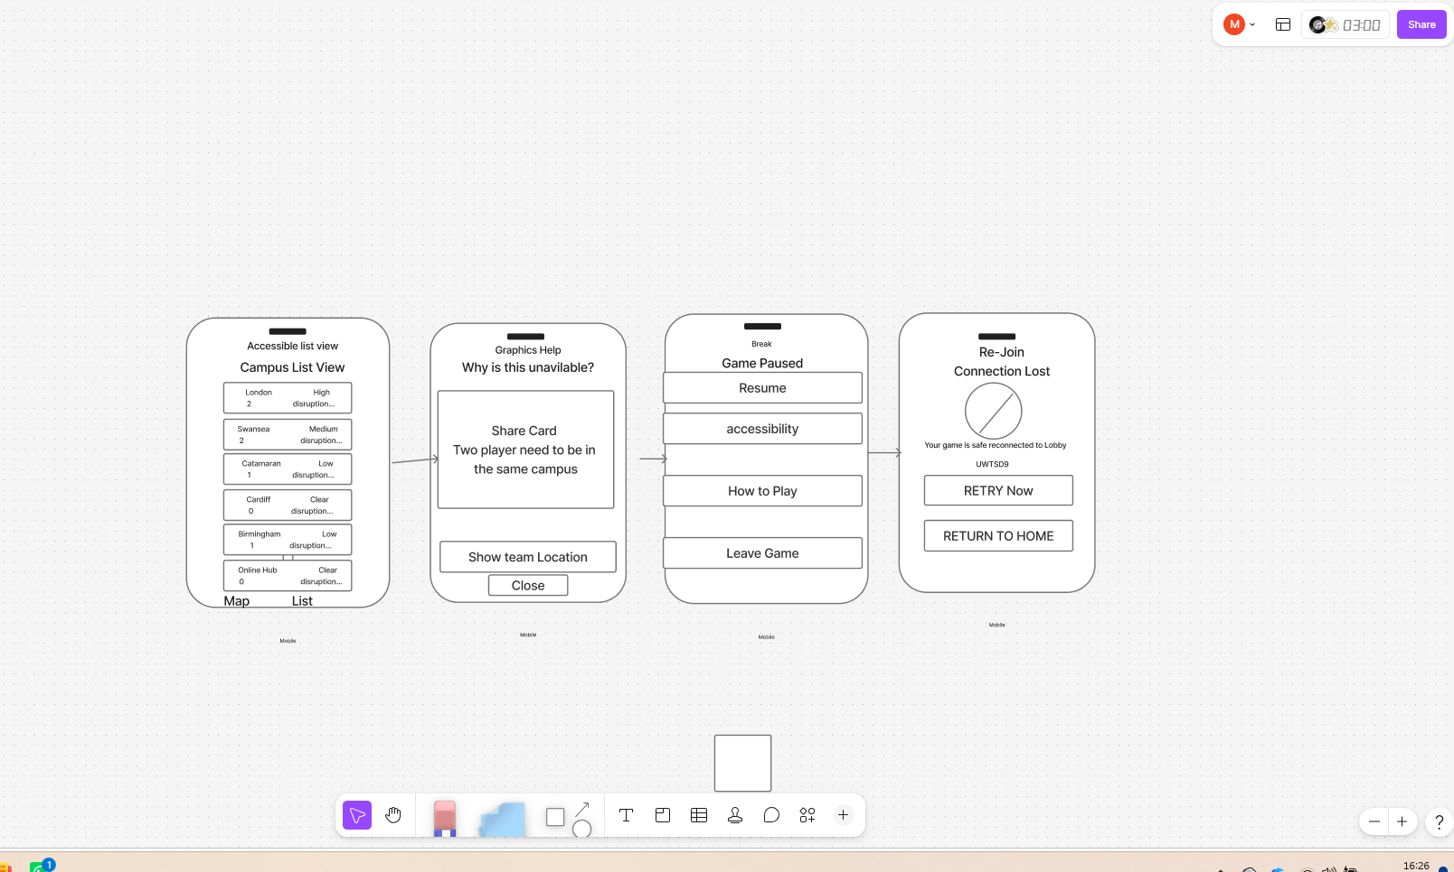
Map alternative, contextual explanation, pause and connection recovery flow.

Appendix 7: Full Low-Fidelity Wireframe Storyboard (F)
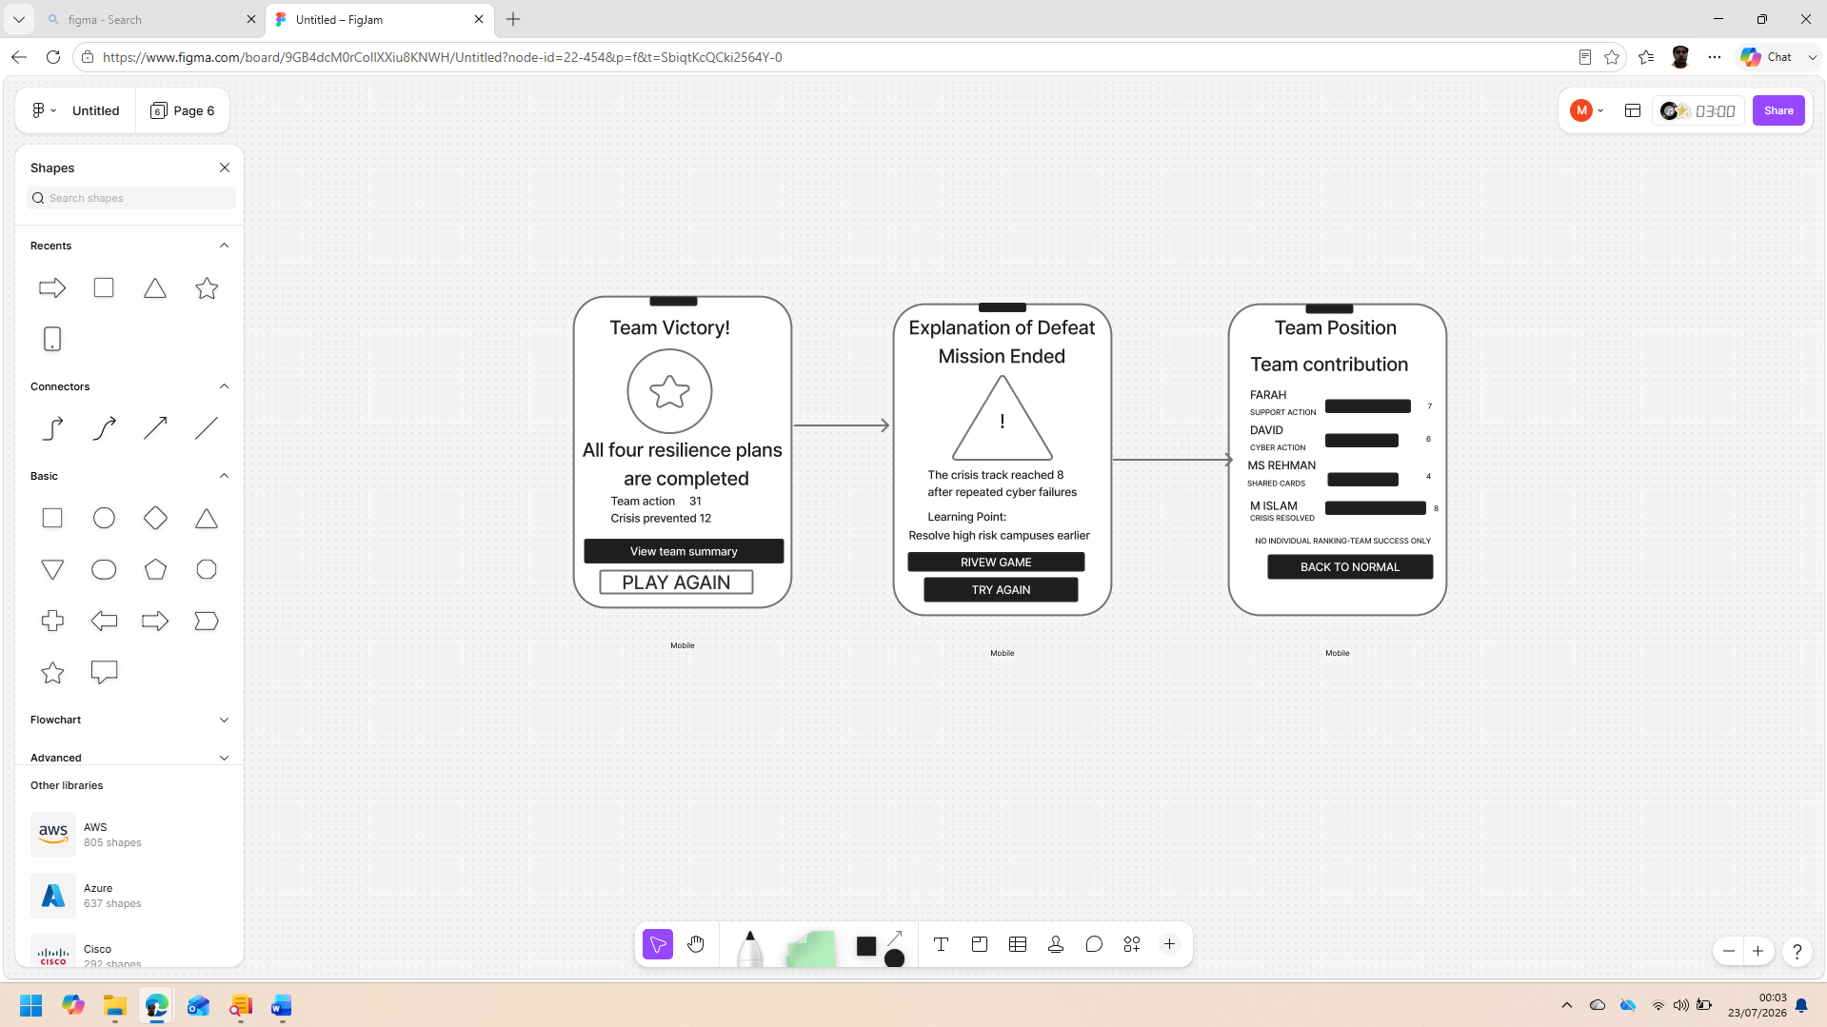

Collective victory, explanatory defeat and non-competitive team contribution summary.

Appendix 8: Survey questionaries and users’ responding record.

https://docs.google.com/forms/d/e/1FAIpQLScD40x7LDEuqOxnBj6xXS5ty8AQ7ePfvWv263eGdB1YdiATQQ/viewform?usp=pp_url


