Student Number 2114731

Module BMH7014

A Report into the findings of the research into

Word Count 2750



Executive Summary
This research report (RR) will evaluate the experiences of newly appointed
CSD clinicians and the role of the current induction process in supporting
learning and transition to this role.
It is a chance to improve employee experience, engagement and
organisational performance and develop a fit for purpose induction process
that includes both directorate and corporate induction.

Objectives of this research is to refresh the induction process in order to;

1. Intuitively induct and onboard.
2. Offer clarity and transparency.
3. Explore and develop L&D elements, building an understanding of our content.
4. Transformation of service delivery - inverted triangle. - the big picture, a
Employee based representation of how CSD induction impacts on retention.
5. Improve employee engagement and employee value proposition to
reduce turnover in first year of employment as well as cost/benefit and risks of doing nothing.
6.Improve recruitment and retention, talent management.

This report highlights how the Welsh Ambulance Service must rise to the challenge in how our Recruitment and People Strategy must be fit for how our services are delivered, now and in the future. Covid 19 has opened both challenge and opportunity to refresh thinking, critically analyse current processes to evaluate internal and external factors impacting on the organisations valuable key assets; Human Capital. This report offers recommendations based on a critical analysis of a small sample survey of CSD clinicians and how their experience of Induction to their role could be improved and how emerging trends in L&D can be incorporated into a new way of learning and developing future clinicians.


Abbreviations and Glossary of Terms
CSD – Clinical Support Desk
ECNS – Electronic Clinical Nursing Notes
IP – Induction Programme
L&D – Learning and Development
VUCA – Volatile, Unpredictable, Complex, Ambiguous
NHS – National Health Service
L&D – Learning and Development
WAST – Welsh Ambulance Services NHS Trust
CIPD – Chartered Institute of Personnel and Development
ROI – Return on Investment
ESR – Electronic Staff Record
PADR – Personal Appraisal and Development Review

Figure 1 -
Figure 2 –
Figure 3 -

Contents -
Page 1 – Cover Page
Page 2 – Executive Summary
Page 3 – Glossary
Page 5 – 1.0 Introduction
Page
Appendices

WORKING TITLE

Retention and Engagement - Evaluating the Design and Effectiveness of Existing Induction Programme for CSD Clinicians in Transitioning to a Remote Clinical Role.

Introduction

The aim of this research is to engage existing clinicians in designing an improved induction
programme for CSD clinicians as part of recruitment, retention and succession
planning. The main objectives are to use design thinking methodology to optimise the induction schema and structure by using an inherently optimistic way of looking at what’s possible and what is needed for todays clinician joining CSD as a multidisciplinary team.
By exploring current perceptions of induction using grounded theory methodology initial findings are explored, then diversified across all regions of the organisation to inform future cohort development using a relative cross sectional sample size of clinicians based in North Wales.
Evaluating current thinking, encouraging creativity and inclusion to increase self
efficacy will challenge existing ways of thoughts and action. Capturing and engaging imaginations and individual differences will not only create a vision for the future but also develop our people to transformational leaders ( Curtis & Cerni, 2020).

Based on findings of the initial research within the North Region, recommendations will be made to build on/create new and better solutions to recruitment and retention practices and delivering a fit for purpose innovative CSD Clinician Induction Programme.
My particular interest in this research comes from taking an insights focused approach to how we recruit, train and retain our specialist clinician for the Clinical Support Desk (CSD). It examines, in order to test a hypothesis that the induction to a new specialist role needs to be changed following feedback and introducing new remote clinical decision making software (RCDM) in May 2022. This research sets out the parameters that need to be considered for appropriate evidence based changes to the induction programme (IP), based on an initial pilot study of a small cohort of clinicians based in the North Region of the trust making up approximately a third of the full establishment of the team across three regions and including different grades of clinicians and professions. This research intends to identify key elements of the current IP using a design thinking approach and to build change based on experiences, innovation and skills of both the clinicians and evolving technology and learning styles. The methodology adopted for this study is grounded theory through a short survey of existing staff of varying lengths of service and methods of induction.

approx 22% of words)
Literature Review

Introduction

The world of work continues to change following the disruption and resulting impact of Covid19. Recruitment and retention affects all areas of the economy, not least the NHS. The most recent NHS Staff Survey (2021) found a considerable dissatisfaction in all grades of staff with 31.1% often thinking about leaving the organisation and 16.6% reporting they will leave as soon as they find another job (NHS Staff Survey, 2022). An interesting contrast to this is the finding that 55.5% felt supported to develop to their potential, though there is no clear link between induction and training in this survey, dissatisfaction and discord is a theme across all the sections therefore links to this research aim in designing an induction programme fit to positively engage in the employee life cycle from onset. It will seek to find what is the key content? What is the design of the content? Delivery and duration, by whom and where? Extended findings on the next phases of this research will be to explore inclusion, accessibility and reasonable adjustments for those who will require additional support in order to induct and engage with a new clinical role.

Employee turnover impacts on the organisation in many ways with turnover in health and social care experiencing significant shortages (CIPD, 2021a). Rethinking the induction process (IP) is vital for first impressions and a missed opportunity if all that is covered is a quick office tour and being issued an employee handbook (CIPD, 2014).

Why is Induction Important?

An induction could be claimed as one of the most important HR functions, it not only introduces the employee to the organisation, its culture and business but also introduces the skills and learning needed for the to transition to their new role (Salau et al, 2014). Kendrick et al (2005) added a further paradigm of shifting attitudes of new employees and how IP influences this.
There is little research in health and social care into the value of induction, how it is delivered, by whom and whether its function serves its purpose.
A study by Hendricks & Louw-Potgieter (2000) though dated is a seminal piece of work that evaluates the value of an induction and whether it aligns to the business objectives, it concluded that a misguided induction impacts significantly on the throughput and function of the organisation. Very little literature has challenged this assertion with some research finding that induction design significantly impacts on staff retention and employer branding. CIPD (2020) gives clear direction on the importance of induction and its impact on retention, employer brand and turnover.
What is an Effective Content and Duration?

Content must be aligned with HR and business objectives, the role itself, values and culture of the organisation and specifics of the L&D package to transition the employee into their new role. Snell (2006) categorises an induction to be a combination of people, processes, technology and clarity on the role itself and the specifics of the IT infrastructure. This is most significant in todays digitalised NHS with advances creating more opportunities for diversity and inclusion.

Induction content embraces the corporate induction and organisation policies and language as part of socialising the employee to the role and Trust. It includes role essential skills, key stakeholders and inter-relationships that enable the wider organisation to function as well as relationships with peers that together enhance the employees experience and set clear expectations for a return on the investment of the whole recruitment and training process. Effective training should enable the employee to have the belief as well as the capability (Gardner et al, 2021).

Bauer et al (2007) cited in Gardner et al (2021 looked organisational socialisation and its impact on adjustment to new roles, positing that role clarity, task mastery and social acceptance reflects different aspects of adjustment and success in new roles building on work by Taormina in (1997), see fig 1.
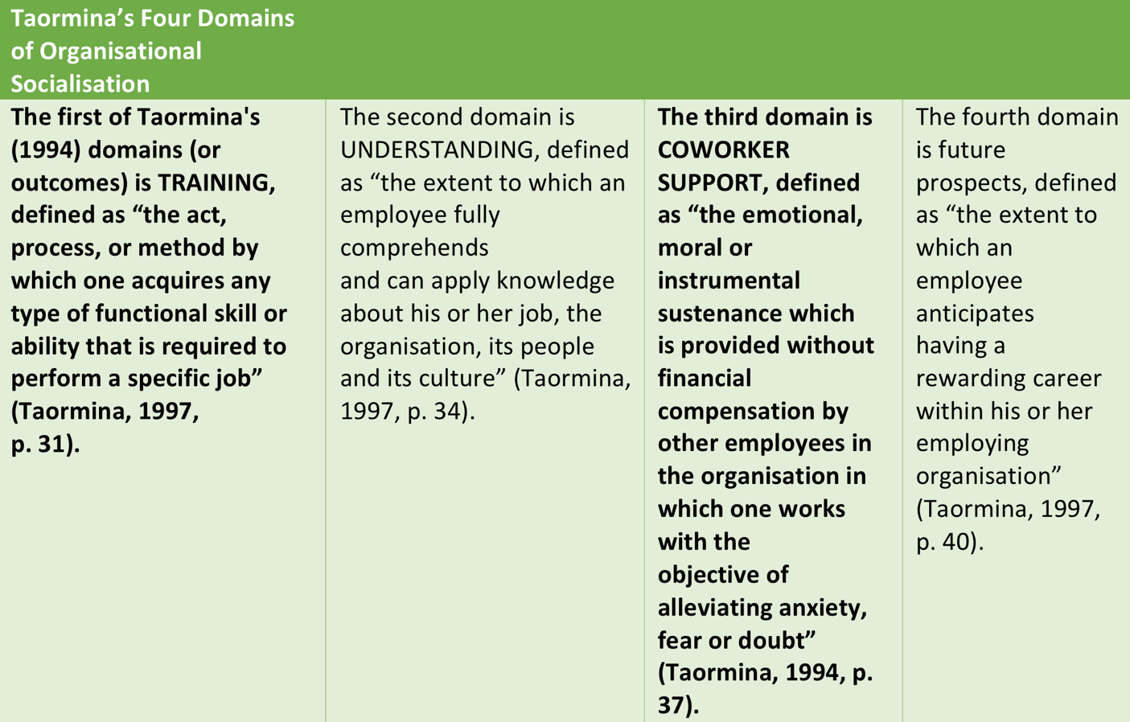

Fig 1. Adapted from Gardner et al (2021).

Delivery and Evaluation

Whilst evaluating and comparing different platforms and methods of delivery is outside the scope of this study it is prudent to consider the challenges of accessibility and delivery of inductions following on from the explosion of teams and zoom based training during the pandemic. Covid19 forced organisations to think differently and adapt with speed to delivering induction online rather than in person. CSD is a remote area of practice and most statutory and mandatory elements can be delivered remotely as well as systems based training, but can we deliver a whole scale induction effectively?

Research design: Grounded Theory Methodology

Grounded Theory (GT) was chosen as the approach as this allows simultaneous collection and analysis of data, the purpose of this will benefit the next stages of this study and inform first pass changes from this pilot. The benefits of GT of the generation of a theory which is grounded in data. Developed by Glaser and Strauss (1967) it allows for questions within the survey to be adapted as the study progresses. A common criticism of this approach is researcher bias , this will be eliminated by adapting questions following the pillow in order to enrich further data themes aimed at improving the aim of the study – developing a person centred IP utilising design thinking as an approach to change. This study is reproducible across the whole trust following the grounded theory approach.

Data Analysis

Fig.2 adapted from Noble (2016) shows how data was analysed to develop theory and a working hypothesis, short codes were used to develop themes that lead to theory. In order to validate the questions on the survey, the practice education lead was interviewed prior to the start of the study to gain insight to current and future inclusions to the IP for new clinicians and how this study can integrate a person centred approach and evidence based practices. The researcher chose this method as it allows for permeation and narrative to be explored and the study to develop with the theory as it evolves.

How the participants were chosen

The participants were selected by localising this pilot to one region. This region is not known to the researcher this reducing bias or researcher influence. It’s is recognised that should this study not continue across all three sites its validity will not be proven.
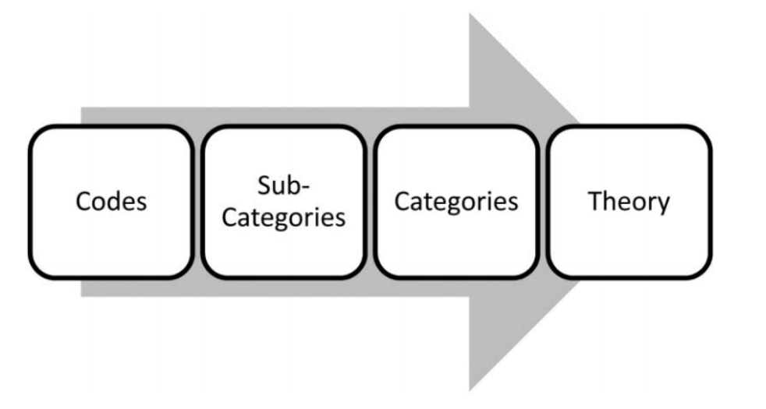

Fig 2. Grounded Theory Data Analysis adapted from Noble (2016).

Research Process

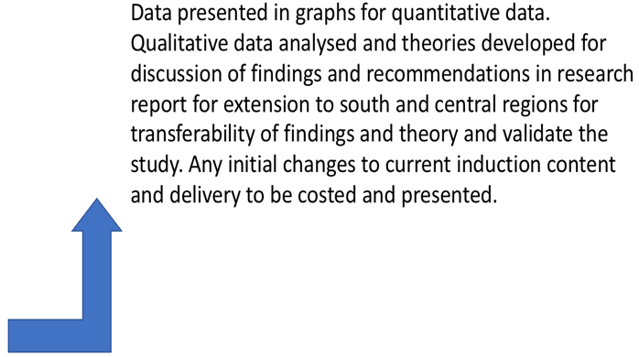
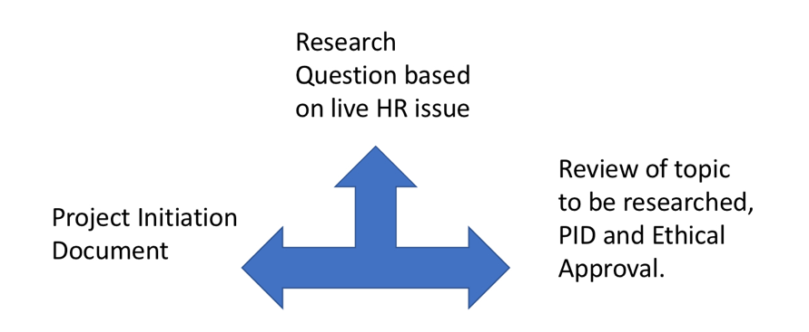
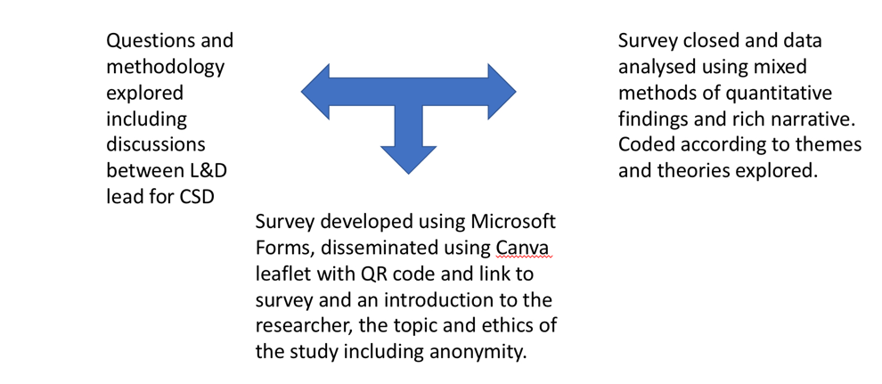
Findings and Discussion (approx 40% of words)

The aim of this research was to engage existing clinicians in designing a new IP, the main objectives were to use a design thinking approach to evaluate current thinking and experiences and improve the current IP. The survey (see appendix one) was based on current experiences and thoughts on how the IP could be improved. The survey was sent to the North staff establishment of 36 with a response rate of 22. Of the respondents, 19 were recruited internally, 3 from external NHS partners,16 were paramedics and 6 were nurses ranging in experience from 5 weeks to 6 years. Respondent one had six years experience and had a classroom based induction of four weeks but felt that there was too much irrelevant information and not enough time to familiarise themselves with the software or systems and no training on how to use the CAD/C3 or telephony systems. Response 2 added more to this by reporting no systems based training or “incorporating the CSD procedures into the induction”. Four of the responses felt similar experiences around the structure of the training and the need for “structured training days on use of software”, “training to be consistent across all three sites’.

Twenty of the responses offered some narrative around how they felt the induction could be improved, with one reporting a deep dissatisfaction with the induction resulting in them seeking new employment. A theme emerged across the responses around face to face vs digital platforms. Currently there are no platforms that integrate with teams based teaching or online course that support the induction. Themes around content dumping, lack of consistency, poor mentorship, poor information governance and soft IT skills, length of training compared to NHS111 colleagues. When analysing the length of the induction, it ranged from 4 weeks classroom based to five days Teams based following the pandemic. One response felt the induction could have been shortened by one day due to the day spent ‘chatting”, this IP was over Teams and a condensed induction as part of a temporary redeployment from a patient facing role.

Insert tables of graphs and percentages. Further discussion on findings to be added…………..

Conclusion

This report details the business case on how the Welsh Ambulance Service must rise to the challenge in how we recruit and induct new clinicians to the Trust and CSD Team and hoping the induction programme must be future fit for how our services are delivered now and in the future. Covid 19 has opened both challenge and opportunity to refresh thinking, critically analyse current processes, both internal and external factors that impact on the organisations key assets, Human Capital, now and in the future. By retaining existing talent, recruiting into key roles and inducting new clinicians efficiently and effectively this will have a positive
impact on our workforce and how we spend public finances.

The benefits of this proposal are summarised in table 2;

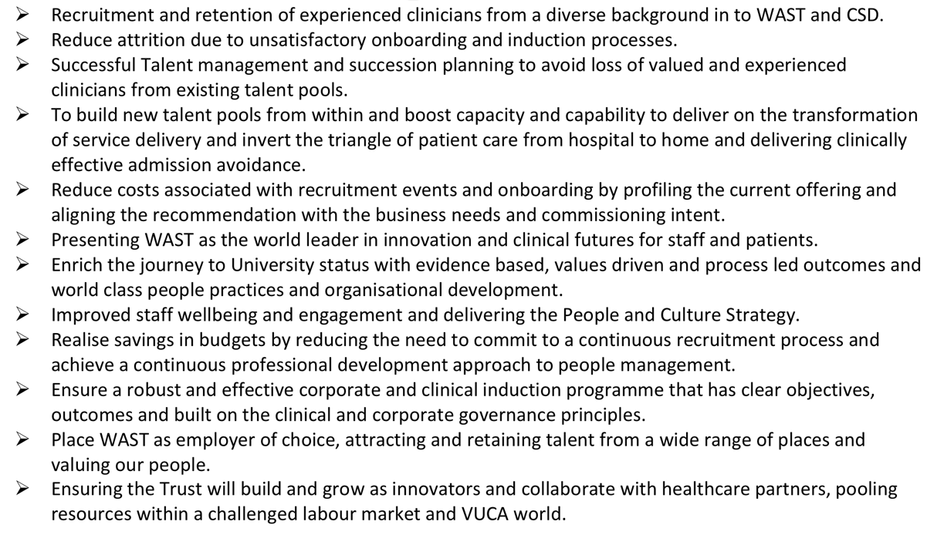
Table 2. Benefits of the proposal

The RR as a whole must provide an analysis and critical evaluation of the topic, which is impossible if you only have your own research findings on which to base the conclusions. In essence, the literature review shows what other people asking similar questions have discovered, and then once you have revealed your own findings, the conclusion can compare and discuss the similarities and differences between the findings. This will ensure that the report is analytical and evaluative (Why? How? Cost? Consequence?) in outlook rather than simply being descriptive (What?). If the RR is descriptive, then the reader is left to make his/her own conclusion. It is the task of the report author to make the conclusion based on the argument presented.

As well as providing the basis for analysis later, the literature review itself also needs to be critical and analytical. This does not necessarily mean being negative and finding fault, but looking for commonality and themes. Furthermore, the literature review should not be a simple recitation of what other authors have written, but how different author’s writings compare and contrast. The literature review is an annotated bibliography, but rather should build up an argument for your particular research and not simply stop when you feel sufficient literature has been reviewed.

It is also useful to separate each chapter/section into clearly headed sub sections which will help structure the literature in a logical and coherent review. Always have clear summaries at the end of each chapter to highlight the key issues you have raised, wish to raise and plan to raise in the following chapter.

- Stakeholders Power and Ethics
- What tensions can exist between the different stakeholders in your research and how can you most effectively deal with these tensions?
- What do you understand by the terms “politics of control”, “politics of access” and politics of honesty”? What are the reasons to consider each of these terms?
- Within the context of your research, to whom do you have ethical responsibilities? What are these responsibilities and how can you ensure that you act ethically at all times?

The aim of the results chapter is to create an argument to accept or reject your hypothesis, or to answer positively or negatively to your research question(s). Therefore, only include the information that helps to develop the argument. You may place a presentation of "raw data" as an appendix if necessary.

In presenting the results, you should ensure that the approach you have used, whether it be pie charts, tables, or graphs, is the most appropriate. It is easier for the reader if there is consistency of approach throughout the section, so keep your presentation easy to read and follow. Marks are awarded for the intellectual clarity of your presentation of results, as well as the visual clarity of presentation. Always use the objectives you have set yourself in your introduction to help ‘frame’ and present your results. In this context it is again useful to present your results in sub sections that relate to each of the objectives you have set.

You need to plan and organise carefully the presentation of your results and the analysis. You can either present and analyse issue by issue or have separate sections where you first present your findings and then secondly discuss them. If you are presenting and analysing qualitative data such as responses to interviews, you must include quotes as evidence. Quantitative data will usually be presented as graphs or charts and figures.

Writing a conclusion (approx 12% of words)
The conclusion section of your RR is easier to present when you have clear and simply stated research questions. The aim of the conclusion is to synthesise and bring together all the information presented throughout the RR so to provide an overall response to the aim of the report. Thus, the views of the authors presented in the literature review should be re-introduced along with the findings of your own research. It is conventional to include a measure of self-criticism in the conclusion, indicating what you might do differently if the research were to be repeated. You should also include discussion on the wider implications of your results. Do not meanwhile, introduce any new information or sources in your conclusion section.

TOP TIP: Readers of your RR should be able to just read the conclusion section to determine whether you have achieved what you set out to achieve

