
Program: Master of Business Administration
Module: Strategic management
Module code: LCMB7003
Assignment: Assessment component – Strategic Analysis of Jet2Holidays
Lecturer: Hoang Dang Nguyen
Student Name: Urjefaben Usmanbhai Patel
Student id: 2504917
Group: 3
Total words: 6408
Date of Submission: 1st May 2026

Contents
Contents 2
Section 1: Strategic Analysis of Jet2holidays 4
1. Introduction to Jet2holidays 4
1.2 Historical Context and Development 4
1.3 Mission, Vision, and Core Values (Core Values of the Organisation) 5
1.4 Business Model: Package Holidays and Partnership with Jet2.com 6
1.5 The UK Travel and Tourism Industry Overview 7
1.6 Major Competitors: TUI Group, easyJet Holidays, and On the Beach 7
1.7 Market Position and Competitive Advantage 9
2. External and Internal Environment Analysis 9
2.1 External Environment Analysis of Jet2holidays (PESTLE Factors) 9
2.2 Critical Success Factors for Package Holiday Companies 13
2.3 Strategic Challenges (Seasonality, Fuel Costs, Competition, Global Disruptions) 14
2.4 Analysis of the Internal Environment of Jet2holidays 15
2.5 VRIO Analysis and Internal Strengths of Jet2holidays 15
3. CSR and Sustainability Objectives 17
3.1 CSR Strategy of Jet2holidays 17
3.2 Environmental Responsibility (Reducing Carbon Footprint, Sustainable Travel Programmes) 18
3.3 Social Responsibility (Customer Welfare, Community Involvement) 19
3.4 Integration of CSR Activities within Company Strategy 19
3.5 Critique of the Effectiveness of CSR Initiatives 20
4. Comprehensive and Holistic View of the Organisation 20
4.1 Balanced Scorecard Framework (Kaplan & Norton, 1992) 20
4.2 Financial Perspective (Objectives, KPIs, Targets, and Strategic Initiatives) 21
4.3 Customer Perspective (Objectives, KPIs, Targets, and Strategic Initiatives) 21
4.4 Internal Business Processes Perspective (Objectives, KPIs, Targets, and Strategic Initiatives) 22
4.5 Learning and Growth Perspective (Objectives, KPIs, Targets, and Strategic Initiatives) 23
Section 2: Reflective Account 25
6. Reflective Practice Using Gibbs' Reflective Cycle 25
6.1 Description and Feelings 25
6.2 Evaluation and Analysis 25
6.3 Conclusion and Future Plans 26
Overall Conclusion 26
References: 28

Section 1: Strategic Analysis of Jet2holidays



1. Introduction to Jet2holidays
Overview - IntroductionJet2holidays is one of the best-known holiday operators in the United Kingdom, providing holiday packages to many destinations in Europe as well as outside it. Being a member of the larger group Jet2plc, the business runs through the combined efforts of Jet2holidays and Jet2.com and offers tourists all the aspects of their stay including flights, accommodation, and transfers. Over the years of its work, Jet2holidays has gained much popularity due to its great emphasis on customer care, affordability, and reliability.
Having been created during the time when the UK travel and tourism sector was quite competitive with TUI Group and easyJet Holidays among its biggest rivals, the firm now holds a high position on this market.

1.2 Historical Context and Development


Jet2holidays was founded in 2007 as a subsidiary of Jet2 plc, a firm which traces its history back to 1978 when it was first started as an air cargo carrier known as Channel Express. The company later expanded its scope of operations into the airline industry by launching Jet2.com, an airline, in 2003. In addition to being a low-cost carrier, Jet2holidays came about as a strategy for moving into the package holiday industry and capitalizing on additional benefits in the travel distribution chain.
Since its formation, Jet2holidays has pursued a vertical business model where flight services are combined with hotel accommodation and transport services in and out of airports, thus providing passengers with everything they require. Such integration has allowed the firm to exercise more control over prices and service delivery levels compared to most online travel agencies. The firm's destination range has since expanded to include some popular European locations like Spain, Greece, Turkey, and the Canary Islands, among other areas.
Jet2holidays' history has always been marked by growth and an emphasis on customer satisfaction. The firm has put a lot of effort into improving its customer service, being flexible when it comes to booking, and offering dependable services, resulting in the development of a positive brand image. Even when encountering external obstacles like economic instability, the effects of Brexit, and the pandemic, Jet2holidays has proved its adaptability and resilience. Currently, it can be considered one of the best UK-based tour operators.

1.3 Mission, Vision, and Core Values (Core Values of the Organisation)
Concept | Short Description
Customer Service | Smiling person/headset icon representing excellent customer service and customer-first thinking.
Teamwork | Group of people icon showing collaboration, employee engagement, and strong internal culture.
Reliability | Shield/checkmark icon for trustworthiness, punctuality, and dependable holiday packages.
Growth | Upward arrow/bar chart icon representing company expansion, profit growth, and strategic improvement.

Jet2holidays’ mission revolves around providing quality and affordable package holidays with an unwavering emphasis on customer satisfaction and reliability. Jet2holidays aims to offer comprehensive travel solutions that incorporate flight bookings, hotel accommodations, and transportation to customers. “Package holidays you can trust” implies that Jet2holidays is dedicated to providing transparent, cost-effective, and reliable services.
While Jet2holidays does not officially have a vision statement, one could infer that the company’s goal is to become the best and most trusted tour operator in the UK. This vision is illustrated by Jet2holidays’ constant efforts to expand its destination options, improve customer service, and deliver exceptional operations. Jet2holidays seeks to distinguish itself from competitors through the provision of unique customer experiences rather than through price competition.

1.4 Business Model: Package Holidays and Partnership with Jet2.com

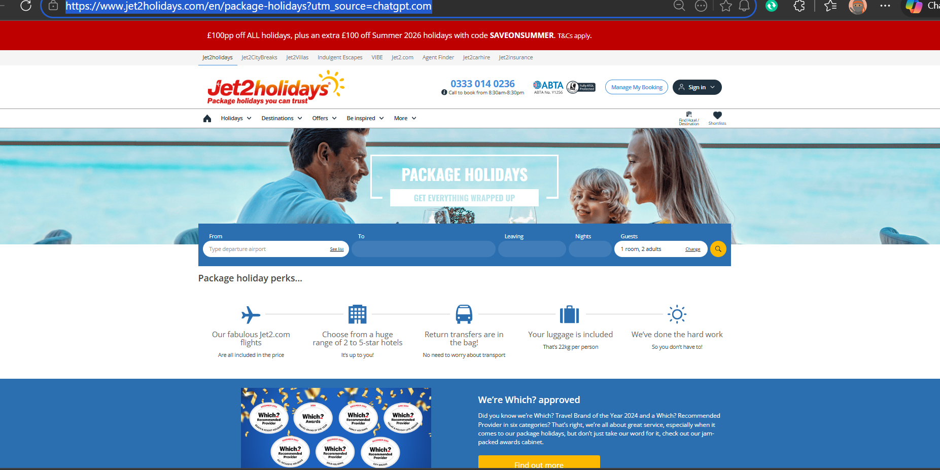
Package holidays | Jet2holidays
Package Holidays You Can Trust | Jet2holidays
Being an integrated airline and resort, Jet2holidays employs the vertical integration business model by providing package holidays to customers which include flight services, accommodation, as well as transfers. By combining all these aspects together, Jet2holidays can guarantee that customers receive quality services from reliable providers at affordable prices, and this can be used as a competitive advantage compared to tour operators and OTAs.
One of the features of the business model of Jet2holidays is its integration with Jet2.com. Being able to use the services of this airline, Jet2holidays is able to provide flights from a number of UK regional airports, making customers' travels easy and comfortable. Furthermore, such integration allows for cost savings and better organisation of flights in order to meet customers' demands.

1.5 The UK Travel and Tourism Industry Overview

The UK travel and tourism industry is an essential part of the country's economy, contributing vast amounts of money every year and employing millions of people engaged in different aspects related to tourism services, such as aviation and hospitality services. In particular, according to figures published by the UK Office for National Statistics (ONS), the contribution of domestic and inbound tourism to the national economy reached about £145 billion before the outbreak of the coronavirus disease. Despite the impact that the COVID-19 outbreak had on the industry, it managed to recover successfully due to a rise in the number of domestic vacations and international travel.
It should be mentioned that there are many segments of the travel and tourism industry, among which are holiday packages, independent travel, luxury, and budget travel. One of the leading positions in the market belongs to package holiday providers, namely Jet2holidays, which provide integrated solutions, including flights, hotels, and transfer services. This segment enjoys benefits associated with economies of scale, loyalty programs, and cooperation with airlines and accommodation providers.
Important trends that affect the sector are digitalization, environmentalism, and changes in customer preferences. Digitalization has affected customer behavior and helped in creating a transparent pricing structure and customized holiday experiences for customers. Environmentalism has become an important trend, where regulations and consumers expect sustainable travel, which includes carbon offsets and eco-friendly hotels. Seasonality, economic cycles, and geopolitics, such as Brexit, are other important factors affecting tourism.

1.6 Major Competitors: TUI Group, easyJet Holidays, and On the Beach

Company | Market Presence | Price Level | Product Range
TUI Group | High | High | High
easyJet Holidays | Medium | Low | Medium
On the Beach | Medium | Low | High

There are numerous rivals in the UK market segment due to the competitive nature of the package holidays industry. Some of the main competitors of Jet2holidays are the TUI group, easyJet Holidays, and On the Beach with their specific competitive strategies targeting diverse customer groups.
One of the most competitive travel businesses is the TUI Group known for its comprehensive holiday packages. It offers all types of holiday activities including flights, cruise ships, and accommodation. As a result of its strong reputation and numerous destinations, it poses a significant threat to Jet2holidays as it targets middle-class customers who are looking for an all-inclusive holiday abroad.
Another company targeting budget-conscious customers is easyJet Holidays, an online portal offering cheap holiday deals. Its success is based on using the airline easyJet that provides low prices and flexibility regarding the booking process. Nevertheless, it does not provide as high levels of individual service and value-added services as Jet2holidays.
On the Beach is mainly an online agency that focuses on convenience and openness. It enables tourists to choose their flights and hotels separately, catering to the needs of tech-savvy consumers who value affordability and simplicity more than comprehensive holiday packages. The low cost is equivalent to Jet2holidays, yet On the Beach lacks the combination of airlines and holidays along with customer services offered by Jet2holidays.
Nevertheless, despite having such fierce rivals, Jet2holidays continues to stay competitive because of its association with Jet2.com, ease of access via regional airports, and customer-friendly approach.

1.7 Market Position and Competitive Advantage
Jet2holidays has a dominant market position within the UK holiday travel sector, especially concerning flight-included holidays using regional airports. The company is further supported in its market position by having vertical integration with Jet2.com, allowing control over flights and schedules.
Some of the competitive advantages Jet2holidays has include being customer-oriented, offering flexible holiday plans, and providing top-notch service to the customers. These features set Jet2holidays apart from other companies like easyJet Holidays that only focus on offering services at affordable prices, and online agencies such as On the Beach that only provide convenience.
Through marketing, use of regional airports, performance in operations, and other strategies, the company will be able to retain and grow its customer base and maintain its competitive advantage.

2. External and Internal Environment Analysis

2.1 External Environment Analysis of Jet2holidays (PESTLE Factors)

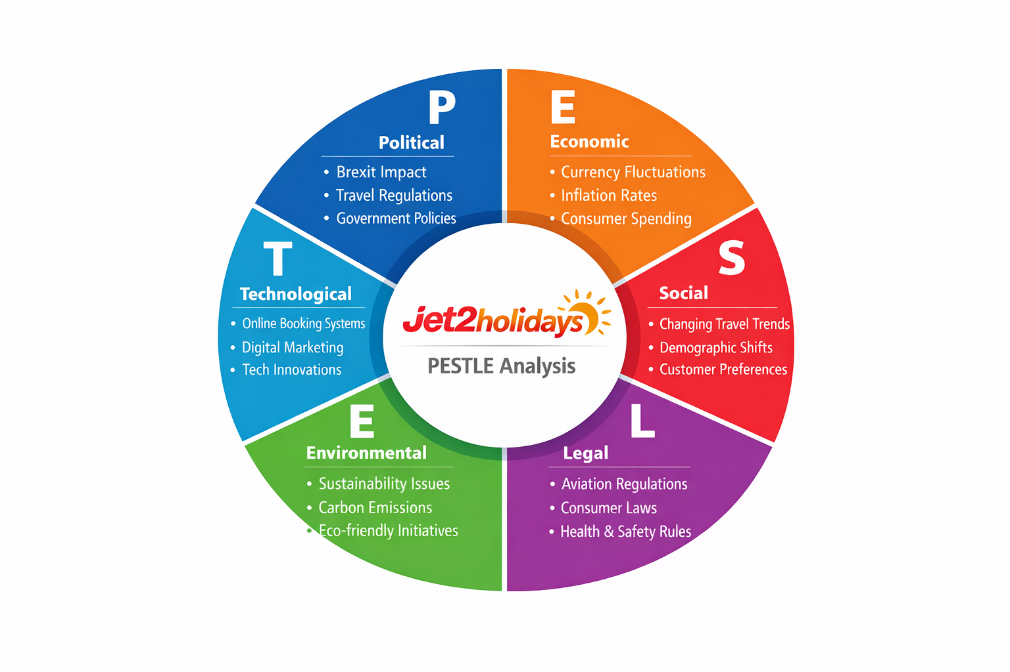
Political Factors:
The political factors influence the decision making process of Jet2holidays significantly. The change in policies due to events like Brexit has led to changing laws regarding visa requirements, customs clearance and aviation policy with respect to European Union. It has necessitated adjustments in flights, informing customers about the changing travel policies and slotting the airline services. Restrictions imposed by the government, like that during the coronavirus crisis, have led to a decline in number of holiday packages sold. Aviation policy is responsible for deciding which route Jet2 can fly and at how many times.
Impact of strategy
There is need for continuous adjustments of the airline’s route system in relation to the different countries, adherence to the terms stipulated in the bilateral air service agreements, and updating of traveler documentation. Effective collaboration with the airport authorities as well as governments is required due to the possibility of any changes in the policies.
Opportunities / Threats:
Threat: The sudden change in policies (such as visas, taxes, travel bans, etc.) can hinder business activities.
Opportunity: The chance to act as a “travel guide” due to the simplification of complicated travel arrangements for clients.
Economic Factors:
The economic factors affect the company’s business operations directly. Changes in currency exchange rates, for instance, from GBP to EUR, influence how affordable the holiday is and, thus, its demand among customers. Inflation has a similar effect. The increase in fuel prices increases the costs of operating airlines; the company has to change its pricing strategy accordingly. The economic slowdown experienced after the coronavirus pandemic resulted in low number of bookings.
Impact
Jet2holidays has to employ dynamic pricing techniques to cope with demand fluctuations. The firm can choose to emphasize high-demand and cost-effective vacation spots as well as hedge against high oil prices. The company can resort to increased promotion and installment booking options during economic slumps.
Opportunity/Threat:
Threat: Higher inflation rates mean reduced discretionary income and lower holiday bookings. Increased fuel prices imply higher operating costs.
Opportunity: Increased demand for value for money holidays provides an opportunity for Jet2holidays.

Social Factors:
It is essential to take into account the trends, demographics, and behavior patterns of the consumers in the development of holiday packages. There has been a rise in the interest towards family trips, city getaways, and adventurous trips that involve both elements of relaxation and excitement. The Jet2holidays has tried to cater to these needs through developing holiday packages in Spain and Greece for families and adventure tours to Portugal. There has also been the growth of a young generation of travelers who rely on technology for bookings and expect personalized experiences and services.
Effect on Strategic Management:
Jet2holidays needs to develop its segmentation strategies, providing various packages based on family, couples, luxurious, and budget tours. Jet2holidays needs to improve the customer experience through flexibility in its bookings, customized services, and after-sale services.
Opportunity / Threat:
Opportunity: Increasing need for personalized and experiential holidays can help to increase sales.
Threat: Not adopting to the changing lifestyles can cost the company to lose its younger clients.

Technological Factors:
Technology is critical to maintaining competitiveness and improving operations. The Jet2holidays has relied heavily on modern technologies in the development of its services by providing users with convenient ways to book flights through its website or mobile app. For instance, customers can book flights using the Jet2holidays mobile app and customize the holidays according to their needs. The firm has also invested in artificial intelligence and big data analysis for improved operations and decision-making processes.
The company has to make heavy investments in the digital transformation process, such as mobile applications, AI-based price setting, chatbot software and CRM technologies. Analysis of the data can help forecast customer behavior and optimize marketing strategies.
Opportunity / Threat:
Opportunity: Advanced digital technologies enhance the customer experience and generate more direct sales.
Threat: Rivals may attract customers through their advanced digital technologies.
Environmental Factors:
The sustainability of the environment is an important strategic issue in the travel industry. Jet2holidays takes various steps to cut carbon emissions as well as encourage ecological travel. The company works with ecologically sound hotel properties, provides carbon offset solutions for flights, and encourages green travel packages. Besides the regulatory requirements and social expectation, the adoption of such strategies by the company enhances its reputation among environmentally concerned travelers, giving it a competitive edge in the travel market.
Implications for Strategic Management:
Jet2holidays will have to incorporate sustainable practices like carbon offset schemes, use of fuel-efficient planes, and collaboration with environmentally friendly hotels. The company can also introduce “green tourism” packages and minimize wastage.
Opportunities/Threats:
Opportunities: Market segment that is increasingly becoming environment-friendly.
Threats: Taxes, carbon emissions, and sustainable practices result in higher costs.
Legal Factors:
Conforming to the law creates legitimacy and trust among customers. The company meets ATOL protection legislation, providing customers with refunds or repatriation should anything happen to the company, including adherence to aviation laws, labor laws, and health laws. For instance, the implementation of the ATOL protection legislation made sure that even when other travel companies went into bankruptcy following the pandemic, Jet2holidays' customers received their money.
Jet2holidays must comply with regulations set by the UK Civil Aviation Authority, retain financial protection through ATOL, and meet standards of consumer rights. Jet2holidays must also keep its policies updated due to changing legislation in different destinations.
Opportunity / Threat:
Opportunity: Legal compliance will increase trust in the brand and improve its reliability.
Threat: Non-compliance may result in fines, legal action, or damage to reputation.

PESTLE analysis demonstrates that Jet2holidays finds itself in a highly dynamic and external environment. Political and legal factors result in a compliance-oriented business model, which needs to be constantly adapted. Economic and social factors affect the demand directly, making it necessary to focus on prices and customer segments in the strategy.
The greatest potential for further development lies in technological improvement, facilitating the company's modernization and customer-oriented activities. Yet, there is an increasing pressure from the environmental factor and rising costs.
Final insight:
The flexibility and technological progressiveness of Jet2holidays are essential prerequisites for success.

2.2 Critical Success Factors for Package Holiday Companies
The critical success factors listed below will be essential for the success of Jet2holidays in the fiercely competitive package holiday industry within the UK market.
Customer satisfaction is one of the crucial critical success factors (CSF). Indeed, the reason why customer satisfaction is a critical success factor lies in the fact that the package holiday business is highly competitive and customers are able to choose other companies besides Jet2holidays as their service provider. Thus, examples of alternative package holiday providers would include TUI, easyJet Holidays, and On the Beach. In general, customer satisfaction is important since customer experience influences repurchasing, review rating, and the company's reputation. Should customers be unsatisfied with the quality of service provided, they will be more likely to change to another service provider.
Another critical success factor is operational efficiency. Jet2holidays provides customers with integrated services (airline services by Jet2.com, hotel services, and packages) and, therefore, efficient operation among those services is required to decrease the number of delays, minimize costs, and deliver quality service.
Third, market adaptability is crucial for survival. Seasonal changes in demand, economic fluctuations, and shifts in consumer tastes have great impacts on the industry. For instance, during the peak season when demand is high, and off-seasons when demand is low, the organization needs to come up with different pricing schemes and other approaches to ensure steady cash flow all year round. If not, it will be difficult to maximize its capacities and profits.
Moreover, brand reputation and regulatory compliance play an important role in the success of any company in this industry. High brand reputation means that people trust the organization; hence, the company must comply with various regulations such as ATOL, since it makes customers feel more confident about their financial security.
Finally, one of the CSFs in the travel industry today is the company's digital capability. This can help Jet2holidays reach out to a large number of customers through the Internet. With good digital capabilities, the organization can provide personalized travel services to its customers at affordable prices. Otherwise, it risks being outperformed by other organizations.

2.3 Strategic Challenges (Seasonality, Fuel Costs, Competition, Global Disruptions)
Strategic challenges that Jet2holidays faces directly correspond to macro-environmental elements found through PESTLE analysis. External elements provide opportunities as well as pose threats and directly affect company’s Critical Success Factors (CSF), such as customers’ satisfaction, efficiency, and profitability.
A key challenge in this case refers to seasonality, which is connected with the social aspect of PESTLE analysis due to changes in consumer demands throughout the year. Jet2holidays experience a high volume of demand when there is a need for vacation and school holidays and an exceptionally low demand at other times of the year. The company’s CSFs associated with efficiency and profitability face significant challenges since its aircraft and hotel capacity could be underused.
A third important threat is related to the issue of the volatility of fuel costs, which falls under the economic component of the PESTLE analysis. Given the nature of Jet2holidays, its operations are very dependent on fuel prices. The increase in the price of crude oil leads to higher operational expenses, which affect pricing decisions. Hence, there is a direct influence on CSFs in terms of competitive pricing and operational effectiveness.
Another serious threat faced by the organization relates to high competition within the UK package holidays market and refers to the economic and technological dimensions of PESTLE analysis. Other organizations, such as TUI, easyJet Holidays, and On the Beach, operate in the same segment offering similar products and implementing more innovative approaches. Thereby, it forces Jet2holidays to differentiate from competitors and makes CSFs including customer satisfaction and reputation more vulnerable.
Finally, another serious risk factor in today's world is the possibility of any global disturbances including epidemics, political instability, or natural calamities, which fall into the categories of political and environmental components of PESTLE analysis. It impacts several CSFs directly, such as customer satisfaction, sustainability of operations, and financial performance due to the uncertainty associated with any event.

Conclusion
To sum up, these are some strategic issues emerging from the external macro-environment as revealed by the PESTLE analysis. This means that the issues have a direct impact on the CSFs of Jet2holidays.

2.4 Analysis of the Internal Environment of Jet2holidays
The internal environment of Jet2holidays is defined by the firm's resources, capabilities, and competences, making it competitive in the UK travel industry. This company enjoys the advantage of having an established brand image based on reliability and customer trust and also benefits from financial stability to ensure growth through exploration into new markets, expansion, and resilience in times of market instability. The ability of Jet2holidays to integrate with Jet2.com enables efficient control of the schedule, holiday arrangements, and services.
In terms of capabilities, Jet2holidays can be described as having customer service skills and operational effectiveness. Trained employees offer personalized and adaptable services to customers, with integrated scheduling and cost management techniques making operational effectiveness possible.
Based on the VRIO approach, the resources and capabilities possessed by Jet2holidays add value since they help serve the needs of customers and build brand reputation. The firm also has a good structure for exploiting these sources, which include proper management, motivated employees, and efficient processes that can guarantee long-term competitive advantages.

2.5 VRIO Analysis and Internal Strengths of Jet2holidays

The company's internal factors form the basis of its competitive advantage in the UK market for package holidays. Using the VRIO analysis helps to identify key resources that allow the company to gain an edge over its rivals. Value is associated with providing customers with a complete set of holiday packages, including flights, accommodation and transfer. Integration with Jet2.com provides vertical benefits related to flight schedule management and service quality improvement, as well as cost savings that allow the company to offer competitive prices while providing high quality services. Finally, the positive reputation of the company and ATOL protection play a crucial role in customer trust and loyalty.
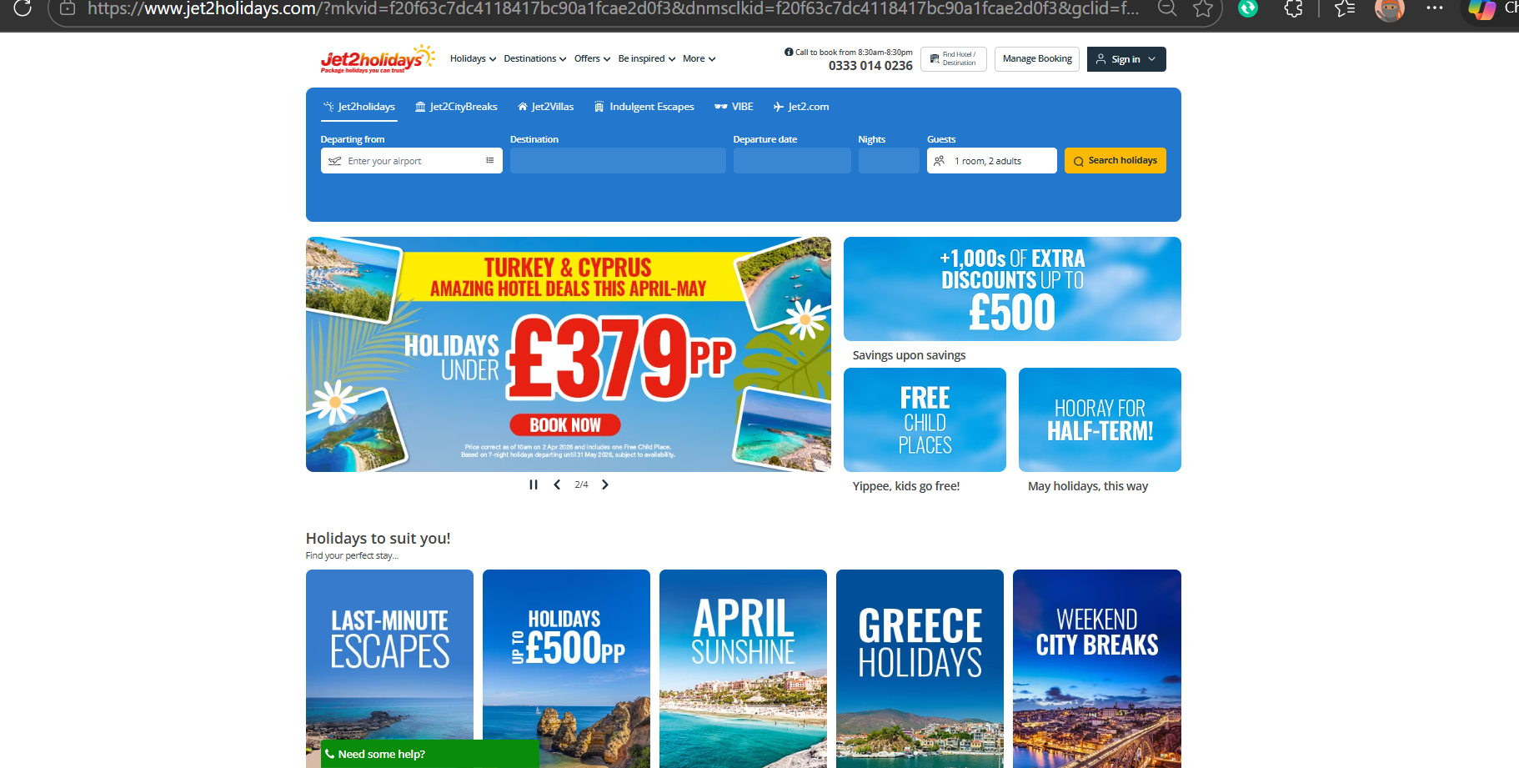
Package Holidays You Can Trust | Jet2holidays
Resources possessed by Jet2holidays are rare, as few other operators on the UK market combine airlines and package holiday provision services. Unique destinations offered by the company, broad coverage across different regional airports, and high service standards allow Jet2holidays to create a unique market position and attract customers looking for efficient and high-quality holiday experiences, which are hard to replicate by other operators to much.
When it comes to the ability to imitate the strategy, Jet2holidays has a considerable benefit. The company may have many followers who will attempt to offer similar packages; however, duplicating its operating system is hardly possible. Indeed, its integrated systems, competent personnel, long-lasting relationships with suppliers, and loyal customers act as barriers against imitation. The new comers or competing firms will incur considerable costs in order to achieve similar results.
Speaking about organization in the VRIO, we need to mention that Jet2holidays' leadership, operation, and customer services departments are organized in such a way as to optimize and enhance their performance. Thanks to the coordination between the departments mentioned above, the company is capable of ensuring high-quality services, efficient marketing campaigns, and positive customer experiences.
All the advantages discussed above constitute a competitive advantage for Jet2holidays. They enable the company to operate efficiently, generate revenues, expand, attract more customers, and remain a market leader. The factors that contribute to creating the sustainable competitive advantage include an integrated operating system, end-to-end holidays management, great customer services, sufficient funds, and efficient marketing strategies.
2.6 Strengths Within the Organization and Competitive Advantage
Internal strengths of Jet2holidays form a foundation of its competitive advantage in the UK packaged holiday market. Jet2holidays' integrated structure allows it to be in charge of its own flights and holidays and thus guarantees the reliability of the service provided and its efficiency. Its positive brand reputation based on trust and quality of services offered by the company also increases customers' loyalty.
The company's main capabilities that distinguish it from its competitors include holiday management, efficient organization, and customer-focused approach to business development. All these resources, together with Jet2holidays' trained employees, advanced booking system, and successful marketing, allow it to satisfy market needs and requirements.
By utilizing resources and capabilities effectively and efficiently, Jet2holidays will be able to cope with various changes that might occur both in the economy and on the market itself. This will help the company to continue making profits and developing successfully in the competitive environment.

3. CSR and Sustainability Objectives

3.1 CSR Strategy of Jet2holidays

CSR strategy for Jet2holidays can be described as implementing sustainable business practices within the operations. Jet2holidays is concerned about minimizing its impact on the environment, ethical tourism practices, as well as working together with the local community at its holiday destinations. This involves implementation of carbon reduction practices, collaboration with eco-certified hotels, and using less single-use plastics, which shows that Jet2holidays promotes sustainable tourism.
In addition, Jet2holidays also considers the aspect of social responsibility. In this regard, the organization works toward making sure that all customers enjoy their holidays and feel safe and comfortable, which is assured by ATOL protection for all its flight-inclusive deals. Also, it contributes to improving the livelihoods of the local communities through employment creation, charity programs, and volunteering activities. 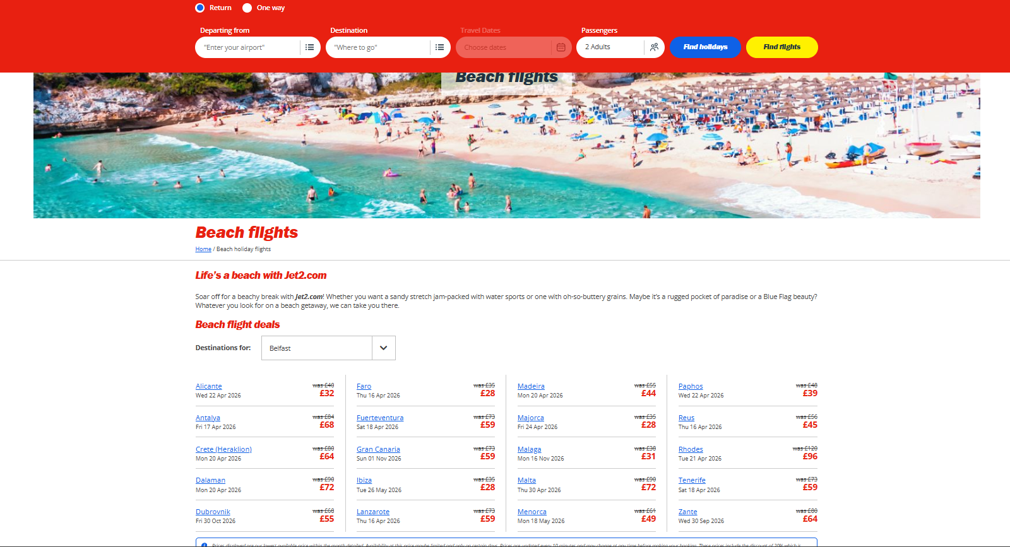
It should be noted that Jet2holidays' CSR strategy is linked with its overall business strategy in terms of its contribution toward achieving its goals.

3.2 Environmental Responsibility (Reducing Carbon Footprint, Sustainable Travel Programmes)

Environmental responsibility plays an important role at Jet2holidays, which is one of the key elements of corporate social responsibility programmes. One of the main areas of attention is the reduction of carbon emissions when flying. The company provides for investments in the purchase of environmentally friendly aircraft and efficient flights, which will result in reduced fuel consumption
In addition, Jet2holidays works with eco-certified hotels and suppliers to ensure sustainable tourism. The measures include the minimization of plastic products in hotels and airports, the development of energy-efficient infrastructure, and encouraging customers to behave responsibly during their holiday trips.
The company implements environmental policies in other ways as well. For instance, technological innovations allow Jet2holidays to implement paperless booking procedures, as well as energy savings in the course of business activities. The company not only reduces the ecological burden on the environment but also responds to customers' demands for environmentally friendly solutions.

3.3 Social Responsibility (Customer Welfare, Community Involvement)

The corporate social responsibility approach of Jet2holidays includes not only concerns about customer welfare but also those related to the community. Specifically, customer welfare is guaranteed through making sure that all flight inclusive package holidays offered by the company are covered by ATOL (Air Travel Organiser's Licence), offering customers financial protection and security in case of travel issues.
At the same time, communities where the company operates can also benefit from its activities in terms of being provided with employment, donations, and volunteer work. This way, Jet2holidays makes a socially positive contribution and creates strong ties within local communities.
Overall, it becomes apparent that Jet2holidays pays particular attention to social responsibilities which are an integral part of the company's CSR policy as it allows for generating competitive advantage by benefiting society.

3.4 Integration of CSR Activities within Company Strategy

There are clear connections between CSR activities and business strategy for Jet2holidays since the company implements sustainability and social responsibility to differentiate itself in the competitive environment. Notably, environmentally friendly actions of the firm (i.e., carbon reduction, green hotels, and efficiency of processes) contribute to reducing the ecological footprint as well as appeal to ecologically minded customers.
The activities of Jet2holidays regarding social responsibility (i.e., customer care, ATOL protection, and interaction with communities) strengthen customer relations and promote trust, which are crucial components of Jet2holidays' value proposition. Therefore, through the integration of CSR into its strategic management, the company can be sure that it will act ethically when making decisions and implementing marketing and service programs.
Thus, integration allows Jet2holidays to achieve both success and corporate social responsibility at once, proving that profitability and sustainability go hand in hand.

3.5 Critique of the Effectiveness of CSR Initiatives

It can be seen that there have been some important achievements by Jet2holidays in terms of applying CSR initiatives in both environmental and social aspects. The carbon reduction projects, eco-certified hotels and operations management practices have helped the firm to reduce environmental impact, and ATOL-protected holiday packages and customer-based policies contribute to social welfare. At the same time, community programs prove that Jet2holidays has taken into account ethics.
There are some issues related to assessment of the CSR program's effectiveness. Firstly, it is rather difficult to estimate environmental impact and supplier compliance. Secondly, it is not very easy to assess social contribution to the local communities from which the company operates. Therefore, despite positive aspects of CSR initiatives, there is room for improvement.

4. Comprehensive and Holistic View of the Organisation

4.1 Balanced Scorecard Framework (Kaplan & Norton, 1992)

Balanced Scorecard (BSC) is a strategic management tool designed by Kaplan and Norton (1992). The tool provides an overall performance perspective that goes beyond conventional financial indicators in order to achieve sustainable success within an organisation. In relation to Jet2holidays, the balanced scorecard framework considers four main perspectives: Financial, Customer, Internal Business Processes, and Learning & Growth.
In the financial perspective, performance measurement is mainly concerned with revenue growth and profitability. On the other hand, customer perspective concentrates on customer satisfaction, loyalty, and trust. Internal business processes perspective measures efficiency, quality of services provided, and process improvements. Last but not least, learning and growth perspective concentrates on human capital and capacity building within the organization.

4.2 Financial Perspective (Objectives, KPIs, Targets, and Strategic Initiatives)

The financial perspective of Jet2holidays seeks to generate profits and revenues in an effective manner and also maintain good cost controls. It seeks to generate more revenues through expansion of the product lines .Effective management of expenses such as fuel expenses and maintenance of long-term contracts with hotels is part of the effort to control expenses.
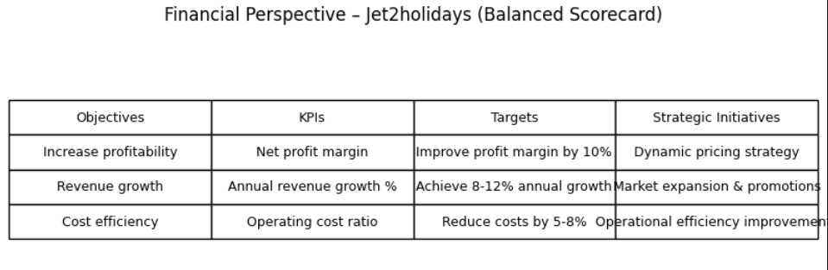
Some of the key goals are monitored using a number of Key Performance Indicators (KPIs), which include net profit margin, revenue per passenger, load factor, and total booking volume. These are important KPIs, as the load factor, for example, will help ensure that flights operate at full capacity, thus increasing revenues.
The organization sets specific financial targets such as steady year-on-year revenue growth of about 10–12%. In addition, it seeks to maintain reasonable profit margins in line with the rest of the travel industry in the UK.
In order to accomplish these objectives, the firm utilizes different strategies such as venturing into areas of high demand for flights like Spain, Greece, and Turkey; adjusting flight schedule and price in response to competition. Increasing flight frequencies in times of increased demand and providing early discount offers on tickets could increase the number of customers and revenues.

4.3 Customer Perspective (Objectives, KPIs, Targets, and Strategic Initiatives)
Objective | KPI | Target | Initiative
Improve satisfaction | NPS | 80%+ | Customer service training

Regarding the customer perspective of Jet2holidays, its objectives revolve around customer satisfaction, customer loyalty, and customer brand trust. Such objectives are vital since the company operates in a competitive environment. Among other things, the company intends to offer quality holidays via quality service, ease of travel, and excellent customer care. An example of such service would be provision of an all-inclusive vacation and efficient airport-to-hotel transportation.
As far as the measures of performance, key performance indicators include such metrics as Net Promoter Score (NPS), customer satisfaction score, and repeat booking rate. For instance, a high NPS would mean that customers are loyal to the company and are willing to promote its products and services among others, which is important for business growth.
Finally, the company identifies several targets associated with its customer objectives. The targets include having high customer satisfaction scores, high customer repeat booking rates, and high brand trust. The targets mentioned above contribute to building long-term relations between Jet2holidays and its customers. For example, an increase in repeat booking rate can be viewed as an indication of customer satisfaction and loyalty.
In order to fulfill its mission, Jet2holidays adopts several strategic measures, such as enhancing customer services, being more flexible in booking procedures, and utilizing digital tools for personalized communication. For instance, giving updates in real-time via mobile applications and making changes to bookings easier makes the process more convenient for customers and improves their relationship with the company.

4.4 Internal Business Processes Perspective (Objectives, KPIs, Targets, and Strategic Initiatives)
As far as the internal business processes perspective is concerned, Jet2holidays aims to achieve greater efficiency in the provision of services by ensuring a proper coordination of activities in all its aspects. In particular, it aims to provide efficient and coordinated transport and accommodation to create a hassle-free holiday experience for its customers. For example, scheduling flights and transports properly contributes to minimizing disruptions.
On the one hand, important KPIs include on-time departure of flights, efficient booking, service efficiency, and costs management. Such measures can reveal how efficiently the operations of the company proceed. On the other hand, among targets, there are high on-time departure rates, booking and service efficiency. They will be achieved through certain measures including investment into new technologies for booking and better coordination between departments.

4.5 Learning and Growth Perspective (Objectives, KPIs, Targets, and Strategic Initiatives)

Finally, the fifth and last perspective relates to employee learning, development, and innovation. It is expected that the development of employees will promote innovations and contribute to sustainable growth. For instance, training customer service representatives will contribute to improved efficiency of services provided to the company's customers.
Some of the most important KPIs would be the staff turnover rate, employee satisfaction levels, and investments in development. Such KPIs reflect how effective the organization is in developing its employees. For example, lower staff turnover implies a healthy work environment and high employee engagement levels.
There will be goals related to skill improvement, employee engagement, and innovation set at a strategic level. The strategic actions will involve training of the staff, leadership development, and using innovative technologies. For instance, the use of digital technologies will enable improvements in efficiency.
5.Strategic Options, Assessment, SWOT and Recommendations
Jet2holidays pursues a differentiation strategy at the business level by providing superior quality holiday packages and flight services compared to cheap prices. Integration with Jet2.com gives Jet2holidays total control over flight operations and offers an advantage over other travel companies such as easyJet Holidays. The introduction of new holiday packages to Greece in 2023 resulted in a 15% rise in reservations, indicating successful implementation of service-oriented differentiation. Corporate-level strategies emphasize market development and product diversification through family holiday packages, luxury breaks, and city breaks for different customer segments.
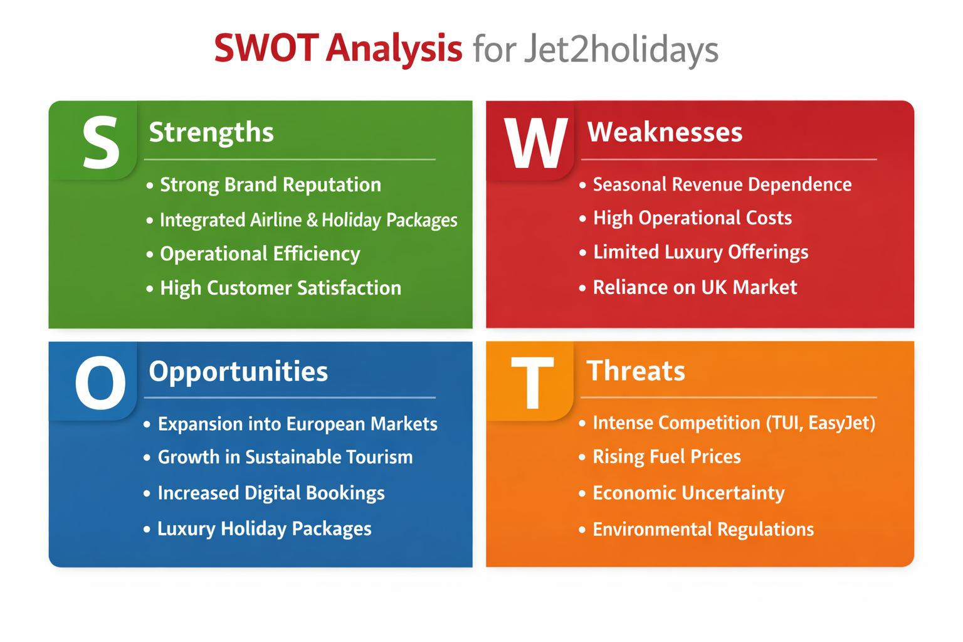
The SWOT analysis indicates strengths in brand image, customer loyalty, and integration, with weaknesses in seasonality. Opportunities include international market development and digital innovation, whereas potential threats arise from competition and high fuel costs. According to Ansoff’s Matrix, Jet2holidays achieves growth through market penetration, market development, and product development.
Financially, the differentiation and development strategies correlate with Porter's (1985) ideas on competitive advantages, ensuring profitability.
Suggestions include improving customer experiences, developing international holiday destinations, digitalization through personalization tools, and sustainability efforts to preserve competitive advantages.

Section 2: Reflective Account

6. Reflective Practice Using Gibbs' Reflective Cycle
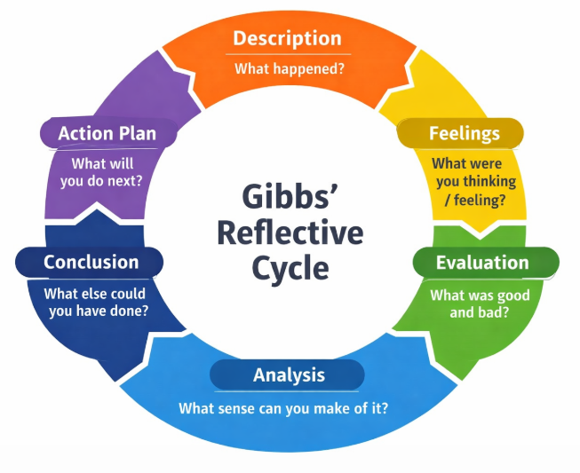

6.1 Description and Feelings
In this part, the focus will be on the internal analysis of Jet2holidays completed through Gibbs' Reflective Cycle. This assignment entailed carrying out internal analysis of Jet2holidays using theories such as VRIO and Corporate Social Responsibility (CSR). The goal of the assignment was to analyze Jet2holidays' internal strengths and resources as well as competitive advantage in the UK travel and tourism sector. VRIO was utilized to analyze the resources of Jet2holidays including its brand recognition, integrated holiday packages, operational efficiency and its relationship with suppliers. The CSR aspect of Jet2holidays entails sustainability, environmental considerations and ethical tourism.
I was at first uncertain about how to apply the frameworks learned in class in a real organization. Even though I was familiar with the theories like VRIO and CSR, I did not know how to apply them practically. However, as I conducted research on Jet2holidays and got to understand what the firm does, I gained more confidence. I realized that theories learnt were practical aspects of business strategy. In particular, during the VRIO analysis of Jet2holidays, I found it challenging to distinguish between valuable, rare and inimitable resources. However, Gained better insights. The most interesting part was CSR since it is connected with the sustainability of the environment.

6.2 Evaluation and Analysis
This assignment provided me with numerous benefits in terms of my academic and analysis skills. First, the main achievement was the application of strategic management techniques such as VRIO and CSR, which assisted in understanding Jet2holidays’ strengths and competitive advantages. In particular, Jet2holidays’ strengths can be explained by the fact that the company possesses a good corporate brand, operational and service integration, as well as a unique business model that distinguishes it from other businesses in the same sphere.
Another skill that has been developed in the process of completing this assignment is associated with critical thinking. Indeed, while initially focusing on describing organisational resources and capabilities, I moved to analysing their significance and value for the company’s competitive advantage. Additionally, through the CSR analysis, I managed to develop an insight into sustainable tourism development and the aviation industry.
Nevertheless, limitations were identified. First, the lack of organisational-level information on CSR made it difficult for me to perform a more critical analysis of this aspect. Besides, some parts of the assignment were initially descriptive, not analytical, meaning that there should have been more criticality involved in those cases. Regardless of these challenges, the task was instrumental for developing my skills in researching and academic writing and applying theoretical knowledge in practical situations. Finally, I learnt about the importance of profit-making businesses' social and environmental responsibilities.

6.3 Conclusion and Future Plans
Summing up, this assignment has been a great experience for developing my skills and understanding of using specific analytical tools in assessing organisations' operations and performance. The assignment helped me develop my confidence in the VRIO and CSR analysis and gain a better insight into how companies like Jet2holidays can achieve and preserve their competitive advantage.
For me to perform better in my subsequent assignments, I will be able to improve my knowledge on strategic approaches through case studies, evaluate instead of describing, and use organization-based information and scholarly sources. Additionally, I will increase my knowledge in the area of corporate social responsibility to make sustainability analysis more in-depth. My time management will also be improved for effective and organized submission of work. Overall, the reflection process has greatly helped my academic growth.

Overall Conclusion
It is evident from this report that an analysis of Jet2holidays has been carried out, where we have analyzed the external environment, resources, capabilities, competitive advantages, and the future directions of Jet2holidays. Through various frameworks like PESTLE analysis, VRIO framework, SWOT analysis, Balanced Scorecard, and Ansoff Matrix, it can be said that Jet2holidays is facing stiff competition within its business, which is a travel and holidays business sector. Despite the difficulties faced by Jet2holidays due to various external factors, the company still performs extremely well because of its integrated business system.
The analysis of the resources and capabilities of Jet2holidays suggests that there are several significant strength points in Jet2holidays that enable it to compete better than its competitors in the UK travel market. The efficient operations, outstanding customer services, and integrated holiday packages of Jet2holidays are some of the strengths that give it a sustainable competitive advantage and a solid position within the UK travel market.
To sum up, Jet2holidays is an established firm and a competitor, which has good grounds for success in the future. Its dedication to customer satisfaction and effectiveness ensures that it performs well now, but in order to succeed in the future, Jet2holidays must learn to adapt to environmental factors, improve its corporate social responsibility strategy, and innovate.

References:
Jet2 plc (2025) Annual Report 2025. https://www.jet2plc.com
Jet2 plc (2024) Annual Report 2024. https://www.jet2plc.com
https://www.iata.org/en/publications/newsletters/iata-knowledge-hub/the-evolving passenger-journey-global-satisfaction-trends-for-airlines/
Jet2 plc (2023) Annual Report 2023. https://www.jet2plc.com
Jet2 plc (2026) ESG Report. https://www.jet2.com
Jet2 plc (2025) Sustainability Report. https://www.jet2.com
Jet2 Holidays (2025) Company Overview. https://www.jet2holidays.com
Jet2 News (2025) Corporate Updates. https://www.jet2.com/news
Jet2 Investor Relations (2025). https://www.jet2plc.com/investors
Barney, J. (1991) Firm Resources and Sustained Competitive Advantage.
Kaplan, R. & Norton, D. (1992) Balanced Scorecard.
Ansoff, H. (1957) Strategies for Diversification.
Porter, M. (1980) Competitive Strategy.
Porter, M. (1985) Competitive Advantage.
Johnson, G., Scholes, K. & Whittington, R. (2017) Exploring Strategy.
Grant, R. (2016) Contemporary Strategy Analysis.
Hill, C. & Jones, G. (2012) Strategic Management.
Mintzberg, H. (1994) The Rise and Fall of Strategic Planning.
Prahalad, C.K. & Hamel, G. (1990) Core Competence of the Corporation.
Figge, F. et al. (2002) Sustainability Balanced Scorecard.
Carroll, A. (1991) CSR Pyramid Model.
European Commission (2020) CSR Strategy. https://ec.europa.eu
United Nations (2023) Sustainable Development Goals. https://sdgs.un.org
World Economic Forum (2024) Sustainability in Aviation. https://weforum.org
IATA (2023) Aviation Carbon Emissions Report. https://iata.org
UK Government (2024) Net Zero Strategy. https://gov.uk
Civil Aviation Authority (2024) UK Aviation Report. https://caa.co.uk
OECD (2023) CSR Guidelines. https://oecd.org
World Tourism Organization (UNWTO) (2023). https://unwto.org
BBC News (2024) UK Travel Industry Trends. https://bbc.co.uk
Statista (2025) UK Holiday Market Data. https://statista.com
IBISWorld (2024) Travel Agency Industry UK. https://ibisworld.com
McKinsey & Company (2024) Travel Industry Outlook. https://mckinsey.com
Deloitte (2023) Tourism Industry Report. https://deloitte.com
PwC (2024) Global Travel Trends. https://pwc.com
KPMG (2023) Aviation Sector Analysis. https://kpmg.com
World Bank (2023) Global Economic Indicators. https://worldbank.org
IMF (2024) Global Economic Outlook. https://imf.org
Eurostat (2023) Tourism Statistics. https://ec.europa.eu/eurostat
Kotler, P. (2017) Marketing Management.
Armstrong, G. (2020) Principles of Marketing.
McCarthy, E. (1960) 4Ps Marketing Mix.
Keller, K. (2013) Brand Equity Model.
Aaker, D. (1991) Brand Equity Theory.
Porter, M. (2008) Five Forces Framework.
TUI Group (2024) Annual Report. https://tui-group.com
EasyJet (2024) Investor Report. https://easyjet.com
On the Beach (2024) Company Overview. https://onthebeach.co.uk
Ryanair (2024) Annual Report. https://ryanair.com
IATA (2024) Airline Industry Overview. https://iata.org
World Travel & Tourism Council (2024) Economic Impact Report. https://wttc.org

