

MODULE: MARKETING MANAGEMENT
MODULE CODE: LCMB7024
ASSESSMENT COMPONENT 1: MARKETING ENVIRONMENT ANALYSIS

LECTURER’S NAME: LAILA MAAZOUZ

WORD COUNT:2596

STUDENT NAME: Sadrakar Om Prakashbhai
STUDENT ID:2526083

Executive Summary
Netflix and Disney are popular OTT channels and platforms. The report aims to analyse the macro environmental factors impacting both brands. It can be inferred from the analysis that political, technological, and environmental factors are supportive, whereas legal, social, and economic factors are threatening for both the brands. The economic factors impact the profit margins of the customers, whereas the supportive technology factors intensify the growth scope for both brands. As a part of the strategic responses, Netflix have focused on investing in data-driven content and on more expansion. However, Disney has focused on price modifications, impacting the user experience and so on.
Table of Contents
1. Introduction 4
1.1 Clearly introduce the purpose and focus of the report 4
1.2 Provide a brief overview of the selected industry 4
1.3 Importance of analysing the macro marketing environment as part of strategic decision-making 4
1.4 Purpose and focus of the report in relation to strategic marketing management 4
2. Task 1: Critical Analysis of Macro Marketing Environment 5
2.1 Macro Marketing Environment 5
2.1.1 PESTLE Analysis 5
2.1.2 Justification of two specific macro factors 7
2.1.3 Reason for significance 7
2.2 Analysis of Macro Factor 1 7
2.2.1 Impact on Netflix 7
2.2.2 Impact On Disney 8
2.3 Analysis of Macro Factor 2 9
2.3.1 Impact on Netflix 9
2.3.2 Impact on Disney 10
3. Task 2: Strategic Responses 11
3.1 Strategic responses of Netflix 11
3.1.1 Response of Netflix to external challenges and opportunities 11
3.1.2 Ansoff growth model and industrial examples 12
3.2 Strategic responses of Disney 13
3.2.1 Mode of adaptation 13
3.2.2 Ansoff matrix with examples 14
4. Conclusion 15
4.1 Summerisation 15
4.2 Strategic significance of environmental scanning and adaptive marketing responses 15
Reference list 17

1. Introduction

1.1 Clearly introduce the purpose and focus of the report
Strategic marketing management is the robust process of detailing the analysis, formulation and stronger implementation that helps in aligning the overall marketing ventures with the long-term goals and objectives of the business. The overall purpose of the report is to meticulously analyse the macro marketing environment and highlight the major operating strategies deployed by Netflix and Disney, with a major focus on this spectrum of objectives.

1.2 Provide a brief overview of the selected industry
The OTT industry in the UK is highly competitive (Yahoo Finance, 2025). However, the overall dynamic growth is quite slow with excessive saturation. There is a greater emphasis on content differentiation. Evolving needs and expectations of the customer base are a strategic characteristic that is transitioning the overall operational landscape of this entertainment industry.

1.3 Importance of analysing the macro marketing environment as part of strategic decision-making
Organisations need to analyse the macro marketing environment as a part of their robust strategic decision-making that helps to evaluate the existing external opportunities, threats, and overall business risk (Yaneva, 2020). This helps in aligning the long-term strategic objectives and dealing with the market shocks. Thus, it ensures more evidence-based proactive decision-making clarity, leading to operational success and overall organisation growth and development.

1.4 Purpose and focus of the report in relation to strategic marketing management
The entire report is structured for dealing with the critical analysis of the macroenvironmental factors, emphasising the PESTLE framework. This is showcased for both Netflix and Disney, and it also projects the strategic responses of both Disney and Netflix along with reliable strategic models. The report finally concludes with an overall synopsis of the major findings from both tasks. Thus, the scope of the report is quite wide.

2. Task 1: Critical Analysis of Macro Marketing Environment

2.1 Macro Marketing Environment

2.1.1 PESTLE Analysis
Factors | Description | Impact
Political | - UK is a politically stable nation (Freedom House, 2023).  - Supportive trade policies (Government of UK, 2025). | Opportunity
Economic | - 3.0% rise in the inflation (Government of UK, 2025a).  - 5.2% rise in the unemployment rate in the UK (Masud, 2026). | Threat
Social | - Unhappy customer base due to hike in the streaming prices (Brown, 2026).  - Transitioning nature of customers in the OTT. | Threat
Technological | - Supportive technology ecosystem in the nation (Government of UK, 2022).  - £55 billion R&D funding in the nation (Government of UK, 2025a). | Opportunity
Legal | - Media Act implementation, ensuring strict control over OTT (Government of UK, 2026).  - Netflix and Disney to come under stricter vigilance in the UK (Sweney, 2026). | Threat
Environmental | - The sustainability culture exists in the UK (Government of UK, 2022a).  - Preference among the customer base for sustainability and environmental compliance. | Opportunity
Table 1: PESTLE Analysis
(Source: Self-Developed)
The above projected table illustrates the PESTLE analysis as a strategic framework and a relevant tool for analysis in the plethora and multitude of macro environmental forces that impact the OTT industry across the UK. It can be inferred from the table that political technology and environmental forces provide opportunity, whereas economic, social and legal forces create a threat.

2.1.2 Justification of two specific macro factors
Two selected specific metro factors are the economic factors and technology factors. Economic factors are considered one of the vital factors that impact the operation of sustenance and business management, even in the OTT industries, whereas the OTT platforms depend upon the technology influence and the technology framework; these two factors are immensely justified.

2.1.3 Reason for significance
Economic factors hold immense significance as they impact the affordability margin of the consumers, the overall profitability index of the OTT business and the scalability of the content development. On the other hand, technology factors are significant because they impact the overexposure and experience of the customer base (Huang and Ho, 2023). This impacts the adoption rate and overall operations.

2.2 Analysis of Macro Factor 1

2.2.1 Impact on Netflix
- Identification of threats
The economic factors create a high range of categorical challenges for Netflix in the UK. The excessive inflationary pressure increases the cost-of-living expenses that hampers the disposable income range of the customer base (Hameed, Augie and Hassan, 2025). This forces the customer to curtail the subscription expenses. The high unemployment rate limits the household income, and as a result, customers fail to afford the streaming subscription charges. This forces the existing customer base to switch to cheaper alternatives to entertainment. Thus, there is saturation in this industry. This aggravates the hostile environment and causes a viability threat to business operations and marketing management.
- Industrial data
The analysed industrial data indicates Netflix is losing market share because of a lack of entertaining content, rising price hikes, and ongoing newly enforced restrictions on the sharing of passwords. In 2019, the charges in the UK used to be around £7.99 per month to avail the standard plans, whereas now it is £10.99 per month (Conway, 2024). Needless to mention, the threat posed by the economic factors, particularly high inflationary pressure and unemployment rate, is hampering the operational and marketing management of Netflix.
- Implications for competitive advantage
The high unemployment rate hampers the competitive advantage as it triggers the price sensitivity index in the market. It also contracts a brand loyalty margin among the customers. It is quite natural that customers are bound to switch to cheaper platforms or free platforms as a medium for availing entertainment. Focusing on an affordable plan, bringing more organic content, and focusing on the cost-conscious consumer section can be recommended. It needs to impart memorable experiences to the customers.

2.2.2 Impact on Disney
- Analysis of Threats
Economic factors also create an existential threat from Disney, as it hampers the mode of availing subscription from the customer range, leading to slow growth. It creates a dent in the profit margin, creating operational turbulence in maintaining strong performance. The customer's buying behaviour is impacted by the economic situation (Alade, 2023). Thus, this factor is directly raising the threat to the brand.
- Comparative vulnerability or adaptability
Comparing with Netflix indicates that Disney is much more vulnerable, as it is dependent on a few streaming titles. This creates complications in retaining the cost-conscious customer segment during economic fluctuations.
- Implications for market position
The excessive inflationary pressure and unemployment rate hamper the market position and reduce the demand for the OTT content. There is a need to focus on bundled offerings, maintaining franchising options and curating pricing to retain the customer base.

2.3 Analysis of Macro Factor 2

2.3.1 Impact on Netflix
- Identification of opportunity
Technology factors provide lucrative opportunities for Netflix. The strong technology ecosystem and high R&D support enable Netflix to provide more personalised content and improve the quality of streaming services. The use of AI for a smooth customer journey and loyalty acts as a strategic game changer (Singh and Singh, 2024). A high-quality infrastructure enables seamless service delivery, improving the marketing mix and marketing management. A strategic partnership enables effective service expansion and a positive user experience.
- Industrial data
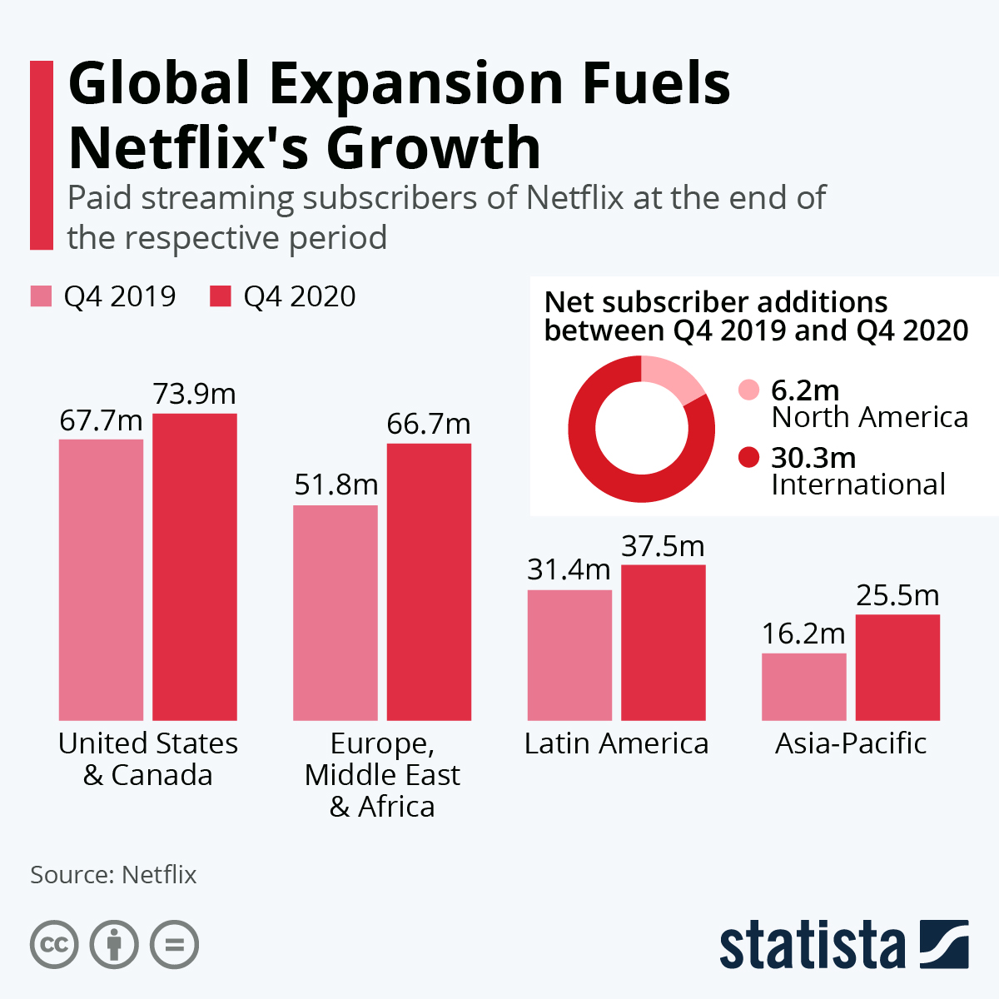
Figure 1: Growth trajectory of Netflix
(Source: Richter, 2021)
The figure projected ever indicates the global expansion of Netflix, along with Europe. The strong technological leverage has catapulted the growth intensity that has fuelled the subscriber additions. In 2024, Netflix has been able to retain and pool a larger audience base (City St George’s, 2025). Thus, the technology factor has a positive impact on Netflix.
- Implications for competitive advantage
Stronger R&D support and a supportive technology ecosystem have amplified the strength of the competitive advantage of Netflix. It helps to switch to advanced personalisation, quick innovation, adaptation, and working on prompt differentiation, which helps to retain the customer base in the UK.

2.3.2 Impact on Disney
- Opportunity
From the perspective of Disney, the technological support system provides an opportunity to modify the content. It also provides scope for improving production efficiency. Thus, the tech-savvy audience can be retained along with the expansion of the digital offering across the competitive OTT landscape.
- Comparative vulnerability or adaptability
Disney has focused on robust adaptation in the UK by integrating Disney+ with various local platforms (BBC, 2020). This helped to improve the market share and expansion. It has also taken advantage of the supportive technology factors for improving the user experience, in contrast to Netflix. Dolby Vision HDR and 4K support are some of the latest adaptations initiated (Archer, 2024). The marketing channels have been modified, triggering the expansion.
- Implications for market position
The technology adaptation has improved the market position to a certain extent. It has helped to compete effectively with various other competitors, which has impacted the brand loyalty margins.

3. Task 2: Strategic Responses

3.1 Strategic responses of Netflix

3.1.1 Response of Netflix to external challenges and opportunities
Netflix, as a Pioneer organisation, has been responding to the high economic pressure, such as the unemployment rate and inflation, by focusing on a low-cost pricing range for the bundle of OTT. The high inflationary pressure and unemployment have triggered the customer sentiments towards switching to cheaper alternative subscription plans. However, this has been challenging in terms of maintaining the desired profit margin. On the contrary, the stock of Netflix has fallen by 30% in the past 2 months of operation (Forbes, 2026). With consistency in price hikes, there is a high risk of customer churn that can further intensify the tension between affordability and profitability margin. On the other hand, the technology factors are quite supportive in the UK, and Netflix has benefited from the advanced technology ecosystem. It has improved the quality of data-driven content. High R&D support from the government has helped to improve the streaming infrastructure. The number of shows for the UK customer base has also been modified and enhanced. Focus on public relations, active advertisements have been emphasised. However, previously, rate cuts in 30 different countries were declared, but recently, the pricing in the UK has been increased (Harris, 2025). Strong brand positioning has also been intensified.

3.1.2 Ansoff growth model and industrial examples
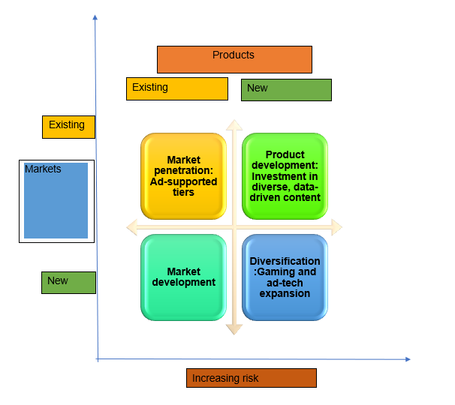
Figure 2: Ansoff matrix of Netflix
(Source: Self-Developed)
The above projected figure indicates the Ansoff matrix that helps to frame strategic responses by Netflix in connection to the existing multitude of external challenges and opportunities. In the market penetration, it has introduced the concept of ad-supported tiers (Rizzo, 2024). It has started operating on a low-cost pricing margin to retain the price-conscious customer segment. In the product development, more investment inflows have been channelled towards data-driven content management. Needless to mention that the R&D support provided by the UK government has been utilised strategically. However, on the contrary, the rising costs are quite challenging. On the other hand, the market development has been less emphasised. This is particularly because of the huge unemployment pressure acting as a major roadblock. In the diversification, Netflix opted for using gaming and ad-tech expansion (Varghese and Lamba, 2025). This reflects the innovative clarity of the brand strategically. This is the outcome of the advanced market information system and marketing management utilised by Netflix. It indicates the mode of information gathering to improve decision-making. This has mainly been undertaken by considering the needs and expectations of the target customer profile.

3.2 Strategic responses of Disney

3.2.1 Mode of adaptation
Disney, as a follower organisation, tries to adapt towards existing opportunities and situations of risks due to adverse economic and supportive technological factors. As an organisation, Disney tries to balance the high inflation and unemployment rates as part of the economic challenges. It has emphasised diversifying its overall revenue streams (Sawalka, 2026). It also maintains its robust adaptation by opting for price discrimination. It has also integrated sustainable marketing options, which have positively impacted the marketing management. It has become a powerful driver to deliver positive, sustainable messages (Srivastava, Rakhee and Singh, 2025). This helps to maintain steady demand to a certain extent across the situation of reduced consumer spending.

3.2.2 Ansoff matrix with examples
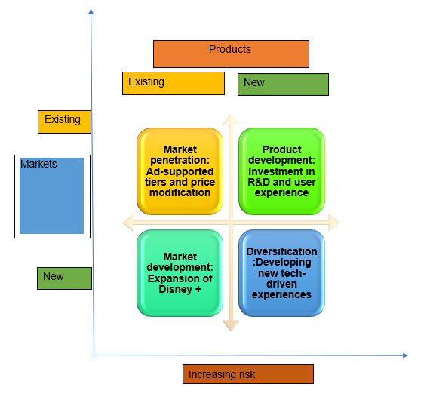
Figure 3: Ansoff matrix of Disney
(Source: Self-Developed)
The figure projected above indicates the Ansoff matrix of Disney. As a part of the market penetration, Disney has diversified its revenue streams and introduced the ad-supported tiers (Sherman and Gerken, 2023). Disney has also switched to price modification. Modification of the pricing and using price discrimination has helped to maintain a certain level of demand in the situation of reduced consumer spending due to high inflation and unemployment rates. Proper marketing management has also help to showcase these developments in front of the customer base, triggering the customer sentiments towards the brand. Similarly, as a part of product development, it has utilised the existing R&D support of the nation to modify and blend the user experience. However, on the contrary note, this can create a dent in the profit and can complicate the long-term goals and stability. As part of the market development, Disney+ has been expanded overall, leveraging the tech ecosystem (Disney, 2026). This has helped to expand the reach of Disney and has facilitated its emergence as a significant market competitor with Netflix. Lastly, as a diversification, a new tech-driven experience, for example, like the metaverse, has been stated to be developed to smooth out the customer journey and brand loyalty (Marr, 2022). However, on the contrary note, it has drastically expanded the capital exposure in the situation of excessive economic turbulence.

4. Conclusion

4.1 Summarisation
Both Netflix and Disney are popular brands in the OTT industry. The report focuses on analysing the macro environment and factors impacting the operational sustenance and management of both brands. It focuses on critical analysis of the macro marketing environment, which indicates that in the nation, political, technological, and environmental factors are highly supportive. On the other hand, legal, social and economic factors are quite threatening for the industry. The specific actors impact the operational sustenance, and technology influences. It is further significant because it impacts the purchasing power of the consumer and the ability to deliver promising services to the customer as a primary stakeholder. The economic factor creates high challenges in terms of excessive inflationary pressure and unemployment rate for Netflix and Disney. Similarly, the technological factor serves as the strongest scope for boosting the overall productivity leverage for Netflix. As a part of a strategic response, Netflix has opted for ad-supported tiers, invested in data-driven content, and acted for expansions and so on. On the other hand, Disney has also focused on price modification and meticulous use of R&D, impacting the user experience.

4.2 Strategic significance of environmental scanning and adaptive marketing responses
Environmental scanning and adaptive marketing responses for both brands help in closely monitoring the external factors impacting the operations and management, whereas the adaptive marketing response helps to amplify the strength of marketing management. This helps to modify the product and service offerings with the essential input and keep the business right on track with operational goals.

Reference list
Alade, O. (2023). The Influence of Socio-Economic Factors on Consumer Behavior: A Theoretical Explanation of Reasoned Action. ResearchGate. [online] Available at: https://www.researchgate.net/publication/375670342_The_Influence_of_Socio-Economic_Factors_on_Consumer_Behavior_A_Theoretical_Explanation_of_Reasoned_Action.
Archer, J. (2024). Disney Adding Dolby Vision To Future 4K Blu-Ray Releases—Starting With ‘Deadpool & Wolverine’. Forbes. [online] 29 Sep. Available at: https://www.forbes.com/sites/johnarcher/2024/09/29/disney-adding-dolby-vision-to-future-4k-blu-ray-releases-starting-with-deadpool--wolverine/ [Accessed 08 Mar. 2026].
BBC (2020). Disney+ to launch a week earlier than planned in the UK. [online] BBC News. Available at: https://www.bbc.co.uk/news/technology-51189379 [Accessed 11 Mar. 2026].
Brown, C. (2026). UK households push back on streaming price hikes. [online] Ey.com. Available at: https://www.ey.com/en_uk/newsroom/2026/01/uk-households-demand-better-value-streaming [Accessed 17 Mar. 2026].
City St George’s (2025). City St George’s, University of London. [online] Netflix is snapping at the heels of the BBC. But there’s more to the battle than just viewing figures. Available at: https://www.citystgeorges.ac.uk/news-and-events/news/2025/january/netflix-overtakes-bbc-one [Accessed 15 Mar. 2026].
Conway, A. (2024). The Problem with Netflix. [online] The Glasgow Guardian. Available at: https://glasgowguardian.co.uk/2024/01/26/the-problem-with-netflix/ [Accessed 17 Mar. 2026].
Disney (2026). Sky and Disney announce expanded multi-year agreement, making Disney+ available to millions more customers in the UK & Ireland. [online] UK Press. Available at: https://press.disney.co.uk/news/sky-and-disney-announce-expanded-multi-year-agreement-making-disneyplud-available-to-millions-more-customers-in-the-uk-ireland [Accessed 08 Mar. 2026].
Forbes (2026). The Risks Stalling Netflix’s 2026 Momentum. Forbes. [online] 10 Mar. Available at: https://www.forbes.com/sites/greatspeculations/2026/03/10/the-risks-stalling-netflixs-2026-momentum/ [Accessed 09 Mar. 2026].
Freedom House (2023). United Kingdom: Freedom in the World 2023 Country Report. [online] Freedom House. Available at: https://freedomhouse.org/country/united-kingdom/freedom-world/2023 [Accessed 17 Mar. 2026].
Government of UK (2022a). Environmental Sustainability and the UK Competition and Consumer regimes: CMA Advice to the Government. [online] GOV.UK. Available at: https://www.gov.uk/government/publications/environmental-sustainability-and-the-uk-competition-and-consumer-regimes-cma-advice-to-the-government/environmental-sustainability-and-the-uk-competition-and-consumer-regimes-cma-advice-to-the-government [Accessed 07 Mar. 2026].
Government of UK (2022b). Technology article great.gov.uk international. [online] Business.gov.uk. Available at: https://www.business.gov.uk/invest-in-uk/investment/sectors/technology/ [Accessed 07 Mar. 2026].
Government of UK (2025a). £55 billion R&D funding boost to unlock UK breakthroughs from health to clean energy. [online] GOV.UK. Available at: http://www.gov.uk/government/news/55-billion-rd-funding-boost-to-unlock-uk-breakthroughs-from-health-to-clean-energy [Accessed 17 Mar. 2026].
Government of UK (2025b). Inflation and Price Indices - Office for National Statistics. [online] ons.gov.uk. Available at: https://www.ons.gov.uk/economy/inflationandpriceindices [Accessed 12 Mar. 2026].
Government of UK (2025c). The UK’s Trade Strategy. [online] GOV.UK. Available at: https://www.gov.uk/government/publications/uk-trade-strategy/the-uks-trade-strategy [Accessed 17 Mar. 2026].
Government of UK (2026). UK’s video-on-demand services to have enhanced Ofcom regulation. [online] GOV.UK. Available at: https://www.gov.uk/government/news/uks-video-on-demand-services-to-have-enhanced-ofcom-regulation [Accessed 15 Mar. 2025].
Hameed, M., Augie, M. and Hassan, Z. (2025). Sarcouncil Journal of Economics and Business Management under a Creative Commons Attribution-NonCommercial-NoDerivatives 4.0 (CC BY-NC-ND 4.0) International License Determinants of Rising Living Costs and its Influence on Financial Distress and Overall Life Satisfaction Among Households in the Maldives. [online] doi: https://doi.org/10.5281/zenodo.17903277.
Harris, J. (2025). Fury as Netflix hikes UK subscription cost by up to £2 a month with users threatening to cancel. [online] The Sun. Available at: https://www.thesun.co.uk/tech/33225922/netflix-price-rises-uk-2025/ [Accessed 17 Mar. 2026].
Huang, J. and Ho, F.N. (2023). The Role of Open Business Models in Times of OTT Video Innovation: Evidence from Taiwanese Platforms. Emerging Media. doi: https://doi.org/10.1177/27523543231198540.
Marr, B. (2022). Disney: the Metaverse, Digital Transformation, and the Future of Storytelling. [online] Forbes. Available at: https://www.forbes.com/sites/bernardmarr/2022/10/07/disney-the-metaverse-digital-transformation-and-the-future-of-storytelling/ [Accessed 08 Mar. 2026].
Masud, F. (2026). UK unemployment hits 5.2%, highest rate for nearly five years. BBC News. [online] 17 Feb. Available at: https://www.bbc.co.uk/news/articles/c1l7pedyzjeo [Accessed 13 Mar. 2025].
Richter, F. (2021). Infographic: Global Expansion Fuels Netflix’s Growth. [online] Statista Daily Data. Available at: https://www.statista.com/chart/20345/netflix-subscriber-growth-by-region/?srsltid=AfmBOooy8PFqSZSNRL4e4r96kaJ1_gN42GaKCxpVC4Pf8759AGZwhQlK [Accessed 17 Mar. 2026].
Rizzo, L. (2024). Netflix ad-supported tier has 70 million monthly users two years after launch. [online] CNBC. Available at: https://www.cnbc.com/2024/11/12/netflix-ad-supported-tier-70-million-monthly-users.html [Accessed 11 Mar. 2026].
Sawalka, V. (2026). Netflix vs. Disney: Which Streaming Giant Has an Edge Right Now? [online] Available at: https://finance.yahoo.com/news/netflix-vs-disney-streaming-giant-164100462.html?guccounter=1&guce_referrer=aHR0cHM6Ly93d3cuZ29vZ2xlLmNvbS8&guce_referrer_sig=AQAAANiyFEYorQBJYkmWpjfSeDPxMJ8ePqwv_NhBR5-F47HGenc0gNWzoG1SJcEHPA2zqetn09o763is5a5qNVW5makBojSEkuXbG1PBhwn87kzvW8GokWY4-cvJbuXPTJ863tJxgeX-F-3loDZTW9roxczPgMHnKlvN7vjOWzmDCG6z [Accessed 18 Mar. 2027].
Sherman, N. and Gerken, T. (2023). Disney to launch cheaper ad-supported service in UK. BBC News. [online] 9 Aug. Available at: https://www.bbc.co.uk/news/business-66454314 [Accessed 18 Mar. 2026].
Singh, P. and Singh, V. (2024). The power of AI: enhancing customer loyalty through satisfaction and efficiency. Cogent Business & Management, [online] 11(1). doi: https://doi.org/10.1080/23311975.2024.2326107.
Srivastava, S., Rakhee, D. and Singh, P. (2025). The Role of OTT Platforms in Promoting Eco-Friendly Content and Advertising-A Case Study Using SAP- LAP Framework. International Journal of Emerging Technology and Advanced Engineering. [online] Available at: https://www.researchgate.net/publication/392786815_The_Role_of_OTT_Platforms_in_Promoting_Eco-Friendly_Content_and_Advertising-A_Case_Study_Using_SAP-_LAP_Framework.
Sweney, M. (2026). Netflix, Disney+ and Prime Video to come under stricter regulation in UK. [online] the Guardian. Available at: https://www.theguardian.com/media/2026/feb/24/netflix-disney-prime-video-uk-regulator-ofcom [Accessed 07 Mar. 2025].
Varghese, H.M. and Lamba, K. (2025). Netflix’s ad, gaming bets in focus as investors seek clarity on pay-off. Reuters. [online] 21 Oct. Available at: https://www.reuters.com/business/media-telecom/netflixs-ad-gaming-bets-focus-investors-seek-clarity-pay-off-2025-10-20/ [Accessed 18 Mar. 2026].
Yahoo Finance (2025). Growth Opportunities in the UK OTT Media Services Market, 2025-2030 - Local Content and Original Programming are Key to Standing Out in the UK’s Crowded Streaming Market. [online] Yahoo Finance. Available at: https://uk.finance.yahoo.com/news/growth-opportunities-uk-ott-media-115800532.html [Accessed 07 Mar. 2026].
Yaneva, D. (2020). IMPORTANCE OF THE MARKETING ENVIRONMENT ANALYSIS IN THE PROCESS OF STRATEGIC MARKETING DECISION MAKING. Economics & Law, [online] 2(2), pp.24–32. doi: https://doi.org/10.37708/el.swu.v2i2.3.

