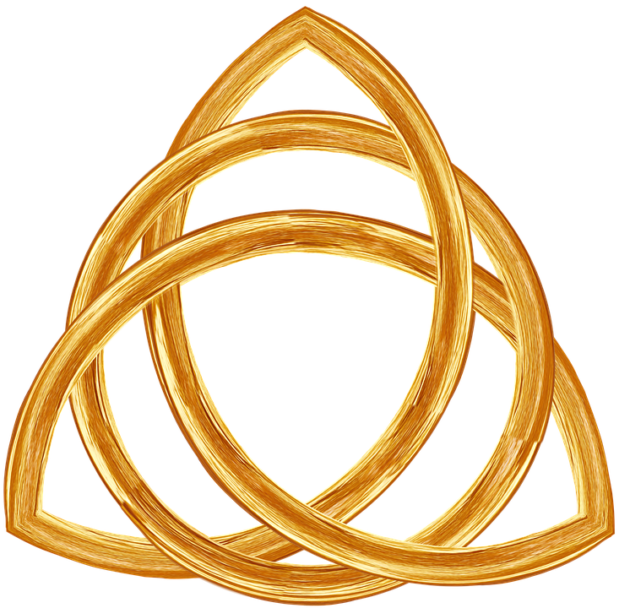 Trinity Hotel 
Address: 13 Helens Road, SA1 3UP, Swansea 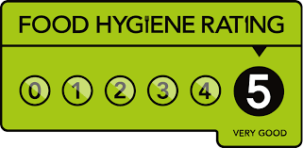
Contact: 029 277 34923
www.trinityhotel.co.uk
Monday – Saturday: 11 am – 10 pm
Take away food menu
Starters:

Mix Welsh Cheese plate
Caerphilly cheddar, Caws Chenarth, Caws Teifi served with grapes and olives
150g – 647 kcal/portion
5,00

Haggis Bon Bons
Breaded haggis balls on a bed of dressed mixed leaves with peppercorn sauce 150g -570 kcal/portion
5,50

Jambo Potato Skins
Jambo potato scoops filled with Cheddar cheese and bacon bits.
175g – 435 kcal/portion
5,50

Mozzarella cheese sticks
Mozzarella cheese sticks sprinkled with pepper and served with white sauce.
150g – 370 kcal/portion
5.00

Honey-Grazed Onion Rings
Sweet Vidalia onions, deep fried in beer batter, glazed with honey
150g – 620 kcal /portion
4.50

If u have a food allergy, intolerance or a special dietary requirement please inform our staff before placing your order.
Mains:

Battered Chicken Fillets
Chicken breast coated in a light crispy batter served with chips and salad
250g – 524 kcal/portion
14.35
Prosecco, Italy 1015

Penne al'Arrabiata
Penne pasta in a tomato garlic spice sauce served with salad garnish
250g - 438 kcal/portion
10,50

Tuna steak
A succulent Tuna Steak served with melted butter, lemon, and herbs
220g – 320 kcal/portion
12,50
Rose - Veneto, Italy 2017

Grilled Salmon
A succulent grilled salmon served with a creamy dill sauce
220g – 245 kcal/portion
12,50

Lamb Chops
Slow pot roasted lamb chops marinated with butter, garlic and served with vegetable
250g – 486 kcal/portion
14,00
Merlot – France, Bordeaux, France 2019
Desserts:

Nutella Crape
1 scoop of gelato and Nutella
150g/576 Kcal
4,95
Chocolate cake
A delicious moist chocolate fudge cake, served with cream or ice cream
150g/ 430kcal
4,95
Ice Cream
3 coup of ice cream different flavours
150g /425 kcal
4,90

Non-Alcoholic drinks:

Orange fresh 0,5 ml/3,00
Lemonade 0.5 ml/ 4.00
Coca-Cola 0,33ml/2,00
Fanta Orange 0,33ml/2,00
Still water 0,5 ml/ 3,00
Sparkle water 0,5 ml/ 3,00

Alcoholic drinks 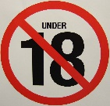

Antonio Fracchin - Prosecco 750 ml 25.00
Italy 2015

Chateau la Roche Merlot organic 750 ml 25.50
Bordeaux, France – 2019

Le Fraghe Rodon Bardolino Chiaretto Rose 750 ml 27.50
Veneto, Italy – 2017

Glenfiddich 40% 0.20 ml 17.50
Single malt scotch whisky

Kids menu
Grilled chicken with mash and steam broccoli/ carrots
Chocolate brownie with ice cream
Hollinger organic fruit juice apple/pear
8.50

Collection – Call when outside & we will place your food in your car boot
Free delivery – during the opening time in all Swansea town area for orders up to £15 by calling 029 277 34923
Payment – we accept cash & card payments

You can find us also in:


References:
- App Store (2022) [store] Deliveroo app. Available at: apps.apple.com/us/app/deliveroo-food-delivery/id1001501844 (accessed:13.06.2022)
- App Store,(2022) [store] Glovo app. Available at: apps.apple.com/gw/app/glovo-more-than-food-delivery/id951812684 (accessed: 13.04.2022)
- App Store (2022) [store] Just eat – food delivery app. Available at: https//apps.apple.com/gb/app/just-eat-food-delivery-uk/id566347057 (accessed:13.06.2022)
- App Store (2022) [store] Uber eats app Available at: https//apps.apple.com/hu/app/uber-eats-food-delivery/id1058959277 (accessed: 13.04.2022)
- Bartec (2022) [official website] Barcode Scanning. Available at: https//www.pixavi.com/use-cases/barcode-scanning-hazardous-areas/ (accessed:13.06.2022)
- Majesti (2022) [online shop] - Chateau la Roche Organic. Available at: https//www.majestic.co.uk/wines/ch-la-roche-organic-bordeaux-61222?gclid=Cj0KCQjwwJuVBhCAARIsAOPwGASb3u8qDl9Iizh_57h4o5ft62m-ggVjF69A3EXyEdZY37qNNx5NNYoaArJ-EALw_wcB ( accessed: 12.06.2022)
- The Sunday times (2022) [vine club] Julien Bouchard Chardonnay. Available at: https//www.sundaytimeswineclub.co.uk/product/3958320?cid=search/JB33/google/productfeed/stwc&istCompanyId=d0a0d765-ebc0-442c-ad34-28954febf47a&istFeedId=2c4d8a44-ac14-4f54-9a8e-ffef68925119&istItemId=pxrxwqrrw&istBid=tztx&gclid=Cj0KCQjwwJuVBhCAARIsAOPwGAQG5zi6FAyq3vrbWxYD0o0iwOIsdcjRuaHT0P0Yd2-yToKKrJ3AhpMaAon0EALw_wcB&gclsrc=aw.ds (accessed:13.06.2022)
- VIVINO (2022) [online shop] Le fraghe – Rodon Bordolino Chiaretto. Available at: https//www.vivino.com/GB/en/le-fraghe-rodon-bardolino-chiaretto/w/1690491 (accessed: 13.06.2022)

