ECO4 scheme does it benefit you
E-PORTFOLIO: REPORT & POSTER ACCA4027 Climate Change
Contemporary Challenges: Making A Difference

BA Animation & VFX / BA Computer Games Design

Philip Richmond
2212266

Contents
Table of Figures 1
Introduction: 2
What is the ECO4 scheme: 2
Technology used: 4
Positives and negatives over renewable energies: 6
Draw backs to the ECO4 scheme. 7
Conclusion: 8
POSTER: 8
Research: 12
References 12

Table of Figures
Figure 1 Technology available [3] 2
Figure 2 [7] Comparison between gas and heat pump. 3
Figure 3 [10] Pros and Cons to air source heat pump. 4
Figure 4 [17] Carbon footprint of set for solar panels vs other means. 6
Figure 5 Mood board for poster. 8
Figure 6 First sketch. 9
Figure 7 My Poster showing light and dark side of energy efficiency. 10

Introduction:
This report focuses on home energy efficiency and the measures taken by the UK government to ensure that residential building use energy in an efficient and sustainable manner. ECO4 goal is to reduce energy consumption, lowering utility bill, and minimizing the environmental impact associated with energy use in homes. This involves insulation, upgrading heating and cooling system, adopting energy efficient appliances, and incorporating renewable energy sources where possible. Sentence on home energy efficiency.
63% of homes in Wales have an EPC rating of D or lower [1]. 23% of domestic buildings in Wales were constructed before 1900 [1]. Over 80% of pre-1930 houses in England and Wales are rated D or worse in energy efficiency [2]. Because of this, retrofitting older properties has become a priority for the government [3].
This is why most of the focus of energy efficiency improvements is on ‘retrofitting’ measures to existing older properties.

What is the ECO4 scheme:

The ECO4 scheme is the fourth and final phase of the Energy Company Obligation (ECO) a government funded scheme in the United Kingdom. The ECO is [1]. This scheme’s main goals are to make homes more energy efficient and help level up fuel poverty by using fewer fossil fuels. This scheme allows households with an EPC Certificate of D or lower to be eligible [4]. Once a house is eligible the customer will need to meet other criteria, including being in receipt of benefits such as:
- Housing benefit
- Income support
- Pension credit
- Universal credit [5]
Once a homeowner has met all the criteria their home will be surveyed for heat saving and energy efficient technology.
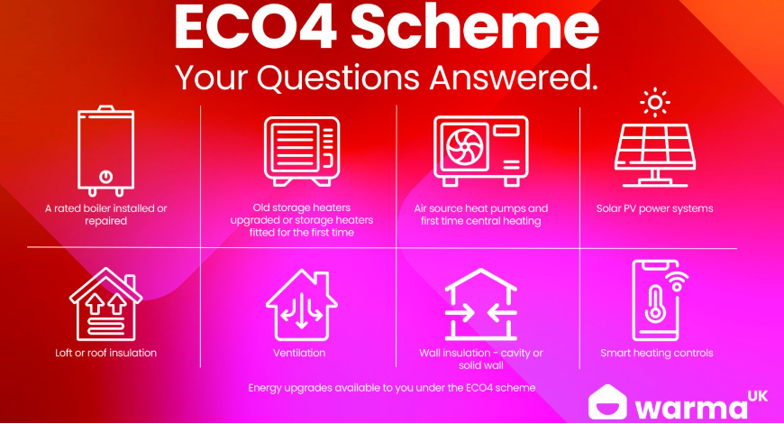
Figure 1 Technology available [6]

Technology used:

- Wall insulation: one of the main reasons for the increase of gas, coal, wood, and electricity bills the lack of insulation on interior and exterior walls [7].

- Heating: the main source of heat consumption generally in most homes is the heating system [8]. With installation of an energy efficient boiler such as an air source heat pump other measures would lead considerable reduction in energy expenditure leading to cost savings and a low carbon footprint [9].

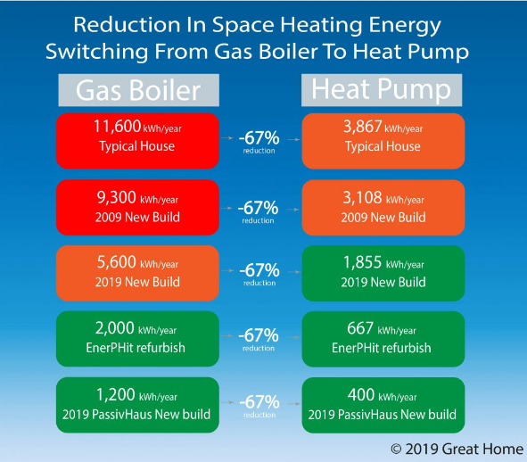
Figure 2 [10] Comparison between gas and heat pump.

- Doors and windows: installation of double or triple glazed doors and windows will provide better installation and therefore lead to reduction in energy bills [11].

- Renewable technologies: solar panels in conjunction with air source heat pump can effectively reduce your electric bill and contribute towards reducing your carbon footprint. [12]

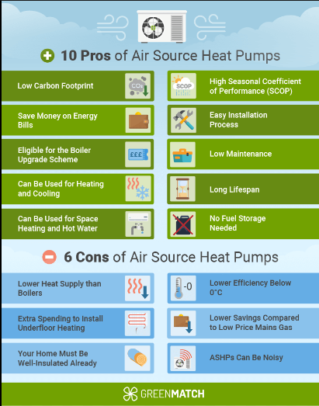
Figure 3 [13] Pros and Cons to air source heat pump.

Positives and negatives over renewable energies:
Positives
- Cheaper energy bills
Solar panels offer an effective means of reducing your electricity coast. [14]
- Free fully funded system
Homes that do not have access to main gas can enhance their property without it costing anything to the homeowner [15]
- Better health
Implementing energy efficiency measures to the local community produces the greatest public health benefits. [16]
- Reduction of individuals carbon footprint
Making small adjustments to one’s daily habits at home can contribute to significant energy savings, effectively reducing both carbon footprint and energy bills. Opting for simple changes in behaviour can accumulate to a more substantial impact than might be anticipated, playing a crucial role in mitigating climate change. [17]
- Growth of new technology jobs
Employment in the renewable energy sector is expanding at a rate four times faster than overall jobs market in the United Kingdom [18]
Negatives
- Renewables availability through the day
Renewable energy sources rely heavily on natural forces, making them weather dependent. Consequently, during adverse weather conditions, technologies like solar may experience reduced effectiveness. [19]
- Startup cost
The initial cost of renewable technologies, despite their potential energy output, can be high and at times unaffordable. Manufacturing and installing devices like PV panels involve relatively expensive processes. Recognizing this financial barrier, governments allocate substantial budgets, including solar panel grants, to support the growth and adoption of these technologies. [19]
The positives above collectively highlight the advantages of renewable energy for the homeowner to take on ECO4 scheme in today’s modern and ever-growing push to renewable technology.

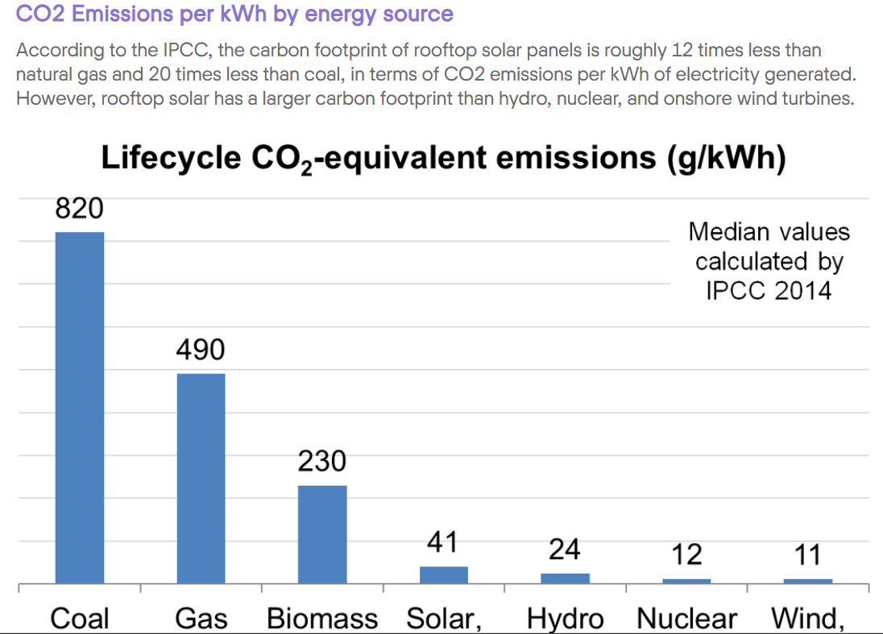
Figure 4 [20] Carbon footprint of set for solar panels vs other means.

Draw backs to the ECO4 scheme.

While there are many companies offering Eco4 scheme installation [21], it is difficult to source online reviews or evidence of their quality of work. At time of writing, only one review for any of these companies could be found and this was highly negative [22]. Research by the Department of Business, Energy and Industrial Strategy states that many tradespeople are installing heating systems with no prior training on carrying out these installations [23]. Due to this, customers confidence in this scheme may be diminished.
The Eco4 scheme does not provide batteries. Batteries allow users to capture unspent energy through the day from the solor panels [24]. Have batteries the homeowner they will have the ability to charge them through the night on a lower energy rated therefore saving money on day theat the solo panels with not the efficient enough.
Some of the new installed technology such as inverter may not be cross compatible with upgrading to own battery storge system there for costing the homeowner more money [25].

Conclusion:

In conclusion the Eco4 scheme gives households that suffer from fuel poverty a way to level up themselves and save money while helping and supporting the environment with reducing their carbon footprint. Not having evidence of these companies’ installation statistics or customer reviews, makes choosing the Eco4 scheme a daunting task of whether homeowners are making the right decision for their household, family, and the future.

POSTER:

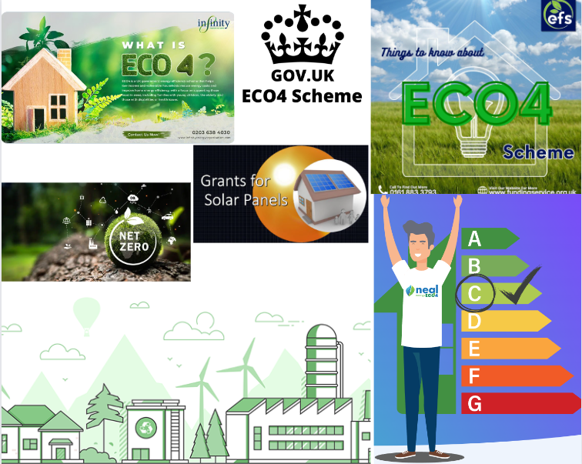
[46]
[45]
[44]
[43]
[42]
[41]
[40]
Figure 5 Mood board for poster.

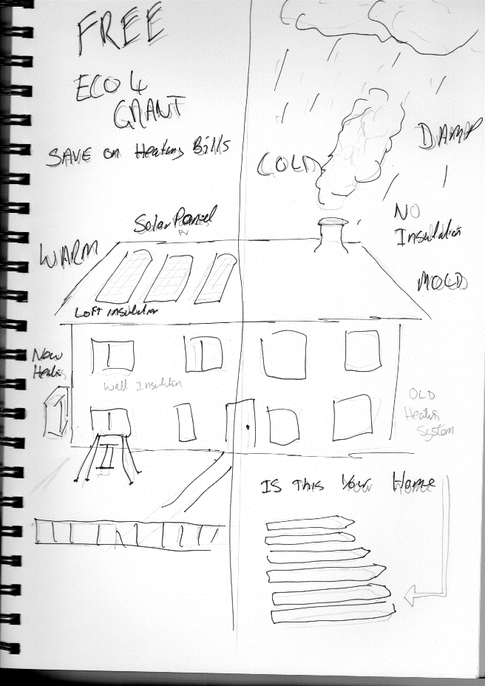
Figure 6 First sketch.
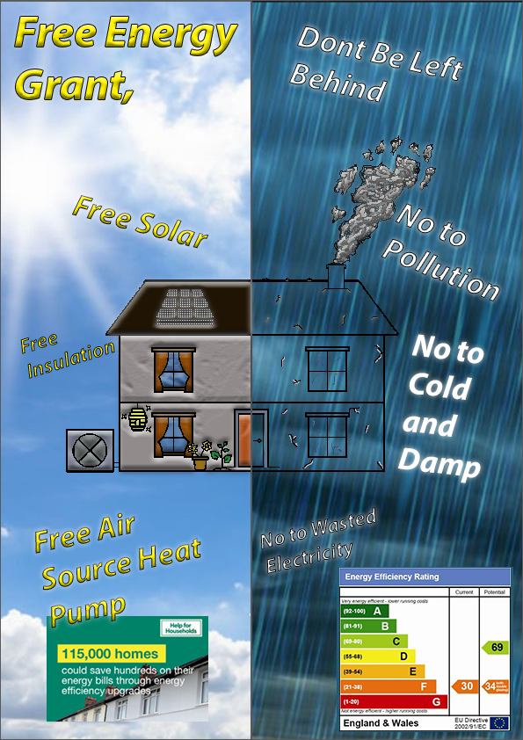
Figure 7 My Poster showing light and dark side of energy efficiency.

Poster Research and Resources:
Software used. [26]
Started off looking for a house and found an image I like with energy efficiency rating table at [27]
Help for household statistics poster [28]
Studied poster design [29]
Sky background [30]
Rain background [31]
Changing textures video [32]

References

[1] | Office for natioanl statistics, “Age of the property is the biggest single factor in energy efficiency of homes,” 2022. [Online]. Available: https://www.ons.gov.uk/peoplepopulationandcommunity/housing/articles/ageofthepropertyisthebiggestsinglefactorinenergyefficiencyofhomes/2021-11-01. [Accessed 01 March 2024].
[2] | Office for National Statistics, “Energy efficiency of housing in England and Wales: 2023,” 2023. [Online]. Available: https://www.ons.gov.uk/peoplepopulationandcommunity/housing/articles/energyefficiencyofhousinginenglandandwales/2023. [Accessed 1 March 2024].
[3] | P. Bolton, “Energy efficiency of UK homes,” House of Commons Library, London, 2024.
[4] | “Find an energy certificate,” [Online]. Available: https://www.gov.uk/find-energy-certificate. [Accessed 02 2024].
[5] | “UK Energy Support,” [Online]. Available: https://ukenergysupport.co.uk/eco4-scheme/?msclkid=64a2f897b2ba1683fe0f9d4644b4681a. [Accessed 02 2024].
[6] | “warma uk,” [Online]. Available: https://warmauk.com/blog/eco4-scheme-your-questions-answered/. [Accessed 02 2024].
[7] | “homebuilding uk,” [Online]. Available: https://www.homebuilding.co.uk/advice/internal-wall-insulation-guide. [Accessed 02 2024].
[8] | “Perch Energy,” 20 12 2022. [Online]. Available: https://www.perchenergy.com/blog/energy/what-appliances-use-most-electricity-home. [Accessed 02 2024].
[9] | M. Brignall, “Air source heat pumps: how the costs and savings stack up,” The Guardian, p. 50, 2021.
[10] | “Great Home,” [Online]. Available: https://great-home.co.uk/reducing-greenhouse-gas-emissions-from-energy-used-in-uk-homes/. [Accessed 02 2024].
[11] | “rix.co.uk,” [Online]. Available: https://www.rix.co.uk/blog/post/how-cost-effective-is-double-glazing-for-me-and-my-family#:~:text=Installing%20double%2Dglazing%20in%20your,fitted%20with%20double%20glazed%20windows.. [Accessed 02 2024].
[12] | “Green Journal,” 30 oct 2023. [Online]. Available: https://www.greenjournal.co.uk/2023/10/what-home-improvements-are-included-in-the-eco4-scheme/. [Accessed 02 2024].
[13] | “Green Match,” [Online]. Available: https://www.greenmatch.co.uk/air-source-heat-pump. [Accessed 02 2024].
[14] | “uswitch.com,” uswitch, [Online]. Available: https://www.uswitch.com/solar-panels/guides/solar-panels-information/. [Accessed 02 224].
[15] | A. southby, “www.walesonline.co.uk,” walesonline, 18 08 2023. [Online]. Available: https://www.walesonline.co.uk/special-features/homes-without-mains-gas-upgrade-27361272?utm_sourc. [Accessed 02 2024].
[16] | B. Magill, “climatecentral.org,” 09 2015. [Online]. Available: https://www.climatecentral.org/news/renewables-benefit-climate-public-health-19397. [Accessed 02 2024].
[17] | “yourcoop.coop,” 08 2021. [Online]. Available: https://energy.yourcoop.coop/help-resources/blog/How-does-renewable-energy-reduce-climate-change/. [Accessed 02 2024].
[18] | A. Lawson, “energy industry,” theguardian, 2023.
[19] | H. Karami, “Green Match,” 20 05 2022. [Online]. Available: https://www.greenmatch.co.uk/blog/2021/09/advantages-and-disadvantages-of-renewable-energy. [Accessed 02 2024].
[20] | “Solar.com,” [Online]. Available: https://www.solar.com/learn/what-is-the-carbon-footprint-of-solar-panels/. [Accessed 02 2024].
[21] | Renewable Energy Hub, “ECO4 Scheme,” 2024. [Online]. Available: https://www.renewableenergyhub.co.uk/main/eco4-scheme/eco4-scheme. [Accessed 1 March 2024].
[22] | “www.trustmark.org.uk,” 2023. [Online]. Available: https://www.trustmark.org.uk/firms/Consumer%20Energy%20Solutions%20Limited-3155731-SA1%203XL?id=00ec742a-c636-4296-be3c-50f802cc8ed3. [Accessed 02 2024].
[23] | E. a. I. S. Department of Business, “Social research with installers of heating systems in off gas grid areas of England and Wales,” BEIS, London, 2021.
[24] | H. Jackson, “otovo,” 2023. [Online]. Available: https://www.otovo.co.uk/blog/photovoltaic-systems/a-guide-to-solar-panel-batteries/. [Accessed 02 2024].
[25] | “The difference between hybrid inverters and battery inverters for energy storage,” [Online]. Available: https://www.hoymiles.com/resources/blog/energy-storage-explained-the-difference-between-hybrid-inverters-and-battery-inverters/. [Accessed 02 2024].
[26] | “Adobe.com,” [Online]. Available: https://www.adobe.com/uk/products/photoshop.html. [Accessed 02 2024].
[27] | “www.westsuffolk.gov.uk,” [Online]. Available: https://www.westsuffolk.gov.uk/environment/reduce-your-impact/energy-saving-advice.cfm. [Accessed 02 2024].
[28] | “£1.8 billion awarded to boost energy efficiency and cut emissions of homes and public buildings across England,” 22 05 2023. [Online]. Available: https://www.gov.uk/government/news/18-billion-awarded-to-boost-energy-efficiency-and-cut-emissions-of-homes-and-public-buildings-across-england. [Accessed 02 2024].
[29] | S. MCGUIRE, “How to Make a Poster in 10 Steps (2024 Poster Design Guide + Templates),” 24 01 2021. [Online]. Available: https://venngage.com/blog/poster-design/. [Accessed 02 2024].
[30] | “Freepik,” [Online]. Available: https://www.freepik.com/free-photos-vectors/sunlight-clouds/74. [Accessed 02 2024].
[31] | “istockphoto.com,” [Online]. Available: ww.istockphoto.com/search/search-by-asset?affiliateredirect=true&assetid=1458311785&assettype=image&utm_campaign=srp_photos_top&utm_content=https%3A%2F%2Funsplash.com%2Fs%2Fphotos%2Frain&utm_medium=affiliate&utm_source=unsplash&utm_term=rain%. [Accessed 02 2024].
[32] | J. W. Co., “Changing Paint Texture Colors in Photoshop,” 13 01 2019. [Online]. Available: https://www.youtube.com/watch?v=OGGcZqwq0cg. [Accessed 02 2024].
[33] | “ECO,” [Online]. Available: https://www.ofgem.gov.uk/environmental-and-social-schemes/energy-company-obligation-eco. [Accessed 02 2024].
[34] | “Solar.com,” Solar.com, 2024. [Online]. Available: https://www.youtube.com/watch?v=j2WnaIN9yg0&t=275s. [Accessed 02 2024].
[35] | “gov.uk,” [Online]. Available: https://www.gov.uk/government/news/training-for-thousands-to-take-advantage-of-green-job-opportunities. [Accessed 02 2024].
[36] | “eco4govscheme.co.uk,” [Online]. Available: https://www.eco4govscheme.co.uk/ecoflex/?gad_source=1. [Accessed 02 2024].
[37] | “heatable.co.uk,” [Online]. Available: https://heatable.co.uk/. [Accessed 02 2024].
[38] | “theguardian,” [Online]. Available: https://www.theguardian.com/environment/2019/mar/12/resource-extraction-carbon-emissions-biodiversity-loss. [Accessed 02 2023].
[39] | “Heatgeek,” Heatgeek, [Online]. Available: https://www.youtube.com/watch?v=BHLpJ5hK80k. [Accessed 02 2024].
[40] | “ENERGYFUNDUK,” [Online]. Available: https://twitter.com/ENERGYFUNDUK/status/1703801053605458160. [Accessed 02 2024].
[41] | “InfinityEnergy,” [Online]. Available: https://twitter.com/InfinityEnergy1/status/1610680003468967936. [Accessed 02 2024].
[42] | “ecopropertydevelopments.co.uk,” [Online]. Available: https://ecopropertydevelopments.co.uk/about-us/eco4-and-other-funding-schemes-6460899. [Accessed 02 2024].
[43] | “eco4.org.uk,” [Online]. Available: https://eco4.org.uk/eco-funding/eco4/. [Accessed 02 2024].
[44] | “nealenergyeco4.co.uk,” [Online]. Available: https://nealenergyeco4.co.uk/eco4-scheme/. [Accessed 02 2024].
[45] | “grantsforsolarpanels.co.uk,” [Online]. Available: https://www.grantsforsolarpanels.co.uk/. [Accessed 02 2024].
[46] | “energygrantaccess.co.uk,” [Online]. Available: https://energygrantaccess.co.uk/guide-to-eco4/. [Accessed 02 2024].

