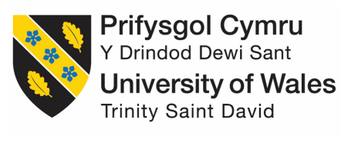

"Discuss and critically evaluate project management process and assess the suitability in the context of the workplace."

Joanne Walker –

Lecturer: Gary MetCalfe

Contents
1. Introduction 3
2. Definitions of Project Management 3
3. Phases of a project 4
4. Project Styles 4
5. Project Management Styles and Processes 6
6. Agile 6
Traditional project management vs agile project management 6
7. Agile Principles & Methods 7
8. Benefits of using Agile as Project Management method (Management, 2022) 8
9. Waterfall 10
10. Waterfall Principles 12
11. In depth discussion into the phases of Waterfall Method (Waseem, 23) 13
12. Lean Project Management 16
13. Lean Project Management Principles 17
14 .Advantages and Disadvantages of Lean Management 19
15 Discussion and Conclusions 20
References 23

Introduction

I work for an educational institute that is classed as a Royal Chartered University, and a Registered Charity that has locations across the UK.

It is governed by its Charter Statues and Ordinances; theses provide a broad framework for the legal structure and governance of the university. Under the Charter and Statues, the Council forms the governing body. The organisation employees over 1200+ employees, with around 53% being academic staff and 47% being non-academic staff. (Department, 2019/2020)

I would like to first define clearly what is a project and the processes involved, before moving on to discussing and critically evaluating the project management process, within my organisation to establish which processes effectively enhance the organisation.

- What is meant by project management?
- what is the project management process?
- What is it made up of?

I would then like to take each process and look at the advantages and disadvantages of these processes. I will then make recommendations based upon my current workplace and how I believe they will benefit the organisation based on my research within this essay.

Definitions of Project Management

The Association for Project Management defines Project Management as the application of processes, methods, skills, knowledge, and experience to achieve specific project objectives according to the project acceptance criteria within agreed parameters. (Edition, 2022)
My management guide describes a project as a unique time and cost limited endeavour undertaken to complete desired objectives within a well-defined lifecycle.
“A project is a temporary, unique, and progressive attempt to produce a tangible or intangible result (A unique product, service, benefit, competitive advantage, etc.) It usually includes a series of interrelated tasks planned for execution over a fixed period and within specific requirements and limitations such as cost, quality, performance, etc.” (Unknown, 2023)

Phases of a project

Within a project there are a number of basic phases that a project will follow they are the following:

Project Initiation - The first stage also known as the Project initiation is an important process where it must be clearly determined if the project has a viable outcome to develop from an initial idea.
Project Planning - The second phase involves project planning, where the projects objectives, scope, goals, and the deliverables are established, including the assignment of tasks and budget availability.
Project Execution- The third phase project execution is it suggests, the point where the team conduct the work on the project.
Project Monitoring and Controlling - The fourth phase involves the project monitoring and controlling runs alongside project execution, to ensure that objections and deliverables are achieved.
Project Closing- The final and fifth phase is the project closure, and indicates the end of the project, and the time when a completion report is produced.

Project Styles
.
There are a number of different types of project management styles that can be adopted, this usually depends on what style the organisation has decided would be a good fit for them. These can range from Agile, Waterfall, Prince 2, Critical Path Method (CPM) or Program Evaluation and Review Technique (PERT).
I will give a brief description of the styles I have found, following this I will analyse three in greater depth.
Agile project management is a type of lean project management it is considered an iterative approach to delivering a project through its life cycle, they are most frequently used in software development projects as they allow more velocity and adaptability, as agile allows for adjustment as you go along, rather than being so linear. One other aim is that benefits can be released along the way rather than at the end of the project. (Anon., 2023)
Waterfall project management is when a project is completed in sequential steps, the name is given as each phase of the project cascades into the next, like a waterfall. Industries that most commonly use this method would be construction, and IT software development. With the waterfall method, the next stage cannot commence until the previous one is completed. This kind of style works best for projects that have a comprehensive plan that requires a single timeline. This style does not like there to be any changes, as this can result in requiring a whole new plan put together which would be timely and costly. (Anon., 2023)
Prince 2 project management is described more as a methodology, which puts the emphasis on organisation and control, it stands for PRojects IN Controlled Environments. This method focuses more around moving initiatives through pre-defined stages. Prince2 is often recommended for beginners to projects, as its processes are clearly defined. (Malsam, 2021)
CPM project management is described as a step-by-step technique for process planning that defines critical and non-critical tasks with the goal of preventing project schedule problems and process bottlenecks. Ideally used when projects consist of numerous activities that interact in a complex manner. (Asana, 2021)
PERT project management is a method used to calculate the minimum amount of time a project will take to complete. (Anon., 2023)
Lean project management is the application of lean manufacturing principles to the practice of project management. (Anon., 2023)
Following this research into the different styles, I have decided to discuss and critically evaluate Agile and Waterfall project management and analyse how they would work within my organisation.

Project Management Styles and Processes
The project management process is essential for successful completion of projects in the workplace.
In this section I will look in more detail at different styles of project management and analyse the pros and cons of using these styles. From this I will then choose two management styles to critically analyse based around the lifecycle of event planning which is an area I use project management. I am going to look at Agile, Waterfall and Lean and will provide a conclusion on the best one to use for my organisation.

Agile
Agile is a philosophy that concentrates on empowered people and their interactions and early and constant delivery of value into an enterprise. Agile has enduring appeal and proved itself in development.
Agile project management is a repetitive approach to delivering a project through its life cycle. The life cycle is composed of several repetitive or incremental steps towards the completion of a project.
One of the main aims of this style of project management is to release benefits throughout the project rather than only at the end of the project. Agile projects should exhibit central values and behaviours of trust, flexibility, empowerment, and collaboration.

Traditional project management vs agile project management
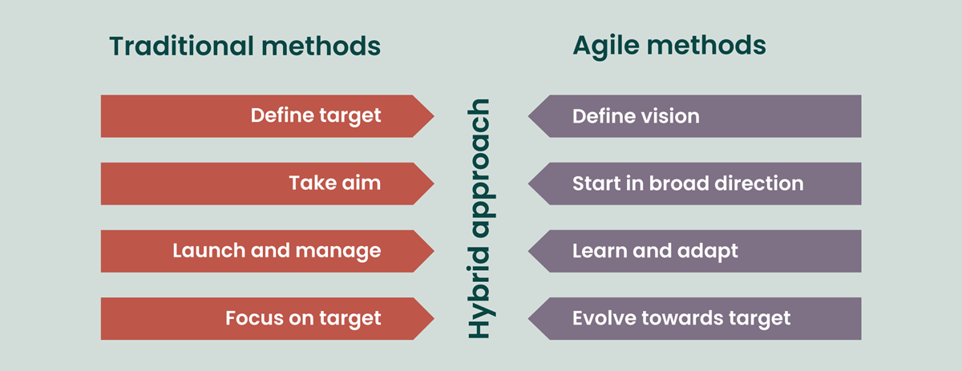
Figure 1 - Traditional vs Agile Project Management

Agile Principles & Methods

Agile working favours the following principles,
- Customer collaboration over contract negotiation
- Individuals and interaction over process and tools
- Responding to change over following a structured plan
- Prototyping /working solutions over comprehensive documentation.
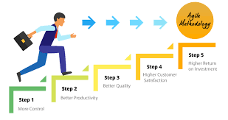
Figure 2-Agile methodology
- In agile project management, how the project is delivered is driven by the team working with the end users, the focus is on a deliverable. By allowing the end user to drive the design of a project, this can make a dramatic difference to the outcome of the project. Agile favours collaboration, and a particular focus on customer satisfaction, quality, and teamwork.

- Agile emphasises on working through a project and having a consensus rather than control. The team focus on achieving benefits from engagement, accountability, sharing of data and learning from feedback.

- An agile environment establishes a minimum viable product, the core project deliverable to trigger the start of a delivery.

- The delivery team focus on the solution to a problem to allow them to deal with it. The team make constant adjustments to the scope of the product.
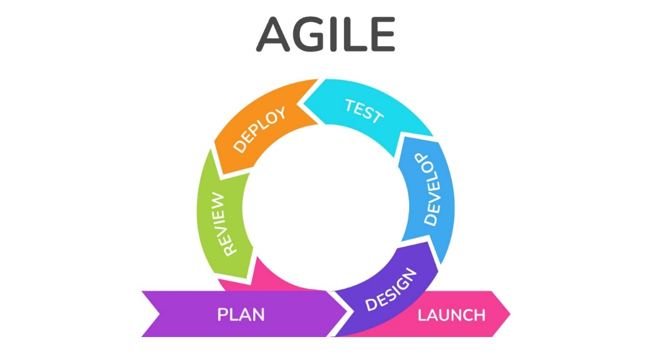
Figure 3- Agile method

Benefits of using Agile as Project Management method (Management, 2022)

Less prone to Error
Requirements of the project are checked throughout the duration of the project.
More Flexible
Agile focuses on shaping the project to the customers specification and is also able to be changed as the project progresses. Agile allows the customer to see a working version of the project early on.
More Predictable end product
Testing continues to be monitored throughout the project; this allows the end user to make any changes/amendments early in the project. This also allows the project team to ensure the project finishes on time and on budget.
More open to changes/additions
Agile can adapt to change and anticipates them and plans for them.
More customer involvement
Agile works very closely with the customer and involves them being part of the implementation team.

There are equally disadvantages caused by some of the benefits of it:
Less Predictable
Although flexibility was a benefit, this can equally cause less predictability. Which means it can be more difficult to accurately estimate resources and time required to complete a project.
More time and commitment
Due to the collaboration involved this can take more time and effort.
Greater demand on developers and clients
Agile requires that everyone involved is committed, otherwise it can have a negative impact on the project.

Lack of necessary documentation
As tasks are completed just in time for development under this method, documentation tends to be less thorough.
Projects easily fall off track
Less structure involved in this style of project management means projects can easily go astray or run beyond the original scope of the project.

Waterfall

The waterfall method is one of the oldest project management procedures that is on the market, although construction & manufacturing firms had traditionally used similar methods, it was not formally recognized until Dr Winston Royce introduced the idea. (Waseem, n.d.)
The concept of the waterfall method was derived in 1970, he developed it to manage the development of large software. A project proceeds in a linear order from its conception, each phase the leading onto the next with deviation. This allowed it to gain support from managers very quickly, as they found the concept an easy one to follow for their staff. It has become a popular choice for software development projects and other sequential fields of work.
It is named as the waterfall, due to the way it mimics a waterfall in its trajectory, as water flows down in direction, the process would flow form one step to another. Due to this the process does not allow for returning to previous phases very easily, without returning to the beginning.

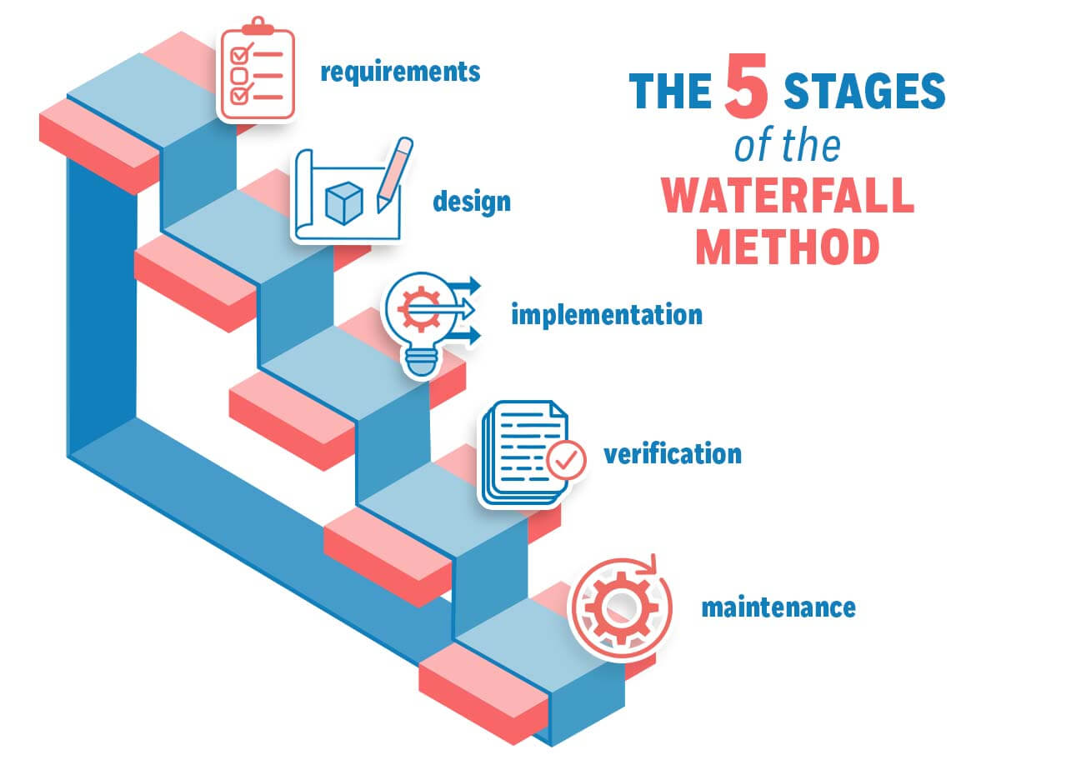
Figure 4- Waterfall Methodology (Waseem, 23)

Waterfall project management is a commonly used method of project management due to the straightforward approach it uses. When it maps out the process, the key part of the phases of the cycle is that until one phase is complete then you cannot commence onto the next phase.
All team members are working towards a linear end goal, they each have a defined role within the project, and that role does not change and their goals.
Waterfall project management works well for projects that require long detailed plans, that only require a single timeline, changes are often costly and not straightforward to implement so they are discouraged. Waterfall stages look different to the traditional method of project management there is more work involved for the project manager before the project starts.
Project Manager is required to gather all the requirements of the project and the documentation involved; they must then design the projects workflow model. Following on from this the team becomes involved and they begin to put the system into practice. Each element is then evaluated to ensure that it works and will fulfil the requirements of the project. Deployment or delivery follows on from this, at which the service or product is officially launched and then the final stage which is an ongoing stage, the team performs upkeeps and maintenance on the product or service.
The waterfall model came out of strict processes that have been used in industries such as construction and manufacturing, the approach it uses are highly focused on creating the best possible final product, when there is little room for adjustment on completion of the project.

All management processes will follow a set of principles and should be looked at when considering the best management process to use for the project or event.

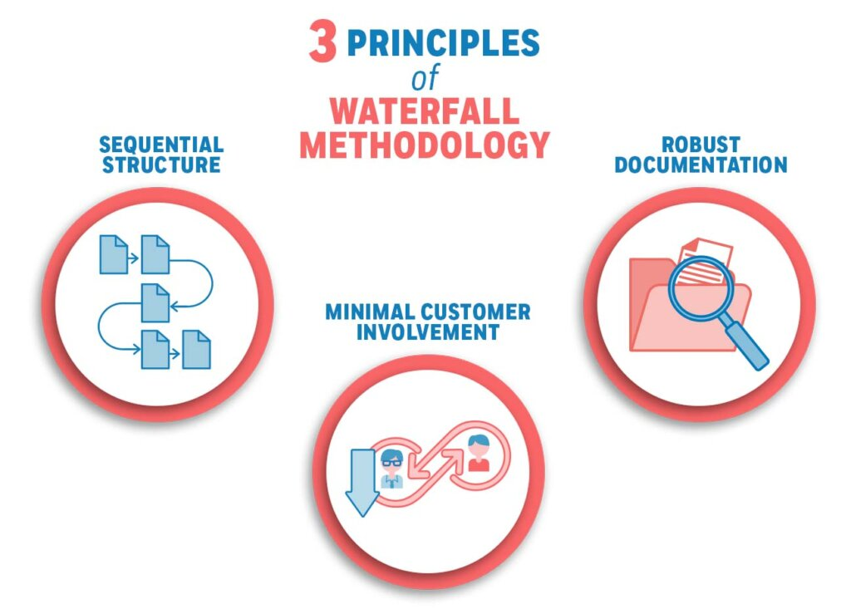
Figure 5- Waterfall Methodology

Waterfall Principles

There are three basic principles with the waterfall methodology:
Sequential Structure
The model divides the operations in sequential phases. Until each phase is completed you cannot move onto the next phase. You are unable to change course or revisit a phase once it has been completed. The only way to go back is to start at the beginning.
Minimal Customer Involvement
There is little customer involvement in this method, this is due to the process only commencing after the customer requirements and objectives have been defined. There is an initial meeting before operations take place, and then next when the project is in its final stages.
Robust Documentation
There is in detail documentation of al the requirements, the development and expected outcome all defined before the process starts. Included in this is the timeline and the precise route that will be taken to solve the client’s problems/projects. Due to the lack of customer involvement this process needs to be heavily documented ahead of commencing the project.

In depth discussion into the phases of Waterfall Method (Waseem, 23)

Stage 1: Documenting Requirements
Waterfall model requires that information be obtained from clients and end users, of their requirements and expectations from the product/service, this information needs to be extensive to allow the process to commence, and not need to revert to the beginning due to lack of information.
This is known as a planning phase and is also the last one where communication is had with the client before the project starts. It is essential that everything and be mapped out and taken in the correct direction.
After scoping out all the necessary information to move forward with the project, there must be a clear description of all the upcoming phases in detail. This must include timelines, costs, risks, assumptions, and dependencies of the project.
Stage 2: Design
The design phase is also known as the analysis stage, this is the stage where a review of the requirements, and a design is developed to meet them. There is logical design and physical design at this stage.
Stage 3: Implementation
At this stage, the this is where the project starts to take shape, and the shortest stage as the design is already in place. The team will now be following the documentation form the first two phases to carry out the deliverables.
Stage 4: Verification
Following the completion of the implementation phase, this is the stage where all requirements are checked to ensure they have been met. At this stage it is critically examined before being delivered to the client.
Stage5: Maintenance
This stage commences after the product/service has been released and users have started to use it. Some issues can only be identified once the client has started to use it. If a fault is found, then this is the team that would take care of it. The stage ends when the client is completely satisfied or if they wish for frequent updates then it would continue.
When is the best time to use Waterfall Methodology?
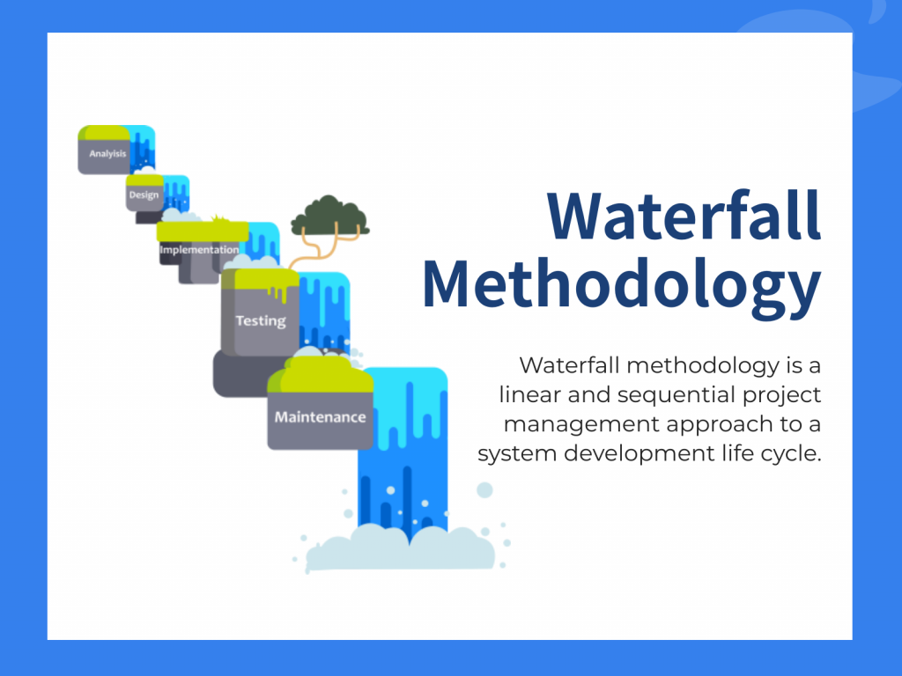
Figure 7- Waterfall Methodology
Kate Eby a content manager at Smartsheet , has many years of experience when planning , managing and tracking projects, she has produced a Smartsheet which looks at both Waterfall and Agile project management and discusses the pros and cons of using one over the other. (Eby, 2023)
She has clearly documented when would be the best times to use the Waterfall method as:
- Requirements are well understood and not likely to change.
- Customer is not prone to demanding changes.
- Customer does not want to be involved at development stage but wants to be consulted at the beginning and end.
- The project is small.
- Speed of delivery is not important.
- Similar projects may arise in the future, allowing for reuse of the project plan and glean lessons from the heavy documentation obtained on a previous project.

She also highlights some of the benefits of a waterfall project as:
- Simple, straight forward approach
- Easy to develop a plan for managing a waterfall project, since all phases have a start and an end.
- Easy to plan resources.
- Clients have a definitive date, and the product is delivered on that date.
- Cost can be determined in advance.
- Team members have more flexibility when working on the project.
She highlights the drawbacks of waterfall project as:
- This is not an appropriate project management method for larger projects.
- Waterfall method has little or no flexibility.
- Changes are not received well in this style.

Lean Project Management

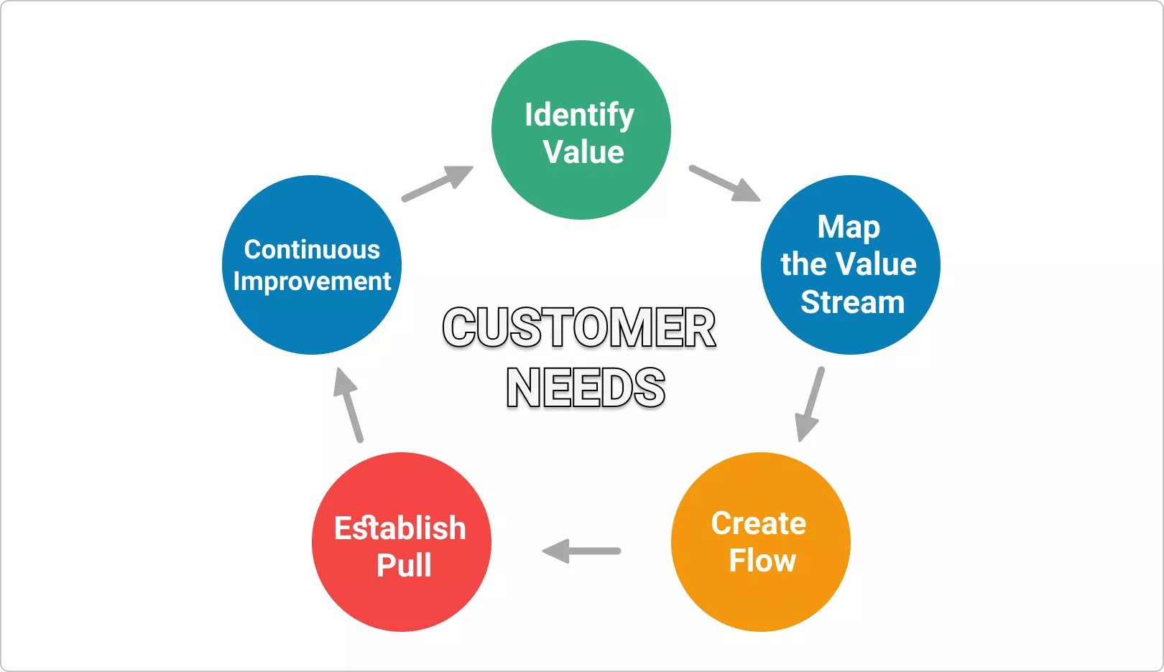
Figure 8- Lean Project Management
The Project Manager website (Landau, 2021)looks at What is Lean Project Management, and what is means for the business.
Lean project management looks at delivering a manufacturing project with the emphasis being on more value and less waste created. It does this by eliminating waste in the value stream of the lean manufacturing process.
For lean to work, there needs to be continuous improvement, and every process in the business stream must have the principle of greater value less waste applied.
Lean manufacturing was a process developed by Toyota, (Marmol, 2015) , it was introduced to look at improving value for the customers of the car manufacturer. The benefits that were realised by Toyota are as follows:
- Greater visibility into the manufacturing process
- More control, better decision making and empowers teams.
- Boosts productivity and morale
- Provides alternative ways to get deliverables out the door.
- Faster projects due to have to respond to fewer issues.
- Boosts profits, as more value added, and waste is reduced.
- Increased customer satisfaction
Toyota applied 14 solid principles as follows:
- Apply a long-term philosophy.
- Create Continuous flow.
- Use pull and avoid overproduction.
- Heijunka
- Build the right culture.
- Standardize tasks.
- Use visual control.
- Use only tested technology.
- Grow leaders who live the philosophy.
- Develop people and teams.
- Respect your outside forces.
- Observe and reflect.
- Decide slowly, implement fast.
- Practice reflection all the time

Lean Project Management Principles

When looking at Project management, and in particular lean project management, there are 5 principles, that function as a guide for how to achieve customer satisfaction. The purpose of following these steps is that when conducting a project, you will have the best chance of reducing product waste, staying within the project scope, and meeting those critical success factors. (Asana, 2021)
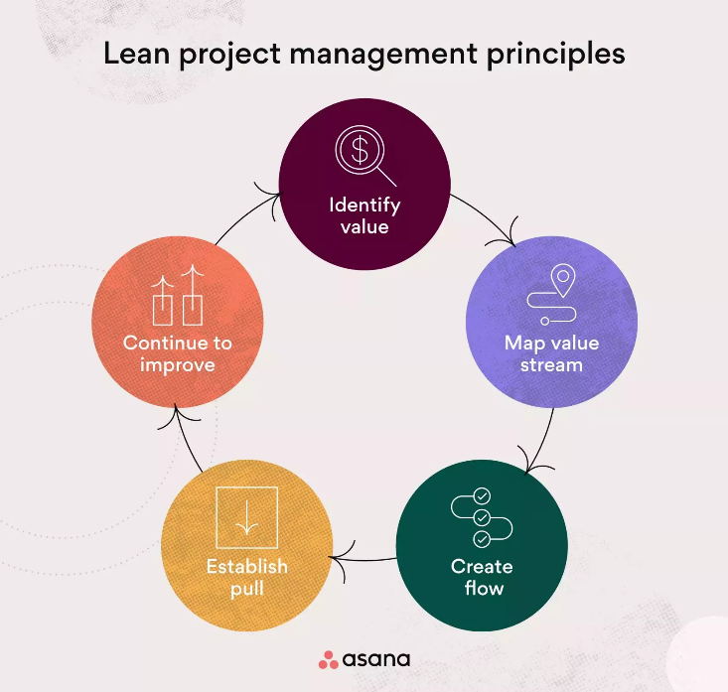
5 principles:
- Identify Value
- Map Value Stream
- Create flow
- Establish Pull
- Continue to improve

- Identifying value
The initial principle is to identify the value of the product. For this to be achieved you need to know the stakeholder; this could be either an internal or external stakeholder.
When you have a clear understanding who they are, you will be able to determine how to make it valuable.
- Map the value stream
Value streaming is the next principle in lean project management. VSM is a visual tool that involves diagramming your current workflow and your ideal workflow from project initiation to completion.
- Create Flow
This process will involve reworking the project management plan to be more efficient by removing waste that was identified in step 2. Use project milestones as checkpoints to ensure new waste does not develop as the project progresses.
- Establish Pull
This means pulling work from the previous process stage as work is completed. This concept originated in the manufacturing industry, to help the factories to meet the needs of the customer with a just in time inventory system. It also allows industries to keep the workflow moving efficiently.
And finally,
- Continuous improvement
It is not a one-time event; it is an iterative process. In this principle there is a strive for perfection, which involves continuous improvements to the workflow.

.Advantages and Disadvantages of Lean Management

When considering if Lean project management is a good project management methodology to use it is important to consider the advantages and disadvantages that would apply. (Together, 2019)
Advantages
Cost Decrease – Lean is all about maximising profits, this means cutting costs within an operation as well as increasing revenue.
The overall selling price can be impacted by numerous factors, there are things that companies can do to control the costs. Lean practices help in cost reduction as well as savings that be added to profit.
Customer Interaction Enhancement – Lean starts with a customer’s viewpoint in mind, in which they communicate with staff, responsiveness to concerns and experiences with the product are some leading drivers of eliminating wasteful practice.
Increased Quality – Lean also drives to aid in the attention to quality and value of the end product. Looking to decrease defects and rework products, hence avoiding potential mistakes.
Disadvantages
Inventory Problems – In order for the inventory to be lean, this can also become a potential problem, as companies depend on suppliers and will hope they are able to adjust and deliver quickly. If there are problems with the inventory process this can potentially derail a company
Implementation Costs – Lean management can mean a new system being implemented into a company; this can bring with it increased expenses.
Difficult Changeover – Changeover can be difficult due to the entire change of the facility. Tis may require a lot of overhead and complete overhaul of the working processes. It is essential that leaders be transparent about potential changes that will happen.

Discussion and Conclusions

Through all my research I have conducted looking at Waterfall, Agile & Lean project management processes, I feel that Agile would work best for the department I work in and the type of projects I undertake.
The complexity of a project has a significant impact on the type of management process to use, if the projects were well defined and within a predictable environment then waterfall would be the correct method, but as majority of the projects I work on within the university are more complex and can have uncertainty as to the viability of them, therefore I would opt to using agile as a project management process.
When I consider the stakeholders that are involved with the projects, that I lead on, I am in discussions heavily with both the government agency and the end user of the project. Due to this Agile would work better than waterfall in this scenario as the stakeholder require frequent feedback, and decision making, is required to ensure that the benefit is realised at the end of the project.
I have highlighted what I consider to be a few key points that have impacted my decision. (Management, 2022)

Flexibility – Agile focuses on a flexible and adaptive approach to project management, when considering event planning there is a large element of uncertainty and last-minute changes that can happen. By using agile project management, I would be able to successfully execute the event regardless of the unexpected changes that may occur.
Throughout the projects I work on, there is a strong emphasis on the need for flexibility, when planning the workload for the team to work on. There are times when certain variables cannot be predicted and therefore to have the flexibility to apply change, revision is important.
Collaboration – Throughout all projects that I have worked on, there has been an element of collaboration between both the internal and external teams. Through regular communication such as board meetings and setting up a team’s site to be able to share work being conducted on the project, there is continued collaboration. By doing this it allows for better coordination and alignment among all the parties concerned.
In order that the project is successful I believe a dedicated team is important, when building the team together, I will clearly lay out task and expectations of the role of each team member. Through regular meetings we can address any issues that may arise and keep the team motivated and happy primarily.
Transparency and visibility- Agile promotes transparency and visibility through the project, we prepare regular meetings, reviews, allowing stakeholders to see the progress made and provide feedback, this allows everyone to have input and to ensure that the product is delivered successfully.
Transparency promotes responsibility in the project team, the team know what is expected of them, and allows them to accomplish the project. Team members can know what each other’s roles are, and how their actions impact on their colleagues.
Continuous Improvement – Agile encourages us to reflect using previous events we have planned and making changes when they have not worked. With projects we look at lessons learnt, this allows us to develop our understanding of best practices and implement them going forward in projects.
Risk Mitigation – Using Agile methodologies helps to identify and address any risks early in the event planning process. When planning a project, I would look to break into manageable tasks, this will involve collaborating with a good team who can help bring this together. This helps to reduce the chances of failure in the event and project.
When using risk mitigation, it produces a plan for also any future collaborations and allows the team to implement them into those projects.
Roles – Agile encourages team members to collaborate on various aspects of the project over time, where waterfall assigns roles and specific duties, which would not work as well for the projects we work on. As a team we have the flexibility to all work on all aspects of the project, and where necessary merge roles to deliver the project/event on time.
Planning – Agile allows us to have continuous improvement throughout the project’s life cycle, with adjustments being able to be made as they are required. In waterfall planning is conducted at the beginning and doesn’t allow for there to be any adjustments as the projects runs, we have found that this would not work in our projects.
Scope – Agile allows for there to be changes in the scope of the project, this can be caused by an end user making amendments or the project team through discussions have identified significant areas that require change.
Customer Satisfaction – Agile project management focuses on the outcome for the customer, and that the project delivers value to them. By involving the customer throughout the process, the needs of the customer are continually validating, and this will lead to improved customer satisfaction and a higher probability that the project will meet their expectations.

References
Anon., 2023. Atlassian. [Online]
Available at: https://www.atlassian.com/agile/project-management/project-management-intro#:~:text=What%20is%20waterfall%20project%20management,to%20revisit%20a%20previous%20stage.
[Accessed 15 09 2023].
Anon., 2023. Wrike. [Online]
Available at: https://www.wrike.com/project-management-guide/faq/what-is-lean-project-management/
[Accessed 15 09 2023].
Asana, T., 2021. Asana. [Online]
Available at: https://asana.com/resources/critical-path-method
[Accessed 15 09 23].
Department, P., 2019/2020. Annual Report Equality and Diversity 2019/20. [Online]
Available at: https://www.uwtsd.ac.uk/media/uwtsd-website/content-assets/documents/strategies-policies/equality-and-diversity-annual-report-2019-20.pdf
[Accessed 11 04 23].
Eby, K., 2023. Smartsheet. [Online]
Available at: https://www.smartsheet.com/when-choose-waterfall-project-management-over-agile
[Accessed 21 04 2023].
Edition, A. B. o. K. 7., 2022. APM Association of Project Management. [Online]
Available at: https://www.apm.org.uk/resources/what-is-project-management/
[Accessed 11 04 2023].
Landau, P., 2021. Project Manager. [Online]
Available at: https://www.projectmanager.com/blog/lean-project-management
[Accessed 13 09 2023].
Malsam, W., 2021. Project Manager. [Online]
Available at: https://www.projectmanager.com/blog/prince2-methodology
[Accessed 15 09 2023].
Management, A. f. P., 2022. Association for Project Management. [Online]
Available at: https://www.apm.org.uk/resources/find-a-resource/agile-project-management/#:~:text=Agile%20project%20management%20is%20an,the%20completion%20of%20a%20project.
[Accessed 23 August 2023].
Marmol, L. D., 2015. Lean Six Sigma. [Online]
Available at: https://leansixsigmabelgium.com/blog/toyota-six-sigma-14-solid-principles/
[Accessed 13 09 2023].
Team, T. C., 2023. The Crm Team. [Online]
Available at: https://thecrmteam.com/5-reasons-why-agile-is-better-than-waterfall/
[Accessed 23 august 2023].
Together, P., 2019. Planet Together. [Online]
Available at: https://www.planettogether.com/blog/advantages-and-disadvantages-of-lean-management
[Accessed 13 09 2023].
Unknown, 2023. My Management Guide.com. [Online]
Available at: https://mymanagementguide.com/basics/what-is-a-project/
[Accessed 11 04 2023].
Waseem, A., 23. Management Library. [Online]
Available at: https://management.org/waterfall-methodology
[Accessed 21 04 2023].
Waseem, A., n.d. Management Library. [Online]
Available at: https://management.org/waterfall-methodology#:~:text=Historical%20Overview%20of%20the%20Waterfall%20Methodology&text=Construction%20and%20manufacturing%20firms%20have,the%20development%20of%20large%20software.
[Accessed 10 09 2023].
(Management, 2022)
(Team, 2023) - Agile vs Waterfall | 5 Reasons why Agile is better | The CRM Team

