Task 1:
E-commerce website builders function as software platforms which enable users and organizations to build online stores through interface-based operations without requiring programming expertise. Modern solutions combine tools which enable users to manage products and payments and market their business and track performance and inventory levels and maintain security. The following section examines two contemporary e-commerce solutions which are Shopify and Wix eCommerce.

- Shopify (software solutions)

Shopify operates as a leading global e-commerce platform which supports businesses at every scale from small to large enterprises. The platform operates as a complete hosted solution because users do not need to download additional software or handle server management tasks. The platform offers users can select from more than 100 pre-designed templates which they can customize through its Liquid coding system. The payment system within Shopify known as Shopify Payments enables businesses to process all payment types including credit cards and Apple Pay and Google Pay without needing external payment processors [1].
The Shopify app store contains thousands of available add-ons which include dropshipping tools and email marketing solutions and live chat functionality and AI-based product recommendation systems. The platform enables users to enhance their workflow operations and user interface experience. The analytics dashboards in the system enable businesses to monitor their sales performance and customer actions and product sales data which helps them make better decisions. The system requires programming knowledge or paid third-party applications for advanced customization which leads to higher expenses [2].

2.Wix eCommerce (software solutions)

Wix operates as a cloud-based website builder which enables users to create websites through its drag-and-drop interface regardless of their technical abilities. The Wix eCommerce platform lets businesses establish online stores quickly by offering customizable templates and built-in shopping functionality and secure payment processing systems. The platform enables businesses to process more than 50 payment options worldwide while providing complete order management capabilities including tracking and abandoned cart recovery and automated customer email sending [3].
Users can modify page layouts through visual controls in Wix without needing to write code. The platform enables users to sell their products across multiple channels including Facebook and Instagram which strengthens their digital marketing efforts.
The platform includes built-in SEO tools which help businesses improve their search engine rankings. The platform lacks advanced integration capabilities when compared to Shopify and its storage capacity might not support large complex online stores.

Summary
Shopify and Wix eCommerce provide complete online selling solutions but Shopify excels at business expansion and Shopify provides better design flexibility to users. The selection between these two options depends on organizational requirements and staff programming abilities and financial resources.

Task 2: Mind-map of Contemporary Software Applications
2a. Description of Mind Mapping and Its Business Benefits

Business Benefits
Mind mapping represents a visual approach which helps users organize their ideas and concepts through central theme-based connections. The system uses branches together with keywords and colours and images to show how different subjects relate to each other. Tony Buzan popularized mind maps which now serve as a standard tool for educational projects and problem-solving activities. Business organizations benefit from mind mapping through several key advantages. Mind maps enable teams to create new ideas through visual presentation which leads to better brainstorming and innovation [4]. Mind maps help users organize complex information into simple structures which enables them to create efficient task plans. Mind maps enable teams to create strategic plans and project schedules and software architectures which teams can understand easily. The process of mapping relationships enables managers to detect dependencies and risks and establish priorities which leads to better decision-making. The software applications MindMeister and XMind and Microsoft Visio enable users to access templates and work together while storing their mind-mapping content in the cloud.

2b. 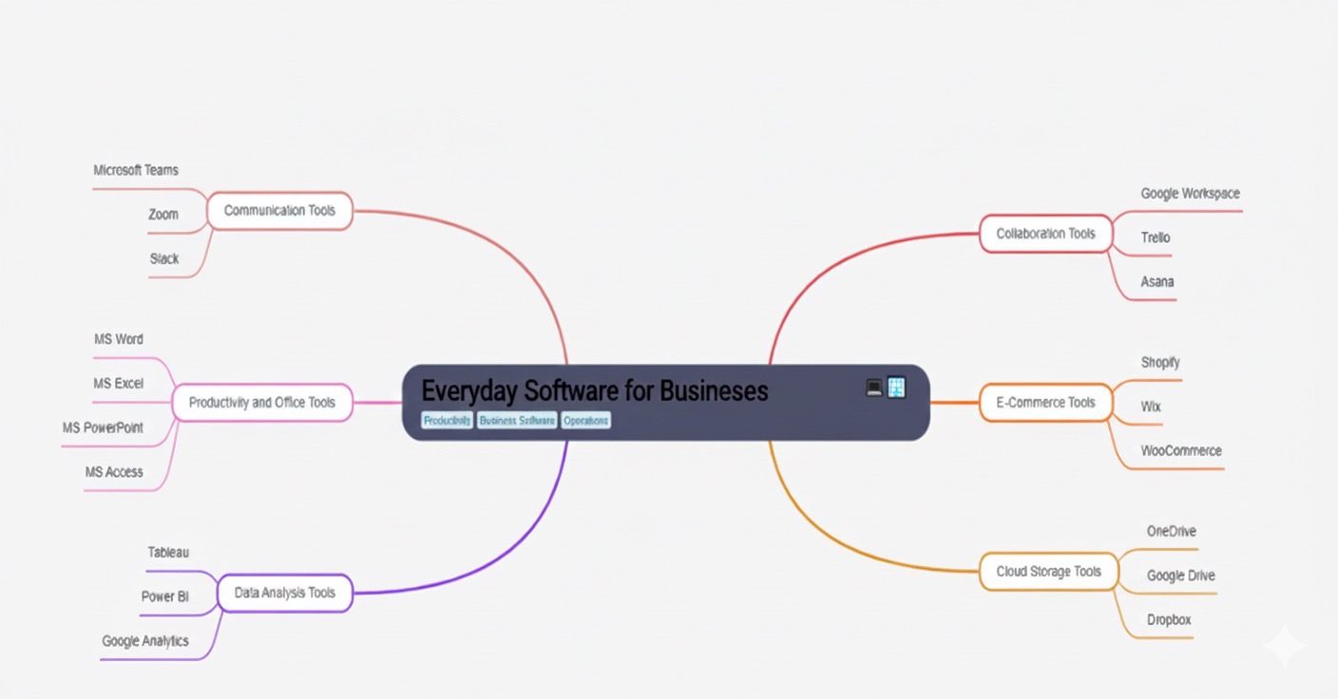

Task 3: Office Applications for Creating, Storing, Presenting and Analysing Data
3a. Explanation of Four Office Suite Software Tools
The management of business information depends heavily on modern office suite software applications which enable users to create process analyse and present their data. These tools help organizations to handle data more efficiently while improving communication and supporting decision-making processes and boosting overall productivity. The most popular applications include Microsoft Word and Microsoft PowerPoint and Microsoft Excel and Microsoft Access which serve specific needs for document management. The following section provides detailed analysis of tool operations and their business benefits and user limitations.
1. Microsoft Word
Microsoft Word serves as a global word-processing application which enables users to create and edit text documents and apply formatting and distribute their work. The document development process requires professional standards which make it essential for academic and administrative and business environments.
Core Capabilities:

Users of Microsoft Word can generate different document formats through the application:
- Business reports
- letters and memos
- manuals and instructional guides
- proposals and contractual documents
- resumes and application forms

The application provides users with multiple built-in templates which help them create structured documents through easy step-by-step processes without needing design abilities. Word provides users with layout options which enable them to adjust margins and headers and footers and page orientation and paragraph organization. The system includes multimedia functionality which allows users to add different types of media content including images and charts and tables and diagrams and hyperlinks and embedded files.
Productivity and Collaboration Features
- Microsoft Word offers users advanced features which enable them to boost their work productivity.
- The system uses AutoCorrect and Spell Check to identify both grammatical mistakes and spelling errors.
- Mail Merge automates the generation of personalized documents (such as letters or labels).

- The Track Changes and Comments function serves as a collaborative platform which allows teams to work together on document editing tasks during their professional work activities.
- Dictation and Accessibility Tools assist users with physical or learning disabilities.
- The OneDrive cloud integration allows users to edit documents together in real-time. The feature functions as an essential collaboration tool which lets teams edit shared documents together from anywhere.

Limitations
- Word contains two essential drawbacks despite its numerous beneficial features.
- File Compatibility Issues
- Word functions as the standard business application yet users face compatibility issues when working with different software versions and when they need to convert files between Google Docs and PDF formats.
- Limited Advanced Design Control
- Word cannot match the layout precision of desktop publishing tools such as Adobe InDesign. The software lacks sufficient formatting options which prevents users from performing complex graphic design tasks.
- Word stands as the top choice for organizations that require professional document creation together with powerful collaboration features.

2. Microsoft PowerPoint
Microsoft PowerPoint functions as a presentation software which enables users to develop digital slideshows for their work needs and educational requirements and training sessions. The tool enables users to create visual content which converts complicated data into simple information that users can understand.
Core Capabilities
PowerPoint includes:
- hundreds of slide templates
- animation and transition effects
- video, audio, and image embedding
- SmartArt graphics for visual diagrams
- The presentation includes Presenter View which displays notes and shows upcoming slides.
- real-time collaboration through Microsoft 365
- The system enables users to create professional presentations for business meetings and educational seminars and marketing presentations and conference events.
- Visual Communication Benefits
- PowerPoint functions at its best for multimodal communication because it enables users to combine text with visual elements and audio content which results in better audience engagement.
For example:
- business analysts can convert financial metrics into charts and dashboards
- Educators use videos and animations to explain complicated concepts which students struggle to learn from written materials.
- Project managers use visual tools to create roadmaps and workflow diagrams which they need for their work.
- Presenters achieve simpler information through visual integration of images and graphs and visual metaphors which produces content that is more engaging and easier to understand.

Limitations
The platform contains a major drawback because users could potentially abuse its functionality. Users tend to use animations and transitions and large text blocks excessively which results in slides that become overwhelming to the eyes. The message becomes less clear because of this approach which pulls attention away from the main message. The effective use of PowerPoint requires designers to follow specific principles which include maintaining design consistency and using minimal text and achieving visual balance.

3. Microsoft Excel
Microsoft Excel serves as the main spreadsheet application which users can reach through their current technology systems. The system allows users to store data while providing tools for organization and analysis through formulas and tables and analytical features.

Core Capabilities
Excel’s functionality includes:
- mathematical formulas and functions
- pivot tables
- statistical analysis
- charts and visual data representations
- macros for process automation
- conditional formatting
- data validation rules

These tools enable businesses to perform financial modelling and forecasting and track performance while managing budgets and inventories.
Business Applications
- All business sectors use Excel as their primary tool for their operations.
- The system tracks inventory changes while it sets automatic reorder points and monitors supplier delivery times.
- Financial Management: Creating budgets, expenditure logs, profit analyses.
- Data Analytics: The evaluation of trends depends on pivot tables and charts for analysis.
- Decision Modelling: Using “What-If Analysis,” Goal Seek, and Scenario Manager.
- Operational Planning: Scheduling, workforce allocation, resource allocation.
- Excel provides flexible operations which enable its use by small businesses and large corporations and government departments and freelance professionals.

Advantages
Excel enables users to process large data sets at high speeds which results in quick calculation results. The system allows users to run automated repetitive tasks through Visual Basic for Applications (VBA) which helps users save time and minimize mistakes. The platform converts raw data into readable patterns through visual charts which enables better managerial decision-making.

Limitations
- The operational efficiency of Excel decreases because it has various built-in restrictions.
- Human Error
- The manual entry process of data creates conditions that lead to errors which result in incorrect research results.
- Scalability Issues
- The processing speed of spreadsheets becomes slow when dealing with massive or complicated datasets.
- The best solution for these situations involves using database systems that include SQL Server and Oracle.
- The system faces multiple restrictions but users continue to depend on Excel because it provides advanced analytical features together with user-friendly operation.

4. Microsoft Access
Microsoft Access functions as a database management system (DBMS) which enables users to build and handle organized datasets. The system functions as a reliable data management platform which supports small to medium-sized businesses through its storage and retrieval capabilities.

Core Capabilities
Access enables users to develop:
- tables for data storage
- forms for data entry
- queries for searching and filtering
- reports for presenting outputs
The relational database structure allows tables to connect which eliminates duplicate data and produces more accurate results. The customer table maintains its own data structure which enables it to connect with the orders table through a link that avoids duplicate customer information in each order entry.
Business Applications:
Access is frequently used for:
- employee records
- customer management systems
- inventory databases
- reservation systems
- small-scale business applications
Because it requires minimal coding knowledge, Access is ideal for users who need a database solution but do not have the expertise to develop a full SQL-based system.
Limitations
- Access faces two main restrictions.
- Limited Scalability
- The system fails to handle big data sets and it is not suitable for business environments that need multiple users to access the system at the same time.

- Lower Performance
The system operates at a lower speed than DBMS tools do while blocking users from executing advanced data management operations. The program maintains its value for small businesses which need an easy-to-use database solution.

3b. Practical Evidence of Excel Features
The IF function is used to evaluate a condition and return one value if the condition is true and another value if it is false.

Figure 1: Applying IF function to determine within budget or over budget status.

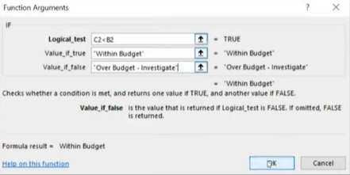

Figure 2: Results of IF function applied across the dataset.
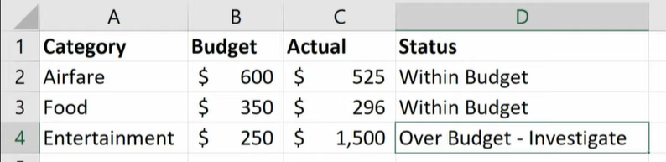

Feature 2: VLOOKUP
Description:
VLOOKUP searches for a value in the first column of a table and returns a corresponding value from a selected column.
Figure 3: Setting up a VLOOKUP formula to retrieve product prices.

Figure 4: Results of VLOOKUP applied to multiple entries.

Task 4: Communication and Collaboration Applications
4a. Analysis of One Communication and One Collaboration Application
Communication Application: Microsoft Teams
Microsoft Teams operates as a cloud-based communication system which serves businesses across the globe. The tool operates as part of Microsoft 365 so users can access it through seamless integration with Outlook and Word and Excel and PowerPoint and OneDrive. The platform Teams enables users to unite people across different locations through video conferencing and audio conferencing and instant messaging and file exchange capabilities.

Core Features of Microsoft Teams
- The Teams platform provides multiple features which enable workplace communication through its platform.
- Instant Chat Messaging
- Users have the ability to send direct messages to their colleagues while also joining group chat discussions. Users can send text messages and files and images and emojis and links through chat which enables them to communicate quickly and adapt to different situations.
- Channels for Organized Discussions
- The platform organizes teams into dedicated channels which serve as dedicated spaces for particular subjects including departmental work and project teams and active projects.
- The system prevents information overload because it maintains an organized structure for all discussions.
- Video and Voice Meetings
- Users can create video meetings through Teams which offers screen sharing and recording capabilities and breakout rooms and live captioning functions. The system provides functions which enable users to conduct training sessions and group discussions and remote learning and professional meetings.

Integration with Microsoft 365
- Users can access Word documents and spreadsheets and PowerPoint slides and shared files through Teams because the platform integrates with other Microsoft tools. Users can access all their files through Teams because the platform enables direct access to Word documents and spreadsheets and PowerPoint slides and shared files without requiring window changes. The method reduces time requirements while it improves team member collaboration.
- File Sharing and Storage
- SharePoint enables every team to access their own specific file storage area. Users can upload documents and edit them while organizing files so team members always access the latest document versions.

Benefits of Microsoft Teams
- Unified communication platform
- Teams provides a single platform which enables users to access chat functions and conduct meetings and share files and connect applications. The system eliminates the requirement for multiple tools because staff members can find all necessary resources through a single application.
- Supports remote and hybrid work
- The platform enables employees to work together through video calls and document exchange and meeting recording functions regardless of their physical locations or time zones.
- The system enables users to send messages quickly while reducing their need to handle email messages.
- Organizations need to decrease their email volume because employees now prefer to use fast chat messages and channel discussions for communication. Information becomes easier to find and respond to.
- The process of uniting different departments leads to better teamwork between staff members.
- Real-time document editing functions enable teams to work more effectively because they prevent different document versions from creating confusion.

Limitations of Microsoft Teams
- Although Teams is feature-rich, it does come with a few challenges:
- Complexity for new users
- The platform contains multiple features which create difficulties for new users to learn its operational methods. The process of learning about channels and meeting tools and integration capabilities requires extended periods of time.
- Performance issues on older devices
- Video calling and file sharing need both contemporary computer devices and high-speed internet access to function properly.
- Notification overload
- Users who belong to multiple teams and channels will experience overwhelming alert notifications which causes them to lose focus.
- The tool functions as an excellent communication solution for professional environments but it has certain operational restrictions.

Collaboration Application: Trello
Trello operates as a web-based project management system which enables users to create visual task organization systems for personal and team work. The system operates through Kanban which displays work progress through boards and lists and cards. The layout design of Trello provides users with an intuitive interface that works well for both technical and non-technical users.

Core Features of Trello
- Boards
- The system shows all projects and workflows through its board interface. The marketing team uses a board for their campaign planning activities but students use theirs to organize their schoolwork.
- Lists function as vertical columns which show task progression through different stages such as "To Do" and "In Progress" and "Completed". The system enables users to monitor their advancement through its interface.
- The cards operate independently as individual work items. Users can add information to cards through checklists and due dates and comments and attachments and member assignments.
- Drag-and-Drop Functionality
- Tasks can be moved between lists simply by dragging the cards. The visual movement enables viewers to track the ongoing work progress.
- Trello Butler (Automation)
- Trello provides automated functions which let users create automatic tasks that move cards based on due dates and send reminders and alert team members.

Benefits of Trello
- Very simple and easy to use.
- The visual structure of Trello provides simple navigation which makes it accessible to users who lack experience. The system allows teams to begin using it right away without needing extensive training.
- Improves task visibility
- The board displays all tasks in an organized way which enables team members to see their work assignments and their specific responsibilities.
- Supports collaboration
- Team members can comment on tasks, upload files, update checklists, and assign responsibilities. The system provides all members with access to receive updates.
- Good for small to medium-sized projects
- Trello functions effectively for managing events and school assignments and running small businesses and conducting research and monitoring workflows.
- Flexible and customizable
- Boards serve multiple functions because they can be used for personal planning and team collaboration and long-term projects and basic task management.

Limitations of Trello
- All tools have their own set of limitations which Trello also possesses.
- Limited advanced project management features
- Trello lacks built-in resource management and workload tracking and budgeting tools and Gantt charts, but users can access these features through external plug-ins.
- The system does not work well for organizations that have extensive operations.
- Trello does not fulfil the requirements of teams which exceed a particular member count. The system fails to provide the sophisticated forecasting capabilities which Microsoft Project and Jira offer.
- Relies on visual organization
- Users who work with lists and spreadsheets experience challenges when using Trello because it structures information through boards.
- Trello continues to be a widely used collaboration platform because it offers users basic functionality which helps them handle their everyday work responsibilities.

Microsoft Teams Practical Test (Communication Tool)
Screenshot 1: Creating a new Team or Channel, go on the Microsoft teams and log in, after you log in press on new meeting, name it and share the link.


Screenshot 2: Posting a message in the channel, after the channel has been created press on the “Chat” button and start typing.



Creating a Task Card
Screenshot 1: New Trello board, press on create and select “Create Board”
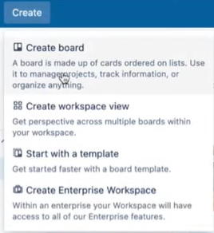
Screenshot 2: Adding a card with due date and checklist, after creating the board press on the + button and name your card, and then press on the card and select the “Add button” to select the due date, and for the checklist select checklist button.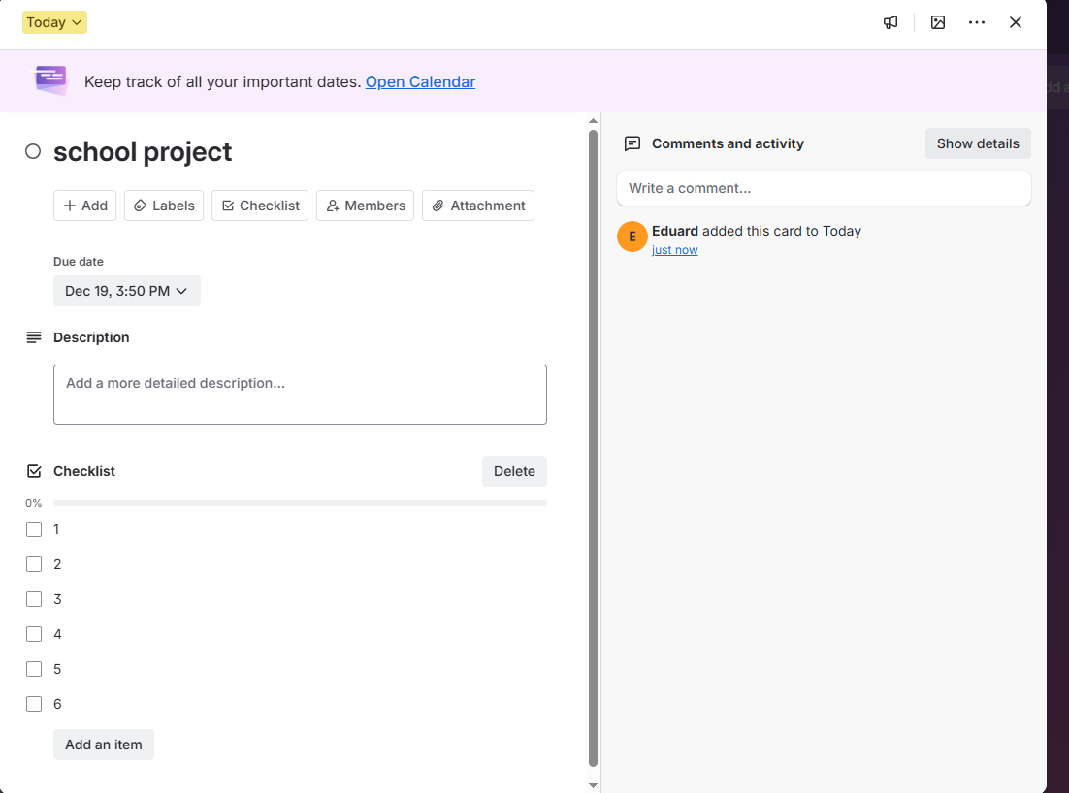

References:
[1] Shopify, “Shopify Features,” Shopify, 2024. [Online]. Available: https://www.shopify.com
[2] Wix, “Wix eCommerce Solutions,” Wix, 2024. [Online]. Available: https://www.wix.com
[3] J. Richards, E-Commerce Technologies. London, UK: Pearson, 2021.
[4] T. Buzan, The Mind Map Book. London, UK: BBC Books, 2018.
[5] Microsoft, “Microsoft Word Documentation,” Microsoft Learn, 2023. [Online]. Available: https://learn.microsoft.com
[6] Microsoft, “Microsoft Teams – Overview and Features,” Microsoft, 2024. [Online]. Available: https://www.microsoft.com/microsoft-teams
[7] Atlassian, “Trello Product Guide,” Atlassian, 2023. [Online]. Available: https://trello.com

